Student Name: Prabhjeet Singh
SAP ID: 590013286

Experiment Name: Implementation of advanced query mechanisms in MongoDB
Date: 4/12/25

Objective:
To perform and understand advanced query features in MongoDB including skip, limit, comparison operators, nested field queries, and array-based filtering. The aim is to demonstrate how flexible schema design in NoSQL enables efficient data retrieval.
Theory/Concepts:
MongoDB offers a rich query model that supports selective retrieval and controlled output formatting. Commonly used query features include:
- skip(n): Omits the first n matching documents before displaying the response.
- limit(n): Restricts the output to n documents.
Comparison operators:
- $gt – selects values greater than a given threshold
- $lt – selects values less than a given threshold
- $ne – returns results not equal to a given value
Dot notation is used to access embedded attributes, such as fields in nested objects or arrays, for example:
- grades.score
- address.coord.1
Each record in the hotel collection comprises:
- hotel_id: unique identifier
- name: hotel name
- borough: geographic region
- cuisine: food category
- grades: array detailing scoring information
- address.coord: coordinates containing longitude and latitude

Procedure
- Launch MongoDB and start the shell using mongosh.
- Create or switch to the working database: use hotelDB_2
- Insert predefined sample hotel records into the hotel collection.
- Execute advanced queries using skip, limit, and comparison operators.
- Filter data based on nested fields, arrays, and coordinate values.
- Record and analyze outputs for all queried results.
Code:
Starting Server:
mongosh
Creating Database:
use hotelDB_2
db.createCollection("hotel")
Inserting documents:
db.hotel.insertMany([
{
hotel_id: "H01",
name: "Sunrise Inn",
borough: "Bronx",
cuisine: "Italian",
grades: [{ score: 85 }],
address: { coord: [-73.90, -95.80] }
},
{
hotel_id: "H02",
name: "Maple Residency",
borough: "Manhattan",
cuisine: "Indian",
grades: [{ score: 91 }],
address: { coord: [-74.00, -66.10] }
},
{
hotel_id: "H03",
name: "Royal Orchid Hotel",
borough: "Bronx",
cuisine: "Chinese",
grades: [{ score: 78 }],
address: { coord: [-72.50, -96.40] }
},
{
hotel_id: "H04",
name: "Blue Lagoon Suites",
borough: "Brooklyn",
cuisine: "Mexican",
grades: [{ score: 95 }],
address: { coord: [-73.10, -94.20] }
},
{
hotel_id: "H05",
name: "Green Leaf Hotel",
borough: "Bronx",
cuisine: "Thai",
grades: [{ score: 88 }],
address: { coord: [-71.80, -96.80] }
},
{
hotel_id: "H06",
name: "Skyline Plaza",
borough: "Queens",
cuisine: "American",
grades: [{ score: 82 }],
address: { coord: [-73.40, -65.90] }
},
{
hotel_id: "H07",
name: "City Crown Hotel",
borough: "Bronx",
cuisine: "Korean",
grades: [{ score: 98 }],
address: { coord: [-75.20, -66.20] }
},
{
hotel_id: "H08",
name: "Harbor View Inn",
borough: "Bronx",
cuisine: "Japanese",
grades: [{ score: 72 }],
address: { coord: [-72.30, -64.70] }
},
{
hotel_id: "H09",
name: "Golden Nest Hotel",
borough: "Manhattan",
cuisine: "Italian",
grades: [{ score: 89 }],
address: { coord: [-73.00, -67.20] }
},
{
hotel_id: "H10",
name: "Crystal Palace Hotel",
borough: "Queens",
cuisine: "Indian",
grades: [{ score: 76 }],
address: { coord: [-72.10, -95.90] }
},
{
hotel_id: "H11",
name: "Palm Tree Resorts",
borough: "Bronx",
cuisine: "Mexican",
grades: [{ score: 92 }],
address: { coord: [-72.90, -96.30] }
},
{
hotel_id: "H12",
name: "Silver Star Hotel",
borough: "Brooklyn",
cuisine: "Chinese",
grades: [{ score: 84 }],
address: { coord: [-74.40, -65.80] }
},
{
hotel_id: "H13",
name: "Moonlight Residency",
borough: "Bronx",
cuisine: "Thai",
grades: [{ score: 69 }],
address: { coord: [-73.80, -96.00] }
},
{
hotel_id: "H14",
name: "Riverfront Hotel",
borough: "Manhattan",
cuisine: "Korean",
grades: [{ score: 87 }],
address: { coord: [-71.90, -66.50] }
},
{
hotel_id: "H15",
name: "Ocean Breeze Inn",
borough: "Bronx",
cuisine: "American",
grades: [{ score: 83 }],
address: { coord: [-73.60, -65.70] }
},
{
hotel_id: "H16",
name: "Sunset Grand Hotel",
borough: "Queens",
cuisine: "Japanese",
grades: [{ score: 94 }],
address: { coord: [-72.80, -96.10] }
},
{
hotel_id: "H17",
name: "Emerald Bay Hotel",
borough: "Bronx",
cuisine: "Italian",
grades: [{ score: 90 }],
address: { coord: [-71.50, -95.76] }
},
{
hotel_id: "H18",
name: "Urban Comfort Hotel",
borough: "Brooklyn",
cuisine: "Mexican",
grades: [{ score: 74 }],
address: { coord: [-72.70, -67.10] }
}
]);
Queries:

Queries Executed
1. Display 5 hotels from Bronx after skipping the first 5 entries
db.hotel.find({ borough: "Bronx" }).skip(5).limit(5);
2. Retrieve hotels with score between 80 and 100 (exclusive)
db.hotel.find({ "grades.score": { $gt: 80, $lt: 100 } });
3. Retrieve hotels that have latitude value below -95.75
db.hotel.find({ "address.coord.1": { $lt: -95.75 } });
4. Fetch hotels that do not serve American cuisine, have score > 70, and latitude below -65.754168
db.hotel.find({
cuisine: { $ne: "American" },
"grades.score": { $gt: 70 },
"address.coord.1": { $lt: -65.754168 }
});

Output:
Starting server and creating database:
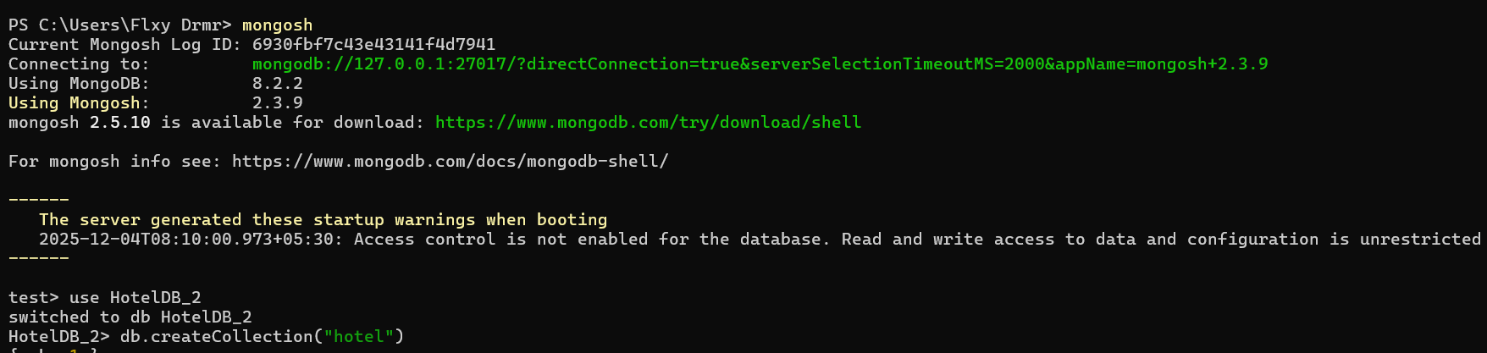
Inserting documents:
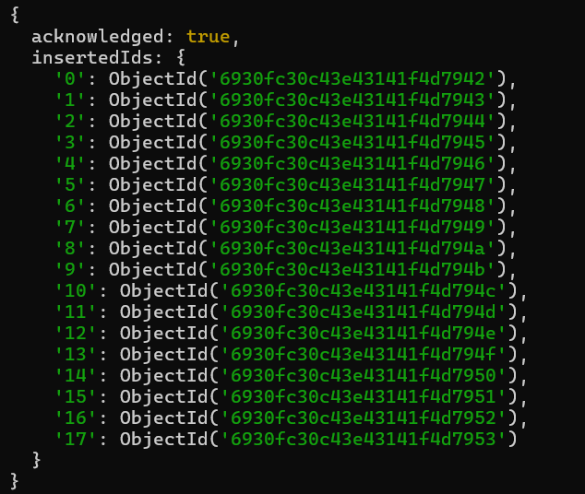
1. Write a MongoDB query to display the next 5 hotels after skipping first 5 which are in the
Borough Bronx.
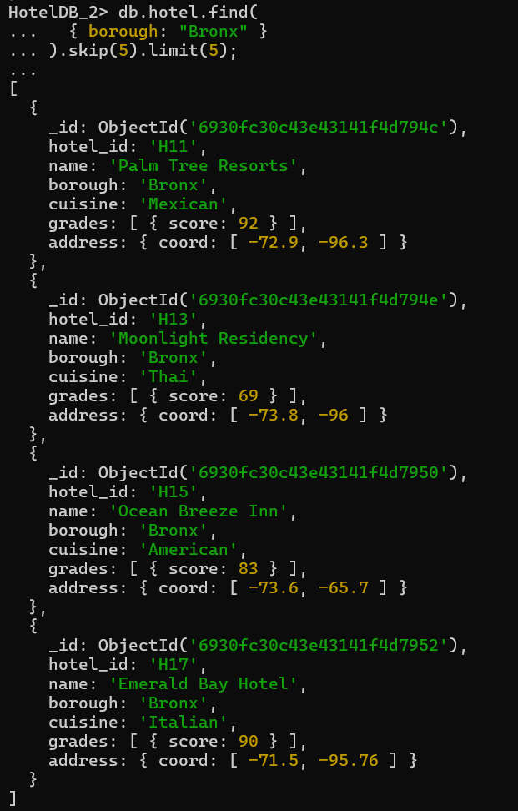

2. Write a MongoDB query to find the hotels that achieved a score, more than 80 but less than 100.
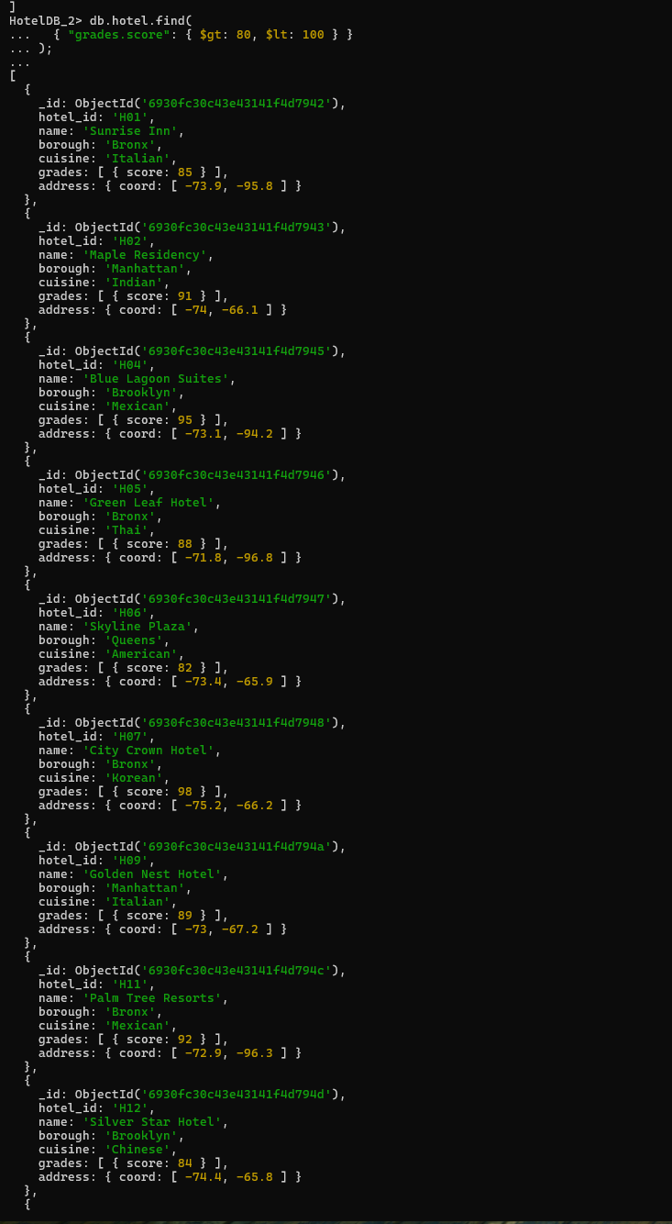
3. Write a MongoDB query to find the hotels which locate in latitude value less than -95.75
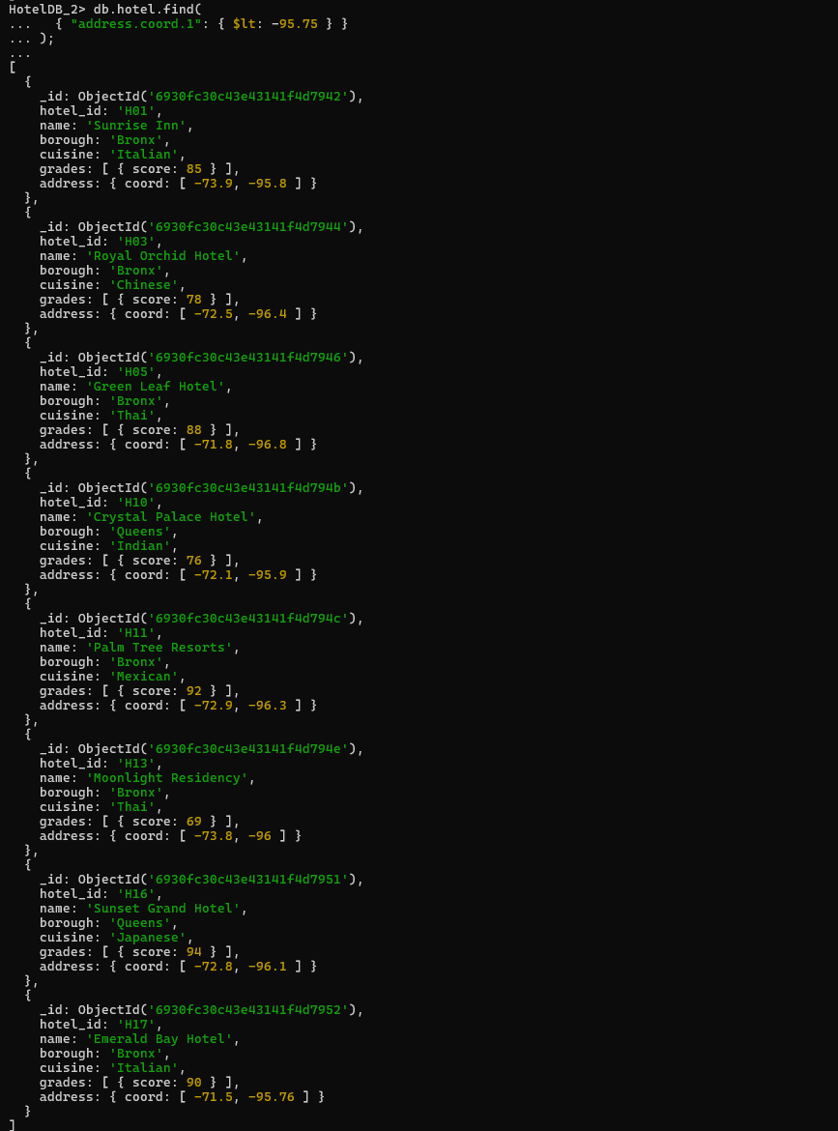
4. Write a MongoDB query to find the hotels that do not prepare any cuisine of 'American' and their grade score more than 70 and latitude less than -65.754168.
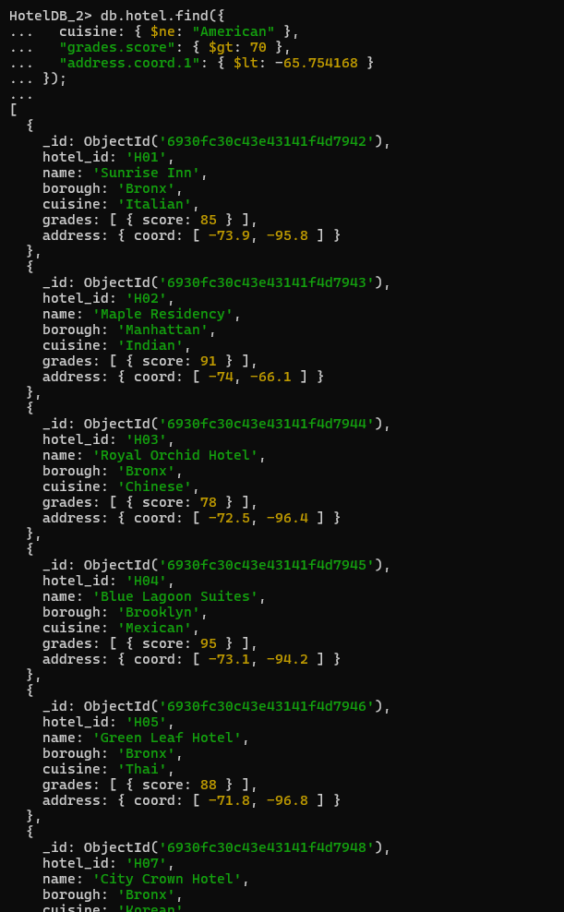
Result:
The experiment validated the use of advanced querying techniques in MongoDB, including controlled output using skip/limit, conditional retrieval using comparison operators, and querying nested fields. Results confirm that MongoDB's document-oriented schema enables dynamic filtering without predefined structural constraints.

