Student Name: Prabhjeet Singh
SAP ID: 590013286

Date: 06/11/2025

Objective: To create and manage relational database tables (Student, Matches, and Play) and perform SQL queries using subqueries, joins, and aggregate functions.

Theory/Concepts
• Join: Used to combine data from multiple tables based on related columns.
• Subquery: A query inside another query used to filter results dynamically.
• Aggregate Functions: Functions like AVG(), COUNT(), and SUM() that perform calculations on data.
• GROUP BY / HAVING: Used for grouping data and applying conditions on grouped results.
Procedure:
• Execute queries to:
- Retrieve match names played by specific students.
- Find students who played matches in particular venues.
- Find students who played multiple matches in a day.
- Calculate the average age of students.
• Display and verify the results for each query.
Code:
CREATE DATABASE Db_8;
USE Db_8;

CREATE TABLE Student
(
sid VARCHAR(8) PRIMARY KEY,
sname VARCHAR(15) NOT NULL,
age INT CHECK (age > 0)
);

CREATE TABLE Matches
(
mid VARCHAR(8) PRIMARY KEY,
mname VARCHAR(50) NOT NULL,
venue VARCHAR(50) NOT NULL
);

CREATE TABLE Play
(
sid VARCHAR(10) NOT NULL,
mid VARCHAR(10) NOT NULL,
day DATE NOT NULL,
PRIMARY KEY (sid, mid, day),
CONSTRAINT fk_play_student FOREIGN KEY (sid) REFERENCES Student(sid),
CONSTRAINT fk_play_match FOREIGN KEY (mid) REFERENCES Matches(mid)
);

INSERT INTO Student VALUES
('S1', 'Ram', 20),
('S2', 'Shyam', 21),
('S3', 'Aman', 22),
('S4', 'Amit', 23),
('S5', 'Karan', 20);

INSERT INTO Matches VALUES
('B10', 'Cricket', 'Delhi'),
('B11', 'Football', 'Mumbai'),
('B12', 'F1', 'Assam'),
('B13', 'Badminton', 'Delhi');

INSERT INTO Play VALUES
('S1', 'B10', '2024-03-12'),
('S1', 'B11', '2024-03-12'),
('S2', 'B11', '2024-03-12'),
('S3', 'B12', '2024-03-14'),
('S4', 'B13', '2024-03-16'),
('S2', 'B10', '2024-03-18');

SELECT S.*
FROM Student S
JOIN Play P ON S.sid = P.sid
WHERE P.mid = 'B10';

SELECT mname FROM Matches
WHERE mid IN (
SELECT mid FROM Play
WHERE sid = (
SELECT sid FROM Student
WHERE sname = 'Amit'));

SELECT sname FROM Student
WHERE sid IN (
SELECT sid FROM Play
WHERE mid IN (
SELECT mid FROM Matches
WHERE venue = 'Delhi'
)
);

SELECT DISTINCT S.sname
FROM Student AS S
JOIN Play AS P ON S.sid = P.sid;

SELECT sid, sname
FROM Student
WHERE sid IN (
SELECT sid
FROM Play
GROUP BY sid, day
HAVING COUNT(DISTINCT mid) >= 2
);

SELECT DISTINCT S.sid
FROM Student AS S
JOIN Play AS P ON S.sid = P.sid
JOIN Matches AS M ON P.mid = M.mid
WHERE M.venue IN ('Delhi', 'Mumbai');

SELECT AVG(age) AS avg_age
FROM Student;
CREATE DATABASE Db_8;
USE Db_8;

CREATE TABLE Student
(
sid VARCHAR(8) PRIMARY KEY,
sname VARCHAR(15) NOT NULL,
age INT CHECK (age > 0)
);

CREATE TABLE Matches
(
mid VARCHAR(8) PRIMARY KEY,
mname VARCHAR(50) NOT NULL,
venue VARCHAR(50) NOT NULL
);

CREATE TABLE Play
(
sid VARCHAR(10) NOT NULL,
mid VARCHAR(10) NOT NULL,
day DATE NOT NULL,
PRIMARY KEY (sid, mid, day),
CONSTRAINT fk_play_student FOREIGN KEY (sid) REFERENCES Student(sid),
CONSTRAINT fk_play_match FOREIGN KEY (mid) REFERENCES Matches(mid)
);

INSERT INTO Student VALUES
('S1', 'Ram', 20),
('S2', 'Shyam', 21),
('S3', 'Aman', 22),
('S4', 'Amit', 23),
('S5', 'Karan', 20);

INSERT INTO Matches VALUES
('B10', 'Cricket', 'Delhi'),
('B11', 'Football', 'Mumbai'),
('B12', 'F1', 'Assam'),
('B13', 'Badminton', 'Delhi');

INSERT INTO Play VALUES
('S1', 'B10', '2024-03-12'),
('S1', 'B11', '2024-03-12'),
('S2', 'B11', '2024-03-12'),
('S3', 'B12', '2024-03-14'),
('S4', 'B13', '2024-03-16'),
('S2', 'B10', '2024-03-18');

SELECT S.*
FROM Student S
JOIN Play P ON S.sid = P.sid
WHERE P.mid = 'B10';

SELECT mname FROM Matches
WHERE mid IN (
SELECT mid FROM Play
WHERE sid = (
SELECT sid FROM Student
WHERE sname = 'Amit'));

SELECT sname FROM Student
WHERE sid IN (
SELECT sid FROM Play
WHERE mid IN (
SELECT mid FROM Matches
WHERE venue = 'Delhi'
)
);

SELECT DISTINCT S.sname
FROM Student AS S
JOIN Play AS P ON S.sid = P.sid;

SELECT sid, sname
FROM Student
WHERE sid IN (
SELECT sid
FROM Play
GROUP BY sid, day
HAVING COUNT(DISTINCT mid) >= 2
);

SELECT DISTINCT S.sid
FROM Student AS S
JOIN Play AS P ON S.sid = P.sid
JOIN Matches AS M ON P.mid = M.mid
WHERE M.venue IN ('Delhi', 'Mumbai');

SELECT AVG(age) AS avg_age
FROM Student;

Output:
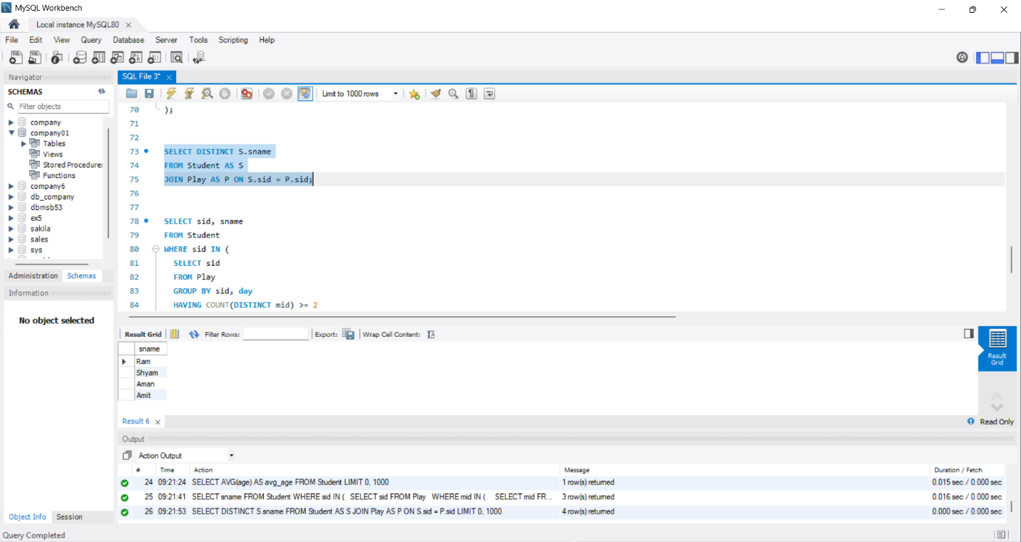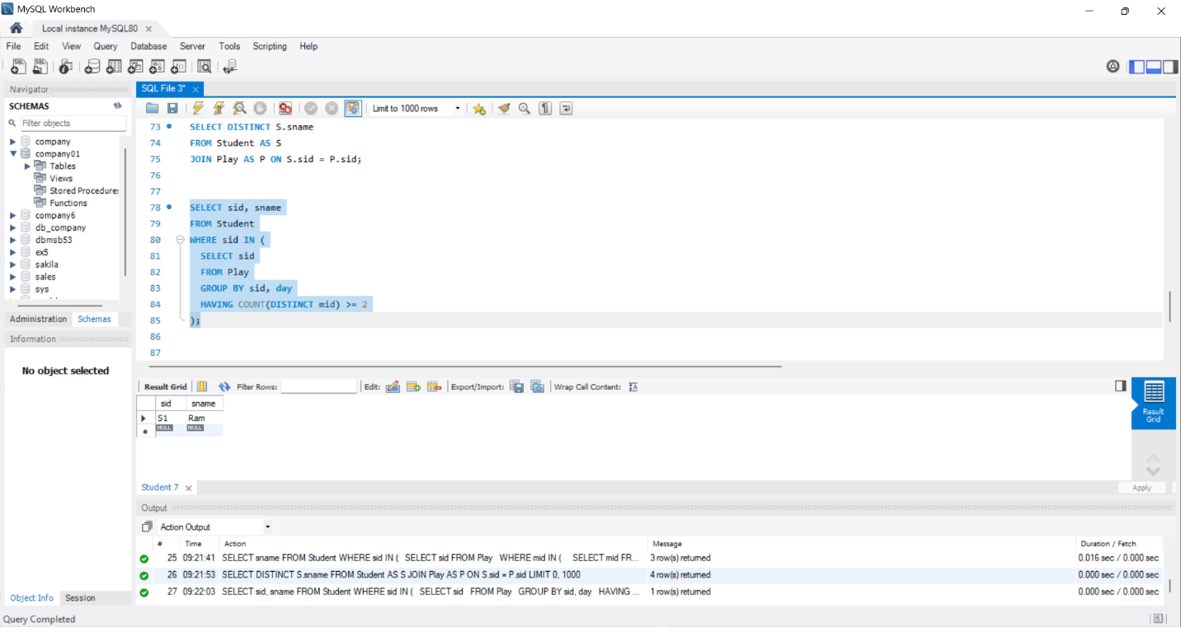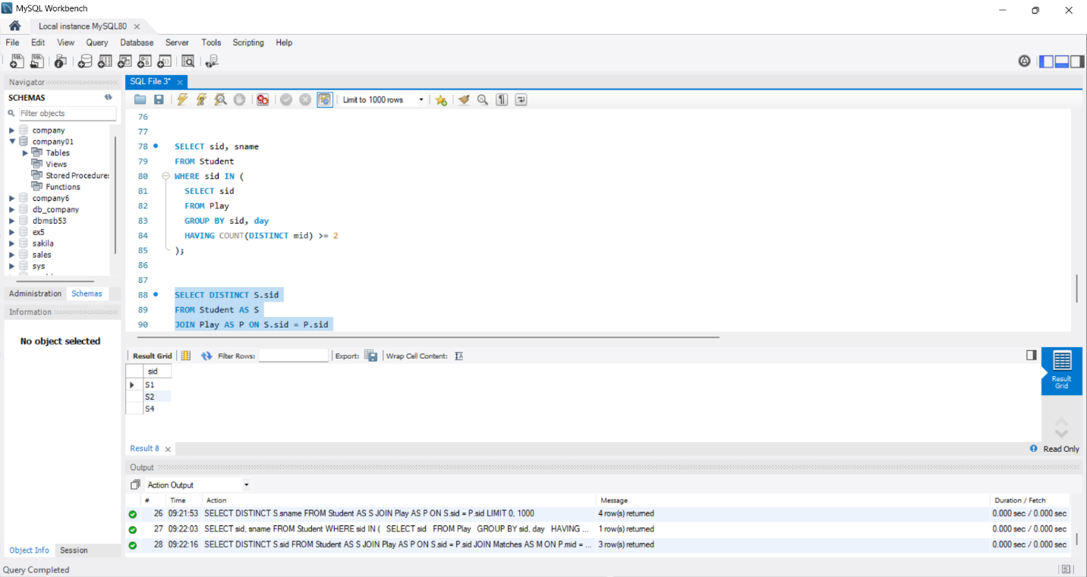

Result:
All SQL queries executed correctly, demonstrating the use of subqueries, joins, and aggregate functions to retrieve and analyze relational data

