Student Name: Prabhjeet Singh
SAP ID: 590013286

Experiment No.: 9
Experiment Name: To understand the concepts of NoSQL Database
Date: 30/11/2025

Objective:
Implement the concept of NoSQL database MongoDB

Theory/Concepts:
NoSQL databases are designed to work with flexible, schema-less structures, making them suitable for unstructured or semi-structured data.
MongoDB is a document-oriented NoSQL database where data is stored in JSON-like BSON format.
• Instead of tables, MongoDB uses collections.
• Data is stored as documents rather than rows or records.
• Schema is fully dynamic, meaning each document can have different fields.
• Used heavily in scalable systems, real-time applications, big-data pipelines, and content-driven platforms.

Procedure:
- Start the MongoDB server.
- Open the MongoDB shell.
- Create a database using: use hotelDB.
- Create a collection named hotel.
- Insert the required documents into the collection.
- Run and verify the queries.

Code:
Create Db and collection
use hotelDB
db.createCollection("hotel")
Insert documents:
db.hotel.insertMany([
{ hotel_id: "H001", name: "Sunrise Inn", Borough: "Bronx", cuisine: "Italian", address: { zipcode: "10451" } },
{ hotel_id: "H002", name: "Green Garden", Borough: "Manhattan", cuisine: "Chinese", address: { zipcode: "10027" } },
{ hotel_id: "H003", name: "Royal Stay", Borough: "Queens", cuisine: "Indian", address: { zipcode: "11368" } },
{ hotel_id: "H004", name: "Ocean View", Borough: "Brooklyn", cuisine: "Seafood", address: { zipcode: "11201" } },
{ hotel_id: "H005", name: "Golden Dragon", Borough: "Bronx", cuisine: "Chinese", address: { zipcode: "10452" } },
{ hotel_id: "H006", name: "Spice Hub", Borough: "Manhattan", cuisine: "Thai", address: { zipcode: "10011" } },
{ hotel_id: "H007", name: "Curry Palace", Borough: "Queens", cuisine: "Indian", address: { zipcode: "11373" } },
{ hotel_id: "H008", name: "Bella Roma", Borough: "Brooklyn", cuisine: "Italian", address: { zipcode: "11215" } },
{ hotel_id: "H009", name: "Taste of Mexico", Borough: "Bronx", cuisine: "Mexican", address: { zipcode: "10453" } },
{ hotel_id: "H010", name: "Urban Dine", Borough: "Manhattan", cuisine: "American", address: { zipcode: "10019" } }
])
Queries:
Display all documents :
db.hotel.find()

Display hotel_id, name, Borough, cuisine :
db.hotel.find({}, { hotel_id: 1, name: 1, Borough: 1, cuisine: 1 })

Display hotel_id, name, Borough, cuisine but exclude _id :
db.hotel.find({}, { _id: 0, hotel_id: 1, name: 1, Borough: 1, cuisine: 1 })

Display hotel_id, name, Borough, zipcode but exclude _id :
db.hotel.find({}, { _id: 0, hotel_id: 1, name: 1, Borough: 1, "address.zipcode": 1 })

Display all hotels in Bronx:
db.hotel.find({ Borough: "Bronx" })

Output:
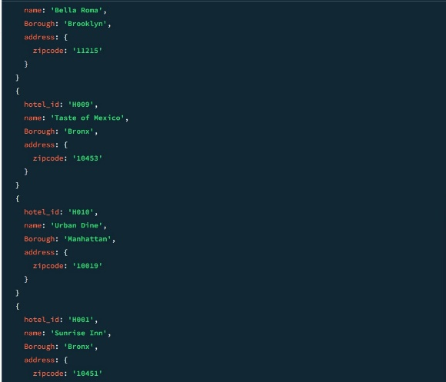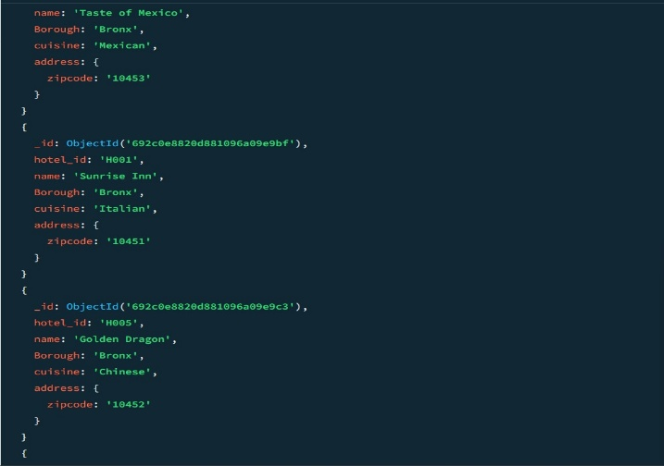

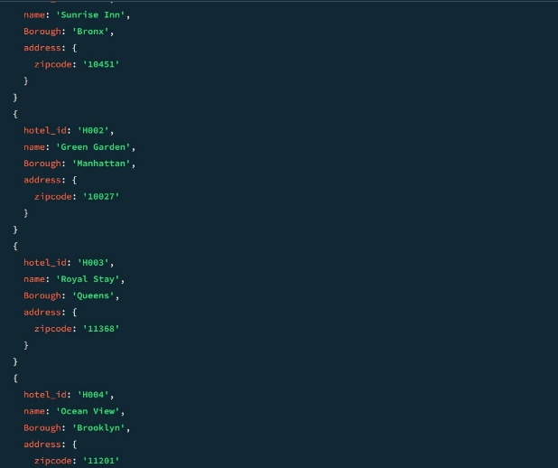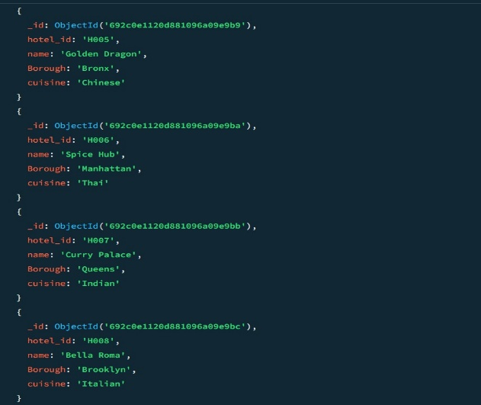

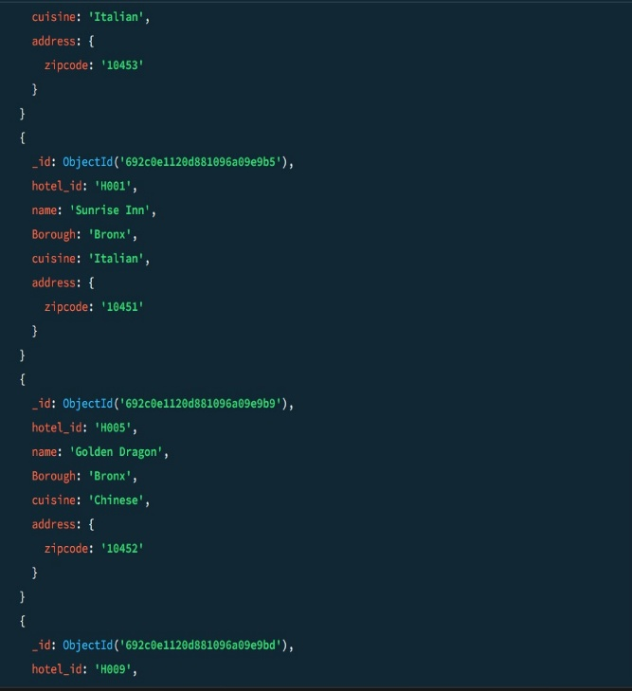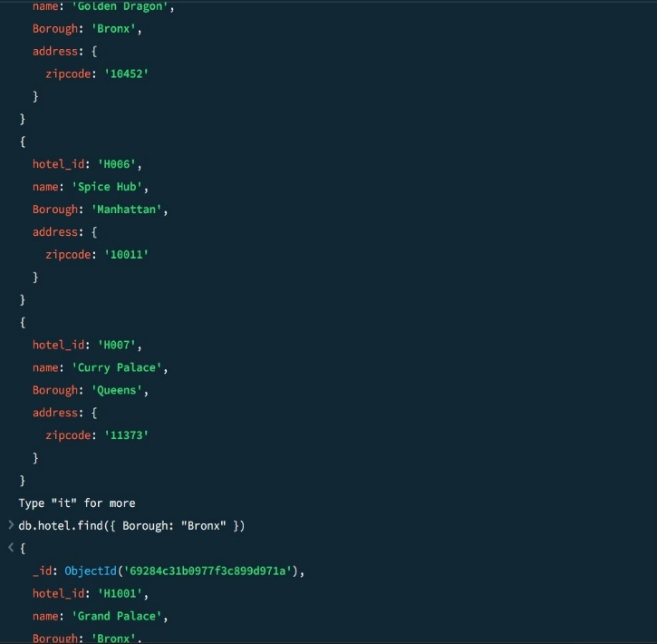

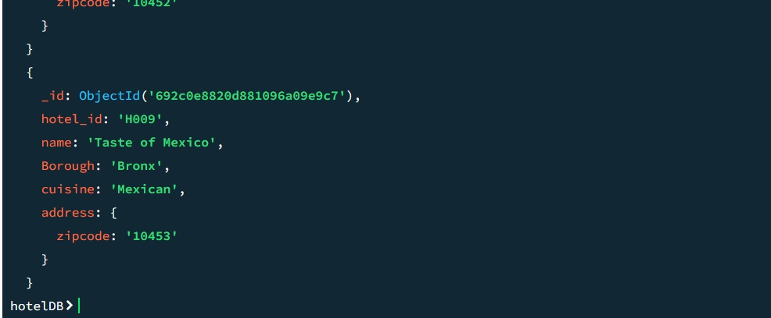

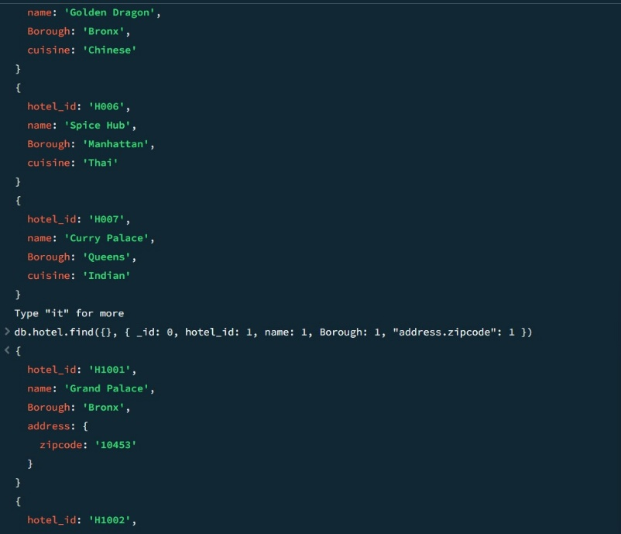

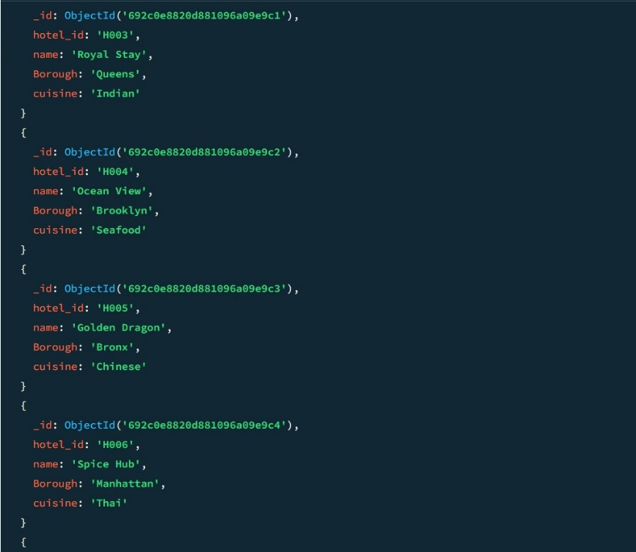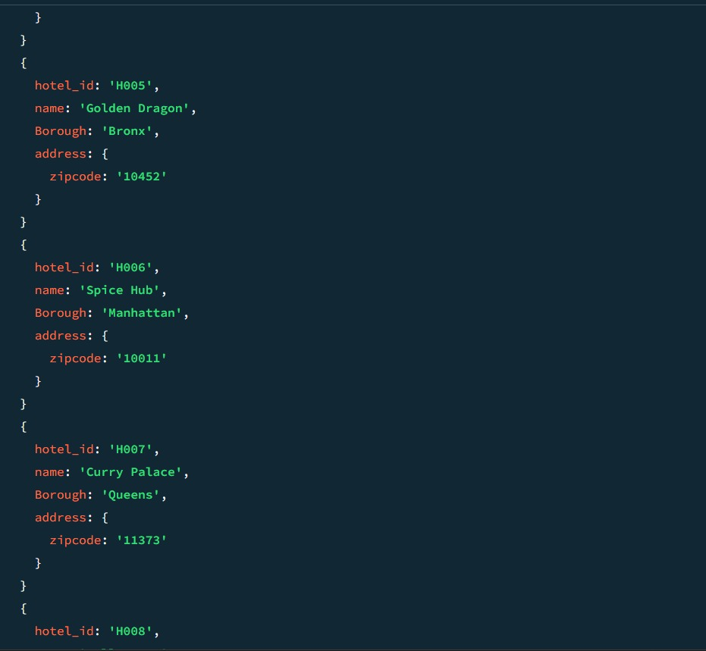

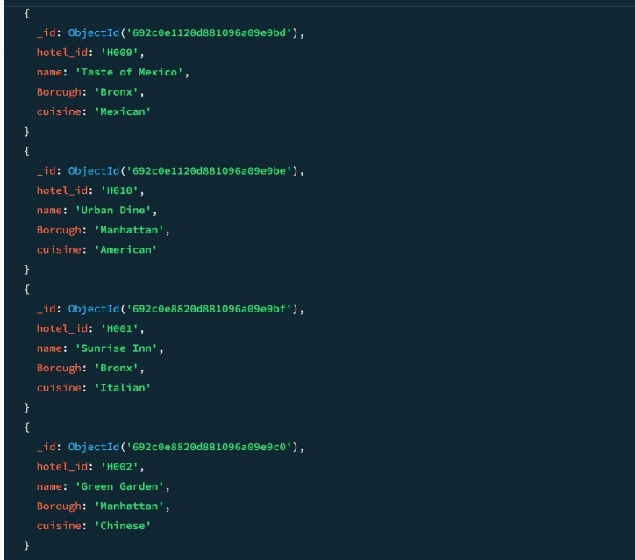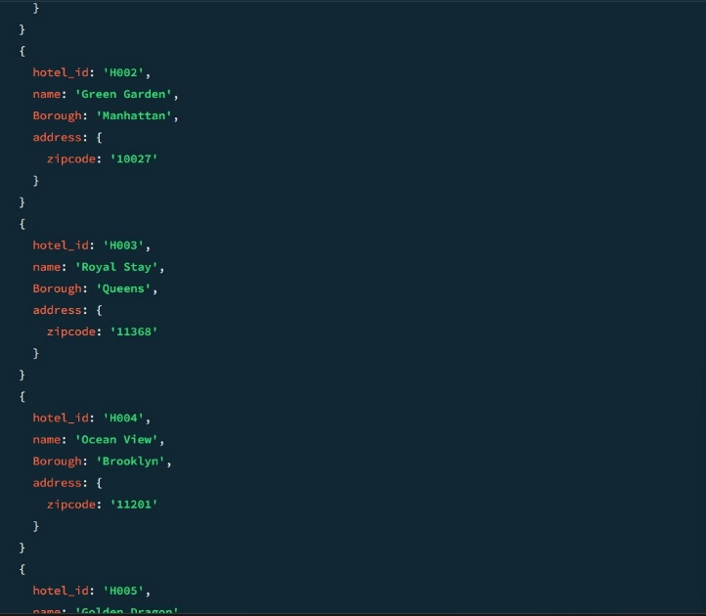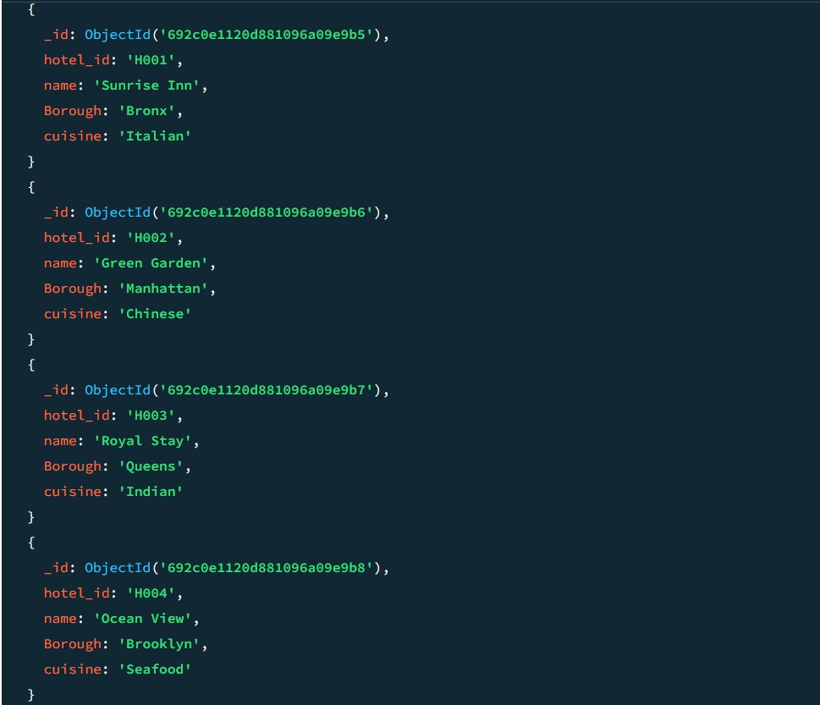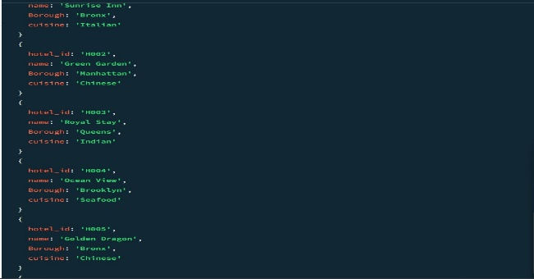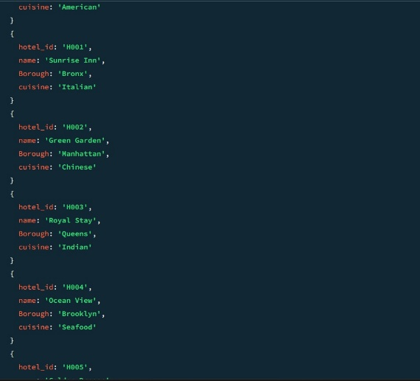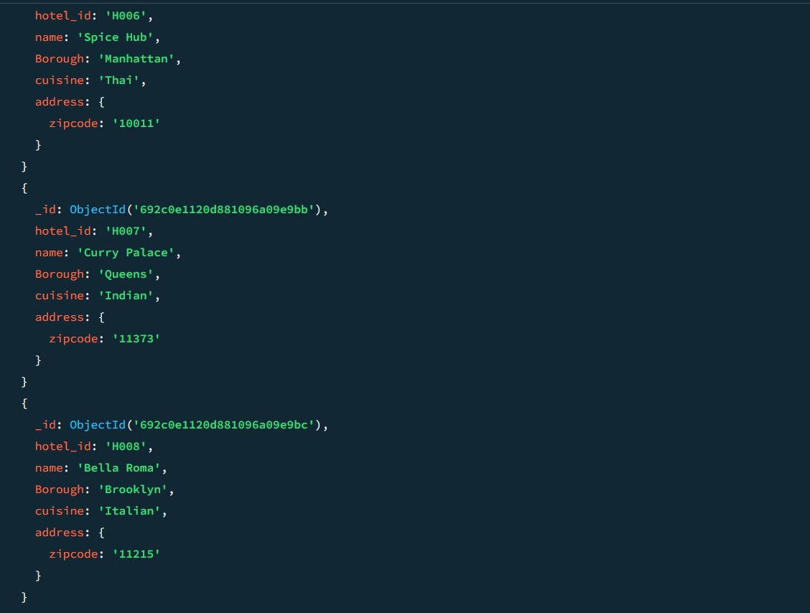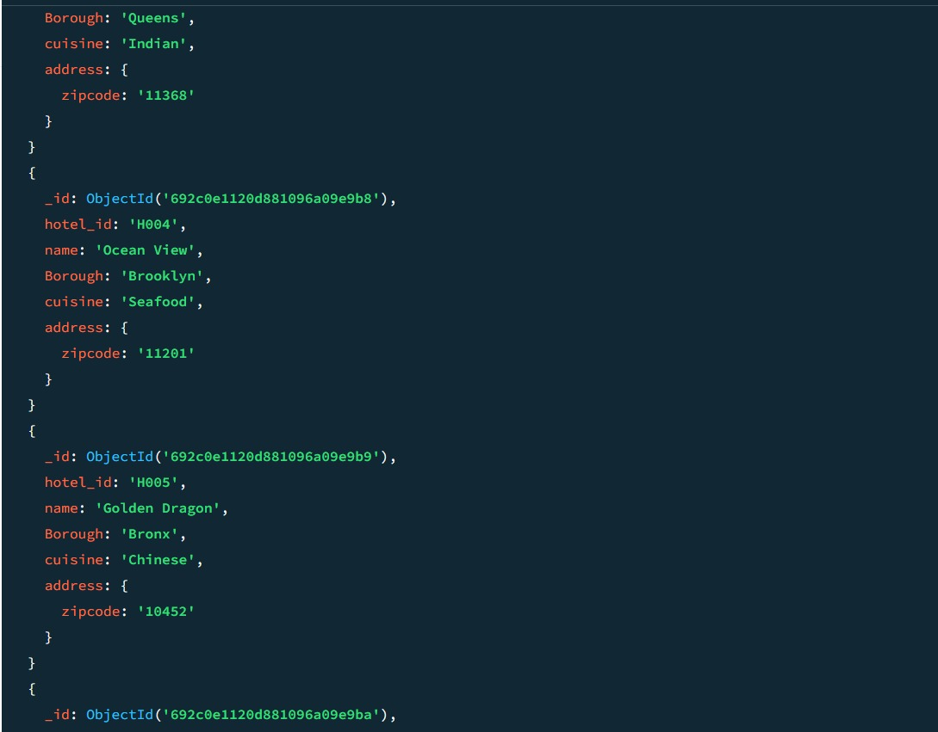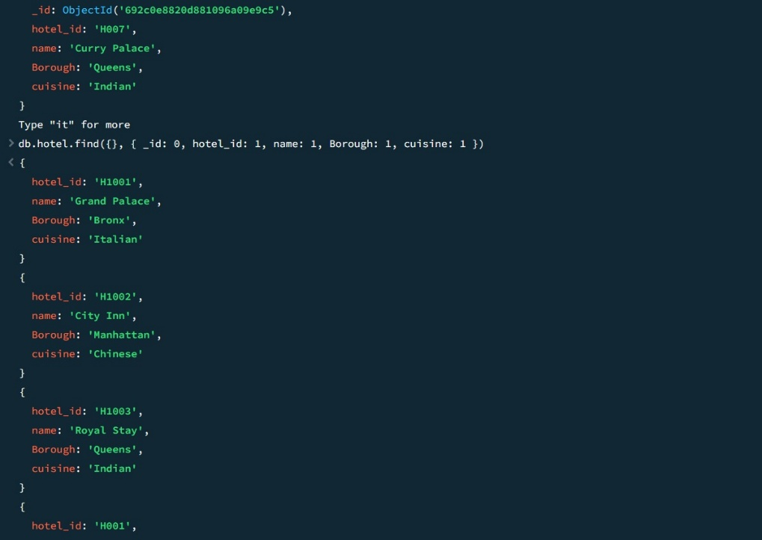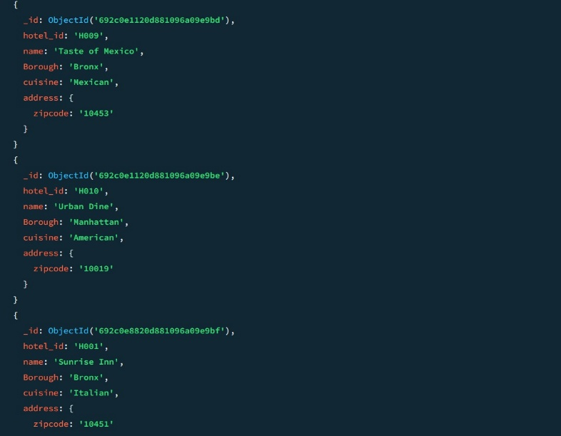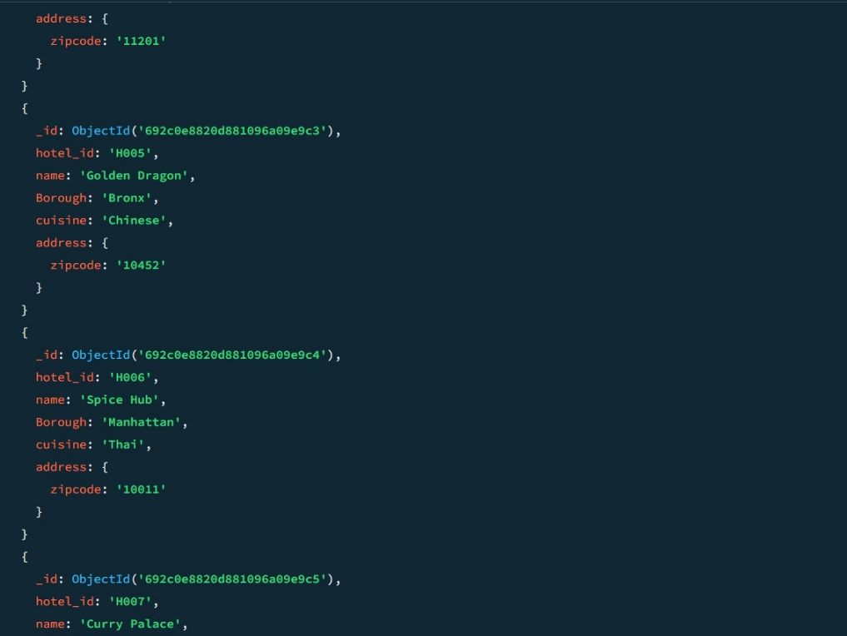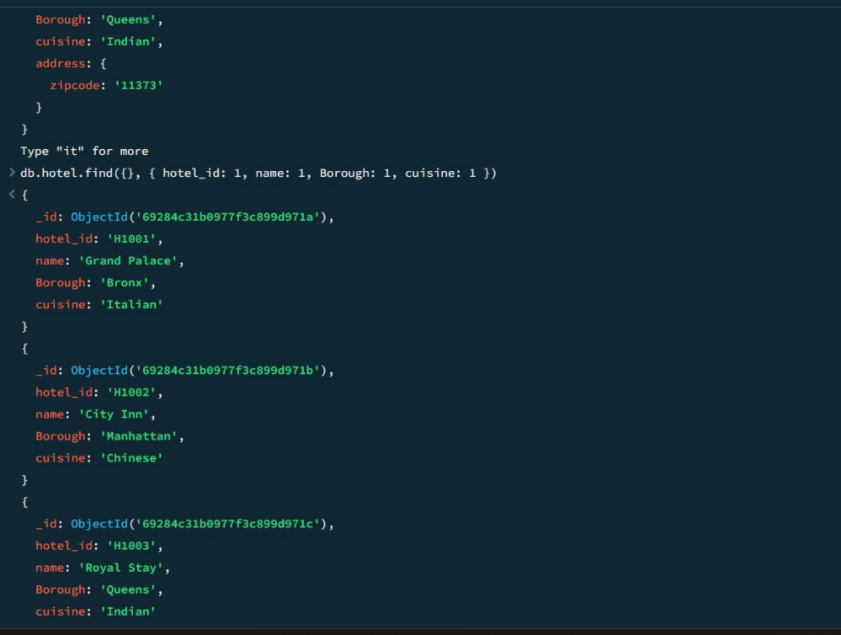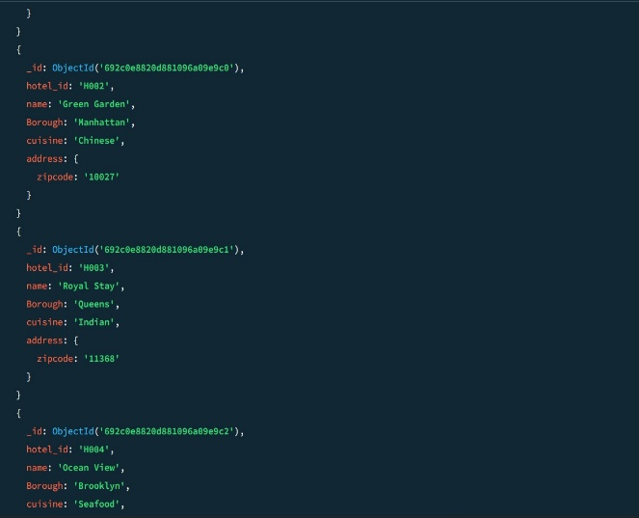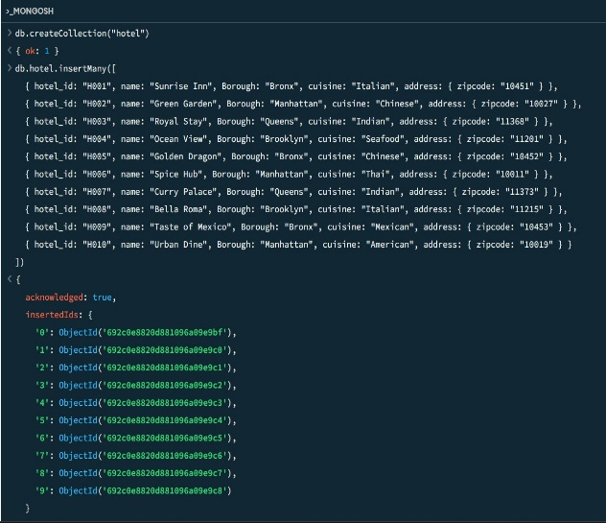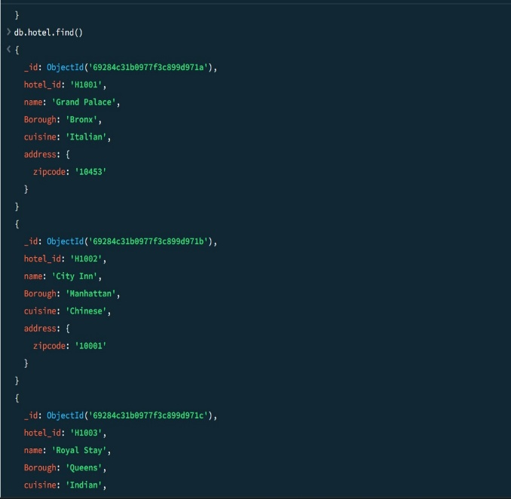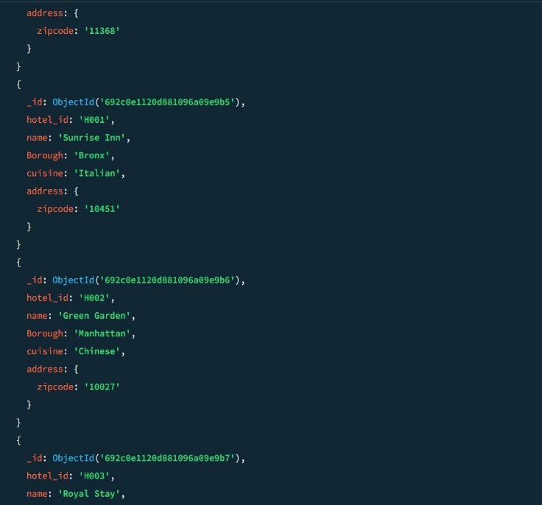

Result:
The implementation of NoSQL concepts using MongoDB was completed successfully. A collection was created, multiple documents were added, and various queries were executed to retrieve and manipulate the data. This demonstrated MongoDB’s flexible schema structure and its efficiency in handling dynamic, document-based datasets.

