Fundamentals of Data Science (FODS)
Project Report

Google Stock Price
Analysis & Prediction

Subject | Fundamentals of Data Science (FODS)
Submitted To | Pitambara Kharna
Institution | UPES Dehradun
Department | Computer Science & Engineering (CSE)

Name | Sap-Id
Prabhjeet Singh | 590013286

Table of Contents

1. Introduction 3
2. Dataset Description 4
3. Technology Stack 4
4. Objectives & Expected Outcomes 5
5. Machine Learning Models Used 5
6. Feature Engineering & Correlation 7
7. Results and Output 7
8. Visualizations & Graphs 9
9. Conclusion 10

Project Architecture Overview
This project is architected across two complementary parts, forming a complete end-to-end data science pipeline for financial prediction:
Part 1 — Model Training & Evaluation: Historical GOOGL stock data is loaded, preprocessed, and used to engineer technical features (SMA_20, EMA_20). Multiple classification and regression models are trained, evaluated using rigorous metrics, and the best-performing models are serialised for deployment. K-Means clustering is also applied for exploratory market segmentation.
Part 2 — Real-Time Streamlit Prediction: An interactive web dashboard, built using Streamlit, fetches live GOOGL data via the yfinance API and applies the trained models in real time. The application delivers two outputs: (a) a directional classification (UP/DOWN) indicating the predicted next-day price movement, and (b) a numerical price prediction for the next trading day’s closing price, accompanied by a live price trend chart and model comparison tables.

1. Introduction
Financial markets generate enormous volumes of data daily, and the ability to extract actionable insights from this data is among the most sought-after applications of modern data science. This project Google Stock Price Analysis & Prediction — was developed as part of the Fundamentals of Data Science course to demonstrate the practical application of machine learning techniques on real-world financial time-series data.
The project focuses on Alphabet Inc. (GOOGL), the parent company of Google, whose stock is one of the most actively traded equities on the NASDAQ exchange. Stock price forecasting is inherently complex due to the non-linear, non-stationary, and noisy nature of financial data. However, by applying systematic feature engineering and rigorous model evaluation, it is possible to build predictive systems that offer meaningful signals.

This project is structured around two complementary objectives:
- Classification: Predicting whether the next day's closing price will move UP or DOWN relative to the current day, enabling directional decision-making.
- Regression: Predicting the exact closing price for the next trading day, providing a numerical estimate for quantitative analysis.

In addition, a real-time interactive web application was developed using Streamlit, which fetches live GOOGL stock data via the yfinance API and delivers both the directional classification and the price prediction through an intuitive dashboard.

2. Dataset Description

2.1 Historical Dataset
The primary dataset, googl_daily_prices.csv, contains historical daily OHLCV (Open, High, Low, Close, Volume) data for Alphabet Inc. (GOOGL). Each record represents a single trading day and includes the following attributes:
Dataset Source: The historical GOOGL stock data was sourced from Kaggle and Yahoo Finance. Yahoo Finance (accessed via the yfinance Python library) provides comprehensive historical OHLCV data for publicly traded equities. The dataset is also available as a curated CSV on Kaggle, making it reproducible and accessible for academic research purposes.
Feature | Type | Description
Open | Numerical | Price at market open
High | Numerical | Highest price during the day
Low | Numerical | Lowest price during the day
Close | Numerical | Price at market close (target variable)
Volume | Numerical | Total shares traded during the day
SMA_20 | Engineered | 20-Day Simple Moving Average of Close price
EMA_20 | Engineered | 20-Day Exponential Moving Average of Close price

2.2 Data Splitting
To preserve the chronological integrity of the time-series data, the dataset was split without shuffling in the following proportions:
- Training Set: 60% — Used for fitting models.
- Validation Set: 20% — Used for hyperparameter tuning and model selection.
- Test Set: 20% — Used for final unbiased evaluation.

2.3 Real-Time Data via yfinance
For live predictions within the Streamlit application, real-time GOOGL data is fetched using the yfinance Python library. This ensures that the predictive model operates on the most current available market data at the time of prediction.

3. Technology Stack
Technology | Role in This Project
Python 3 | Core programming language for all data processing, modelling, and evaluation.
Pandas & NumPy | Data loading, manipulation, feature engineering, and numerical computations.
Scikit-Learn | Implementation of all ML models (classification, regression, clustering) and evaluation metrics.
Streamlit | Building the interactive real-time web dashboard for predictions and visualisations.
yfinance | Fetching real-time and historical GOOGL stock price data from Yahoo Finance.
Plotly | Interactive charts including real-time price trends, model comparisons, and regression plots.
Matplotlib | Plotting confusion matrices and supplementary static charts.
SHAP | Explaining model predictions and quantifying feature importance in a model-agnostic manner.

4. Objectives & Expected Outcomes

4.1 Primary Objectives
- To perform exploratory analysis on GOOGL historical stock data and engineer meaningful predictive features.
- To train and compare multiple classification models for real-time predicting of next-day price direction (UP/DOWN).
- To train regression models for predicting the exact next-day closing price.
- To apply K-Means clustering to identify natural market regimes within the stock data.
- To develop a real-time Streamlit web application that delivers both classification and regression predictions on live data.
- To ensure model transparency using SHAP-based feature importance analysis.

4.2 Expected Outcomes
The project is expected to yield the following deliverables and insights:
- A well-evaluated classification model achieving strong accuracy, precision, recall, and ROC-AUC scores for directional prediction.
- A regression model with a low Mean Squared Error (MSE) and high R² score for price prediction.
- Clear identification of which engineered features (SMA_20, EMA_20) most influence model predictions.
- A functional and user-friendly Streamlit dashboard serving real-time stock predictions.

5. Machine Learning Models Used

5.1 Classification Models (UP / DOWN Prediction)
The target variable for classification is a binary label: 1 (UP) if the next day's closing price is higher than today's, and 0 (DOWN) otherwise. The following classifiers were evaluated:

Model | Rationale for Use
Logistic Regression | A simple, interpretable linear classifier that serves as a strong baseline. Effective when the relationship between features and the binary target is approximately linear.
K-Nearest Neighbours (KNN) | A non-parametric model that classifies based on the majority class among the k closest training examples. Useful for capturing local non-linear patterns in price movements.
Support Vector Machine (SVM) | Finds the optimal hyperplane that maximally separates UP and DOWN classes. Effective in high-dimensional feature spaces and robust to overfitting with proper regularisation.
Decision Tree | A tree-structured model that partitions the feature space into regions. Highly interpretable and capable of capturing non-linear decision boundaries.
Random Forest | An ensemble of decision trees trained on bootstrapped subsets. Reduces variance through aggregation and generally delivers superior generalisation performance.
Naive Bayes | A probabilistic classifier based on Bayes' theorem with feature independence assumptions. Fast and effective, especially in scenarios with limited training data.

5.2 Regression Models (Exact Price Prediction)
The regression task predicts the numerical closing price for the next trading day. The following models were employed:

Model | Rationale for Use
Linear Regression | The foundational regression model that estimates closing price as a weighted linear combination of input features. Serves as the primary baseline for regression performance.
Lasso Regression | Extends Linear Regression with an L1 regularisation penalty. Encourages sparsity in feature weights, effectively performing automatic feature selection — particularly beneficial given the high correlation among stock features.

5.3 Clustering (K-Means)
K-Means clustering was applied to identify latent market regimes (e.g., trending up, trending down, consolidating) within the historical GOOGL data. The optimal number of clusters (k) was determined using the Elbow Method, which plots the Within-Cluster Sum of Squares (WCSS) against k and identifies the inflection point where adding more clusters yields diminishing returns. Clustering results are used for exploratory analysis and are not used directly in the prediction pipeline.

6. Feature Engineering & Correlation

6.1 Engineered Features
Two technically significant features were engineered from the raw Close price series:

Feature | Description & Significance
SMA_20 | The 20-Day Simple Moving Average is computed as the arithmetic mean of the closing price over the previous 20 trading days. It smooths short-term fluctuations and reveals the underlying trend direction. A price above its SMA_20 is generally considered bullish.
EMA_20 | The 20-Day Exponential Moving Average assigns exponentially decreasing weights to older prices, making it more responsive to recent price changes than SMA. It is widely used by traders as a dynamic support/resistance indicator.

Both indicators are standard tools in technical analysis and provide the models with contextual information about the current price relative to its recent historical trajectory information that cannot be derived from a single-day snapshot alone.

Analysis of feature correlations reveals several actionable insights. When the closing price trades above its SMA_20, this is generally interpreted as a bullish signal, indicating sustained upward momentum over the recent 20-day window. The EMA_20, by assigning greater weight to recent prices, reacts faster to short-term price changes than the SMA_20, making it particularly sensitive to emerging trend reversals. Together, the relationship between the closing price and both moving averages serves as a strong indicator of market momentum, capturing the directional energy of the stock that static price snapshots alone cannot convey.

6.2 Feature Importance via SHAP
SHAP (SHapley Additive exPlanations) values were used to quantify the contribution of each feature to individual model predictions. SHAP is grounded in cooperative game theory and provides consistent, locally accurate explanations regardless of the model type. In this project, SHAP was applied to the best-performing classification model to reveal which features (e.g., Close, SMA_20, EMA_20, Volume) most strongly influence the UP/DOWN prediction. The resulting SHAP summary plot provides both global feature importance rankings and the direction of each feature's effect on the prediction.

7. Results and Output

7.1 Model Evaluation Framework
All models were evaluated on the held-out test set (the final 20% of chronologically ordered data) using the following metrics:

Metric | Applicable To | Description
Accuracy | Classification | Proportion of correctly classified directional predictions.
Precision | Classification | Of all predicted UP days, the fraction that were truly UP.
Recall | Classification | Of all actual UP days, the fraction correctly identified.
F1 Score | Classification | Harmonic mean of Precision and Recall; balances both.
ROC-AUC | Classification | Area under the ROC curve; measures discriminative ability.
Confusion Matrix | Classification | Visual breakdown of TP, TN, FP, FN predictions.
MSE | Regression | Mean Squared Error; average squared deviation from true price.
R² Score | Regression | Coefficient of determination; proportion of variance explained.

7.2 Best Model Selection
The evaluation pipeline, implemented in evaluation.py, automatically compares all trained classification models on the validation set using a composite score (weighted by F1 and ROC-AUC) and selects the best-performing model. This model is then serialised and deployed within the Streamlit application for live inference. A similar selection process identifies the best regression model based on lowest MSE and highest R².

7.3 The Streamlit Web Application (app.py)
The interactive dashboard, built using Streamlit, is the primary interface for the project's real-world demonstration. It is organised into the following tabs:

- Real-Time Predictor (app.py → 'Real-Time Predictor' tab): Fetches live GOOGL data via yfinance, computes SMA_20 and EMA_20 on-the-fly,
- outputs:
  - the predicted closing price for the next trading day, and
  - the directional classification (UP/DOWN) with confidence probability. A real-time price trend chart is displayed.
- Model Comparison (app.py → 'Model Comparison' tab): Renders a comprehensive table comparing all trained classification and regression models across all evaluation metrics, enabling side-by-side benchmarking.
- Visualisations (app.py → 'Visualisations' tab): Displays the confusion matrix, ROC curve, actual vs. predicted regression plot, K-Means elbow curve, and SHAP feature importance plot for in-depth model analysis.

7.4 File Structure Overview
File | Purpose
app.py | Main Streamlit dashboard — renders all tabs, charts, and live predictions.
data_loader.py | Loads googl_daily_prices.csv and performs initial data validation.
preprocessing.py | Engineers SMA_20 and EMA_20 features; performs chronological train/val/test splitting.
models.py | Defines and instantiates all classification, regression, and clustering models.
evaluation.py | Evaluates all models, computes metrics, selects the best model, and serialises it.

8. Visualizations & Graphs
The following visualisations provide empirical validation of the project’s methodology, model performance, and analytical depth. The following section provides placeholders for screenshots captured from the Streamlit application. These visualisations serve as empirical evidence of the project’s functionality and analytical depth.

8.1 Real-Time Price Trend Graph
Source: 'Real-Time Predictor' tab of the Streamlit application. Displays live GOOGL stock price movement with overlaid SMA_20 and EMA_20 indicators.
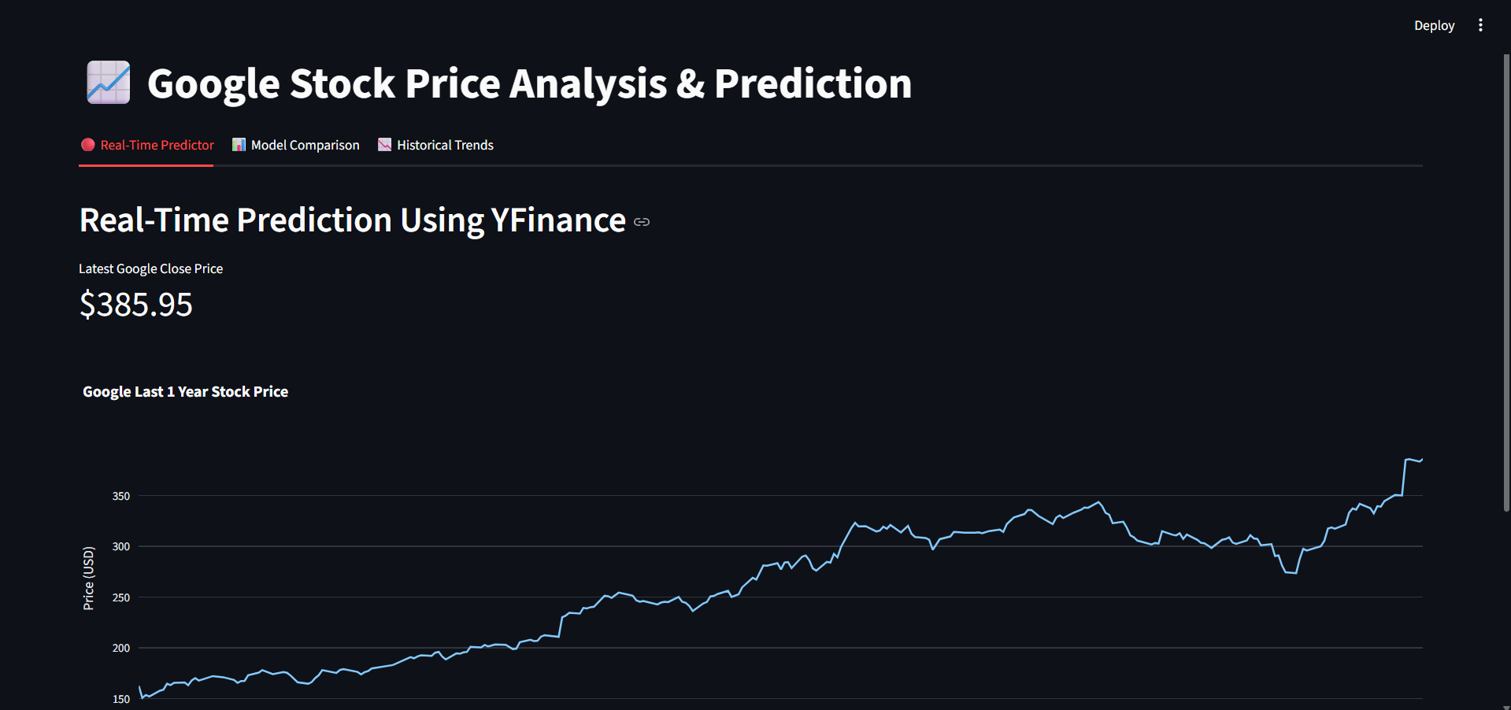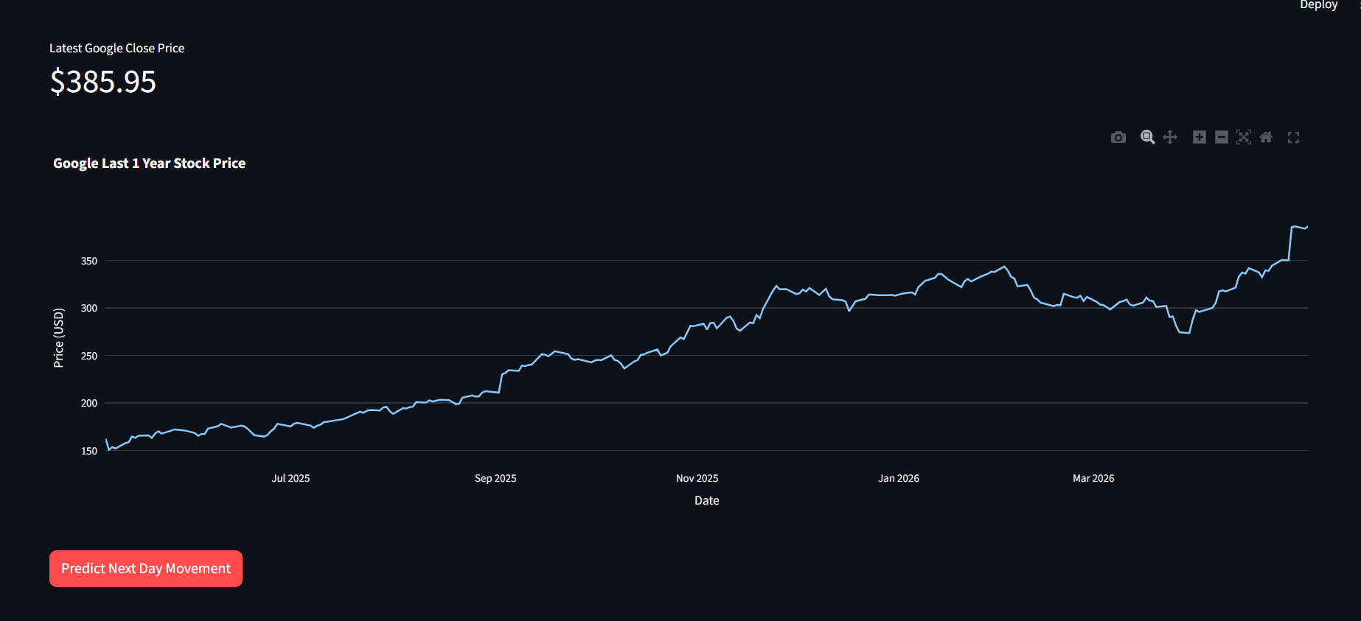
Real-Time Price Trend Graph

8.2 Model Comparison Tables
Source: 'Model Comparison' tab. Side-by-side comparison of all classification models (Accuracy, Precision, Recall, F1, ROC-AUC) and regression models (MSE, R²).
[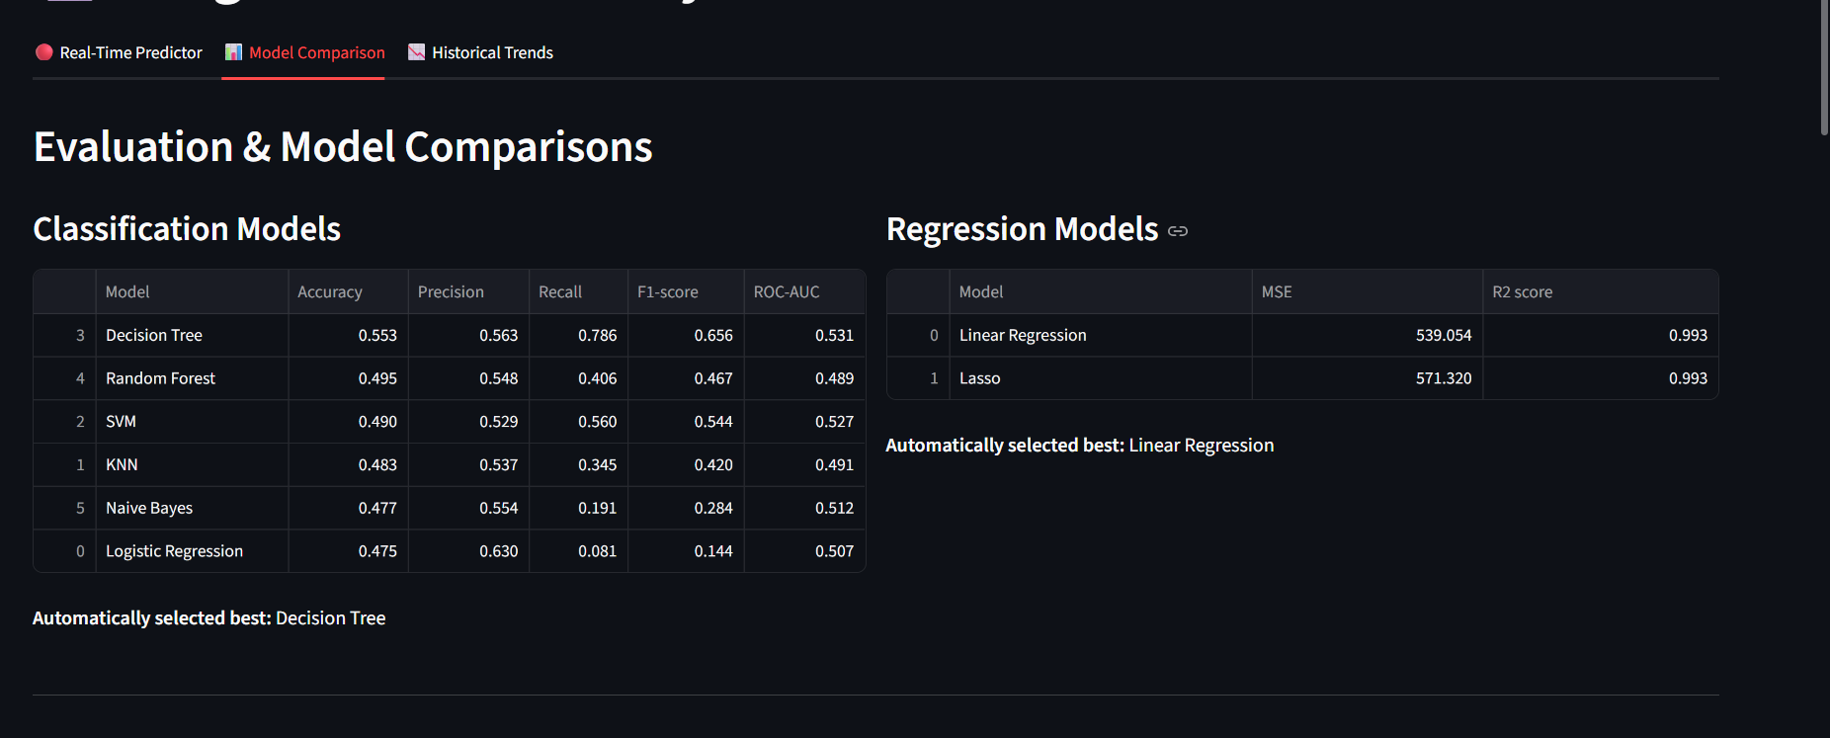 Model Comparison Tables

8.3 Confusion Matrix (Validation Set)
Displays the True Positives, True Negatives, False Positives, and False Negatives for the best-performing classification model on the validation set, providing insight into error patterns.
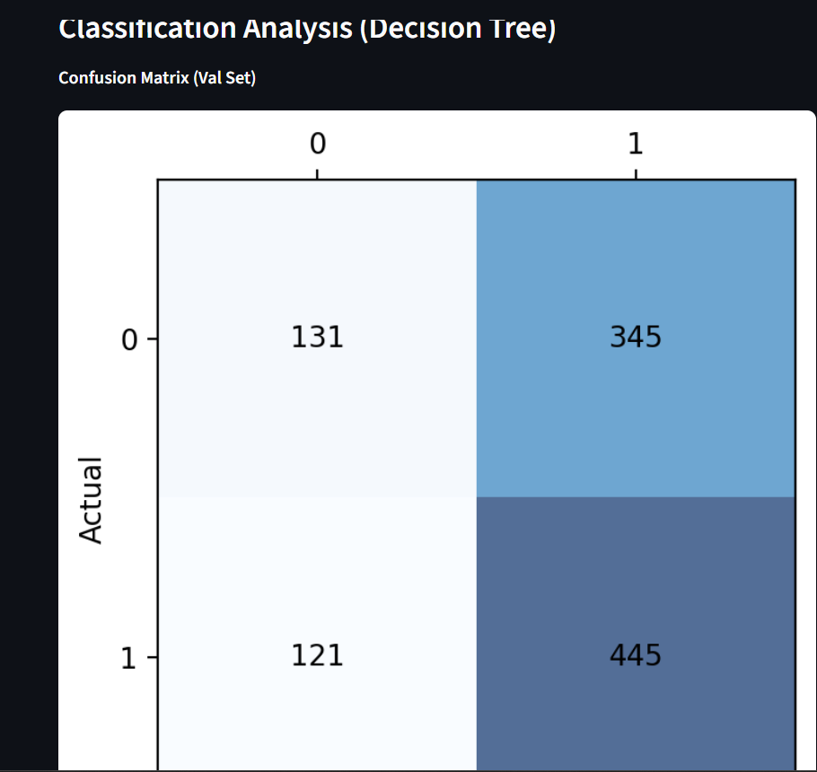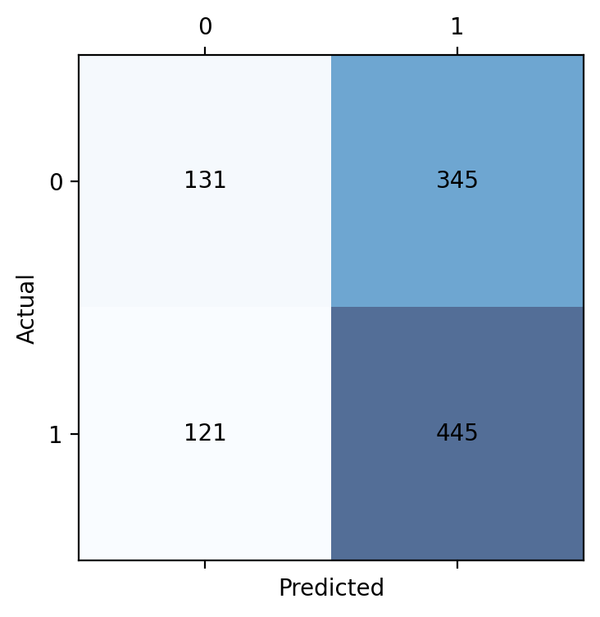
Confusion Matrix (Validation Set)

8.4 ROC Curve
The Receiver Operating Characteristic curve plots the True Positive Rate against the False Positive Rate at various classification thresholds. A higher Area Under the Curve (AUC) indicates superior discriminative performance.
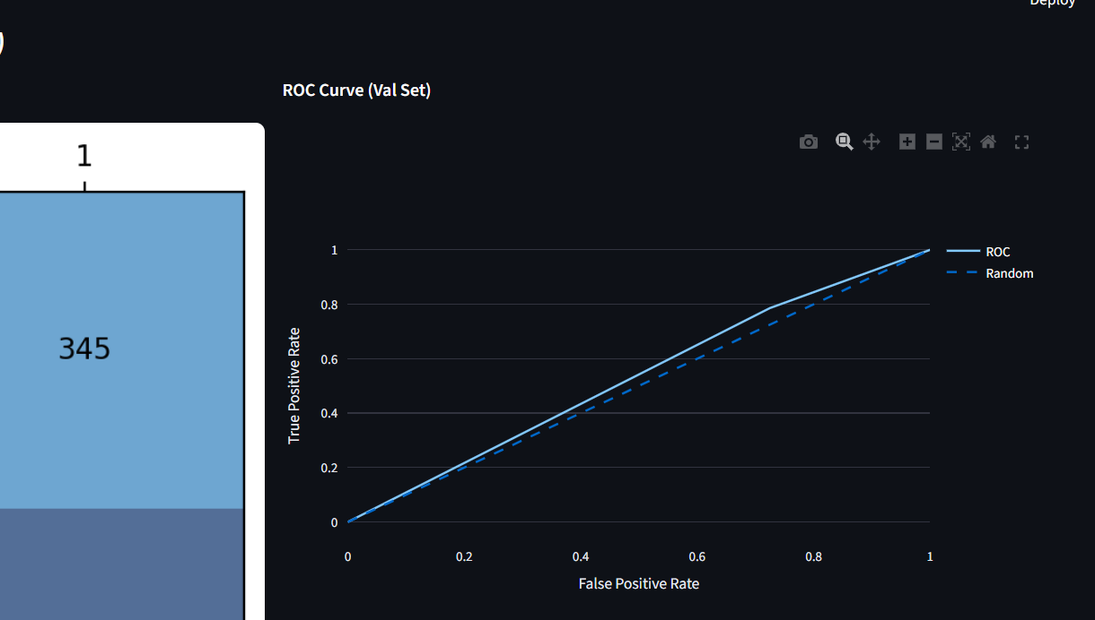ROC Curve

8.5 Actual vs. Predicted Regression Fit Graph
A scatter or line plot comparing the model's predicted closing prices against the actual closing prices on the test set. Points/lines closer to the diagonal indicate better regression fit.
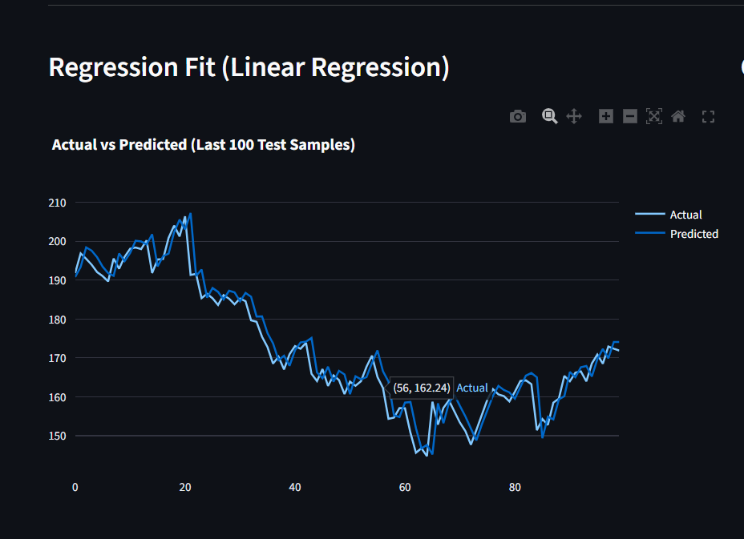Actual vs Predicted Regression Fit Graph

8.6 K-Means Elbow Method Graph
The Elbow Method chart plots Within-Cluster Sum of Squares (WCSS) for k = 1 to 10. The 'elbow' (point of inflection) identifies the optimal number of clusters for segmenting market regimes.
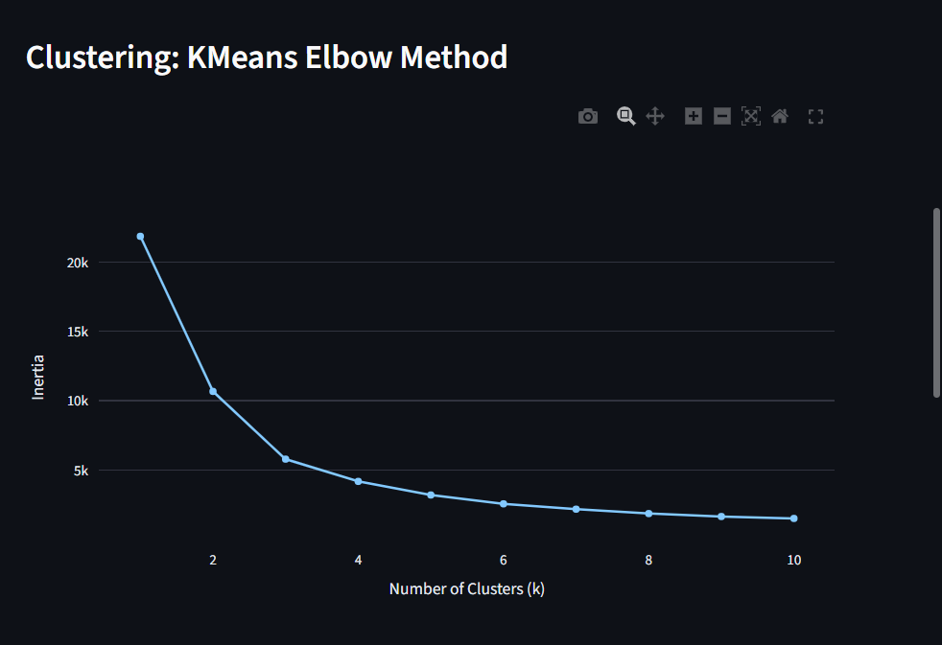K-Means Elbow Method Graph

8.7 SHAP Feature Importance Plot
The SHAP summary plot ranks features by their average absolute SHAP value, revealing which inputs most strongly influence the model's predictions and in which direction.
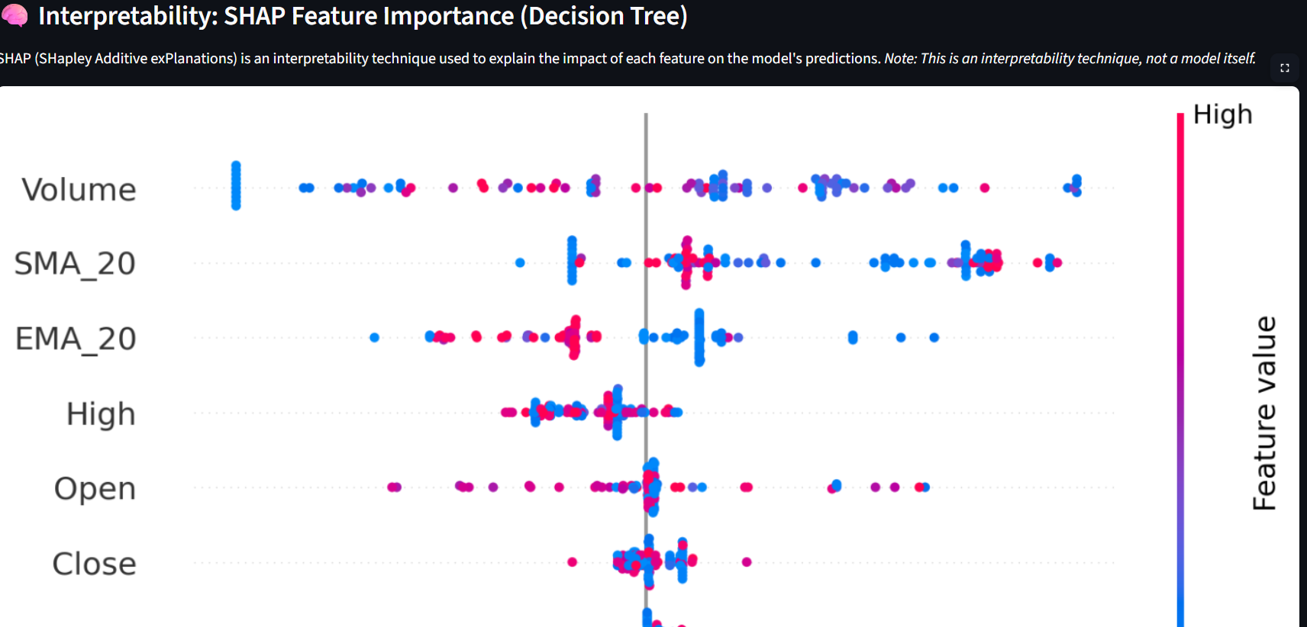
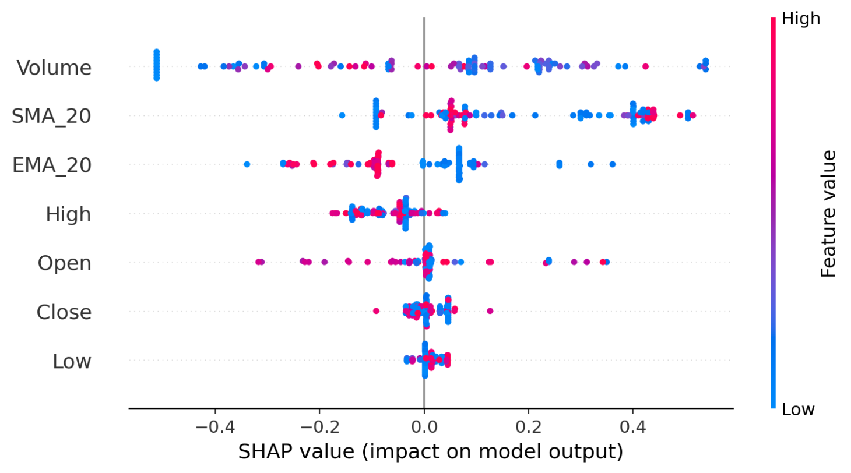SHAP Feature Importance Plot

8.8 Historical Data Price Trend with Moving Averages Source
Historical Trends' tab. Illustrates the long-term closing price trajectory extracted directly from the historical CSV dataset. The plot is overlaid with the 20-day Simple Moving Average (SMA_20) and 20-day Exponential Moving Average (EMA_20) to highlight historical market momentum and smooth out short-term price fluctuations
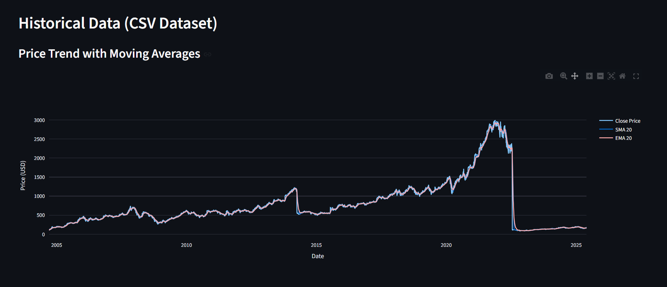
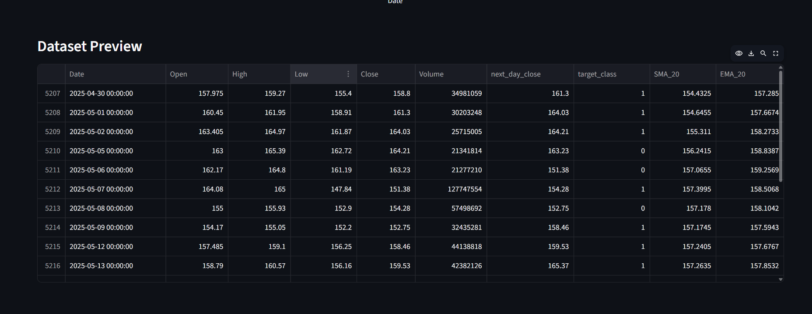

Historical Data (CSV Dataset)) and Price Trend with Moving Averages

9. Limitations & Future Scope

9.1 Limitations
Despite the project’s promising results, several limitations must be acknowledged. First, financial markets are inherently unpredictable: exogenous shocks such as geopolitical events, regulatory changes, and macroeconomic announcements can cause abrupt price dislocations that no model trained solely on historical price data can anticipate. Second, the current feature set is limited to technical indicators derived from price and volume; it does not incorporate sentiment signals from financial news, social media, or earnings call transcripts, which are known to exert significant short-term influence on stock price movements. Third, the classical machine learning models employed (Logistic Regression, Random Forest, etc.) treat each time step independently and do not natively capture the sequential temporal dependencies present in financial time series.

9.2 Future Scope
Several avenues exist for extending this work. Deep learning architectures such as Long Short-Term Memory (LSTM) networks and Temporal Convolutional Networks are well-suited to sequential financial data and could meaningfully improve predictive accuracy by capturing long-range temporal dependencies. Integrating natural language processing-based sentiment analysis from financial news sources and social media feeds would enrich the feature space with forward-looking signals beyond historical prices. Additionally, expanding the technical indicator library to include RSI, MACD, Bollinger Bands, and momentum oscillators would provide the models with a richer representation of market dynamics. Portfolio-level analysis and multi-stock modelling could further increase the practical applicability of the system in real-world investment contexts.

10. Conclusion
This project successfully demonstrates the application of a diverse set of machine learning methodologies to the domain of financial time-series analysis. By combining classification and regression approaches within a cohesive pipeline — supported by rigorous feature engineering, systematic model evaluation, and SHAP-based interpretability — the project delivers both directional market signals and quantitative price forecasts for Google (GOOGL) stock.
The Streamlit-based web application bridges the gap between offline model development and real-world deployment, enabling live predictions on current market data. The integration of yfinance ensures that the system remains operationally relevant beyond the static historical dataset.
Key insights from this project include the demonstrated value of technical indicators (SMA_20 and EMA_20) as predictive features, the comparative strengths of ensemble methods (Random Forest) over simpler baselines in classification, and the utility of Lasso regularisation in producing sparse, interpretable regression models for financial data.
Future extensions of this work could incorporate deeper time-series models (e.g., LSTM, Prophet), sentiment analysis from financial news, or additional technical indicators to further enhance predictive accuracy.
Fundamentally, the dual-model approach adopted in this project — combining a classification model for directional prediction with a regression model for price estimation — significantly improves both the interpretability and the practical usability of the system. Whereas a standalone regression output may be difficult for non-technical stakeholders to act upon, the paired UP/DOWN classification provides an immediately actionable signal, while the regression output supports deeper quantitative analysis. Together, they form a more complete and robust decision-support tool than either model could offer in isolation.

— End of Report —
Thank You

