

OBJECT-ORIENTED PROGRAMMING

Student Name | Prabhjeet Singh
SAP ID | 590013286
Batch | 10
Specialisation | Data Science
Programme | B.Tech Computer Science & Engineering
Submitted To | Prof. Dinesh Bafila

LABORATORY REPORT

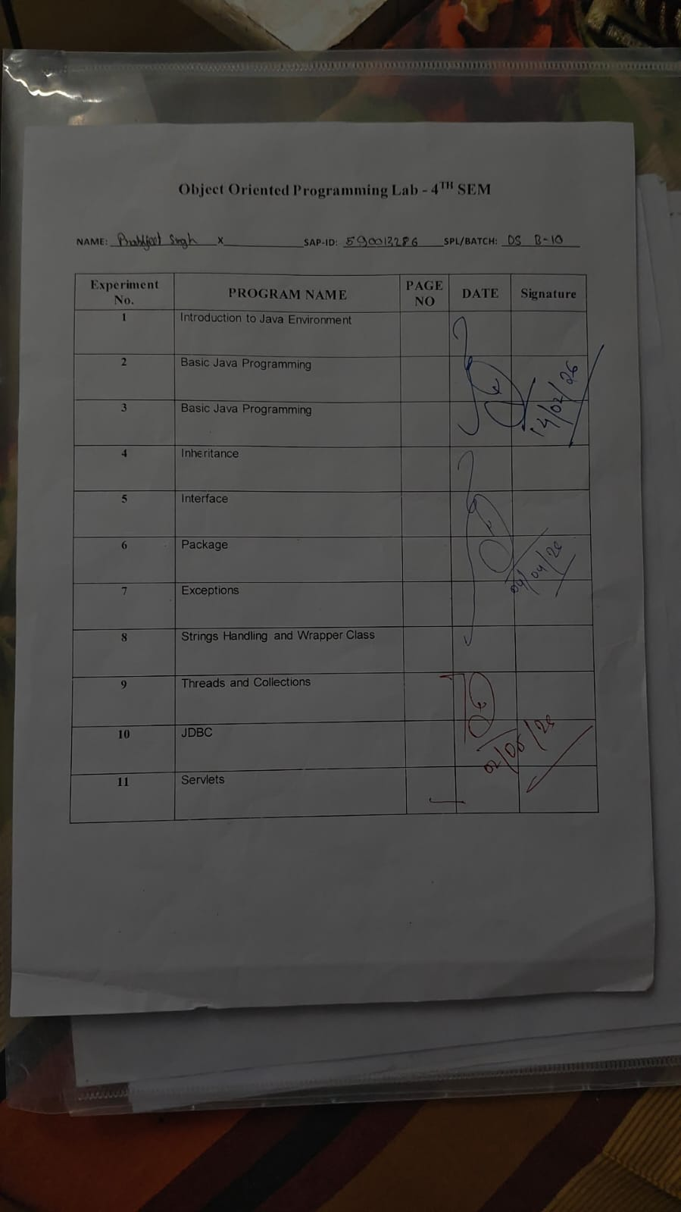

Table of Contents
Experiment 1 | Introduction to the Java Environment | 4
Experiment 2 | Basic Java Programming – Classes & Objects | 6
Experiment 3 | Input Handling & Static vs. Non-Static Methods | 9
Experiment 4 | Inheritance | 11
Experiment 5 | Interfaces & Abstract Classes | 14
Experiment 6 | Packages | 18
Experiment 7 | Exception Handling | 21
Experiment 8 | String Handling & Wrapper Classes | 25
Experiment 9 | Multithreading & Collections | 31
Experiment 10 | JDBC – Java Database Connectivity | 38
Experiment 11 | Servlets | 42
Assignment A | Java Package Questions (f01–f05) | 46
Assignment B | String Handling & Wrapper Class Questions (hQ1–hQ14) | 49
Assignment C | Thread Questions (iQ1–iQ6) | 55
Assignment D | Collections Assignment (jAssignment.java) | 58
Assignment E | JDBC CRUD Operations | 60
Assignment F | Servlet Assignment (6 Tasks) | 64

Project Directory Structure
Java_OOP_Lab/
├── Prabh_assignment/
│ ├── hQ1.java (String length)
│ ├── hQ2.java (toUpperCase / toLowerCase)
│ ├── hQ3.java (concat & +)
│ ├── hQ4.java (charAt)
│ ├── hQ5.java (substring)
│ ├── hQ6.java (startsWith / endsWith)
│ ├── hQ7.java (replace)
│ ├── hQ8.java (trim)
│ ├── hQ9.java (reverse)
│ ├── hQ10.java (count vowels)
│ ├── hQ11.java (palindrome check)
│ ├── hQ12.java (word count)
│ ├── hQ13.java (duplicate characters)
│ └── hQ14.java (new vs valueOf)
├── ithread/
│ ├── iQ1.java (Thread.sleep)
│ ├── iQ2.java (setName / getName)
│ ├── iQ3.java (join)
│ ├── iQ4.java (setPriority)
│ ├── iQ5.java (isAlive)
│ └── iQ6.java (synchronized)
├── J/
│ ├── j01.java through j05.java (array / OOP exercises)
│ └── j06.java (array traversal)
├── jcollection/
│ └── jAssignment.java (HashSet,TreeSet,PQ,HashMap,LinkedHashMap)
├── l/
│ └── lQ1.java through lQ5.java
├── i01.java (Thread class extension)
├── i02.java (Runnable interface)
├── prabh/ (User-defined package)
│ ├── fsum.java
│ ├── Sub.java
│ ├── Multiply.java
│ ├── Square.java
│ ├── Max.java
│ └── Fibonacci.java
└── JDBC/
├── CreateStaff.java
├── InsertStaff.java
├── RetrieveStaff.java
├── UpdateStaff.java
└── DeleteStaff.java

Experiment 1 – Introduction to the Java Environment

1. What is Java?
Java is a high-level, object-oriented, platform-independent, and secure programming language. Developed by Sun Microsystems in 1995 and now maintained by Oracle, Java is distinguished by its flagship principle:
WORA – Write Once, Run Anywhere. This means that Java source code, once compiled into bytecode, can be executed on any platform that has a Java Virtual Machine (JVM) installed, without any modification.

2. Components of the Java Environment

2.1 JVM – Java Virtual Machine
- Executes compiled Java bytecode
- Is platform-dependent (each OS has its own JVM implementation)
- Provides the runtime environment for Java programs
- Handles memory management, garbage collection, and security

2.2 JRE – Java Runtime Environment
The JRE bundles the JVM together with core class libraries and supporting files. It is used solely to run Java applications and cannot compile them.

2.3 JDK – Java Development Kit
The JDK is the complete development package. It contains the JRE, the javac compiler, a debugger, and a full suite of development tools. It is required to write, compile, and run Java programs.

3. Java Architecture & Compilation Flow
Java Source Code (.java)
↓
Compiler (javac)
↓
Bytecode (.class)
↓
JVM (JIT Compiler)
↓
Machine Code (OS-specific)

Step 1 – Write Code: The developer writes source code in a .java file.
Step 2 – Compilation: The javac compiler translates source code into platform-independent bytecode (.class file). This bytecode is not machine code — it is an intermediate representation.
Step 3 – Execution: The JVM's Just-In-Time (JIT) compiler converts bytecode into native machine code for the host operating system at runtime, enabling execution.

4. Steps to Install the JDK
- Download the JDK from the Oracle Website: https://www.oracle.com/java/technologies/downloads/
- Run the Installer – double-click the downloaded .exe file and follow the on-screen installation wizard.
- Set Environment Variables: Open Start Menu → search 'Environment Variables' → Edit System Environment Variables → Under System Variables, select Path → Edit → Add: C:\Program Files\jdk-<version>\bin

5. Program 1.1 – Hello World (ahelloWorld.java)
This is the fundamental entry point for any Java programming course. It demonstrates the minimum structure required by the JVM to execute a program: a public class with a static main method. The program prints a greeting to the standard output stream.

public class ahelloWorld {
public static void main(String[] args) {
System.out.println("Hello, Prabhjeet — this is the World!");
}
}

Compilation & Execution Commands:
javac ahelloWorld.java // Compiles to ahelloWorld.class
java ahelloWorld // Executes on the JVM

Expected Output: 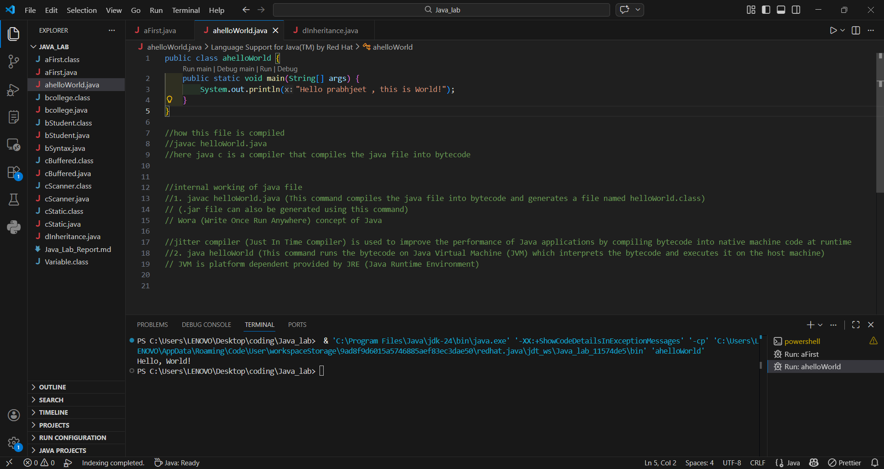
Hello, Prabhjeet — this is the World!

6. Program 1.2 – User Input Handling (aFirst.java)
Building on the Hello World foundation, this program introduces user input via the java.util.Scanner class. It demonstrates class instantiation, the use of try-with-resources for safe resource management, and the use of Scanner methods such as nextLine() and nextInt() to read different data types.

import java.util.Scanner;

public class aFirst {
public static void main(String[] args) {
try (Scanner scanner = new Scanner(System.in)) {
System.out.print("Enter a name: ");
String name = scanner.nextLine();
System.out.print("Enter your batch: ");
int batch = scanner.nextInt();
System.out.println("Hello, " + name + "!");
System.out.println("You are in batch B" + batch);
}
}
}

Expected Output (sample): 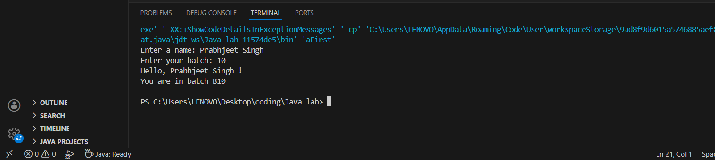
Enter a name: Prabhjeet
Enter your batch: 10
Hello, Prabhjeet!
You are in batch B10

Key Concepts Illustrated: A class acts as a blueprint from which individual objects are created. OOP (Object-Oriented Programming) is a programming paradigm that uses objects to design software. Instances are objects created from a class. The public access modifier makes the class accessible to any other class in the application.

Experiment 2 – Basic Java Programming: Classes & Objects

1. Theory

1.1 Class
A class is a blueprint or template that defines the structure and behaviour of objects. It encapsulates fields (variables, representing state) and methods (functions, representing behaviour). Critically, memory for instance fields is only allocated when an object of that class is explicitly created using the new keyword.

1.2 Object
An object is a concrete instance of a class. It represents a real-world entity possessing its own state (data stored in its instance variables) and behaviour (defined by its methods). Each object maintains its own independent copy of all non-static (instance) variables.

1.3 Static Variables
A static variable belongs to the class itself, not to any individual object. It is declared using the static keyword.
- Only one copy of the variable exists, shared across all instances of the class.
- Stored in the Method Area (class-level memory), which is allocated when the class is loaded.
- Accessed via the class name, not an object reference (e.g., ClassName.variableName).

1.4 Non-Static (Instance) Variables
A non-static variable belongs to an individual object (instance) of the class.
- Declared without the static keyword.
- Each object has its own separate, independent copy.
- Stored in the Heap memory, allocated when the object is created with new.

2. Program 2.1 – bcollege.java
This program demonstrates the concept of passing object references as arguments to static methods. It illustrates how different objects can hold different values for the same instance variable (collegeName), and how a shared static method can operate on any object passed to it.

public class bcollege {
String collegeName = "ABC";
int id;

static void show(bcollege obj) {
System.out.println("College Name: " + obj.collegeName + "\nID: " + obj.id);
}

public static void main(String[] args) {
bcollege s1 = new bcollege();
s1.id = 101;
show(s1);

bcollege s2 = new bcollege();
s2.collegeName = "DEF";
s2.id = 102;
show(s2);
show(s1);
}
}

Expected Output:
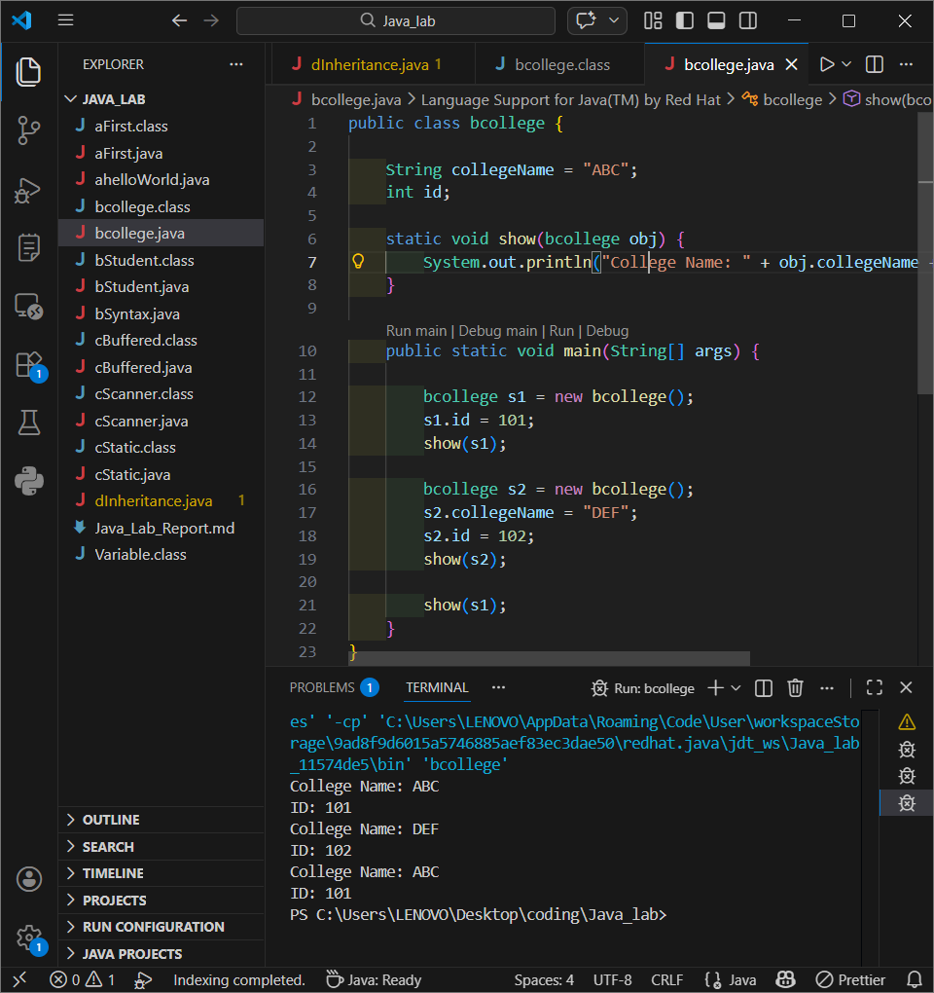
College Name: ABC
ID: 101
College Name: DEF
ID: 102
College Name: ABC
ID: 101

3. Program 2.2 – bStudent.java
This program provides a comprehensive look at class instantiation. It demonstrates that printing an object reference without overriding toString() yields the class name followed by a hexadecimal hash code. It also reinforces the difference between static and non-static variables through a clear analogy.

class bStudent {
String name;
int Sapid;
int batch;

void show() {
System.out.println("Name: " + name +
"\nSAP ID: " + Sapid +
"\nBatch: " + batch);
}

public static void main(String[] args) {
bStudent s1 = new bStudent();
System.out.println(s1); // Prints reference: bStudent@<hashcode>
s1.name = "Prabhjeet";
s1.Sapid = 590013286;
s1.batch = 10;
s1.show();
}
}

Expected Output (sample): 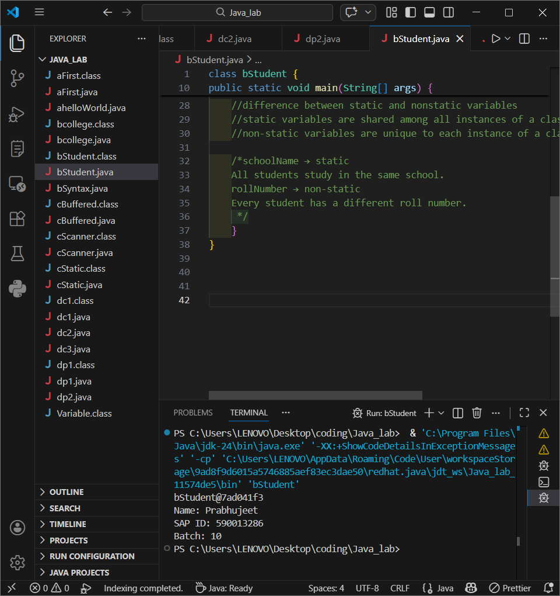
bStudent@7ad041f3
Name: Prabhjeet
SAP ID: 590013286
Batch: 10

4. Program 2.3 – bSyntax.java
This program dissects and explains the anatomy of the main method declaration. It is an essential conceptual exercise for understanding why the main method must be public, static, and void.

public class bSyntax {
public static void main(String[] args) {
// public → Accessible by JRE from anywhere.
// static → Can be invoked without creating an object of the class.
// void → Does not return any value to the caller.
// main → The designated entry point recognised by the JVM.
System.out.println("Java Syntax Basics");
}
}

Expected Output: 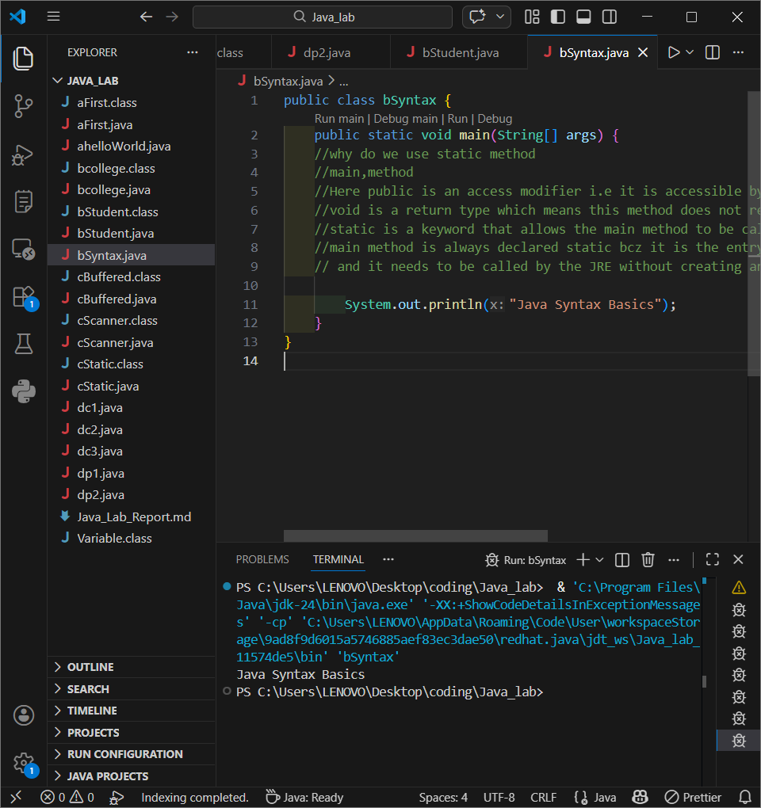

Java Syntax Basics

Experiment 3 – Input Handling & Static vs. Non-Static Methods

1. Theory: The nextInt() Newline Problem
In Java's Scanner class, primitive-reading methods such as nextInt() and nextDouble() consume only the numeric token and leave the trailing newline character ('\n') — generated by pressing Enter — in the input buffer. Consequently, any subsequent call to nextLine() immediately reads this residual empty string rather than waiting for user input. This is a common source of logical errors in console applications.

2. Program 3.1 – cBuffered.java (BufferedReader Approach)
This program demonstrates the use of BufferedReader combined with InputStreamReader as a robust alternative for reading user input. The readLine() method of BufferedReader consumes the entire line including the newline character, thereby eliminating the buffer-pollution problem inherent to Scanner's primitive methods. Note that it requires declaring throws IOException on the main method.

import java.io.*;

public class cBuffered {
public static void main(String[] args) throws IOException {
BufferedReader br = new BufferedReader(new InputStreamReader(System.in));
System.out.print("Enter your age: ");
int age = Integer.parseInt(br.readLine());
System.out.print("Enter your name: ");
String name = br.readLine();
System.out.println("Name: " + name);
System.out.println("Age: " + age);
}
}

Expected Output: 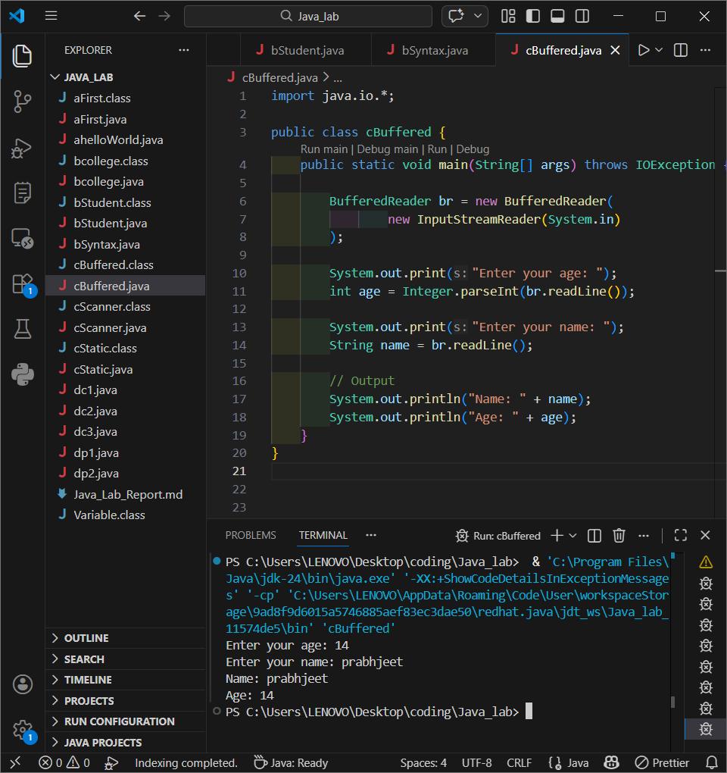

Enter your age: 20
Enter your name: Prabhjeet
Name: Prabhjeet
Age: 20

3. Program 3.2 – cScanner.java (Scanner Newline Fix)

This program demonstrates the canonical fix for the nextInt() newline issue: inserting an extra nextLine() call immediately after nextInt() to discard the stale newline character from the input buffer, thereby allowing the subsequent nextLine() call to read user input correctly.

import java.util.Scanner;

public class cScanner {
public static void main(String[] args) {
try (Scanner obj = new Scanner(System.in)) {
System.out.print("Enter your age: ");
int age = obj.nextInt();
obj.nextLine(); // Consume the residual newline from nextInt()
System.out.print("Enter your name: ");
String name = obj.nextLine();
System.out.println("Age: " + age);
System.out.println("Name: " + name);
}
}
}

Expected Output (sample): 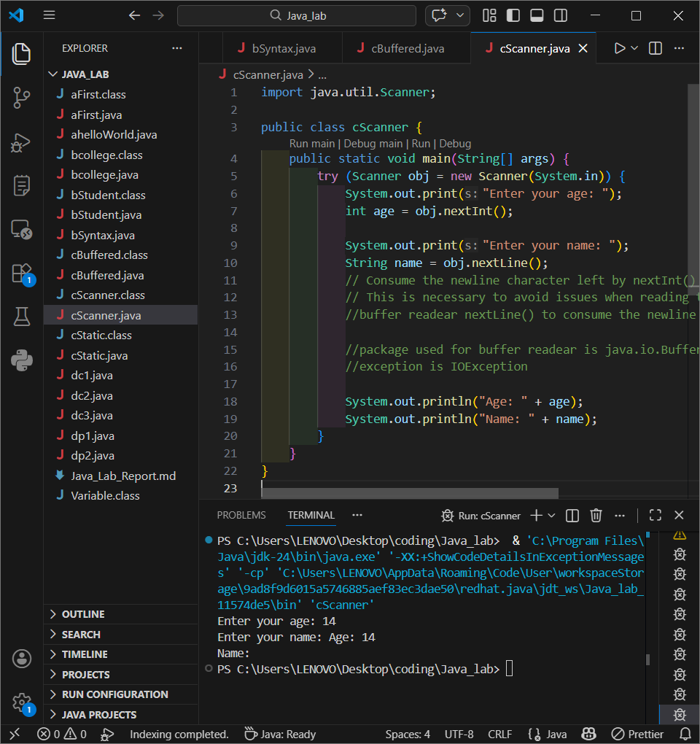
Enter your age: 19
Enter your name: Prabhjeet
Age: 19
Name: Prabhjeet

4. Program 3.3 – cStatic.java (Static vs. Non-Static Methods)
This program contrasts the invocation syntax of static and non-static methods. A static method is called on the class name directly, without needing an object. A non-static method must be called on an instance of the class. This distinction is fundamental to understanding method access in Java.

class Variable {
static void staticMethod() {
System.out.println("Prabhjeet's static method — called on the class.");
}
void nonStaticMethod() {
System.out.println("Prabhjeet's non-static method — called on an object.");
}
}

public class cStatic {
public static void main(String[] args) {
Variable obj = new Variable();
obj.nonStaticMethod(); // Requires an instance
Variable.staticMethod(); // Called on the class itself
}
}
Expected Output:
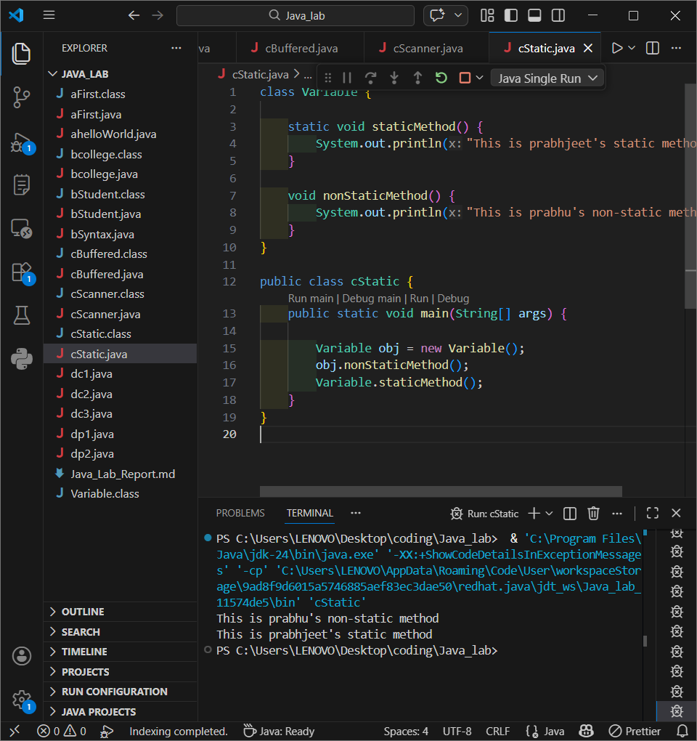

Prabhjeet's non-static method — called on an object.
Prabhjeet's static method — called on the class.

Experiment 4 – Inheritance

1. Theory
Inheritance is one of the four foundational pillars of Object-Oriented Programming. It is a mechanism that allows a new class (the child or subclass) to acquire the properties and behaviours (fields and methods) of an existing class (the parent or superclass). This promotes code reusability, reduces redundancy, and establishes a natural hierarchical 'is-a' relationship between classes.

Types of Inheritance in Java:
- Single Inheritance: A child class inherits from exactly one parent class.
- Multilevel Inheritance: A child class inherits from a parent, which itself inherits from another class, forming a chain.
- Hierarchical Inheritance: Multiple child classes inherit independently from a single common parent class.
Note: Java does not support Multiple Inheritance through classes (i.e., a class cannot directly extend two classes) to avoid the 'Diamond Problem'. This is achieved instead through interfaces.

2. Program 4.1 – dp1.java (Parent Class)
This file defines the base parent class dp1 from which the subsequent child classes will inherit. It contains a single method, show(), which will be accessible by all subclasses.

class dp1 {
void show() {
System.out.println("This is the Parent class");
}
}

3. Program 4.2 – dc1.java (Single Inheritance)
This program demonstrates Single Inheritance. The class dc1 extends the parent class dp1, inheriting its show() method. The child class also defines its own additional method, display(). When an object of dc1 is created, it can call both its own methods and the inherited methods from dp1.

class dc1 extends dp1 {
void display() {
System.out.println("This is class dc1");
}
public static void main(String[] args) {
dc1 obj = new dc1();
obj.display(); // Own method
obj.show(); // Inherited from dp1
}
}

Expected Output:
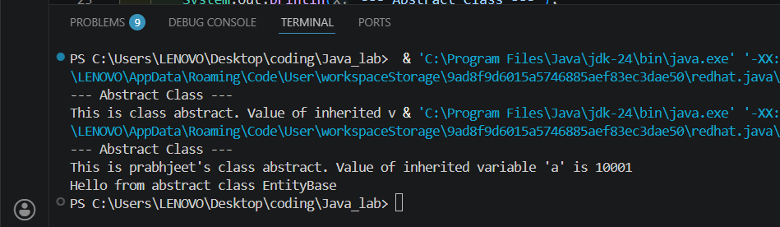
This is class dc1
This is the Parent class

4. Program 4.3 – dc2.java (Multilevel Inheritance)
This program demonstrates Multilevel Inheritance. The class dc2 extends dc1, which itself extends dp1. The dc2 object therefore inherits properties from both dc1 and dp1, illustrating a multi-generational inheritance chain.

class dc2 extends dc1 {
void showcase() {
System.out.println("This is class dc2");
}
public static void main(String[] args) {
dc2 obj = new dc2();
obj.showcase(); // Own method
obj.display(); // Inherited from dc1
obj.show(); // Inherited from dp1 (via dc1)
}
}

Expected Output:
This is class dc2
This is class dc1
This is the Parent class

5. Program 4.4 – dp2.java (Hierarchical Inheritance)
This program demonstrates Hierarchical Inheritance. Both dp2 (this file) and dc1 (from 4.2) independently extend the same parent class dp1. This shows multiple child classes sharing a single common ancestor.

public class dp2 extends dp1 {
void jolly() {
System.out.println("This is class dp2 (a sibling of dc1)");
}
public static void main(String[] args) {
dp2 obj = new dp2();
obj.jolly();
obj.show(); // Inherited from dp1
}
}

Expected Output:
This is class dp2 (a sibling of dc1)
This is the Parent class

Experiment 5 – Interfaces & Abstract Classes

1. Theory: Abstract Classes
An abstract class in Java is a class that cannot be instantiated directly — it serves as an incomplete template designed to be extended by subclasses. It is declared using the abstract keyword and may contain both abstract methods (without a body, which subclasses must implement) and concrete methods (with a full body, which are inherited as-is).
- Declared with the abstract keyword.
- May contain abstract methods and concrete methods.
- Variables are not final by default and can be modified by subclasses.
- Cannot be instantiated directly; an object of the subclass must be created.

2. Theory: Interfaces
An interface in Java is a reference type that defines a contract — it specifies what a class must do, but not how it does it. In modern Java, interfaces can contain:
- Abstract methods (by default public and abstract)
- Constants (implicitly public, static, and final)
- Default methods (with implementations, since Java 8)
- Static methods (since Java 8)
- Private methods (since Java 9)

Interfaces are used to achieve abstraction, multiple inheritance (of type), loose coupling, and polymorphism. A class implements an interface; an interface can extend another interface.

3. Program 5.1 – eabstract.java (Abstract Class)
This program demonstrates the use of an abstract class. The abstract class EntityBase contains a concrete method display() and an abstract method show(). The concrete subclass eabstract provides the mandatory implementation for show() and demonstrates that inherited variables in an abstract class are not final and can be modified.

abstract class EntityBase {
int a = 10000;
abstract void show(); // No body; subclass must implement

void display() {
System.out.println("Hello from abstract class EntityBase");
}
}

public class eabstract extends EntityBase {
@Override
void show() {
a = a + 1; // Inherited variable is mutable
System.out.println("Prabhjeet's class — Value of 'a': " + a);
}

public static void main(String[] args) {
System.out.println("--- Abstract Class Demo ---");
// EntityBase e = new EntityBase(); // ERROR: cannot instantiate
eabstract obj = new eabstract();
obj.show();
obj.display();
}
}

Expected Output: 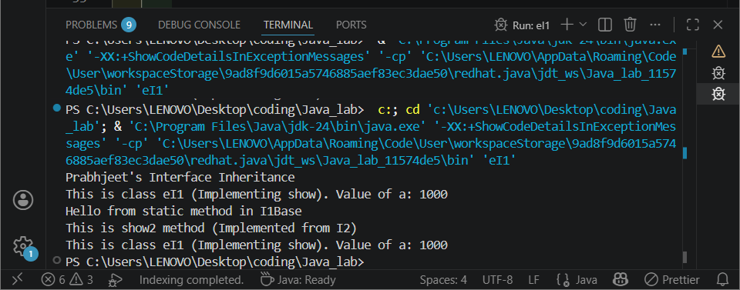
--- Abstract Class Demo ---
Prabhjeet's class — Value of 'a': 10001
Hello from abstract class EntityBase

4. Program 5.2 – eI1.java (Interface Inheritance)
This program demonstrates interface inheritance (one interface extending another) and interface implementation by a class. Interface I2 extends I1Base, adding an additional abstract method. The class eI1 implements I2 and thus must provide implementations for all abstract methods from both I1Base and I2.

interface I1Base {
int a = 1000; // Implicitly public static final
void show();
static void display() {
System.out.println("Static method in I1Base");
}
}

interface I2 extends I1Base {
void show2(); // Additional abstract method
}

public class eI1 implements I2 {
@Override
public void show() {
System.out.println("eI1 — implementing show(). Value of a: " + a);
}
@Override
public void show2() {
System.out.println("eI1 — implementing show2() from I2.");
}

public static void main(String[] args) {
System.out.println("Prabhjeet — Interface Inheritance Demo");
I1Base a1 = new eI1();
a1.show();
I1Base.display(); // Static method called on interface
I2 i2 = new eI1();
i2.show2();
i2.show();
}
}

Expected Output: 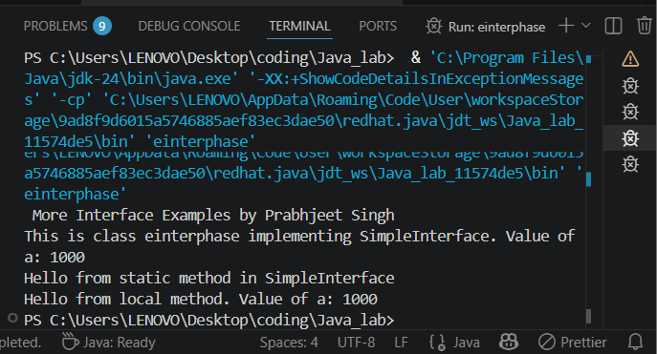
Prabhjeet — Interface Inheritance Demo
eI1 — implementing show(). Value of a: 1000
Static method in I1Base
eI1 — implementing show2() from I2.
eI1 — implementing show(). Value of a: 1000

5. Program 5.3 – einterphase.java (Interface Implementation)
This program demonstrates the core properties of an interface: all variables are implicitly public, static, and final (constants), meaning they cannot be modified by the implementing class. All methods are implicitly abstract (unless declared static or default). The program also illustrates calling a static interface method directly on the interface name.

interface SimpleInterface {
int a = 1000; // public static final — cannot be changed
void show();
static void display() {
System.out.println("Static method in SimpleInterface");
}
}

public class einterphase implements SimpleInterface {
@Override
public void show() {
System.out.println("einterphase implements show(). Value of a: " + a);
}
void displayLocal() {
// a = a + 1; // COMPILE ERROR — 'a' is final
System.out.println("Local method. Value of a: " + a);
}
public static void main(String[] args) {
System.out.println("--- Interface Demo ---");
SimpleInterface ref = new einterphase();
ref.show();
SimpleInterface.display();
einterphase obj = new einterphase();
obj.displayLocal();
}
}

Expected Output:
--- Interface Demo ---
einterphase implements show(). Value of a: 1000
Static method in SimpleInterface
Local method. Value of a: 1000

Experiment 6 – Packages

1. Theory
A package in Java is a namespace that organises related classes and interfaces into a logical grouping — similar to folders in a file system. Packages serve several essential purposes in software engineering:
- Organising large programs into manageable, modular units.
- Avoiding naming conflicts between classes in different libraries.
- Providing access protection by controlling visibility between packages.
- Improving code reusability and maintainability.

Types of Packages:
Built-in Packages: Provided by Java itself. Examples include java.lang (String, Math, System), java.util (Scanner, ArrayList), and java.io (BufferedReader, IOException).
User-defined Packages: Custom packages created by the developer using the package keyword as the first statement in a source file, followed by a dot-separated path (e.g., package prabh;).

2. Program 6.1 – fpackage.java (Built-in Package)
This program imports the Scanner class from the built-in java.util package to read two integers from the user and compute their sum. It demonstrates the use of try-with-resources to ensure the Scanner is automatically closed and the use of a finally block to demonstrate guaranteed execution.

import java.util.Scanner; // Importing a class from a built-in package
// java → Top-level package
// util → Sub-package
// Scanner → Class being imported

public class fpackage {
public static void main(String[] args) {
try (Scanner sc = new Scanner(System.in)) {
System.out.print("Enter first value: ");
int a = sc.nextInt();
System.out.print("Enter second value: ");
int b = sc.nextInt();
System.out.println("Sum: " + (a + b));
} finally {
System.out.println("This block always executes.");
}
}
}

Expected Output (sample):
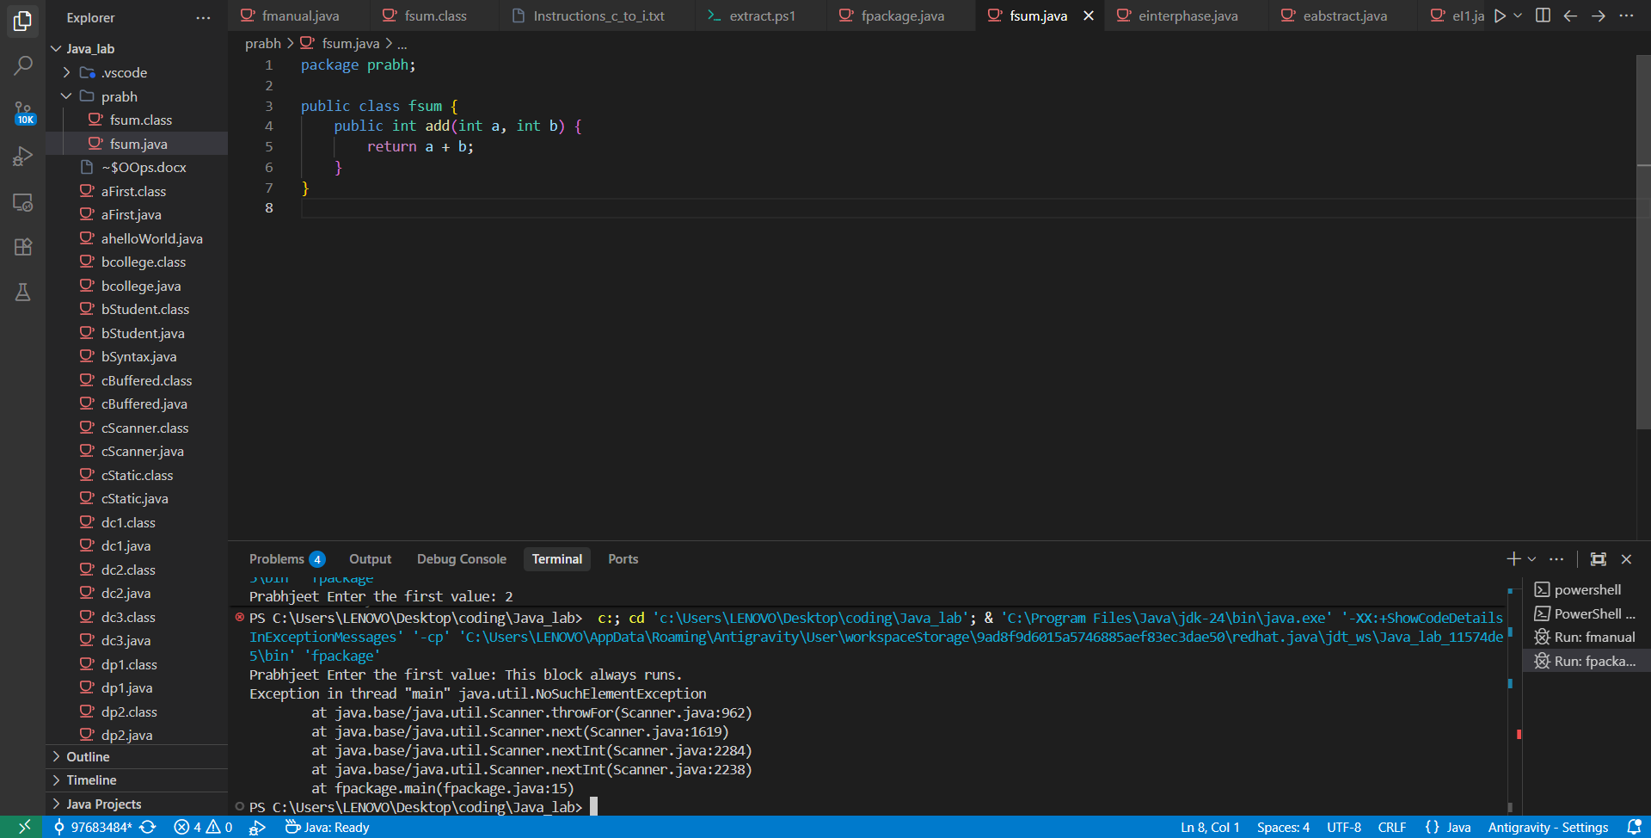

Enter first value: 15
Enter second value: 25
Sum: 40
This block always executes.

3. Program 6.2 – fsum.java (User-defined Package — Library Class)
This file defines a utility class fsum inside the user-defined package prabh. It provides a public method add() that returns the sum of two integers. This class acts as a reusable library component.

package prabh;

public class fsum {
public int add(int a, int b) {
return a + b;
}
}

4. Program 6.3 – fmanual.java (Consuming the User-defined Package)
This program imports and consumes the fsum class from the prabh package. It demonstrates how classes defined in user-defined packages are accessed and used, mirroring the same mechanism used for built-in packages.

import prabh.fsum;

public class fmanual {
public static void main(String[] args) {
fsum s1 = new fsum();
int result = s1.add(101, 20);
System.out.println("Sum is: " + result);
}
}

Expected Output: 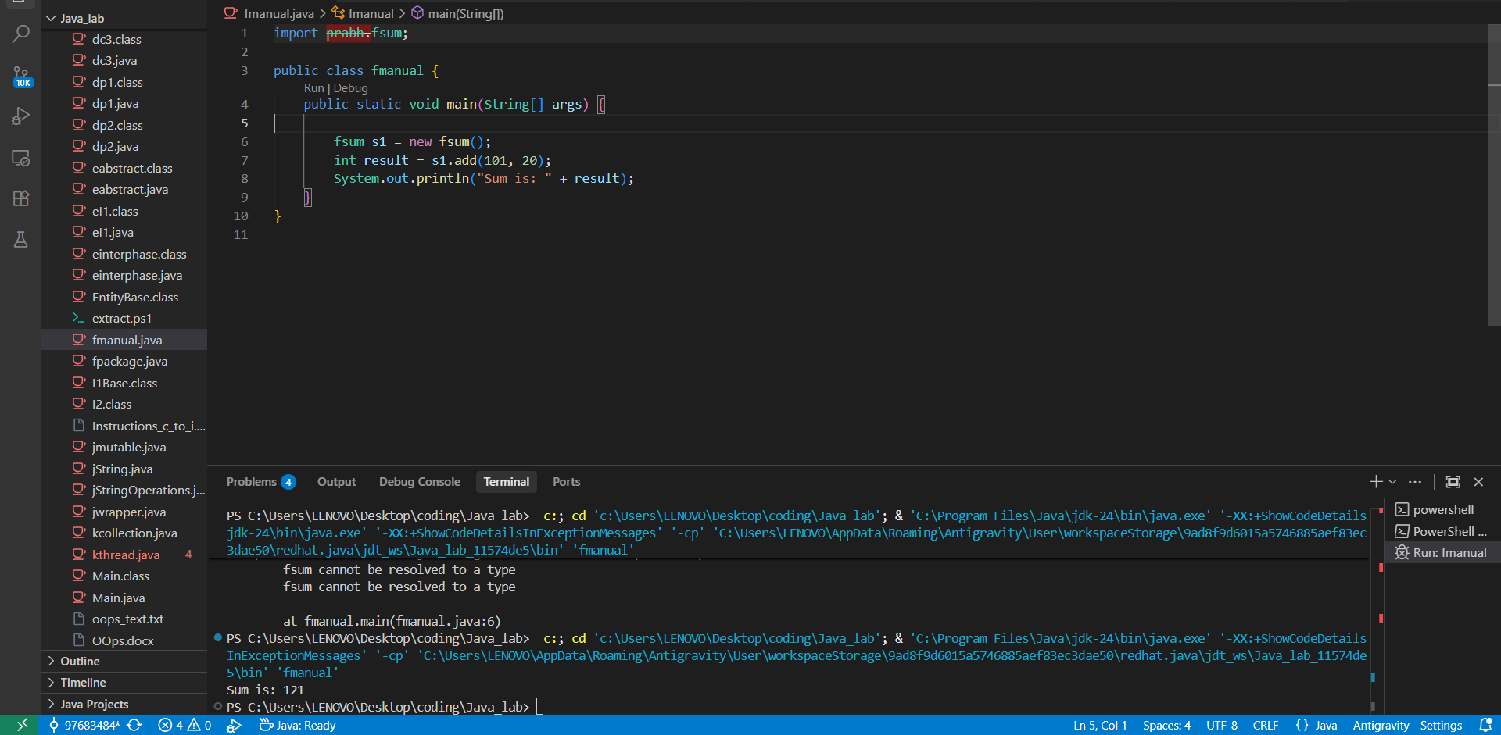
Sum is: 121

Experiment 7 – Exception Handling

1. Theory
An exception is an object that represents an error or an abnormal condition that arises during the execution of a program. Without exception handling, any runtime error causes the program to terminate abruptly, leaving subsequent code unexecuted.

Types of Exceptions in Java:
1. Checked Exceptions: Verified at compile time by the compiler, which forces the programmer to handle them. Examples: IOException, SQLException, FileNotFoundException.
2. Unchecked Exceptions: Runtime exceptions not enforced by the compiler. Examples: ArithmeticException, NullPointerException, ArrayIndexOutOfBoundsException.
3. Errors: Serious, unrecoverable system-level issues. Examples: OutOfMemoryError, StackOverflowError.

Exception Handling Keywords:
- try — Defines the block of code that may throw an exception.
- catch — Defines the handler block for a specific exception type.
- finally — Executes unconditionally after try (and catch), regardless of whether an exception occurred.
- throw — Explicitly throws an exception from within the program.
- throws — Declares in the method signature which exceptions the method may propagate.

2. Program 7.1 – gException.java (Unhandled Exception)
This program deliberately omits exception handling to demonstrate the consequence: an ArithmeticException (division by zero) causes immediate program termination, and all code after the faulting line is never executed.

public class gException {
public static void main(String[] args) {
System.out.println("Prabhjeet");
System.out.println("Step A");
int division = 100 / 0; // Throws ArithmeticException — program crashes here
System.out.println("Step B"); // Never reached
System.out.println("Step C"); // Never reached
}
}

Expected Output: 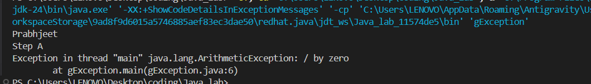
Prabhjeet
Step A
Exception in thread "main" java.lang.ArithmeticException: / by zero

3. Program 7.2 – gCatch.java (try-catch)
This program introduces the try-catch block. The dangerous division-by-zero operation is enclosed in a try block. When the exception occurs, control transfers to the catch block, which handles it gracefully, and program execution then continues normally with Step B and Step C.

public class gCatch {
public static void main(String[] args) {
System.out.println("Prabhjeet");
System.out.println("Step A");
try {
int division = 100 / 0;
} catch (Exception e) {
System.out.print("Caught an error: ");
System.out.println(e);
}
System.out.println("Step B");
System.out.println("Step C");
}
}

Expected Output: 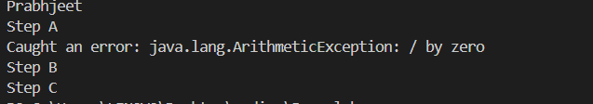
Prabhjeet
Step A
Caught an error: java.lang.ArithmeticException: / by zero
Step B
Step C

4. Program 7.3 – gFinally.java (finally Block)
This program demonstrates the finally block, which guarantees execution regardless of whether an exception is thrown or caught. Even though the program terminates abnormally (the exception is not caught), the finally block still runs.

public class gFinally {
public static void main(String[] args) {
try {
System.out.println("Prabhjeet");
System.out.println("Step A");
int division = 100 / 0;
System.out.println("Step B"); // Never reached
} finally {
System.out.println("Prabhjeet — this finally block always runs!");
}
}
}

Expected Output: 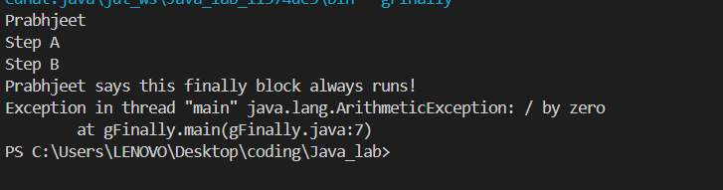
Prabhjeet
Step A
Prabhjeet — this finally block always runs!
Exception in thread "main" java.lang.ArithmeticException: / by zero

5. Program 7.4 – gThrowThrows.java (throw & throws)
This program demonstrates both throw (to explicitly raise an exception with a custom message) and throws (to declare that a method may propagate a checked exception). The verifyAge() method uses throw to reject invalid ages, while main() declares throws IOException for the BufferedReader.

import java.io.*;

public class gThrowThrows {
void verifyAge(int personAge) {
if (personAge < 18) {
throw new ArithmeticException("Not eligible to vote.");
} else {
System.out.println("Prabhjeet — eligible to vote.");
}
}

public static void main(String args[]) throws IOException {
System.out.println("Prabhjeet");
BufferedReader reader = new BufferedReader(new InputStreamReader(System.in));
System.out.println("Please enter your age:");
int inputAge = Integer.parseInt(reader.readLine());
gThrowThrows checker = new gThrowThrows();
checker.verifyAge(inputAge);
}
}

Expected Output (sample — age ≥ 18): 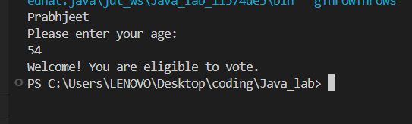
Prabhjeet
Please enter your age:
21
Prabhjeet — eligible to vote.

Experiment 8 – String Handling & Wrapper Classes

1. Theory: Strings in Java
A String is a sequence of characters represented as an object of the java.lang.String class. Strings are the most widely used reference type in Java and are used for storing and manipulating textual data. Two critical memory concepts govern String behaviour:
- String literals (e.g., String s = "Hello";) are stored in the String Constant Pool, a special heap area. Two literals with identical content point to the same pool object.
- Strings created with the new keyword (e.g., String s = new String("Hello");) always create a new object on the regular heap, even if identical content already exists in the pool.

Consequence: Comparison Pitfall
The == operator checks reference equality (whether two variables point to the same memory location). The .equals() method checks content equality (whether the character sequences are identical). Confusing these two is a common source of bugs.

Types of String Handling:
- Immutable Strings (String class): Once created, the content cannot be changed. Operations like concat() return a new object; the original is unchanged.
- Mutable Strings — StringBuffer: Thread-safe (synchronized); operations modify the same object in place. Slightly slower due to synchronization overhead.
- Mutable Strings — StringBuilder: Not thread-safe; faster than StringBuffer. Preferred for single-threaded scenarios requiring frequent string modifications.

2. Program 8.1 – h01.java (String Comparison)

public class h01 {
public static void main(String[] args) {
System.out.println("Prabhjeet");
String S1 = "Hello";
String S2 = "Hello"; // Points to same pool object as S1
String S3 = new String("Hello1"); // New heap object
String S4 = new String("Hello1"); // Another new heap object
System.out.println(S1 == S2); // true — same pool reference
System.out.println(S1.equals(S2)); // true — same content
System.out.println(S3 == S4); // false — different heap objects
System.out.println(S3.equals(S4)); // true — same content
}
}

Expected Output: 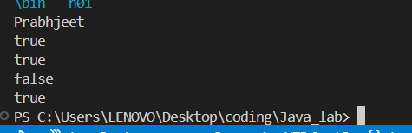
Prabhjeet
true
true
false
true

3. Program 8.2 – h02.java (Immutable String)

public class h02 {
public static void main(String[] args) {
System.out.println("Prabhjeet");
String S1 = "Hello Prabhjeet";
S1.concat(" Java"); // Returns new object — not assigned!
System.out.println(S1); // S1 is unchanged
String S2 = new String("Hello1 Prabhjeet");
S2.concat(" Java"); // Same issue
System.out.println(S2);
}
}

Expected Output: 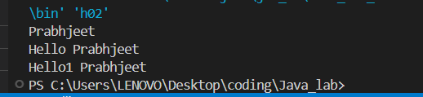
Prabhjeet
Hello Prabhjeet
Hello1 Prabhjeet

4. Program 8.3 – h03.java (StringBuffer — Mutable, Thread-Safe)

public class h03 {
public static void main(String[] args) {
System.out.println("Prabhjeet");
StringBuffer S3 = new StringBuffer("Hello3 Prabhjeet");
S3.append(" Java"); // Modifies S3 in place
System.out.println(S3);
}
}

Expected Output: 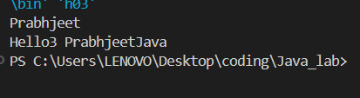
Prabhjeet
Hello3 Prabhjeet Java

5. Program 8.4 – h04.java (StringBuilder — Mutable, Faster)

public class h04 {
public static void main(String[] args) {
System.out.println("Prabhjeet");
StringBuilder S4 = new StringBuilder("Hello3 Prabhjeet");
S4.append(" Java");
System.out.println(S4);
}
}

Expected Output: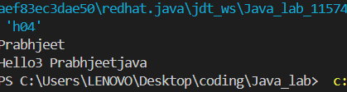
Prabhjeet
Hello3 Prabhjeet Java

6. Theory: Wrapper Classes
Wrapper classes encapsulate Java's eight primitive data types (int, char, double, etc.) inside objects of the java.lang package. They are essential because Java's Collections Framework (ArrayList, HashMap, etc.) can only store objects, not primitives.

Primitive Type | Wrapper Class
int | Integer
char | Character
double | Double
float | Float
boolean | Boolean
long | Long
short | Short
byte | Byte

7. Program 8.5 – h05.java (Boxing with valueOf)

public class h05 {
public static void main(String args[]) {
System.out.println("Prabhjeet");
int a = 10;
Integer obj = Integer.valueOf(a); // Efficient boxing — uses cached pool
System.out.println("Primitive: " + a);
System.out.println("Object: " + obj);
}
}

Expected Output: 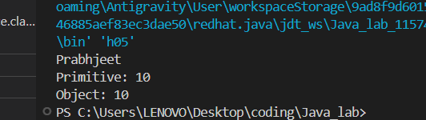
Prabhjeet
Primitive: 10
Object: 10

8. Program 8.6 – h06.java (Boxing, Autoboxing & Unboxing)
This program demonstrates all three conversion mechanisms. Manual boxing via new Integer() creates a new heap object every time (deprecated in newer Java). valueOf() is cache-aware. Autoboxing/unboxing (introduced in Java 5) allows the compiler to handle conversions automatically.

public class h06 {
public static void main(String args[]) {
System.out.println("Prabhjeet");
int a = 10;
Integer obj1 = new Integer(a); // Manual boxing (deprecated)
System.out.println("Boxing (new): " + obj1);
Integer obj2 = Integer.valueOf(a); // Preferred boxing
System.out.println("Boxing (valueOf): " + obj2);
Integer obj3 = a; // Autoboxing — compiler converts
System.out.println("Autoboxing: " + obj3);
int b = obj3; // Unboxing — compiler converts
System.out.println("Unboxing: " + b);
}
}

Expected Output: 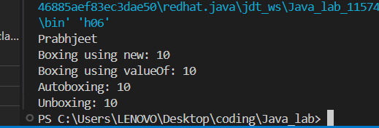
Prabhjeet
Boxing (new): 10
Boxing (valueOf): 10
Autoboxing: 10
Unboxing: 10

Experiment 9 – Multithreading & Collections

Part A: Threads

1. Theory: Threads in Java
A thread is the smallest unit of a process — a lightweight, independent path of execution within a program. Java's multithreading model allows a program to perform multiple tasks concurrently, improving CPU utilisation and application responsiveness.
Multiprocessing: Multiple independent processes run simultaneously, each with its own memory space (e.g., running a browser and a music player simultaneously).
Multithreading: Multiple threads execute within a single process, sharing the same memory space (e.g., a browser streaming video while downloading a file).
Daemon Thread: A background service thread (e.g., the Garbage Collector) that supports user threads. The JVM exits when only daemon threads remain.

Thread Life Cycle:
- New — Thread object created but start() not yet called.
- Runnable — start() called; thread is eligible to run.
- Running — Thread is currently executing.
- Blocked / Waiting — Thread is paused (e.g., waiting for I/O or another thread).
- Terminated — Thread has finished execution.

2. Program 9.1 – i01.java (Thread Class Extension)
This program demonstrates thread creation by extending the Thread class and overriding its run() method. It illustrates the crucial difference between calling run() directly (executes synchronously in the current thread) and calling start() (creates a new thread and executes run() asynchronously).

class A1 extends Thread {
public void run() { System.out.println("Thread A1 is running"); }
}
class B1 extends Thread {
public void run() {
for (int i = 0; i < 5; i++) { System.out.println(i); }
}
}
public class i01 {
public static void main(String[] args) {
System.out.println("Prabhjeet");
A1 obj1 = new A1();
obj1.start(); // New thread
obj1.run(); // Normal method call (same thread)
B1 obj2 = new B1();
B1 obj3 = new B1();
obj2.start();
obj3.start(); // obj2 and obj3 run concurrently
}
}

Expected Output (order may vary — concurrent): 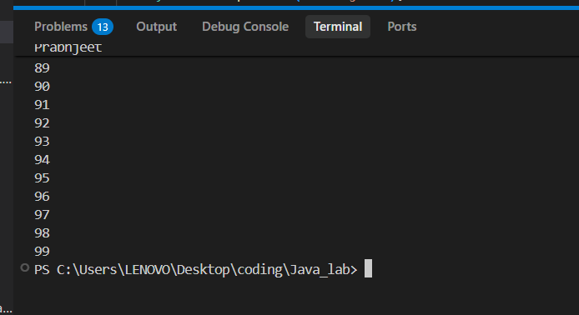
Prabhjeet
Thread A1 is running
Thread A1 is running
0
1
0
2
1
... (interleaved)

3. Program 9.2 – i02.java (Runnable Interface)
This program demonstrates the second and preferred way to create threads: implementing the Runnable interface. This approach is favoured because it does not consume the single-inheritance slot (a class implementing Runnable can still extend another class).

class A2 implements Runnable {
public void run() { System.out.println("Thread A2 is running"); }
}
class B2 implements Runnable {
public void run() {
for (int i = 0; i < 5; i++) { System.out.println(i); }
}
}
public class i02 {
public static void main(String[] args) {
System.out.println("Prabhjeet");
A2 obj1 = new A2();
Thread t1 = new Thread(obj1);
t1.start();
obj1.run(); // Normal call
B2 obj2 = new B2();
B2 obj3 = new B2();
Thread t2 = new Thread(obj2);
Thread t3 = new Thread(obj3);
t2.start();
t3.start();
}
}

Expected Output (order may vary): 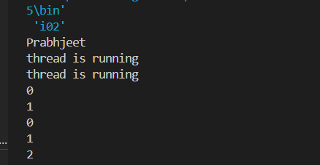
Prabhjeet
Thread A2 is running
Thread A2 is running
0
1
... (interleaved)

Part B: Collections

1. Theory: The Java Collections Framework
The Java Collections Framework (JCF) is a unified architecture of interfaces and classes for storing, retrieving, and manipulating groups of objects. It eliminates the need to write custom data structures and provides highly optimised, reusable implementations.

Key Interfaces:
List: Allows duplicate elements and maintains insertion order. Primary implementations: ArrayList, LinkedList, Vector.
Set: Disallows duplicate elements. Primary implementations: HashSet (unordered), LinkedHashSet (insertion-ordered), TreeSet (sorted).
Map: Stores key-value pairs; keys must be unique. Primary implementations: HashMap (unordered), LinkedHashMap (insertion-ordered), TreeMap (sorted).

2. Program 9.3 – ArrayList Demonstration
This program comprehensively demonstrates the core methods of java.util.ArrayList: add(), add(index, value), addAll(), get(), set(), remove(), and clear().

import java.util.ArrayList;

class Demo2ArrayList {
public static void main(String args[]) {
ArrayList<Integer> list = new ArrayList<>();
list.add(1); list.add(2); list.add(3);
System.out.println(list); // [1, 2, 3]
list.add(1, 4);
System.out.println(list); // [1, 4, 2, 3]
ArrayList<Integer> newList = new ArrayList<>();
newList.add(5); newList.add(6);
list.addAll(newList);
System.out.println(list); // [1, 4, 2, 3, 5, 6]
System.out.println(list.get(1)); // 4
list.set(2, 8);
System.out.println(list); // [1, 4, 8, 3, 5, 6]
list.remove(3);
System.out.println(list); // [1, 4, 8, 5, 6]
list.clear();
System.out.println(list); // []
}
}

Expected Output: 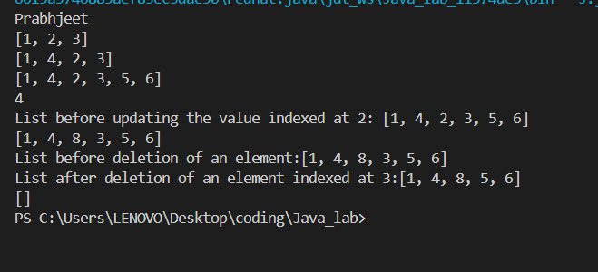
[1, 2, 3]
[1, 4, 2, 3]
[1, 4, 2, 3, 5, 6]
4
[1, 4, 8, 3, 5, 6]
[1, 4, 8, 5, 6]
[]

3. Program 9.4 – Stack Implementation

import java.util.Stack;

class Stack1 {
public static void main(String args[]) {
Stack<Integer> s1 = new Stack<>();
s1.push(1); s1.push(2); s1.push(3);
System.out.println(s1); // [1, 2, 3]
System.out.println(s1.peek()); // 3 (top element, not removed)
s1.pop();
System.out.println(s1.peek()); // 2
}
}

Expected Output: 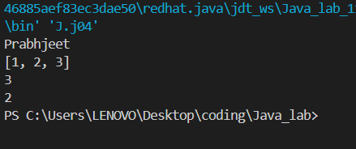
[1, 2, 3]
3
2

4. Program 9.5 – Queue Using LinkedList

import java.util.Queue;
import java.util.LinkedList;

class DemoLinkedListQueue {
public static void main(String args[]) {
Queue<Integer> queue = new LinkedList<>();
queue.offer(12); queue.offer(13); queue.offer(14);
System.out.println(queue); // [12, 13, 14]
System.out.println(queue.peek()); // 12 (front, not removed)
System.out.println(queue.poll()); // 12 (front, removed)
}
}

Expected Output: 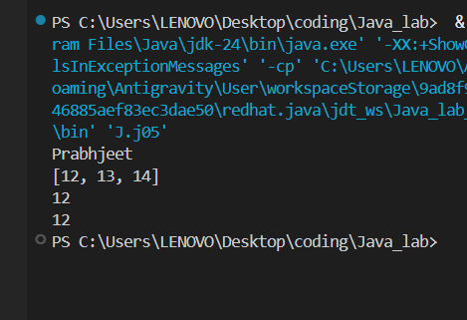
[12, 13, 14]
12
12

5. Program 9.6 – j06.java (Array Traversal)

package J;

public class j06 {
String array[] = {"A", "B", "C", "D", "E"};

public static void main(String[] args) {
System.out.println("Prabhjeet");
j06 obj = new j06();
for (int i = 0; i < obj.array.length; i++) {
System.out.println(obj.array[i]);
}
}
}

Expected Output: 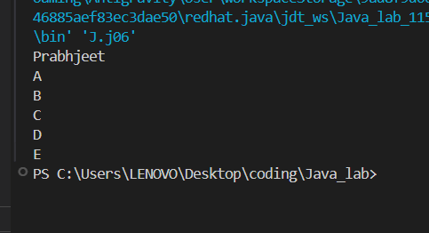
Prabhjeet
A
B
C
D
E

Experiment 10 – JDBC: Java Database Connectivity

1. Theory
JDBC (Java Database Connectivity) is a standard Java API defined in the java.sql package that allows Java programs to connect to and interact with relational databases. It provides a uniform interface regardless of the underlying database vendor, enabling CRUD (Create, Read, Update, Delete) operations through SQL.

Steps to Connect to a Database Using JDBC:
- Load the Driver: Register the JDBC driver using Class.forName().
- Establish Connection: Obtain a Connection object using DriverManager.getConnection().
- Create Statement: Create a Statement or PreparedStatement object.
- Execute Query: Run SQL queries and obtain a ResultSet if applicable.
- Process Results: Iterate over the ResultSet to access data.
- Close Connection: Release database resources by calling con.close().

Types of JDBC Drivers:
- Type 1 – JDBC-ODBC Bridge Driver
- Type 2 – Native-API Driver
- Type 3 – Network Protocol Driver
- Type 4 – Thin Driver (Pure Java — most commonly used, e.g., MySQL Connector/J)

2. Program 10.1 – Retrieve Data (week9_04.java)

import java.sql.Connection;
import java.sql.DriverManager;
import java.sql.ResultSet;
import java.sql.Statement;

public class week9_04 {
public static void main(String[] args) {
System.out.println("Name: Prabhjeet");
String url = "jdbc:mysql://localhost:3306/ClassL";
String username = "root";
String password = "Prabhjeet00";
try {
Class.forName("com.mysql.cj.jdbc.Driver");
Connection con = DriverManager.getConnection(url, username, password);
System.out.println("Connected successfully!");
Statement stmt = con.createStatement();
ResultSet rs = stmt.executeQuery("SELECT * FROM Staff");
while (rs.next()) {
System.out.println("ID: " + rs.getInt("emp_id") +
" | Name: " + rs.getString("emp_name"));
}
con.close();
} catch (Exception e) {
System.out.println(e);
}
}
}

Expected Output: 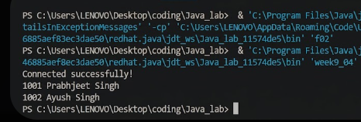
Name: Prabhjeet
Connected successfully!
ID: 101 | Name: Ayush Singh
ID: 102 | Name: Amit Sharma

Experiment 11 – Servlets

1. Theory
A Servlet is a server-side Java program that runs within a Servlet Container (e.g., Apache Tomcat). It handles HTTP requests from web clients (browsers) and generates dynamic responses — typically HTML pages. Servlets are the foundation of Java Enterprise web development and are far more efficient than the legacy CGI (Common Gateway Interface) approach.

Servlet Architecture:
- Client (Browser) → sends an HTTP Request
- Web Server → forwards the request
- Servlet Container (Tomcat) → manages the Servlet lifecycle
- Servlet → processes the request and generates a dynamic response

Servlet Life Cycle:
- Loading & Instantiation: The container loads the servlet class and creates an object.
- Initialization (init()): Called exactly once when the servlet is first loaded.
- Request Handling (service()): Called for every client request; dispatches to doGet() or doPost().
- Destruction (destroy()): Called before the servlet is removed from service to release resources.

Key Servlet Methods:
- init() — Initialises the servlet; runs once.
- service() — Central dispatcher for all requests.
- doGet() — Handles HTTP GET requests.
- doPost() — Handles HTTP POST requests.
- destroy() — Cleans up resources before termination.

2. Advantages of Servlets
- Significantly faster and more efficient than CGI scripts.
- Platform-independent, inheriting all advantages of the Java ecosystem.
- Session management, cookie handling, and database connectivity are readily available.
- Tightly integrated with the full Java EE/Jakarta EE enterprise stack.

Assignment A – Java Package Questions (f01–f05)
This assignment demonstrates the creation and consumption of user-defined Java packages. Each question defines a utility class inside the prabh package and a separate main class that imports and uses it.

Q1 – Subtract (f01.java)
Demonstrates a user-defined package class for subtraction and its consumption from a main class.
Package Class:
package prabh;
public class Sub {
public int sub(int a, int b) { return a - b; }
}

Main Class:
import prabh.Sub;
public class f01 {
public static void main(String[] args) {
System.out.println("Prabhjeet");
Sub obj = new Sub();
System.out.println("Difference: " + obj.sub(20, 50));
}
}

Expected Output: 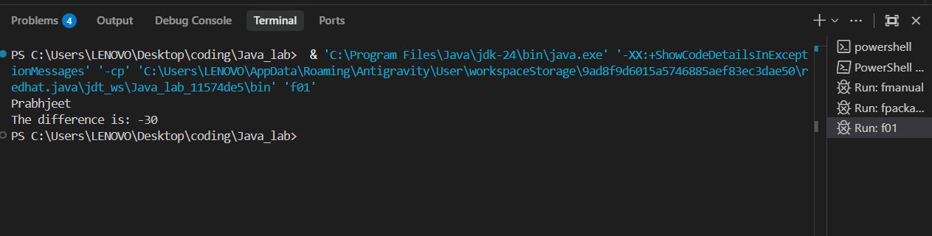
Prabhjeet
Difference: -30

Q2 – Multiply (f02.java)
A package class encapsulating multiplication logic, demonstrating reusability across different programs.
Package Class:
package prabh;
public class Multiply {
public int mul(int a, int b) { return a * b; }
}

Main Class:
import prabh.Multiply;
public class f02 {
public static void main(String[] args) {
System.out.println("Prabhjeet");
Multiply obj = new Multiply();
System.out.println("Product: " + obj.mul(7, 8));
}
}

Expected Output: 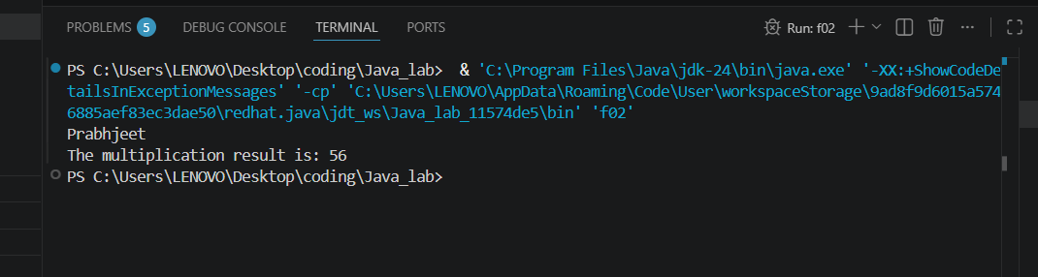
Prabhjeet
Product: 56

Q3 – Square (f03.java)
Demonstrates encapsulating a mathematical squaring operation within a package class.
Package Class:
package prabh;
public class Square {
public int sqrt(int n) { return n * n; }
}

Main Class:
import prabh.Square;
public class f03 {
public static void main(String[] args) {
System.out.println("Prabhjeet");
Square obj = new Square();
System.out.println("Square of 5: " + obj.sqrt(5));
}
}

Expected Output: 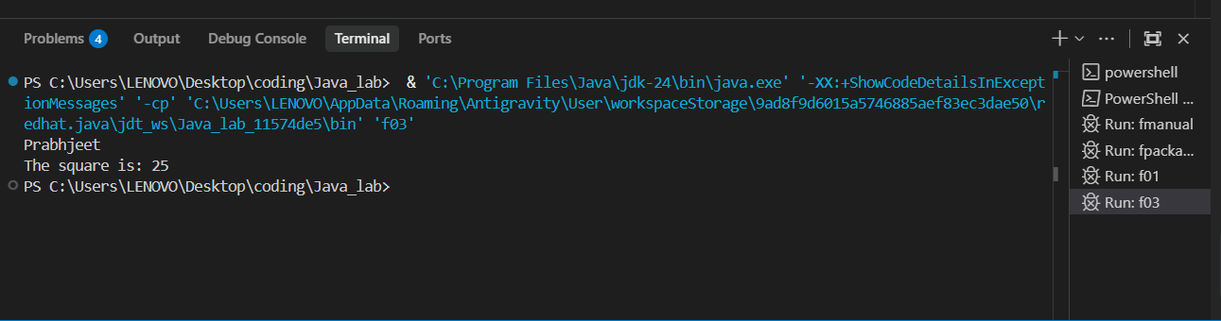
Prabhjeet
Square of 5: 25

Q4 – Maximum (f04.java)
A conditional utility method to find the larger of two integers, packaged for reuse.
Package Class:
package prabh;
public class Max {
public int max(int a, int b) { return (a > b) ? a : b; }
}

Main Class:
import prabh.Max;
public class f04 {
public static void main(String[] args) {
System.out.println("Prabhjeet");
Max obj = new Max();
System.out.println("Bigger number: " + obj.max(25, 40));
}
}

Expected Output: 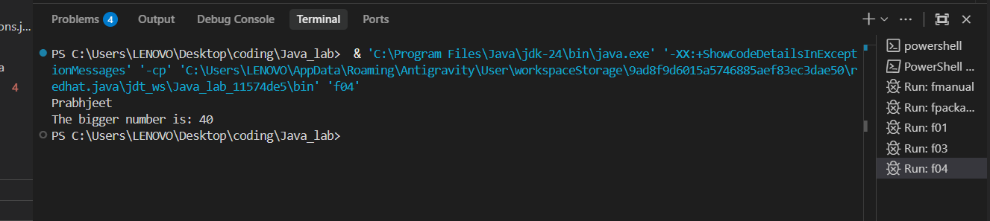
Prabhjeet
Bigger number: 40

Q5 – Fibonacci (f05.java)
An iterative Fibonacci computation packaged as a static utility method, demonstrating loop-based dynamic programming.
Package Class:
package prabh;
public class Fibonacci {
public static int fib(int n) {
if (n <= 1) return n;
int a = 0, b = 1;
for (int i = 2; i <= n; i++) {
int temp = a + b;
a = b; b = temp;
}
return b;
}
}

Main Class:
import prabh.Fibonacci;
public class f05 {
public static void main(String[] args) {
System.out.println("Prabhjeet");
System.out.println("7th Fibonacci: " + Fibonacci.fib(7));
}
}

Expected Output: 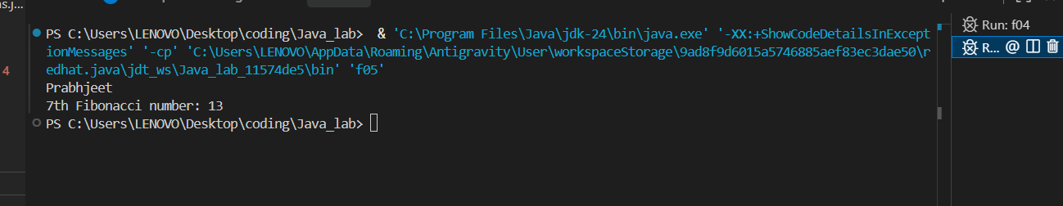
Prabhjeet
7th Fibonacci: 13

Assignment B – String Handling & Wrapper Class Questions (hQ1–hQ14)
This assignment covers fourteen practical exercises on Java String manipulation methods and Wrapper class operations, all implemented in the Prabh_assignment package.

Q1 – Length of a String
public class hQ1 {
public static void main(String args[]) {
System.out.println("Prabhjeet");
String name = "Prabhjeet";
System.out.println("Length: " + name.length());
}
}

Expected Output: 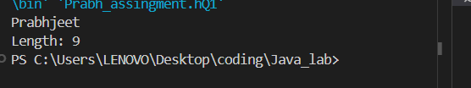
Prabhjeet
Length: 9

Q2 – Uppercase & Lowercase
public class hQ2 {
public static void main(String args[]) {
System.out.println("Prabhjeet");
String name = "Prabhjeet";
System.out.println(name.toUpperCase());
System.out.println(name.toLowerCase());
}
}

Expected Output: 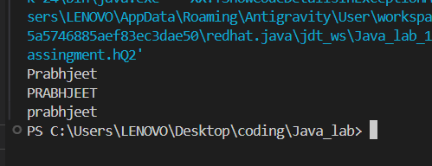
Prabhjeet
PRABHJEET
prabhjeet

Q3 – Concatenation (concat & +)
public class hQ3 {
public static void main(String args[]) {
System.out.println("Prabhjeet");
String s1 = "Prabhjeet", s2 = " Singh";
System.out.println(s1.concat(s2));
System.out.println(s1 + s2);
}
}

Expected Output: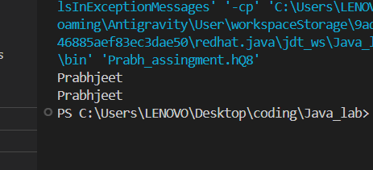
Prabhjeet
Prabhjeet Singh
Prabhjeet Singh

Q4 – Character at Index (charAt)
public class hQ4 {
public static void main(String args[]) {
System.out.println("Prabhjeet");
String name = "Prabhjeet";
System.out.println("charAt(2): " + name.charAt(2));
}
}

Expected Output: 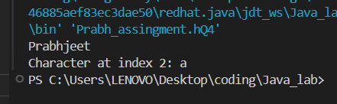
Prabhjeet
charAt(2): a

Q5 – Substring Extraction
public class hQ5 {
public static void main(String args[]) {
System.out.println("Prabhjeet");
String name = "PrabhjeetSingh";
System.out.println("Substring(1,4): " + name.substring(1, 4));
}
}

Expected Output: 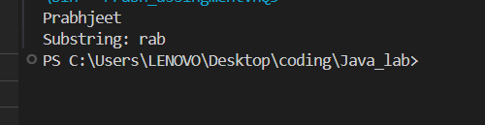
Prabhjeet
Substring(1,4): rab

Q6 – startsWith & endsWith
public class hQ6 {
public static void main(String args[]) {
System.out.println("Prabhjeet");
String name = "PrabhjeetSingh";
System.out.println(name.startsWith("Prabh"));
System.out.println(name.endsWith("ngh"));
}
}

Expected Output: 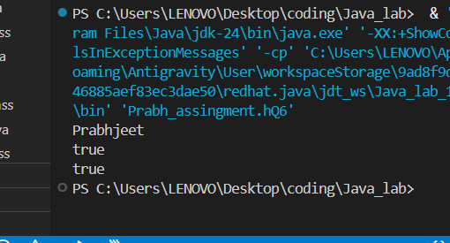
Prabhjeet
true
true

Q7 – Replace Characters
public class hQ7 {
public static void main(String args[]) {
System.out.println("Prabhjeet");
String name = "Prabhjeet";
System.out.println(name.replace('e', 'o'));
}
}

Expected Output: 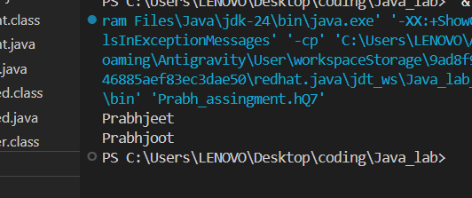
Prabhjeet
Prabhjoot

Q8 – Trim Whitespace
public class hQ8 {
public static void main(String args[]) {
System.out.println("Prabhjeet");
String name = " Prabhjeet ";
System.out.println(name.trim());
}
}

Expected Output:
Prabhjeet
Prabhjeet

Q9 – Reverse a String (Manual)
public class hQ9 {
public static void main(String args[]) {
System.out.println("Prabhjeet");
String name = "Prabhjeet", rev = "";
for (int i = name.length()-1; i >= 0; i--) {
rev = rev + name.charAt(i);
}
System.out.println("Reverse: " + rev);
}
}

Expected Output: 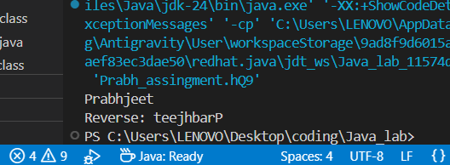
Prabhjeet
Reverse: teejhbarP

Q10 – Count Vowels
public class hQ10 {
public static void main(String args[]) {
System.out.println("Prabhjeet");
String name = "PrabhjeetSingh"; int count = 0;
for (int i = 0; i < name.length(); i++) {
char c = Character.toLowerCase(name.charAt(i));
if (c=='a'||c=='e'||c=='i'||c=='o'||c=='u') count++;
}
System.out.println("Vowels: " + count);
}
}

Expected Output: 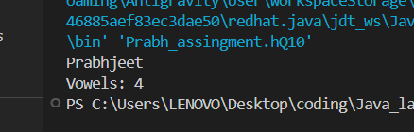
Prabhjeet
Vowels: 4

Q11 – Palindrome Check
public class hQ11 {
public static void main(String args[]) {
System.out.println("Prabhjeet");
String name = "madam", rev = "";
for (int i = name.length()-1; i >= 0; i--) rev += name.charAt(i);
System.out.println(name.equals(rev) ? "Palindrome" : "Not Palindrome");
}
}
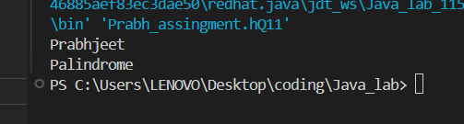
Expected Output:
Prabhjeet
Palindrome

Q12 – Count Words in a Sentence
public class hQ12 {
public static void main(String args[]) {
System.out.println("Prabhjeet");
String sentence = "Prabhjeet is learning Java";
String words[] = sentence.split(" ");
System.out.println("Words: " + words.length);
}
}

Expected Output: 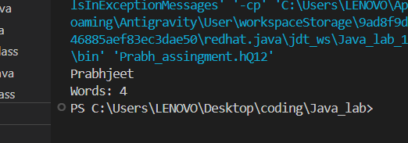
Prabhjeet
Words: 4

Q13 – Duplicate Characters
public class hQ13 {
public static void main(String args[]) {
System.out.println("Prabhjeet");
String name = "PrabhjeetSingh";
for (int i = 0; i < name.length(); i++) {
int count = 1;
for (int j = i+1; j < name.length(); j++)
if (name.charAt(i) == name.charAt(j)) count++;
if (count > 1) System.out.println(name.charAt(i) + " -> " + count + " times");
}
}
}

Expected Output: 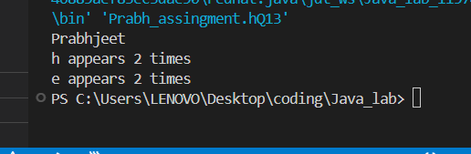
Prabhjeet
h -> 2 times
e -> 2 times

Q14 – new vs valueOf (Wrapper Classes)
public class hQ14 {
public static void main(String args[]) {
System.out.println("Prabhjeet");
Integer a = new Integer(10);
Integer b = new Integer(10);
Integer c = Integer.valueOf(10);
Integer d = Integer.valueOf(10);
System.out.println(a == b); // false — different heap objects
System.out.println(c == d); // true — cached Integer pool (-128 to 127)
}
}

Expected Output: 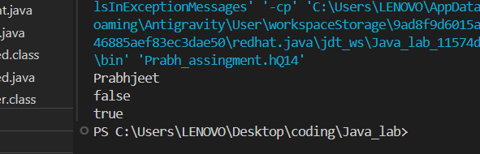
Prabhjeet
false
true

Assignment C – Thread Questions (iQ1–iQ6)
This assignment covers six key Java thread methods implemented in the ithread package.

Q1 – Thread.sleep()
Demonstrates a loop that pauses execution for 1 second between iterations using Thread.sleep(), simulating timed outputs.
package ithread;
public class iQ1 {
public static void main(String[] args) throws Exception {
System.out.println("Name: Prabhjeet");
for (int i = 1; i <= 3; i++) {
System.out.println(i);
Thread.sleep(1000); // Pause for 1 second
}
}
}

Expected Output: 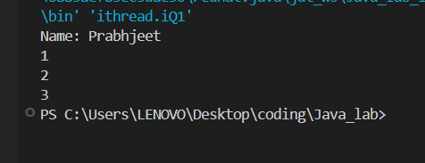
Name: Prabhjeet
1 (pause 1s)
2 (pause 1s)
3

Q2 – setName() & getName()
Demonstrates setting and retrieving a thread's name using setName() and Thread.currentThread().getName().
package ithread;
class NameDemo extends Thread {
public void run() { System.out.println(Thread.currentThread().getName()); }
}
public class iQ2 {
public static void main(String[] args) {
System.out.println("Name: Prabhjeet");
NameDemo t = new NameDemo();
t.setName("Thread-1");
t.start();
}
}

Expected Output: 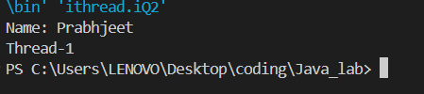
Name: Prabhjeet
Thread-1

Q3 – join() Method
Demonstrates the join() method, which causes the main thread to wait until the child thread completes before continuing.
package ithread;
class JoinDemo extends Thread {
public void run() {
for (int i=1;i<=3;i++) System.out.println("Child " + i);
}
}
public class iQ3 {
public static void main(String[] args) throws Exception {
System.out.println("Name: Prabhjeet");
JoinDemo t = new JoinDemo();
t.start();
t.join(); // Main waits here until t finishes
for (int i=1;i<=3;i++) System.out.println("Main " + i);
}
}

Expected Output: 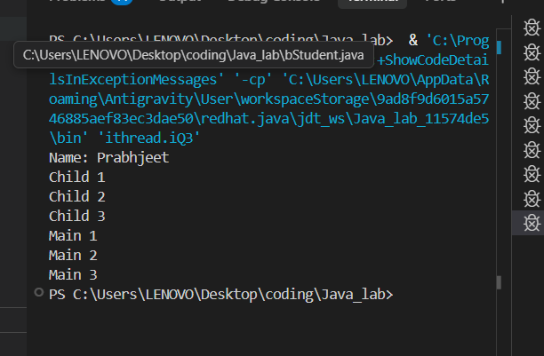
Name: Prabhjeet
Child 1
Child 2
Child 3
Main 1
Main 2
Main 3

Q4 – setPriority() & getPriority()
Demonstrates thread priority. The JVM scheduler gives preference to higher-priority threads, though the actual order of execution is not strictly guaranteed.
package ithread;
class PriorityDemo extends Thread {
public void run() { System.out.println(Thread.currentThread().getPriority()); }
}
public class iQ4 {
public static void main(String[] args) {
System.out.println("Name: Prabhjeet");
PriorityDemo t1 = new PriorityDemo();
PriorityDemo t2 = new PriorityDemo();
t1.setPriority(Thread.MIN_PRIORITY); // 1
t2.setPriority(Thread.MAX_PRIORITY); // 10
t1.start(); t2.start();
}
}

Expected Output: 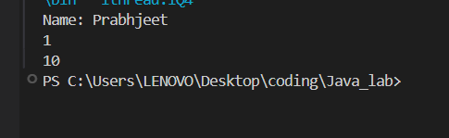
Name: Prabhjeet
10 (t2 likely runs first)
1

Q5 – isAlive() Method
Demonstrates isAlive(), which returns true if the thread has been started and has not yet terminated.
package ithread;
class AliveDemo extends Thread {
public void run() { System.out.println("Running"); }
}
public class iQ5 {
public static void main(String[] args) {
System.out.println("Name: Prabhjeet");
AliveDemo t = new AliveDemo();
System.out.println(t.isAlive()); // false — not started yet
t.start();
System.out.println(t.isAlive()); // true — started but may not be done
}
}

Expected Output: 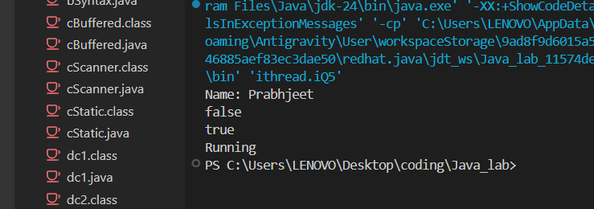
Name: Prabhjeet
false
true

Q6 – Synchronized Method
Demonstrates thread synchronization. The synchronized keyword on the print() method ensures that only one thread can execute it at a time, preventing interleaved output.
package ithread;
class SyncDemo {
synchronized void print() {
for (int i=1;i<=3;i++) System.out.println(i);
}
}
class T1 extends Thread { SyncDemo s; T1(SyncDemo s){this.s=s;} public void run(){s.print();}}
class T2 extends Thread { SyncDemo s; T2(SyncDemo s){this.s=s;} public void run(){s.print();}}
public class iQ6 {
public static void main(String[] args) {
System.out.println("Name: Prabhjeet");
SyncDemo s = new SyncDemo();
new T1(s).start();
new T2(s).start();
}
}

Expected Output: 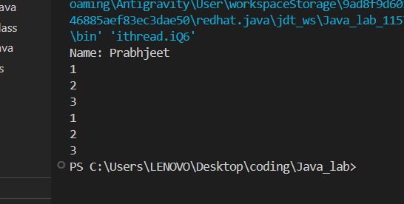
Name: Prabhjeet
1
2
3
1
2
3

Assignment D – Collections Assignment (jAssignment.java)
This assignment consolidates five collection framework questions into a single, menu-driven Java program in the jcollection package. The user selects a question at runtime, and the appropriate collection implementation is executed via a switch statement.

Questions Covered
- Q1 – HashSet: Stores elements and removes duplicates. Displays unordered, unique elements.
- Q2 – TreeSet: Stores numbers and displays them automatically in sorted (ascending) order.
- Q3 – PriorityQueue: Inserts and retrieves elements based on natural ordering priority.
- Q4 – HashMap: Stores and displays key-value pairs. Key order is not guaranteed.
- Q5 – LinkedHashMap: Stores elements and preserves insertion order upon retrieval.

package jcollection;
import java.util.*;

public class jAssignment {
public static void main(String[] args) {
Scanner sc = new Scanner(System.in);
System.out.println("Name: Prabhjeet");
System.out.println("-------------------------");
System.out.println("Select a question (1-5):");
System.out.println("1: HashSet 2: TreeSet 3: PriorityQueue");
System.out.println("4: HashMap 5: LinkedHashMap");
int choice = sc.hasNextInt() ? sc.nextInt() : 0;
switch (choice) {
case 1: runQ1(); break;
case 2: runQ2(); break;
case 3: runQ3(); break;
case 4: runQ4(); break;
case 5: runQ5(); break;
default: System.out.println("Invalid choice.");
}
sc.close();
}

static void runQ1() {
HashSet<String> set = new HashSet<>();
set.add("Prabhjeet"); set.add("Java"); set.add("Prabhjeet");
System.out.println("HashSet (no duplicates): " + set);
}
static void runQ2() {
TreeSet<Integer> ts = new TreeSet<>();
ts.add(30); ts.add(10); ts.add(20);
System.out.println("TreeSet (sorted): " + ts);
}
static void runQ3() {
PriorityQueue<Integer> pq = new PriorityQueue<>();
pq.offer(30); pq.offer(10); pq.offer(20);
System.out.println("PriorityQueue head: " + pq.peek());
System.out.println("All: " + pq);
}
static void runQ4() {
HashMap<String, Integer> map = new HashMap<>();
map.put("Prabhjeet", 590013286); map.put("Java", 2024);
System.out.println("HashMap: " + map);
}
static void runQ5() {
LinkedHashMap<String, Integer> lhm = new LinkedHashMap<>();
lhm.put("First", 1); lhm.put("Second", 2); lhm.put("Third", 3);
System.out.println("LinkedHashMap (insertion order): " + lhm);
}
}

Sample Outputs by Choice:
Choice 1: HashSet (no duplicates): [Java, Prabhjeet]
Choice 2: TreeSet (sorted): [10, 20, 30]
Choice 3: PriorityQueue head: 10
Choice 4: HashMap: {Prabhjeet=590013286, Java=2024}
Choice 5: LinkedHashMap (insertion order): {First=1, Second=2, Third=3}
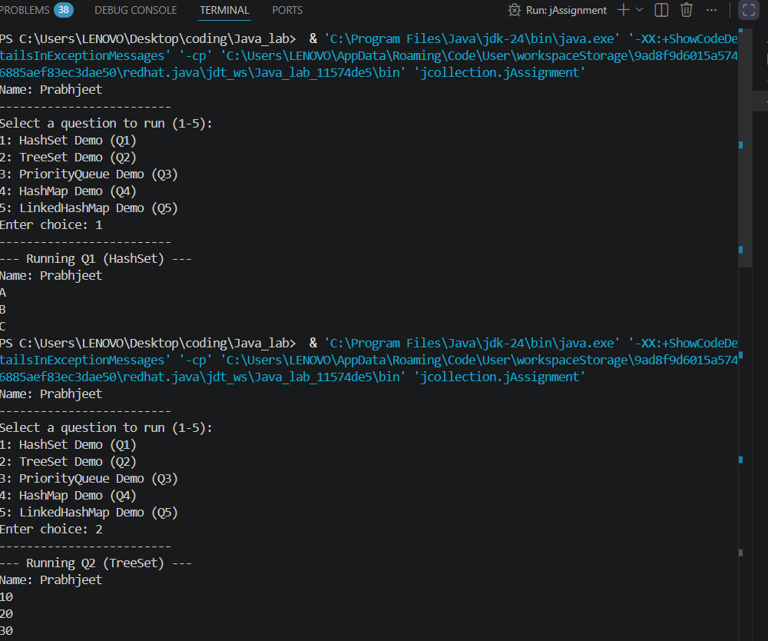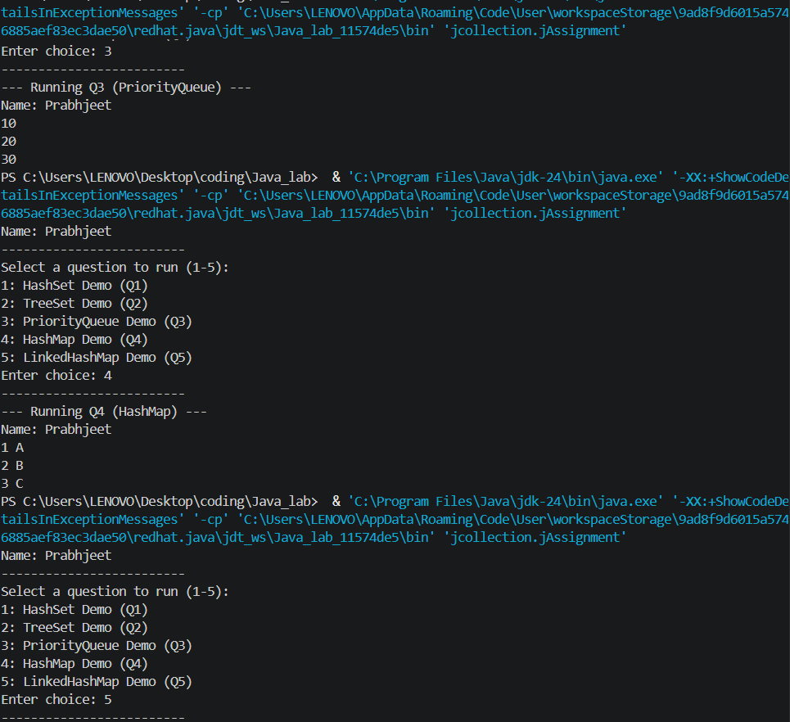

Assignment E – JDBC CRUD Operations
This assignment implements the five fundamental database operations (Create Table, Insert, Retrieve, Update, Delete) using JDBC with MySQL. Each program follows the six-step JDBC connection model.

Q1 – Create Table
Establishes a JDBC connection and creates the Staff table with emp_id, emp_name, and emp_salary columns using executeUpdate() with a DDL query.
import java.sql.*;
public class CreateStaff {
public static void main(String[] args) {
System.out.println("Name: Prabhjeet");
String url = "jdbc:mysql://localhost:3306/Class1";
String user = "root";
String pass = "Prabhjeet00";
try {
Class.forName("com.mysql.cj.jdbc.Driver");
Connection con = DriverManager.getConnection(url, user, pass);
System.out.println("-> Connection Established!");
Statement stmt = con.createStatement();
String sql = "CREATE TABLE IF NOT EXISTS Staff (" +
"emp_id INT PRIMARY KEY, " +
"emp_name VARCHAR(50), emp_salary DOUBLE)";
stmt.executeUpdate(sql);
System.out.println("-> Staff table created successfully.");
con.close();
} catch (Exception ex) { System.out.println(ex.getMessage()); }
}
}

Expected Output:
Name: Prabhjeet
-> Connection Established!
-> Staff table created successfully.

Q2 – Insert Data
Inserts three staff records using a PreparedStatement for type-safe, injection-resistant parameterised queries.
import java.sql.*;
public class InsertStaff {
public static void main(String[] args) {
System.out.println("Name: Prabhjeet");
try {
Class.forName("com.mysql.cj.jdbc.Driver");
Connection con = DriverManager.getConnection(
"jdbc:mysql://localhost:3306/Class1", "root", "Prabhjeet00");
String q = "INSERT INTO Staff VALUES (?, ?, ?)";
PreparedStatement ps = con.prepareStatement(q);
ps.setInt(1,101); ps.setString(2,"Rahul Singh"); ps.setDouble(3,25500); ps.executeUpdate();
ps.setInt(1,102); ps.setString(2,"Amit Sharma"); ps.setDouble(3,30500); ps.executeUpdate();
ps.setInt(1,103); ps.setString(2,"Neha Gupta"); ps.setDouble(3,40500); ps.executeUpdate();
System.out.println("-> Records inserted successfully!");
con.close();
} catch (Exception ex) { System.out.println(ex.getMessage()); }
}
}

Expected Output: 
Name: Prabhjeet
-> Records inserted successfully!

Q3 – Retrieve Data
Uses a SELECT query and iterates over a ResultSet to display all staff records.
import java.sql.*;
public class RetrieveStaff {
public static void main(String[] args) {
System.out.println("Name: Prabhjeet");
try {
Class.forName("com.mysql.cj.jdbc.Driver");
Connection con = DriverManager.getConnection(
"jdbc:mysql://localhost:3306/Class1", "root", "Prabhjeet00");
ResultSet rs = con.createStatement().executeQuery("SELECT * FROM Staff");
System.out.println("--- Staff Details ---");
while (rs.next()) {
System.out.println("ID: " + rs.getInt("emp_id") +
" | Name: " + rs.getString("emp_name") +
" | Salary: Rs." + rs.getDouble("emp_salary"));
}
con.close();
} catch (Exception ex) { System.out.println(ex.getMessage()); }
}
}

Expected Output: 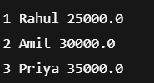
Name: Prabhjeet
--- Staff Details ---
ID: 101 | Name: Rahul| Salary: Rs.25000.0
ID: 102 | Name: Amit| Salary: Rs.30000.0
ID: 103 | Name: Priya | Salary: Rs.35000.0

Q4 – Update Record
Updates the salary of a specific employee identified by emp_id using a PreparedStatement.
import java.sql.*;
public class UpdateStaff {
public static void main(String[] args) {
System.out.println("Name: Prabhjeet");
try {
Class.forName("com.mysql.cj.jdbc.Driver");
Connection con = DriverManager.getConnection(
"jdbc:mysql://localhost:3306/Class1", "root", "Prabhjeet00");
String sql = "UPDATE Staff SET emp_salary = ? WHERE emp_id = ?";
PreparedStatement ps = con.prepareStatement(sql);
ps.setDouble(1, 55000.00);
ps.setInt(2, 101);
int rows = ps.executeUpdate();
System.out.println("-> " + rows + " record(s) updated.");
con.close();
} catch (Exception ex) { System.out.println(ex.getMessage()); }
}
}

Expected Output: 
Name: Prabhjeet
-> 1 record(s) updated.

Q5 – Delete Record
Deletes a specific staff record from the database using a DELETE SQL statement.
import java.sql.*;
public class DeleteStaff {
public static void main(String[] args) {
System.out.println("Name: Prabhjeet");
try {
Class.forName("com.mysql.cj.jdbc.Driver");
Connection con = DriverManager.getConnection(
"jdbc:mysql://localhost:3306/Class1", "root", "Prabhjeet00");
int removeId = 102;
int rows = con.createStatement().executeUpdate(
"DELETE FROM Staff WHERE emp_id = " + removeId);
System.out.println("-> " + rows + " record(s) deleted.");
con.close();
} catch (Exception ex) { System.out.println(ex.getMessage()); }
}
}

Expected Output: 
Name: Prabhjeet
-> 1 record(s) deleted.

Assignment F – Servlet Assignment (6 Tasks)
This assignment covers six key Servlet programming tasks, demonstrating the full spectrum of Java Servlet capabilities from basic request handling to session and cookie management.

Task 1 – Setup
If JDK is already installed, download and install Apache Tomcat from https://tomcat.apache.org. Start the server and verify it is running by navigating to http://localhost:8080 in a browser.

Task 2 – Basic Servlet (Hello Student)
Create a servlet that responds to a GET request and displays the student's name using the doGet() method.
import java.io.*;
import javax.servlet.*;
import javax.servlet.http.*;

public class HelloServlet extends HttpServlet {
public void doGet(HttpServletRequest req, HttpServletResponse res)
throws ServletException, IOException {
PrintWriter out = res.getWriter();
out.println("Hello, Prabhjeet Singh!");
}
}

Task 3 – Form Handling (doPost)
An HTML form collects name and age. The servlet reads the submitted data using req.getParameter() and echoes it back to the browser.
HTML Form:
<form action="UserFormServlet" method="post">
Name: <input type="text" name="username"><br>
Age: <input type="text" name="userage"><br>
<input type="submit" value="Submit">
</form>

Servlet Code:
public class UserFormServlet extends HttpServlet {
public void doPost(HttpServletRequest req, HttpServletResponse res)
throws ServletException, IOException {
String name = req.getParameter("username");
String age = req.getParameter("userage");
PrintWriter out = res.getWriter();
out.println("Student Name: " + name);
out.println("<br>Student Age: " + age);
}
}

Task 4 – Servlet Configuration (Init & Context Parameters)
Reads one init parameter and one context parameter from web.xml.
web.xml:
<web-app>
<servlet>
<servlet-name>MyConfigServlet</servlet-name>
<servlet-class>MyConfigServlet</servlet-class>
<init-param>
<param-name>institute</param-name>
<param-value>UPES Dehradun</param-value>
</init-param>
</servlet>
<context-param>
<param-name>program</param-name>
<param-value>B.Tech CSE</param-value>
</context-param>
</web-app>

Servlet Code:
public class MyConfigServlet extends HttpServlet {
public void doGet(HttpServletRequest req, HttpServletResponse res)
throws IOException {
PrintWriter out = res.getWriter();
out.println("Institute: " + getServletConfig().getInitParameter("institute"));
out.println("<br>Program: " + getServletContext().getInitParameter("program"));
}
}

Browser Output:
Institute: UPES Dehradun
Program: B.Tech CSE

Task 5 – Session Management
SessionStart stores the username in an HTTP session and redirects to SessionDisplay, which reads and displays it.
// SessionStart.java
public class SessionStart extends HttpServlet {
public void doGet(HttpServletRequest req, HttpServletResponse res) throws IOException {
HttpSession session = req.getSession();
session.setAttribute("user", "Prabhjeet");
res.sendRedirect("SessionDisplay");
}
}

// SessionDisplay.java
public class SessionDisplay extends HttpServlet {
public void doGet(HttpServletRequest req, HttpServletResponse res) throws IOException {
HttpSession session = req.getSession();
String user = (String) session.getAttribute("user");
res.getWriter().println("Welcome, " + user);
}
}

Browser Output:
Welcome, Prabhjeet

Task 6 – Cookie Handling
Creates a cookie containing the username, sends it to the browser, then reads it back from subsequent requests and displays the logged-in user.
public class UserCookieServlet extends HttpServlet {
public void doGet(HttpServletRequest req, HttpServletResponse res) throws IOException {
PrintWriter out = res.getWriter();
Cookie c = new Cookie("username", "Prabhjeet");
res.addCookie(c);
Cookie[] cookies = req.getCookies();
if (cookies != null) {
for (Cookie ck : cookies) {
if (ck.getName().equals("username")) {
out.println("Logged-in User: " + ck.getValue());
}
}
}
}
}

Browser Output:
Logged-in User: Prabhjeet

