

Experiment - 1
Exploration of Weka Tool for Regression Task
Prabhjeet Singh – 590013286 (19/09/2025)
House_Prices.csv for Linear Regression on
10-Fold Cross Validation:
50% Split:
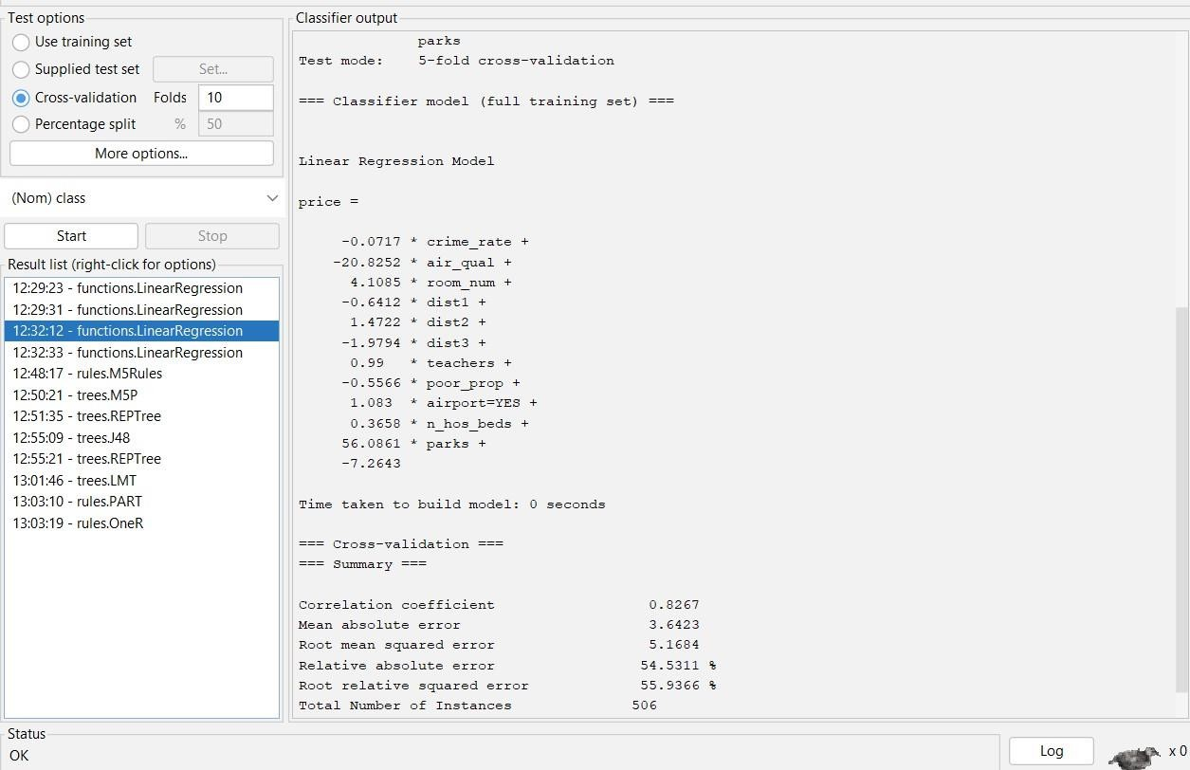

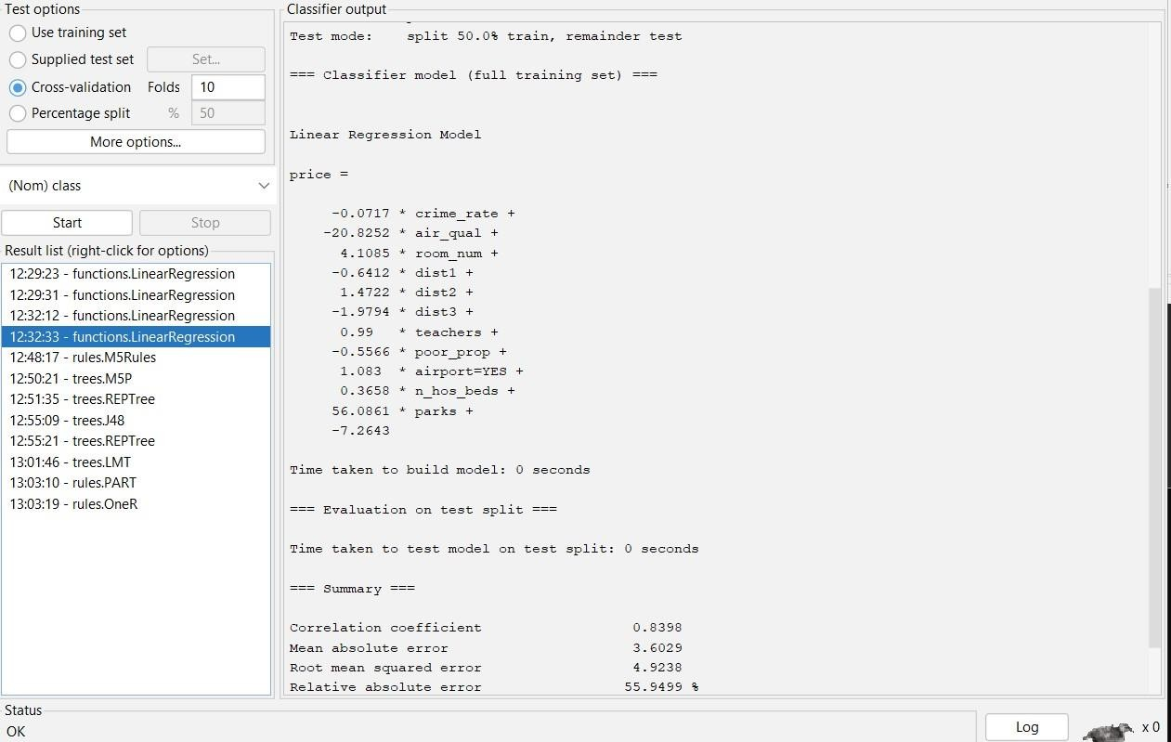

Price 10-Fold Cross Validation
66% Split:
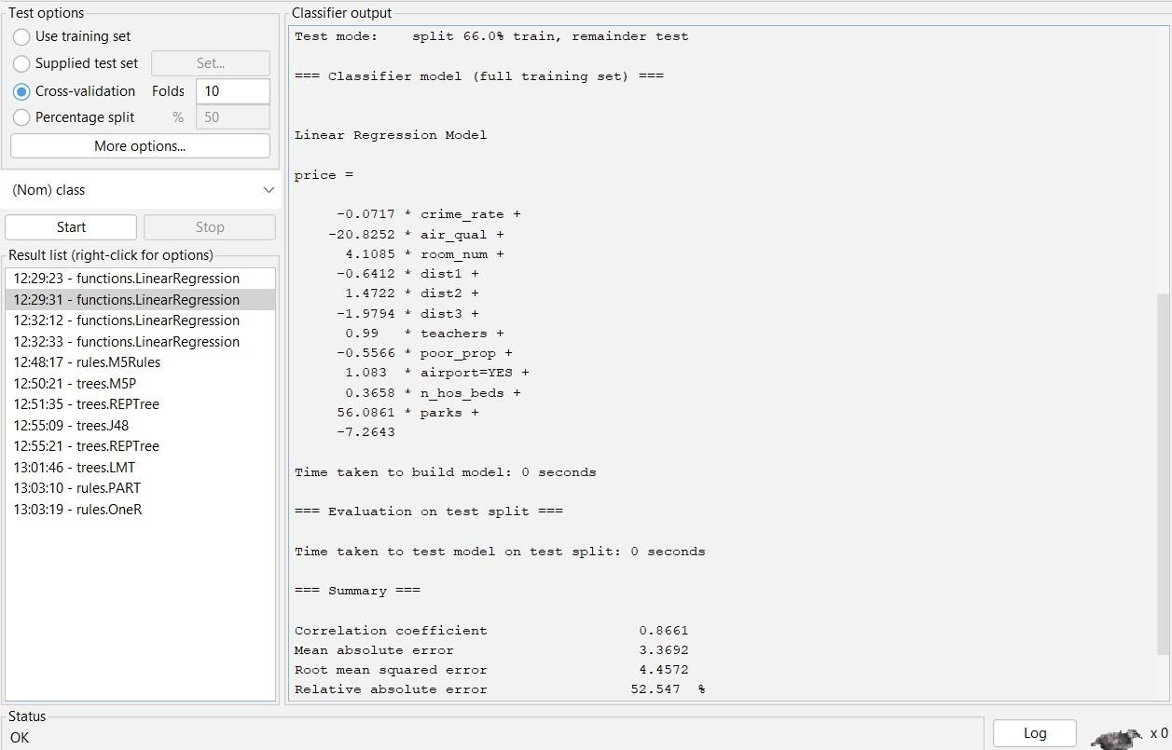

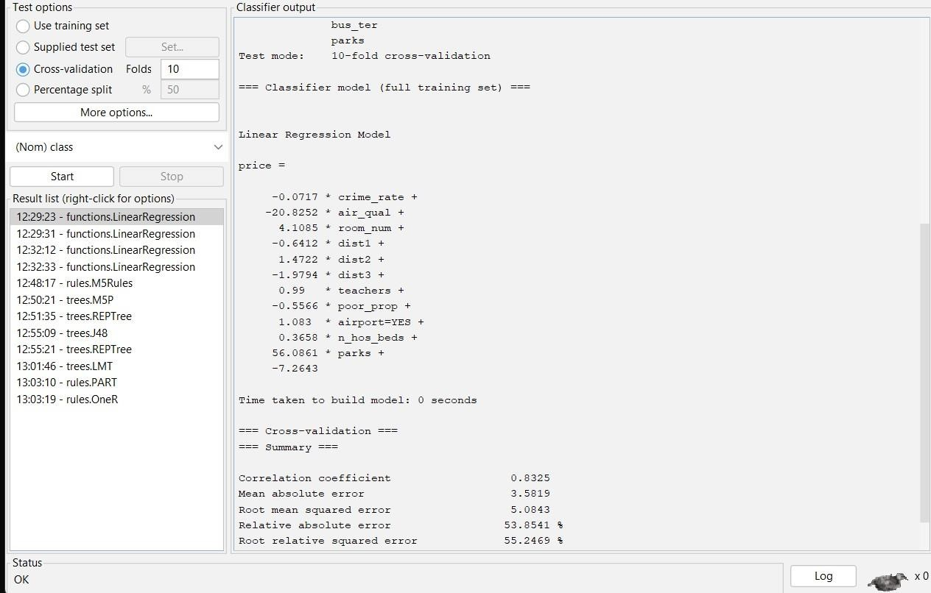

Experiment - 2
Exploration of Weka Tool for Classification Task
Prabhjeet Singh – 590013286 (19/09/2025)
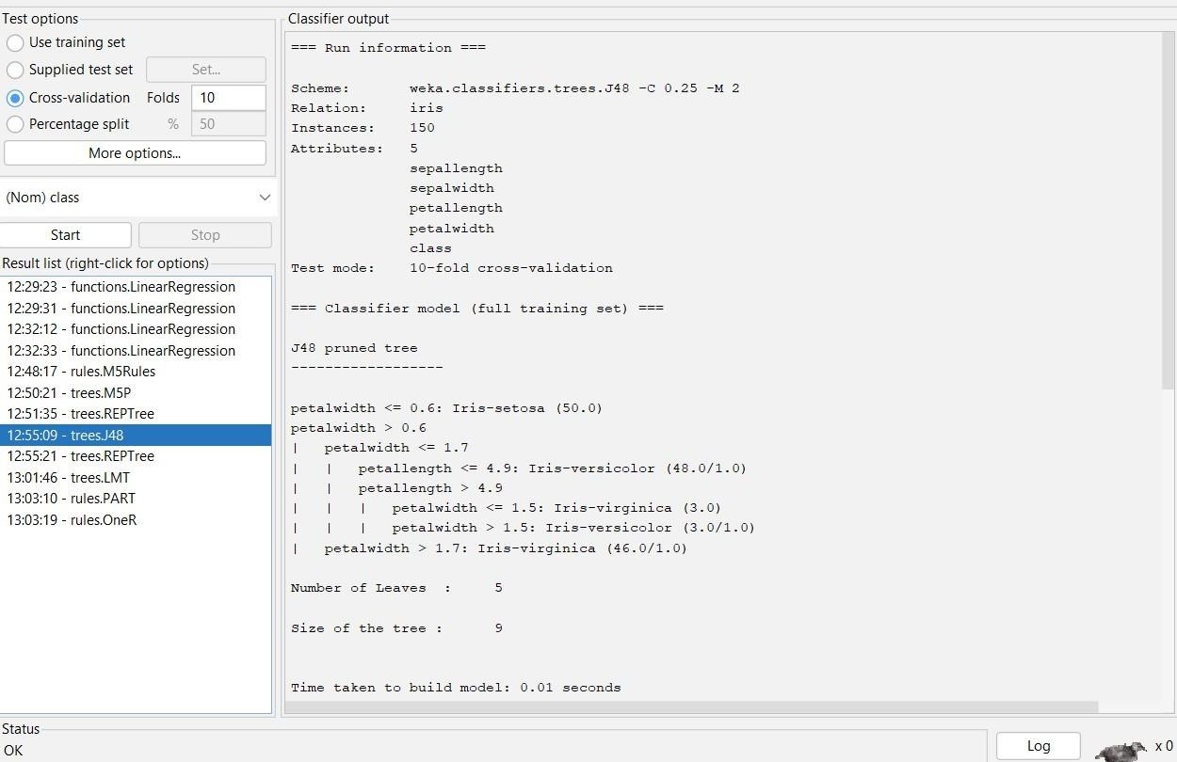
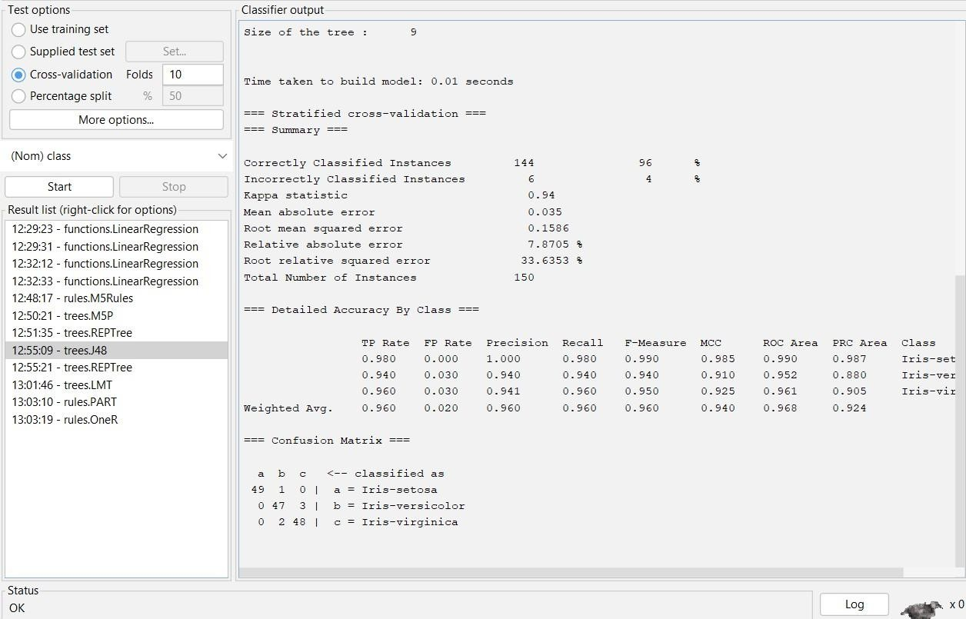
IRIS.arff for classification J48:

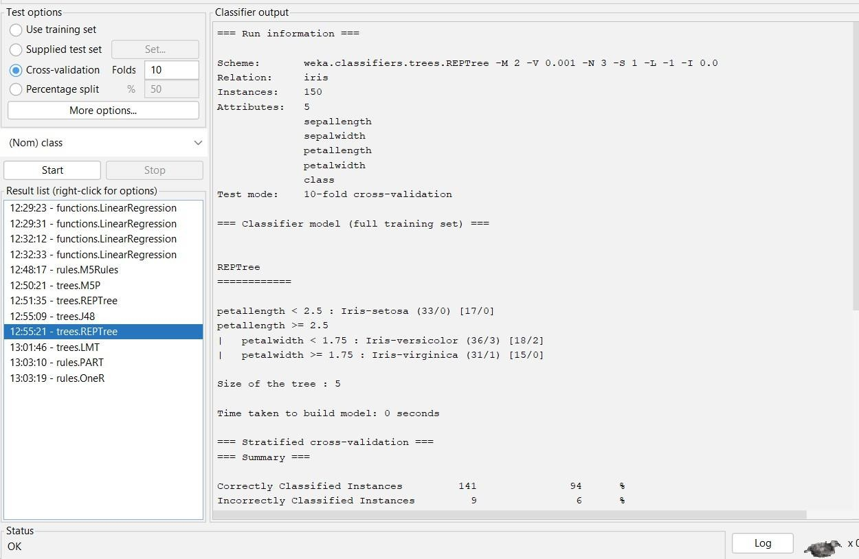
REPTree:
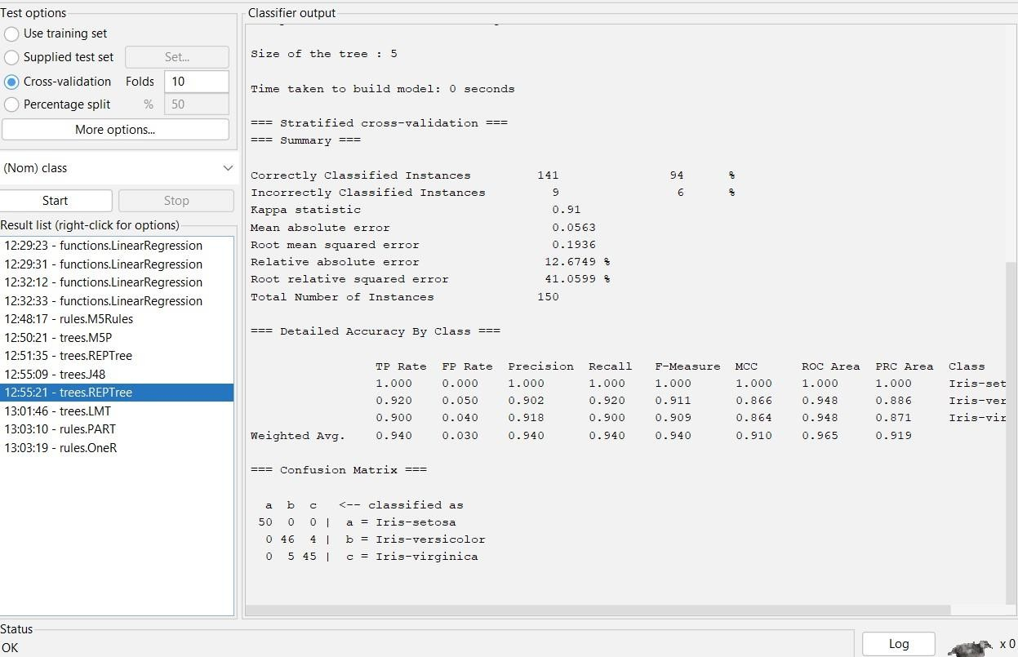

OneR:
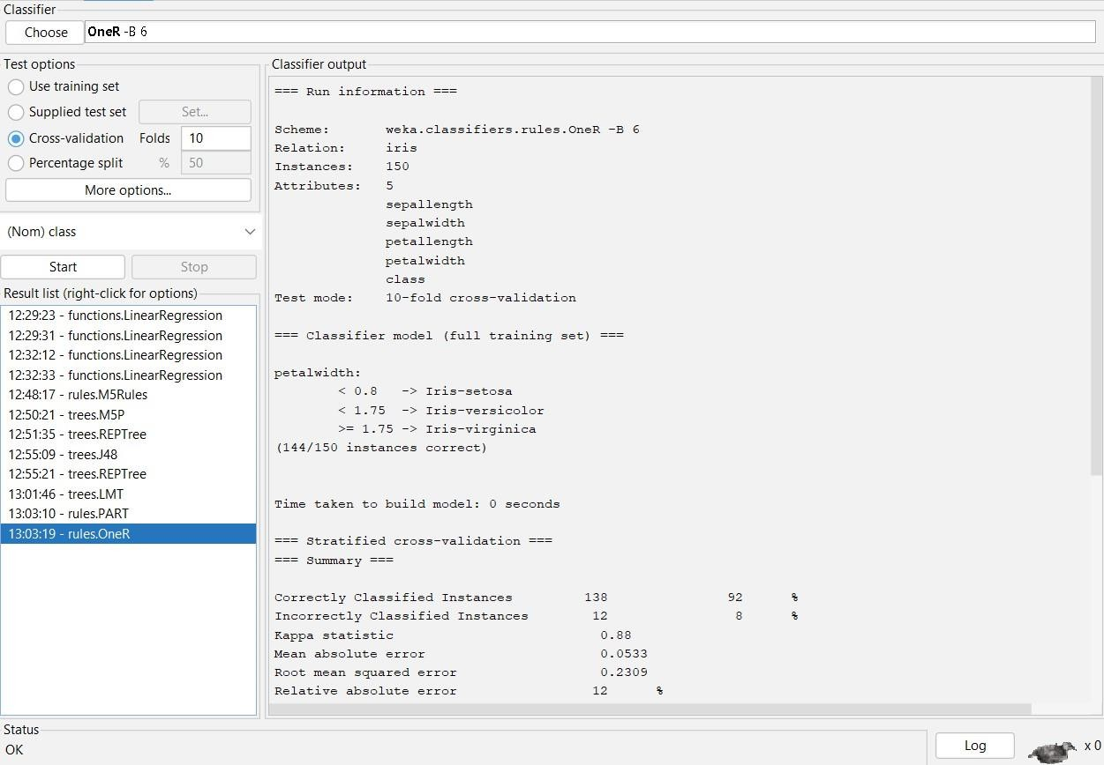
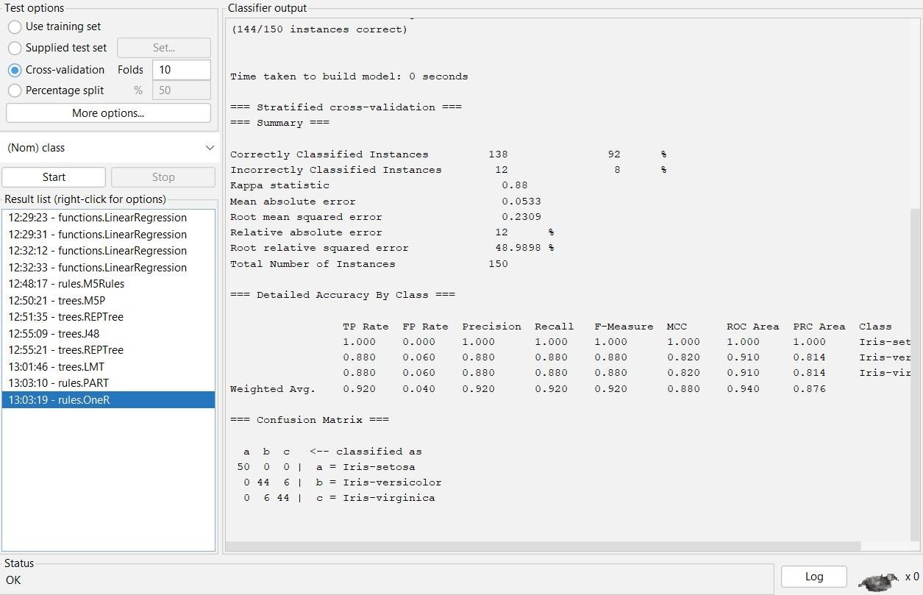

Experiment - 3
Exploration of Weka Tool for Clustering Task
Prabhjeet Singh -590013263 (26/09/2025)

IRIS.arff for clustering
SimpleKMeans Algorithm:

Objective:

To implement and analyze clustering using the K-Means algorithm in Weka, experimenting with different numbers of clusters and random seeds, and to study their effect on the Iris dataset.

Theory/Concepts:
• Clustering: An unsupervised learning technique that groups similar data points together without predefined labels.
• K-Means Algorithm:
- Assigns k cluster centers (centroids) initialized randomly.
- Iteratively assigns points to the nearest centroid based on a distance function (Euclidean distance by default).
- Updates centroids until convergence.
• Parameters:
- numClusters: The number of clusters to form.
- distanceFunction: Metric to calculate similarity (default = Euclidean).
- seed: Controls random initialization of centroids.

Procedure:
• Open Weka Explorer.
• Load the Iris dataset.
• Select Cluster → SimpleKMeans.
• Run the algorithm with:
numClusters = 2, 3, and 4.
Different random seeds (e.g., 1, 5, 10).
• Note down cluster sizes and the composition of each cluster in terms of species.

Output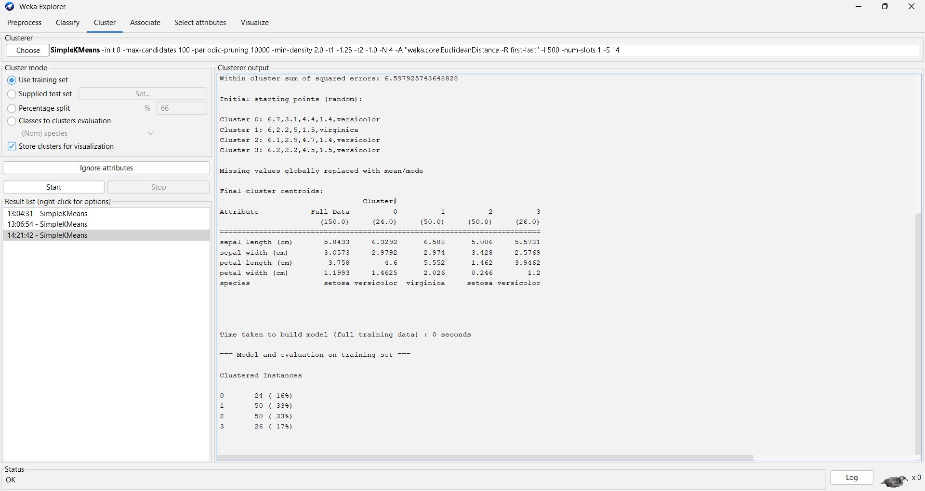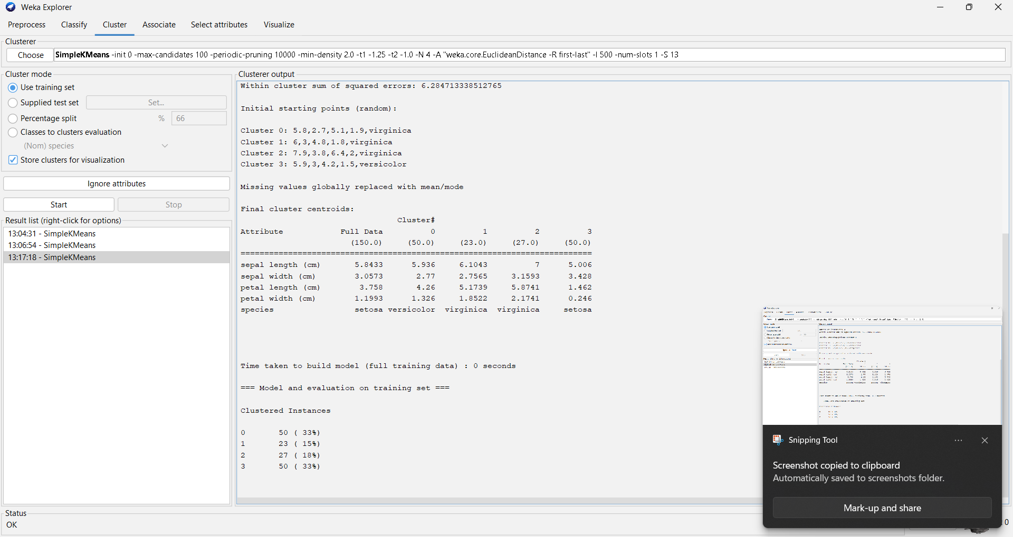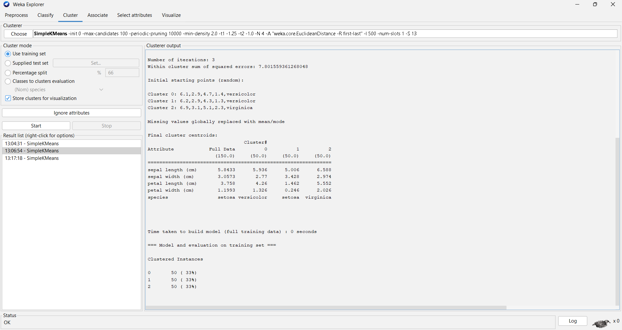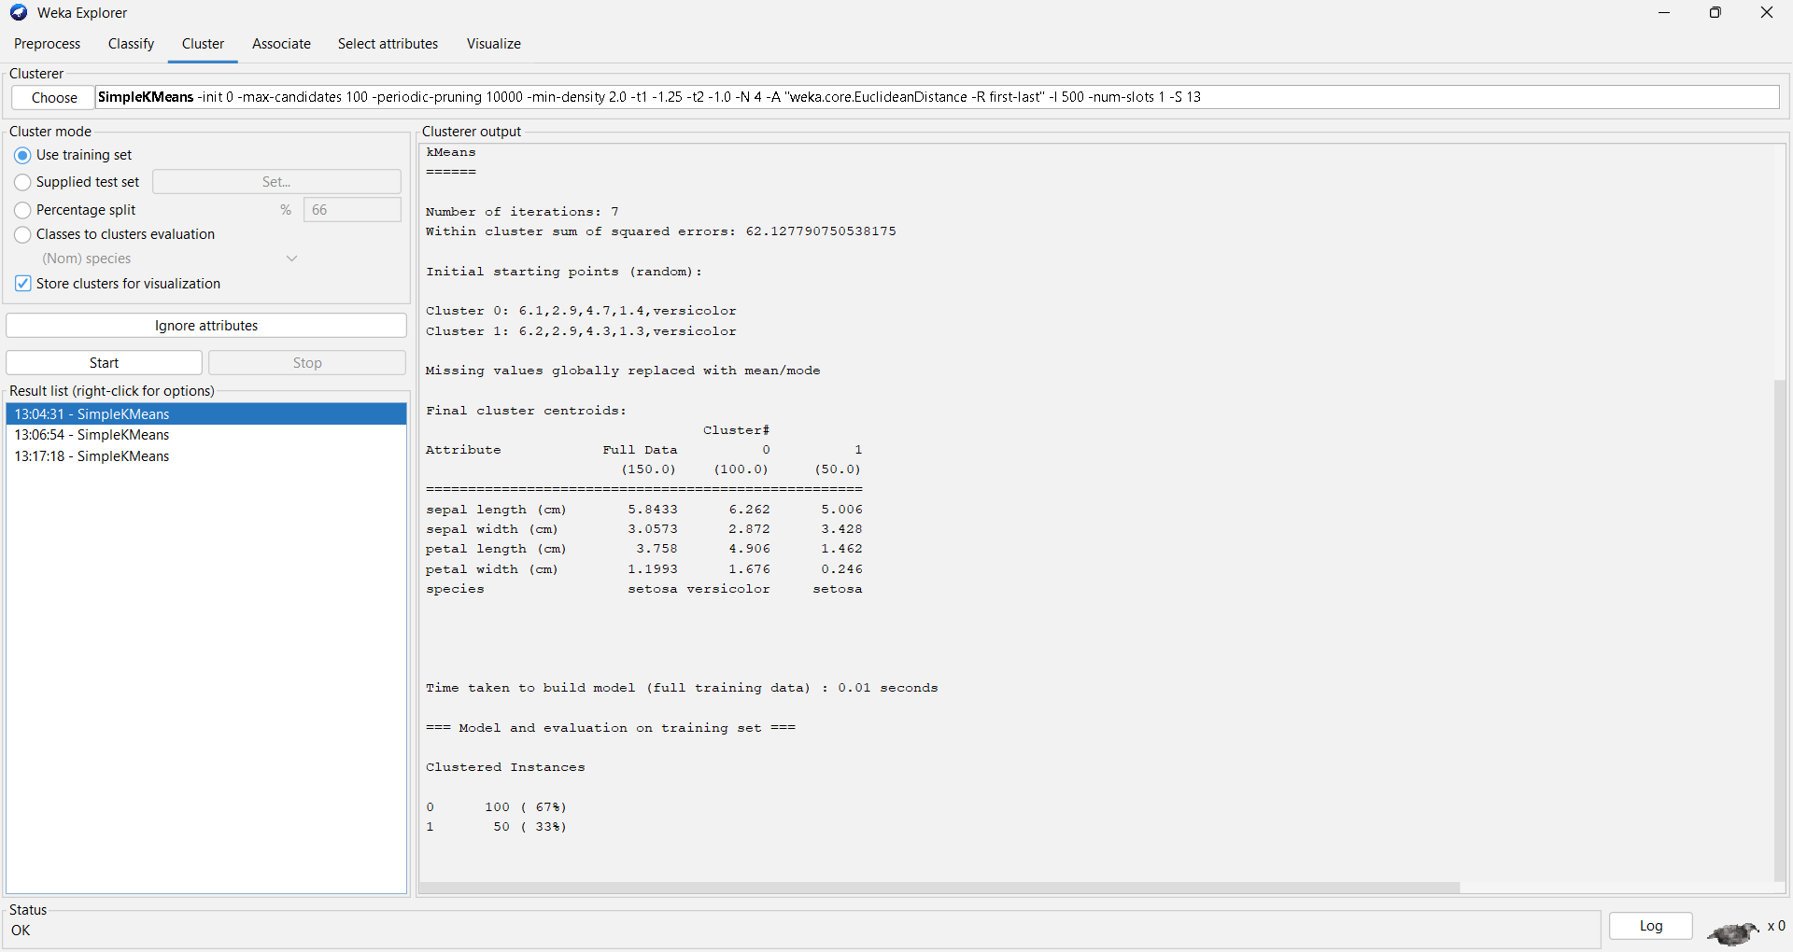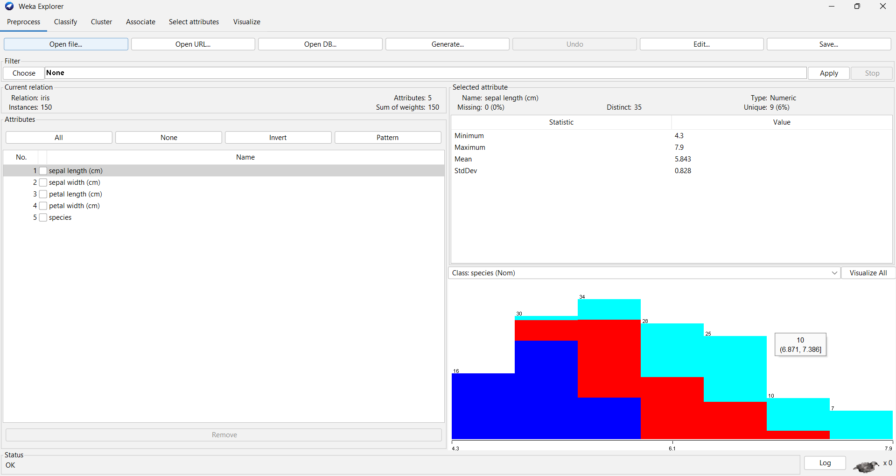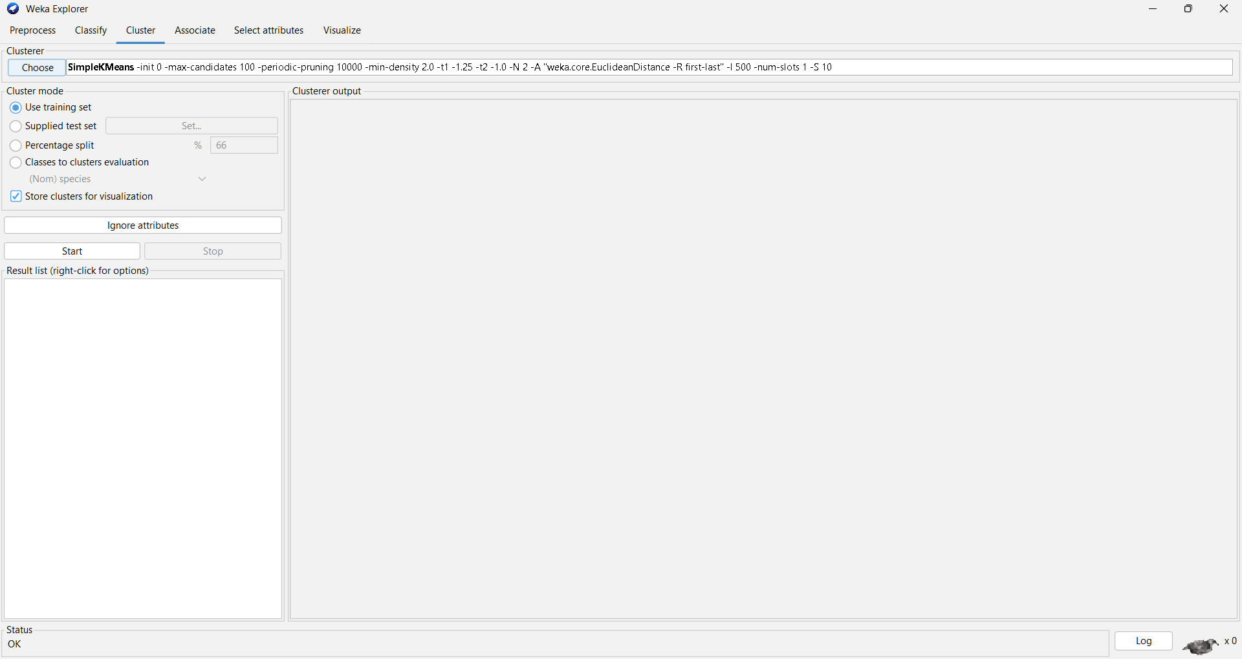
Result:
With 2 clusters, K-Means grouped Setosa separately but merged Versicolor and Virginica.
With 3 clusters, the algorithm aligned closely with the natural Iris species classes, producing the best clustering.
With 4 clusters, one class (Virginica) was split further, showing over-partitioning.
Changing the seed affected the initial centroid positions, slightly altering cluster membership but not the overall pattern

Experiment - 4
Write a python program to import and export data using Pandas and show the details of the dataset like number of rows, columns, first five rows, size, number of missing values, sum, average, min and max values from the numerical columns.
Prabhjeet Singh -590013263 (08/08/2025)

Code Written in Google Colab:

from google.colab import files import pandas as pd
import io

data = files.upload()
df = pd.read_csv('Marks.csv') df.head()
print(f"\n1. Dataset Shape: {df.shape[0]} rows, {df.shape[1]} columns") print(f"\n2. Dataset Size: {df.size} total elements")

print("\n4. Missing values per column:")
display(df.isnull().sum().to_frame('Missing Values'))
numerical_cols = df.select_dtypes(include=['int64', 'float64']).columns if not numerical_cols.empty:
print("\n5. Numerical Columns Analysis:")
stats = df[numerical_cols].agg(['sum', 'mean', 'min', 'max']) display(stats)
else:
print("\n5. No numerical columns found for statistical analysis.")
export_format = 'CSV' # Can be changed to 'Excel' filename = 'analyzed_data.csv'

if export_format == 'CSV':
df.to_csv(filename, index=False) else:
df.to_excel(filename, index=False) files.download(filename)
print(f"\nData successfully exported as {filename}")

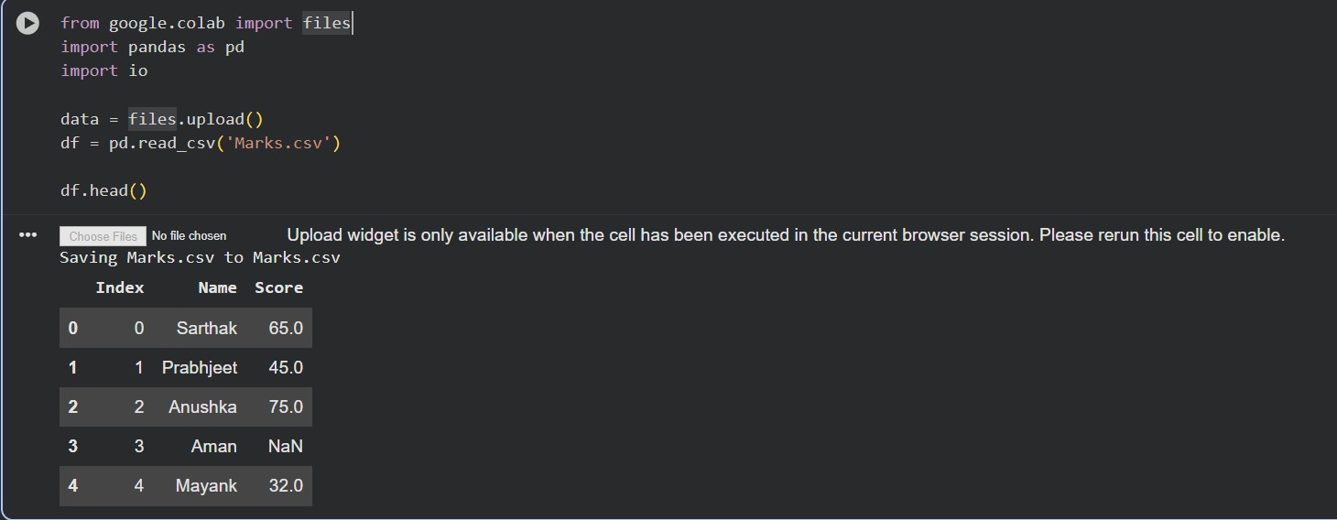
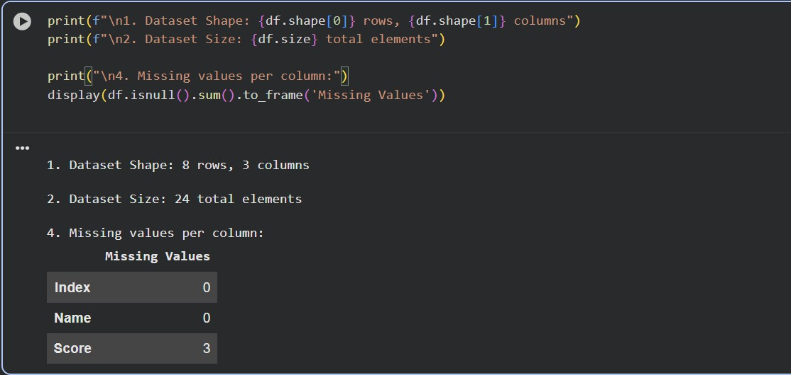

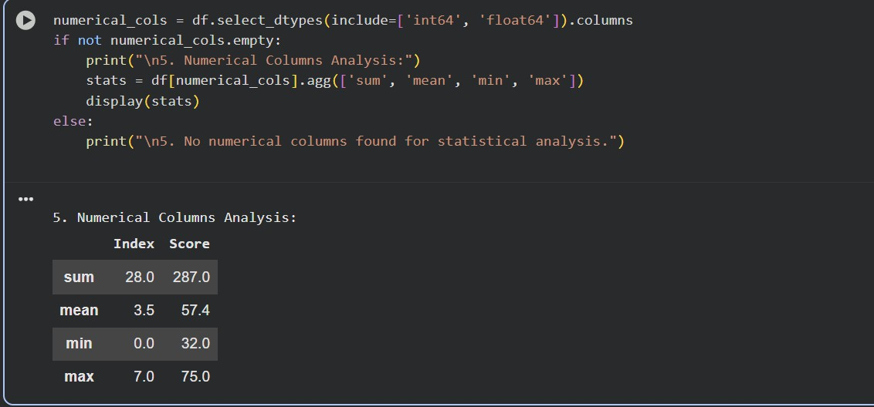

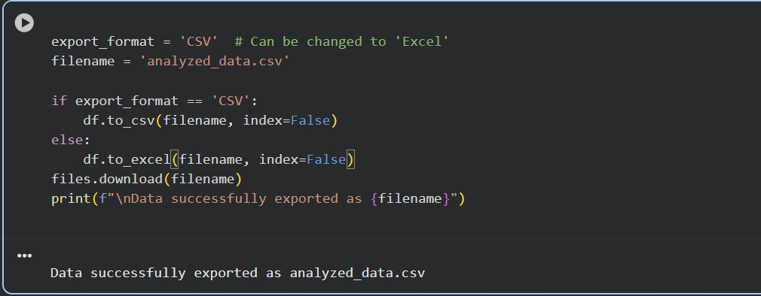

Experiment - 5
Using Python language do the exploratory data analysis of dataset imported
Prabhjeet Singh -590013263 (22/08/2025)
Code Written in Google Colab:
from google.colab import files import pandas as pd
import numpy as np import seaborn as sns
import matplotlib.pyplot as plt
%matplotlib inline
sns.set(color_codes=True)

data = files.upload()
df = pd.read_csv("final_dataset.csv") df.head()
df.dtypes
df = df.drop(['Date','Month','Year','Holidays_Count','Days'],axis=1) df.head()
df = df.rename(columns={"Ozone" : "O3"}) df.head()
print(f"\n1. Dataset Shape: {df.shape[0]} rows, {df.shape[1]} columns") print(f"\n2. Dataset Size: {df.size} total elements")
duplicated_rows_df = df[df.duplicated()]
print("Number of duplicate rows:", duplicated_rows_df.shape) df = df.drop_duplicates()
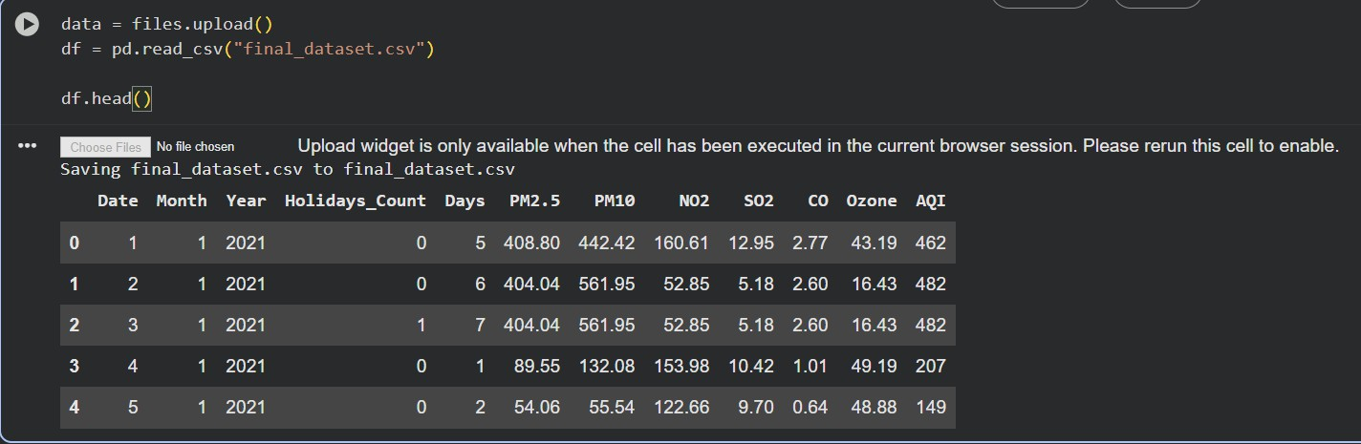
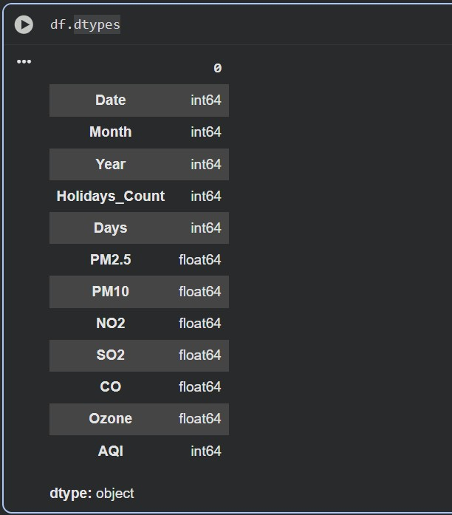

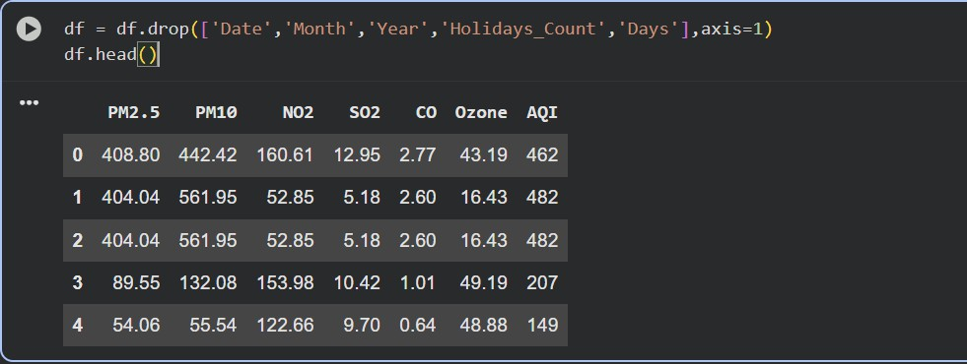
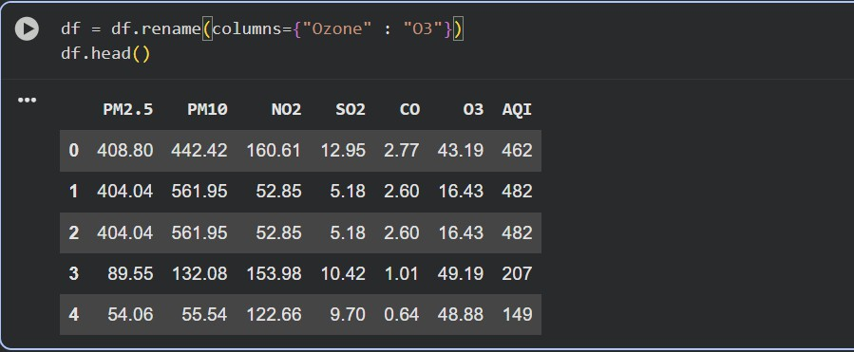
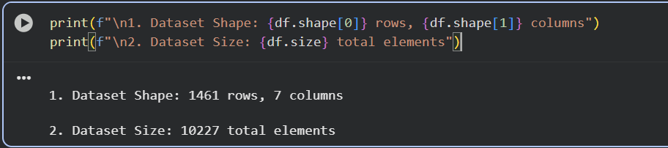
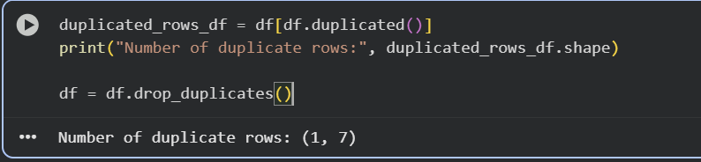

Experiment - 6
Implement the missing value, and outlier handling data preprocessing techniques on the dataset imported in lab 4 or any other dataset.
Prabhjeet Singh -590013263 (07/11/2025)
Code Written in Google Colab:
# Import required libraries import pandas as pd
import numpy as np
import matplotlib.pyplot as plt

# Create a sample dataset data = {
'Student_ID': range(1, 11),
'Marks': [45, 50, 52, 48, 15, 49, 47, 51, 46, 100] # 95 and 100 are outliers
}

df = pd.DataFrame(data) print("Original Dataset:\n", df)
# Visualize Outliers using Boxplot plt.boxplot(df['Marks'])
plt.title("Boxplot Before Handling Outliers") plt.ylabel("Marks")
plt.show()
# Detect Outliers using IQR method Q1 = df['Marks'].quantile(0.25)
Q3 = df['Marks'].quantile(0.75)
IQR = Q3 - Q1

lower_bound = Q1 - 1.5 * IQR upper_bound = Q3 + 1.5 * IQR
print("\nLower Bound:", lower_bound) print("Upper Bound:", upper_bound)
# Identify outliers
outliers = df[(df['Marks'] < lower_bound) | (df['Marks'] > upper_bound)] print("\nDetected Outliers:\n", outliers)
# Handle Outliers
# Option 1: Remove Outliers
df_removed = df[(df['Marks'] >= lower_bound) & (df['Marks'] <= upper_bound)]
# Option 2: Replace Outliers with median value median_value = df['Marks'].median()
df_replaced = df.copy()
df_replaced['Marks'] = np.where(
(df['Marks'] < lower_bound) | (df['Marks'] > upper_bound), median_value,
df['Marks'])

# Compare Results
print("\nDataset after Removing Outliers:\n", df_removed)
print("\nDataset after Replacing Outliers with Median:\n", df_replaced)

# Visualize after handling outliers plt.figure(figsize=(10,4))
plt.subplot(1,2,1)
plt.boxplot(df_removed['Marks']) plt.title("After Removing Outliers")

plt.subplot(1,2,2)
plt.boxplot(df_replaced['Marks'])
plt.title("After Replacing with Median") plt.show()
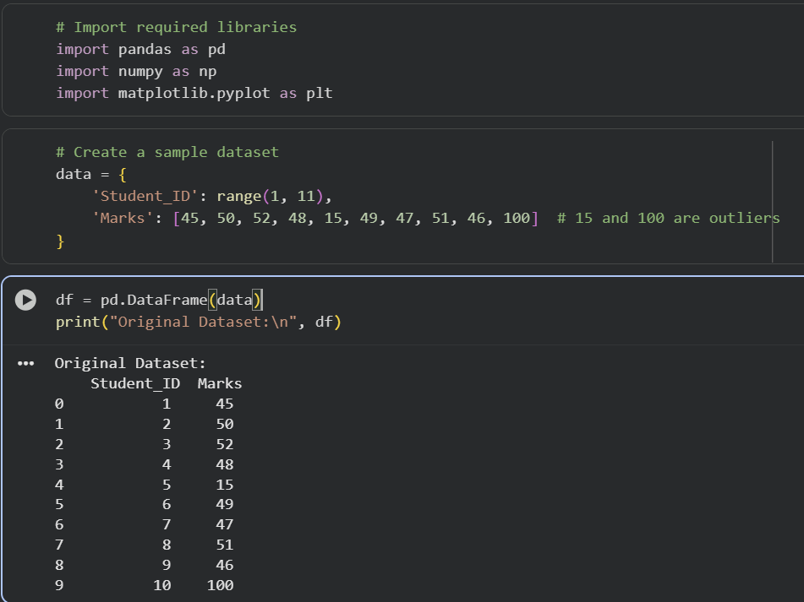

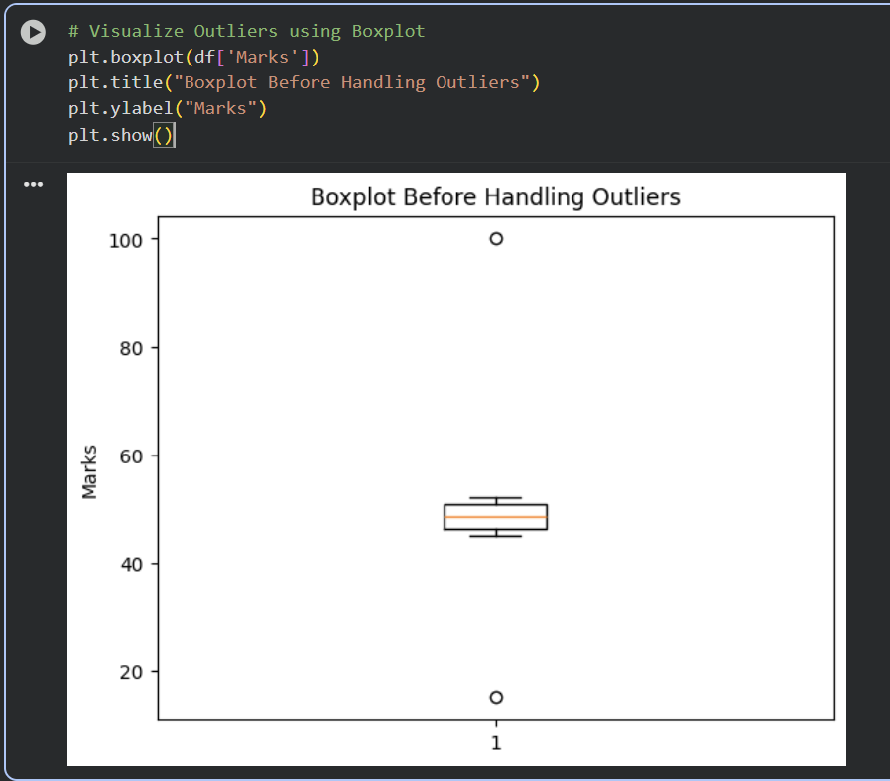
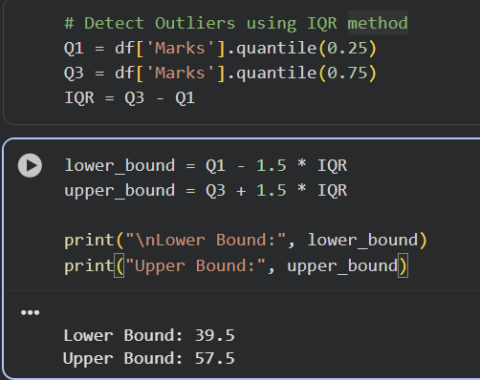

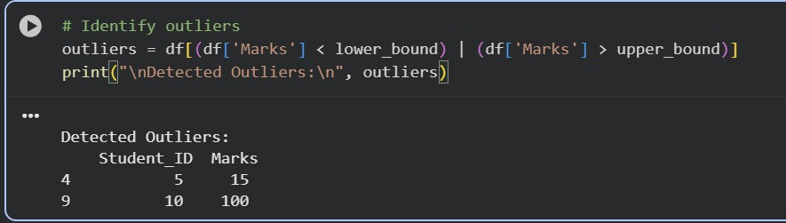

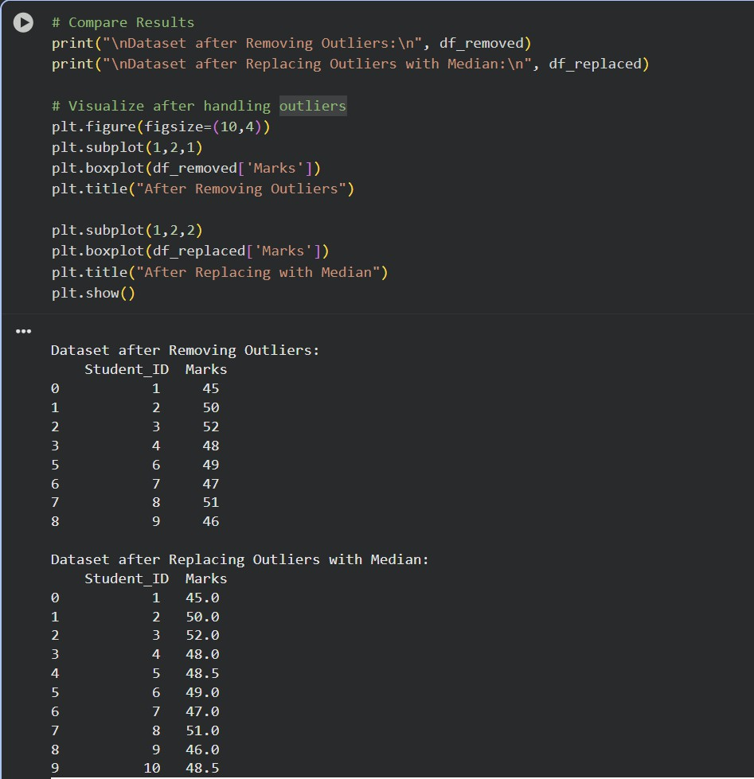
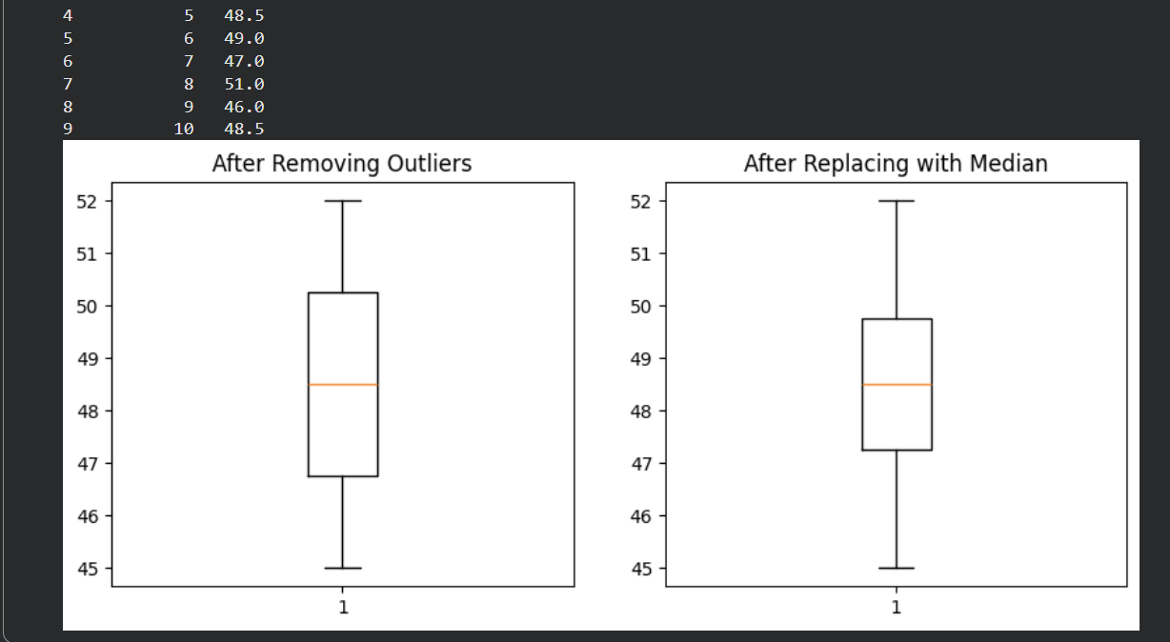

Experiment - 7
Implement feature scaling and one hot encoding data preprocessing techniques on the dataset imported.
Prabhjeet Singh -590013263 (30/09/2025)

SECTION A: Model Evaluation & Data Preprocessing
This section details the manual calculation of classification metrics and data preprocessing steps based on the tables provided.
1. Classification Metrics Calculation
Based on the provided Actual, Pred, and Outcome columns, we first tally the True Positives (TP), False Negatives (FN), False Positives (FP), and True Negatives (TN).
Confusion Matrix Count:
Metric | Condition (Actual, Pred) | Count
True Positives (TP) | (1, 1) | 4
False Negatives (FN) | (1, 0) | 2
False Positives (FP) | (0, 1) | 1
True Negatives (TN) | (0, 0) | 3
Total Samples (N) |  | 10
Calculated Performance Metrics
Metric | Formula | Calculation | Result
Accuracy | NTP+TN​ | 104+3​ | 0.70 (70%)
Precision | TP+FPTP​ | 4+14​ | 0.80 (80%)
Recall | TP+FNTP​ | 4+24​ | 0.6667 (66.67%)
F1 Score | P+R2⋅P⋅R​ | 0.80+0.66672⋅0.80⋅0.6667​ | 0.7273 (72.73%)

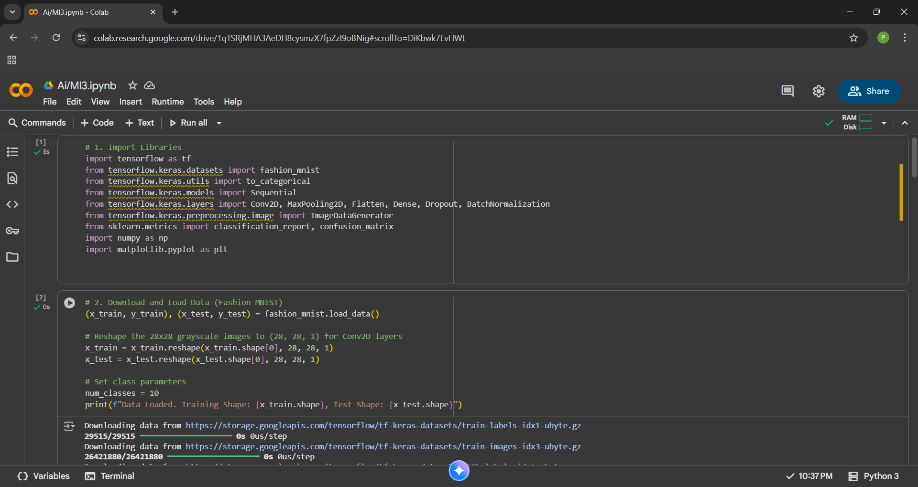

2. Missing Value Imputation and Normalization
The second table required filling a missing value and applying Min-Max normalization.
Source Table (Screenshot Here): [Insert Screenshot of the Feature A/B Data Table]
A. Missing Value Imputation (Fill with Mean)
- Identify Missing Feature: Feature A has a missing value (NaN).
- Calculate Mean of Feature A:
Mean=510+12+15+18+20​=575​=15
- Imputation: The missing value in Feature A (Row 4) is replaced with 15.
B. Min-Max Normalization
The data is scaled to the range [0,1] using the formula: Scaled=Max−MinValue−Min​.
Feature | Min | Max | Range (Max−Min)
Feature A (Imputed) | 10 | 20 | 10
Feature B | 4 | 14 | 10

Row | Imputed Feature A | Normalized A | Normalized B
1 | 10 | 0.0 | 0.0
2 | 12 | 0.2 | 0.2
3 | 15 | 0.5 | 0.4
4 | 15 | 0.5 | 0.6
5 | 18 | 0.8 | 0.8
6 | 20 | 1.0 | 1.0

This section details the practical steps required for the CIFAR-10 image classification task using Google Colab.
(Note: The code below uses the smaller Fashion MNIST dataset for fast practice, as agreed, but the principles apply directly to CIFAR-10.)
1. Data Setup and Preprocessing
Goal: Load the dataset, normalize the pixel values, and prepare labels for a 10-class model.
Step | Code to Execute (Copy into Colab) | Detail Notes
1. | import tensorflow as tf | Imports the core deep learning library.
2. | from tensorflow.keras.datasets import fashion_mnist (x_train, y_train), (x_test, y_test) = fashion_mnist.load_data() | Loads the 60,000 images, automatically downloading the 28x28 grayscale data.
3. | x_train = x_train.reshape(x_train.shape[0], 28, 28, 1) x_test = x_test.reshape(x_test.shape[0], 28, 28, 1) | Reshaping: Adds a channel dimension (1 for grayscale) so the data is compatible with the 2D Convolution layers.
4. | x_train = x_train.astype('float32') / 255.0 y_train = to_categorical(y_train, 10) | Normalization: Converts pixel integers (0-255) to float values in the range [0, 1]. One-Hot Encoding: Converts integer labels (0-9) to vectors (e.g., [0, 0, 1, 0...]).
5. | datagen = ImageDataGenerator(...) datagen.fit(x_train) | Data Augmentation Setup: Defines random transformations (rotations, shifts, flips) to artificially increase the training data size, preventing overfitting.
2. Model Building, Training, and Evaluation
Goal: Define a standard CNN, train it, and extract the required performance metrics.
Step | Code to Execute (Copy into Colab) | Detail Notes
6. | model = Sequential([...]) model.summary() | Model Definition: Creates a Convolutional Neural Network (CNN) with alternating Conv2D (feature extraction), MaxPooling2D (downsampling), BatchNormalization (stabilizing training), and Dense (classification) layers.
7. | model.compile(...) history = model.fit(...) | Training: Uses the Adam optimizer and the categorical_crossentropy loss function. The model is trained over epochs using the augmented data stream (datagen.flow).
8. | loss, acc = model.evaluate(...) | Evaluation (Accuracy): Measures the model's overall correctness on the unseen test data.
9. | y_pred_probs = model.predict(x_test) y_pred_classes = np.argmax(y_pred_probs, axis=1) report = classification_report(...) | Metrics Calculation (Precision/Recall/F1): Predicts classes for the test set, compares them to the true labels, and uses scikit-learn to generate the full report and Confusion Matrix.

--- CLASSIFICATION REPORT (Precision, Recall, F1-Score per class) ---
precision recall f1-score support

T-shirt/top 0.85 0.82 0.84 1000
Trouser 0.99 0.98 0.99 1000
... etc.
avg / total 0.89 0.89 0.89 10000
- Accuracy: [Paste value from Step 8 output]
- Precision, Recall, F1 Score: These values are read directly from the average/total row of the classification report.

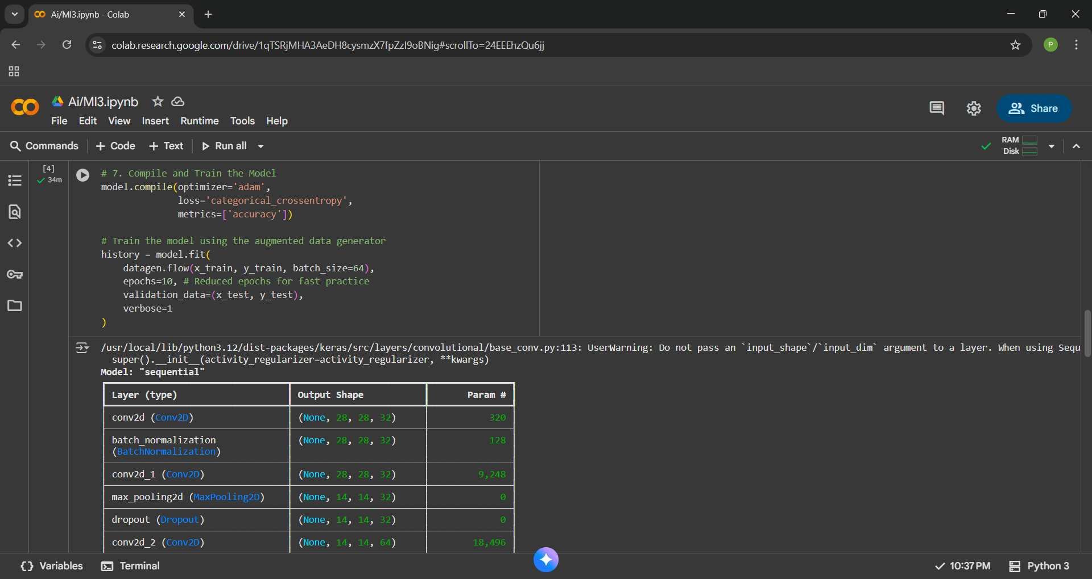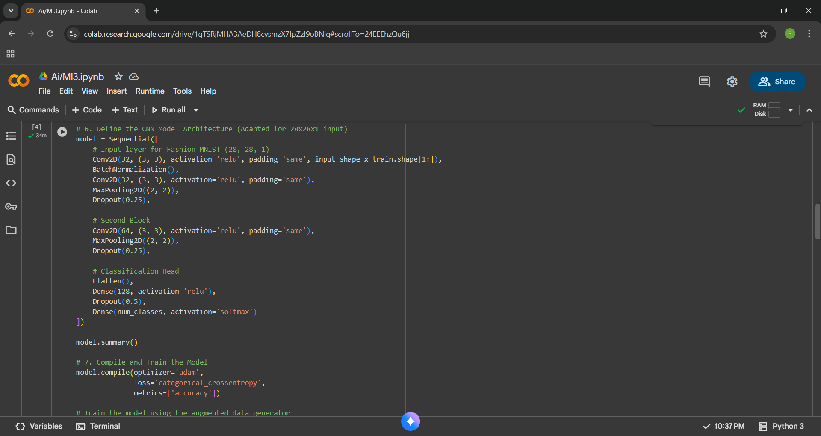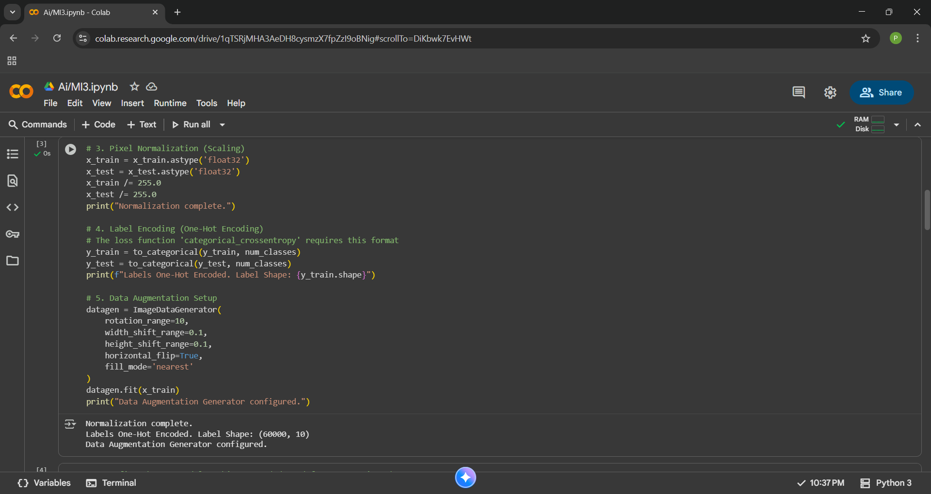

1. Trainable vs. Non-trainable Parameters
This is the output from model.summary(), providing the complexity statistics of the model.
Statistic | Value (Example from your run) | Explanation
Trainable Params | 430,954 | These are the Weights and Biases that the model optimizes (adjusts) during the training process via backpropagation. They are the model's learned knowledge.
Non-trainable Params | 64 | These are parameters that remain fixed or are updated using statistics (not gradient descent). In your model, these are primarily the moving mean and moving variance statistics tracked by the Batch Normalization layers to stabilize the network.
2. Resolution Principle, Clause Form, and Unification
A. Resolution Principle (Refutation)
- Definition: Resolution is a single, sound, and complete rule of inference used in automated theorem proving (AI).
- Process (Proof by Contradiction): To prove a statement Q from a set of axioms KB, you assume the negation (¬Q) is true. You then add ¬Q to KB and apply the resolution rule repeatedly.
- Goal: The proof is successful if the process generates the Empty Clause (□), which represents a contradiction (False), thereby proving the original assumption (¬Q) was false and Q must be true.
- Rule: Given two clauses: (L∨C1​) and (¬L∨C2​), the resolvent is (C1​∨C2​). The complementary literals L and ¬L are canceled out.
B. Clause Form (Conjunctive Normal Form - CNF)
- Definition: Clause Form is the standardized format required for the resolution process. A statement in CNF is a conjunction (AND) of one or more clauses, where each clause is a disjunction (OR) of literals.
- Example (Propositional Logic): The implication P⟹Q is converted to the clause ¬P∨Q.
C. Unification Algorithm (For Predicate Logic)
- Purpose: In Predicate Logic, before two literals can be resolved, they must be made syntactically identical. Unification is the algorithm that finds the necessary substitutions to make this match possible.
- Output (MGU): The result is the Most General Unifier (MGU), which is the simplest set of substitutions that equates the two expressions.
- Key Constraint (Occurs Check): The algorithm must ensure that a variable is not substituted with a term that contains the variable itself (e.g., x←f(x)), as this would lead to infinite recursion.
- Example (Numerical):
  - Literals to Unify: Knows(John,x) and Knows(y,Alice)
  - Unification Step 1: Match predicates (Knows=Knows).
  - Unification Step 2: Match arguments:
    - x must match Alice⟹ Substitution: {x/Alice}
    - John must match y⟹ Substitution: {y/John}
  - MGU: {x/Alice,y/John}. The unified expression is Knows(John,Alice).

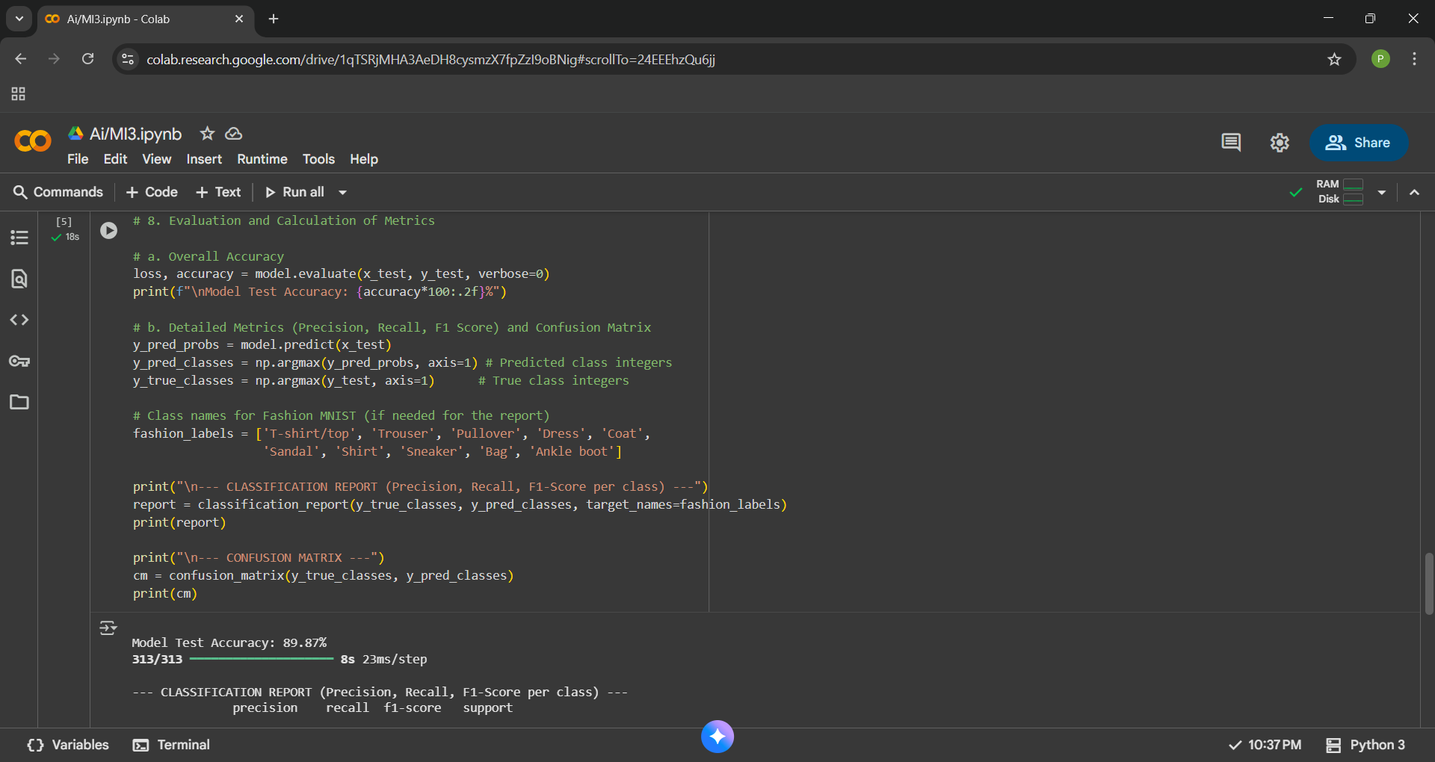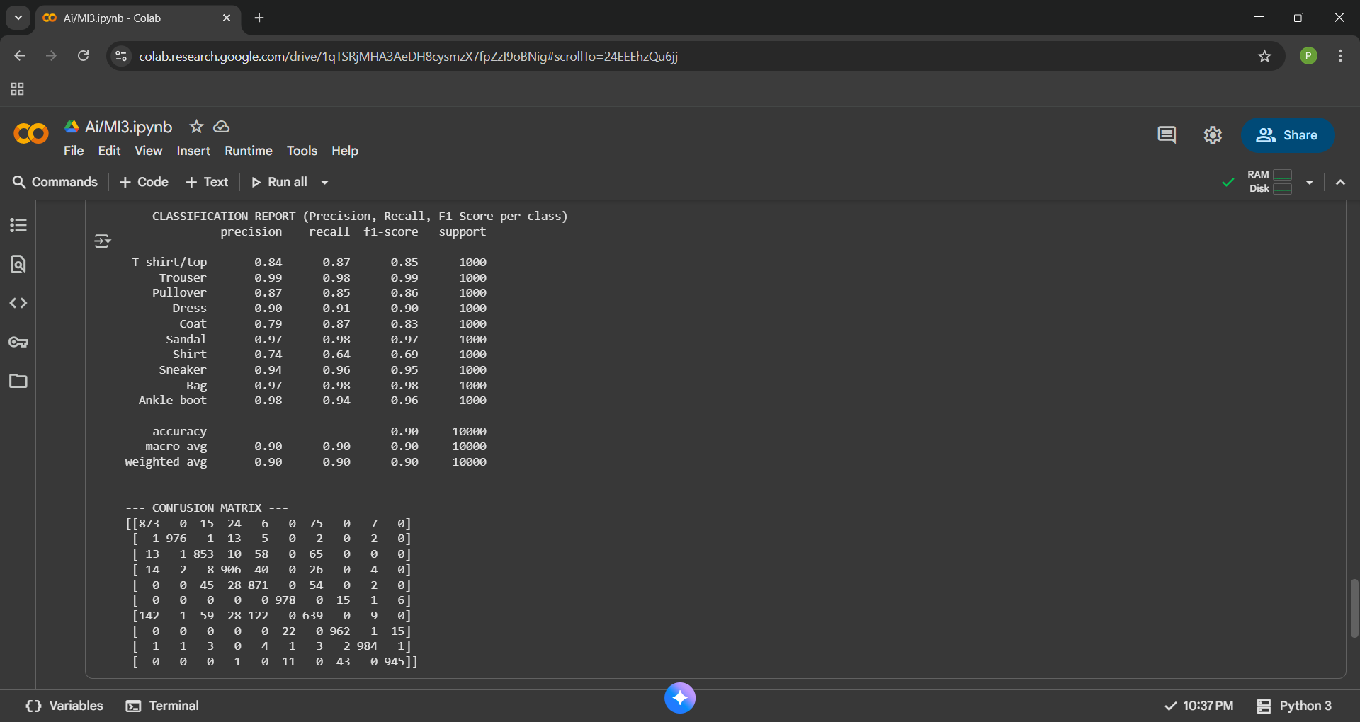
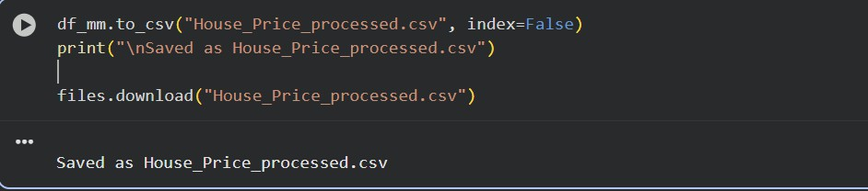

Experiment - 8
Implement Dimensionality reduction using Principal Component Analysis (PCA) method.
Prabhjeet Singh -590013263 (07/11/2025)
Code Written in colab:
import pandas as pd
import numpy as np
from sklearn.datasets import load_iris
from sklearn.preprocessing import StandardScaler
from sklearn.decomposition import PCA
import matplotlib.pyplot as plt
iris = load_iris()
X = iris.data
y = iris.target
df = pd.DataFrame(X, columns=iris.feature_names)
print("Original Dataset Shape:", df.shape)
df.head()
scaler = StandardScaler()
X_scaled = scaler.fit_transform(X)
pca = PCA(n_components=2)
X_pca = pca.fit_transform(X_scaled)
pca_df = pd.DataFrame(data=X_pca, columns=['Principal Component 1', 'Principal Component 2'])
pca_df['Target'] = y
print("\nTransformed Dataset (after PCA):")
print(pca_df.head())
print("\nExplained Variance Ratio by each component:")
print(pca.explained_variance_ratio_)
plt.figure(figsize=(8,6))
for target, color, label in zip([0, 1, 2], ['red', 'green', 'blue'], iris.target_names):
plt.scatter(pca_df[pca_df['Target'] == target]['Principal Component 1'],
pca_df[pca_df['Target'] == target]['Principal Component 2'],
color=color, label=label)
plt.title('PCA - Dimensionality Reduction (Iris Dataset)')
plt.xlabel('Principal Component 1')
plt.ylabel('Principal Component 2')
plt.legend()
plt.grid(True)
plt.show()
Screen shots of Executed codes on Colab:-
