

UNIVERSITY OF PETROLEUM & ENERGY STUDIES School of Computer Science
Dehradun

LAB FILE

Name :Prabhjeet Singh

SAP ID :590013286

Programme :BTECH-CSE

Course : DCN

Semester :4TH

Session :2

Batch :10

Faculty :Ayushi Malik

Faculty Signature:
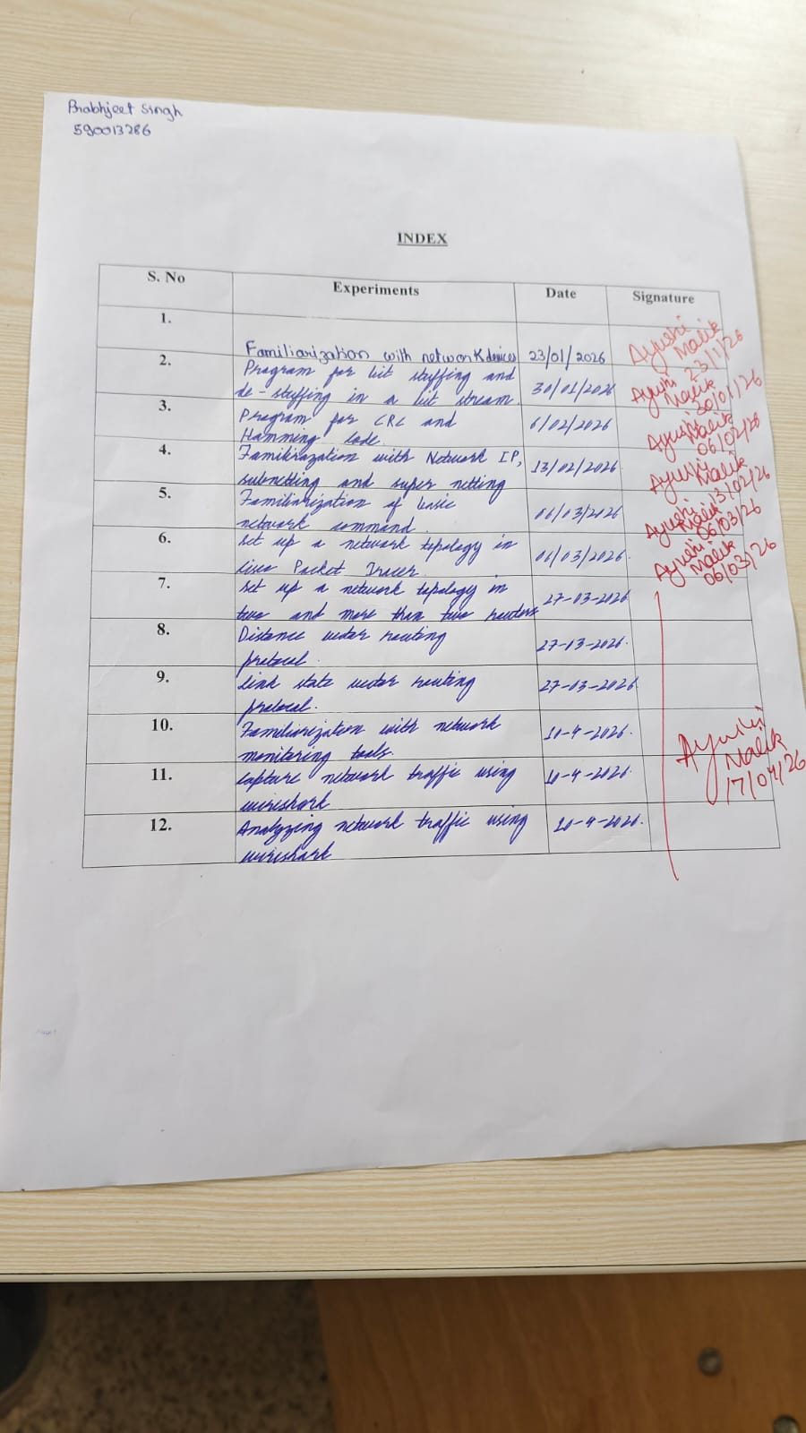
Experiment 1: Familiarization with networking devices

Definition of Network Devices
Network devices, also known as networking hardware, are physical components used to connect computers, servers, printers, and other electronic devices within a network to enable efficient and secure data communication. These devices form the backbone of data communication systems by transmitting, receiving, directing, and securing data. They act as the “plumbing” of the network, ensuring smooth data flow, signal amplification, traffic control, and overall network security.

Types of Network Devices
1. Hub
A hub is a basic networking device used to connect multiple computers within a network, and it operates at the Physical Layer of the OSI model. It is simple and easy to use, making it a low-cost option for small or basic networks. However, a hub broadcasts data to all connected devices, which causes unnecessary network traffic and makes it less secure and inefficient. Hubs commonly use a star topology to connect devices.
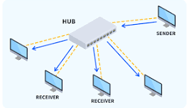
Fig1. Hub

2. Repeater
A repeater is a networking device used to regenerate and amplify weak signals in a network, and it operates at the Physical Layer (Layer 1) of the OSI model. Its main advantages include increasing the network range and improving signal strength, especially over long distances. However, it cannot filter or control network traffic and may amplify noise along with the signal. Repeaters are commonly used in bus topology, star topology, and wireless networks.
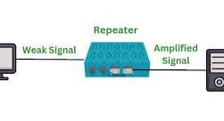
Fig 2. Repeater

3. Bridge
A bridge is a networking device that connects two or more LAN segments and works at the Data Link Layer of the OSI model. It helps reduce network traffic by filtering data and improves overall network performance. Despite these benefits, bridges are slower than switches and have limited scalability. Bridges are typically used in bus topology and star topology networks.
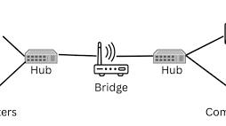
Fig 3. Bridge

4. Gateway
A gateway is a networking device that connects two different networks that use different communication protocols. It enables communication between dissimilar networks and supports protocol conversion, making it essential in complex networking environments. However, gateways are often expensive and require complex configuration. They are commonly used in hybrid topology and wide area networks (WANs).

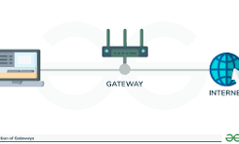
Fig 4. gateway

5. Firewall
A firewall is a network security device that monitors and controls incoming and outgoing network traffic based on predefined security rules. It enhances network security and protects systems from cyber threats, but it can slow down network performance and requires regular maintenance and updates. Firewalls are commonly implemented in star topology, hybrid topology, and enterprise network architectures.

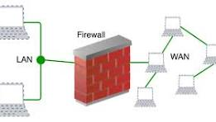
Fig 5. Firewall

Experiment 2: Program for bit stuffing and de-stuffing in a bit stream

#include <iostream>
using namespace std;

string bitStuffing(string data) {
string stuffed = "";
int count = 0;

for (char bit : data) {
stuffed += bit;

if (bit == '1') {
count++;
if (count == 5) {
stuffed += '0';
count = 0;
}
} else {
count = 0;
}
}
return stuffed;
}

string bitDestuffing(string data) {
string destuffed = "";
int count = 0;

for (int i = 0; i < data.length(); i++) {
destuffed += data[i];

if (data[i] == '1') {
count++;
if (count == 5) {
i++;
count = 0;
}
} else {
count = 0;
}
}
return destuffed;
}

int main() {
string data;
cout << "Enter bit stream: ";
cin >> data;

string stuffed = bitStuffing(data);
cout << "Stuffed Data: " << stuffed << endl;
string destuffed = bitDestuffing(stuffed);
cout << "De-stuffed Data: " << destuffed << endl;
return 0;
}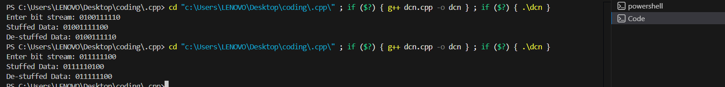

Experiment 3 - Program for CRC and Hamming code

• CRC Code
#include <stdio.h>
#include <string.h>

void crc_xor(char *temp, char *gen) {
for (int j = 1; j < strlen(gen); j++) {
temp[j] = (temp[j] == gen[j]) ? '0' : '1';
}
}

void calculate_crc(char *data, char *gen) {
int data_len = strlen(data);
int gen_len = strlen(gen);
char temp[20], remainder[20];

// Copy first part of data into temp
strncpy(temp, data, gen_len);

for (int i = 0; i < data_len; i++) {
if (temp[0] == '1') {
crc_xor(temp, gen);
}

// Shift bits: Move next bit from data into temp
for (int j = 0; j < gen_len - 1; j++) {
temp[j] = temp[j + 1];
}

if (i + gen_len < data_len + gen_len - 1)
temp[gen_len - 1] = data[i + gen_len];
else
temp[gen_len - 1] = '0';
}

strncpy(remainder, temp, gen_len - 1);
remainder[gen_len - 1] = '\0';
printf("CRC Remainder: %s\n", remainder);
printf("Final Codeword: %s%s\n", data, remainder);
}

int main() {
char data[] = "1101";
char gen[] = "1011"; // Generator polynomial
printf("Data: %s, Generator: %s\n", data, gen);
calculate_crc(data, gen);
return 0;
}

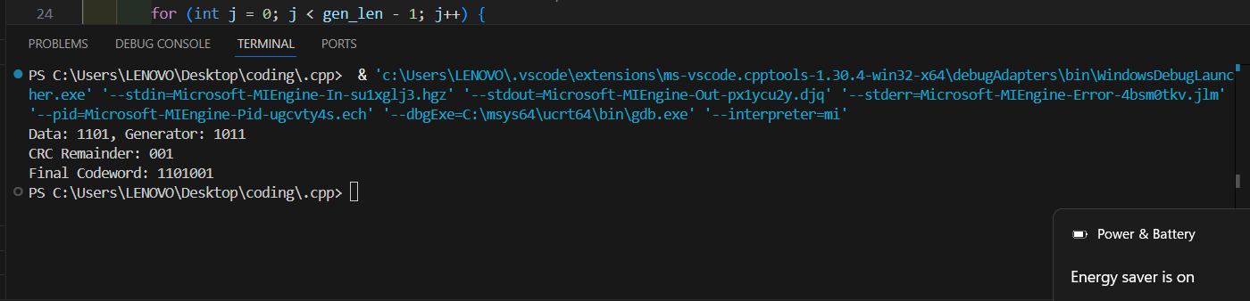

- Hamming code
#include <stdio.h>
#include <string.h>
int main() {
char data_str[5];
int data[5], code[8], recv[8];

printf("Enter 4-bit data (e.g., 1011): ");
scanf("%s", data_str);

// Convert char to int array for math operations
for(int i = 0; i < 4; i++) {
data[i] = data_str[i] - '0';
}

/*
Mapping Data to Hamming Positions:
Pos 1: P1 (Parity)
Pos 2: P2 (Parity)
Pos 3: D1 (Data[0])
Pos 4: P3 (Parity)
Pos 5: D2 (Data[1])
Pos 6: D3 (Data[2])
Pos 7: D4 (Data[3])
*/
code[3] = data[0];
code[5] = data[1];
code[6] = data[2];
code[7] = data[3];

// Calculate Even Parity bits
code[1] = code[3] ^ code[5] ^ code[7];
code[2] = code[3] ^ code[6] ^ code[7];
code[4] = code[5] ^ code[6] ^ code[7];

printf("Encoded Hamming Code: ");
for(int i = 1; i <= 7; i++) printf("%d", code[i]);
printf("\n\n");

// --- Error Detection Logic ---
char recv_str[8];
printf("Enter received 7-bit code (to check for errors): ");
scanf("%s", recv_str);

for(int i = 1; i <= 7; i++) {
recv[i] = recv_str[i-1] - '0';
}

// Recalculate Parity Checkers (Syndromes)
int s1 = recv[1] ^ recv[3] ^ recv[5] ^ recv[7];
int s2 = recv[2] ^ recv[3] ^ recv[6] ^ recv[7];
int s3 = recv[4] ^ recv[5] ^ recv[6] ^ recv[7];

// Calculate error position (Binary to Decimal conversion)
int error_pos = (s3 * 4) + (s2 * 2) + (s1 * 1);

if(error_pos == 0) {
printf("Result: No error detected.\n");
} else {
printf("Result: Error detected at position %d\n", error_pos);

// Correct the bit
recv[error_pos] = (recv[error_pos] == 0) ? 1 : 0;

printf("Corrected Codeword: ");
for(int i = 1; i <= 7; i++) printf("%d", recv[i]);

printf("\nOriginal Decoded Data: %d%d%d%d\n", recv[3], recv[5], recv[6], recv[7]);
}

return 0;
}

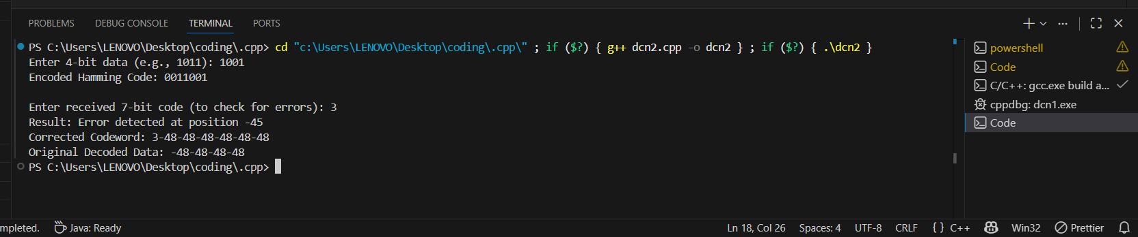
Experiment 4 - Familiarization with Network IP, subnetting and super -netting

1. IP Addressing (The Home Address)
An IP (Internet Protocol) address is a unique identifier for a device on a network. The most common version, IPv4, consists of 32 bits divided into four octets (8 bits each), separated by dots.
• Format: 192.168.1.1
• Structure: Every IP address is split into two parts:
1. Network ID: Identifies the specific network.
2. Host ID: Identifies the specific device on that network.

2. Subnetting (Dividing the Neighbourhood)
Subnetting is the process of breaking a single large network into smaller, manageable sub-networks (subnets).
Why do it?
• Efficiency: Reduces "broadcast storms" where too many devices talk at once.
• Security: Keeps different departments (like Accounting and Guest Wi-Fi) isolated.
• Organization: Makes troubleshooting much easier.
The Subnet Mask
The mask tells the computer where the "Network" part ends and the "Host" part begin.
• A common mask is 255.255.255.0.
• In binary, the 1s represent the network and the 0s represent the available seats for devices.

3. Super netting (Combining the Blocks)
Super netting (or CIDR - Classless Inter-Domain Routing) is the exact opposite of subnetting. It involves combining multiple smaller network addresses into one single, large "super-network."
Why do it?
• Route Aggregation: Instead of a router having 100 entries for 100 small networks, it has one entry for the "super net."
• Performance: It reduces the size of routing tables, making the internet faster and routers less stressed.
To determine how many hosts or subnets you have, we use these two basic formulas where n is the number of bits borrowed:
• Number of Subnets: 2^n
• Number of Hosts per Subnet: 2^n - 2
Note: We subtract 2 because the first address is the Network ID and the last is the Broadcast Address.

Subnetting vs. Super netting
Feature | Subnetting | Super netting
Action | Divides a network into smaller pieces. | Combines smaller networks into one.
Mask Length | The mask gets "longer" (more 1s). | The mask gets "shorter" (fewer 1s).
Purpose | Better local management and security. | Reducing routing table complexity.
Direction | Borrowing bits from the Host portion. | Borrowing bits from the Network portion.

Experiment 5 - Familiarization of basic network command and network configuration commands

1. Basic Network Commands
Basic network commands are used to test network connectivity, monitor network status, and troubleshoot common network problems. These commands help determine whether a system is connected to the network and whether communication between devices is functioning properly.

1. ping
- The ping command checks the connectivity between your computer and another device on a network.
- It sends small packets called ICMP Echo Requests to the target host and waits for a response.
- If a reply is received, it means the host is reachable.
Example:
ping google.com
Use:
- Tests internet connection.
- Checks if a server or website is reachable.
- Measures response time (latency).

2. ipconfig (Windows) / ifconfig or ip addr (Linux)
- The ipconfig command displays network configuration details such as:
  - IP address
  - Subnet mask
  - Default gateway
- It is used to verify whether the system has received a valid IP address.
Example (Windows):
ipconfig
Use:
- Checks network settings.
- Verifies DHCP configuration.
- Helps diagnose connectivity issues.

3. tracert (Windows) / traceroute (Linux)
- The tracert command shows the path taken by packets from the source computer to the destination host.
- It displays every router (hop) through which the data passes.
Example:
tracert google.com
Use:
- Identifies network delays.
- Locates where packet loss occurs.
- Helps analyze routing problems.

4. netstat
- The netstat command displays active network connections and listening ports.
- It also shows routing tables and network statistics.
Example:
netstat -an
Use:
- Displays active TCP and UDP connections.
- Helps detect suspicious network activity.
- Monitors open ports.

5. nslookup
- The nslookup command is used to query the Domain Name System (DNS).
- It retrieves the IP address associated with a domain name.
Example:
nslookup google.com
Use:
- Verifies DNS resolution.
- Troubleshoots DNS issues.
- Finds IP addresses of websites.

6. arp
- The arp command displays and manages the ARP (Address Resolution Protocol) table.
- It maps IP addresses to MAC addresses on the local network.
Example:
arp -a
Use:
- Shows devices connected to the local network.
- Helps identify network conflicts.
- Assists in network troubleshooting.

2. Network Configuration Commands
Network configuration commands are used to modify, manage, and view network settings on a computer system.

1. ipconfig /all
- Displays complete network configuration information including:
  - MAC address
  - DHCP status
  - DNS servers
  - IP configuration details.
Example:
ipconfig /all

2. ipconfig /release
- Releases the current IP address assigned by the DHCP server.
- Used when resetting the network connection.
Example:
ipconfig /release

3. ipconfig /renew
- Requests a new IP address from the DHCP server after releasing the previous one.
Example:
ipconfig /renew

4. route
- The route command displays or modifies the routing table.
- It shows how packets are forwarded in a network.
Example:
route print

5. hostname
- The hostname command displays the name of the computer on the network.
Example:
hostname
Use:
- Identifies the system on the network.
- Useful for network administration.

6. netsh (Windows)
- The netsh (Network Shell) command is used for advanced network configuration and management.
- It allows administrators to configure network interfaces and settings.
Example:
netsh interface ip show config

3. Importance of These Commands
These commands are essential tools for network management and troubleshooting.
They help to:
- Troubleshoot network connectivity issues
- Test internet and network connections
- Diagnose DNS, IP, and routing problems
- Monitor active network connections
- Manage and configure network settings
These commands are widely used by students, network administrators, and IT professionals for maintaining and diagnosing computer networks.

Experiment 6 - Set up a network topology in Cisco Packet Tracer (Ring)

Step 1 -Open Cisco Packet Tracer
Launch Cisco Packet Tracer.
You will see the workspace where devices can be added.
Step 2 - Add the Switch
At the bottom device panel click Network Devices.
Select Switches.
Drag Cisco 2960 Switch to the workspace.

Step 3 -Add 5 PCs
Click End Devices.
Select PC.
Drag 5 PCs into the workspace.
Arrange them around the switch

Step 4 - Connect Using Copper Straight-Through Cable
Click Connections
Choose Copper Straight-Through Cable.
Now connect each PC:
For each PC:
Click PC → select FastEthernet0.
Click the Switch → choose any port like FastEthernet0/1, 0/2, 0/3, 0/4, 0/5.
Repeat until all 5 PCs are connected to the switch.

Step 5 - Configure IP Addresses
Click each PC and assign IP :
Steps Steps:
- Click PC
- Go to Desktop
- Click IP Configuration

Step 6 - Switch to Simulation Mode
At the bottom right, click Simulation.
Select add filters select only ICMP

Step 7 – Add simple PDU
envelope icon

Step 8- Test Communication
Click PC4 (source).
Click PC1 (destination).
Press Auto Play.
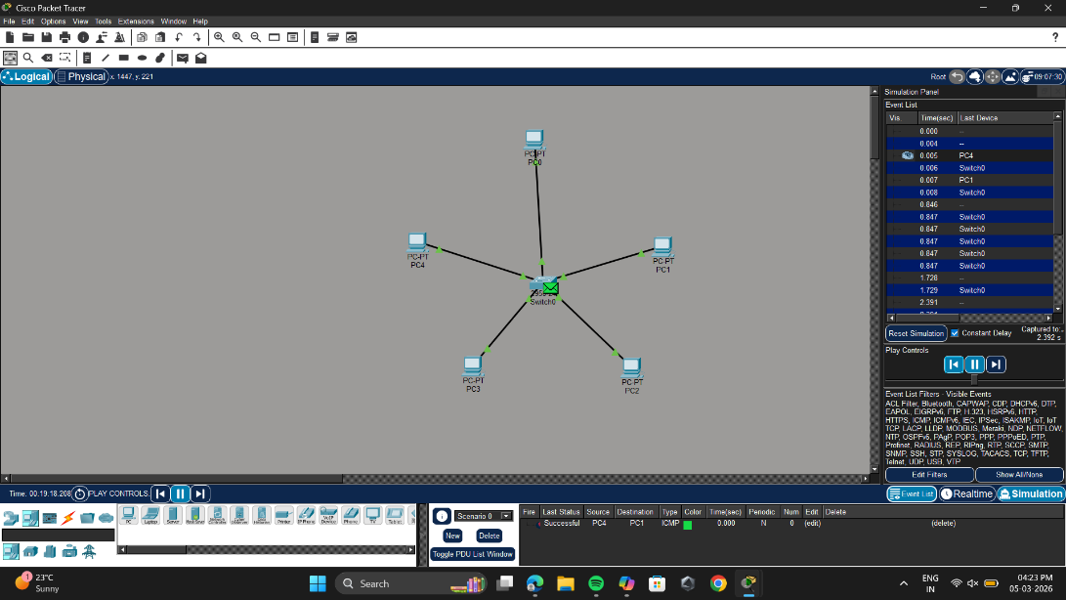
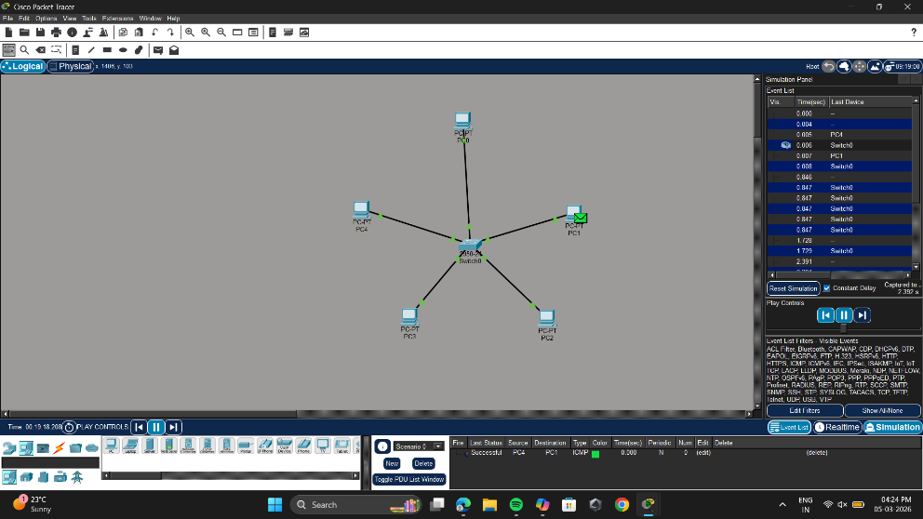
Experiment 7: Set up a network topology in two and more than two routers

Steps:
- Open Cisco Packet Tracer and select a 2901 Router from the router devices list.
- Add two 2960 switches to the workspace.
- Add six PCs to the workspace.
- Connect all devices using the Automatically Chosen Connection option so that the appropriate cable type is selected automatically.
- Arrange the topology in a rectangular layout and divide the network into two parts:
  - LAN 1 containing three PCs connected to Switch 1
  - LAN 2 containing three PCs connected to Switch 2
- Configure the network address 192.168.0.1 for LAN 1.
- Configure the network address 10.0.0.1 for LAN 2.
- Click on the Router, go to the Config tab, and configure the interfaces:
  - Assign 192.168.0.1 to GigabitEthernet 0/0 and turn on the port status.
  - Assign 10.0.0.1 to GigabitEthernet 0/1 and turn on the port status.
- Configure IP addresses for the PCs in LAN 1 as follows:
  - PC0 → 192.168.0.2
  - PC1 → 192.168.0.3
  - PC2 → 192.168.0.4
- Configure IP addresses for the PCs in LAN 2 as follows:
- PC3 → 10.0.0.2
- PC4 → 10.0.0.3
- PC5 → 10.0.0.4
- Click on the Add Simple PDU (Message Icon) and select two PCs one from each LAN between which communication will be tested.
- Switch to Simulation Mode, clear existing filters, select ICMP, and run the simulation.
- The communication will fail initially because the PCs do not know how to reach devices located in another network.
- Since two different IP networks are used, the router must be specified as the default gateway so that packets can be forwarded between networks.
- Configure the default gateway for PCs in LAN 1:
- Open PC0 → Desktop → IP Configuration
- Set the Default Gateway to 192.168.0.1
- Repeat the same configuration for all PCs in LAN 1.
- Configure the default gateway for PCs in LAN 2:
- Open PC3 → Desktop → IP Configuration
- Set the Default Gateway to 10.0.0.1
- Repeat the same configuration for all PCs in LAN 2.
- After configuring the default gateways, all PCs in both LANs are able to route packets through the router.
- Again use the Add Simple PDU (Message Icon) to send a packet between one PC in LAN 1 and one PC in LAN 2.
- Switch to Simulation Mode and run the simulation.
- The packet transmission will now be successful, demonstrating communication between two different networks using a router.

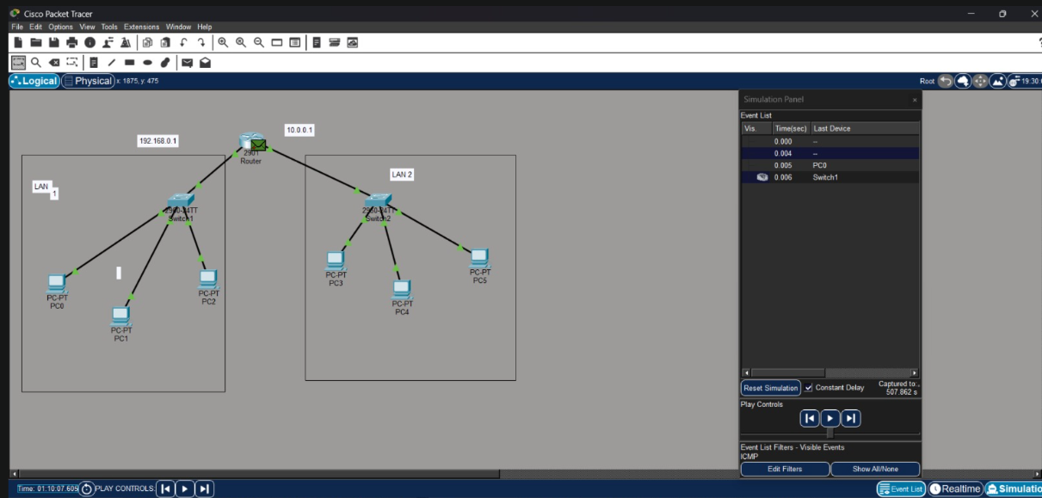

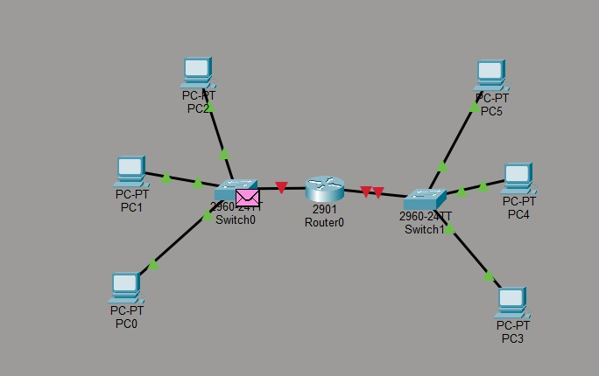

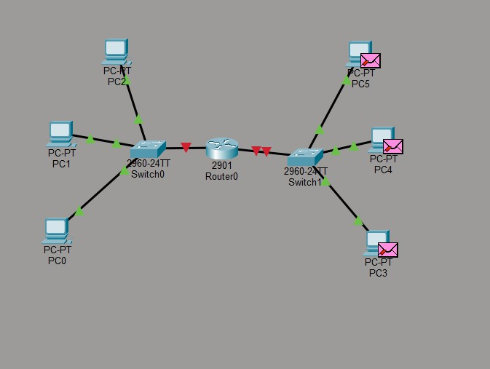

EXPERIMENT 8: Distance vector routing protocol

A Distance Vector Routing Protocol (DVRP) is a type of networking protocol used to determine the most efficient path for data packets to travel from a source to a destination. In this approach, each router maintains a routing table that stores information about the distance (cost) to different networks and the next-hop router (direction) to reach them. The term “distance vector” comes from these two elements: distance refers to the metric (commonly hop count), and vector indicates the path or next router.
Routers periodically share their entire routing tables with their immediate neighbors. When a router receives updated information, it applies the Bellman-Ford algorithm to compare new routes with existing ones and selects the path with the lowest cost. For example, if a router discovers a shorter path to a network through a different neighbor, it updates its table accordingly.
Initially, routers are only aware of directly connected networks, but through continuous updates, they gradually learn routes to all networks in the system. When all routers have consistent and accurate routing information, the network is said to have reached convergence. A common metric used is hop count, which counts how many routers a packet must pass through.
A well-known example of DVRP is Routing Information Protocol (RIP), which limits the maximum hop count to 15 to avoid routing loops. However, DVRPs can still face issues like routing loops and the count-to-infinity problem. To handle these challenges, techniques such as split horizon, route poisoning, and hold-down timers are used to improve stability
Experiment 9: Link-State Routing Protocol
A Link-State Routing Protocol is a method used in computer networks where each router creates a complete view of the entire network and then finds the best path to every destination. Unlike distance vector routing, routers do not depend only on their neighbors’ information.
Instead, they share detailed data about their own links with all routers in the network.

In this method, each router first identifies its directly connected neighbors and calculates the cost of reaching them (based on factors like bandwidth or delay). This information is formed into packets called Link-State Advertisements (LSAs) and sent to all routers through a process called flooding. As a result, every router receives the same information and builds a full map of the network, known as the topology database.
After building this database, each router uses the Dijkstra Shortest Path Algorithm to calculate the most efficient path to every destination. It selects the route with the lowest total cost.

Working Steps:
- Routers discover their neighbors
- Link costs are calculated
- Link-state information (LSAs) is created
- LSAs are flooded across the network
- Each router builds a topology database
- Shortest path algorithm is applied to create the routing table

Common examples of link-state routing protocols include OSPF (Open Shortest Path First) and IS-IS (Intermediate System to Intermediate System). These are widely used in large networks because they provide faster convergence and better scalability.

Advantages:
  - Faster convergence
  - Complete network knowledge
  - Very low chance of routing loops

Disadvantages:
  - Requires more memory
  - Higher CPU usage due to complex calculations

Experiment:10 Familiarization with network monitoring tools
(NMAP and Wireshark)
Aim
To study and understand the working of Nmap and Wireshark, which are commonly used network monitoring and analysis tools.
Theory
Network monitoring tools are essential in computer networks for analyzing traffic, detecting security issues, and understanding how devices communicate with each other. These tools help network administrators monitor network performance, troubleshoot communication problems, and identify unauthorized activities.
One of the most widely used tools is Nmap, also known as Network Mapper. It is an open-source tool used for network discovery and security auditing. Nmap works by sending packets to a target host and analyzing the responses received. Through this process, it can determine which hosts are active on a network, which ports are open, and what services are running on those ports. It can also attempt to detect the operating system of the target machine.
Nmap is commonly used to scan individual hosts or entire networks. It helps administrators identify vulnerabilities, manage network security, and understand the structure of a network. Some common Nmap operations include scanning a single host, scanning a network range, detecting open ports, and identifying running services.
Another powerful network monitoring tool is Wireshark. Wireshark is a packet analyzer that captures and inspects data packets traveling across a network in real time. Unlike Nmap, which focuses on discovering devices and services, Wireshark analyzes the actual data communication between systems.
When Wireshark captures packets, it provides detailed information such as the source and destination IP addresses, the protocol used (such as TCP, UDP, DNS, or HTTP), packet size, and time stamps. It also allows users to inspect packet contents in detail. This makes Wireshark extremely useful for learning network protocols, troubleshooting connectivity problems, and analyzing network traffic.
Both tools play an important role in network monitoring. While Nmap helps in discovering hosts and identifying open ports on a network, Wireshark helps in capturing and analyzing packet-level communication between devices.

Difference Between Nmap and Wireshark

Feature | Nmap | Wireshark
Type | Network scanning tool | Packet analysis tool
Purpose | Discover hosts and open ports | Capture and analyze packets
Usage | Security auditing and network mapping | Troubleshooting and traffic analysis
Data Handled | Port and service information | Packet-level network data

Applications of Network Monitoring Tools
- Network troubleshooting
- Security auditing
- Monitoring network traffic
- Understanding network protocols
- Detecting suspicious activities in the network

Result
The study of network monitoring tools Nmap and Wireshark was successfully completed. Their features, working principles, and applications in network monitoring and security were understood.

Experiment:11 Capture network traffic using Wireshark.
Aim
To capture and analyze network traffic using Wireshark.

Theory
Network traffic refers to the flow of data packets across a computer network. Monitoring and analyzing this traffic helps in understanding how devices communicate, identifying network problems, and detecting suspicious activities.
Wireshark is a widely used network protocol analyzer that captures packets in real time and displays detailed information about them. It allows users to inspect network protocols such as TCP, UDP, DNS, and HTTP.
When packets are captured, Wireshark shows information such as:
- Source IP address
- Destination IP address
- Protocol used
- Packet length
- Time stamp
- Packet details and contents
Wireshark also provides display filters, which allow users to view only specific types of packets. For example:
- dns → shows only DNS packets
- tcp → shows only TCP packets

These filters make it easier to analyze particular network activities.
Another important protocol observed during packet capture is UDP (User Datagram Protocol). UDP is a connectionless transport protocol that allows data to be sent without establishing a prior connection between devices. It is faster than TCP but does not guarantee delivery or ordering of packets. UDP is commonly used in applications such as streaming, online gaming, and DNS queries.

Procedure
- Install and open Wireshark.
- Select the active network interface (Wi-Fi).
- Start packet capture.
- Generate network traffic by opening a website in a browser.
- Observe the packets being captured in real time.
- Stop the capture after a few seconds.
- Apply display filters such as:

dns:-
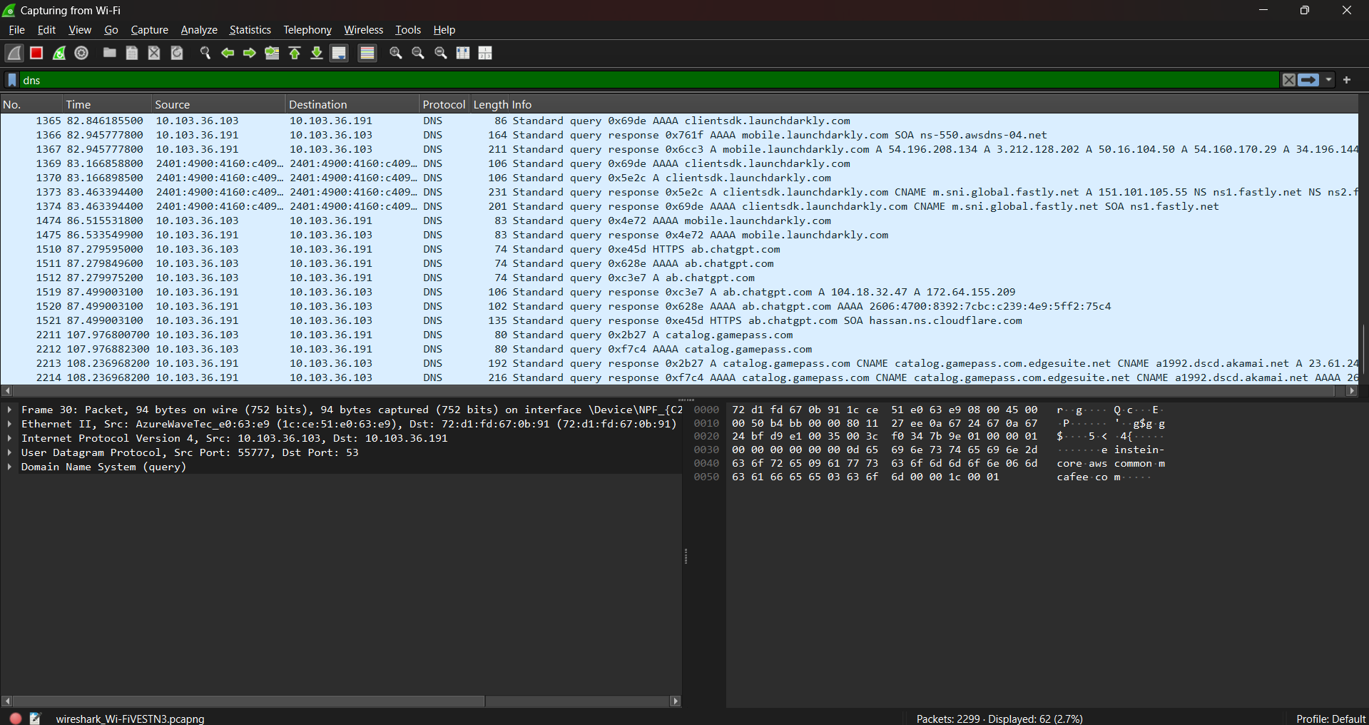
tcp:-
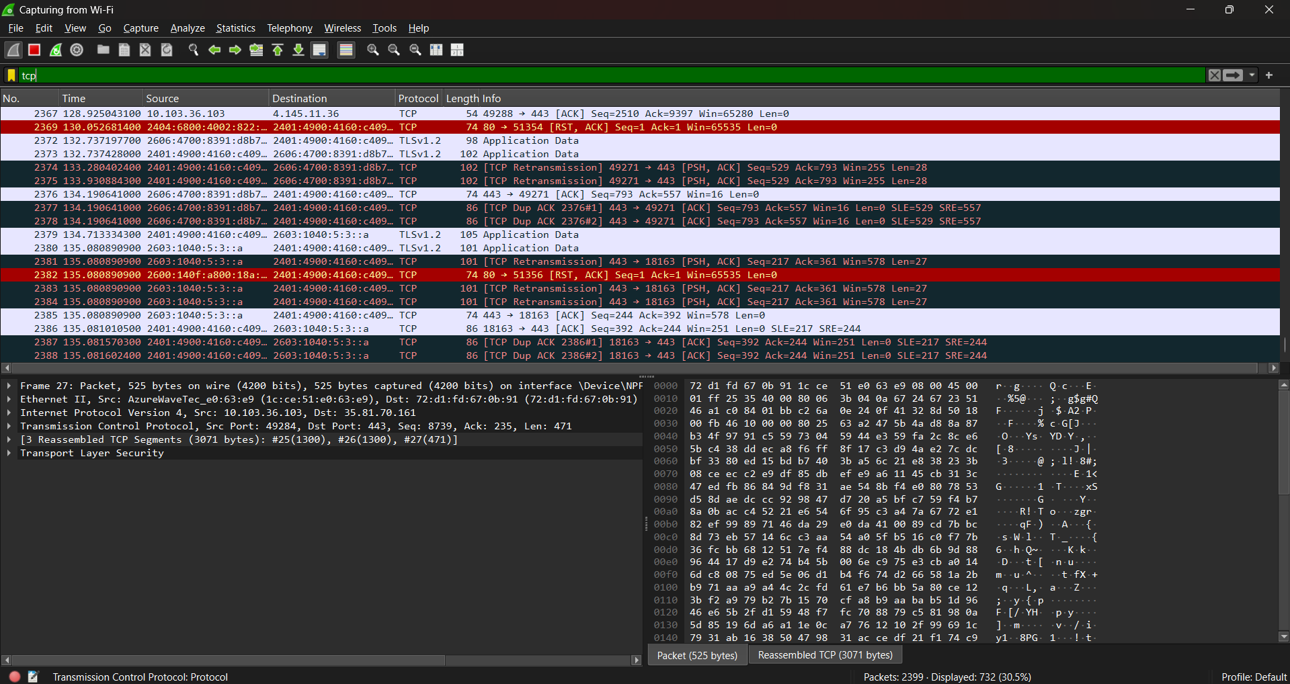

udp:-
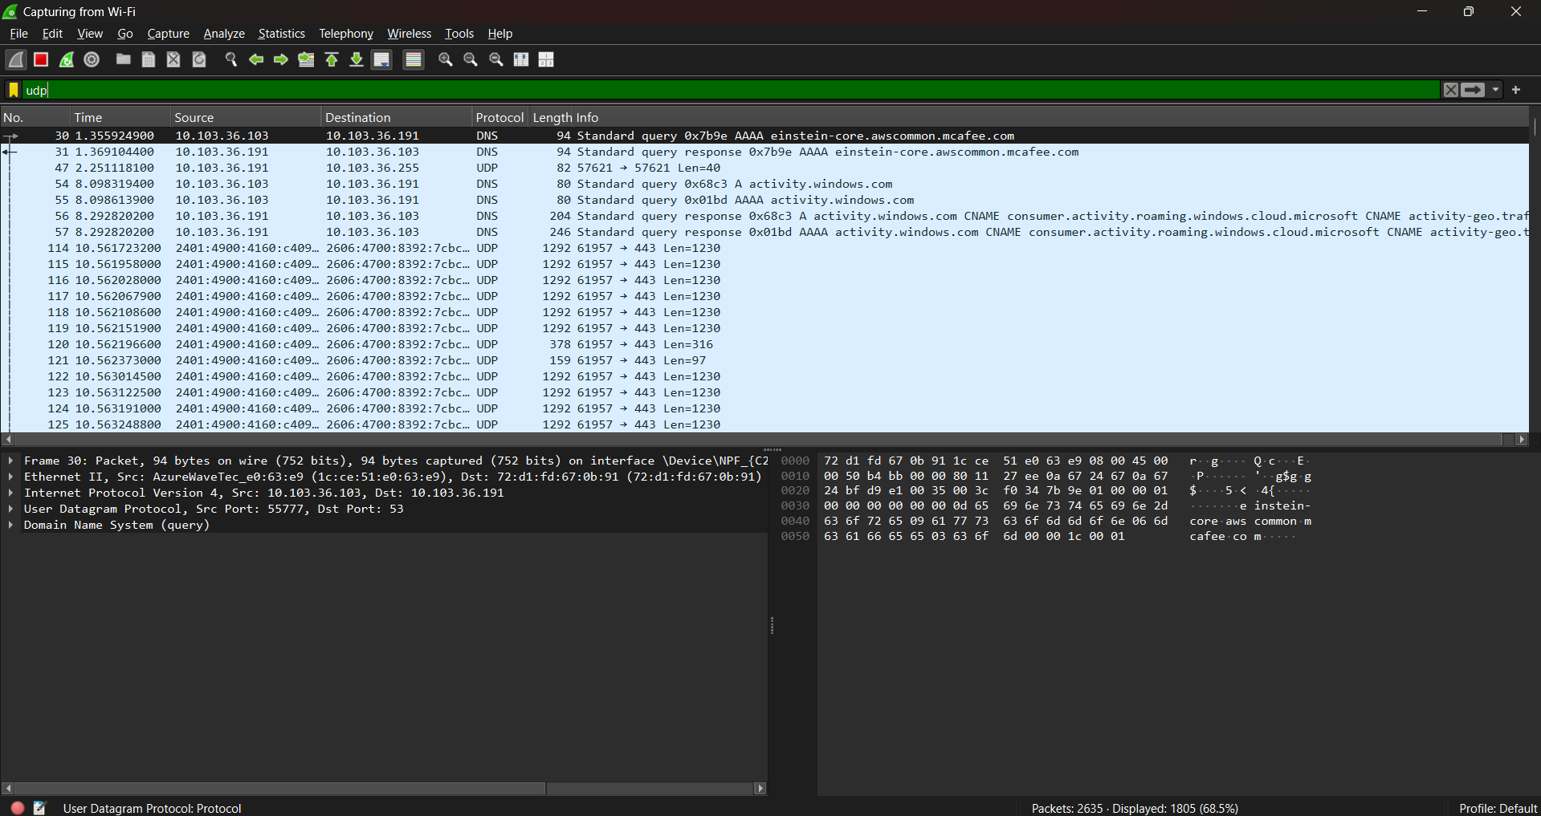
- Analyze the packet details including source address, destination address, protocol, and packet length.

Observations
- Network packets were successfully captured using Wireshark.
- Different protocols such as DNS, TCP, UDP were observed in the captured traffic.
- The source and destination IP addresses of packets were displayed.
- DNS packets showed domain name resolution requests.
- TCP packets showed communication between devices during data transmission.
- UDP packets were also observed using the udp display filter, showing connectionless data transmission in the network.

Result
The experiment was successfully performed. Network traffic was captured and analyzed using Wireshark, and different types of packets such as DNS and TCP were observed using display filters.
Comparison: Distance Vector vs Link-State Routing

Feature | Distance Vector Routing | Link-State Routing
Network knowledge | Knows only distance and next hop | Knows full network topology
Information sharing | Shares routing table with neighbors | Floods link-state info to all routers
Algorithm used | Bellman–Ford | Dijkstra
Convergence speed | Slow | Fast
Routing loops | More chances | Very rare
Resource usage | Low CPU & memory | High CPU & memory
Examples | RIP | OSPF, IS-IS
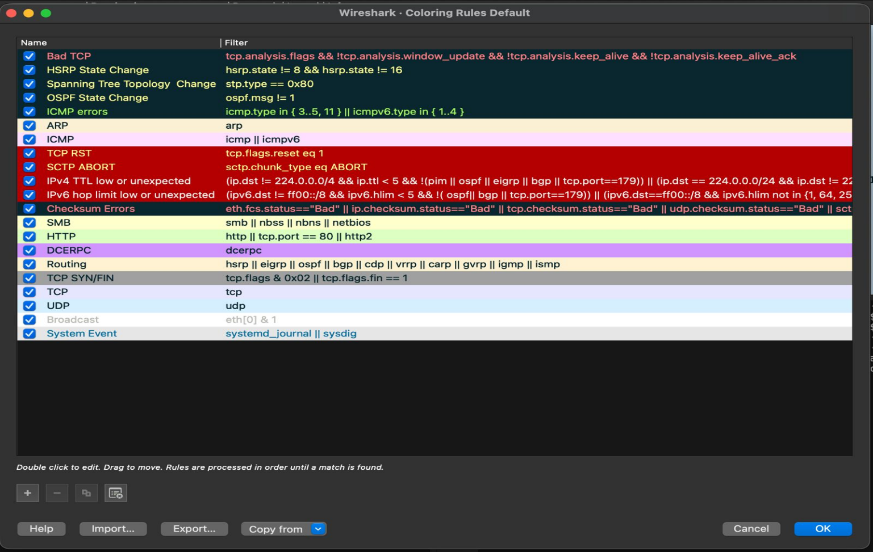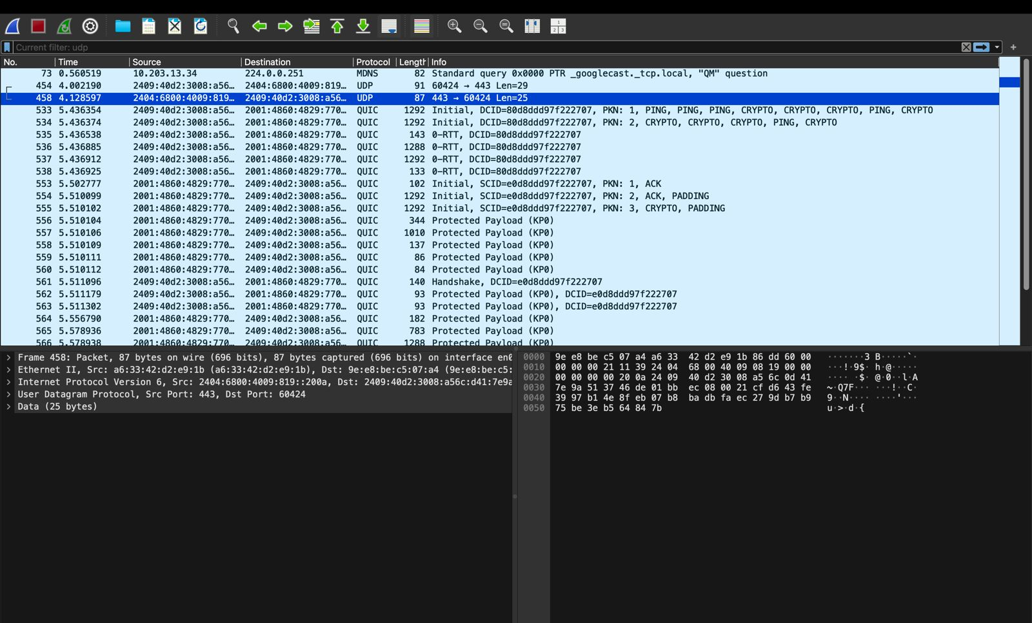

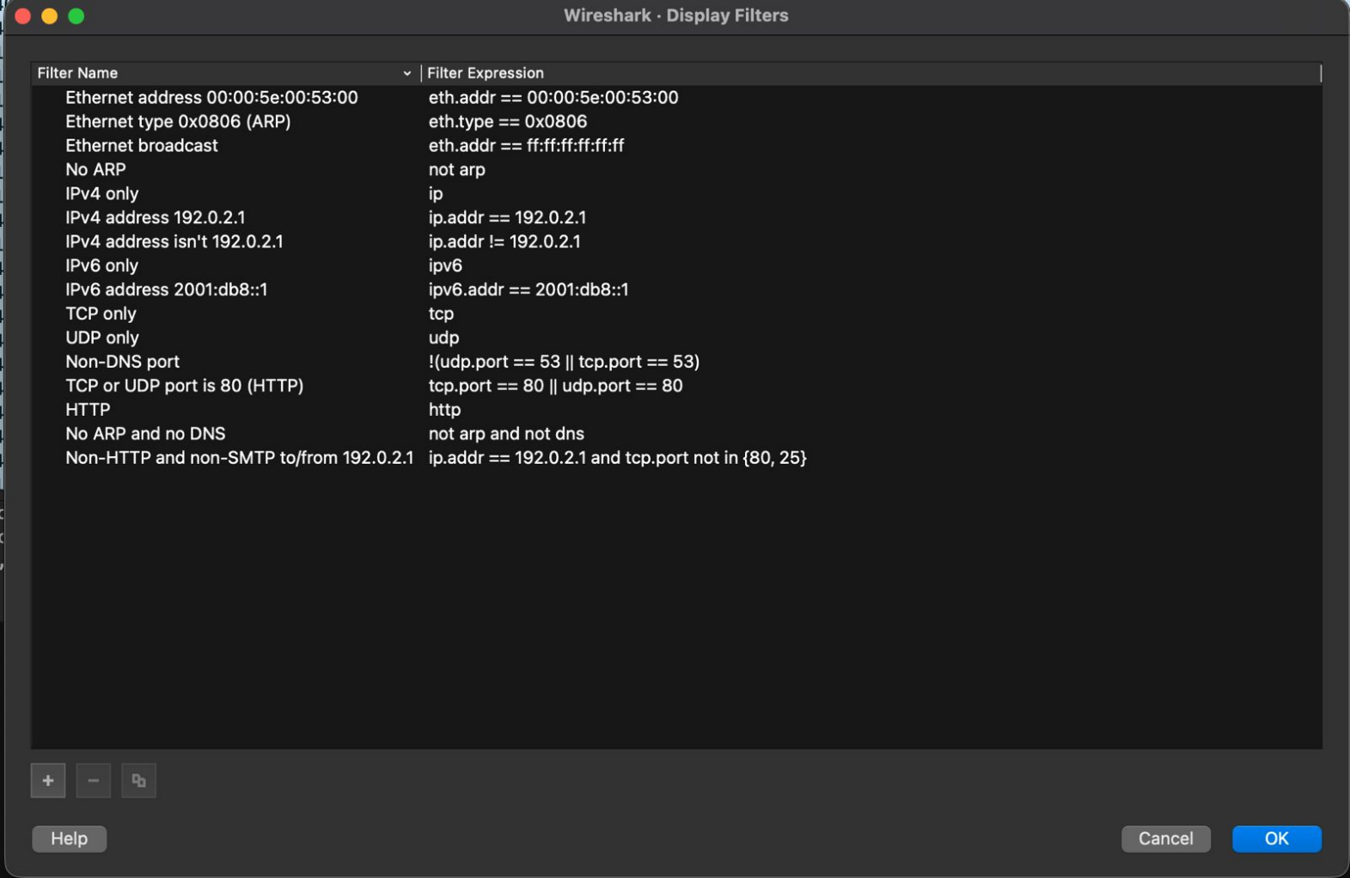
Experiment: 12:Analyzing Network Traffic using Wireshark
Network traffic analysis is the process of examining data packets transmitted across a network to understand communication patterns, detect issues, and ensure security. It plays a crucial role in network management, troubleshooting, and cybersecurity. A widely used tool for performing such analysis is Wireshark. Wireshark is an open-source packet analyzer that captures and displays network traffic in real time. It allows users to inspect each packet in detail and understand how devices communicate over a network. While capturing traffic is the first step, analyzing the captured data provides deeper insights into network behavior. When packets are captured, Wireshark organizes them into a structured format. Each packet contains multiple layers based on network protocols such as Ethernet, IP, TCP/UDP, and application-layer protocols like HTTP or DNS. By analyzing these layers, users can study how data moves from source to destination. Wireshark provides powerful filtering and analysis features that help users focus on specific traffic. Display filters such as:
• http – shows only HTTP traffic
• dns – shows DNS queries and responses
• tcp – displays TCP packets
enable efficient examination of large amounts of data. Users can also follow streams (e.g., TCP stream) to view complete communication between two devices. Through traffic analysis, important information can be extracted, such as
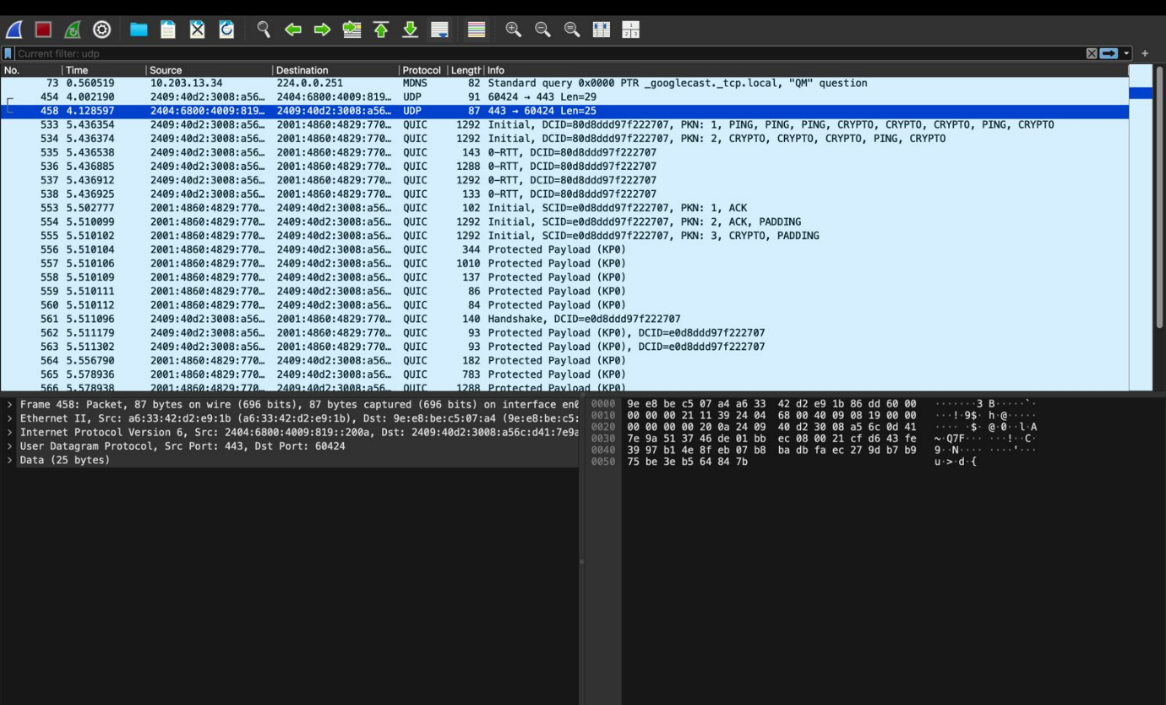
Source and destination IP addresses
- Protocol types and communication sequence
- Packet size and time intervals
- Errors, retransmissions, or packet loss
This analysis helps in identifying network performance issues, detecting unusual activities, and understanding protocol operations. For example, analyzing HTTP packets can reveal how a web page is requested and delivered, while DNS analysis shows how domain names are resolved into IP addresses.
Wireshark is also widely used in cybersecurity to detect suspicious patterns, unauthorized access attempts, or malicious traffic. However, it must be used responsibly and only on authorized networks, as it can expose sensitive information.
Conclusion
Analyzing network traffic using Wireshark provides a deep understanding of network communication and protocol behavior. It is an essential skill for network engineers and cybersecurity professionals, as it helps in troubleshooting, performance monitoring, and enhancing network security.
