Lab 1: Version Control

CREATING SIMPLE APP

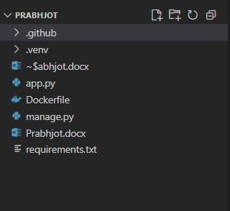

Creating app.py
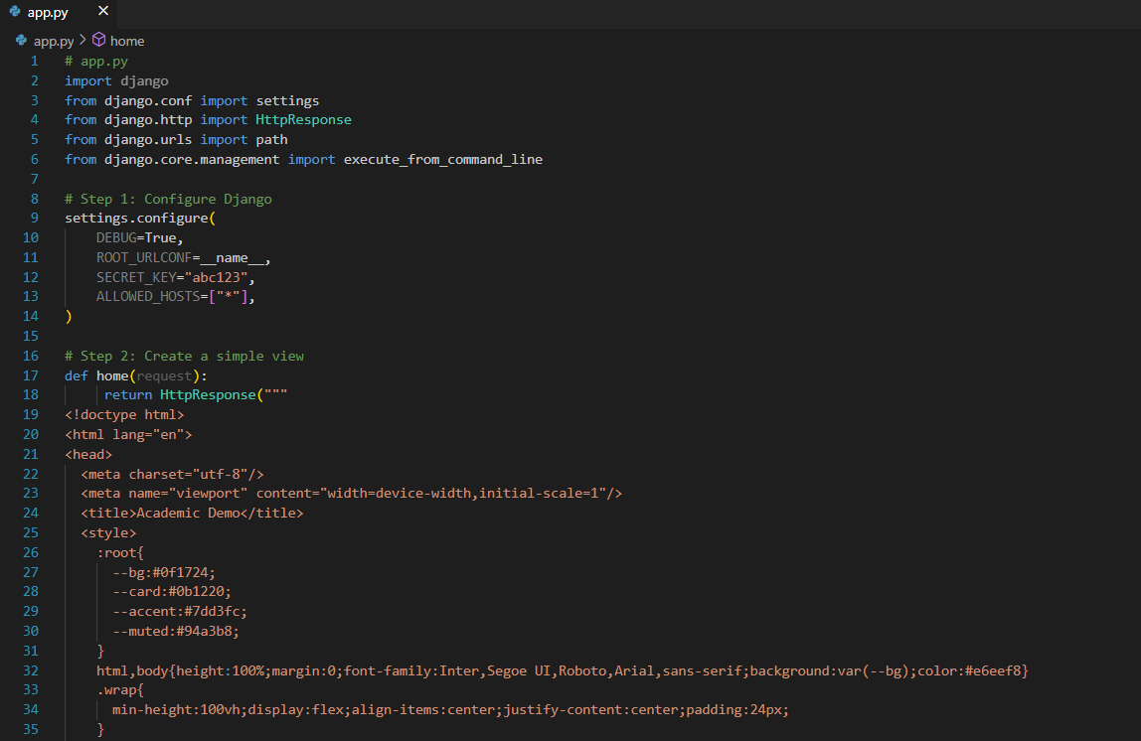

Testing app.py
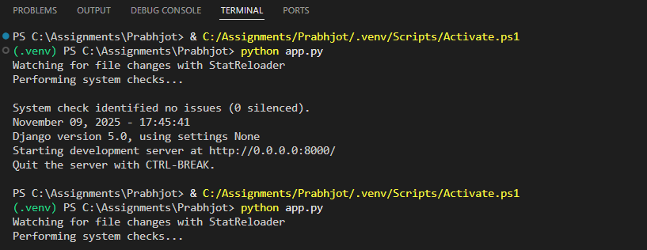
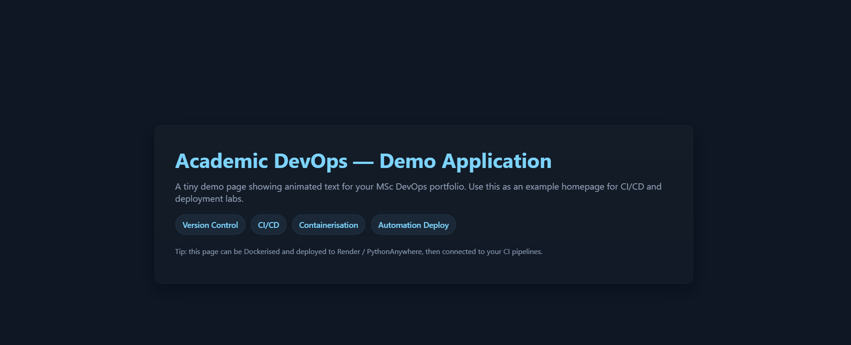

GitHub Repository

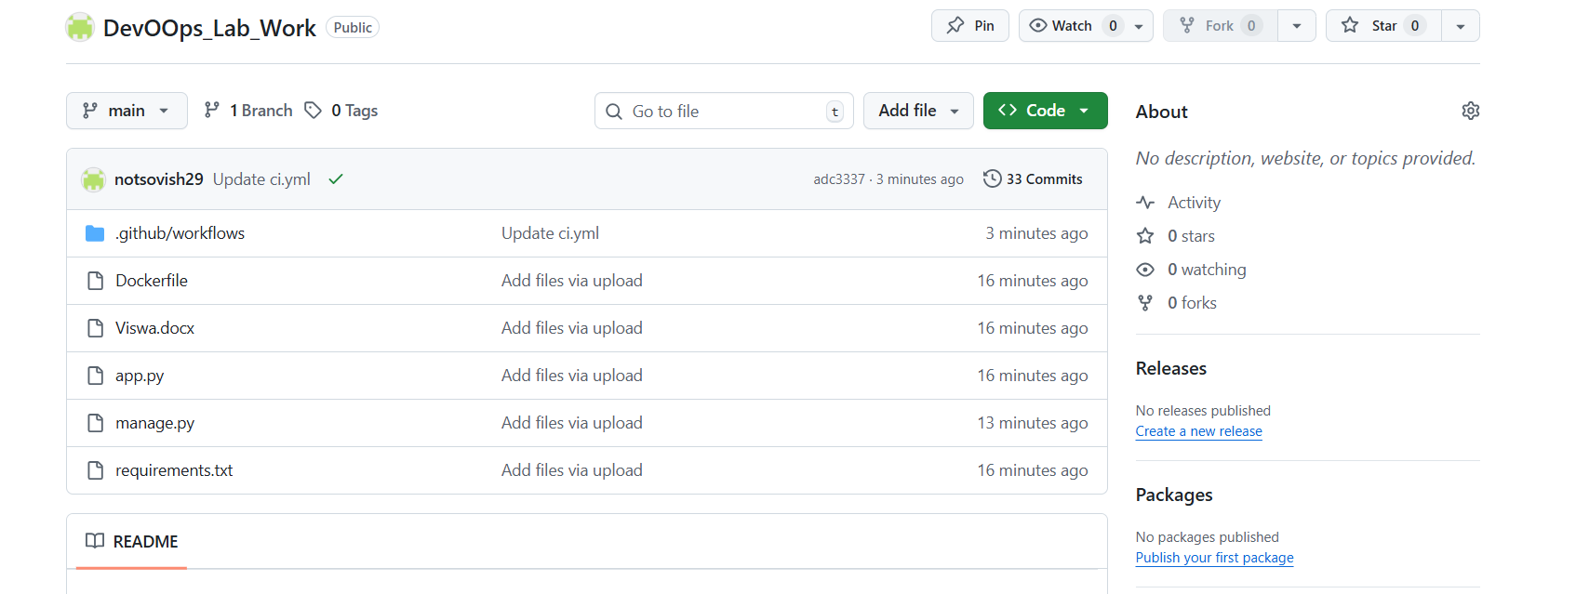

Lab 2: Planning using Trello
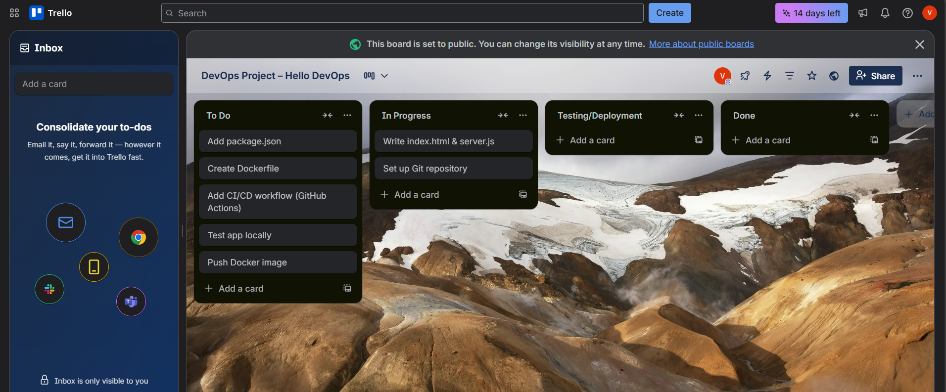
Trello was used to plan and track DevOps tasks for the Hello DevOps project, showing workflow stages and task completion.

Lab 3: CI/CD Pipeline with GitHub Actions

Downloading GitHub Actions
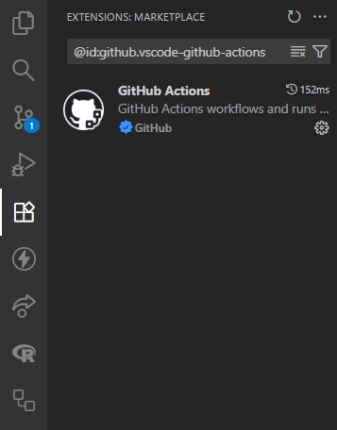

GitHub Workflow ci.yml file
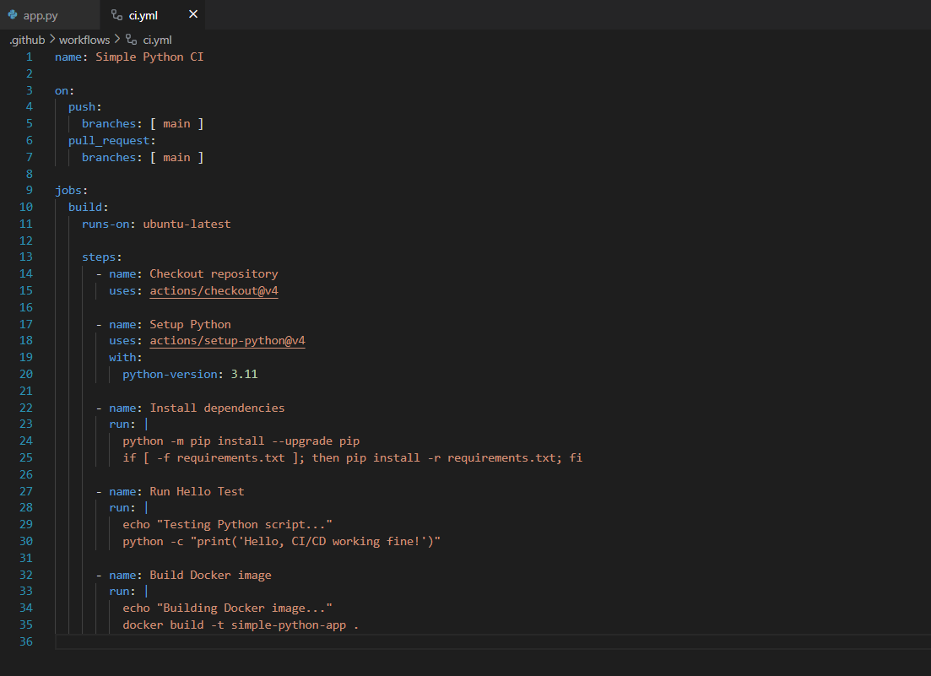

Dockerfile Setting up
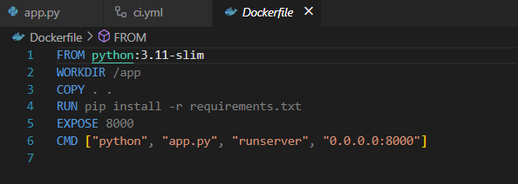

GitHub Action
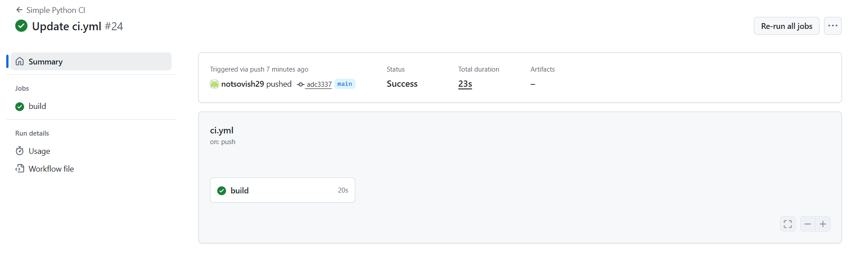

LAB 6 — Containerisation using Docker

Docker Image yml File
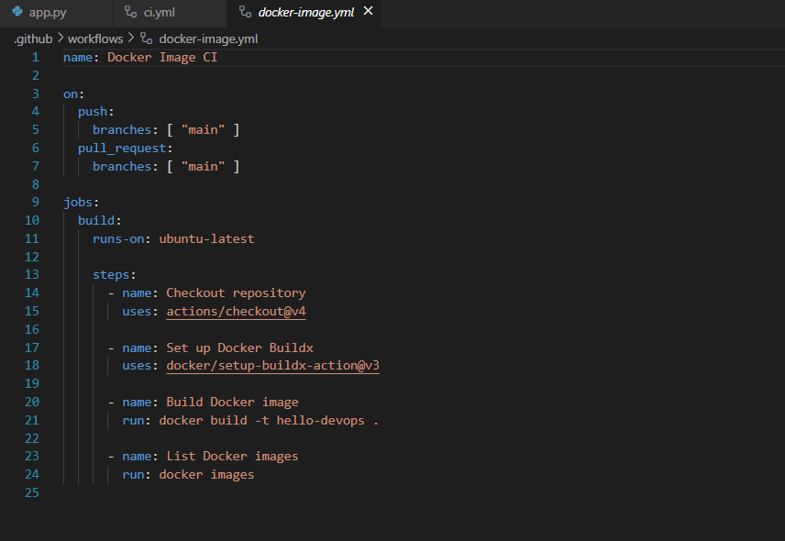

GitHub Actions
