Project Setup
- Created Django project and virtual environment
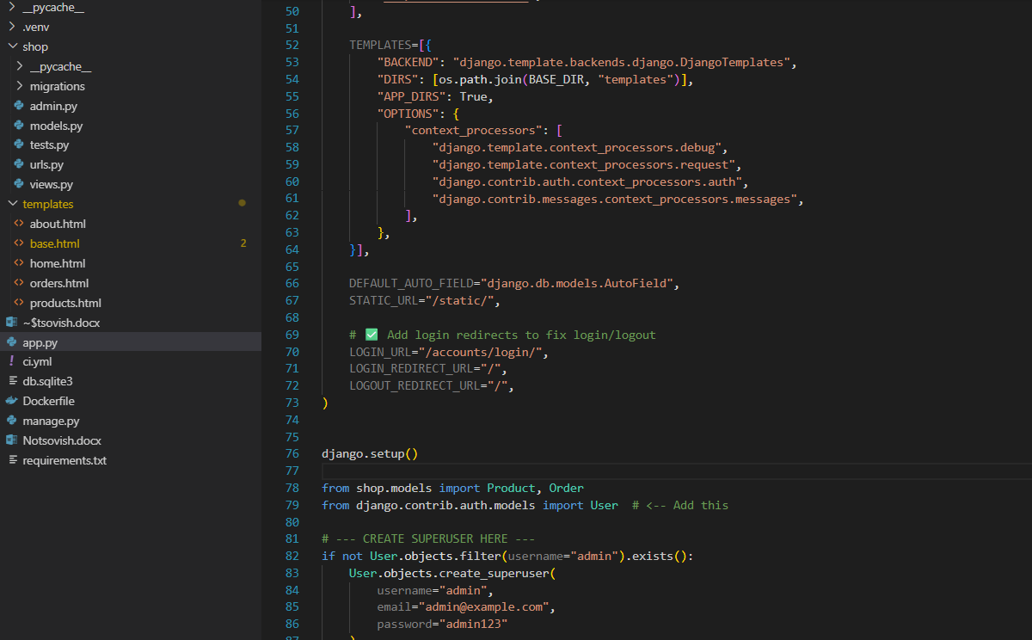
- Installed required packages (django)
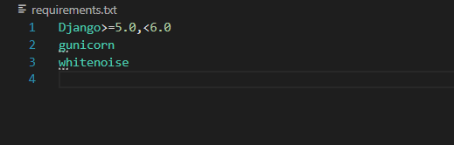

2. Models
- Created Product model with name, price, description, image
- Created Order model with product foreign key and quantity
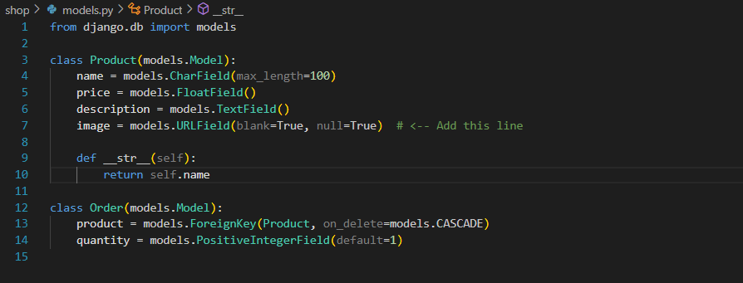

Views
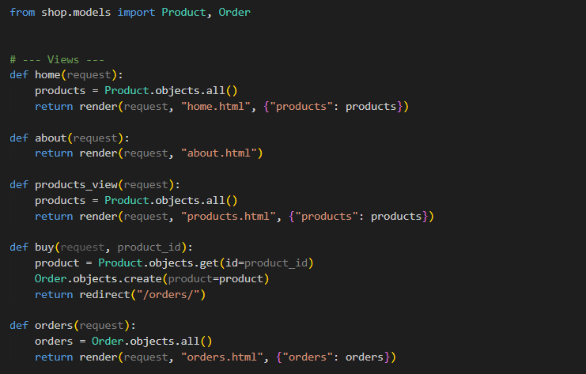
- Created home view to display products
- Created about view
- Created products_view to list all products
- Created buy view to create orders
- Created orders view to list all orders

3. Templates
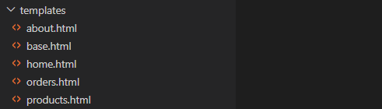
- Created home.html, about.html, products.html, orders.html
- Added inline CSS in templates where required
- Added content with headings, subheadings, paragraphs, and bullet points

4. Database
- Configured SQLite database

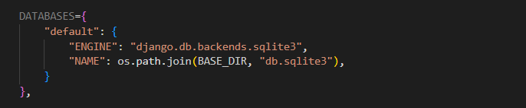
- Ran makemigrations and migrate commands
- Seeded 20 products in the database
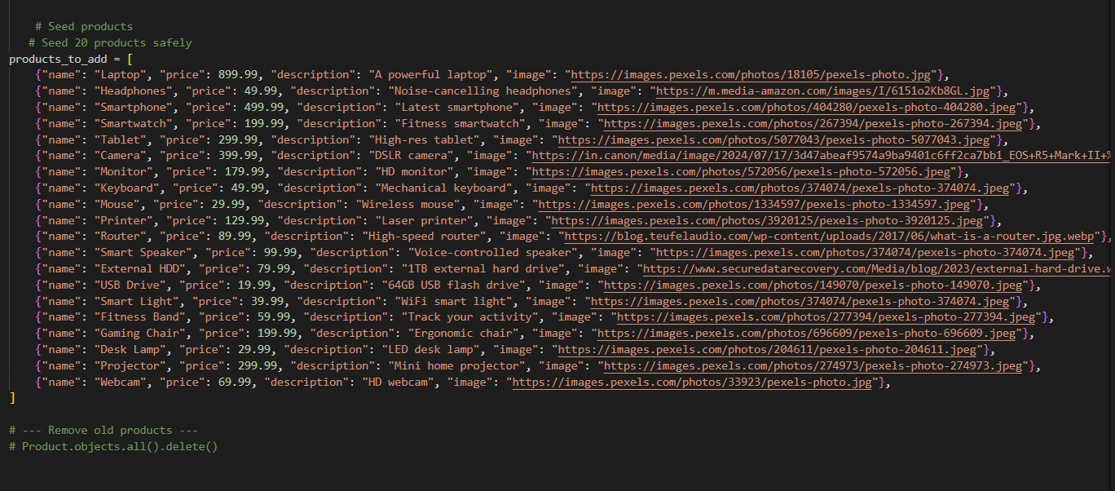

5. Create Repository on GitHub
- Go to GitHub → New Repository
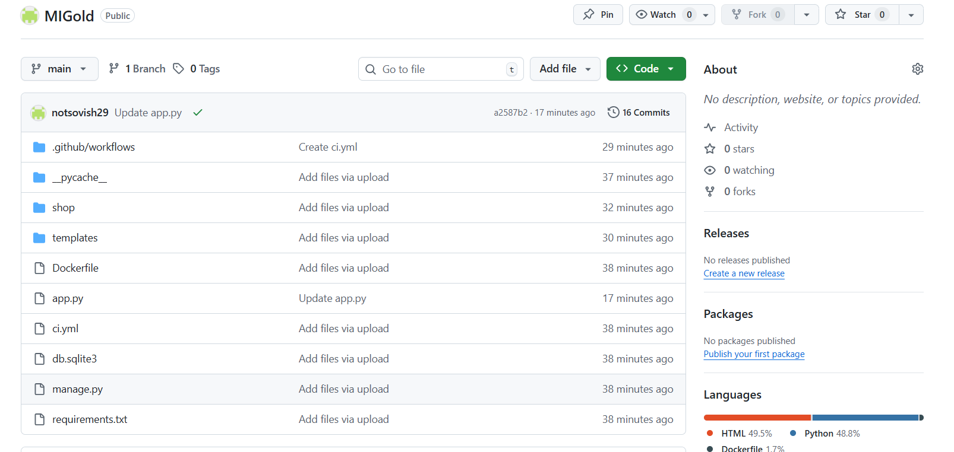
- Creating Workflow File
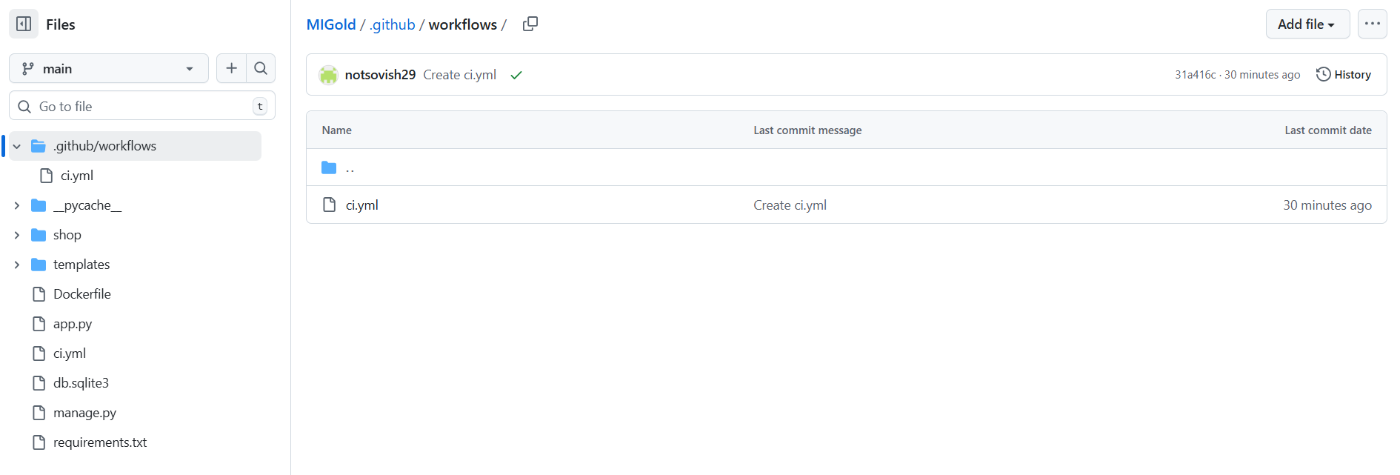
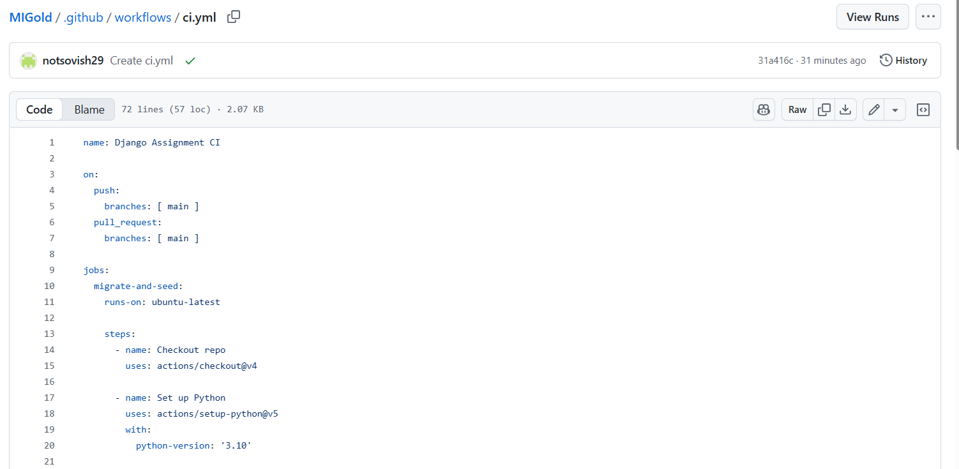

- Executing Workflow
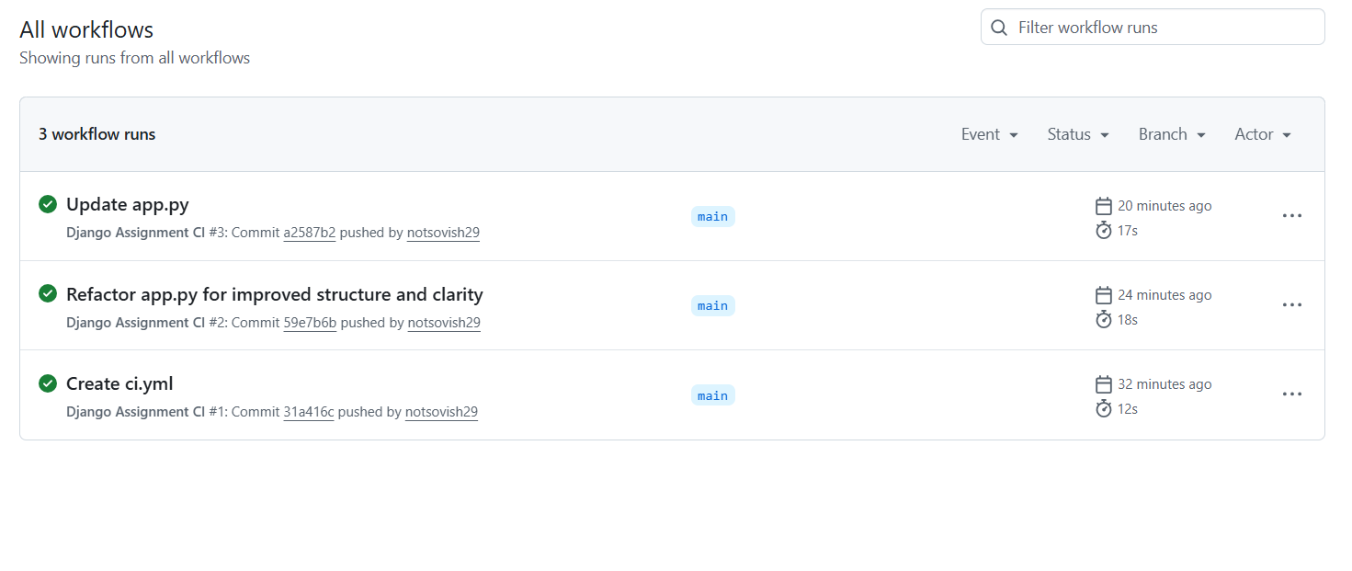

6. Deployment on render

Adding Name and Plan

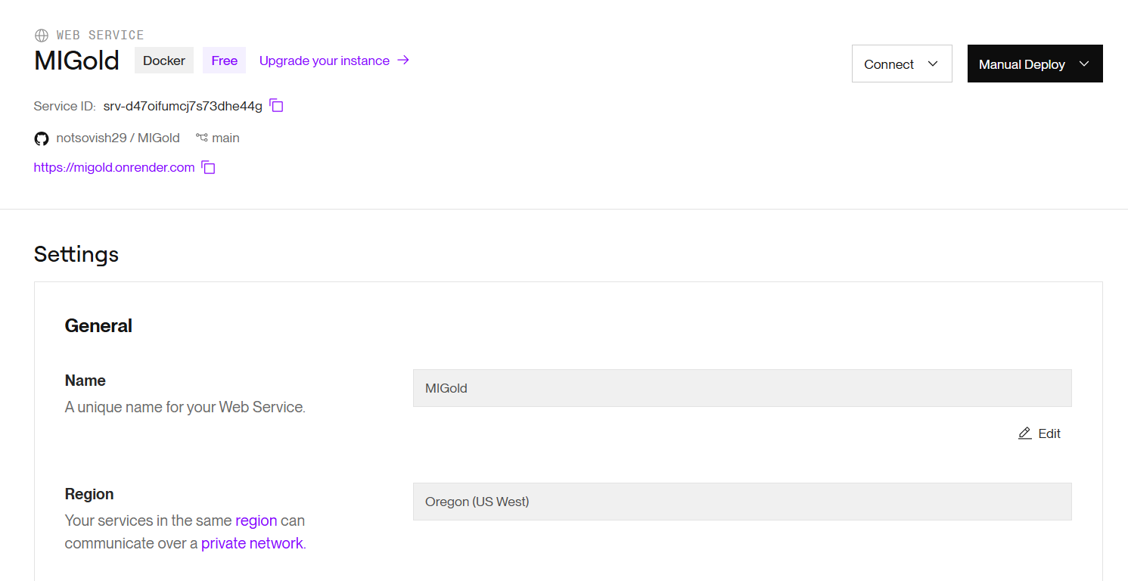

Connecting with GitHub
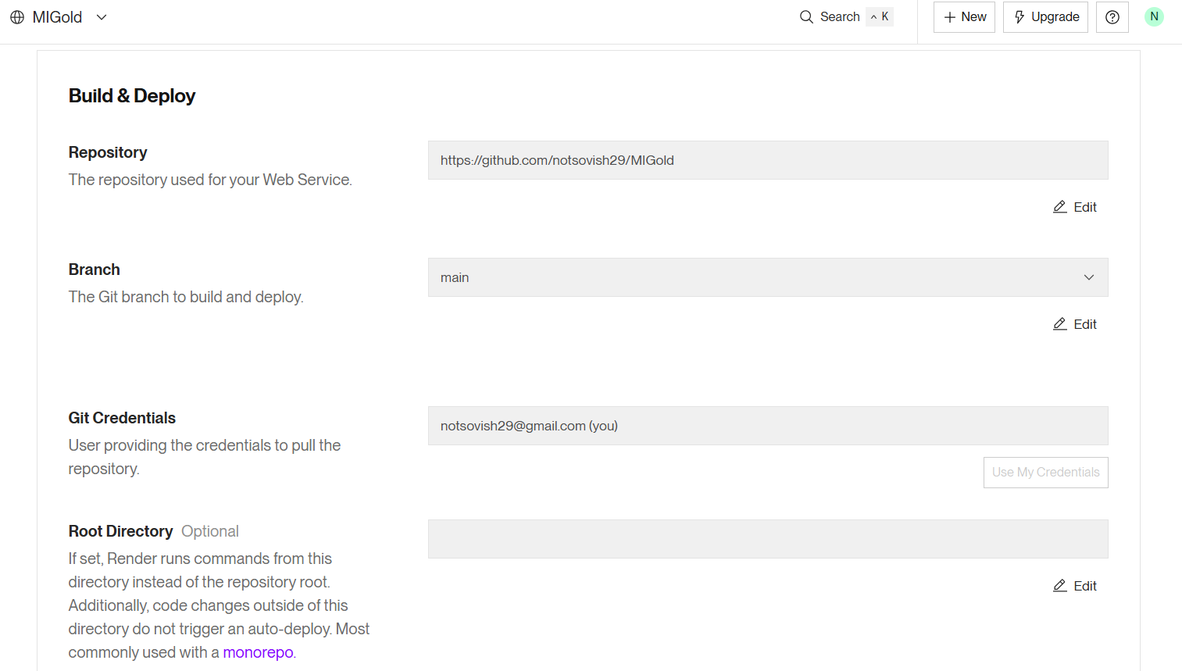

Setting Up Dockerfile
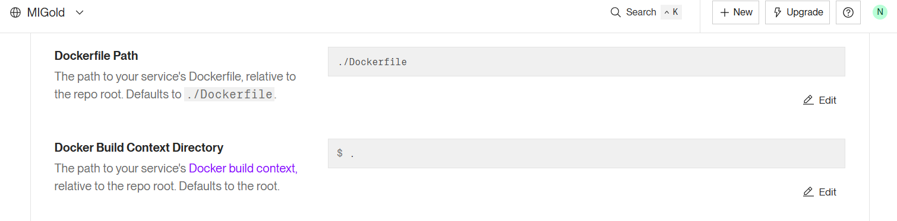

Deployment Logs

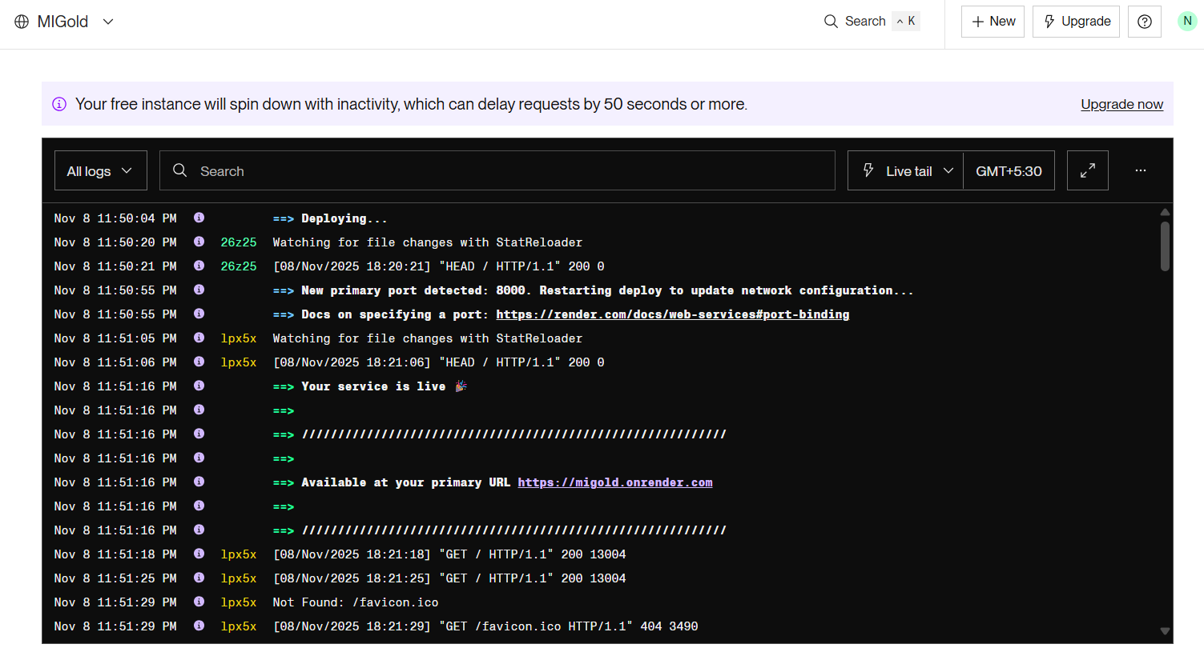

Live Link of Website
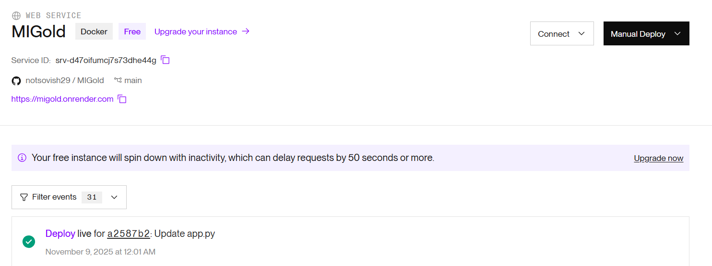

https://migold.onrender.com

7. Ecommerce Webapp Preview
Landing Page
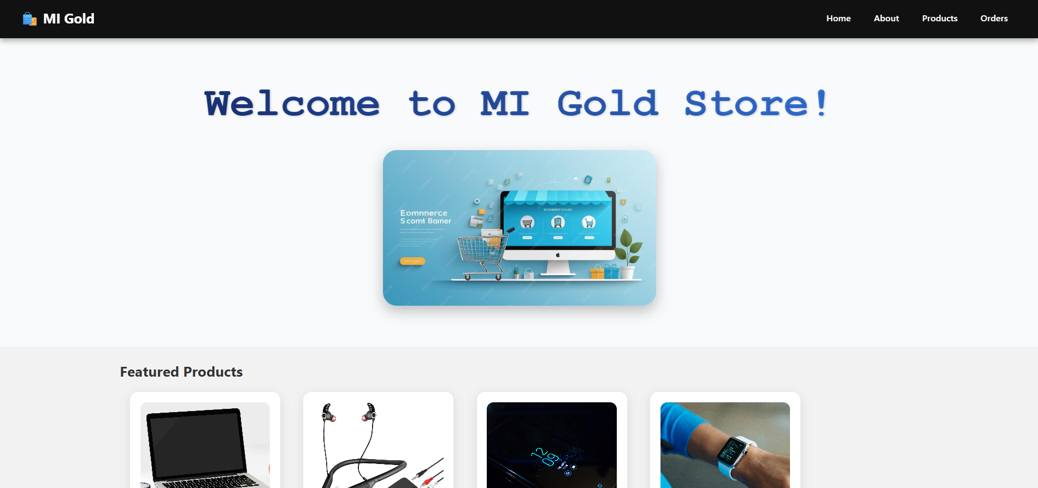
Product Page
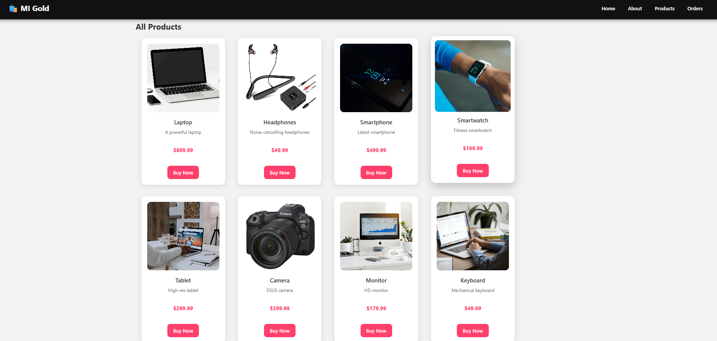

Buy Now
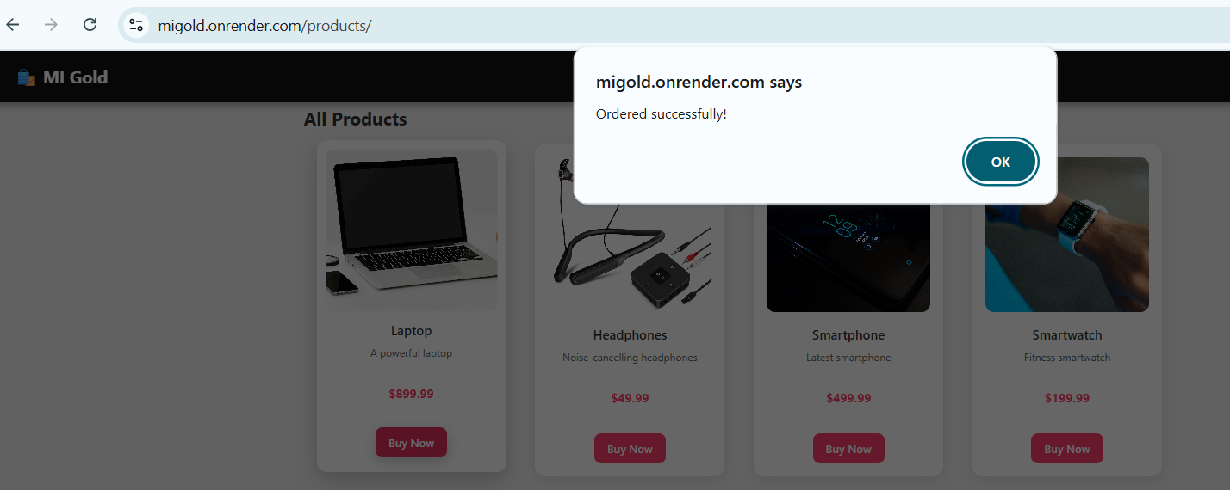
Ordered Item
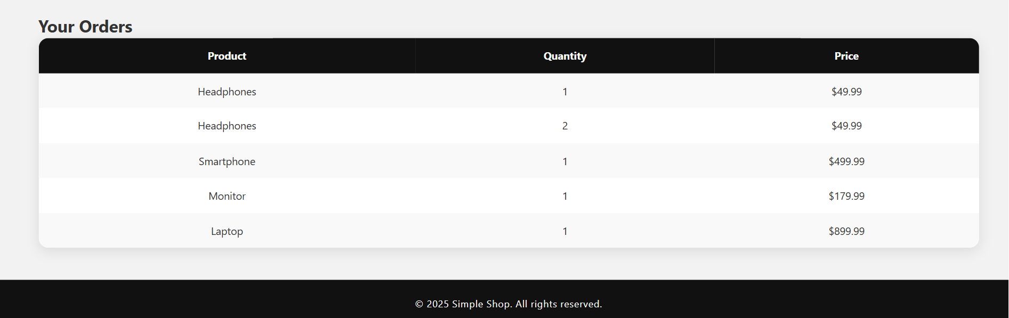

Simple About Page
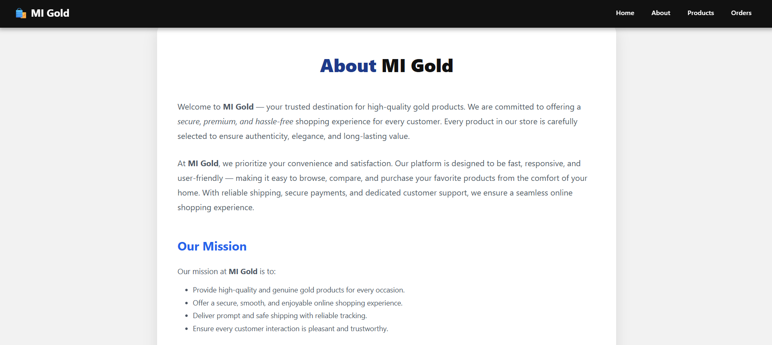

8. Admin page interaction Django administration
URL https://migold.onrender.com/admin
Admin Login
Username : admin
Password : admin123
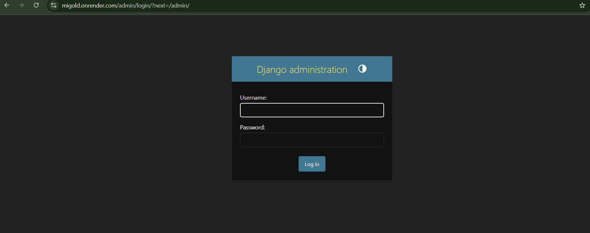

Admin Dashboard
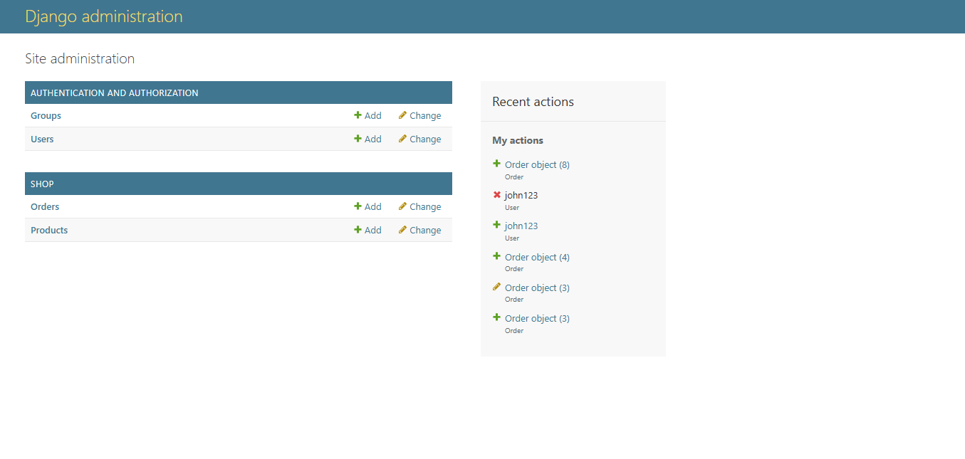

Add Orders

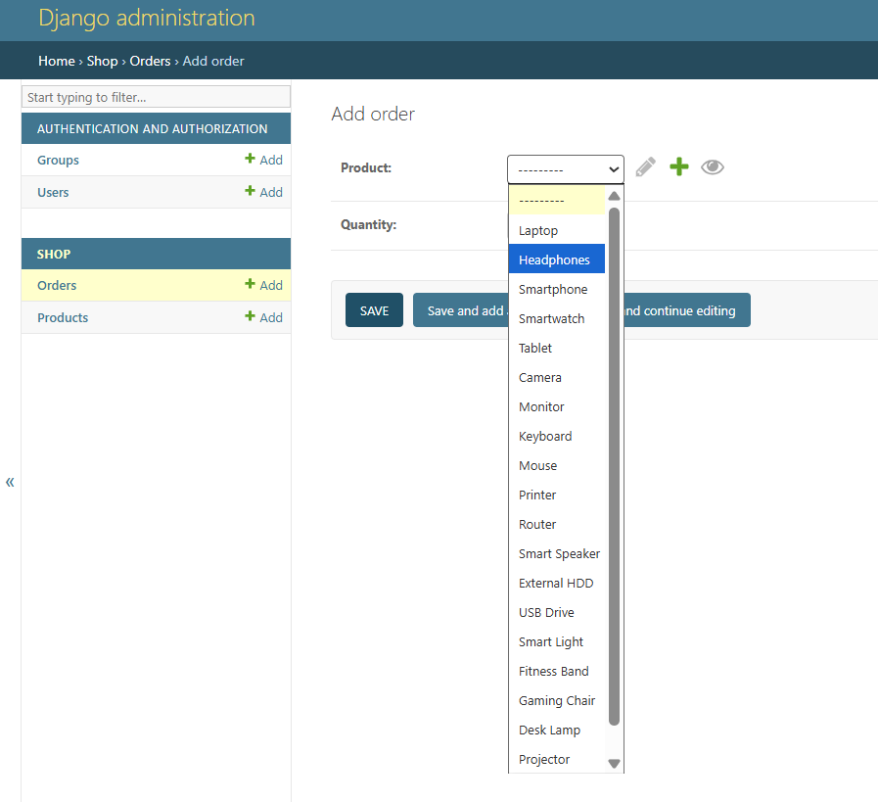

Order Added Successfully
