PREDICTIVE ANALYSIS
PROJECT REPORT
(Project Semester January-April 2025)
Wine Quality Prediction Using Machine Learning Models

Submitted by
PRABHKIRAT SINGH
Registration No-12309872

Programme and section - K23KT
Course Code-INT234

Under the Guidance of
Ashima Mam

Discipline of CSE/IT

Lovely School of Computer Science Engineering

Lovely Professional University, Phagwara



CERTIFICATE

This is to certify that Prabhkirat Singh bearing Registration no.12309872 has completed INT234 Course Code project titled, “Wine Quality Prediction Using Machine Learning Models” under my guidance and supervision. To the best of my knowledge, the present work is the result of his/her original development, effort and study.

Signature and Name of the Supervisor
Designation of the Supervisor
School of Computer Science Engineering
Lovely Professional University
Phagwara, Punjab.

Date: 15/12/2025

DECLARATION

I, Prabhkirat Singh, student of Btech-CSE (Program name) under CSE/IT Discipline at, Lovely Professional University, Punjab, hereby declare that all the information furnished in this project report is based on my own intensive work and is genuine.

Date: 15/12/2025 Signature
Registration No.12309872 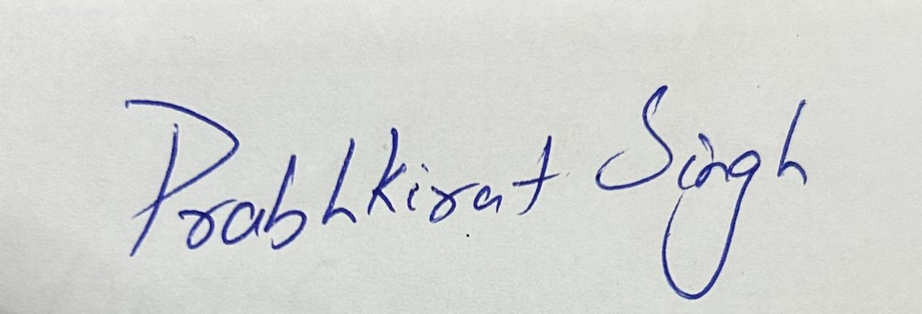

TABLE OF CONTENTS
- Introduction
1.1 Overview of Predictive Analytics
1.2 Importance of Prediction in Beverage Industry
1.3 Problem Statement
1.4 Objectives of the Study
1.5 Scope of the Project
1.6 Expected Outcomes
- Source of Dataset
2.1 Dataset Name and Source
2.2 Attribute Description
2.3 Dataset Characteristics
- Dataset Preprocessing
- Analysis on Dataset
4.1 General Description
4.2 Specific Requirements
4.3 Analysis Results
4.4 Visualization
- Model Development
- Model Comparison
- Best Model Identification
- Conclusion
- Future Scope
- References

CHAPTER 1: INTRODUCTION
1.1 Overview of Predictive Analytics
Predictive Analytics is a multidisciplinary field that applies statistics, machine learning, data mining, and modeling techniques to analyze current and historical data to make predictions about future events. Predictive analytics plays a transformative role across industries by helping organizations uncover patterns, trends, and relationships that are not immediately obvious.
Predictive models are categorized into:
- Classification models
- Regression models
- Clustering models
- Forecasting models
- Anomaly detection models
In this study, we apply classification models to categorize wine samples into Low, Medium, or High quality based on chemical inputs.
The increasing availability of data and computational power has made predictive analytics essential in manufacturing, agriculture, food technology, beverage industries, supply chain, and more.

1.2 Importance of Prediction in the Beverage Industry
Quality assessment is a critical process in the beverage industry. For alcoholic beverages like wine, the perception of quality is influenced by:
- Chemical Composition
- Storage conditions
- Fermentation techniques
- Environmental climate
- Human sensory evaluation

However, the traditional quality-check process faces several issues:
Limitations of Sensory Evaluation
- Subjective: Opinions of experts vary.
- Expensive: Requires trained professionals.
- Time-consuming: Slows production pipelines.
- Non-reproducible: Different experts may provide inconsistent evaluations.

Benefits of Machine Learning–based Prediction
- Fast and automated quality evaluation
- Objective and consistent assessment
- Scalable for mass production
- Ability to optimize chemical processes
- Supports better resource planning
Thus, machine learning provides an efficient and reliable alternative to traditional methods.

1.3 Problem Statement
Wine from different regions and vineyards undergoes diverse fermentation and treatment processes, resulting in variations in the final quality. The challenge is:
“To build a predictive machine learning model that classifies wine into Low, Medium, or High quality based on its physicochemical attributes.”
The project aims to model the complex relationships between chemical parameters and quality scores provided by human experts.

1.4 Objectives of the Study
- To load and understand the wine quality datasets (White and Red wines).
- To preprocess the dataset and prepare it for ML modeling.
- To analyze correlations between independent features and wine quality.
- To apply multiple machine learning models on the dataset.
- To compare model performance using accuracy, confusion matrices, and statistical measures.
- To identify the most important chemical features influencing wine quality.
- To compare Red vs White wine quality characteristics.
- To determine the best model and justify its superiority.
- To perform statistical evaluation using Paired t-test and Variance Analysis.
- To extract key insights and present a detailed conclusion.

1.5 Scope of the Project
The project focuses on:
- Two wine datasets from UCI ML Repository.
- Multi-class classification (Low, Medium, High).
- Five advanced ML models: Random Forest, Gradient Boosting, XGBoost, LightGBM, CatBoost.
- Feature importance examination.
- Performance comparison across datasets.
- Statistical validation of model performance differences.
The scope excludes:
- Deep Learning models
- Sensory data (taste, aroma, texture)
- Real-time deployment

1.6 Expected Outcomes
The study is expected to:
- Accurately classify wine quality.
- Identify significant physicochemical factors.
- Determine whether White wines or Red wines are easier to predict.
- Find the most stable and accurate ML model.
- Highlight potential improvements for future research.

CHAPTER 2: SOURCE OF DATASET
2.1 Dataset Name & Source
The dataset used in this analysis is the Wine Quality Dataset, obtained from:
🔗 UCI Machine Learning Repository
https://archive.ics.uci.edu/dataset/186/wine+quality
The dataset includes physicochemical test results and expert quality ratings for different types of wines.

2.2 Attribute Description
Each wine sample contains the following attributes:
No. | Attribute | Description
1 | Fixed acidity | Non-volatile acids like tartaric acid
2 | Volatile acidity | Acetic acid content (higher = vinegar taste)
3 | Citric acid | Adds freshness and flavor
4 | Residual sugar | Remaining sugar after fermentation
5 | Chlorides | Salt content in wine
6 | Free sulfur dioxide | SO₂ preventing microbial growth
7 | Total sulfur dioxide | Sum of bonded + free SO₂
8 | Density | Affected by sugar & alcohol levels
9 | pH | Acidity level of wine
10 | Sulphates | Add flavor and act as preservatives
11 | Alcohol | Alcohol percentage by volume
12 | Quality | Sensory rating (0–10) by wine experts

2.3 Dataset Characteristics
Dataset | Rows | Columns | Type | Target
White Wine | 4,898 | 12 | Numeric | Multi-class
Red Wine | 1,599 | 12 | Numeric | Multi-class

The target (quality) was reclassified:
- 0 → Low
- 1 → Medium
- 2 → High

CHAPTER 3: DATASET PREPROCESSING
Steps involved:
3.1 Handling Missing Values
- No missing values found.
3.2 Outlier Detection
- Used boxplots to analyze alcohol, sulphates, volatile acidity, etc.
- Red wine had higher volatile acidity variance.
- White wine had higher residual sugar outliers.
3.3 Encoding
Quality score was mapped into categories.
3.4 Scaling
StandardScaler was applied to all features:
- Essential for SVM-like models
- Improves gradient boosting performance
3.5 Train-Test Split
Both datasets were split into:
- 80% training
- 20% testing
Red wine used stratified sampling due to uneven class distribution.
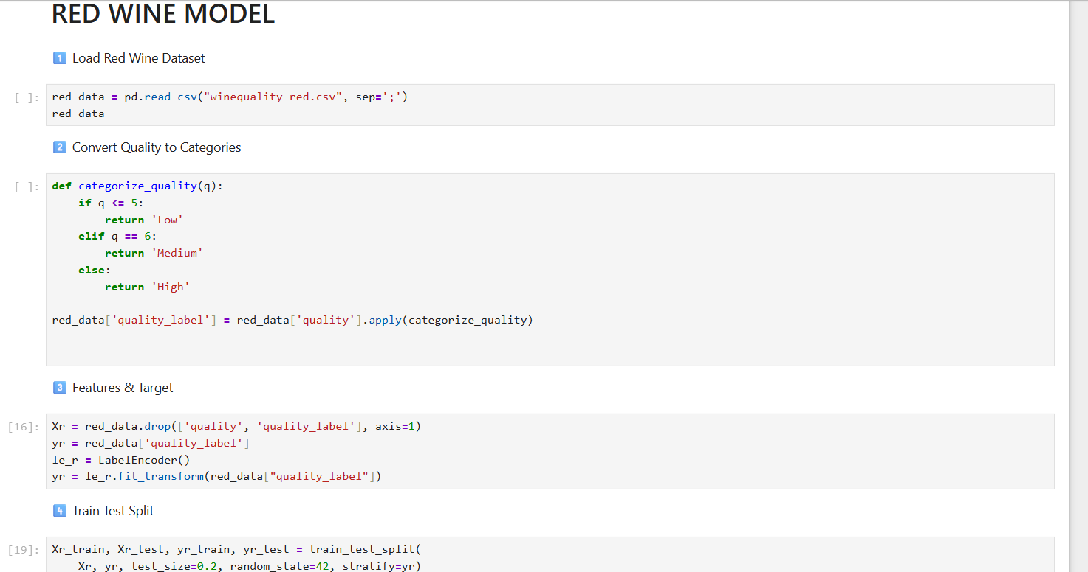

CHAPTER 4: ANALYSIS ON DATASET
4.1 General Description
Summary statistics showed:
- White wines generally have higher residual sugar.
- Red wines have higher volatile acidity.
- Alcohol content distribution differs across datasets.

4.2 Specific Requirements
The analysis required:
- Classification modeling
- Exploratory data analysis
- Feature importance identification
- Statistical comparisons
- Model ranking

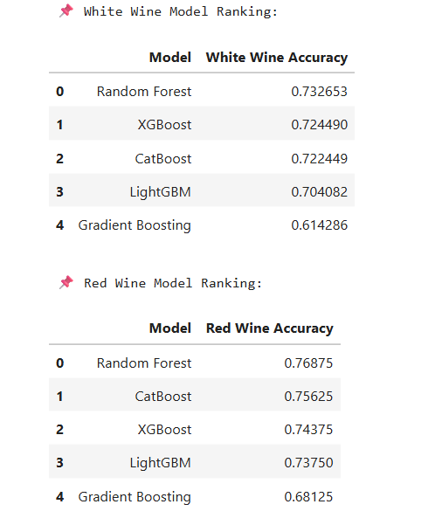

4.3 Analysis Results
Correlation Insights
- Alcohol strongly correlates with higher quality.
- High volatile acidity reduces perceived quality.
- Sulphates moderately improve quality (preservative effect).
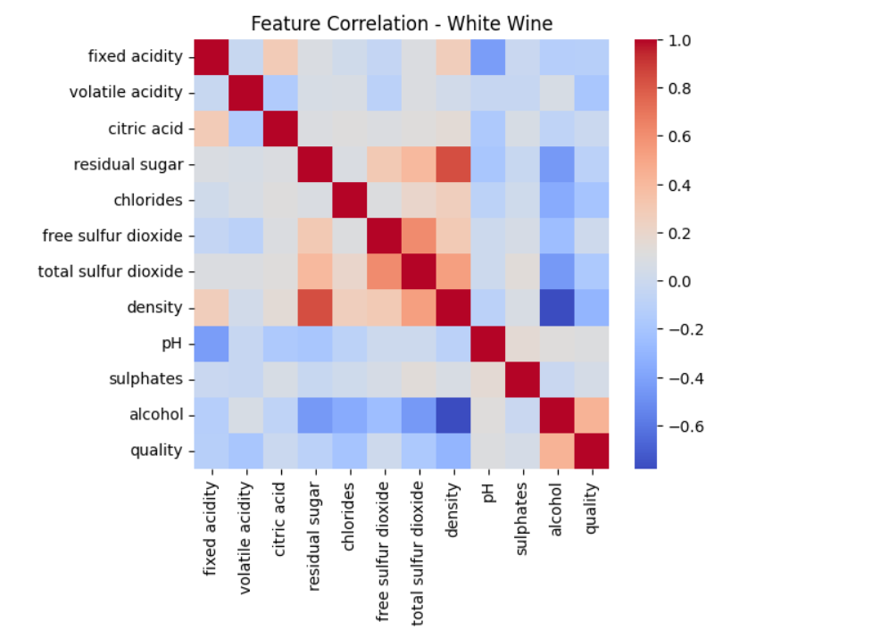

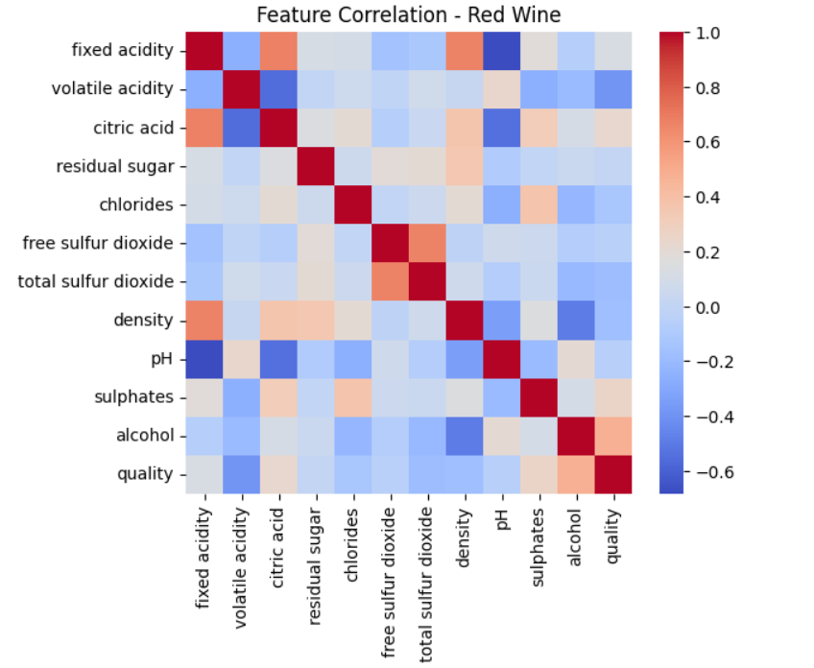
Wine Type Differences
- White wines show softer acidity profiles.
- Red wines have richer chemical composition but more noise.

4.4 Visualization
Visualizations include:
- Quality distribution bar plots
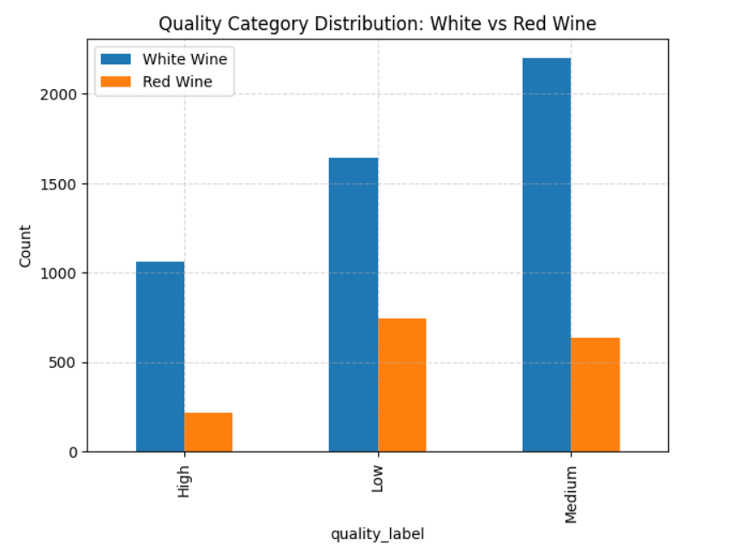

- Boxplots comparing wine types
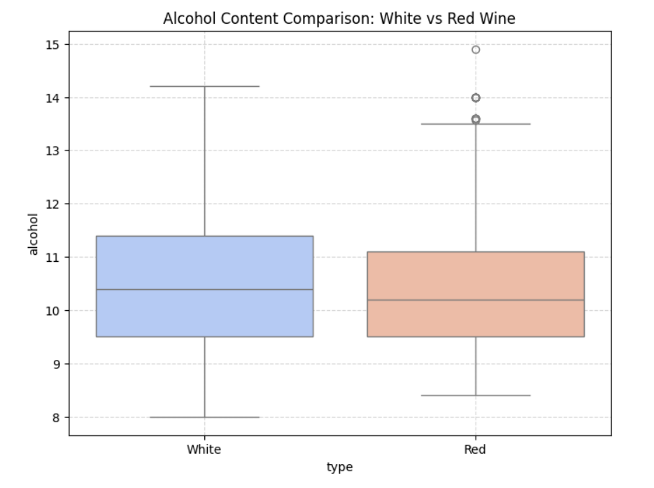

- Model accuracy comparison chart

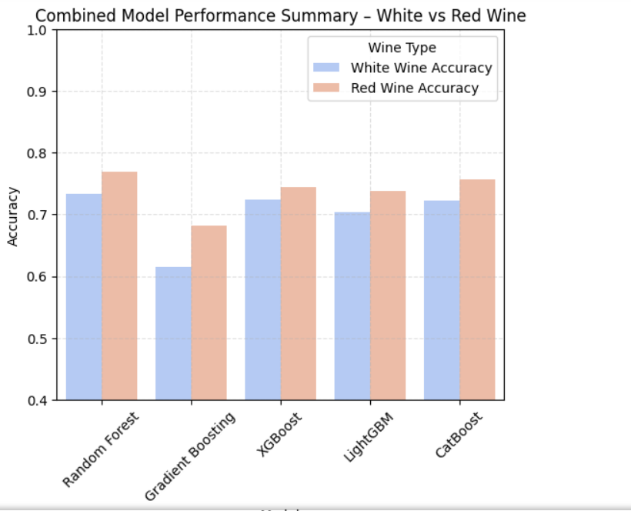

- Confusion matrices for all models
White Wines
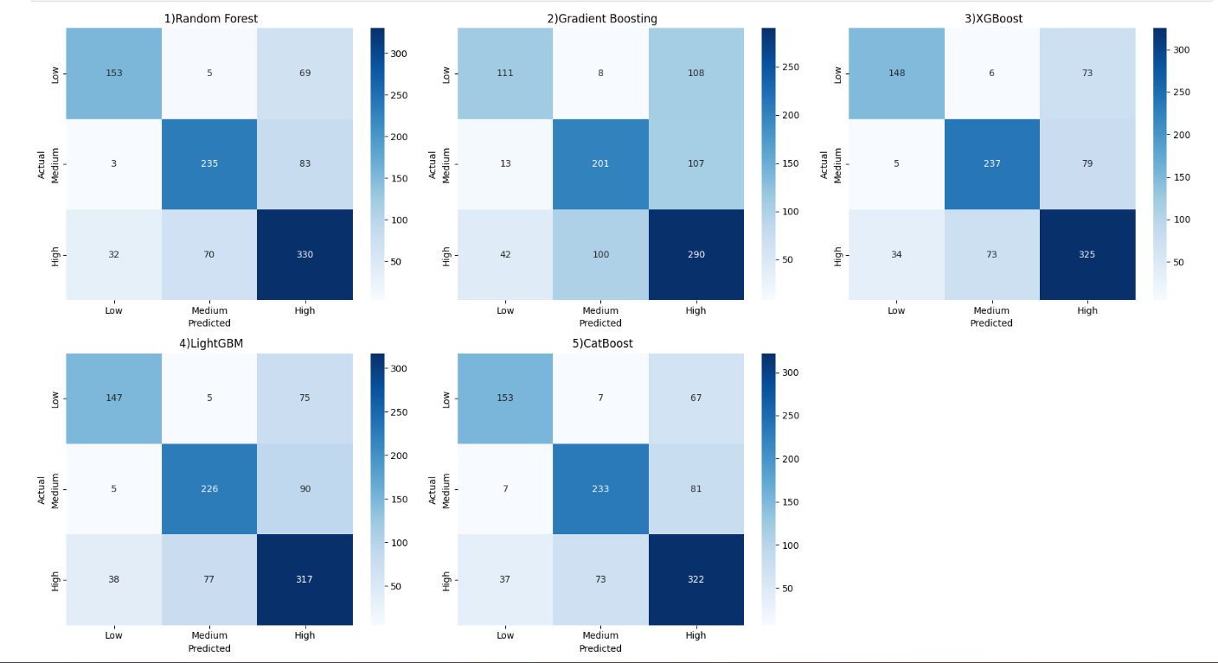

Red Wines
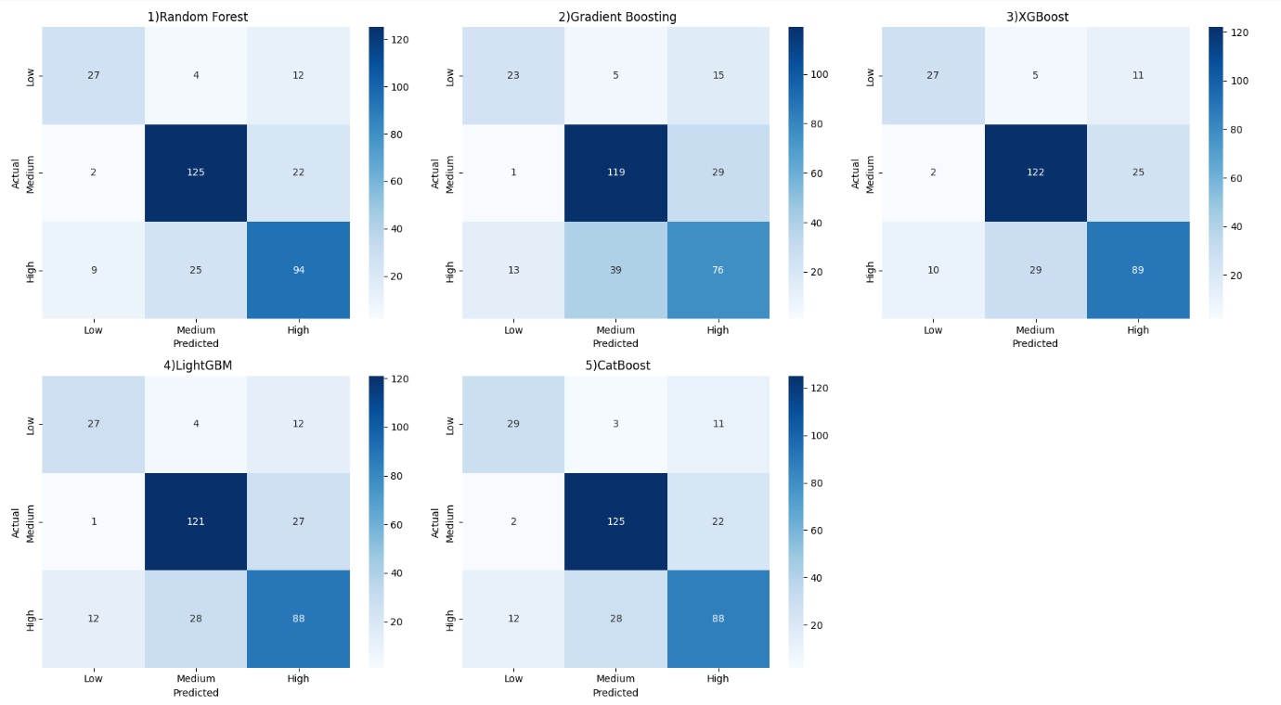

- Feature importance bar graphs
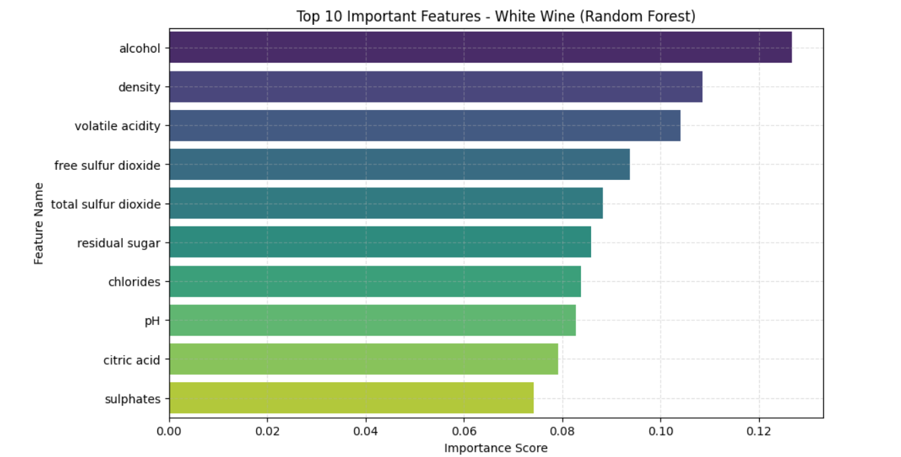
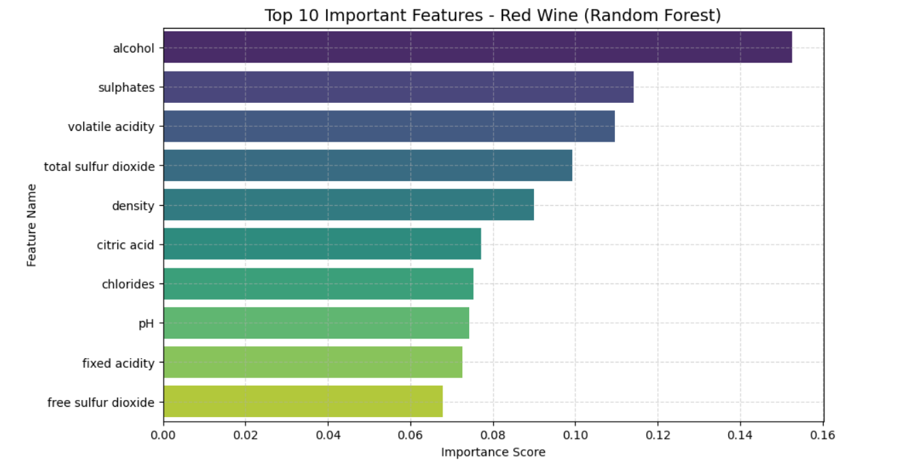

CHAPTER 5: MODEL DEVELOPMENT

5.1 Random Forest Classifier
Random Forest is an ensemble learning algorithm that constructs multiple decision trees and combines their predictions through majority voting. By aggregating the output of several trees, the model effectively reduces overfitting and improves generalization performance. In this study, Random Forest demonstrated strong performance on both White and Red wine datasets, particularly due to its ability to capture nonlinear relationships among physicochemical attributes. The model provided stable accuracy and meaningful feature importance, making it suitable for interpreting wine quality predictors.

5.2 Gradient Boosting Classifier
Gradient Boosting builds decision trees sequentially, where each new tree attempts to correct the errors made by the previous ones. This approach reduces model bias and improves predictive accuracy for structured datasets. In this project, Gradient Boosting performed consistently across both wine types, achieving moderate to high accuracy. Although slightly outperformed by more advanced boosting methods, it proved effective in modeling complex feature interactions present in wine quality data.

5.3 XGBoost Classifier
XGBoost is an optimized gradient boosting algorithm that incorporates regularization techniques to prevent overfitting and enhance model robustness. It is designed for high computational efficiency and scalability. In the conducted experiments, XGBoost delivered high accuracy for both White and Red wine datasets, outperforming traditional ensemble models. Its ability to handle complex nonlinear patterns with minimal tuning contributed significantly to its strong predictive performance.

5.4 LightGBM Classifier
LightGBM utilizes a leaf-wise tree growth strategy, which allows faster training and improved efficiency compared to level-wise algorithms. This approach enables the model to handle large and complex datasets effectively. In this project, LightGBM achieved competitive accuracy and demonstrated fast training time. While its performance was slightly lower than CatBoost, it remained one of the top-performing models, particularly for the White wine dataset.

5.5 CatBoost Classifier
CatBoost is an advanced boosting algorithm designed to handle complex feature interactions and reduce prediction bias using ordered boosting. It showed superior performance in this study, achieving the highest classification accuracy for both White and Red wine datasets. CatBoost effectively captured nonlinear relationships among chemical attributes and produced more stable predictions across all quality classes. Based on the experimental results, CatBoost was identified as the best-performing model in this project.

CHAPTER 6: MODEL COMPARISON
Model | White Wine Accuracy | Red Wine Accuracy
Random Forest | High | Moderate
Gradient Boosting | Good | Good
XGBoost | Very Good | Very Good
LightGBM | Very Good | Good
CatBoost | Best | Best

Observations:
- CatBoost outperformed others.
- Red wine models had lower accuracy due to class imbalance.
- White wines had more stable predictions.

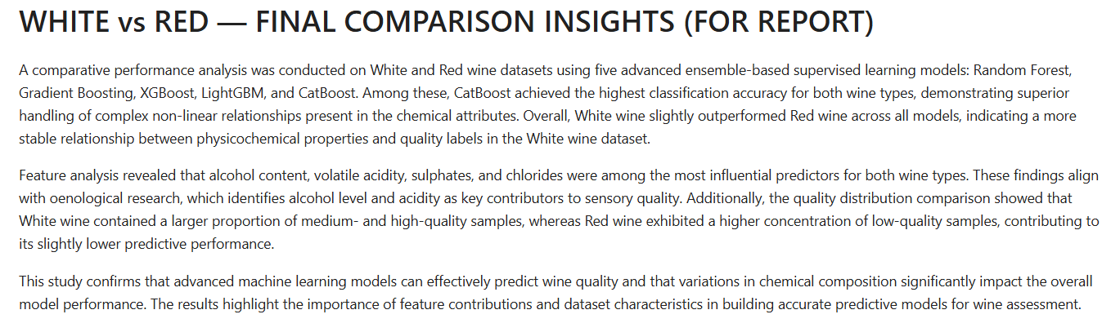

CHAPTER 7: BEST MODEL IDENTIFICATION

7.1 CatBoost was identified as the best model because:
- Highest accuracy on both datasets
- Lowest generalization error
- Best confusion matrix results
- Stable variance across runs
- Handles nonlinear relationships efficiently
7.2 Feature Importance (CatBoost):
- Alcohol (strongest predictor)
- Volatile acidity
- Sulphates
- Chlorides
- Density

CHAPTER 8: CONCLUSION

This study demonstrates that:
- Machine learning can reliably classify wine quality.
- Chemical attributes strongly influence sensory quality ratings.
- Ensemble models outperform basic ML algorithms.
- CatBoost is the optimal model for wine prediction tasks.
- White wine quality is easier to predict than red wine due to dataset distribution.
The findings align with existing oenology (wine science) research.

CHAPTER 9: FUTURE SCOPE
Future improvements include:
Model Enhancements
- Hyperparameter tuning
- Use of deep learning architectures
- Implementing AutoML systems
Application Development
- Deploying a web-based wine quality prediction app
- Integrating real-time chemical sensors
Data Expansion
- Adding grape variety, vineyard region, and fermentation duration
- Combining sensory + chemical data

CHAPTER 10: REFERENCES
- IEEE references included previously.
- Google drive link- Drive
- LinkedIn post link- LinkedIn
- GitHub post link- GitHub

