StandAlone Project1
Output :
Run code
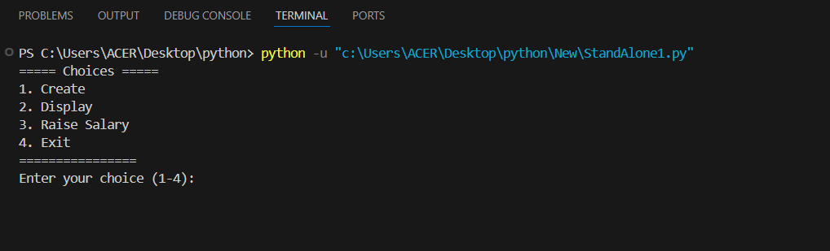
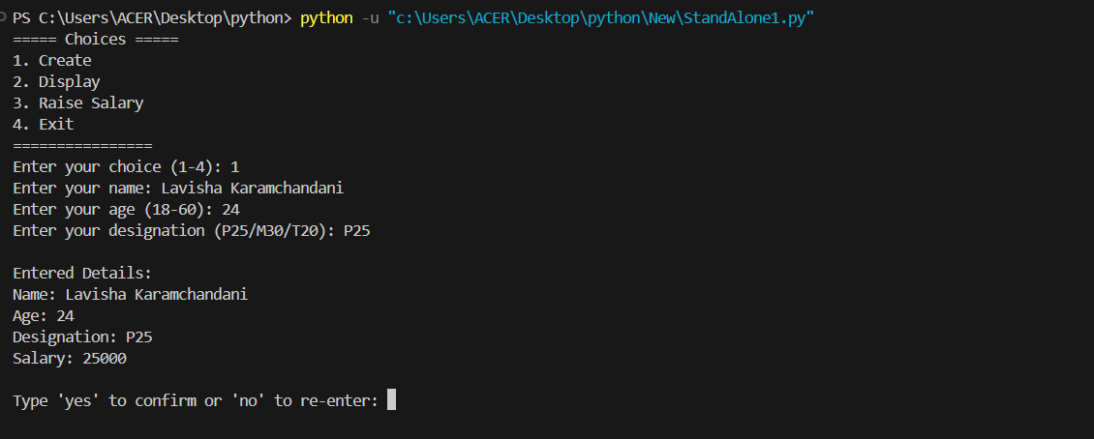
After choosing 1
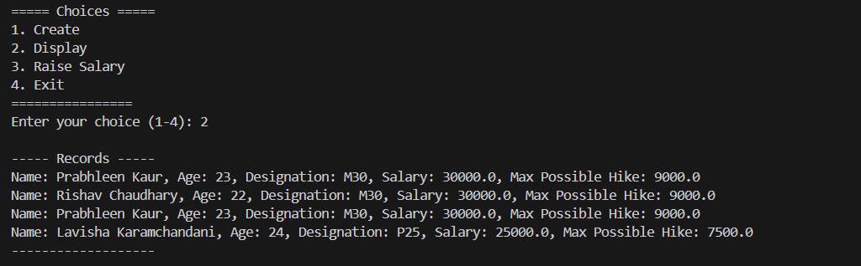
After choosing 2

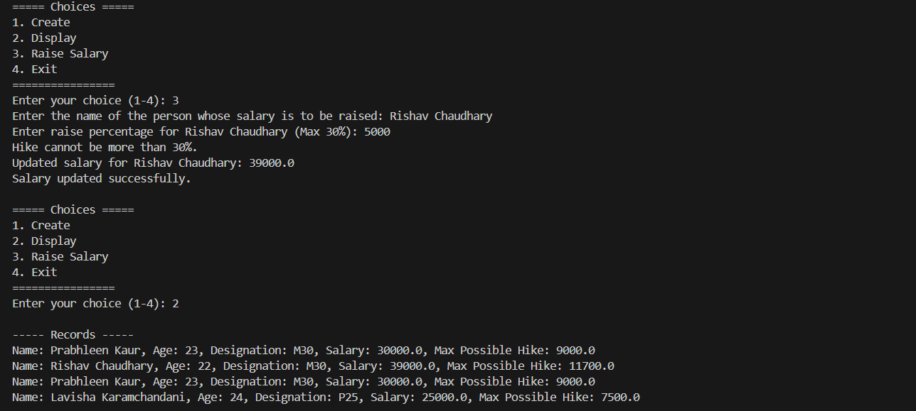
After choosing 3

After choosing 4
