**Attendance Management System (AMS) - Android Application**

**Prabhleen Kaur**

**Abstract:**

This project is based on the development of Android Application and implementation of Encryption and Decryption. AMS is an Android Mobile Application which will work to manage the attendance for each individual student enrolled in different courses. It will have student and professor login account with the details about the student, course and the schedule for the classes. It uses Authentication and encryption for student to login into its account and for submitting attendance to the professor. It uses Google Map APIs to display and store the student location while submitting the attendance .It is used to confirm and verify student‘s presence by the location of the student.

**Introduction:**

AMS is an android app used to manage attendance. It will track the attendance for each individual students enrolled in different courses. The purpose of the app is to prevent the risk if student submit attendance while not present physically in the class. In order to do this, I have used Google API’s to get and store location of the student while the student is submitting the attendance.

For Storing the data having details of student and the courses they are enrolled in and the details pf professors, I have used Firebase. For Authentication of user, I have used Firebase Authentication service.

In order to ensure the privacy of the student, I have implemented Advanced Encryption Standard algorithm to save the location in encrypted form in the database which will be only visible to the Professor through his account. This is done to provide an extra layer of protection towards the privacy of the student.

**Features of AMS app:**

* College credentials will be user so user is not required to register for an account.
* It will allow student to submit attendance only after the class has started and before class ends.
* It will show the exact time left for student next to start.
* The location will be stored in database in encrypted form but will be available to professor’s account.
* The change in status is reflected immediately in the database.

**Background and Related works:**

The motivation of the project was to link the Attendance Submission with location tracking and to implement the encryption on the location of user instead of using for user authentication and to make that Student location details available only in professor account.

**Existing System:**

The concept of android app to track the attendance is not new and there are many apps in the google play store for the same purpose but the unique feature of this app is that when the student submit the attendance the location of the student is also recorded and submitted. It prevents the risk of the student cheating about their presence in the class and their attendance irrespective of the number of students in the class**.**

**Proposed System:**

The project uses Advanced Encryption Standard algorithm to encrypt student location and store encrypted location in database. The key used for encrypting the location is set during launch of the application and is used throughout the app for encryption process. It uses AES algorithm with Base 64 to encrypt and decrypt. To implement encryption java built in crypto library is used. It uses SHA 1 to encrypt user location. It uses java security package which has a secure one way hash function that takes arbitrary sized data and output a fixed length hash values. This provides an additional layer of security for the application and the data stored in database

It provides the timer for each class which displays how many hours, minutes and seconds left for next class to start and shows the status of the class as “in progress” of the class which already started.

**Methodology:**

System specifications used for building the apps:

The app is built using android studio version 3.1.2 and programming language used is JAVA and JSON.

* For database, I have used Firebase services.
* For app development the libraries used are java built in libraries.
* For implementation of encryption java built in crypto package and security package is used.

This works as every registered student will its account and will use these credentials .i.e. College user ID and password to access the account.

* When open the app, first the flash screen with the delay of 5000ms will land us to the login screen which will ask the credentials for the user to login.

This page uses authentication for the user to access the account. It has two

Buttons one to login and other to clear the entered data.

 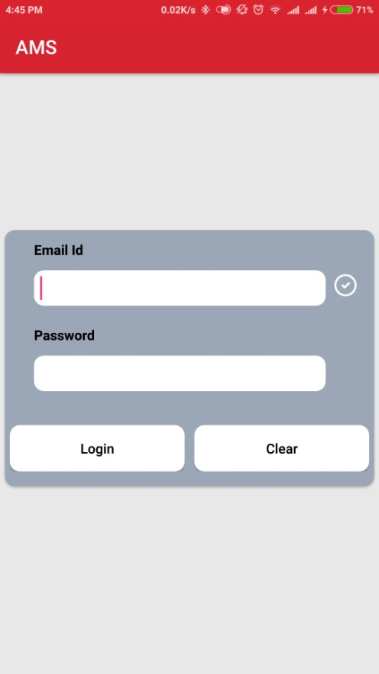

* The login button is used ,it will launch the page with the tabs for each day of the week with only the tab accessible with the current day to the student.

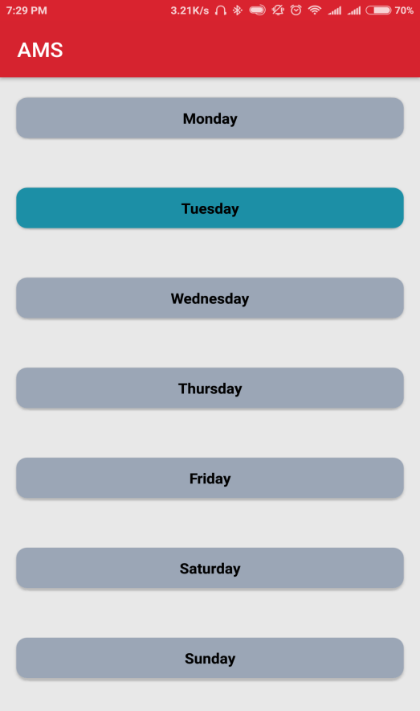 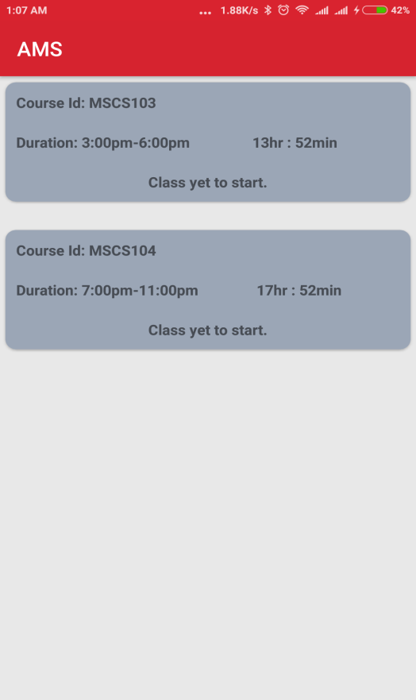

* After clicking the current day tab, student will be directed to the schedule for the current day .The page will include the course details. It will also display the status of the class if it is in progress or how much time left for the class to begin of if the class is over.
* Student can have access only to the courses with the class status in progress ,to submit the attendance to the professor for the approval.

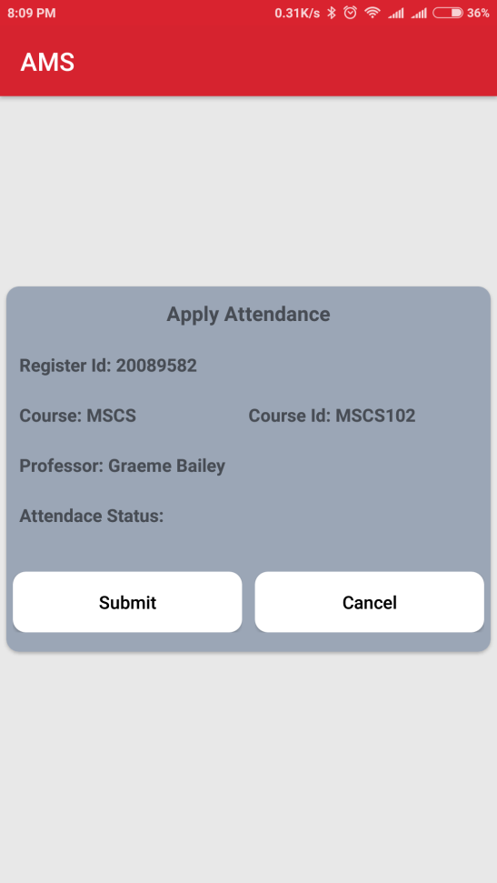 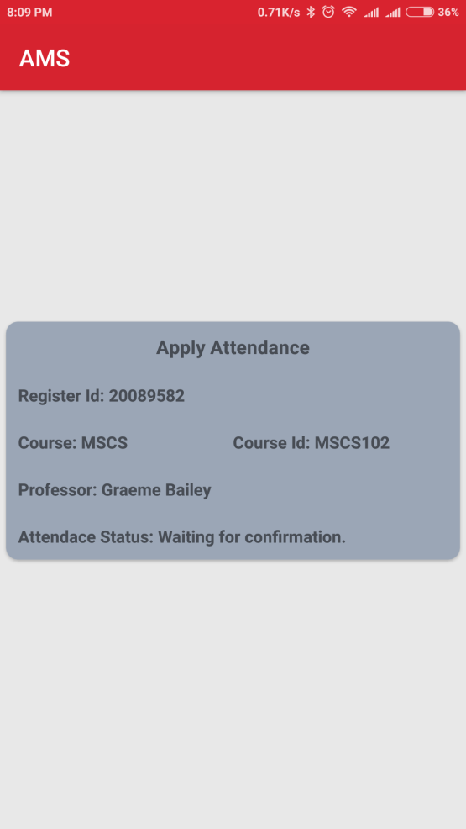

By clicking on the submit button for the class in progress, student can submit

attendance .

* The next page will display the status of attendance along with the students location whether the student is in the class or somewhere else at the time of submitting the attendance .
* The attendance will be in the status of awaiting confirmation till the professor accepts from the account.
* Once the Professor accepts/rejects the attendance, the status will be changed in the database as well as students account.

**Experiment:**

1. Tested the application using the data for all the seven days of the week.
2. Tested the status of the class using the schedule for every hour and the details for the courses.
3. Tested the location by using fake student data and the account credentials.

**Analysis and possible additional features:**

The complete data is linked and stored using the Firebase .For tracking and storing the location Google Map APIs are used. The student data for authentication and course details are stored in the database using JSON file. The encrypted data of the user is used for the authentication purpose.

**Limitations:**

* It shows Schedule only for current week
* Student cannot retrieve the record for whole semester
* Student has to manually turn On location permission
* Cannot be changed once Accepted or rejected

Additional possible features:

* It can have overall record of the student along with the academic record and grades for all the courses student is enrolled in.
* It can be made available even if student is not connected with the data or Wi-Fi (in offline mode).
* Use of fingerprint or face detection feature to access the user account .
* Can be made available in different languages as per the user choice.
* Announcement and notification
* Professor can view only students present in location same as professor
* Extend on IOS platform

**System specification:**

Hardware : Mobile ,tablet or iPad

Software : Android version 4.3 and above

Programming language :Java ,HTML ,SQL ,JSON

IDE : Android studio 2.3.1

APIs : Google Map APIs

Note: I have attached the video for Activity window which shows the complete working of the app and the database. I have also attached the Student activity video and professor video.

The code for the app is attached in separate folder.

**Conclusion:**

The AMS android app will used to update and maintain the attendance by reducing the time and efforts of the professor to manually update and verify for the presence of each student during the class. This app will reduce the risk of false attendance of the student by recording the location of the student at the time of submitting attendance.

**Reference:**

* <https://developer.android.com/studio/intro/index.html>
* <https://firebase.google.com/docs/>
* <https://developers.google.com/maps/documentation/>
* Vishal Bhalla, Tapodhan Singla, Ankit Gahlot, Vijay Gupta, "Bluetooth Based Attendance Management System", *International Journal of Innovations in Engineering and Technology (IJIET)*.
* https://www.youtube.com/watch?v=k1D0_wFlXgo
* Md. Milon Islam, Md. Kamrul Hasan, Md Masum Billah, Md. Manik Uddin, "Development of smartphone-based student attendance system", *Humanitarian Technology Conference (R10-HTC) 2017 IEEE Region 10*, pp. 230-233, 2017, ISSN 2572-7621.

**Screenshot and code snips**



