I installed Magento 2.3.0 using LEMP stack:

Dependency versions i used:
Ubuntu: 20.04
Nginx: 1.18.0
Php: 7.2
mySQL: 8.0.26

Steps I followed:

You can check the requirements system for Magento 2.3 in the link https://devdocs.magento.com/guides/v2...

- apt-get update
- apt-get -y install git wget curl nano unzip sudo vim net-tools openssh-server
- apt-get -y install nginx
- service nginx start
- nginx -v
- apt-get install software-properties-common
- add-apt-repository ppa:ondrej/php
- apt-get update
- apt-cache search php7.2
- apt-get install php7.2 libapache2-mod-php7.2 php7.2-common php7.2-gd php7.2-mysql php7.2-curl php7.2-intl php7.2-xsl php7.2-mbstring php7.2-zip php7.2-bcmath php7.2-soap php-xdebug php-imagick
- php -v
- apt-get install php7.2-fpm
- nano /etc/php/7.2/fpm/php.ini
- press ctrl + w for searching memory_limit = 2G max_execution_time = 3600 max_input_time = 1800 upload_max_filesize = 10M zlib.output_compression = On press ctrl + O for saving
- service php7.2-fpm start
- apt-get install -y mysql-server mysql-client
- enter the password for the root user: giaphugroup
- service mysql start
- mysql_secure_installation
- SHOW VARIABLES LIKE "%version%";
- curl -sS https://getcomposer.org/installer | php -- --install-dir=/usr/local/bin --filename=composer
- composer --version
- ***************************************************************
- MY ERROR:
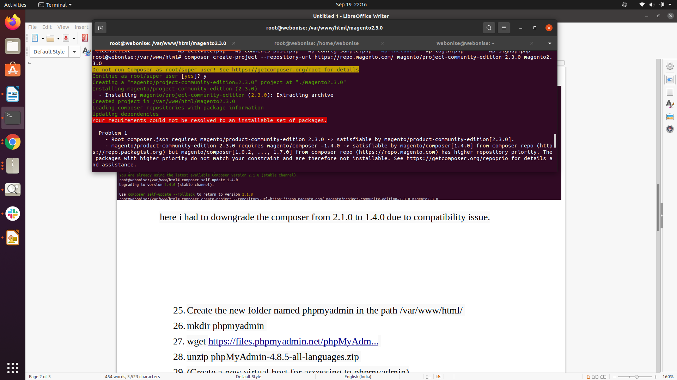

here i had to downgrade the composer from 2.1.0 to 1.4.0 due to compatibility issue.
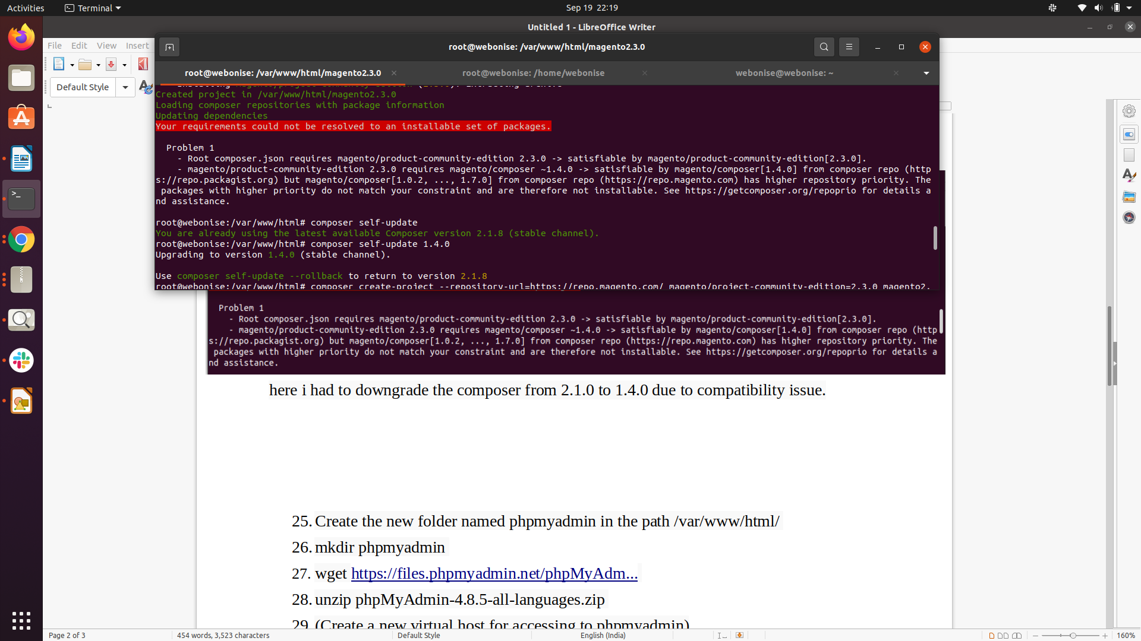

After this, all the next steps worked fine.
********************************************************************
- Create the new folder named phpmyadmin in the path /var/www/html/
- mkdir phpmyadmin
- wget https://files.phpmyadmin.net/phpMyAdm...
- unzip phpMyAdmin-4.8.5-all-languages.zip
- (Create a new virtual host for accessing to phpmyadmin)
- nano /etc/nginx/sites-available/phpmyadmin
server {
listen 9000;
root /var/www/html/phpmyadmin/phpMyAdmin-4.8.5-all-languages; server_name localhost;
index index.php index.html index.htm;
location / { try_files $uri $uri/ /index.php?$args; }
location ~ \.php$ { include snippets/fastcgi-php.conf; fastcgi_pass unix:/run/php/php7.2-fpm.sock; }
location ~ /\.ht { deny all; }
}
- ln -s /etc/nginx/sites-available/phpmyadmin /etc/nginx/sites-enabled
- nginx -t
- service nginx restart
- netstat -plnt (3306 is of mysql service , 9000 of the phpmyadmin site)
- Install and configure Magento 2.3.0
- Create the Magento authentication keys: https://marketplace.magento.com/
- Create the new database named magento2_3_0: http://localhost:9000
- - cd /var/www/html - composer
- create-project --repository-url=https://repo.magento.com/ magento/project-community-edition=2.3.0 magento2.3.0 - cd magento2.3.0
- find var generated vendor pub/static pub/media app/etc -type f -exec chmod g+w {} +
- find var generated vendor pub/static pub/media app/etc -type d -exec chmod g+ws {} +
- chown -R :www-data .
- chmod u+x bin/magento
- php bin/magento setup:di:compile
- (Create a new virtual host for accessing to the Magento2.3.0 site)
- nano /etc/nginx/sites-available/magento2.3.0
upstream fastcgi_backend { server unix:/run/php/php7.2-fpm.sock; }
server {
listen 86;
server_name localhost;
set $MAGE_ROOT /var/www/html/magento2.3.0;
include /var/www/html/magento2.3.0/nginx.conf.sample;
}
- ln -s /etc/nginx/sites-available/magento2.3.0 /etc/nginx/sites-enabled
- nginx -t
- service nginx restart
- netstat -plnt (86 is of the magento 2.3.0 site)
- Install Magento 2.3.0: http://localhost:86
- cd /var/www/html/magento2.3.0
- php bin/magento setup:static-content:deploy -f

