|  |  |
| --- | --- |
| **Name :** | |
| ***Question 1 (70 points)*** | ***Question 2 (30 points)*** |

**RULES**

During the practical test, all students are expected to follow the rules outlined below:

* + The practical test consists of developing an App in Android Studio.
  + Use of laptops or lab computers and other materials:
    - In the practical test, you are allowed to use any materials including slides, books, assignments/programs created by you or the solutions provided by the professor, Android developer Documentation, and Internet.
    - Lap computers or Laptops must be used in the practical test.
    - Code will be submitted in e-centennial and check with the professor that the submission was successful before you leave the exam.
    - Students are not allowed to use someone else’s solutions – only solutions created by them or the professor.

**BE SURE TO READ THE FOLLOWING GENERAL INSTRUCTIONS CAREFULLY:**

* + This lab test must be completed individually by all the students.
  + You should attach the solution with **output screen** shots and then **submit the project.**
  + You should complete this lab test given time duration and no extra time given.

**Question 1 (*70 points*)**

# INSTRUCTIONS AND DESCRIPTION

1. Design a JSP page “**orderApplicationForm.jsp**” that handles a request and an action on “**orderApplicationController**.java. The page is a simple “**Online Order Application**” form as shown in next page.

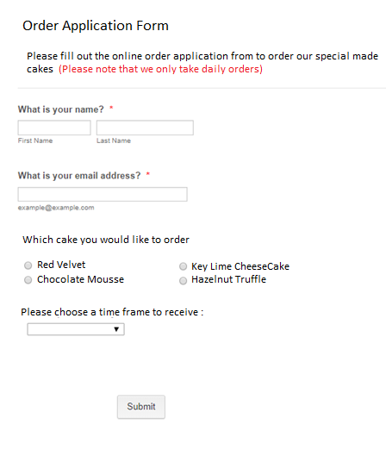

**Hint:**

1. Create a Model class “**orderApplicationModel**” with the appropriate properties and methods to handle the user input data and printouts.

1. Code a controller “**orderApplicationController**” to get the data from “**orderApplicationForm.jsp**” page and publish the output as the following format in the “**thankYouView.jsp”** page.

|  |
| --- |
| Thank you **Azer KARADAG** for your order. Your order, **Key Lime CheeseCake** will be delivered today at **5:00 pm**. |
|  |

**Question 2 (*30 points*)**

# INSTRUCTIONS AND DESCRIPTION

* 1. Run following SQL statement in your MySQL Workbench

use Centennial;

SET SQL_SAFE_UPDATES = 0;

delete from employee;

INSERT INTO employee values( 2122, 'John', 'Professor',75000.00);

INSERT INTO employee values( 2123, 'Anna', 'Assistant',50000.00);

INSERT INTO employee values( 2124, 'Jeff', 'Professor',70000.00);

INSERT INTO employee values( 2125, 'Malik', 'Professor',65000.00);

INSERT INTO employee values( 2126, 'David', 'Professor',65000.00);

INSERT INTO employee values( 2127, 'Cobi', 'Assistant',30000.00);

INSERT INTO employee values( 2128, 'Jennifer', 'Manager',55000.00);

INSERT INTO employee values( 2129, 'Halim', 'Manager',75000.00);

INSERT INTO employee values( 2130, 'Kim', 'Manager',85000.00);

INSERT INTO employee values( 2131, 'Sue', 'Assistant',35000.00);

INSERT INTO employee values( 2132, 'Ally', 'Manager',95000.00);

select * from employee;

commit;

Confirm that you have an output like below after you run the SQL statements provided :

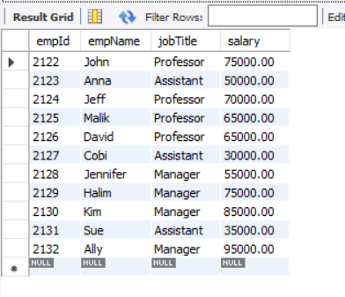

Now modify your EmployeeJPA print out only staff who has salary less than 56000.00, Only include and zip your EmployeeController as your answer.

**Don’t forget to zip your solutions before you submit**

**Good Luck!!**