SECURITY IMPLEMENTATION:

databricks service principal

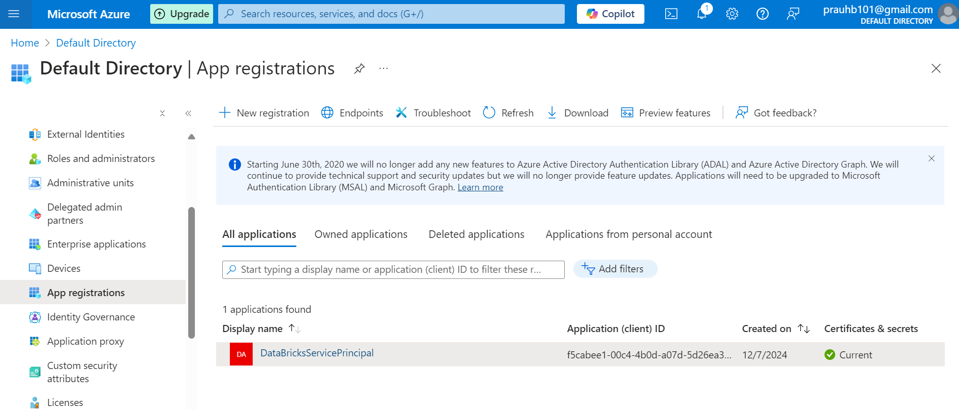

Azure key vault to store the “service-credential-key” as a secret and use it to connect to ADLS from databricks.

Created a group in azure entra and added the required members, this group can be used while assigning data contributor roles on ADLS. The group contains service principals (databricks, ADF, Synapse Analytics)

Cluster configuration to access the ADLS using via Azure service principal

Access to databricks for data factory via system assigned managed identity

data contributor role on raw ADLS, assigned to the group created earlier

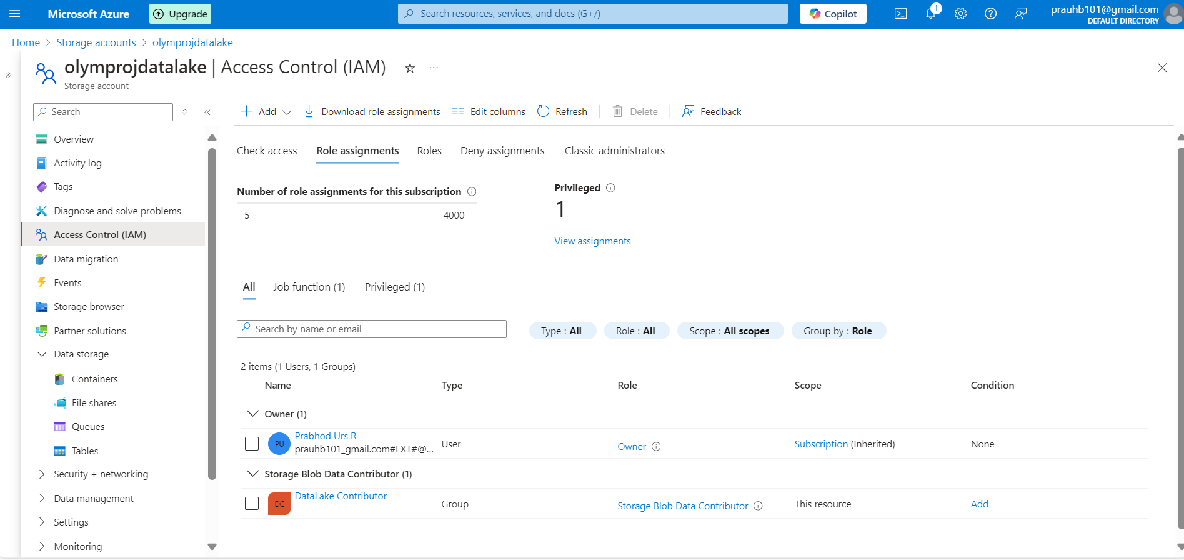

data contributor role on curated ADLS, assigned to the group created earlier

