Ans 1

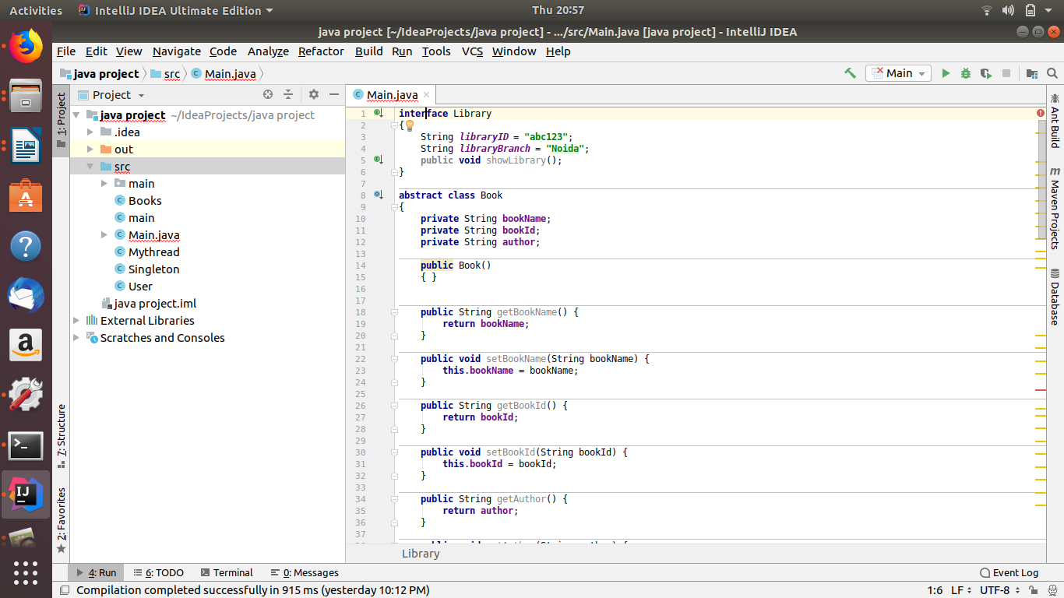
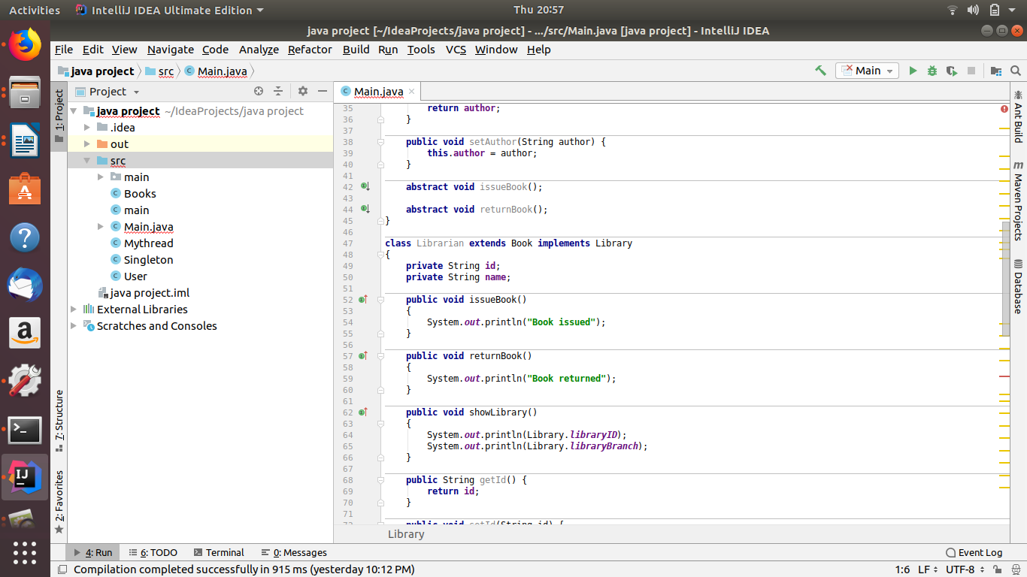
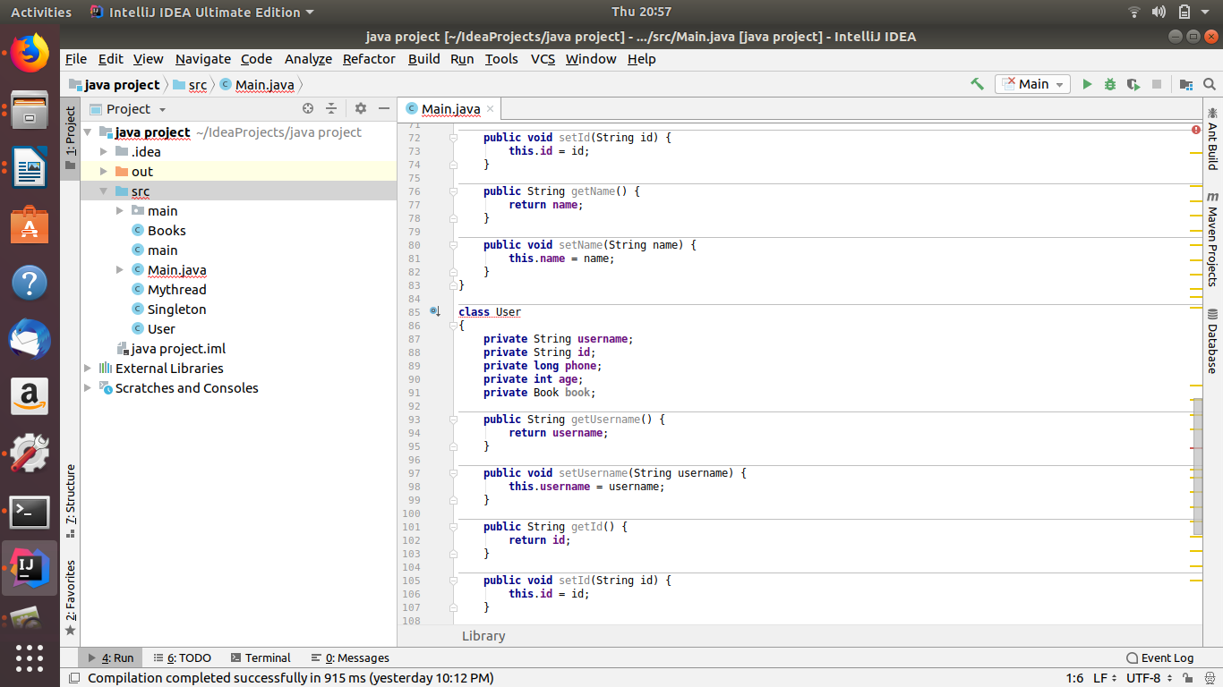

Ans 2

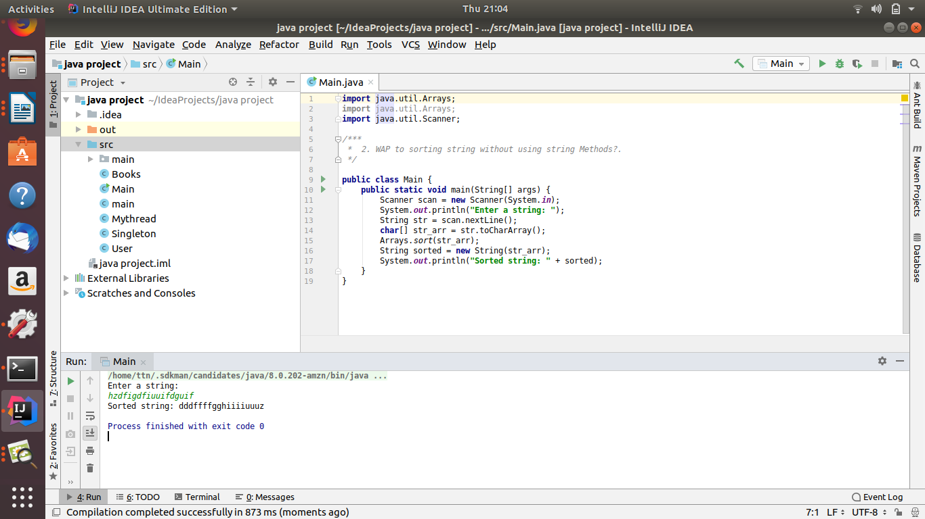
Ans 3

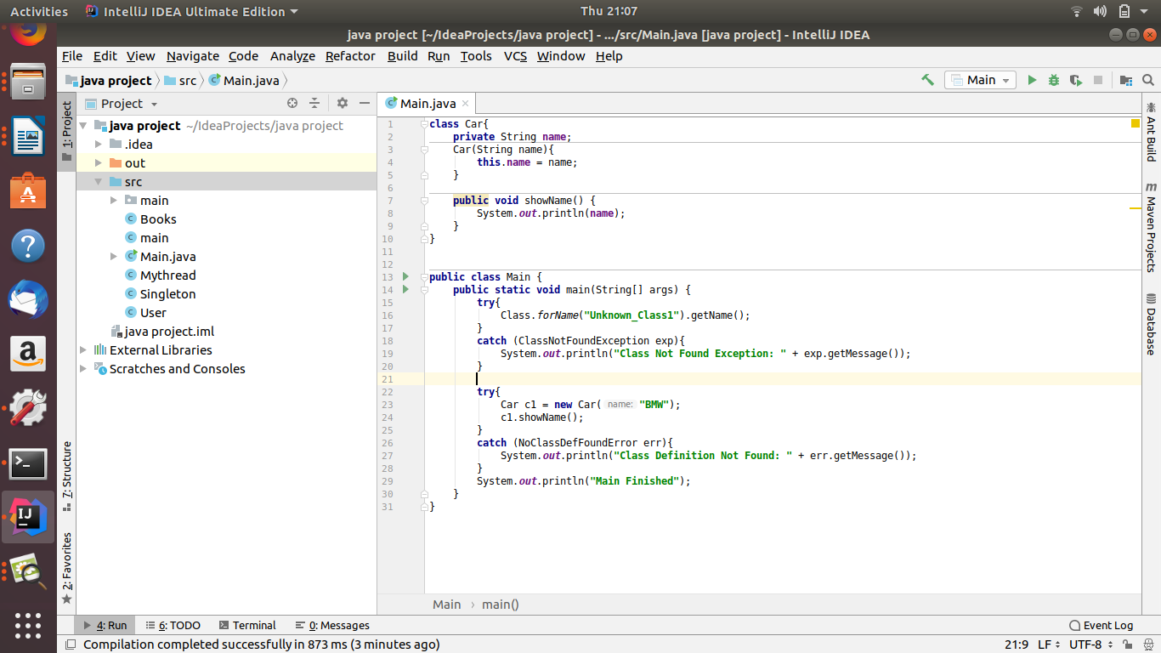

Ans 4
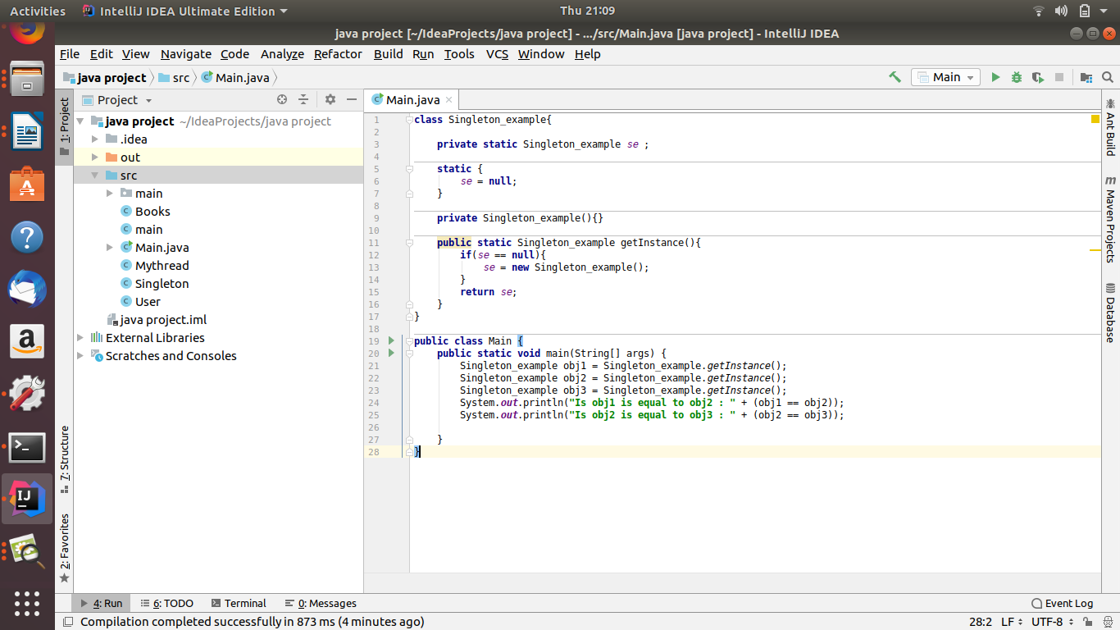
Ans 5

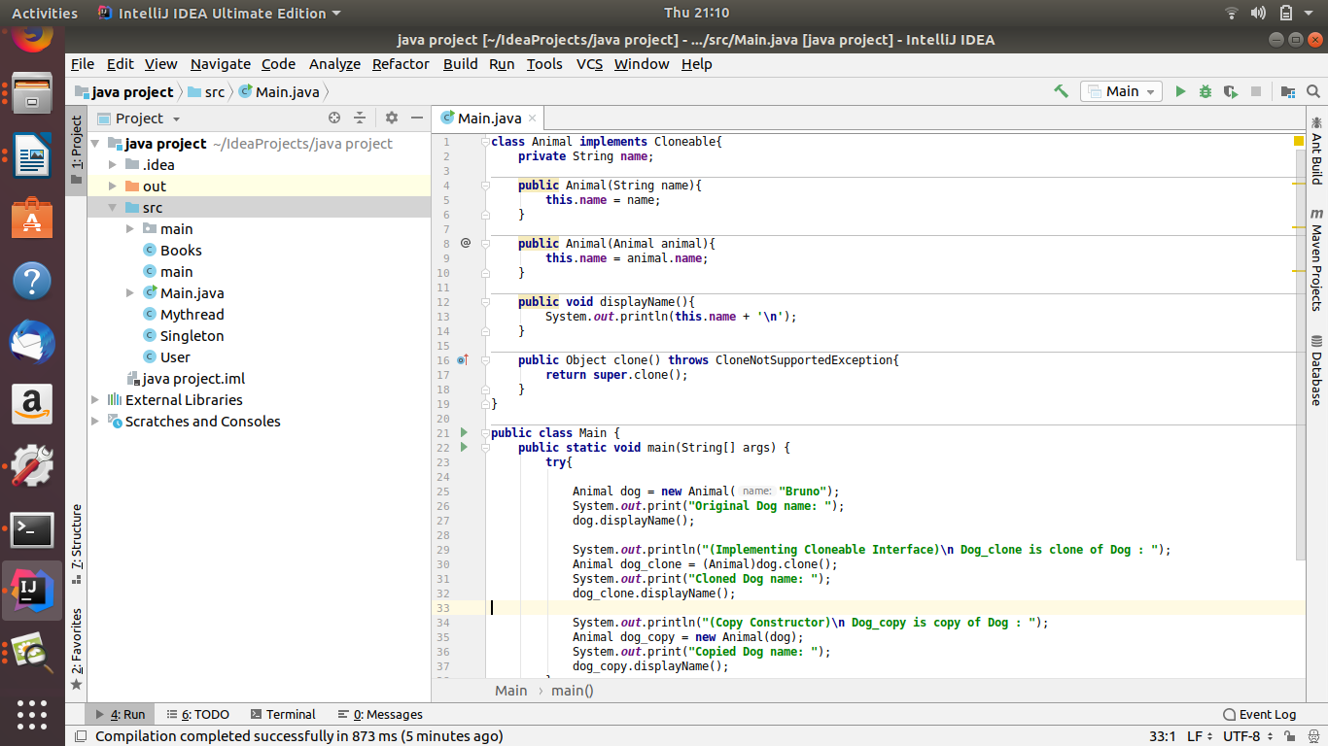

Ans 6

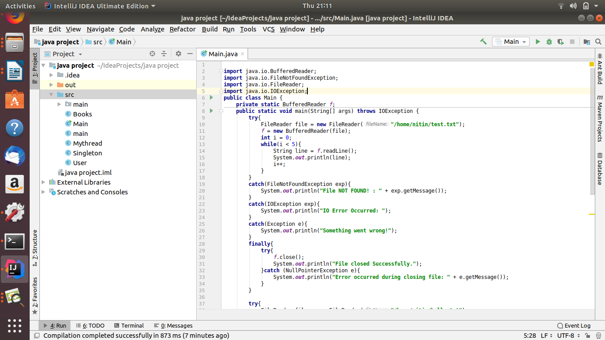
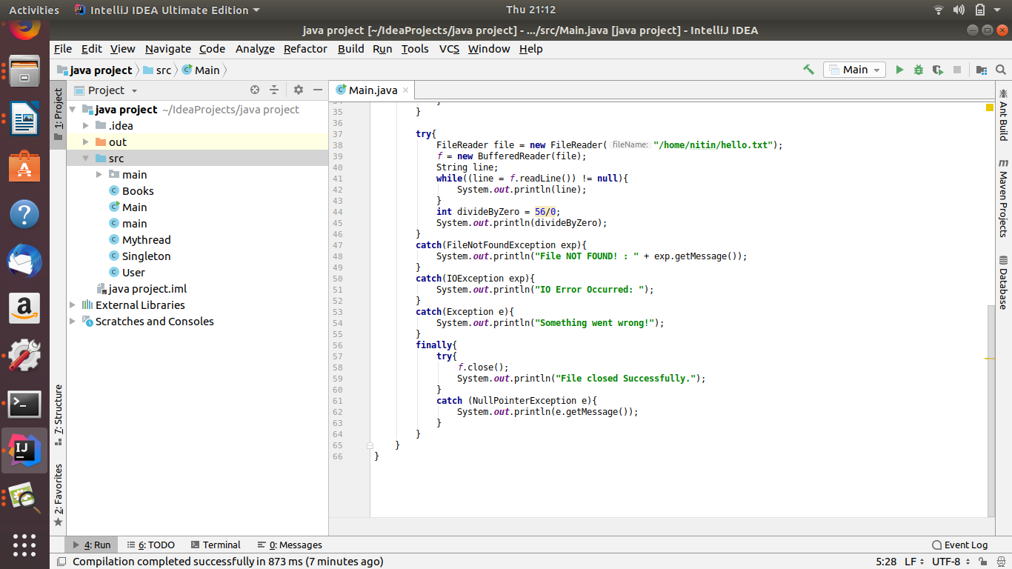

Ans 7
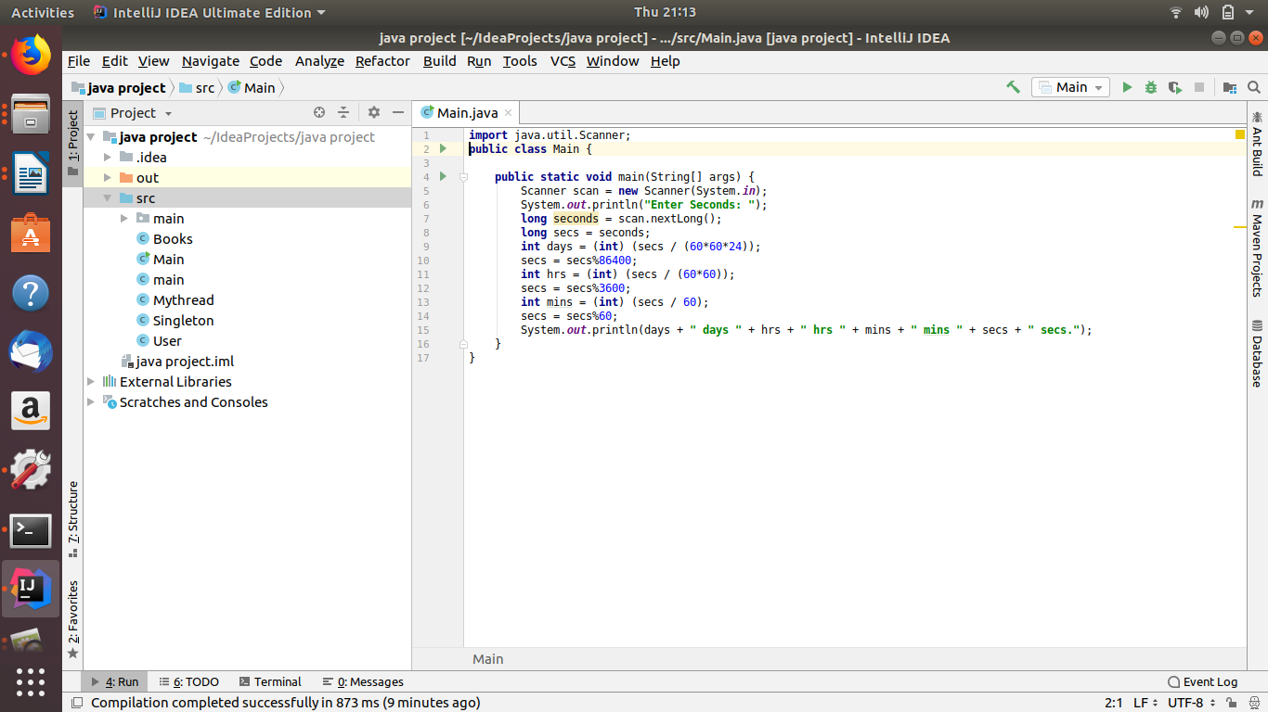
Ans 8

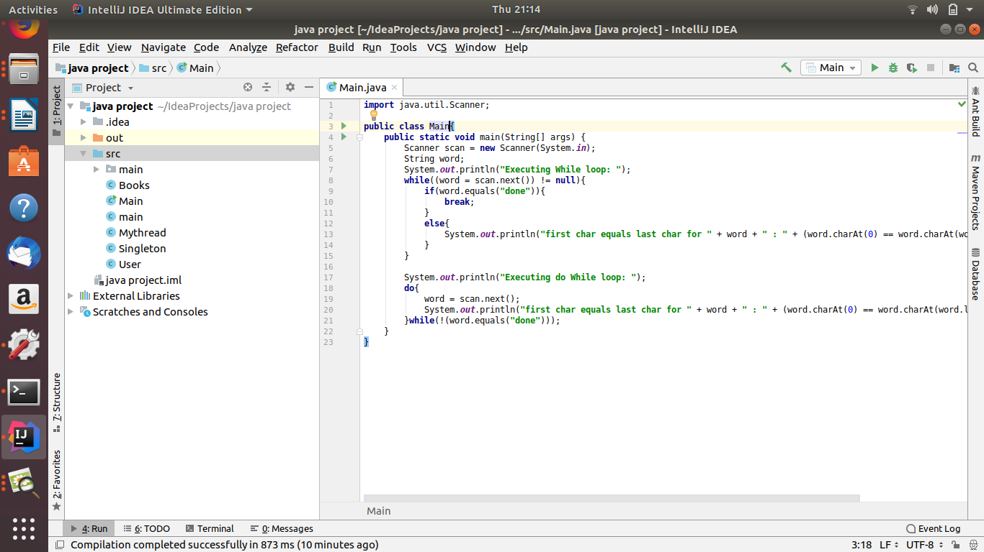

Ans 9
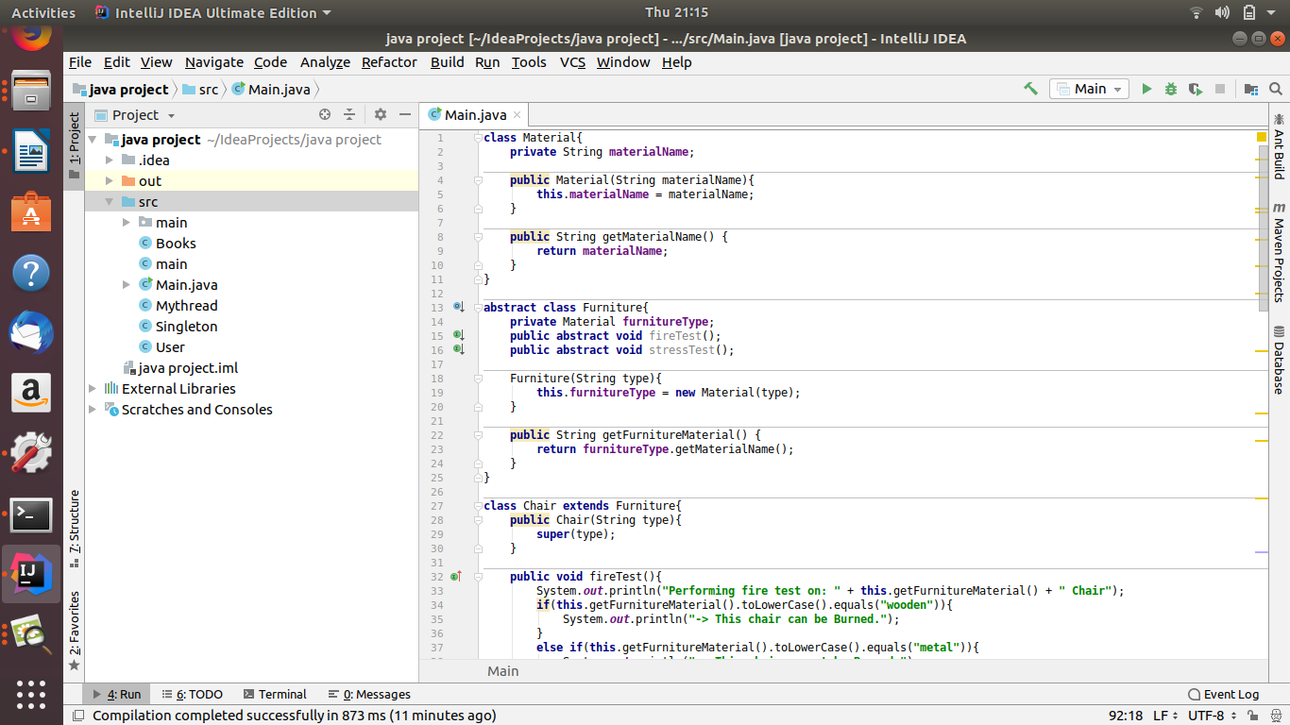
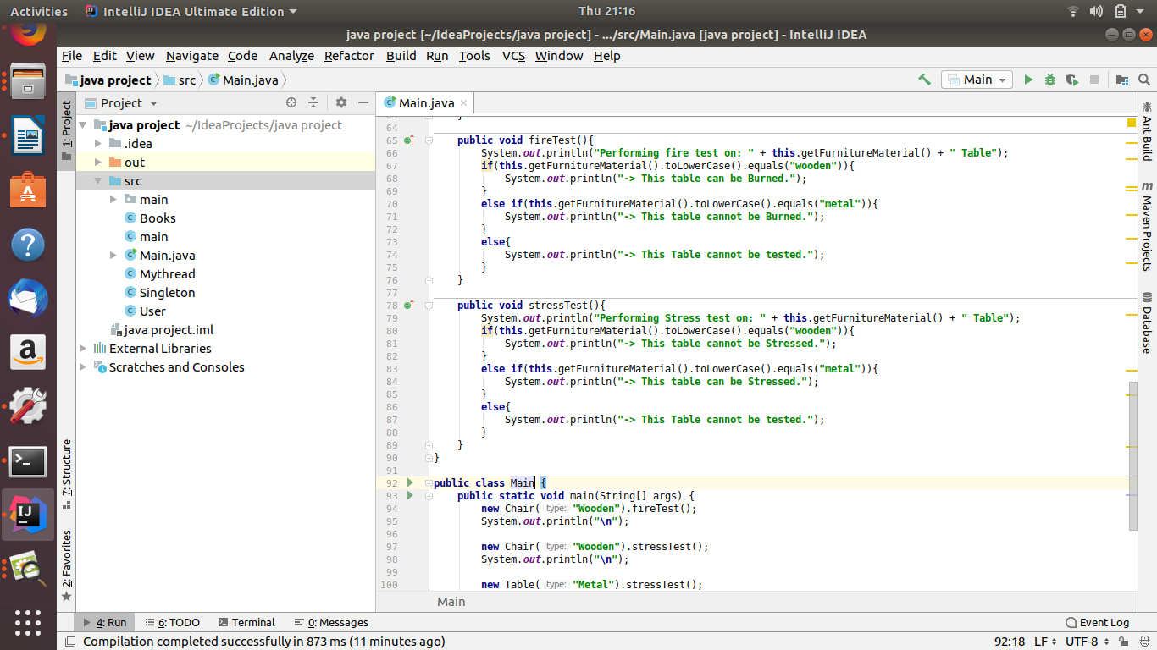

Ans 10

enum Coffee{
Cappuchino(500), Espresso(600), Latte(750);
private int price;
Coffee(int price){
this.price = price;
}
public int getPrice() {
return price;
}
}
class CoffeeShop{
private static List<Order> pendingOrders = new ArrayList<>();
private static List<Order> completedOrders = new ArrayList<>();
public Order getOrder(int OrderId){
return pendingOrders.get(OrderId);
}
public static void addOrder(Order o){
pendingOrders.add(o);
}
public static void completeOrder(Order o){
if(pendingOrders.remove(o)){
completedOrders.add(o);
}
else{
System.out.println("Error Occurred!");
}
}
public static Order popOrder(){
return pendingOrders.remove(0);
}
}
class Token{
private static int token = 0;
public static int setToken(){
return token++;
}
public static void releaseToken(){
token--;
}
}
class Order{
public int order_id;
public int token;
private List<Coffee> order_items = new ArrayList<>();
Order(){
this.order_id = new Random().nextInt(1000);
this.token = Token.setToken();
}
List<Coffee> getItems(){
return this.order_items;
}
void addItems(Coffee c){
order_items.add(c);
}
void removeItems(Coffee c){
order_items.remove(c);
}
double totalAmount(){
double GST = 0.17;
double sum = 0;
for(Coffee c : this.order_items){
sum = sum + c.getPrice();
}
sum = sum + (sum*GST);
return sum;
}
public int getToken(){
return token;
}
}
class Customer{
private String name;
private String phn;
public static int token;
public static Order o = null;
Customer(String name, String phn){
this.name = name;
this.phn = phn;
}
public void placeOrder(List<Coffee> coffees, double amountReceived){
o = new Order();
for(Coffee c : coffees){
o.addItems(c);
}
pay(o, amountReceived);
}
private void pay(Order o,double amountReceived){
Cashier.makePayment(o, amountReceived);
}
private void enjoy(Order o){
System.out.println("Customer Enjoying Coffee: ");
System.out.println(o.getItems());
}
public void collectOrder(Order o){
System.out.println("Your Order is Ready! Please Collect it.");
Token.releaseToken();
enjoy(o);
}
}
class Cashier{
private String name;
private int empId;
private String phn;
public Cashier(String name, int empId, String phn) {
this.name = name;
this.empId = empId;
this.phn = phn;
}
public static void makePayment(Order o,double amountReceived){
if(o.totalAmount() <= amountReceived){
CoffeeShop.addOrder(o);
Customer.token = Token.setToken();
}
else{
System.out.println("Payment Failed!");
}
}
}
class Barista{
private String name;
private int empId;
private String phn;
private static Order next;
public Barista(String name, int empId, String phn) {
this.name = name;
this.empId = empId;
this.phn = phn;
}
private void nextOrder(){
next = CoffeeShop.popOrder();
prepare(next);
}
private void prepare(Order o){
System.out.println("Please Wait while we are preparing your Coffee: " + o.getItems() + "for Order id : " + o.order_id);
}
private void completeOrder(Order o){
CoffeeShop.completeOrder(o);
}
}
public class Ques10_Coffee_shop {
public static void main(String[] args) {
}
}

Ans 11
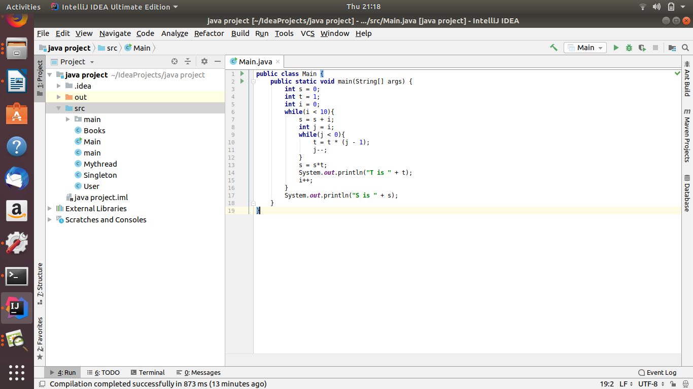

Ans 11

class Parent extends GrandParent{
{
System.out.println("instance - parent");
}
public Parent(){
System.out.println("constructor - parent");
}
static {
System.out.println("static - parent");
}
}
class GrandParent{
static {
System.out.println("static - grandparent");
}
{
System.out.println("instance - grandparent");
}
public GrandParent(){
System.out.println("constructor - grandparent");
}
}
class Child extends Parent{
public Child(){
System.out.println("constructor - child");
}
static{
System.out.println("static - child");
}
{
System.out.println("instance - child");
}
}
public class Ques12_output {
public static void main(String[] args) {
Child c = new Child();
}
Ans 13

class MyException extends Throwable{
// public MyException(String msg,Throwable cause, boolean enableSuppression,boolean writeStackTrace){
public MyException(String msg, boolean flag){
super(msg, null, flag, !flag);
}
public MyException(String msg){
super(msg);
}
}
public class Ques13_Custom_exception {
public static void main(String[] args) {
try{
// throw new MyException("Custom exception with Stack Trace");
throw new MyException("Custom exception without Stack Trace", true);
}
catch (MyException exp){
System.out.println("Caught custom exception: " + exp.getMessage());
exp.printStackTrace();
}
}
}

