MOVIE RECOMMENDATION SYSTEM USING NLP, TF-IDF & COSINE SIMILARITY
1. INTRODUCTION
In today’s digital entertainment era, users are exposed to an extremely large number of movies across multiple streaming platforms such as Netflix, Amazon Prime, Disney+, and others. While this vast availability of content is beneficial, it also creates a significant challenge known as information overload, where users find it difficult to select movies that match their interests and preferences.
Traditional recommendation systems often rely on ratings, popularity, or genre-based filtering. However, these approaches fail to capture the actual meaning and context of a movie’s storyline, which plays a crucial role in understanding whether a user will enjoy a particular film.
To address this limitation, this project focuses on building a Content-Based Movie Recommendation System Using Natural Language Processing (NLP) techniques. The system analyzes the textual descriptions (storylines) of movies and identifies similarities between them based on semantic content.
By leveraging techniques such as text preprocessing, TF-IDF vectorization, and cosine similarity, the system intelligently recommends movies that are contextually similar to the user’s input storyline. Additionally, an interactive Streamlit web application is developed to provide a user-friendly interface where users can input a movie description and instantly receive the top 5 most relevant movie recommendations.
This project demonstrates how NLP can be effectively applied in real-world recommendation systems to improve user experience and enhance content discovery.
2. METHODOLOGY
The dataset used in this project consists of movie titles and their corresponding storylines. The storyline column is the most important feature as it contains rich textual information describing the plot of each movie. This text is the foundation for building the recommendation system.
Text Preprocessing (NLP Pipeline)
The raw storyline data is unstructured and contains noise such as punctuation, special characters, and common words that do not contribute to meaning. To clean this data, several preprocessing steps are applied. The text is first converted to lowercase to ensure uniformity. Special characters and numbers are removed using regular expressions. The text is then tokenized into individual words. Stopwords such as “is”, “the”, and “and” are removed because they do not add meaningful information. Finally, lemmatization is applied to convert words into their base forms. This ensures that different variations of a word are treated as a single meaningful unit.
TF Feature Extraction
After preprocessing, the cleaned text is prepared for feature extraction. At this stage, the important words that represent each movie storyline are identified. These words act as features that capture the meaning and essence of each movie. This step is essential because machine learning models cannot directly understand raw text.
TF-IDF Conversion
The Term Frequency–Inverse Document Frequency (TF-IDF) technique is used to convert textual data into numerical vectors. TF-IDF assigns higher importance to words that are frequent in a specific movie storyline but rare across other movies. This helps highlight unique and meaningful words while reducing the impact of common words. As a result, each movie storyline is transformed into a high-dimensional numerical vector that represents its importance in the dataset.
Cosine Similarity Calculation
Once the TF-IDF vectors are created, cosine similarity is used to measure the similarity between movies. Cosine similarity calculates the angle between two vectors to determine how closely related they are. A higher similarity score indicates that two movies share similar themes, while a lower score indicates that they are different. This mathematical approach helps identify movies that are contextually similar based on storyline.
Recommendation Generation and Results
When a user inputs a movie storyline, the system processes it using the same preprocessing and TF-IDF transformation steps. The cosine similarity score is then calculated between the user input and all movies in the dataset. Based on these scores, the top 5 most similar movies are selected and displayed as recommendations. The system effectively identifies movies with similar themes such as action, science fiction, survival, and adventure based on storyline similarity.
Observations and Insights
It was observed that the quality of preprocessing significantly affects the performance of the recommendation system. Lemmatization improves accuracy by reducing word variations. TF-IDF effectively highlights important keywords, while cosine similarity provides a reliable method for measuring textual similarity. However, the system is limited in its ability to understand deep semantic meaning and context beyond keywords.
Technology Stack
The project is developed using Python as the core programming language. Pandas is used for data loading and manipulation. NLTK is used for natural language processing tasks such as tokenization, stopword removal, and lemmatization. Scikit-learn is used for implementing TF-IDF vectorization and cosine similarity calculations. Streamlit is used to build an interactive web interface that allows users to interact with the recommendation system in real time.
3. IMPLEMENTATION OVERVIEW (CODE FLOW)
The system begins by loading the dataset using pandas. The storyline text is then cleaned using a custom preprocessing function that performs lowercasing, removal of special characters, tokenization, stopword removal, and lemmatization. The cleaned text is stored in a new column.
Next, TF-IDF vectorization is applied to convert the cleaned text into numerical vectors. These vectors represent the importance of each word in each movie storyline.Cosine similarity is then computed between all movie vectors to measure how similar each movie is to others.
A recommendation function is created that takes user input, processes it in the same way, and computes similarity scores. The top 5 most similar movies are then selected and returned as output.
Finally, a Streamlit web application is built to provide a user-friendly interface where users can enter a storyline and receive recommendations instantly.
Step 1: Data Collection
Dataset contains:
Movie Name
Storyline (plot description)
Step 2: Data Preprocessing (NLP Pipeline)
Text data is cleaned using multiple steps:
✔ Lowercasing
Converts all text to lowercase to maintain uniformity.
✔ Removing Special Characters
Regex is used to remove numbers, punctuation, and symbols.
✔ Tokenization
Splits sentences into individual words.
✔ Stopword Removal
Removes common words like “the”, “is”, “and”.
✔ Lemmatization
Converts words to base form:
running → run
fights → fight
Step 3: Feature Extraction (TF-IDF)
TF-IDF (Term Frequency–Inverse Document Frequency) is used to convert text into numerical vectors.
Why TF-IDF?
Gives importance to meaningful words
Reduces weight of common words
Converts text into machine-readable format
Step 4: Similarity Calculation
Cosine Similarity is used to measure similarity between movie vectors.
Formula idea:
It calculates the angle between two vectors.
Score = 1 → Highly similar
Score = 0 → Not similar
Step 5: Recommendation Engine
Workflow:
User inputs a storyline
Text is preprocessed
Converted into TF-IDF vector
Compared with all movies
Top 5 similar movies are returned
Step 6: Web Application (Streamlit)
Streamlit is used to create an interactive UI:
Input box for storyline
Button to trigger recommendation
Display of top 5 movies
4. TECHNOLOGY STACK
Component | Technology
Programming Language | Python
NLP Library | NLTK
Data Handling | Pandas
ML Library | Scikit-learn
Vectorization | TF-IDF
Similarity | Cosine Similarity
Web Framework | Streamlit

5. CODE OVERVIEW
#Data Loading
df = pd.read_csv("imdb_cleaned.csv")
#Text Cleaning Function
def clean_text(text):
text = str(text).lower()
text = re.sub(r"[^a-z\s]", "", text)
tokens = word_tokenize(text)
tokens = [w for w in tokens if w not in stop_words]
tokens = [lemmatizer.lemmatize(w) for w in tokens]
return " ".join(tokens)
#TF-IDF Conversion
vectorizer = TfidfVectorizer()
tfidf_matrix = vectorizer.fit_transform(df["clean_story"])
#Cosine Similarity
similarity_scores = cosine_similarity(user_vector, tfidf_matrix)[0]
#Recommendation Function

Returns top 5 most similar movie
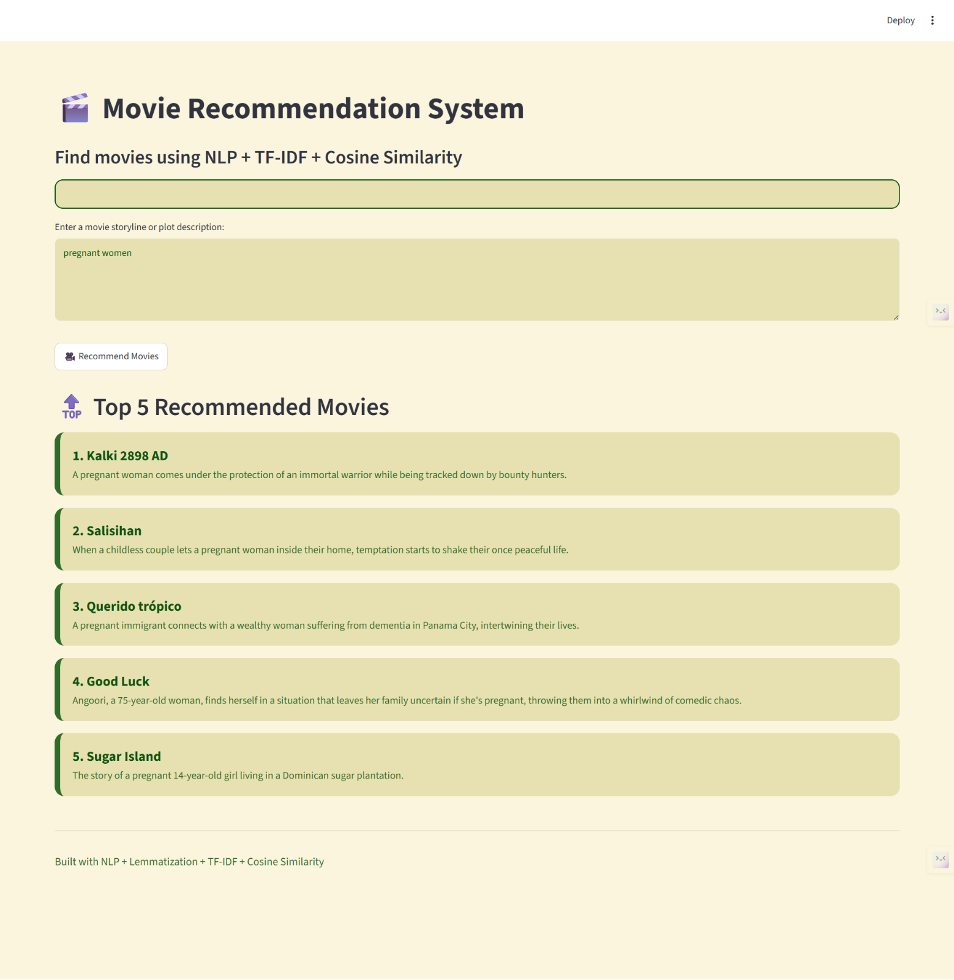

4. CONCLUSION
The Movie Recommendation System successfully demonstrates the application of Natural Language Processing techniques in building a content-based recommendation engine. By analyzing movie storylines and converting them into numerical representations using TF-IDF, the system effectively measures similarity between different movies.
The use of cosine similarity enables accurate identification of movies that share similar themes and narratives. The integration of Streamlit enhances usability by providing an interactive and user-friendly interface where users can easily input a storyline and receive instant recommendations.
This project highlights the importance of text preprocessing techniques such as stopword removal and lemmatization in improving NLP system performance. Although the current system performs well for keyword-based similarity detection, it has limitations in understanding deeper semantic relationships between texts.
In conclusion, this project serves as a strong foundation for building advanced recommendation systems. It can be further enhanced using deep learning-based models such as BERT or transformer-based embeddings to achieve more accurate and context-aware recommendations. Overall, it demonstrates a practical and efficient approach to solving movie discovery problems using NLP techniques.

