|  |  |  |  |  |
| --- | --- | --- | --- | --- |
| **Name of the class** | **No. of records** | **No. of training samples** | **No. of testing samples** | **No. of validation samples** |
| **AF** | 445 | 319 | 41 | 85 |
| **AFIB** | 1780 | 1249 | 169 | 362 |
| **SB** | 3889 | 2691 | 429 | 769 |
| **SR** | 1826 | 1267 | 185 | 374 |
| **ST** | 1568 | 1091 | 160 | 317 |
| **SVT** | 587 | 409 | 66 | 112 |
| **TOTAL** | 10,095 | 7026 | 1050 | 2019 |

**Numerical details of Diminished class**

|  |  |  |  |  |
| --- | --- | --- | --- | --- |
| **Lead** | **Accuracy (%)** | **Recall** | **Precision** | **F1 Score** |
| **12-leads** | **94.89** | **0.95** | **0.95** | **0.94** |
| I | 93.75 | 0.94 | 0.93 | 0.93 |
| II | 94.60 | 0.95 | 0.94 | 0.94 |
| III | 94.11 | 0.94 | 0.94 | 0.94 |
| aVR | 94.50 | 0.95 | 0.94 | 0.94 |
| aVL | 93.66 | 0.94 | 0.94 | 0.94 |
| **aVF** | **94.69** | **0.95** | **0.94** | **0.94** |
| V1 | 94.49 | 0.95 | 0.94 | 0.94 |
| V2 | 91.62 | 0.92 | 0.90 | 0.91 |
| V3 | 93.41 | 0.93 | 0.91 | 0.92 |
| V4 | 92.27 | 0.92 | 0.91 | 0.91 |
| V5 | 93.66 | 0.94 | 0.93 | 0.93 |
| V6 | 93.02 | 0.93 | 0.92 | 0.92 |

**Experimental result values for Diminished class**

|  |  |  |  |
| --- | --- | --- | --- |
| **Name of the class** | **Precision** | **Recall** | **F1 Score** |
| **AF** | 0.71 | 0.32 | 0.44 |
| **AFIB** | 0.87 | 0.97 | 0.92 |
| **SB** | **0.99** | **0.99** | **0.99** |
| **SR** | 0.98 | 0.97 | 0.97 |
| **ST** | 0.97 | 0.97 | 0.97 |
| **SVT** | 0.87 | 0.95 | 0.91 |
| **AVG** | 0.95 | 0.95 | 0.94 |

**Diminished class performance of each class for 12-lead model**

**Numerical details of Combined class**

|  |  |  |  |  |
| --- | --- | --- | --- | --- |
| **Name of new class** | **Combined rhythms** | **No. of records** | **No. of training samples** | **No. of testing samples** |
| **AFIB** | AF, AFIB | 2225 | 1568 | 210 |
| **SB** | SB | 3889 | 2691 | 429 |
| **SR** | SR | 1826 | 1267 | 185 |
| **GSVT** | ST, SVT | 2155 | 1500 | 226 |
| **TOTAL** | TOTAL | 10,095 | 7026 | 1050 |

|  |  |  |  |  |
| --- | --- | --- | --- | --- |
| **Lead** | **Accuracy (%)** | **Recall** | **Precision** | **F1 Score** |
| **12-leads** | **97.18** | **0.97** | **0.97** | **0.97** |
| I | 95.74 | 0.96 | 0.96 | 0.96 |
| II | 94.50 | 0.95 | 0.95 | 0.94 |
| III | 93.51 | 0.94 | 0.94 | 0.94 |
| aVR | 95.34 | 0.95 | 0.96 | 0.95 |
| aVL | 94.45 | 0.94 | 0.94 | 0.94 |
| **aVF** | **96.83** | **0.97** | **0.97** | **0.97** |
| V1 | 96.08 | 0.96 | 0.96 | 0.96 |
| V2 | 95.74 | 0.96 | 0.96 | 0.96 |
| V3 | 95.29 | 0.95 | 0.95 | 0.95 |
| V4 | 93.41 | 0.93 | 0.94 | 0.93 |
| V5 | 94.25 | 0.94 | 0.95 | 0.94 |
| V6 | 93.52 | 0.93 | 0.94 | 0.93 |

**Experimental result values of Combined class**

**Combined class performance of each class using 12-lead model**

|  |  |  |  |
| --- | --- | --- | --- |
| **Name of the class** | **Precision** | **Recall** | **F1 Score** |
| **AFIB** | 0.94 | 0.93 | 0.93 |
| **SB** | **0.98** | **0.99** | **0.99** |
| **SR** | 0.99 | 0.94 | 0.96 |
| **GSVT** | 0.94 | 0.96 | 0.94 |
| **AVG** | 0.97 | 0.97 | 0.97 |

|  |  |  |  |  |
| --- | --- | --- | --- | --- |
| **Lead** | **Accuracy (%)** | **Recall** | **Precision** | **F1 Score** |
| I | 82.26 | 0.82 | 0.81 | 0.81 |
| II | 83.35 | 0.83 | 0.83 | 0.82 |
| III | 82.86 | 0.83 | 0.83 | 0.82 |
| aVR | 84.64 | 0.85 | 0.86 | 0.84 |
| aVL | 77.17 | 0.77 | 0.76 | 0.76 |
| aVF | 82.12 | 0.82 | 0.82 | 0.81 |
| V1 | 83.95 | 0.84 | 0.85 | 0.84 |
| V2 | 80.58 | 0.81 | 0.79 | 0.78 |
| V3 | 81.77 | 0.82 | 0.80 | 0.80 |
| V4 | 76.17 | 0.76 | 0.76 | 0.74 |
| V5 | 79.04 | 0.79 | 0.78 | 0.77 |
| V6 | 82.11 | 0.82 | 0.79 | 0.80 |

**Lead wise performance values of student model for diminished class before distillation**

|  |  |  |
| --- | --- | --- |
| **Lead** | **Accuracy (%)** | |
| **Before distillation** | **After distillation** |
| I | 82.26 | 86.52 |
| II | 83.35 | 85.38 |
| III | 82.86 | 76.86 |
| **aVR** | **84.64** | **87.68** |
| aVL | 77.17 | 79.64 |
| aVF | 82.12 | 84.64 |
| V1 | 83.95 | 87.12 |
| V2 | 80.58 | 83.30 |
| V3 | 81.77 | 81.22 |
| V4 | 76.17 | 84.10 |
| V5 | 79.04 | 85.53 |
| V6 | 82.11 | 82.15 |

**Comparison of student model before and after distillation for diminished class**

|  |  |  |
| --- | --- | --- |
| **Lead** | **Accuracy (%)** | |
| **Before distillation** | **After distillation** |
| I | 78.41 | 84.64 |
| II | 80.38 | 84.54 |
| III | 80.48 | 82.02 |
| aVR | 67.26 | 80.38 |
| **aVL** | **69.04** | **83.61** |
| aVF | 79.74 | 83.11 |
| V1 | 78.40 | 87.86 |
| V2 | 76.86 | 83.51 |
| V3 | 81.32 | 81.22 |
| V4 | 74.64 | 84.59 |
| V5 | 83.80 | 85.73 |
| V6 | 81.82 | 83.15 |

**Comparison of student model before and after distillation for combined class**

**a) Lead I – 82.26%**

**b) Lead II – 83.35%**

**c) Lead III – 82.86%**

**d) Lead aVR – 84.64%**

**e) Lead aVL – 77.17%**

**f) Lead aVF – 82.12%**

**g) Lead V1 – 83.95%**

**h) Lead V2 – 80.58%**

**i) Lead V3 – 81.77%**

**j) Lead V4 – 76.17%**

**k) Lead V5 – 79.04%**

**l) Lead V6 – 82.11%**

**Epoch vs Accuracy of Student models for diminished class before distillation**

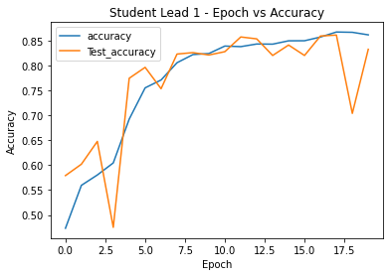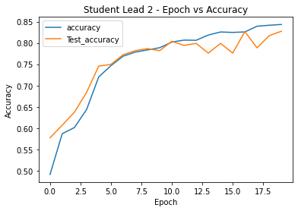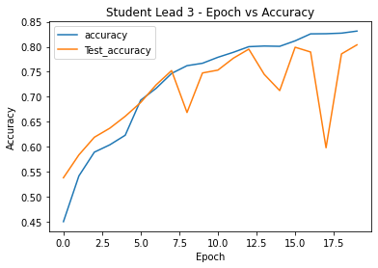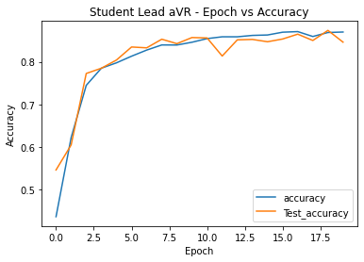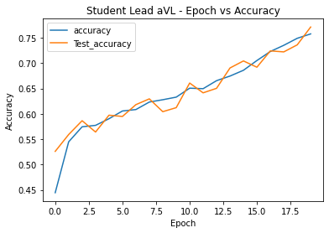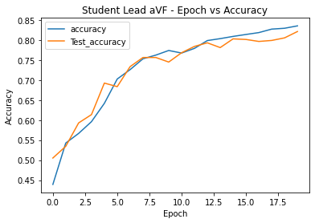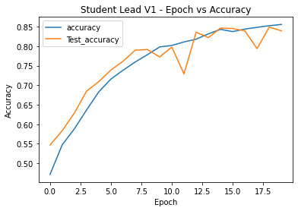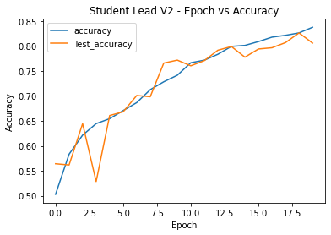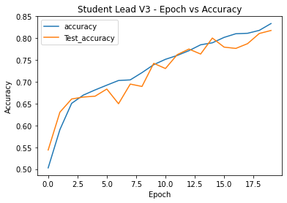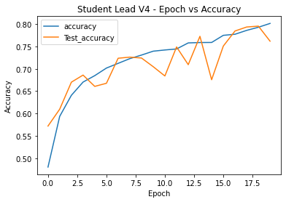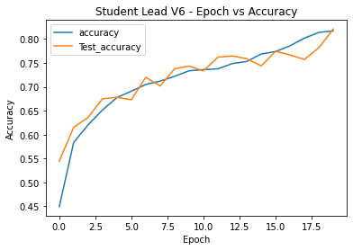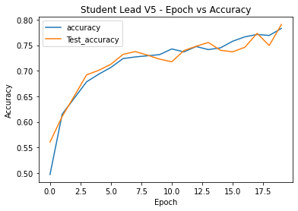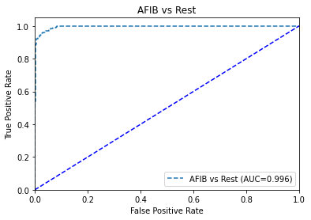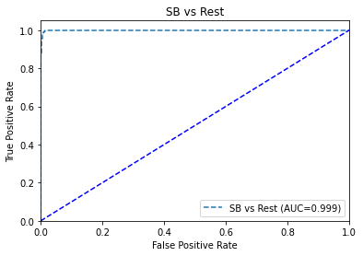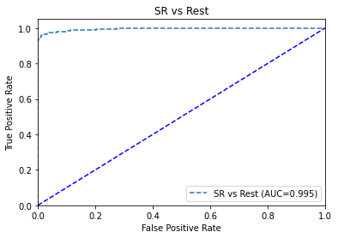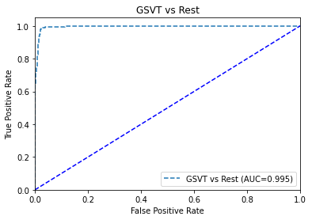

**a) AFIB vs Rest AUC: 99.6%**

**b) SB vs Rest AUC: 99.9%**

**c) SR vs Rest AUC: 99.5%**

**d) GSVT vs Rest AUC: 99.5%**

**ROC curve with AUC value of 12-lead model for Combined class**

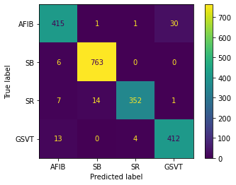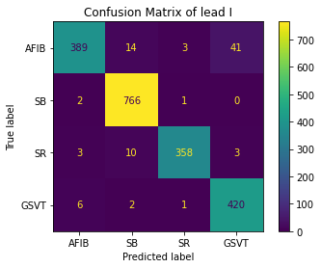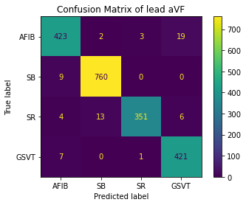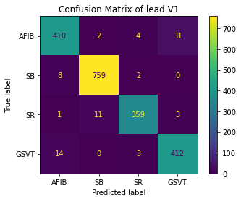

**a) 12-Leads – 97.18%**

**b) Lead I – 95.74%**

**c) Lead aVF – 96.83%**

**d) Lead V1 – 96.08%**

**Confusion Matrices of 12-lead model and best performed leads for Combined class**

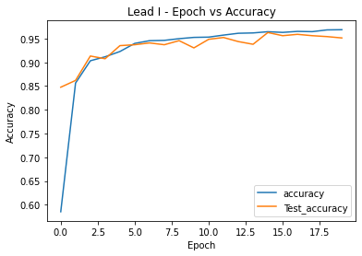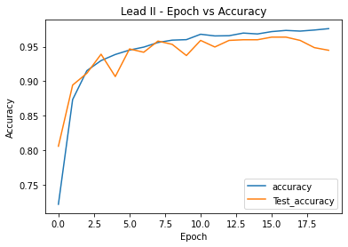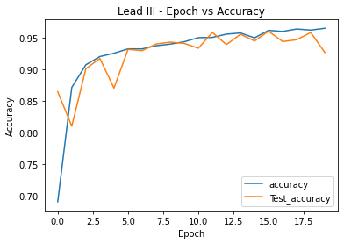

**a) Lead I – 95.74%**

**b) Lead II – 94.5%**

**c) Lead III – 93.51%**

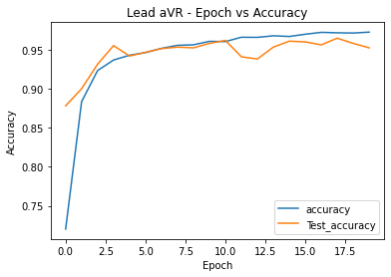

**d) Lead aVR – 95.34%**

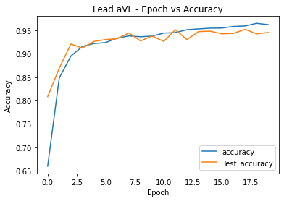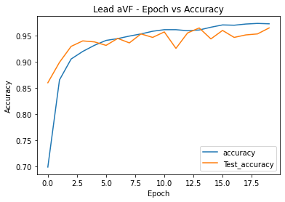

**e) Lead aVL – 94.45%**

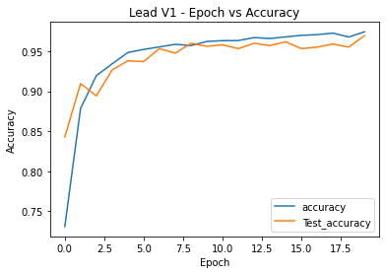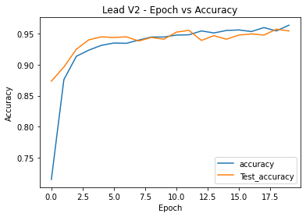

**g) Lead V1 – 96.08%**

**h) Lead V2 – 95.74%**

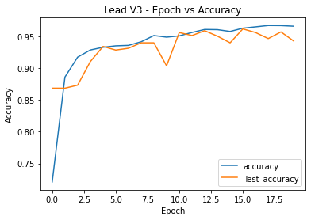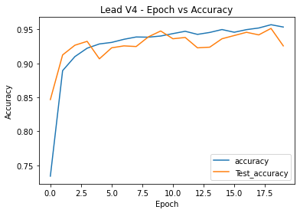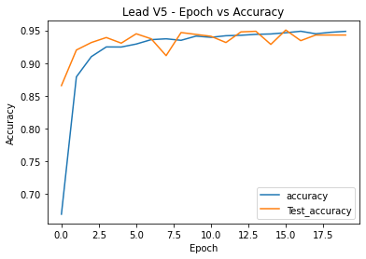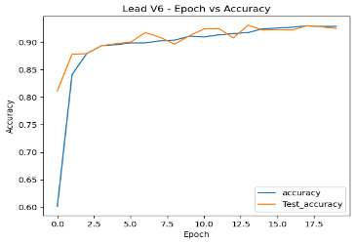

**i) Lead V3 – 95.29%**

**j) Lead V4 – 93.41%**

**k) Lead V5 – 94.25%**

**l) Lead V6 – 93.52%**

**Epoch vs Accuracy of 12 leads individually for Combined class**

**f) Lead avF – 96.83%**

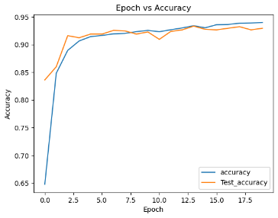

**a) Lead I – 93.75%**

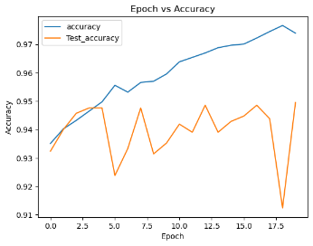

**b) Lead II – 94.6%**

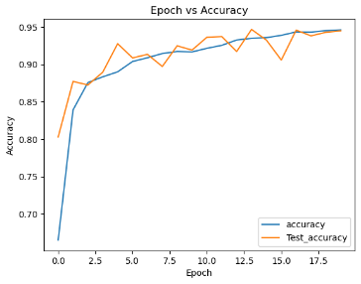

**c) Lead III – 94.11%**

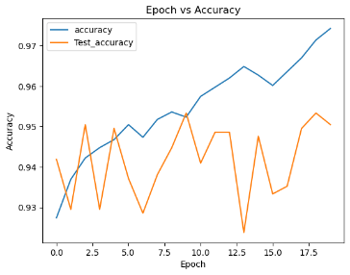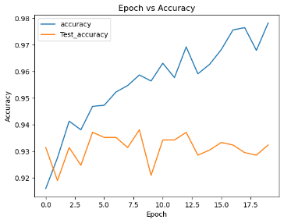

**e) Lead aVL – 93.66%**

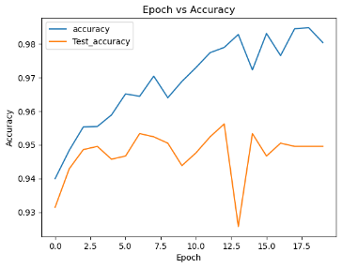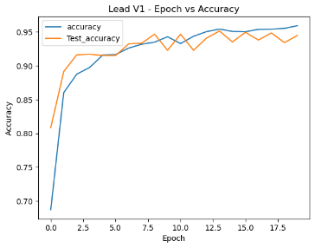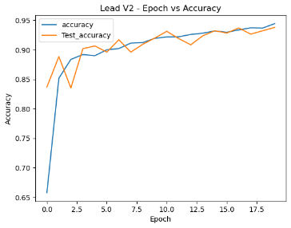

**h) Lead V2– 91.2%**

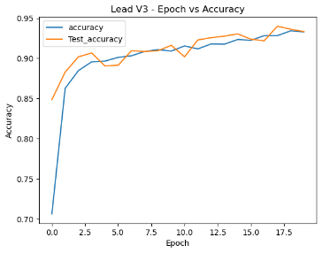

**i) Lead V3 – 93.41%**

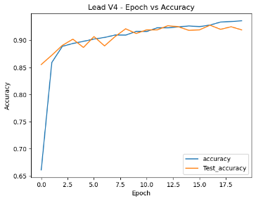

**j) Lead V4 – 92.27%**

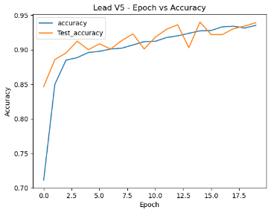

**k) Lead V5 – 93.66%**

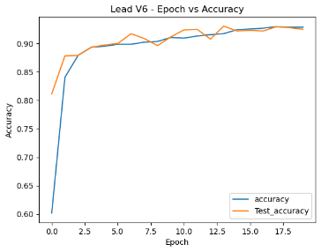

**l) Lead V6 – 93.02%**

**Epoch vs Accuracy of 12 leads individually for Diminished class**

**g) Lead V1– 94.49%**

**d) Lead aVR – 94.5%**

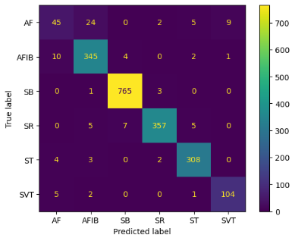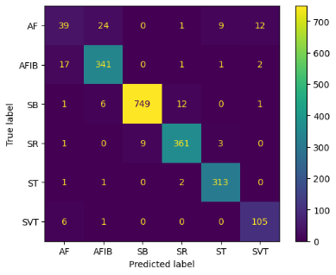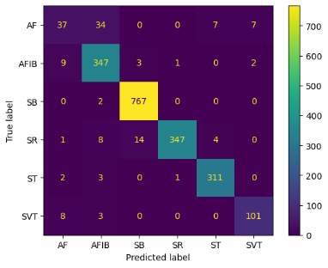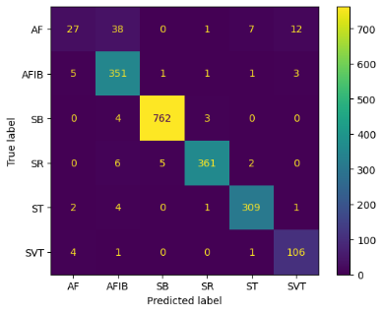

**Confusion Matrices of 12-lead model and best performed leads for Diminished class**

**a) 12 Leads – Acc: 94.89%**

**b) Lead II – Acc: 94.60%**

**c) Lead aVR– Acc: 94.5%**

**d) Lead aVF – 94.69%**