Date: 23.11.20

3.Write a Python program to remove and print every second number from a list of

numbers until the list becomes empty.

Note:use function

Take input (total number of element in the list, list element) from the user and

call the function removeThirdNumber(int_list)).

AIM :

To remove and print every second number from a list of numbers until the

list becomes empty.

PROGRAM:

def removeThirdNumber(lst):

lst1=[]

pos=1

s=0

for i in range(0,len(lst)):

s=(pos+s)%len(lst)

el=lst.pop(s)

lst1.append(el)

return lst1

n=int(input())

int_list=[]

for i in range(0,n):

e=int(input())

int_list.append(e)

p=removeThirdNumber(int_list)

print(p)

OUTPUT :

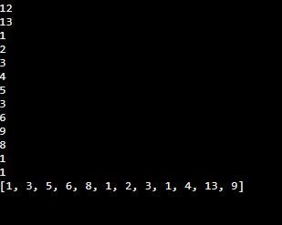

link : <http://103.53.53.18/mod/vpl/forms/submissionview.php?id=231&userid=1665>

RESULT :

Thus the python program to remove and print every second number

from a list of numbers until the list becomes empty.