**Student ID: Group**  **Student Name: Group**

**Course Code: ITECH3208** **Course Name: Project 1**

**Date Submitted: 10/04/2020** **Lecturer’s Name: Ahmed Nadeem Saeed**

**Tutor’s Name: Ahmed Nadeem Saeed**

**ASSIGNMENT TITLE:**

**Project Vision Document**

PLAGIARISM

Plagiarism is the presentation of the expressed thought or work of another person as though it is one's own without properly acknowledging that person. You must not allow other students to copy your work and must take care to safeguard against this happening.

Plagiarism is a serious offence. As set out in University Regulation 6.1.1., students who are caught plagiarising will, for a first offence, be given a zero mark for that task. A second offence will result in a failing grade for the Course(s) involved and any subsequent offence will be referred to the Student Discipline Committee.

Declaration

Except where appropriately acknowledged, this assignment is my own work, has been expressed in my own words and has not previously been submitted for assessment. I have also retained a copy of this assessment piece for my own records.



**Assignment Cover Sheet**

Faculty of

Science and Technology

Signature: Group Date: 10/04/2020

**Feedback / Assessment:**

|  |  |
| --- | --- |
| **LECTURER’S SIGNATURE:** | **DATE:** |
|  |  |

Faculty of Science and Technology, Federation University

Mt Helen Campus: PO Box 663 Ballarat Vic 3353

Gippsland Campus: PO Box 3191 Gippsland Mail Centre Vic 3481

CRICOS Provider Number 00103D



**Group Assignment: ITECH3208 Project 1**

**ASSSIGNMENT 2:**

**Handbook-Vision Document**

|  |  |
| --- | --- |
| Tutor Name: | Ahmed Nadeem Saeed |
| Lecturer Name: | **Ahmed Nadeem Saeed** |

|  |  |
| --- | --- |
| Name | Student ID |
| 1. Birochan Chaudhary | **30378729** |
| 1. Bishal Raj Adhikari | **30381788** |
| 1. Robin Kayastha | **30378751** |
| 1. Prabin Subedi | **30382013** |
| 1. Sunil Thapa Magar | **30345321** |

Project Handbook

SP77897 Hello Application

|  |
| --- |
| This template is loosely based on the following standards:   * Australian Standard AS4071-1992(R2014) - Software project management plans * AS/NZS ISO/IEC/IEEE 42010:2013 – Systems and software engineering – Architecture description   Note that following this template is not enough to claim conformance to either of the above standards! For Project courses, some sections have been excluded completely, and some are optional. These are noted, and may be skipped |



Contents

Revision 4

Preface 4

List of figures 4

List of Tables 4

Vision Statement 5

Introduction 5

Project Overview 5

Project Deliverables 7

Evolution of the Handbook 8

Reference Materials 9

Definitions and Acronyms 9

Organization 10

Process Model 10

Organizational Structure 12

Organization Boundaries and Interfaces 14

Project Responsibilities 14

Managerial Process 16

Management Objectives and Priorities 16

Assumptions, Dependencies, and Constraints 16

Technical Process 17

Methodology 17

Scrum in Agile methodology 17

Tools and technology 17

Software Documentation 18

Product documentation 19

Process documentation 19

# Revision

# Preface

# List of figures

|  |  |  |
| --- | --- | --- |
| Figure number | Name | Page Number |
| 2.1 | Agile Framework | 9 |
| 2.2 | Scrum Structure | 11 |
| 2.3 | Organizational Hierarchy | 12 |
| 4.1 | Software Documentation | 20 |

# List of Tables

|  |  |  |
| --- | --- | --- |
| Table Number | Name | Page Number |
| Table 1.1 | Project Details | 6 |
| Table 1.2 | Deadlines | 7 |
| Table 1.3 | Project Deliverables | 8 |
| Table 1.4 | Evolution | 9 |
| Table 1.5 | Acronyms | 9 |
| Table 2.1 | Work break-down structure | 11 |
| Table 2.2 | Project Team details | 14 |
| Table 2.3 | Team responsibility | 15 |
| Table 4.1 | Tools and Technology | 19 |

# Vision Statement

# Introduction

## Project Overview

This project aims to develop a private chat application which will be compatible in both android and apple phones for SP77897, a strata management company. This application supports around 500 users and can support further expansion. The application supports the day to day communication of tenants, owners, managing agents, strata management company and EC. Our main aim is to support all the end users in discussing the cleaning, security and movements of goods and items. This application will also support scheduled messaging which can be controlled by the Executive Committee and OC Admin.

This document has been developed to outline the basic requirements of the project, the project objectives and deliverables, and any other work that is required as part of the project.

This project is based on the requirement of SP77897 for Strata Management to meet the needs of the tenants, the executive committee and owners.

|  |  |
| --- | --- |
| SP77897 - Hello | |
| Project Start Date | 18/03/2020 |
| Project Completion Date | 30/10/2020 |
| Project Manager | Prabin Subedi |
| Project Type | Chat Application |
| Project Budget | AUD $ 80,000 |

Table 1.1 Project Details

**Resources Required**:

For the successful execution of the project following resources will be required:

1. Laptops

2. Notepad++

3. Java and PHP

**Deadlines:**

After the discussion with the client (SP77897) and the project team members following deadlines have been set.

|  |  |  |
| --- | --- | --- |
| Project Task | Review | Finalization |
| Project Deliverables | 12/04/2020 | 3/05/2020 |
| Project Backlog | 12/04/2020 | 17/04/2020 |
| Iteration 1 | 15/05/2020 | 31/05/2020 |
| Iteration 2 |  |  |

Table 1.2 Deadlines

The deadlines can be reviewed and adjusted upon requirements or upon the change of scope of work.

**Budget:**

The project budget is currently set as $80,000 AUD which can be reviewed as per the change in the scope of work.

## Project Deliverables

Upon the agreement with the client, SP77897, the following deliverable are agreed to be required for the project to be complete:

|  |  |  |
| --- | --- | --- |
| Deliverables | Person Responsible | Final Date |
| Project Handbook | Prabin Subedi, Birochan Chaudhary, Robin Kayastha, | 12/04/2020 |
| Project Backlog | Prabin Subedi, Birochan Chaudhary, Robin Kayastha, | 17/04/2020 |
| Meeting Timetable | Prabin Subedi, Birochan Chaudhary, Robin Kayastha, | 20/04/2020 |
| Technical Documentation | Prabin Subedi, Birochan Chaudhary, Robin Kayastha, | 12/04/2020 |
| Sprint 1: First Iteration | Prabin Subedi, Birochan Chaudhary, Robin Kayastha, |  |
| Sprint 2: Second Iteration | Prabin Subedi, Birochan Chaudhary, Robin Kayastha, |  |

Table 1.3 Project Deliverables

## Evolution of the Handbook

The project handbook will be updated as per the requirement of the project in a timely manner. The project team will meet once in two months and discuss the updates (if required). In case of urgent updates required, the project manager will be contacted, and discussion will be held, and update will be processed if approved. All the team members and stakeholders will be sent an email with the digital copy and will be provided with a printed handbook in the next meeting. An update register will be maintained to keep track of the updates.

|  |  |  |
| --- | --- | --- |
| ***Document version*** | ***Date of Development*** | ***Approved By*** |
| ***Initial Project Handbook v.1*** | *10/04/2020* | *Prabin Subedi* |
|  |  |  |

Table 1.4 Evolution

## Reference Materials

This is a complete list of materials referenced elsewhere in the handbook, such as style guides, coding standards, documentation standards, methodologies, etc.

Platform | Stratafy - Strata Management Software. (2020). Retrieved 8 April 2020, from <https://stratafyconnect.com/platform/#Platform_MobileApp>

About Our Body Corp - Our Body Corp. (2020). Retrieved 11 April 2020, from <https://www.ourbodycorp.com.au/about-us/>

## Definitions and Acronyms

List of all the key word and acronyms used in the backlog are listed below:

|  |  |  |
| --- | --- | --- |
| S. N | Key words | Definition |
| 1 | HELLO | Communication tool for SP377897 Strata Plan. |
| 2 | EC | Executive Committee |
| 3 | OC | Owners Corporation |
| 4 | BBQ Area | Area for Barbeque |
| 5 | Strata | Strata is a model of property ownership that allows for individual ownership of certain parts of a property or parcel of land and shared ownership of others. |
| 6 | SMS | Short Message Services |
| 7 | Levies | Notice issued on quarterly basis by the strata Manager |
| 8 | Scrum | A set of practices used in agile project management that emphasize daily communication and the flexible reassessment of plans that are carried out in short, iterative phases of work. |

Table 1.5 Acronyms

# Organization

## Process Model

Agile Project Management is an approach to manage software development projects iteratively. It has an ability to respond to market trends as it focuses on continuous capture and release of customer feedback with every sprint. Throughout our project we will be constantly interacting with our stakeholders, improving process at every stage. We will begin with owner corporation briefing the functionality and the purpose of the end product. Once we begin the work, we will be constantly refining the process to produce a better product according to the demand. This process includes planning, executing and evaluating.

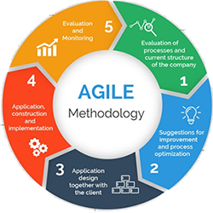

<https://www.google.com/url?sa=i&url=http%3A%2F%2Fwww.softwareprocessinc.com%2Fagile-safe-scaled-agile-framework.html>

Fig 2.1 Agile Framework

This project is divided into five sprints with every sprint being very crucial for the app development. A rough time estimating table is shown below:

|  |  |  |  |  |
| --- | --- | --- | --- | --- |
| Iteration | % done | Due Date | Completion Date | Outcome |
| 1. Iteration 1   Analysis | 100% | 2nd April | 1st April | Interview and User Stories. |
| 1.1 Interview | 100% | 1st April | 1st April | Company Requirement were identified. |
| 1.2 User Stories | 100% | 1st April | 1st April | User Stories were produced from different stakeholders. |
| 1. Iteration 2   Documentation | 62.5% | 10th May | Pending | Backlog and Project handbook was produced. |
| 2.1 Backlog | 100% | 3rd April | 3rd April | All the User stories and business requirements were compiled. |
| 2.2 Project Handbook | 25% | 10th May | Pending | Project Vision was Identified. |
| 1. Iteration 3   Development | On Process | 13th July | Pending | Design and Program the application. |
| 3.1 Design | On Process | 15th May | Pending | Design of user interface and prototype. |
| 3.2 Programming | On Process | 13th July | Pending | Programming the software with the design guideline and client requirement. |
| 1. Iteration 4   Testing | On Process | 15th July | Pending | Testing of the application developed is done. |
| 1. Iteration 5   Implementation | On Process | 15th July | Pending | Application is made live. |
| Total | 32.5% | 1st April-15th July |  |  |

Table 2.1 Work Break-down Structure

## Organizational Structure

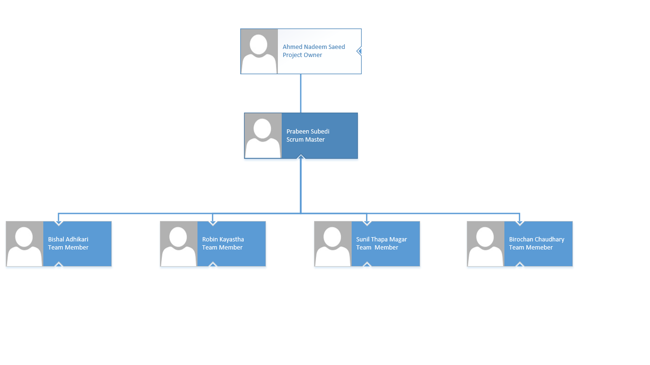

Fig.2.2 Agile Structure

Our Project Model has three roles: Product owner, scrum master and the development team members. These three roles define the responsibilities of each team. It also helps our team to improve themselves organize in responsible manner. The Product Owner is responsible to deliver the most value. The Product Owner represents the business and helps identify the development team what is important. On other hand our scrum master is responsible for collaborating every process to make sure the project is running according to the business requirement. They ensure that the product owner to understand the backlog and help the team to break down the work among each other to produce an effective output. And finally, our development team are the individual who do the work. They are self-organized and can make their own decision to ensure the work is done.

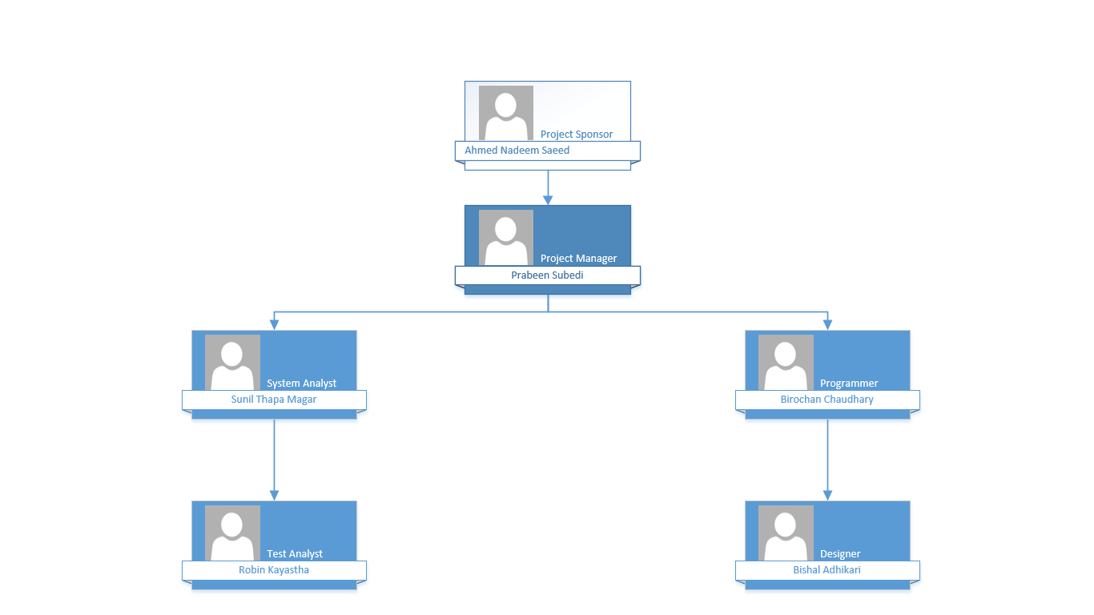

Fig 2.3 Internal Structure

The project manager plays the head role in the project who ensure that the project run smoothly. Our Project manager Prabeen is responsible for its success and quality. The main job of Prabeen is to make sure that the project run and complete within the specified time frame with allocated budget and producing its goal at same time. Secondly, Project sponsor are them who have interest in the project to ensure a successful outcome. They are involved in high level project planning along with project manager. Thirdly, Project team including designer, programmer, tester are all the people who work in various stage of the project. Finally, the system analyst foresees the system requirement and suggests the solutions for the problem.

## Organization Boundaries and Interfaces

The relationship between the project team and Starta Manager, our client is very important for the most of the part of our business. As we move deep in our project, we will extend our relationship with executive committee, owners corporation, secretary as well as the tenants and cleaners. This relationships between the parties are very crucial and full cooperation is important. Stakeholders in this Project include tenant, cleaner, project sponsor and client. Along with that stakeholders will include Project plan company the project manager, project team, Business analyst. In case of any addition of the project goal Strata Manager can directly contact with Prabeen.

|  |  |
| --- | --- |
| Role | Details |
| Client | SP777897 |
| Project Sponsor | Ahmed Nadeem Saeed |
| Project Manager | Prabeen Subedi |
| Project Team | 5 |
| End User | Tenant, OC Admin, Unit Owners, Cleaners |
| Project Company | Application Solutions |

Table 2.2 Project Team Details

## Project Responsibilities

This section describes the responsibilities of each member of the Project team:

|  |  |  |  |
| --- | --- | --- | --- |
| Role | Name | Contact | Responsibility |
| Project Owner | Ahmed Nadeem Saeed | [Ahmed@gmail.com](mailto:Ahmed@gmail.com)  0426734051 | Responsible to help identify the project team to deliver the most value. |
| Project Manager | Prabeen Subedi | [Prabeen@gmail.com](mailto:Prabeen@gmail.com)  0426734052 | Head of the Project who will ensure the project to run smoothly and main job is to complete project in allocated time frame with specified budget. |
| Programmer | Birochan Chaudhary | [birochan@gmai.com](mailto:birochan@gmai.com)  0426734053 | Responsible to create code for mobile phone applications(Hello) that runs on both android and iOS device. |
| Designer | Bishal Adhikari | [Bishal@gmail.com](mailto:Bishal@gmail.com)  0426734054 | Create a prototype of the whole application and mainly involve in the architecture and Data design. |
| System Analyst | Sunil Thapa Magar | [Sunil@gmail.com](mailto:Sunil@gmail.com)  0426734055 | Responsible to foresee the system requirement and produce solution to the problems. |
| Test Analyst | Robin Kayastha | [Robin@gmail.com](mailto:Robin@gmail.com)  0426734056 | Responsible to test the software packages including all the functional and non-functional requirement. |
| Documentation | Sunil Thapa Magar | [Sunil@gmail.com](mailto:Sunil@gmail.com)  0426734057 | Responsible to compile all the analysis and the app requirements. |

Table 2.3 Team Responsibility

# Managerial Process

## Management Objectives and Priorities

Managerial process can be defined as a process of setting goals, planning and or/controlling the organizing and leading the execution of any type of activity, such as: a project or a process. The management objectives and priorities are given below.

The following are the steps to carry out a project management process.

1. Planning: The main objective of our project is to develop a private messaging app that would run on both the android and the IOS devices so that the current tenants, owners, managing agents, strata management committee and the executive committee all or on the same page so that they could communicate effectively and come together for the strata development plan. To be successful in developing our strata plan, we need to work together to develop an app first and to develop the app, all the current tenants, strata management committee and the OC Admin should work together.

2. Organizing: Organizing defines the group’s functions and defines authority and responsibility of the group members. To successfully develop the app, the owners should approve the current tenants through the electronic workflow and the admin should send the private notifications to the selected users. Besides this, OC Admin can also help to manage add and remove users from the chat group upon needed. Above all of these, the Strata Manager holds the most responsibility for the strata development and app development too as it is the prime duty of the strata manager to manage every problem within the strata. The major responsibilities of the strata manager are described below.

3. Staffing: Staffing refers to recruitment or placement and training that takes place for the development of the group members for the project. During our project development, we did not undergo any staffing plan.

4. Directing: Directing is about giving direction to the group members. The Strata Manager, being the senior of them all, can give direction to the members when they make a mistake or face any problem during the development of the project plan.

In the context of our group, the senior member, i.e. the Strata Manager is responsible for carrying out the management process and its activities. It is the prime role and responsibility of the Strata Manager to manage the problems within the strata. The Strata Manager looks after all the activities that takes place within the strata. The Strata Manager has got huge set of roles and responsibilities that can help to manage the problems of the strata.

## Assumptions, Dependencies, and Constraints

Generally, the strata managers are confused with the property managers. The Property, Stock and Business Agents Act 2002 NSW defines the strata manager as a person who carries out various owner’s corporation functions that are outlined in the act for some reward. The strata managers do not sell or rent the properties like the property managers or other managers.

The strata manager is appointed by the unit owners as a collective. It is the duty and responsibility of the strata manager to look after the day-to-day activities that includes the proper implementation and management of the strata properties. The owners can elect more than one strata manager depending upon the nature of the property, i.e. (complexity and size) of the property. The relationship between the strata corporation and the manager is governed by the contract between them and

the duties that he or should undertake. The strata managers have well designed processes and systems that place them in a better position to carry out their functions as compared to the property owners. The difference between the strata manager and the property manager is that the strata manager does not provide its services to the individual owners instead provides its services to the whole corporation. Similarly, the strata manager provide suggestion about the common property management and are entitled with the following set of duties and responsibilities.

1. Property Maintenance

It is the role of the strata manager to make sure that the people occupying a strata property are living without any problems.

2. Keeping custody of and updating records

It is the responsibility of the strata manager to keep up-to-date strata records. Besides this, it is also the responsibility of the owner’s corporation team.

3. Financial management and taxation

It is the role of the strata management to prepare the budget and submit them to the owner’s corporation committee for necessary review and approval.

4. Administration and setting up of meetings

It is the prime duty of the strata manager to discuss and team up with the owners regarding the property maintenance issues and any other information regarding the strata property.

5. Interpersonal relations and sharing information

The strata manager is responsible for the organisation of the events and various social occasions where they can get feedback from the tenants and the residents regarding the improvement of any services.

6. Ensuring compliance with building and safety requirements

The strata manager is responsible for ensuring that the strata property is compliant.

In these ways, the Strata Manager can help to manage the problems within the strata by undertaking its role and responsibilities.

It is the duty and responsibility of the strata manager to manage the group of properties and address all the matters that affect the general property and the communication between the lot owners in accordance with the law and the strata rules and regulations. It is also the prime duty of the strata manager to manage the conflict that takes place within the property. The strata manager can manage the conflicts that takes place within the property in the following ways;

- By organising meetings.

- By arranging the property maintenance.

- By maintaining the strata register.

- By collecting fees from owners on time.

- By payment and distribution of financial statements and budgets.

- By payment of all the invoices on time.

# Technical Process

## Methodology

### Scrum in Agile methodology

For the development of our project we are using scrum methodology. It is one of the most popular and widely used method for system development. It Is also one of the implementations of agile methodology. In this method each progress in the project are delivered to the client or customers in every two- or three-weeks’ time. So, as we are about to develop a chatting application for our client we are going through each step and we will be updating our clients with each incremental build in every two- or three-weeks’ time. We are using this method because it is self-organizing, flexible as it quickly reacts to changes. As we will be inspecting regularly on our project in each one or two weeks so there won’t be need of too many changes at the end of our project as well. (guru99, 2018)

### Tools and technology

|  |  |
| --- | --- |
| Tools | Usage |
| Messenger | For general discussion, online meeting, video calls, regular updates on the work |
| Ms teams | For video conference, code sharing, easy communication and more professional interactions |
| Google drive | Sharing files and information |
| GitHub | To manage scrum, code review |
| Gmail | To share information and knowledge with all the stakeholders |
| Draw.io | For the designing of prototypes of the app that we are going to develop |
| HTML 5 | Platform used to develop codes |
| Java script | Develop codes |
| Phone gap | Cross platform uses for application development |
| CSS | Generate codes |
| Ms word | Documentation of our files and overall project procedures and progress |
| Visio | Tools for software design |
| invasion | Used for UI designing |

Table 4.1 Tools and Technology

## Software Documentation

The main objective of the software documentation is to make sure that the software developers and stakeholders are all headed towards the same destination or same point. In agile methodology software documentation cam, be divided into two categories and they are:

1. Product documentation
2. Process documentation

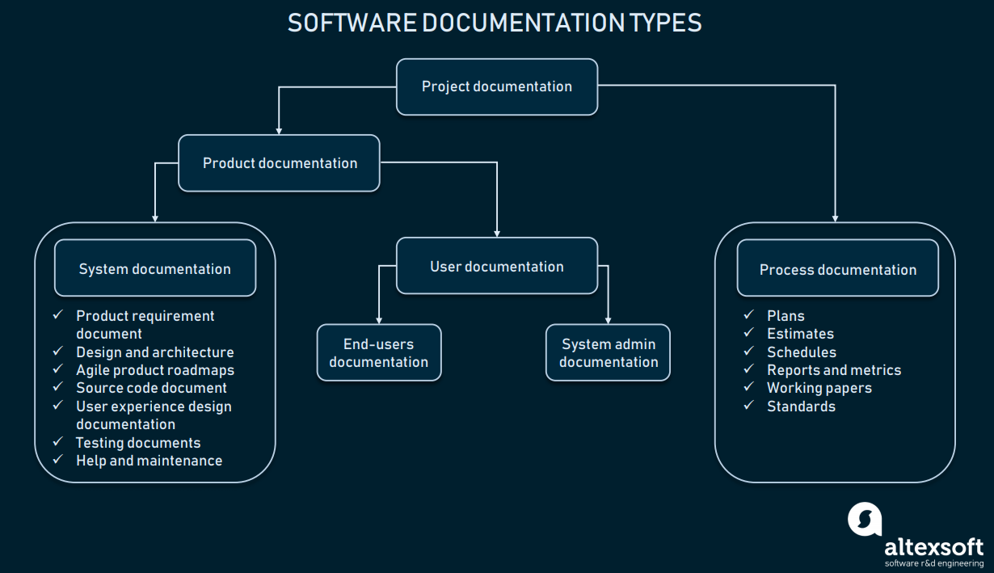

(altexsoft, 2019)

Fig 4.1 Software Documentation

### Product documentation

In this category of documentation, it describes about the product that is being developed and facilities with the instruction on how to work on different kinds of activities. There are also two kinds of product documentation:

1. System documentation which represents documents that give the brief information on the system itself and it parts. Which includes required information and documents, design decision, architecture description, program source code and FAQs.
2. User documentation covers manuals that are mainly prepared for end-users of the product and system administrators. User documentation includes tutorials, user guides, troubleshooting manuals, installation, and reference manuals.

### Process documentation

Process documentation represents overall documents from prepared from the process of development and maintenance that briefly describes the whole process. Some common example of process related documents are standards, project documentation, such as project plans, test schedules, reports, meeting notes or even business correspondence.

The main difference between product and process documentation is the first one describes about the product that is being developed and the second one describes and record the process of development of the product**.** (altexsoft, 2019)