

Network Design & Management (IT 3010)
3rd Year, 1st Semester

Assignment

Virtualized Network Infrastructure Deployment & Service Configuration

Submitted to
Sri Lanka Institute of Information Technology

IT23831490
Hewamaramage HMCS

In partial fulfillment of the requirements for the
Bachelor of Science Special Honors Degree in Information Technology

07/04/2026
Abstract
This assignment demonstrates the design and deployment of a virtualized network infrastructure within a Linux-based environment, integrating essential network services and socket-level communication. A structured IP addressing scheme was derived from the student registration number to ensure a unique /24 subnet, enabling controlled internal communication between virtual machines.
A DNS server was configured using BIND to provide authoritative forward and reverse name resolution for the custom domain, supporting service discovery and hostname-to-IP mapping. Special emphasis was placed on proper zone configuration, including SOA, NS, A, PTR, and MX records to ensure reliable resolution and compatibility with higher-level services.
A Mail server was implemented using Postfix, enabling domain-based internal email communication. The configuration leveraged DNS MX records for correct mail routing, while user-level mailboxes were utilized to simulate real-world message exchange within a closed network environment.
At the application layer, a TCP-based client–server system was developed in C using Berkeley sockets. The server was designed as an iterative TCP server, performing socket creation, binding, listening, and connection acceptance. Upon successful connection establishment, the server retrieves the system time and transmits it to the client, ensuring reliable data delivery through connection-oriented communication. Both client and server implement session-level logging, capturing IP addresses, port numbers, and timestamps for traceability and debugging.
The entire system was validated through functional testing, including DNS resolution, mail transmission, and socket communication. This implementation highlights the interaction between network infrastructure services and application-layer protocols, demonstrating practical competency in network configuration, system administration, and low-level network programming.

Declaration
I certify that this report does not incorporate without acknowledgement, any material previously submitted for a degree or diploma in any university, and to the best of my knowledge and belief it does not contain any material previously published or written by another person, except where due reference is made in text.

Student name: Hewamaramage HMCS
Student ID: IT23831490

07/04/2026  ……………. | 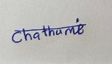  ………………………….
Date | Sign

Acknowledgement

I would like to express my sincere gratitude to my lecturer and instructors for their guidance and support throughout this assignment. Their insights and feedback were invaluable in understanding the practical aspects of network design and implementation.
I also thank the Sri Lanka Institute of Information Technology for providing the necessary resources and learning environment to successfully complete this work.
Finally, I appreciate the support of my friends who assisted and encouraged me during the completion of this assignment.

TABLE OF CONTENT

CHAPTER 1: INTRODUCTION 1
CHAPTER 2: NETWORK CONFIGURATION 2
2.1 Virtual Machine setup 2
2.2 IP address configuration 2
2.3 Hostname configuration 3
CHAPTER 3: DNS SERVER CONFIGURATION 5
3.1 Installation 5
3.2 Service configuration 5
3.3 name.conf configuration 6
3.4 Zone configuration 7
3.5 Create zone files 8
3.6 Set Permissions 10
3.7 validation 11
3.8 Client DNS Setup (Fedora) 12
3.9 Testing 13
Chapter 4 : MAIL SERVER CONFIGURATION 16
4.1 Installation 16
4.2 Start Services 17
4.3 Configuration 19
4.4 User creation 21
4.5 Testing Mail 22
CHAPTER 5: CLIENT SERVER APPLICATION DEVELEOPMENT 23
5.1 Implementation 23
5.2 installing GCC complier 24
5.3 Server code 26
5.4 Client code 28
5.5 Compilation & execution 29
5.6 Output 31
5.7 Log files 31
CHAPTER 6: RESULTS 33
CHAPTER 7: CONCLUTION 34

Figure table
Figure 2.2 1:IP configuration on centOS server 2
Figure 2.2 2:IP configuration on Fedora Client 3

Figure 2.3 1:hostname configuration on centOs server 4
Figure 2.3 2:hostname configuration on Fedora client 5

Figure 3.1 1:DNS package installation 6

Figure 3.2 1:DNS service status 6

Figure 3.3 1:name.conf configuration 7

Figure 3.4 1:Zone configuration on named.conf 8

Figure 3.5 1:Forword zone file configuration 9
Figure 3.5 2:Reverse zone file configuration 10

Figure 3.6 1:permission settings 11

Figure 3.7. 1:DNS validation using named-checkzone 11
Figure 3.7. 2:DNS service status after restart 12

Figure 3.8. 1:DNS client configuration 13

Figure 3.9. 1:nslookup output 13
Figure 3.9. 2DNS resolv configuration 14
Figure 3.9. 3:dig foreword lookup result 14
Figure 3.9. 4:dig revers lookup result 15

Figure 4.1. 1:Mail server installation 16

Figure 4.2. 1:Postfix service status 17
Figure 4.2. 2:installing of dovecot Mail serever 18
Figure 4.2. 3:Dovecot service status 19

Figure 4.3. 1:postfix network interface setting 20
Figure 4.3. 2:Postfix Mail destination setting 20
Figure 4.3. 3:Postfix Domain and Network settings 20

Figure 4.4. 1:User creation 21

Figure 4.5. 1:sending and receiving mails 22

Figure 5.2. 1:install GCC to server side 24
Figure 5.2. 2:install GCC compiler to client side 25

Figure 5.5. 1:server compilation and execution 29
Figure 5.5. 2:client compile and execution 30

Figure 5.6 1:sever connection details 31

Figure 5.7. 1:sever log file 31
Figure 5.7. 2:client log file 32

CHAPTER 1: INTRODUCTION

This assignment focuses on the design and implementation of a virtualized network infrastructure using Linux-based virtual machines. It integrates core network services such as DNS and Mail, alongside a TCP-based client–server application developed in C.
The objective is to demonstrate how network services and application-layer communication operate together within a controlled environment. By combining system configuration with socket programming, this implementation reflects practical aspects of real-world network deployment and management.

CHAPTER 2: NETWORK CONFIGURATION

2.1 Virtual Machine setup
Two virtual machines were created:
- CentOS9 – Server
- Fedora – Client

2.2 IP address configuration
IT number: IT23831490
Remove: IT & Last two digit
Result: 238314
Derived into octets as 23.83.14.1 Create a network address 23.83.14.0/24.
Device | IP Address
Server (CentOS) | 23.83.14.1
Client (Fedora) | 23.83.14.2

Static IP Adress were configured using nmcli command and apply the network interface.
- CentOS Server
nmcli con mod ens33 ipv4.addresses 23.83.14.1/24
nmcli con mod ens33 ipv4.method manual
nmcli con down ens33
nmcli con up ens33

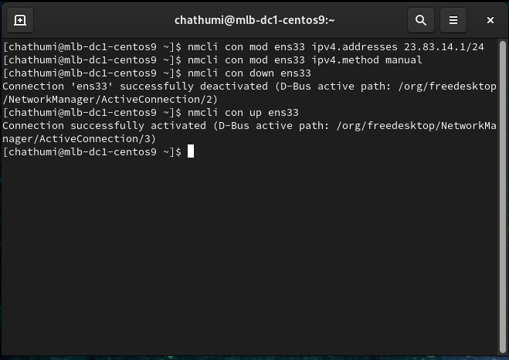
Figure 2.2 1:IP configuration on centOS server

- Fedora Client
nmcli con mod "Wired connection 1" ipv4.addresses 23.83.14.2/24
nmcli con mod "Wired connection 1" ipv4.method manual
nmcli con down "Wired connection 1"
nmcli con up "Wired connection 1"
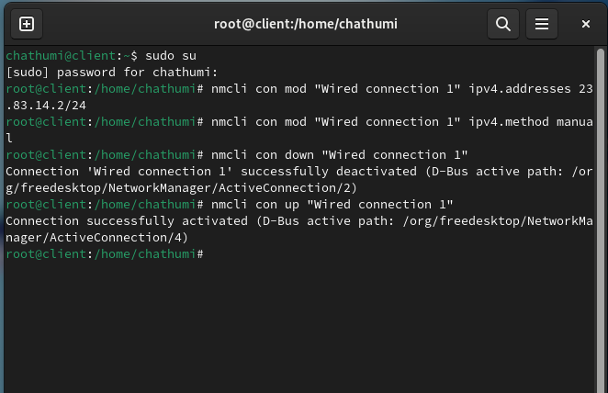
Figure 2.2 2:IP configuration on Fedora Client

2.3 Hostname configuration

hostnamectl set-hostname chathuhewa1490-server
hostnamectl

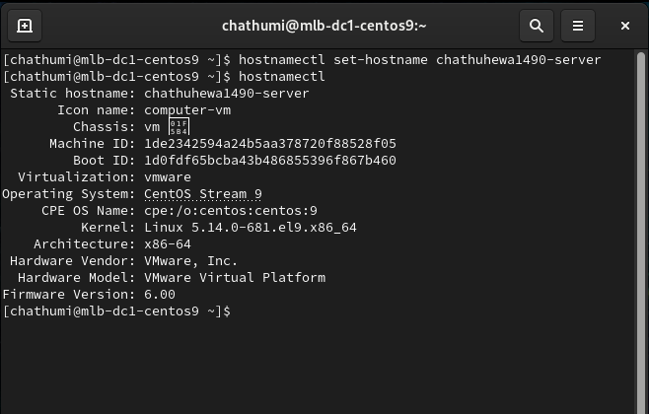
Figure 2.3 1:hostname configuration on centOs server

hostnamectl set-hostname chathuhewa1490-client
hostnamectl

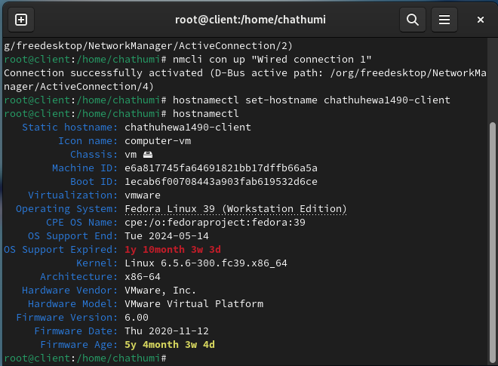
Figure 2.3 2:hostname configuration on Fedora client

CHAPTER 3: DNS SERVER CONFIGURATION

3.1 Installation
Using following commands installed the DNS server.
dnf install -y bind bind-utils
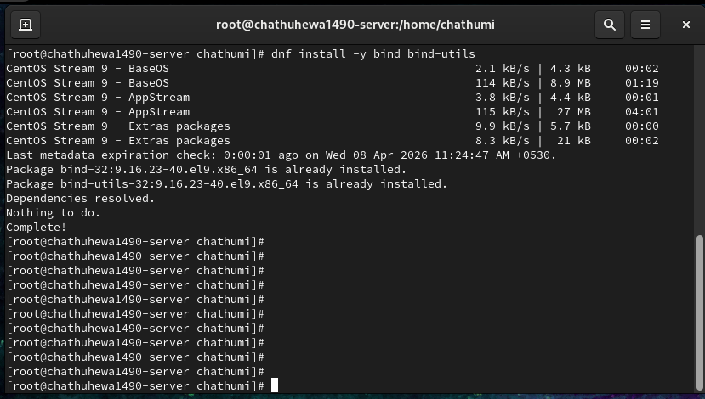
Figure 3.1 1:DNS package installation

3.2 Service configuration
The DNS service was enabled and starting using-
systemctl enable named
systemctl start named
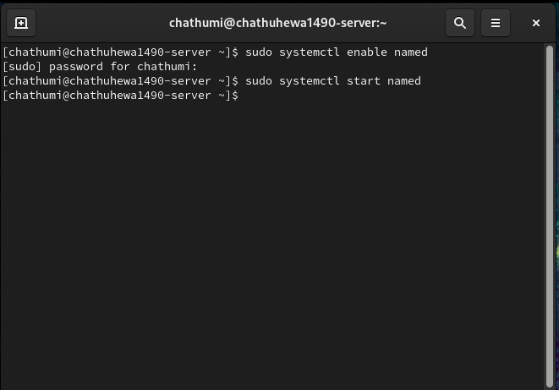
Figure 3.2 1:DNS service status

3.3 name.conf configuration
Modified by DNS configuration file called vi /etc/named.conf.
It is modified to:
- Allow connections from any host
- Listen on all interfaces

vi /etc/named.conf :-
listen-on port 53 { any; };
allow-query { any; };
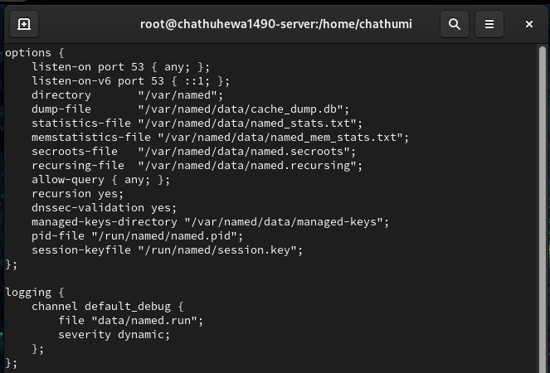
Figure 3.3 1:name.conf configuration

3.4 Zone configuration
Forward and reversed zone were added to vi /etc/named.conf this file
Forward lockup Zone :-
zone "IT23831490.lk" IN {
type master;
file "forward.IT23831490.lk";
};
Reversed lockup Zone:-
zone "14.83.23.in-addr.arpa" IN {
type master;
file "reverse.IT23831490.lk";
};

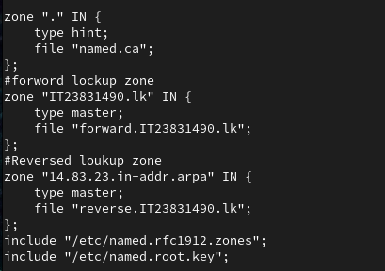
Figure 3.4 1:Zone configuration on named.conf

3.5 Create zone files
Go to zone directory
cd /var/named
open the vi forward.IT23831490.lk forward lockup zone file and add followings

@ IN SOA chathuhewa1490-server.IT23831490.lk. root.IT23831490.lk. (
2026040701 3600 1800 604800 86400 )
@ IN NS chathuhewa1490-server.IT23831490.lk.
@ IN A 23.83.14.1
@ IN A 23.83.14.2
chathuhewa1490-server IN A 23.83.14.1
chathuhewa1490-client IN A 23.83.14.2

Forward lockup zone file
This file is to be the process of translating the domain name in to corresponding IP Address.

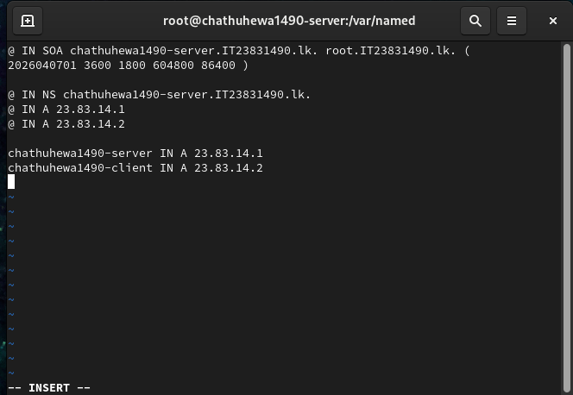
Figure 3.5 1:Forword zone file configuration

open the vi reverse.IT23831490.lk forward lockup zone file and add followings
and added,
@ IN SOA yourname1490-server.IT23831490.lk. root.IT23831490.lk. (
2026040701 3600 1800 604800 86400 )

@ IN NS yourname1490-server.IT23831490.lk.
@ IN A 23.83.14.1

1 IN PTR server.IT23831490.lk.
2 IN PTR client.IT23831490.lk.

Reversed lockup file :-
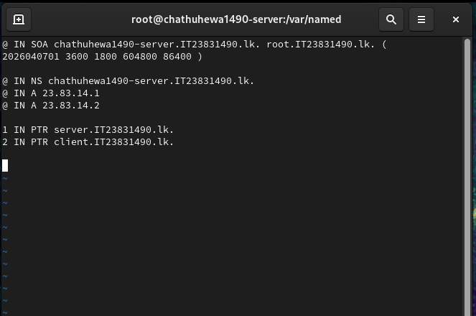
Figure 3.5 2:Reverse zone file configuration

3.6 Set Permissions
Set right ownership and permissions so the to DNS server to access the zone files using following commands:
This command changes the owner of the file to the root user and assigns the group ownership to the named group:
sudo chown root:named /var/named/forward.IT23831490.lk
sudo chown root:named /var/named/reverse.IT23831490.lk

This command defines specific access levels (permissions) for the file using a numeric code:
sudo chmod 640 /var/named/forward.IT23831490.lk
sudo chmod 640 /var/named/reverse.IT23831490.lk

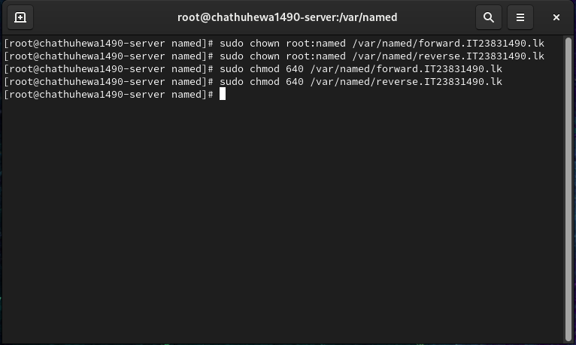
Figure 3.6 1:permission settings

3.7 validation
named-checkconf
named-checkzone IT23831490.lk /var/named/forward.IT23831490.lk
named-checkzone 14.83.23.in-addr. arpa /var/named/reverse.IT23831490.lk
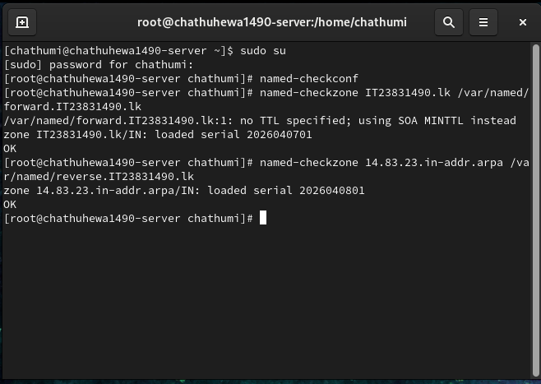
Figure 3.7. 1:DNS validation using named-checkzone

Then restart DNS and check status
systemctl restart named
systemctl status named
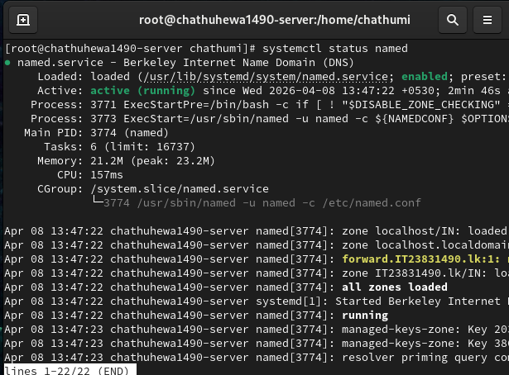
Figure 3.7. 2:DNS service status after restart

3.8 Client DNS Setup (Fedora)
Network manager was configured DNS setting on the client machine ensure that the configuration is persistent even after system restarts.
nmcli con mod "Wired connection 1" ipv4.dns "23.83.14.1"
nmcli con mod "Wired connection 1" ipv4.ignore-auto-dns yes
nmcli con down "Wired connection 1"
nmcli con up "Wired connection 1"
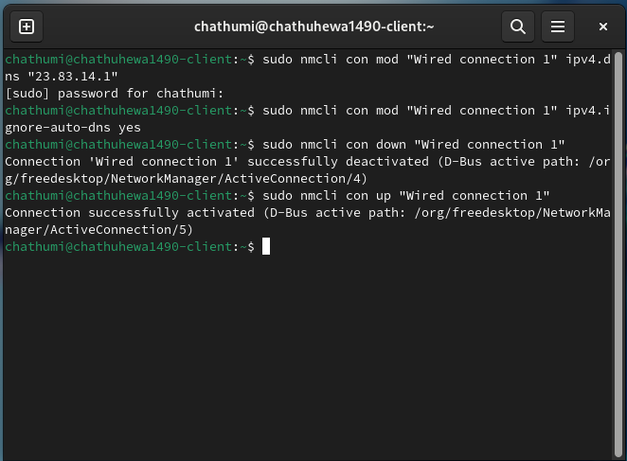
Figure 3.8. 1:DNS client configuration

3.9 Testing
After doing above verifications done in client side now doing test part to confirm that the DNS server is functioning correctly by resolving domain names to IP address and IP address convert to Domain name
nslookup IT23831490.lk
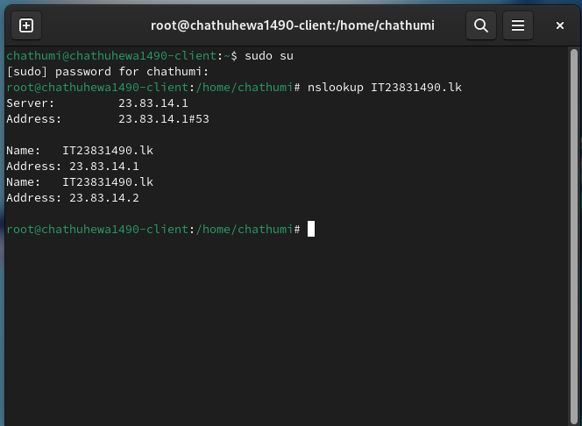
Figure 3.9. 1:nslookup output

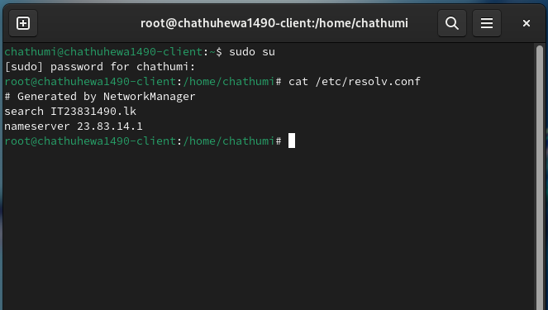
Figure 3.9. 2DNS resolv configuration
dig IT23831490.lk
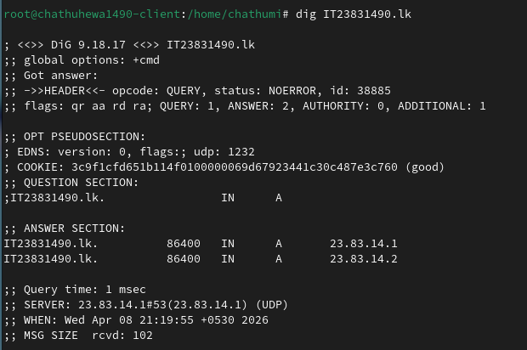
Figure 3.9. 3:dig foreword lookup result

dig -x 23.83.14.1
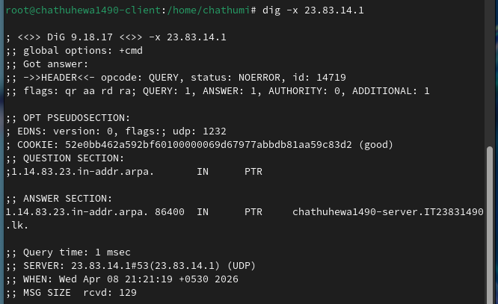
Figure 3.9. 4:dig revers lookup result

Chapter 4 : MAIL SERVER CONFIGURATION

4.1 Installation
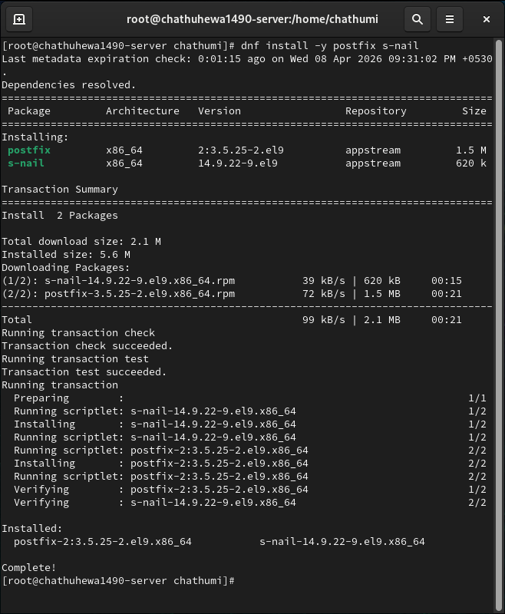
Figure 4.1. 1:Mail server installation

4.2 Start Services
Then enable and started to active mail functionality:
systemctl enable postfix
systemctl start postfix
systemctl status postfix
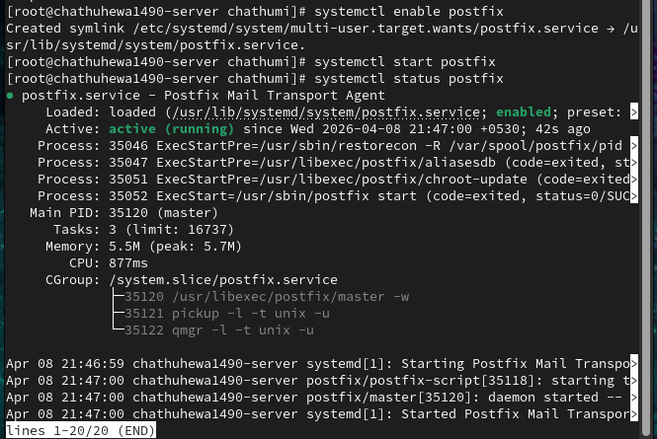
Figure 4.2. 1:Postfix service status

In addition, to postfix Dovecot was install to user to access and read emails from their mailboxes using:

dnf install -y dovecot
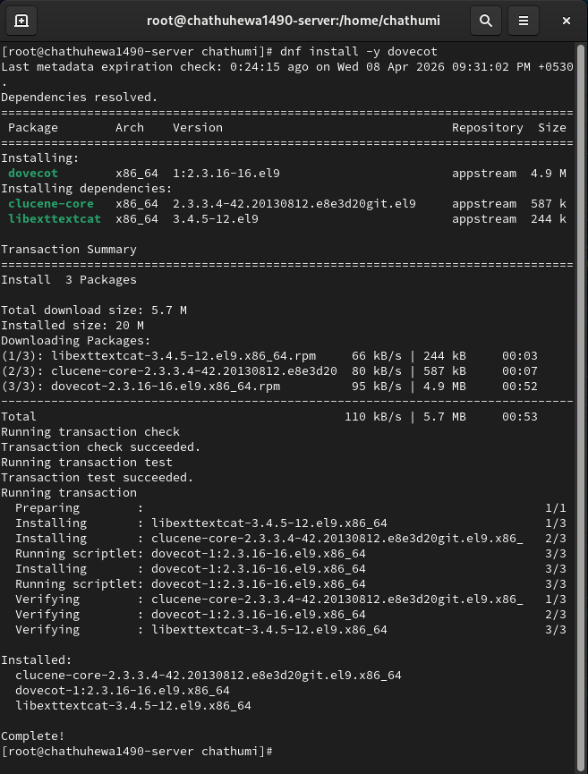
Figure 4.2. 2:installing of dovecot Mail serever

systemctl enable dovecot
systemctl start dovecot
systemctl status dovecot
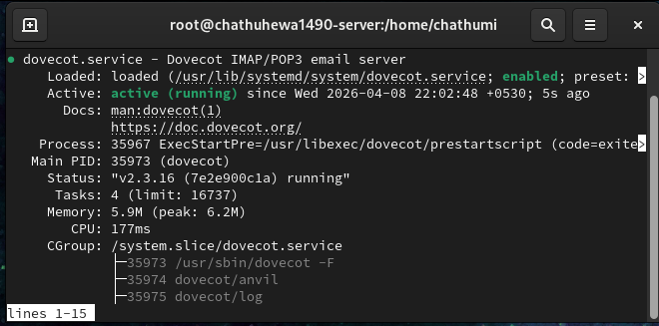
Figure 4.2. 3:Dovecot service status

4.3 Configuration
The post configuration files/etc/postfix/main.cf was modified to hostname, domain and mail routing parameters
Open file:
vi /etc/postfix/main.cf
Add to the file:
myhostname = chathuhewa1490-server.IT23831490.lk
mydomain = IT23831490.lk
myorigin = $mydomain
mynetworks = 127.0.0.0/8, 23.83.14.0/24
inet_interfaces = all
mydestination = $myhostname, localhost.$mydomain, localhost, $mydomain

network interface setting
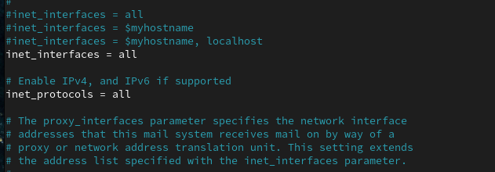
Figure 4.3. 1:postfix network interface setting

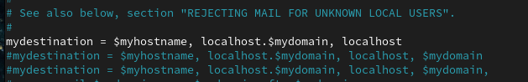
Figure 4.3. 2:Postfix Mail destination setting

Domain and network setting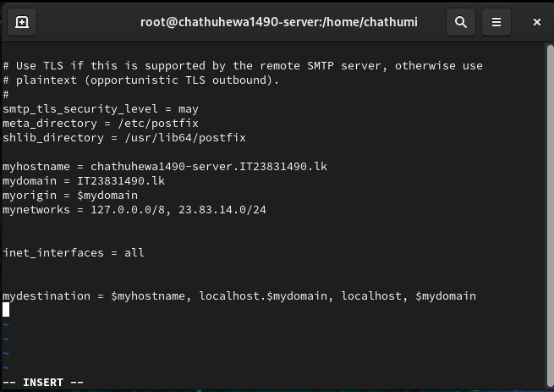
Figure 4.3. 3:Postfix Domain and Network settings

Restart again: systemctl restart postfix

4.4 User creation
useradd user1
passwd user1
useradd user2
passwd user2
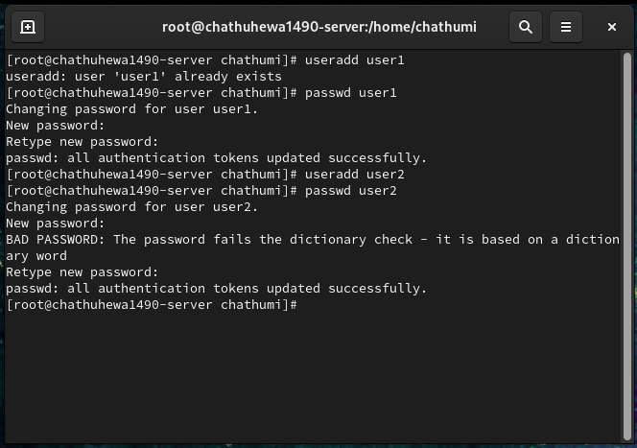
Figure 4.4. 1:User creation

4.5 Testing Mail
echo "Test Mail" | mail -s "Hello" user2
An mail was sent from one user to another user using the mail command.
The sender logging to the system using su-user2 command and access the email box using the
Same command to verify that the email was successfully received.
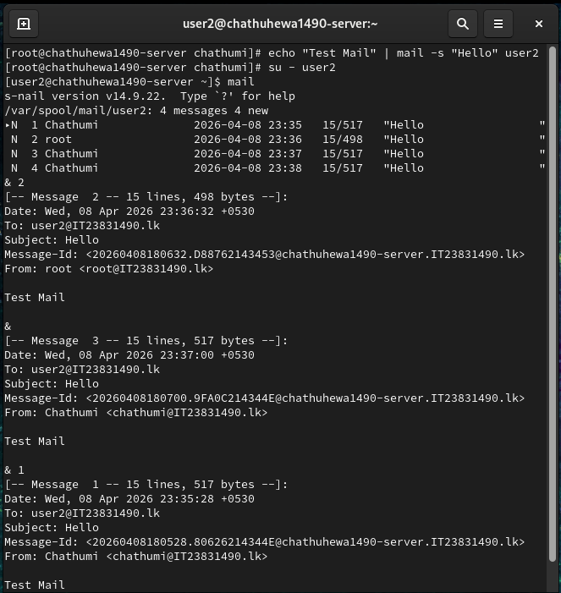
Figure 4.5. 1:sending and receiving mails

CHAPTER 5: CLIENT SERVER APPLICATION DEVELEOPMENT

In this phase of the assignment, a socket-based communication system was implemented to facilitate data exchange between a server and a client within the virtualized network. The system was developed using the C Programming Language, following a standard TCP-based architecture to ensure reliable data transmission

5.1 Implementation
The application is divided into two primary functional components:
- Iterative TCP Server: The server is designed to listen for incoming connection requests on a specific port. Once a client establishes a connection, the server retrieves the current system date and time and transmits this data to the client.
- Client Application: The client initiates a connection to the server using the designated IP address. Upon a successful handshake, it receives the timestamp sent by the server and displays it clearly on the terminal
To meet the audit and monitoring requirements of the network design, comprehensive logging functionality was integrated into both programs.
- Server-Side Logs: The server automatically records each session, capturing essential socket details including the client’s IP address and the port number used for the connection.
- Client-Side Logs: The client maintains a log of the initiated session and the data received, ensuring that all communication events are properly documented for debugging and verification purposes.

5.2 installing GCC complier
The GCC compiler was installe to the both client and server machine to complie C base client server applictaions using: dnf install -y gcc
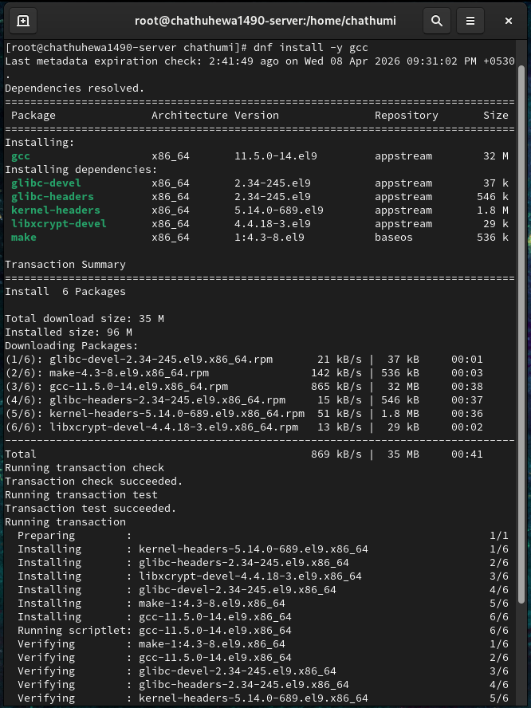
Figure 5.2. 1:install GCC to server side

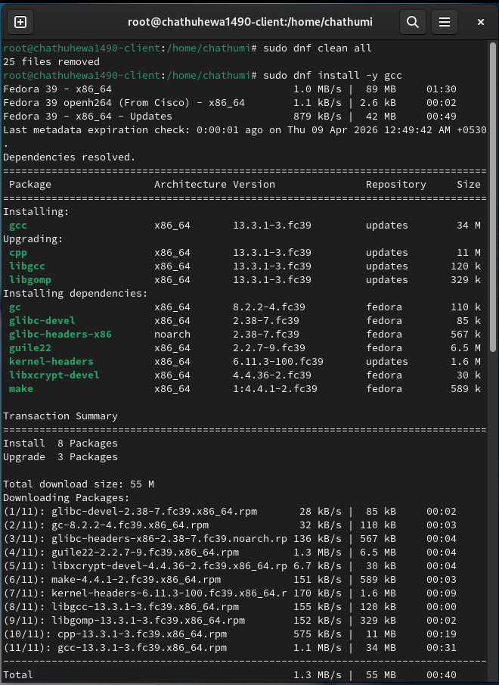
Figure 5.2. 2:install GCC compiler to client side

5.3 Server code
First of all, create file: vi server.c
After that enter the code:
#include <stdio.h>
#include <stdlib.h>
#include <string.h>
#include <unistd.h>
#include <arpa/inet.h>
#include <time.h>

#define PORT 1234

int main() {
int server_fd, client_socket;
struct sockaddr_in server_addr, client_addr;
socklen_t addr_len = sizeof(client_addr);

// Create socket
server_fd = socket(AF_INET, SOCK_STREAM, 0);
if (server_fd < 0) {
perror("Socket creation failed");
exit(1);
}

// Server configuration
server_addr.sin_family = AF_INET;
server_addr.sin_addr.s_addr = INADDR_ANY;
server_addr.sin_port = htons(PORT);

// Bind
if (bind(server_fd, (struct sockaddr*)&server_addr, sizeof(server_addr)) < 0) {
perror("Bind failed");
exit(1);
}

// Listen
if (listen(server_fd, 5) < 0) {
perror("Listen failed");
exit(1);
}

printf("Server running on port %d...\n", PORT);

while (1) {
// Accept client
client_socket = accept(server_fd, (struct sockaddr*)&client_addr, &addr_len);
if (client_socket < 0) {
perror("Accept failed");
continue;
}

// Get current time
time_t now = time(NULL);
char *time_str = ctime(&now);

// Send time to client
send(client_socket, time_str, strlen(time_str), 0);

// Print client info
printf("Client connected: %s : %d\n",
inet_ntoa(client_addr.sin_addr),
ntohs(client_addr.sin_port));

// Logging
FILE *log = fopen("server.log", "a");
if (log != NULL) {
fprintf(log, "Client IP: %s | Port: %d | Time: %s",
inet_ntoa(client_addr.sin_addr),
ntohs(client_addr.sin_port),
time_str);
fclose(log);
}

close(client_socket);
}

close(server_fd);
return 0;
}

5.4 Client code
Create file : vi client.c
Then add code to the file
#include <stdio.h>
#include <stdlib.h>
#include <string.h>
#include <unistd.h>
#include <arpa/inet.h>

#define PORT 1234
#define SERVER_IP "23.83.14.1" // change if needed

int main() {
int sock;
struct sockaddr_in server_addr;
char buffer[1024];

// Create socket
sock = socket(AF_INET, SOCK_STREAM, 0);
if (sock < 0) {
perror("Socket creation failed");
exit(1);
}

// Server configuration
server_addr.sin_family = AF_INET;
server_addr.sin_port = htons(PORT);

if (inet_pton(AF_INET, SERVER_IP, &server_addr.sin_addr) <= 0) {
perror("Invalid address");
exit(1);
}

// Connect
if (connect(sock, (struct sockaddr*)&server_addr, sizeof(server_addr)) < 0) {
perror("Connection failed");
exit(1);
}

// Receive data
int bytes = recv(sock, buffer, sizeof(buffer) - 1, 0);
if (bytes < 0) {
perror("Receive failed");
exit(1);
}

buffer[bytes] = '\0';

printf("Server Time: %s\n", buffer);

// Logging
FILE *log = fopen("client.log", "a");
if (log != NULL) {
fprintf(log, "Received: %s\n", buffer);
fclose(log);
}

close(sock);
return 0;
}

5.5 Compilation & execution
Server:
gcc server.c -o server
./server
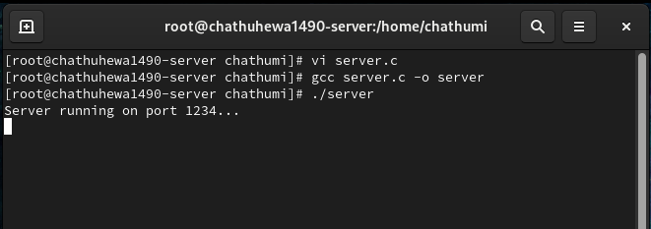
Figure 5.5. 1:server compilation and execution

Client:
gcc client.c -o client
./client
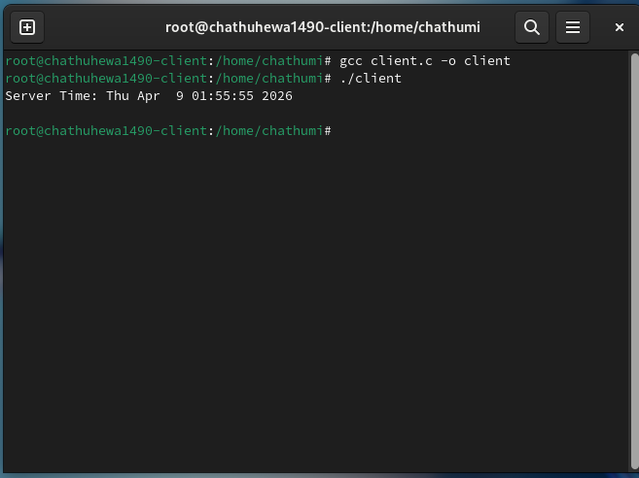
Figure 5.5. 2:client compile and execution

5.6 Output
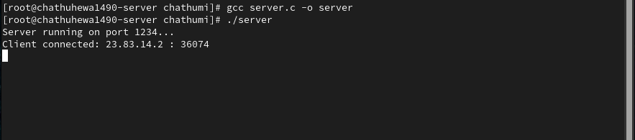
Figure 5.6 1:sever connection details

5.7 Log files
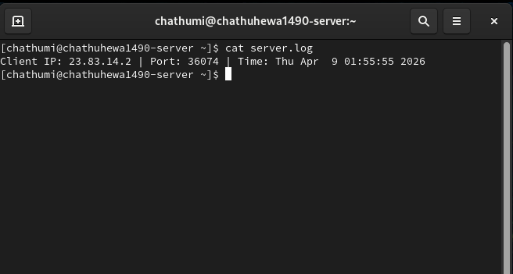
Figure 5.7. 1:sever log file

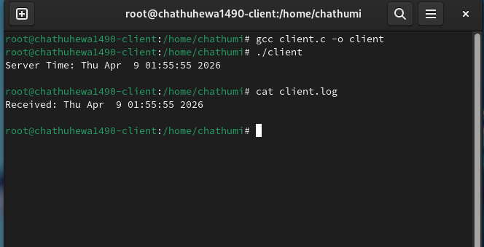
Figure 5.7. 2:client log file

CHAPTER 6: RESULTS

The virtualized network infrastructure and all required services were successfully configured and tested. The DNS server accurately performed forward and reverse lookups for the configured domain. The Linux-based mail server facilitated seamless internal email communication between clients. Furthermore, the C-based iterative TCP client-server application was successfully executed; upon connection, the server accurately transmitted the current system date and time to the client terminal. Both the client and server successfully logged all initiated sessions, accurately recording the respective IP addresses and port numbers.

CHAPTER 7: CONCLUTION

In conclusion, this assignment demonstrated practical implementation of a network infrastructure using virtualization. Key services including DNS, Mail, and TCP-based communication were successfully deployed and tested. The project enhanced understanding of networking concepts and Linux system administration.

