**Table 1. Comparison of the model performance for different patch sizes with learning rate = 0.001 and weight decay = 0.0001 and Adam optimizer**

|  |  |  |  |
| --- | --- | --- | --- |
| **Patch size** | **Number of patches** | **Overall accuracy** | **Time taken to process(s)** |
| 16 × 16 | 4 | 56.70% | 700 |
| 8 × 8 | 16 | 59.23 | 1900 |
| 4 × 4 | 64 | 62.56% | 8600 |
| 2 × 2 | 256 | - | 56100 (Estimated) |

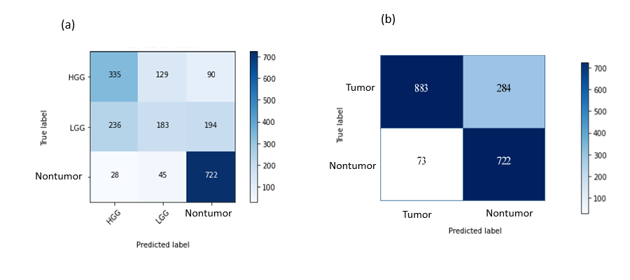

Accuracy:

CNN – 24.61%

Vision transformers – 3 classes (HGG/LGG/No Tumor) – 63.2%

Vision transformers – 2 classes (Tumor/No Tumor) – 81.8%