Prabuddha Banerjee

Prabuddha.banerjee1@marist.edu

Dr. Pablo Rivas

Homework 0

MSCS 630L 711 20S

1. Setup Java in your computer

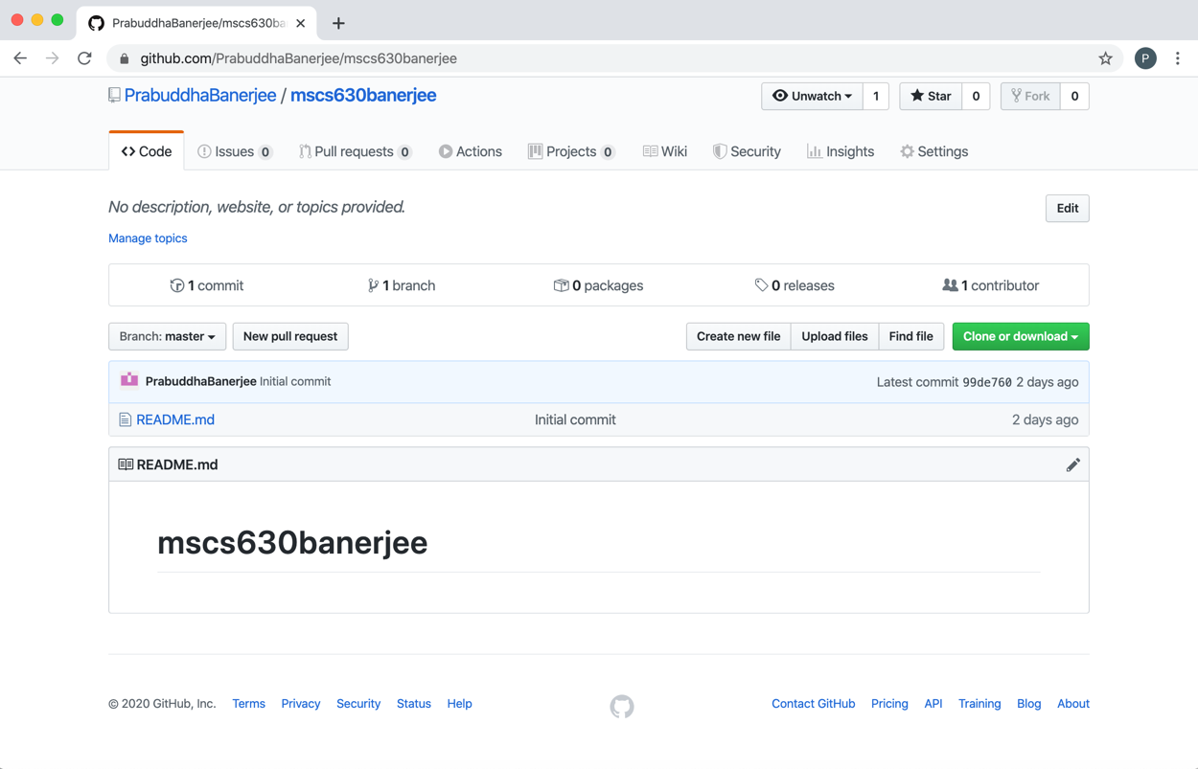

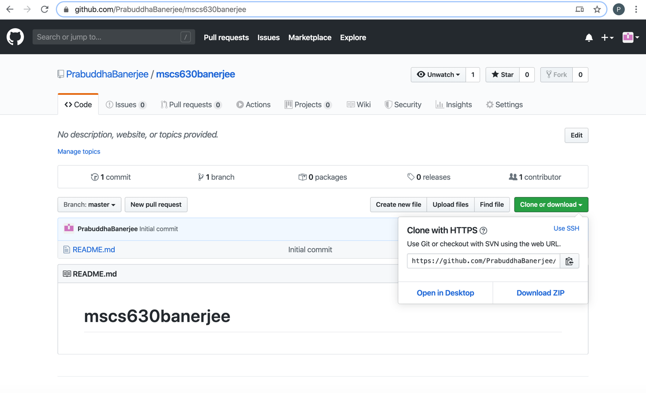

<https://github.com/PrabuddhaBanerjee/mscs630banerjee.git>

