**JAVA PROJECT REPORT**

**“STAFF GENIE: Any Staff at One Snap”**

Submitted by:

**1.PRABUDDH RAJ PANDEY 12109163**

**2.SRISTI MAURYA 12113041**

**Project Group Number - 01**

**Course Code – CSE 310(JAVA PROGRAMMING)**

Under the Guidance of

**“DR. RANJITH KUMAR A (26108)”**

# School of Computer Science and Engineering



**TABLE OF CONTENT**

1. **INTRODUCTION**
2. **SCOPE OF THE PROJECT**
3. **DESIGN**
   1. **MODULE**
   2. **SUB-MODULE**
4. **SCREENSHOTS**
5. **SAMPLE CODES**
6. **OUTCOME OF THE PROJECT**
7. **INTRODUCTION:**

As it is mentioned that the project title is “APPLICANT TRACKING SYSTEM AND EMPLOYEE INFORMATION SYSTEM” which contains the data of the employee which are working in a particular company.

The project comprises of 7 frames in which the first frame will have the home page. The home page will be consisting of 3 options as admin page, punch attendance and apply for job.

While logging in to the admin panel, we will see that the page will be consisting of 3 options as add employee, remove employee and scrutiny for job application.  
In the first option, the admin can add any employee in the company by seeing his data which is provided by the employee itself.

The second option has the facility of deleting the employee by the admin based on certain criteria which is decided by the admin.

The third option is scrutiny for the job applications which is done by the admin.

All the data which has been asked by the company to the employee will be displayed on the screen and the admin has the option to accept it and reject it.

In the home page, the second option is applying for job. In this module, the user or the employee have to enter some data which are asked by the company like his name, age, previous experience kind of things.

The next option in the home page is the attendance page. In this page the employee of the company can punch his/her attendance by entering the credentials given to him/her by the admin block.

If the employee enters any details which does not matches with the database of the company, a popup message will be displayed on the console that the entered credentials do not match with the data in the database of the company.

There are certain constraints on every module of the project. The admin page will only be accessed by the admin rather than anyone in the company. Like if the employee enters his age in form of string, a popup message will be displayed on the console of the employee that the details entered by you is wrong. The constraints which are applied on each and every module increases the efficiency of the project as if by in any case while applying for job or while punching attendance, if any credentials in wrong, a popup message will be displayed regarding it.

As per the performance of the employee in the company, the admin can take the decision that whether we have to keep this employee for future or we have to fire him as he is not useful for the company.

So, thus above mentioned is the idea of the project regarding the management of the employees in any of the particular company owned by the admin. Through this, the admin has all the data of the employees who are working in his company and even he can add employees if he wants so and can discard too.

1. **SCOPE OF THE PROJECT:**

As business owners, everyone is willing to know what is an effective employee management system. We have some research on employee management systems which provide to help you. Continue to read our blog to manage your firm employee in effective ways.

An effective employee management system is used to manage the work process and organizational responsibilities of human resources and other departments. It helps managers and employees to work together and accurately monitor, access, manage, and efficiently utilize the working hours for better business growth. Also, it helps in error-free payrolls that can be done on time.

An HR management system streamlines the HR functions by managing business operations by the department.

Employee management systems are designed to monitor, assess, and control the working hours of employees in order to utilize their resources efficiently. The payrolls are also done on time with the help of payroll software.

Employee Management software or labour management is an organizational process that meets the productivity, social, and practical requirements of employees. Also, it helps recruit employees, onboarding, and enhance their performance up to mark.

Employee management provides many direct and indirect responsibilities to human resources. Have a look at some of them:

• Investment

• Engagement and Retention

• Productivity Management

• Benefits and Payroll

1. **DESIGN:**

In the designing of the project;

1. The program features a simple and user-friendly interface that makes it easy to enter and manage employee data.

2. A robust input validation system ensures that only valid data is entered into the system, reducing the risk of errors and improving data quality.

3. The program uses an event-driven programming model, which helps to ensure that the program is responsive and efficient.

Overall, the program is designed to be scalable and extendable, making it a flexible solution for managing employee data in a variety of settings.

**3.1 MODULE:**

The project is basically divided into 2 modules.

Each module has its own task and specification.

* The first module comprises of the home page which further have options of admin page, applying for job and punching the attendance of the employee. Every sub-module has its own task specification. Sub-modules are added so that the project would be more efficient and good looking.  
  While applying for job, the user need to enter the credentials which are being demanded by the company. On entering all the credentials, a popup message will come that your details are submitted successfully.  
  The details are stored in the database and are forwarded to the admin panel where the admin can access all the job entries.  
  The next sub-module is punching the attendance of the employee who are working in the company. While punching the attendance, the employee need to enter his user id and the password which has been provided by the company. If the entry matches with the database which contains the details of all the employees working in that particular company, a popup message will be displayed on the console of the employee that your attendance has been recorded or punched.
  + The second module consists of the admin panel which further have options of adding a new employee, removing an employee and doing scrutiny for the applications which are submitted by employees who want to work in the company.  
    This task would be done by the admin as only the admin has the access of this sub-module.  
    Based on the criteria’s made by the admin, he will take decisions on the employee who are working in his company.

**3.2 SUB-MODULE:**

The project is basically divided into 2 modules.  
The first module comprises of the home page.  
The second module comprises of the admin panel.  
Each sub-module is connected with the database in the backend.  
As soon as the admin removes a employee, the data of that employee is also removed from the backend(database).

Same is applicable on adding the employee.  
The project is scheduled in such a way that it runs on real time.  
It will display the date as well as the exact time that when the attendance of a particular employee has been punched. And thus, it will be automatically stored in the database. Thus, all these features make the project an efficient and useful project in the sector of employee management.

1. **SCREENSHOTS:**

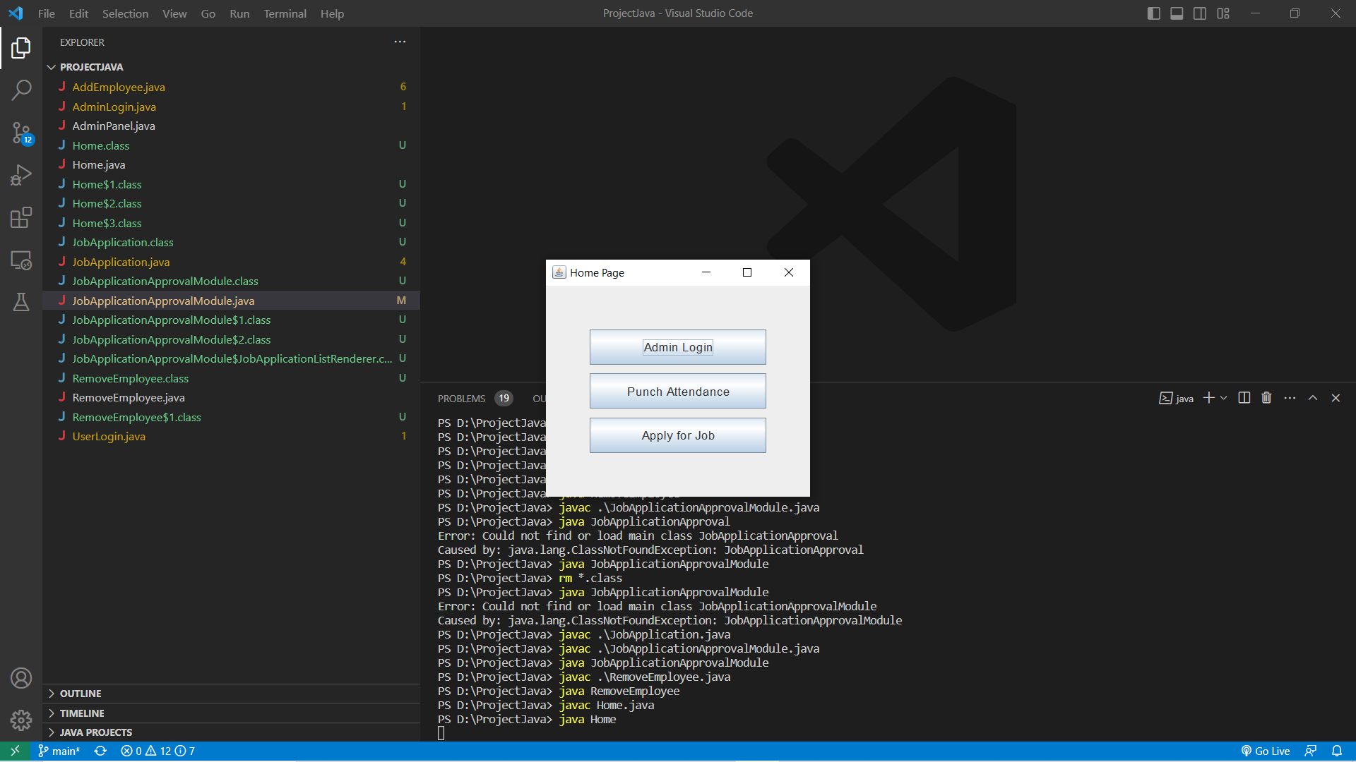

This is the first frame of the module.

Here, different options are available and as per the requirement by the specified person, options need to be clicked.

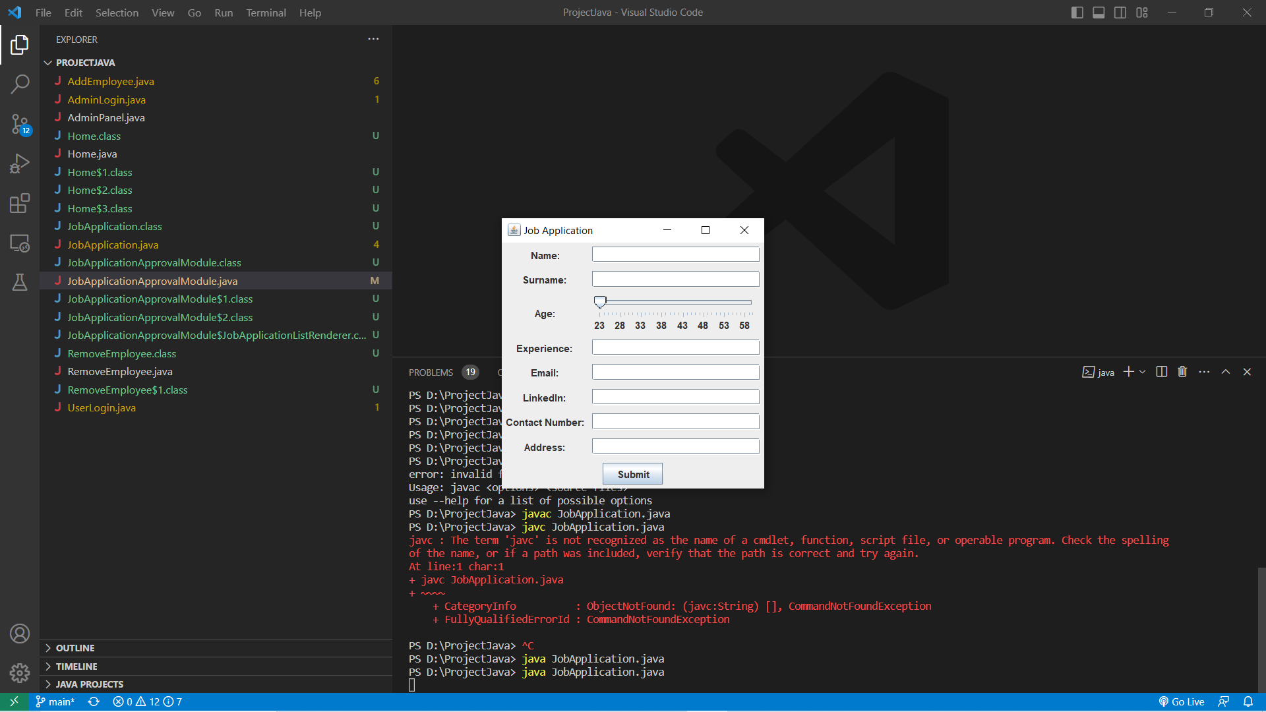

This is the second module of the project.

Here the details are entered by the user who want to apply for the job in the company.  
The user need to enter the details as asked in the module.  
On entering wrong details, the database will reject it with a popup message on the console regarding that it is wrong. On entering the right credentials, the user will get a popup message on his console that your details are submitted successfully.

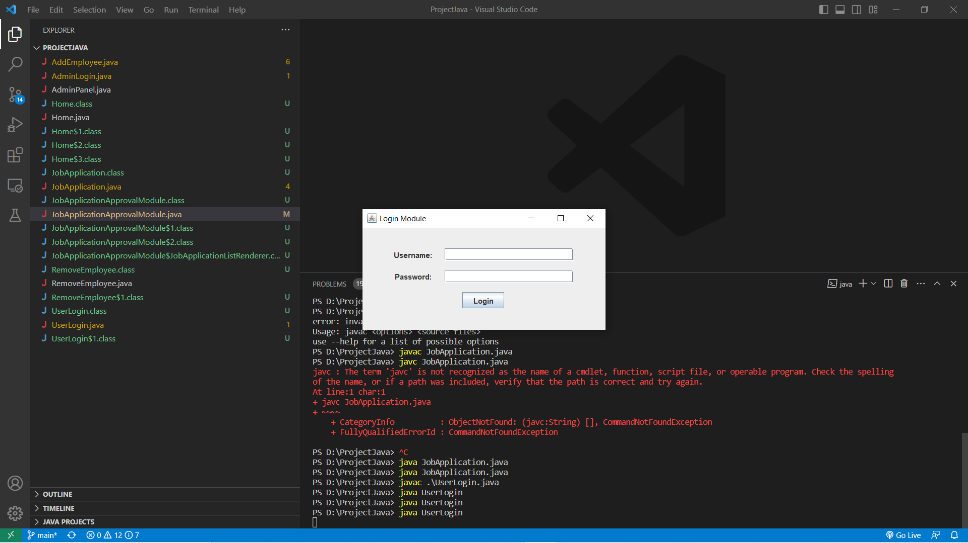

This is the third frame of the project.  
Here, the current working need to enter his asked credentials and on submitting the correct credentials, a popup message will be displayed on the screen that your attendance has been marked.

Let’s move to the second module of the project.  
The second module of the project is the admin panel where the admin have the access of all the data of the employees working in the company.  
Based on certain criteria the admin would take the decisions.

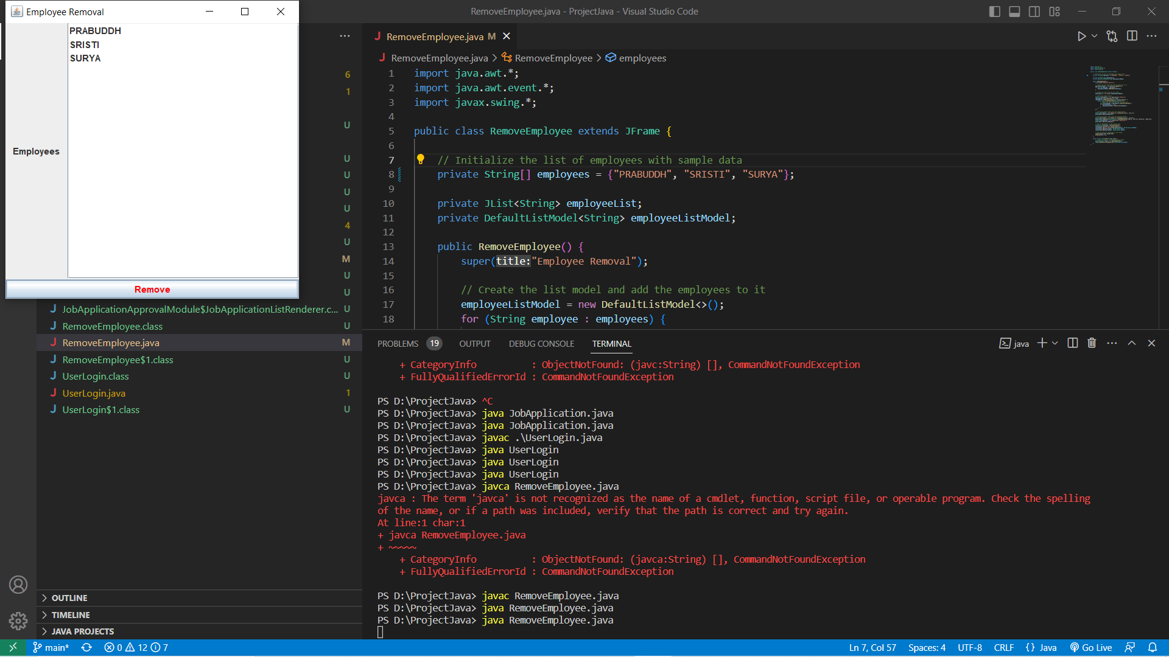

This is the first sub-module of the admin panel.

Here the admin can remove the employee whose names are being displayed on the console. The reason could be anything like not performing good in the company or stealing data of the company.

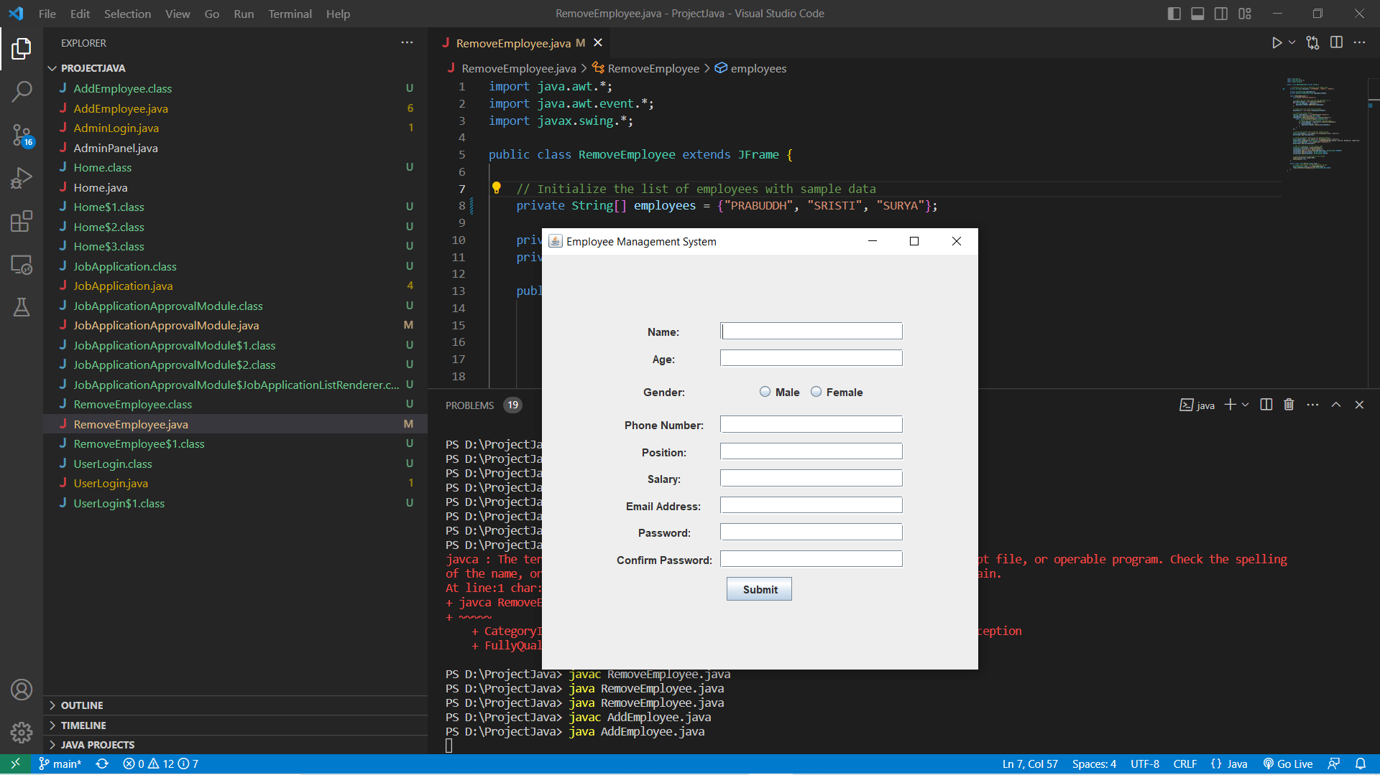

This is the second sub-module of the admin panel.  
Here the details need to be filled by the admin.  
The sub-module is regarding adding a new employee in the company.  
All the things need to be clearly clarified by the admin that at position and at what salary will the new employee be hired.

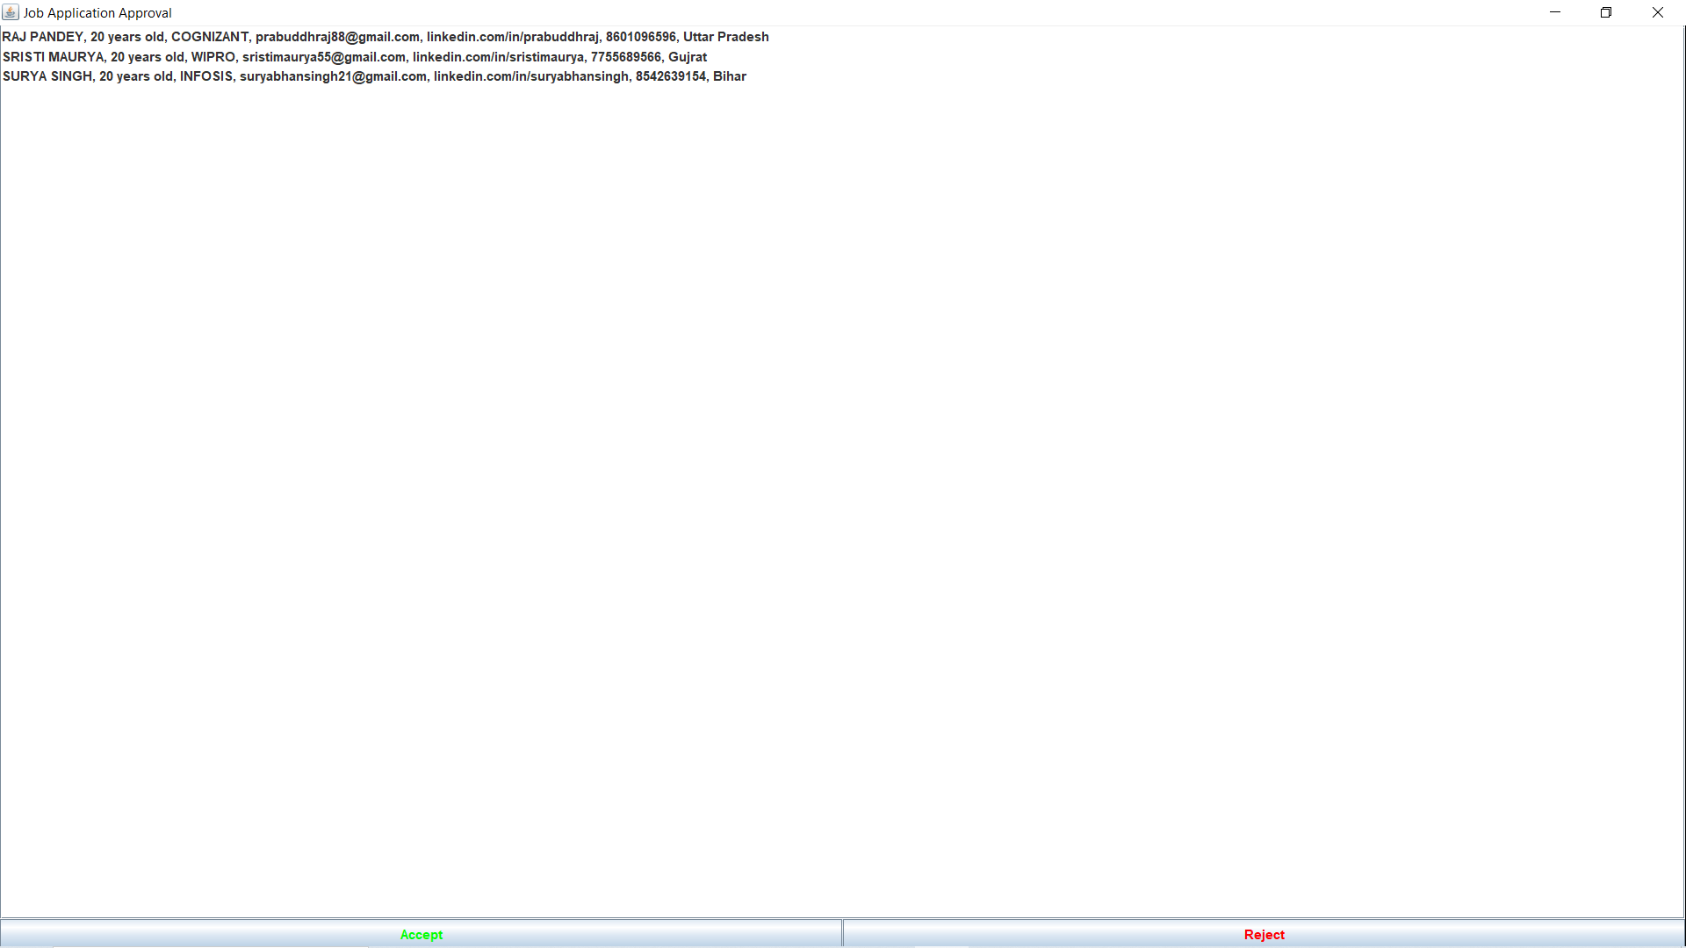

This is the last sub-module of the admin panel.  
Here the details of employees are being displayed on the screen and as per the requirement in the company, the admin can either add them or reject them.

**SAMPLE CODE:**

Some sample code screenshots are attached below;

The attached screenshots have sample code not the entire code.  
The code is readable as comments are written in it.  
The code is efficient and divided into sub-modules.

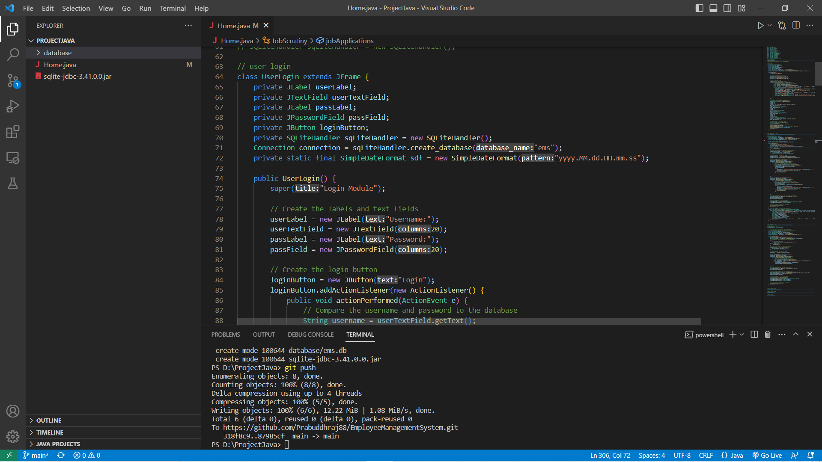

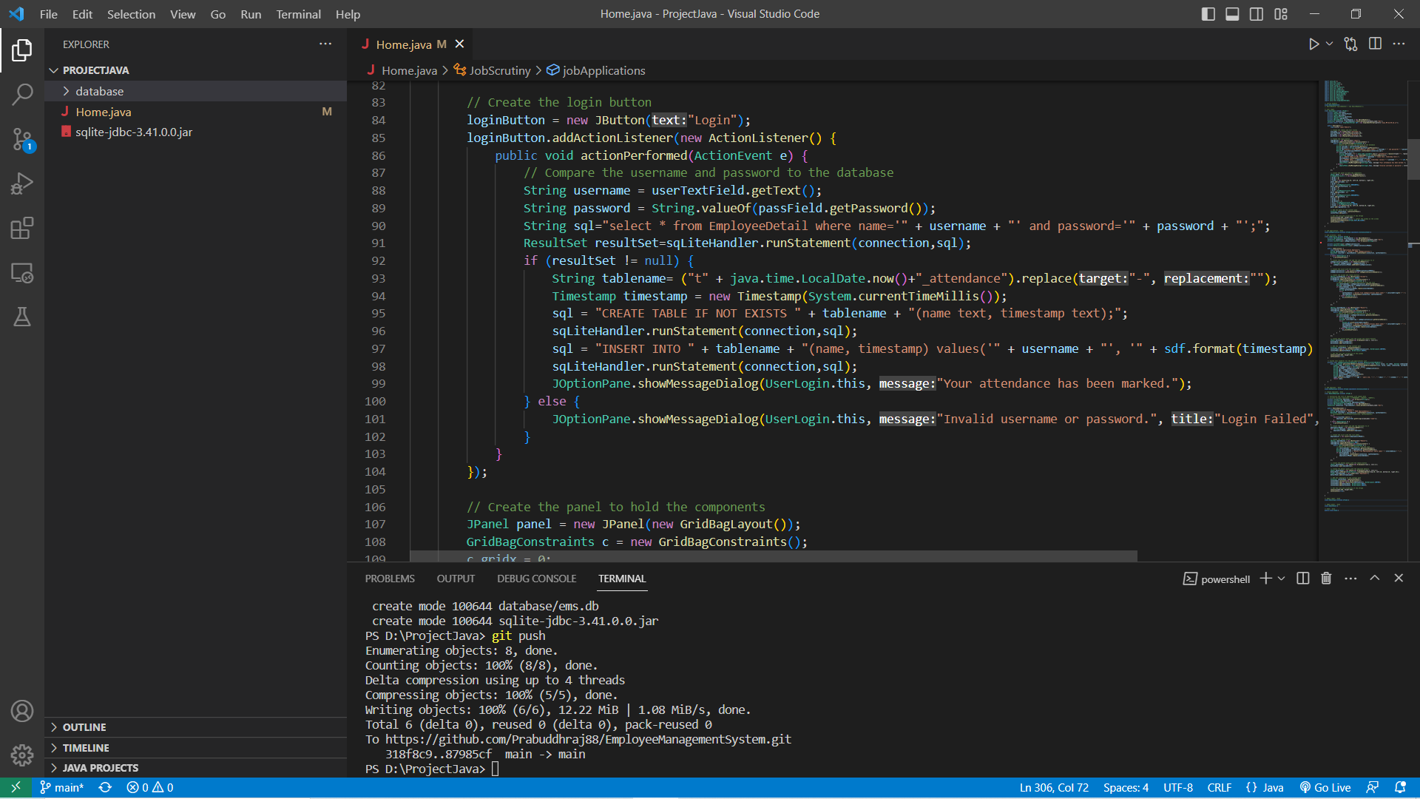

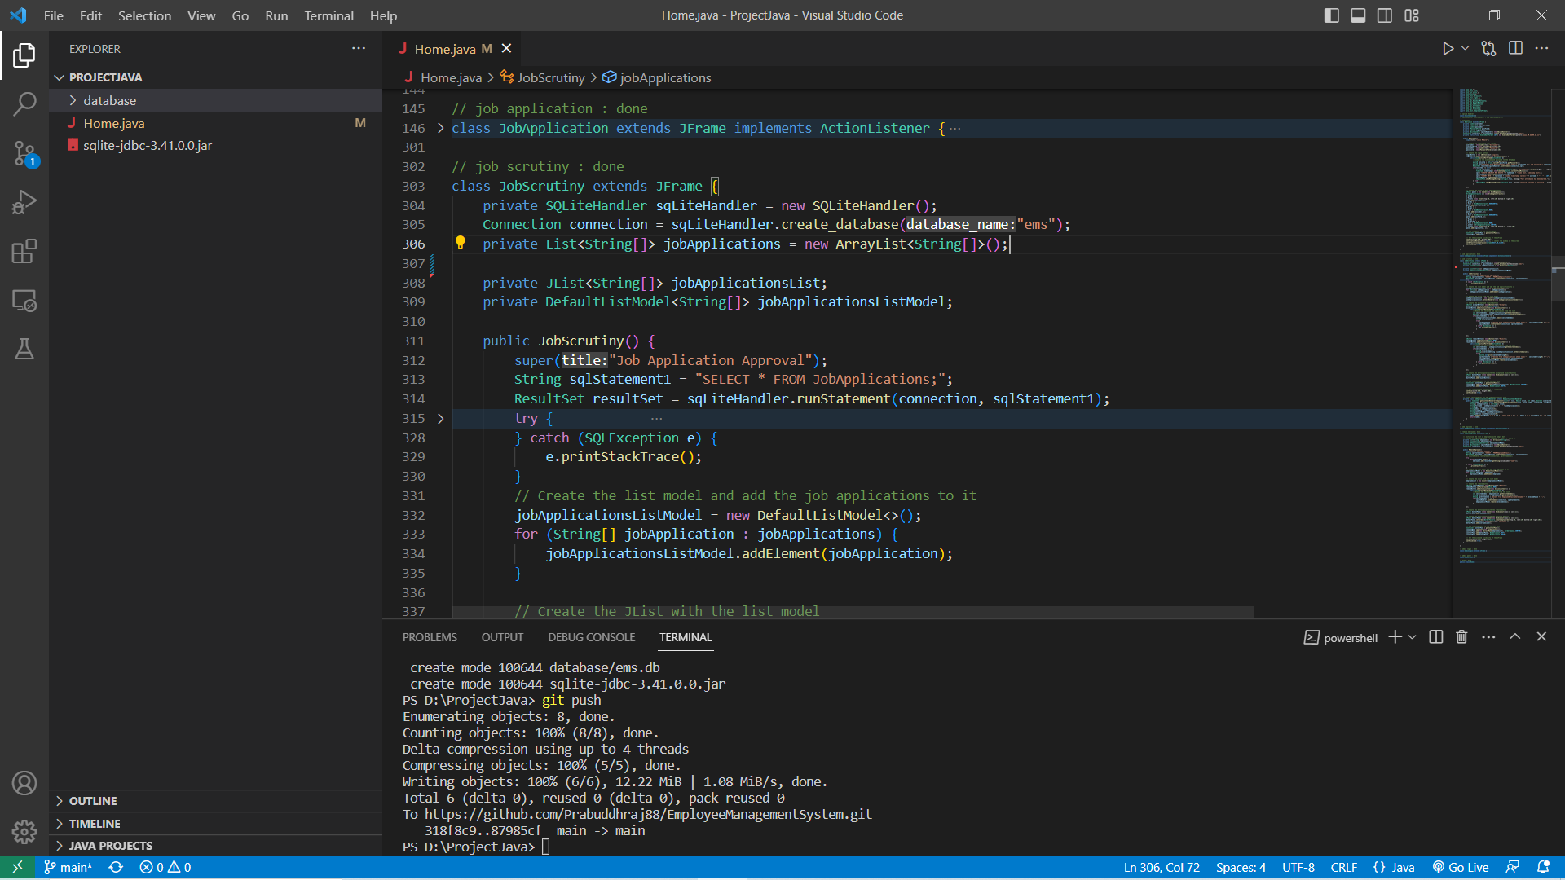

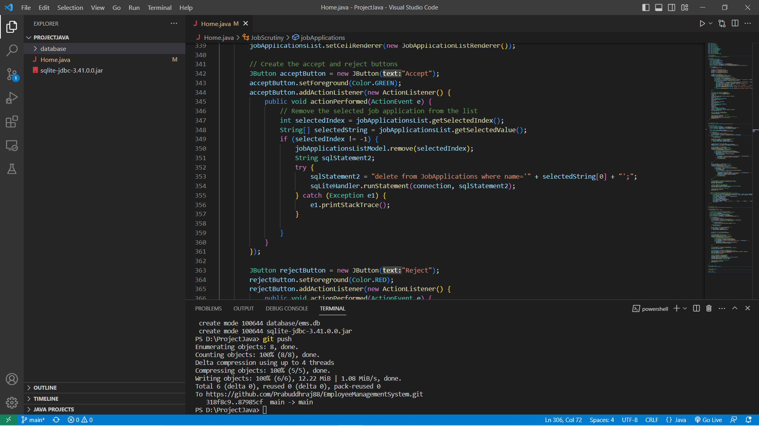

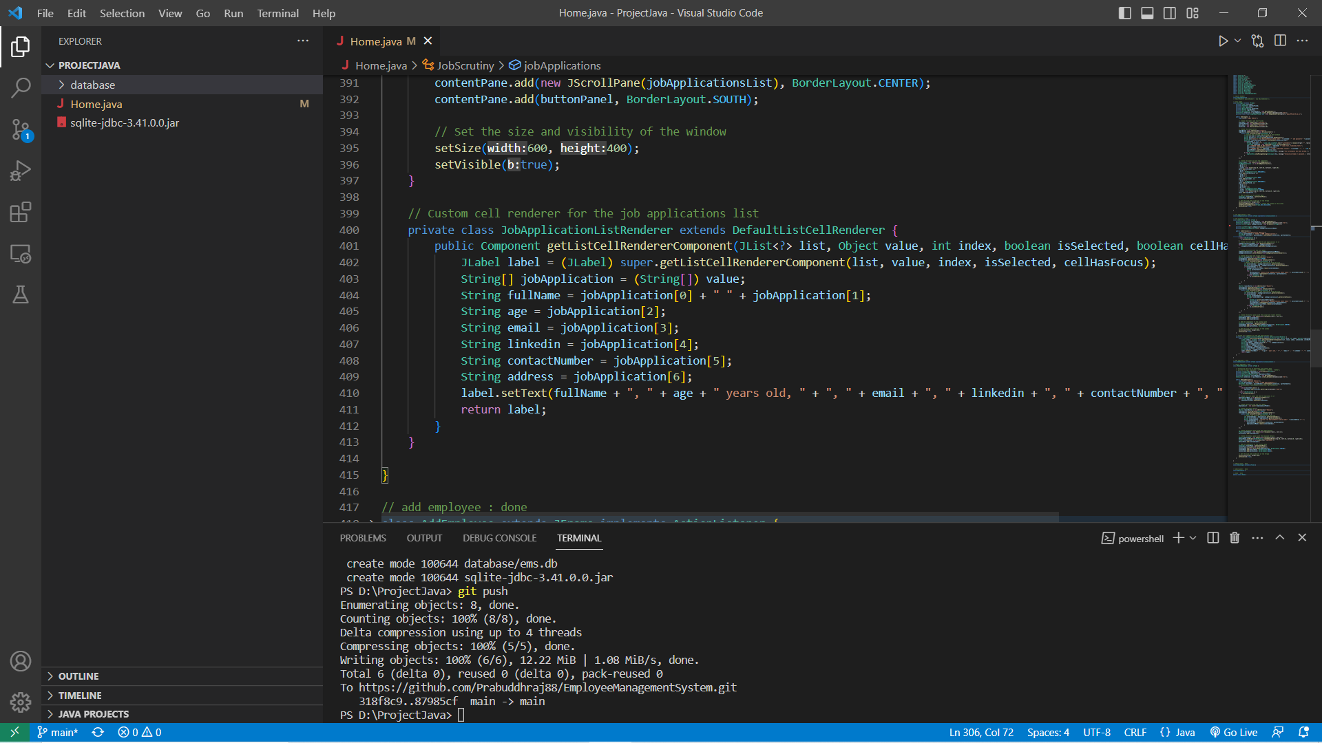

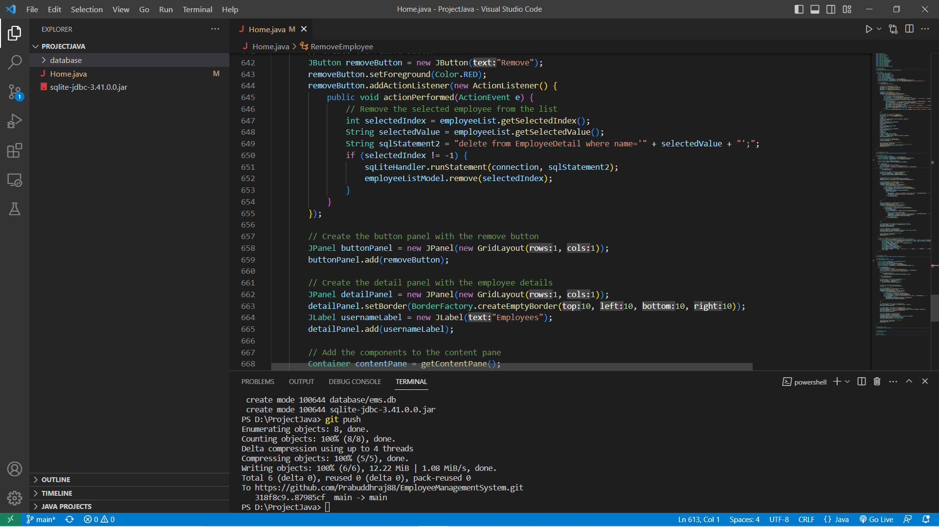

**OUTCOME/CONCLUSION OF THE PROJECT:**

On observing the project, a conclusion can be made from the project that:

* The project is very efficient when it is divided into modules and sub-modules.  
  As per the requirement in the company, the admin can take action as per his understanding.
* The admin panel is very beneficial as the admin can access all the details of the database that which employee is working in his company and whether he have punched the attendance or not or he is doing his job in a good way or not.
* The employee can even have his own personal and unique credentials through which he can enter into the database of the company but he cannot access it as the admin has made restrictions on the database of the company.
* The project is connected with real time database and it will be shown through the live presentation of the project.

Overall, we can say that the management system is very useful for both the company and the employees of the company. As per the constraints made by the admin, the employee can have access to the data which could be beneficial to them only.  
The data would be in a very efficient way as the system is in a organised manner.  
And whenever the admin want to see any data or want to change any data, he already have the access of the database so he could commit the changes as per the need and requirements of the company.  
So, we could also say that the command of handling the company is in safe hands.

THANK YOU!