**PROJECT REPORT TEMPLATE**

**RETAIL MANAGEMENT APPLICATION USING SALESFORCE VIEW**

**1:- INTRODUCTION**

* 1. **Overview**

A **retail CRM**, on the other hand, is optimized to help support the high frequency, repeat purchasing of a business-to-consumer (B2C) model. Good retail CRM software will provide insights on when it’s best to reach out to a specific customer again and what the customer is likely looking for. For example, Endear’s CRM solution informs its users about a customer’s lifetime spend and their average order value (AOV), along with a thorough omnichannel order history so that sales associates  know what to focus on in their outreach.

* 1. **Purpose**

A retail management system (RMS) is a platform that combines several modules to aid in the day-to-day operation of a retail store or chain, such as managing and buying inventory, checking out customers, scheduling employee shifts, keeping track of finances, etc.

**2**:- **Problem Definition & Design Thinking**

**2.1 Empathy Map**

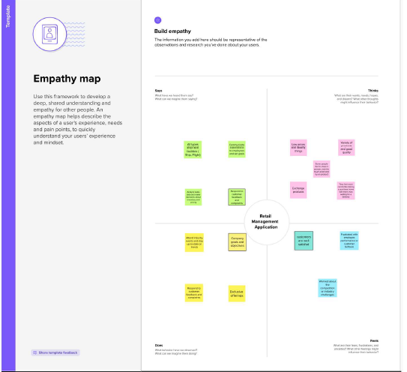

**2.2 IDEATION & BRAINSTORMING MAP**

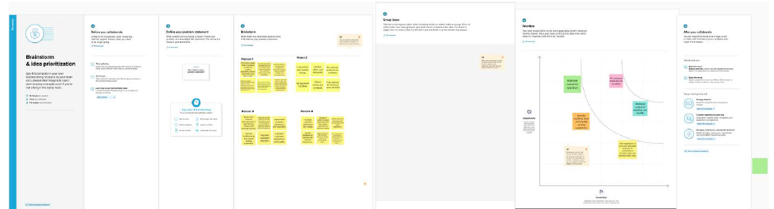

**3:- RESULT**

**3.1 DATA MODEL**:

|  |  |  |  |
| --- | --- | --- | --- |
| OBJECT NAME | FIELDS IN THE OBJECT | | |
| 1)Display Tracking | S.NO | FIELD LABLE | DATA TYPE |
| 1  2  3  4 | Field Label  Dispatched  Expected date of delivery  Tracking Id | Data Type  Checkbox  Date/Time  Text |
| 2)Warehouse | 1  2  3 | Field Label  Product Name  Stock Available | Data Type  Text  Number |
|  |  |  |  |

**3.2 ACTIVITY & SCREENSHOT**

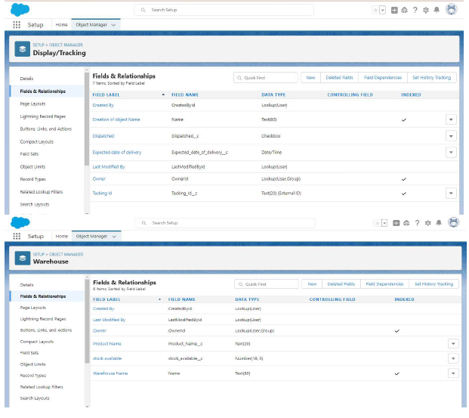

**4:- TRAILHEAD PROFILE PUBLIC URL**

Team Lead-

Team Member 1-

Team Member 2-

Team Member 3-

**5:- ADVANTAGES**

1. Increased Sales: Effective retail management can lead to an increase in sales through effective inventory management, merchandising, and sales techniques.

2. Customer Satisfaction: Retail management helps in creating a positive customer expe

maintaining the quality of the products and services offered, and providing.

3. Cost Control: Effective retail management can lead to cost savings through efficient inventory management, staffing, and operational practices.

4. Improved Brand Image: Successful retail management can improve the brand image and reputation of a business, leading to increased customer loyalty and trust.

5. Better Decision Making: Retail management provides

informed decisions about pricing, promotions, and product offering.

**DISADVANTAGE**

1. High Competition: Retail management operates in a highly competitive e

challenging to stand out from the competition.

2. High Staff Turnover: Retail management has high staff turnover rates, which can impact

productivity and customer service.

3. Technological Challenges: Keeping up with the latest technology can be costly, and retail

management may struggle to keep up with the fast

4. Seasonal Fluctuations: Retail management is affected by seasonal fluctuations, which can

sales and profitability.

5. External Factors: Retail management is vulnerable to external factors such as economic conditions, natural disasters, and changes in consumer behavior, which can impact sales and profitability

**6:- APPLICATIONS**

1. Inventory Management: Retail management helps businesses manage their inventory by tracking stock levels, monitoring sales trends, and identifying slow reduce waste, increase sales, and improve customer satisfaction.

2. Point of Sale (POS) Systems: POS systems are an essential tool in retail management. They allow businesses to process sales transactions, track sales data, manage inventory, and generate reports. POS systems can also integrate with other retail management tools, such as customer relationship management (CRM) software.

3. Customer Relationship Management (CRM): Retail management involves managing customer relationships through CRM systems. These systems allow businesses to t

and purchase history, and use that information to personalize marketing efforts and improve customer satisfaction.

4. Staff Management: Retail management includes managing staff, including scheduling, training performance management. Effective staff management can improve productivity, reduce turnover, and enhance the customer experience.

5. Overall, the applications of retail management are essential for businesses to streamline their operations, improve efficiency, and increase profitability.

**7:- CONCLUSION**

Businesses in the retail industry need to implement effective retail management strategies to remain competitive and profitable in today's fast changing retail environment.

**8:- FUTURE SCOPE**

The future of retail management is exciting and challenging. Retailers must adapt to changing consumer behavior and new technologies to remain competitive and profitable in the fast-paced retail environment.

Trailhand URLS:

<https://trailblazer.me/id/pprabu6>

<https://trailblazer.me/id/rramachandiran2>

<https://trailblazer.me/id/kishg10>

https://trailblazer.me/id/vinop18