EXPERIMENT NO. 7
STUDY OF H plane and E plane TEE CHARACTERISTICS

Date: 28/10/2025 | Group No. 1
Name: Pranav Chandra Nagulakonda Venkat | ID No: 2023AAPS0013P
Name: Het Ronak Shah | ID No: 2023AAPS0746P
Name: Hitesh Chotwani | ID No: 2022B4AA1063P
Name: Adhyayan Berlia | ID No: 2023AAPS0767P
Name: Jayaditya Singh | ID No: 2022B4AA0739P

Aim: To study the characteristics of the E plane and H plane Tee.

Software: CST Studio
Theory:
In electromagnetic radiation, there is always the E-Field component and the H-Field component. The orientation and variation of these fields define the mode of propagation. We may leverage this fact in order to split a wave into it’s constiuent parts, the E and H fields.

The E-Plane Tee and H-Plane Tee become useful here. Because we know the relative orientation of the E and H planes (180 degrees), we are able to split them with the appropriate tees. Knowing that the E wave propagates along the YZ plane, and the H wave propageates along the XZ plane, we may construct Tee waveguides to isolate each field.

Figure 1: E-Plane (left) and H-Plane (right) Tee

We know that the output wave for an E-Plane will be in phase with the input, while the output of a H-Plane will be 90 degrees out of phase. We will use this fact as for verification during the simulation period.

Results:

We begin by modeling the E-plane and H-planes in CST.
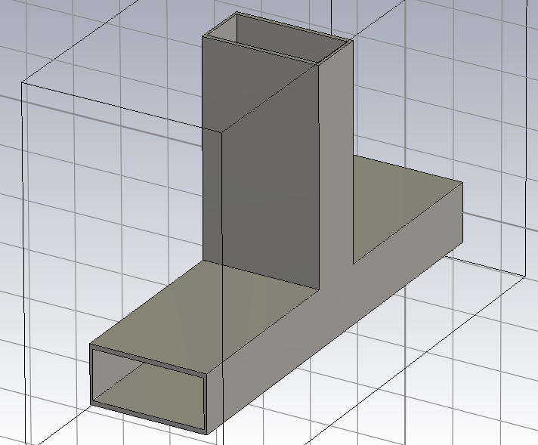Figure 2: E-Plane Tee

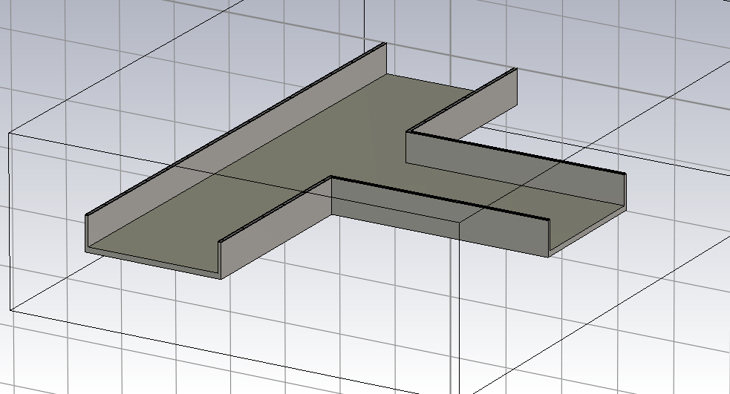Figure 3: Sectional View of H-Plane Tee

From here, we add on waveguides to the various ports of the Tees. These waveguides allow us to identify inputs and outputs of the tees.
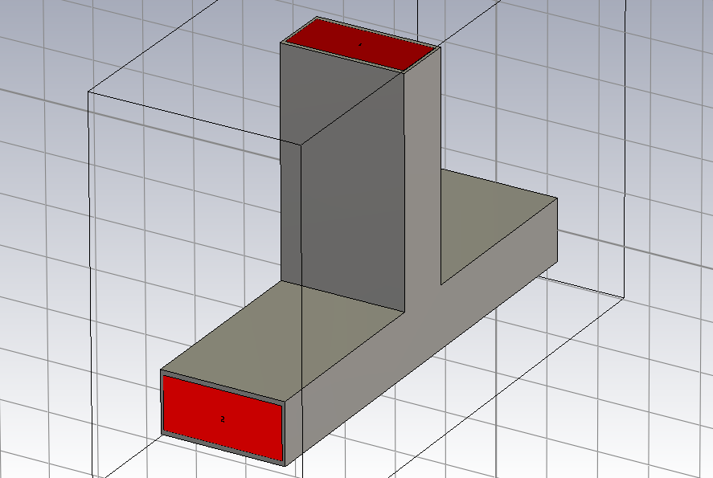Figure 4: Waveguides added to the E-Plane Tee

Now, we input a wave from Port 1, and view the outputs at the various ports You can observe the electric field distribution within the tees when input is provided.
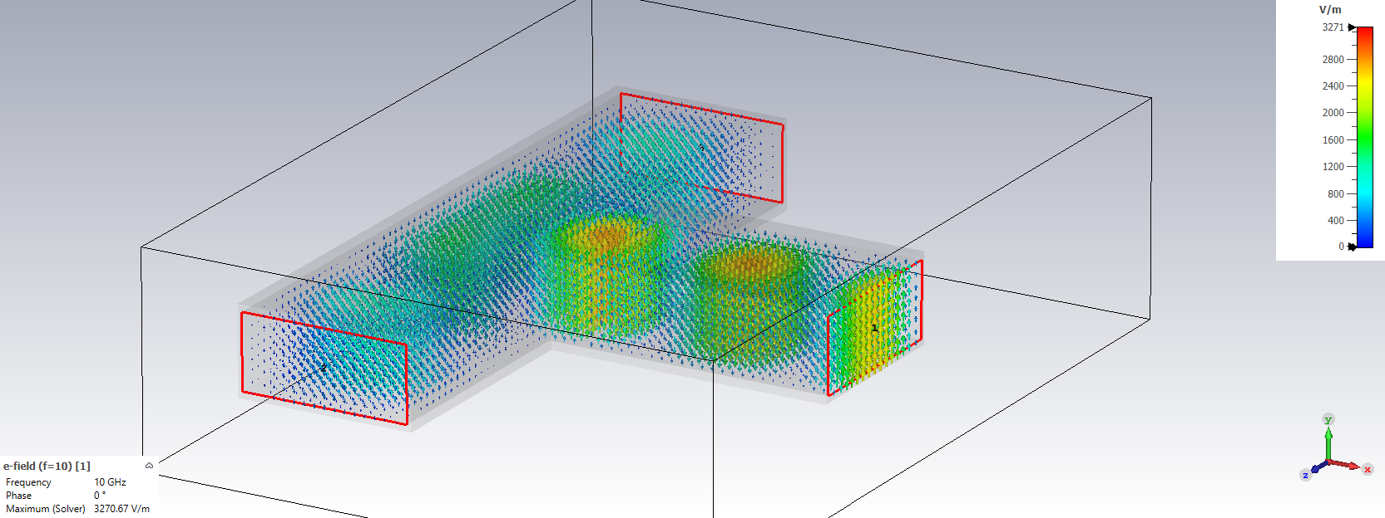Figure 5: Electric Field Distribution in H-Plane Tee
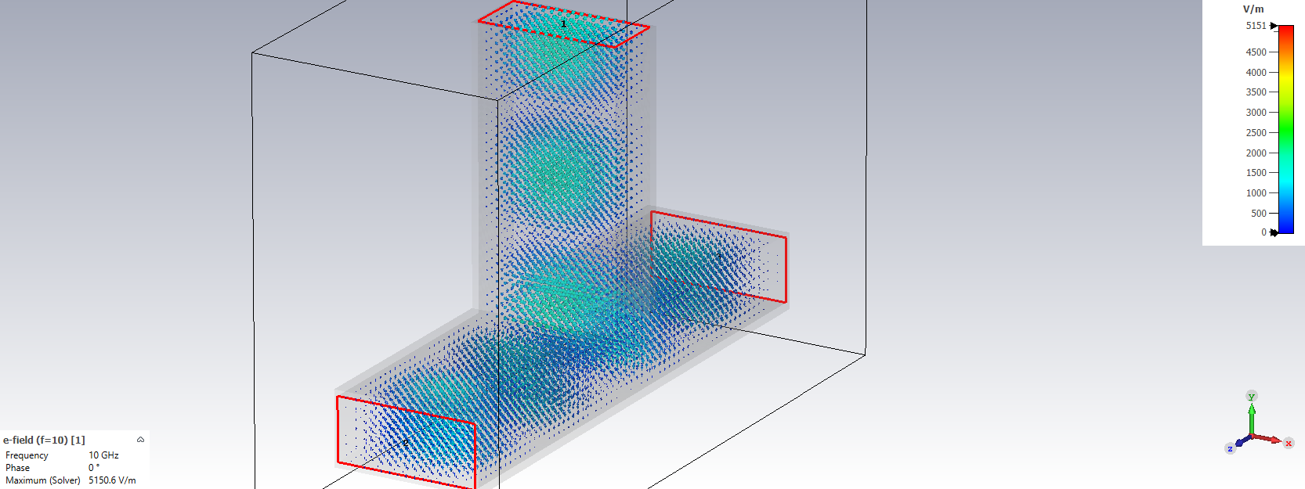Figure 6: Electric Field Distribution in E-Plane Tee

Further, observing the H-Field of the tees also reveals some interesting observations
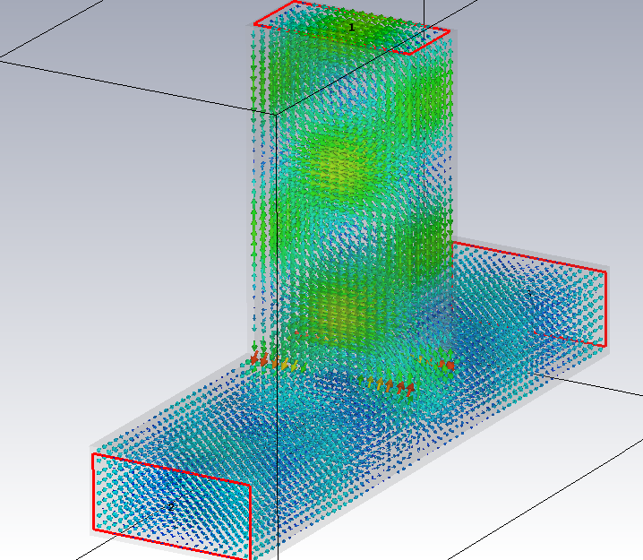Figure 7: H-Field in E-Plane Tee
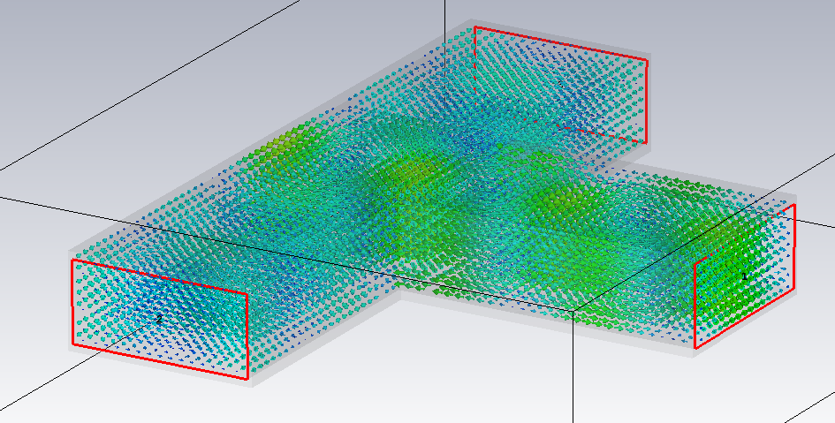Figure 8: H-Field in H-Plane Tee

The electric and magnetic field distribution demonstrates the specific properties of the E and H planes, and the directionality of the distribution.
Scattering Parameters
For the tees, we observe a few main points, self reflection parameters and gain parameters. We will observe the self reflection parameters (of the E-Plane) first:
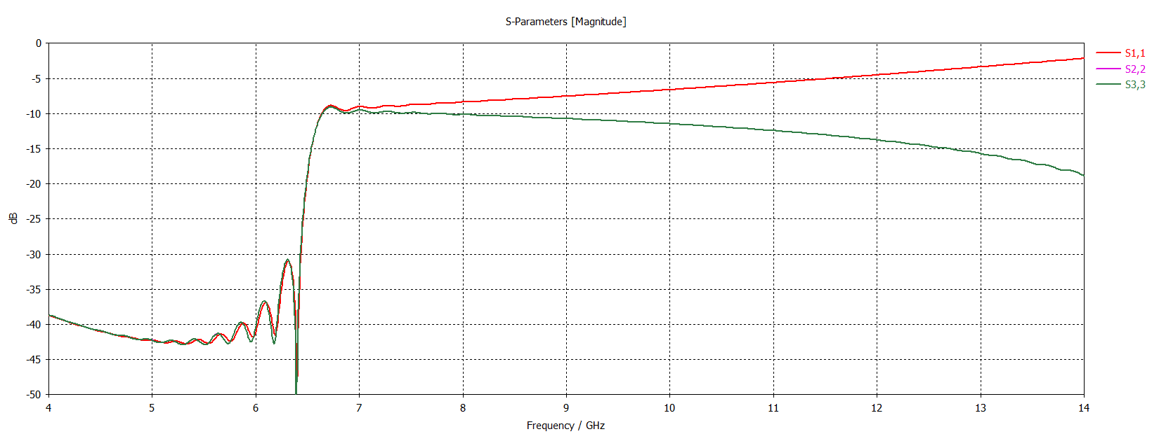

You note how the self reflection parameters initially have quite a high transmission, then fater the cutoff frequency suddenly shoots up.
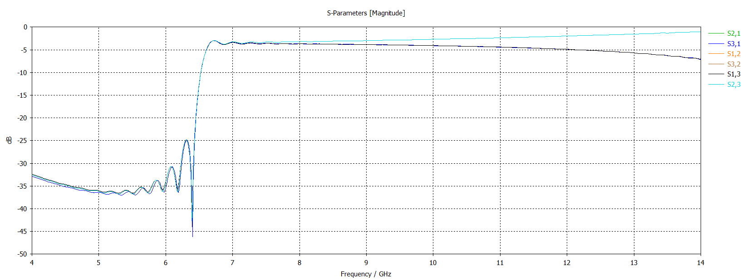
Gain parameters show a similar composition. For final verification, we observe the phase plots of S_12 and S_23 to verify the phase difference.
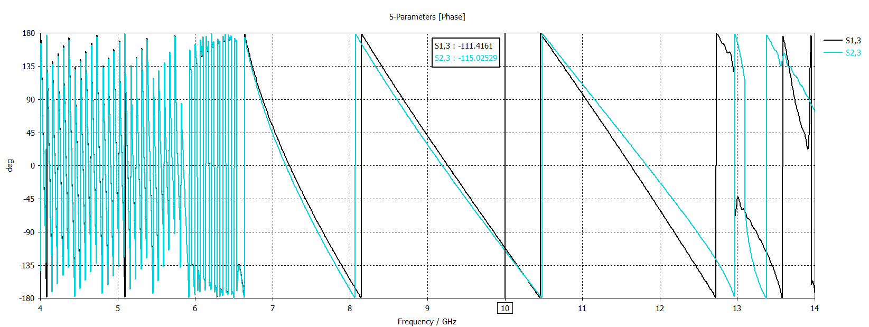

For the H-Plane, we expect the same phase at the target frequency of 10 GHz. This fact is proven true, with a very small and negligble delta in the phases at the target frequency, highlighted by the marker in the graph. For the E-Plane, we expect the phases to be 180 degrees apart.
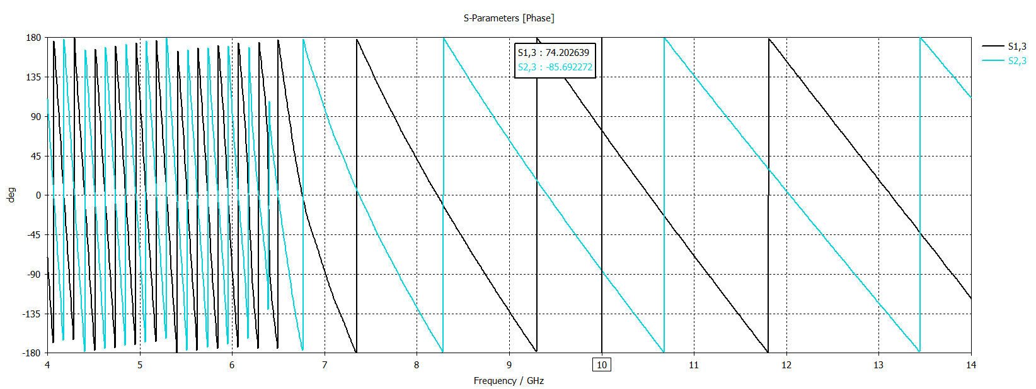
This is proven true by the phase difference hsown by the marker at 10 GHz.

CONCLUSIONS:
As porven by the Phase Graphs, the E and H planes are fully working for this particular setup. The Phase difference has been verified. Implementing this in a Magic Tee is fully feasible. So as long as the frequency of the input wave is greater than the cutoff frequency, the system works well. We also note the reduction in power due to the split at the various junctions.

