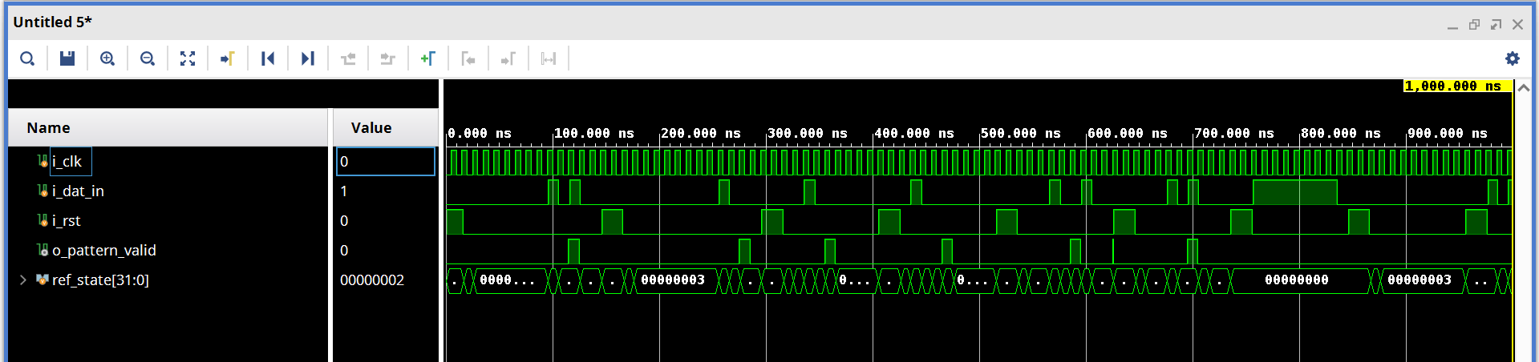
Task 1 Waveform

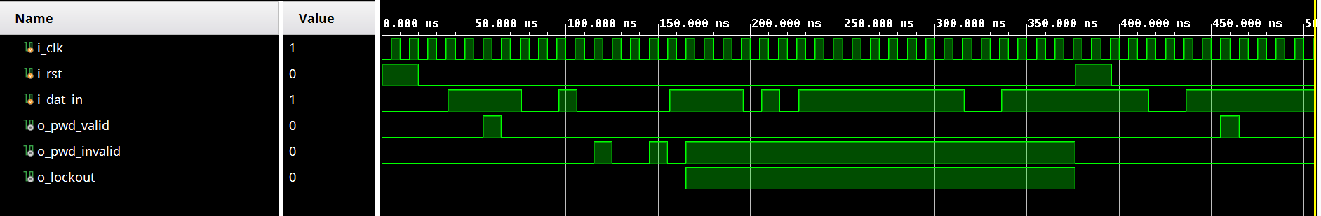
Task 2 Waveform

