HR Analytics Project

**Title: Employee Attrition Analysis**

**Step 1: Using SQL to explore the dataset and gain an understanding of the data.**

1. **Data Exploration**

Explore the dataset to understand its structure and content.

1. **Attrition Analysis:**

Analyze attrition rates and factors contributing to it.

1. **Salary Analysis:**

Analyze salary-related information.

1. **Job Satisfaction and Performance:**

Analyze job satisfaction and performance-related information.

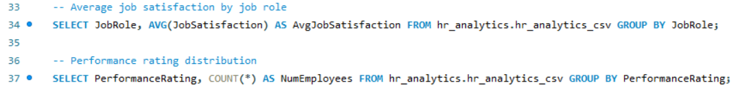

1. **Years of Service Analysis:**

Analyze the impact of years of service on attrition and other factors.

**Step 2: Data Cleaning,** **handle missing values, outliers, and any necessary data transformations. and Preparation with Python and Excel**

1. **Data Loading and Exploration**

1. **Data Cleaning**

1. **Exploratory Data Analysis (EDA)**

1. **Feature Engineering**

1. **Data Visualization for Insights**

