**IoT based Smart Gym Application**

**TE CSE Mini project**

By

Saman Arora

Siddhi Pande

Nishant Kulkarni

Pracheta Deshpande

Under the guidance of

Prof. Madhubala Gandhi



Department of Computer Engineering

**BRaCT’S Vishwakarma Institute Technology PUNE – 411 037**

|  |  |
| --- | --- |
|  | Bansilal Ramnath Agarwal Charitable Trust’s  **Vishwakarma Institute Technology**  **PUNE – 411 037** |

**CERTIFICATE**

Certified that this Project report titled “IoT based Smart Gym Application” by “Saman Arora, Pracheta Deshpande, Nishant Kulkarni, Siddhi Pande” is approved by me for submission. Certified further that, to the best of my knowledge, the report represents work carried out by the student as the Mini project as prescribed by the University of Pune in the academic year 2013-14

**27 November 2016 Prof. Madhubala Gandhi Prof. Mansi Patwardhan**

**Date: Guide Head of Department**

**ACKNOWLEDGEMENT**

In order to achieve better performance, we should have to learn our outside environment. There are lots of forces which will acting upon us to get the better result, but for that we have to change our attitude to see them. There are lots of problems we facing, but due to it we don’t stop. It is not a good human being ,if he is stop. Yes, we are sometimes frustrated due to the problems we can’t solve it.

But the next day we act on the problem with same efficiency and strength we have.

I would like to thank my guide Prof Madhubala Gandhi for allowing me to do this project in VIT Pune. Also I would like to thank honourable Head of Department of Computer department Dr. Mrs. Mansi Patwardhan, VIT Pune for giving me this opportunity.

**CONTENTS**

**Abstract**

1. **Introduction** 
   1. **IoT explained**
   2. **My Gym app**
2. **Existing System Study**
   1. **Drawbacks of the system**
3. **Proposed System** 
   1. **Proposed solution ( Narrated / Algorithms / Methods)**
   2. **Design Modeling**
   3. **Estimation**
      1. **Resources required** 
         1. **Hardware Software**
         2. **Cost ( In case of purchase/ hiring of components or outsourcing )**
4. **Conclusion**
5. **Future work**
6. **References**

**Abstract**

The objective of our project is to create an IoT based app which will bring in smart workout. This app is for the fitness freaks who are very meticulous about their fitness regime and would make their workout analysis and diet plans much more efficient.

This application is very useful for all the gym users and trainers who are workout regularly.

**1. Introduction**

**1.1 Internet of things explained**

* The Internet of Things (IoT) is a system of interrelated computing devices, mechanical and digital machines, objects, animals or people that are provided with [unique identifiers](http://whatis.techtarget.com/definition/unique-identifier-UID) and the ability to transfer data over a network without requiring human-to-human or human-to-computer interaction.
* A [thing](http://whatis.techtarget.com/definition/thing-in-the-Internet-of-Things), in the Internet of Things, can be a person with a heart monitor implant, a farm animal with a [biochip transponder](http://searchsecurity.techtarget.com/definition/injectable-ID-chip), an automobile that has built-in [sensors](http://whatis.techtarget.com/definition/sensor) to alert the driver when tire pressure is low -- or any other natural or man-made object that can be assigned an [IP address](http://searchunifiedcommunications.techtarget.com/definition/Internet-Protocol) and provided with the ability to transfer data over a network.
* Currently, the “Internet of Things” is not a second Internet – rather it’s a network of devices that are connected to the Internet that is used every day to search Google, upload images and connect with friends. It’s a network of products that are connected to the Internet, thus they have their own IP address and can connect to each other to automate simple tasks.

**1.2 MyGym app**

While everything is going smart these days, why would our gyms should be left behind! Through our application, we have made the equipments of our gym smart. Now these equipments could log your weight lifting sessions, counts the reps and displays the analysis. This application tracker is efficient, reliable and of reduced expenses.

**2. Existing System Study**

BowFlex has been showing off it [ST560 Smart Dumbbells](http://www.bowflex.com/selecttech/560/100405.html) for a couple of years now. The 560s connect to a smart device via Bluetooth, keeping tracking things within a 10-foot range. Flip into Just Lift mode and the system keeps track of reps, calories burned, time and total pounds lifted and lets you know how long to rest in-between.

The app features a slew of different workout options, including a six-week strength training plan and around a dozen different exercises. Users can customize their own, as well. This is due in no small part to the weight adjustment feature, allowing each one to hold anywhere between five to 60 pounds. The weight is displayed as both kg and pounds, on the two sides, the numbers, changing as you rotate the bar to adjust the weight with a click for each 2.5 pound increment.

**Disadvantages:**

1. The downside is that the dumbbells are quite large – and when you’re lifting less than the full 60 pounds, the unit has the tendency to jiggle around – not quite the solid mass of self-contained analog systems.
2. Cost: The cost of Bowflex dumbbells is $500.
3. We can use our solution to any equipment. It is not only restricted to dumbbells.

**3.Proposed System**

**3.1 Proposed solution**

Our system will have a small box affixed on the dumbbell or any equipment whose weight will be negligible considering the weight of the dumbbell. This box will contain the circuitry for implementing IoT and to make the equipment smart.

The hardware components are as follows

1. Raspberry Pi 3b
2. MPU 6050 accelerometer sensor
3. EM-18 RFID

The accelerometer gives out the 3-D coordinates. When a person lifts the weights, the accelerometer also moves along with it. This changes the output coordinates of the accelerometer. This change is modelled as one weight lift.

The user will punch the RFID tag on the RFID module. When this happens, the RFID sends a unique id to the application. Then the user can start using the equipment.

Such counts are sent from the circuitry to the app where it is stored in the database. We have used UDP protocol to establish communication between raspberry pi and mobile app. Other parameters such as duration of workout are also measured.

From the above information, our app calculates the calories burnt by the user in that particular workout session and plots a bar graph.

Our application also has the feature to maintain workout history and displays graph. We can also set a target for number of reps to be made.

**3.3 Design Modelling**

**3.3.1.Hardware Interfacing**

1. Interfacing Raspberry Pi and MPU 6050

To connect the sensor you need to use the GPIO pins on the Pi, the important pins are

• Pin 1 - 3.3V connect to VCC

• Pin 3 - SDA connect to SDA

• Pin 5 - SCL connect to SCL

• Pin 6 - Ground connect to GND

these need to be connect as shown in the image.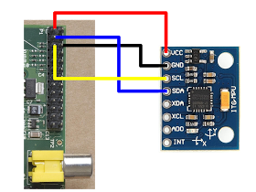

**2. Interfacing EM-18 RFID with Raspberry Pi**

[RFID](https://electrosome.com/rfid-radio-frequency-identification/) (Radio Frequency Identification) uses electromagnetic fields to read, monitor and transfer data from tags attached to different objects. It is not necessary that the cards are to be in visibility of the reader, it can be embedded in the tracked object. The tags can be actively powered from a power source or can be passively powered form the incoming electromagnetic fields.

[EM-18 RFID reader module](https://electrosome.com/shop/em-18-rfid-reader-module/) is one of the commonly used reader and can read any 125KHz tags. It features low cost, low power consumption, small form factor and easy to use.

**Voltage divider**

The UART TX output of [EM-18](https://electrosome.com/shop/em-18-rfid-reader-module/) is of 5v. The input pin of [Raspberry Pi](https://electrosome.com/raspberry-pi/) GPIO is rated at 3.3v. So 5v cannot be directly given to the unprotected 3.3v input pin. Therefore we use a voltage divider circuit using appropriate resistors to bring down the voltage to 3.3V.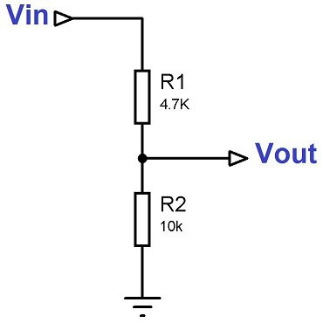

**Circuit Diagram**

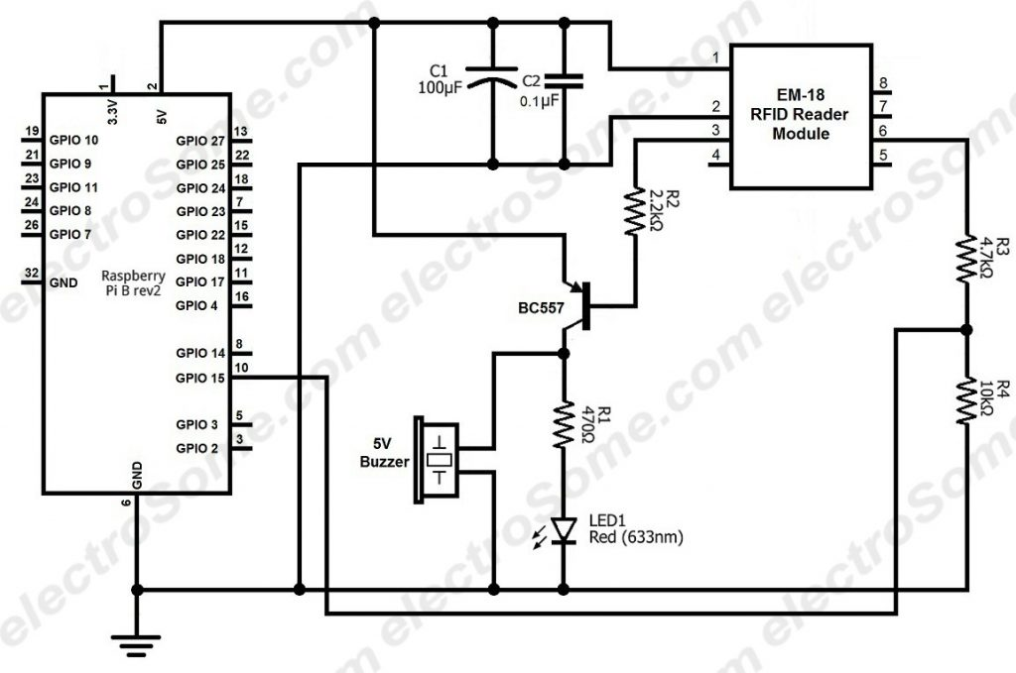

**3.4 Estimation**

**3.4.1 Resources required**

**3.4.1.1 Hardware**

1. Raspberry Pi 3b

Raspberry Pi is a credit card sized computer. It is the main driving unit for the hardware components. The raspberry pi gets the data from the sensors and sends it to the mobile application via wireless network.

Specs:

**SoC:** Broadcom BCM2837

**CPU:** 4× ARM Cortex-A53, 1.2GHz

**GPU:** Broadcom VideoCore IV

**RAM:** 1GB LPDDR2 (900 MHz)

**Networking:** 10/100 Ethernet, 2.4GHz 802.11n wireless

**Bluetooth:** Bluetooth 4.1 Classic, Bluetooth Low Energy

**Storage:** microSD

**GPIO:** 40-pin header, populated

**Ports:** HDMI, 3.5mm analogue audio-video jack, 4× USB 2.0, Ethernet, Camera Serial Interface (CSI), Display Serial Interface (DSI)

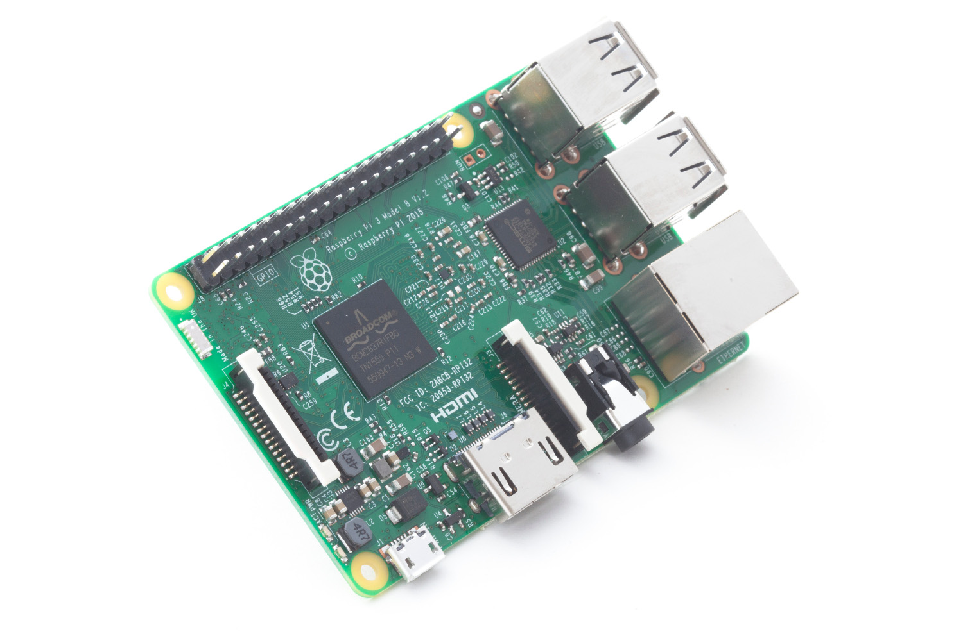

**2. EM-18 RFID module**

[RFID](https://electrosome.com/rfid-radio-frequency-identification/) (Radio Frequency Identification) uses electromagnetic fields to read, monitor and transfer data from tags attached to different objects. It is not necessary that the cards are to be in visibility of the reader, it can be embedded in the tracked object. The tags can be actively powered from a power source or can be passively powered form the incoming electromagnetic fields.

[EM-18 RFID reader module](https://electrosome.com/shop/em-18-rfid-reader-module/) is one of the commonly used reader and can read any 125KHz tags.

**Working of EM-18 RFID module**

The module radiates 125KHz through its coils and when a 125KHz passive RFID tag is brought into this field it will get energized from this field. These passive RFID tags mostly consist of CMOS IC EM4102 which can get enough power for its working from the field generated by the reader.

By changing the modulation current through the coils, tag will send back the information contained in the factory programmed memory array.

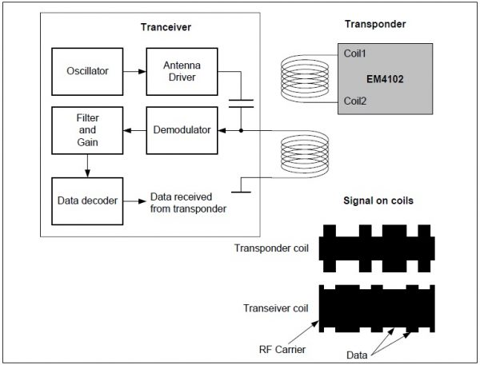

**3. MPU 6050 sensor**

MPU sensor consists of 3 axis gyroscope, 3 axis accelerometer. It gives raw data in volts according to motion of the object.

Accelerometers measure acceleration. That is acceleration due to movement and also acceleration due to gravity. Accelerometers are often used to calculate a tilt angle. They can only do this reliably when they are static and not moving. To get an accurate angle of tilt they are often combined with one or more gyro's and the combination of data is used to calculate the angle. Digital accelerometers will give you information using a serial protocol like I2C.

For a static object that is the acceleration due to gravity (1g). Note also, that the output from accelerometers is not linear but is a sinewave, so you cannot take the direct output as a proportional representation of an angle of tilt based on gravity.

Normally an accelerometer's x and y output voltages will be half the supply voltage when measuring zero g (i.e. the device is perpendicular to gravity - horizontal). Tilt it one way and the voltage will increase, tilt it the other way and it will decrease. With a Triple axis accelerometer the z axis will be measuring 1g with the device horizontal.

**Measuring Tilt Angle using Two Axis**

The reduction in resolution and accuracy beyond 45 degrees of tilt can be improved by using 2 axis to measure the tilt

The component of gravity acting on the x axis is a sine function whilst that acting on the y axis is a cosine. When the sensitivity of the x axis starts dropping off after 45 degrees of tilt, the sensitivity of the y axis is increasing. As can be seen in the chart below, the bolded parts of each line show the area of most sensitivity.

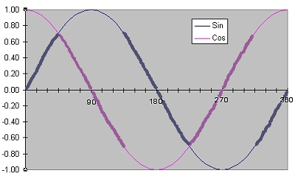

Thus by combining the x and y values a much improved accuracy can be obtained

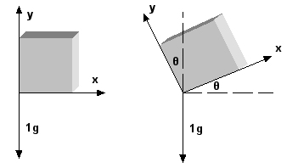

The angle is calculated using the formula 

**Measuring Tilt Angle using Three Axis**

For accurate measurements of tilt in the x and y planes we therefore need a 3 axis accelerometer. We could use the formula above to calculate the angles using x and z for the x axis and using y and z for the y axis. However we can improve things further by using all three outputs to calculate each angle. This is done using the following formulas.

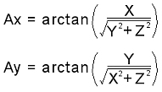

**3.4.1.2 Software**

**1.Android studio**

Our main application was built in android studio.

**2. Establishing database connection**

SQLite is a open source SQL database that stores data to a text file on a device. Android comes in with built in SQLite database implementation.

SQLite supports all the relational database features. In order to access this database, you don't need to establish any kind of connections for it like JDBC,ODBC e.t.c.

**3. UDP protocol**

The User Datagram Protocol (UDP) is simplest Transport Layer communication protocol available of the TCP/IP protocol suite. It involves minimum amount of communication mechanism. UDP is said to be an unreliable transport protocol but it uses IP services which provides best effort delivery mechanism.

In UDP, the receiver does not generate an acknowledgement of packet received and in turn, the sender does not wait for any acknowledgement of packet sent. This shortcoming makes this protocol unreliable as well as easier on processing.

**Requirement of UDP**

A question may arise, why do we need an unreliable protocol to transport the data? We deploy UDP where the acknowledgement packets share significant amount of bandwidth along with the actual data. For example, in case of video streaming, thousands of packets are forwarded towards its users. Acknowledging all the packets is troublesome and may contain huge amount of bandwidth wastage. The best delivery mechanism of underlying IP protocol ensures best efforts to deliver its packets, but even if some packets in video streaming get lost, the impact is not calamitous and can be ignored easily. Loss of few packets in video and voice traffic sometimes goes unnoticed.

**Features**

• UDP is used when acknowledgement of data does not hold any significance.

• UDP is good protocol for data flowing in one direction.

• UDP is simple and suitable for query based communications.

• UDP is not connection oriented.

• UDP does not provide congestion control mechanism.

• UDP does not guarantee ordered delivery of data.

• UDP is stateless.

• UDP is suitable protocol for streaming applications such as VoIP, multimedia streaming.

**UDP Header**

UDP header is as simple as its function.

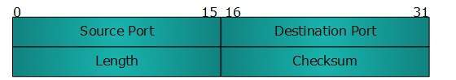

UDP header contains four main parameters:

**• Source Port**  - This 16 bits information is used to identify the source port of the packet.

**• Destination Port**  - This 16 bits information, is used identify application level service on destination machine.

**• Length**  - Length field specifies the entire length of UDP packet (including header). It is 16-bits field and minimum value is 8-byte, i.e. the size of UDP header itself.

**• Checksum**  - This field stores the checksum value generated by the sender before sending. IPv4 has this field as optional so when checksum field does not contain any value it is made 0 and all its bits are set to zero.

**3.4.1.3 Cost**

**Hardware costs:**

Raspberry Pi- Rs 4000

MPU 6050-RS 150

EM-18 RFID-Rs 650

**Software Costs**

None

**4. Conclusion**

Our application demonstrates that gymnasiums can be smart using our proposed low cost technology. We have connected the gym equipments to our application over a network. Through our application, we have made the equipments of our gym smart. Now these equipments could log your weight lifting sessions, counts the reps and displays the analysis. This application tracker is efficient, reliable and of reduced expenses. We can also implement this model not only on dumbbells but other equipments as well, like lat pulley, push down, shrugs, barbells etc, by considering different parameters for different equipments.

**5. Future scope**

**Exercise correctness detection:**

Many times the trainer can not devote his full concentration to a person who is working out. Hence there is a possibility of doing the weightlifting exercise in an incorrect way.

Incorrect weightlifting exercise can affect muscle formation in our body and cause more harm than good.

Our app can be extended to detect such errors using machine learning.

**6. References**

<http://www.hobbytronics.co.uk/accelerometer-info>

<http://blog.bitify.co.uk/2013/11/reading-data-from-mpu-6050-on-raspberry.html>

<https://electrosome.com/>

[www.developers.android.com](http://www.developers.android.com)