KLE Society's

KLE Technological University



**A Capstone Project Report**

**On**

**GENERATIVE ADVERSARIAL NETWORK BASED BRAIN MRI DETECTION USING LIMITED ANNOTATIONS.**

*submitted in partial fulfillment of the requirement for the degree of*

**Bachelor of Engineering in**

**Computer Science and Engineering**

**Submitted By**

### Pracheth M Harish 01fe16bcs096

### Tanushree Kale 01fe16bcs216

### Rakesh kuratti 01fe17bcs419

### Sushant s huilgol 01fe17bcs424

**Under the guidance of**

**Dr. Shrinivas.D.Desai**

.

SCHOOL OF COMPUTER SCIENCE & ENGINEERING,

HUBLI – 580 031 (India).

Academic year 2019-20

|  |  |  |  |
| --- | --- | --- | --- |
| **Chapter No.** | **Table of Contents** | | **Page No.** |
| **1.** | **Introduction** | |  |
|  | 1.1 | Overview of the project | **1** |
|  | 1.2 | Motivation | **1** |
|  | 1.3 | Literature Survey | **2** |
|  | 1.4 | Problem Definition | **4** |
|  | 1.5 | Objectives of the project | **4** |
| **2.** | Software Requirement Specification | |  |
|  | 2.1 | Overview of SRS | **5** |
|  | 2.2 | Requirement Specification | **6** |
|  | 2.3 | Software and Hardware requirement specifications | **7** |
| **3.** | **System Design** | |  |
|  | 3.1 | System Architecture | **8** |
|  | 3.2 | Data Flow Diagrams | **9** |

# 

# 1. Introduction

**1.1. Overview of the project**

A mass or growth of abnormal cells in brain leads to brain Tumor. The brain is one of the largest and most complex organs in the human body. Any unexpected growth may affect human function and may spread into other body organs and affect human functions. Brain Tumors are classified based on their origin. Tumors first originate in brain are called as primary tumors and tumors which arise in any other part of the body and then transferred into brain are called secondary tumors (malignant). The different brain tumors are glioma (Grade 1-Grade 4), Meningioma and pituitary tumor. Detection of brain tumor is very complicated and difficult due to the size, shape, location and type of tumor in the brain, and hence early detection and classification of brain tumor helps in treatment method.

Diagnosis is usually done by medical examination, with computer tomography (CT) or Magnetic Resonance Imaging (MRI). MRI is one of the commonly used techniques due to its superior image quality and using no ionizing radiation during the scan.

The classification stage may be complex and difficult to locate the tumor, to compare its tissue with adjacent regions and finally conclude whether it is a tumor, and identify its type and grade. This process is tedious and time consuming and that’s why there is need for a Computer Aided Diagnosis (CAD) system to detect the brain tumor in much less time.

**1.2. Motivation**

The existing method of brain tumor segmentation and its type is time consuming and tedious and requires an expert intervention or annotation tools to analyze and annotate the images. Due to the insufficiency of various tools and due to the unavailability of medical experts the data is not properly annotated. This motivated us to design a system that uses roughly annotated data and detects tumors in them.

**1.3. Literature Survey**

In [1], a Synthetic data augmentation method using GAN for improved liver lesion classification. This method has applied CNN for the Sheba Medical center dataset and has an accuracy of 85.7% and is demonstrated on a limited dataset of computed tomography (CT) images of 182 liver lesions.

In [2], a Tumor-Aware, Adversarial Domain Adaption from CT to MRI for lung cancer segmentation, a cycle- GANS technique is applied on NSCLC datasets and has an accuracy of 80%. It has limited labeled CT scan images of 377 patients with lung cancer.

In [3], Automated Pulmonary Nodule Classification in Computed Tomography Images Using a Deep Convolutional Neural Network Trained by Generative Adversarial Networks has used DCNN classifier on Fujita Health University Hospital, Japan dataset and has an accuracy of 66.7% benign and 93.3% malignant. It has limited dataset of 60 CT scans. In [4], Diagnostic classification of lung nodules using 3D neural networks, on LIDC-IDRI and has an accuracy of 90.47%. it has limited dataset of 147 CT scans.

In [5], V-Net-Fully Convolutional Neural Networks for Volumetric medical image segmentation, a V- Net model of CNN classifier was applied on PROMISE2012 dataset which had MRI’s of Prostate. The V-Net dice loss achieved a challenge score of 82.39.

The limitation of this dataset was that they had limited number of annotated volumes available for training

|  |  |  |  |  |  |  |  |
| --- | --- | --- | --- | --- | --- | --- | --- |
| Sl. No | Author Name and Year | Proposed Method | Dataset | Classifier | Result | Application | Limitations |
| 1 | Maayan Frid-Adar, 2018 | Synthetic data augmentation using GAN for improved liver lesion classification | The Sheba Medical Center | CNN | 85.7% | Liver lesion | Demonstrated on a limited dataset of computed tomography (CT) images of 182 liver lesions |
| 2 | Jue Jiang, Yu-Chi Hu | Tumor-Aware ,Adversarial Domain Adaption from CT to MRI for lung cancer segmentation | NSCLC datasets | Cycle-GANs | 80% | Lung Cancer | Labelled CT scan images of 377 patients with lung cancer |
| 3. | Yuya Onishi,1 Atsushi Teramoto,2019 | Automated pulmonary Nodule Classification in Computed Tomography Images Using a Deep Convolutional Neural Network Trained by Generative Adversaria66l Networks | Fujita Health University Hospital, Japan | DCNN | 66.7 %benign,93.3%malignant | Pulmonary nodules | 60 CT scans |
| 4 | Raunak Dey,  2018 | Diagnostic classification of lung nodules using 3D neural networks. | LIDC-IDRI | 3D CNN | 90.47% | Lung Nodules | Limited dataset(147 CT scans). |
| 5 | Fausto Milletari, 2016 | V-Net-Fully Convolutional Neural Networks for Volumetric medical image segmentation | PROMISE2012 | CNN(V-Net model) | Challenge score 82.39 | Prostate | Limited number of annotated volumes available for training. |

***Table 1 represents the literature survey***

**Research gaps:**

* Limited Dataset (min 60, max 400 annotated images) used in the papers
* Error due to manual annotation may contribute significantly on outcome
* Most of the experiments are carried on limited annotated data for brain MRI and chest nodules.
* Performance drastically drops when dataset from BRATS or ISLES is used.
* Differences in Modality and technical specifications types have significant effect on images.
* Conventional DNN, AI, ML have reported less accuracy, false positive when tested. Some literatures have claimed better accuracy, but have not validated the results with medical experts.

**1.4. Problem Statement**

Generative Adversarial Networks (GAN) based data augmentation for brain metastases detection using limited annotation on MR Images.

**1.5. Objectives**

* To develop a model using Generative Adversarial Network (GAN) for the synthesis of brain image dataset.
* Evaluate and validate the model.

# 2. Software Requirement Specification

**2.1. Overview of SRS**

When you are aiming to develop a software solution for your business, writing software requirements specification is a must. A software requirements document is a starting base for defining requirements and other essential elements of the future system. In a nutshell, the software requirements document considers the wishes and requirements of the persons involved, all functional and non-functional requirements, how the system functions and what goals should accomplish what problems the system will solve?

Unfortunately, the process of writing SRS documentation is not as simple, as it seems to be. It, on the contrary, is a time-consuming and tedious process that should be done at the very beginning, based on the requirements elicited and analysed. The SRS should provide a comprehensive, easy-to-understand, narrative-driven overview of what the software will accomplish and how it will behave.

**2.2. Requirement Specification**

**2.2.1. Functional Requirements**

1. User shall be able to input an image to the system.
2. The system shall be able to give a message if the file type is not supported.
3. The system shall be able to detect if there is a tumor in the input image.
4. The system shall be able to display a message to the user, saying if the image has a tumor or no.

**2.2.2. Use Case Diagrams**

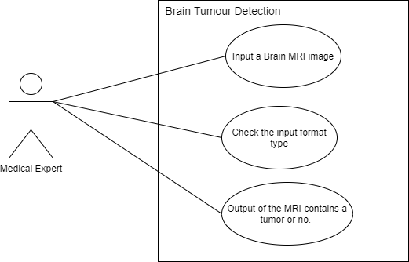

**Figure 1: Represents the Use Case Diagram of Brain Tumour Detection**

**2.2.3. Use Case descriptions using scenarios.**

|  |  |
| --- | --- |
| **Use Case:** | Detect a tumor by giving an MRI image as input. |
| **Primary actor:** | Medical Expert |
| **Goal in context:** | To input an MRI image into the system and get the result & detect the tumor. |
| **Pre- Conditions:** | The input image should be of file extension “.png” |
| **Trigger:** | The medical expert inputs an MRI scan to check if it has a tumor present in it. |
| **Scenario:** | 1. The medical expert selects an input image of a brain MRI and gives its path to the system. 2. The system takes in the image and checks if the file type is compatible and gives an error message if it is not compatible. 3. The system detects if the input image has a tumor or no and outputs a message to the actor |
| **Exceptions:** | 1. The input image is not in the required format. 2. The image might not be of a brain MRI which incase might lead to a wrong output |

**2.2.4 Non-functional Requirements**

1. The system shall be able to perform detection under ……
2. The system shall be able to run on different platforms.

**2.3 Software and Hardware requirement specifications**

1. Windows 10/Ubuntu
2. CPU quad-core or Hexa-core intel i7/intel i9/threadripper/Xeon
3. Hard disk :SSD
4. 16 GB RAM
5. 30 GB free space

# 3.System Design

**3.1 System Architechture**

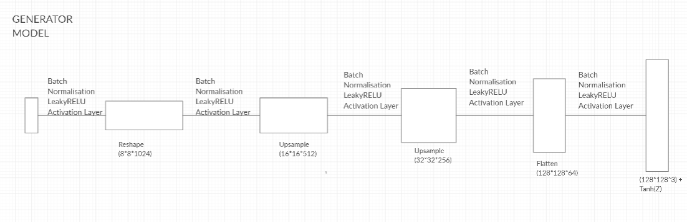

*Fig 2 Generator Model*

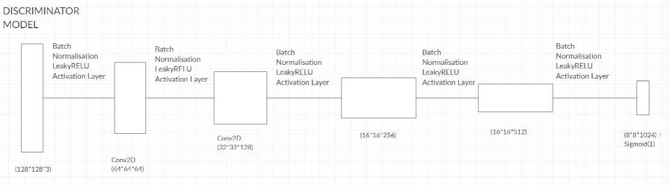

*Fig 2 Discriminator Model*

**3.2 Data flow diagrams**

3**.2.1 DFD(level 0)**

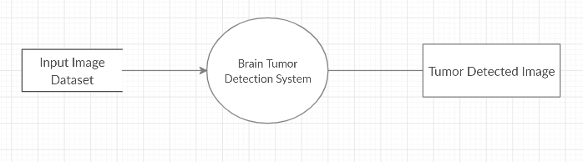

*Fig 2 Level 0 DFD*

3.2.2 DFD(level 1)

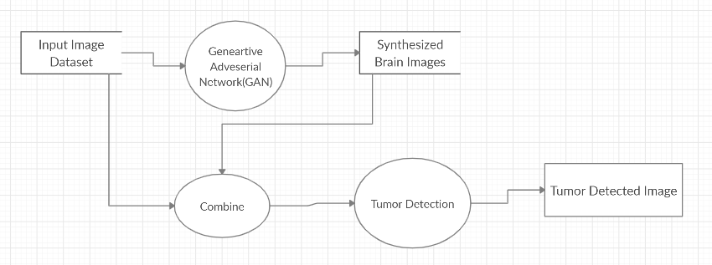

*Fig 2 Level 1 DFDl*

**References**

* [1] Frid-Adar, Maayan, et al. "Synthetic data augmentation using GAN for improved liver lesion classification." *2018 IEEE 15th international symposium on biomedical imaging (ISBI 2018)*. IEEE, 2018.
* [2] Jiang, Jue, et al. "Tumor-aware, adversarial domain adaptation from ct to mri for lung cancer segmentation." *International Conference on Medical Image Computing and Computer-Assisted Intervention*. Springer, Cham, 2018.
* [3] Onishi, Yuya, et al. "Automated pulmonary nodule classification in computed tomography images using a deep convolutional neural network trained by generative adversarial networks." *BioMed research international* 2019 (2019).
* [4] Dey, Raunak, Zhongjie Lu, and Yi Hong. "Diagnostic classification of lung nodules using 3D neural networks." *2018 IEEE 15th International Symposium on Biomedical Imaging (ISBI 2018)*. IEEE, 2018.
* [5] Milletari, Fausto, Nassir Navab, and Seyed-Ahmad Ahmadi. "V-net: Fully convolutional neural networks for volumetric medical image segmentation." *2016 Fourth International Conference on 3D Vision (3DV)*. IEEE, 2016.