# ABSTRACT

Meal Magic is an ground-breaking application designed to streamline the process of connecting users with chefs for various culinary needs. In today's fast-paced world, where individuals often lack the time to prepare meals, this system serves as a convenient solution by offering access to a diverse pool of talented chefs specializing in different cuisines and culinary styles.

Through Meal Magic, users can browse a diverse selection of skilled chefs, each with their own specialties, cuisines, and culinary styles. The platform facilitates direct communication between clients and chefs, allowing for customized menu planning and tailored dining experiences to suit any occasion or dietary preference. Additionally, the system facilitates transparent communication by providing users with access to chef profiles, including detailed information about their culinary expertise, experience, and customer feedback.

For chefs, the Meal Magic offers a platform to showcase their skills, expand their clientele, and manage their bookings efficiently. Chefs can create personalized profiles highlighting their culinary specialties, availability, and pricing, allowing them to attract potential clients and build their reputation within the culinary community.

Meal Magic represents a future-ready solution that transcends traditional culinary paradigms, offering users unprecedented access to culinary expertise, creativity, and cultural diversity. With a relentless commitment to innovation and user-centric design, the system is poised to shape the future of culinary experiences, empowering individuals to explore, create, and savor memorable dining experiences like never before.

# ACKNOWLEDGEMENT

I take this occasion to thank God, almighty for blessing us with his grace and taking our endeavor to a successful culmination. I extend my sincere and heartfelt thanks to our esteemed guide, Mrs. Sonali Mogal for providing me with the right guidance and advice at the crucial juncture sand for showing me the right way. I extend my sincere thanks to our respected Centre Co-Ordinator Mr. Rohit Puranik, for allowing us to use the facilities available. I would like to thank the other faculty members also, at this occasion. Last but not the least, I would like to thank my friends and family for the support and encouragement they have given me during the course of our work.

Prachi Agrawal (230941220121)

Sakshi Wasankar (230941220152)

# INDEX

|  |  |  |
| --- | --- | --- |
| **Sr No.** | **TITTLE** | **Page No.** |
| 1 | INTRODUCTION | 4 |
| 1.1 | PURPOSE | 5 |
| 1.2 | SCOPE | 5 |
| 1.3 | OBJECTIVE OF PROJECT ON WHEELS ON DEMAND | 5 |
| 1.4 | FUNCTIONALITIES PROVIDED BY WHEELS ON DEMAND ARE AS FOLLOWS | 5 |
| 2 | REQUIREMENT | 7 |
| 3 | DATABASE DESIGN | 10 |
| 4 | APPENDIX A | 14 |
| 5 | APPENDIX B | 23 |
| 6 | REFERENCES | 24 |

# 1. INTRODUCTION

In an era defined by hectic schedules, diverse culinary preferences, and a growing emphasis on personalized dining experiences, Meal Magic emerges as a transformative solution poised to revolutionize the way individuals engage with professional culinary services. Rooted in innovation and driven by a passion for culinary excellence, this system represents a convergence of technology, creativity, and gastronomic expertise, offering users unparalleled access to a diverse network of skilled chefs and culinary artisans.

At its essence, Meal Magic is more than just a digital platform; it embodies a culinary renaissance, redefining the traditional boundaries of culinary exploration and engagement. By seamlessly integrating advanced technological features with the artistry of culinary craftsmanship, the system empowers users to embark on a culinary journey unlike any other, where culinary aspirations are realized, and gastronomic boundaries are transcended.

This introduction sets the stage for a comprehensive exploration of the Meal Magic, delving into its core functionalities, innovative features, and future-forward vision. From its inception, the system has been driven by a commitment to excellence, user-centric design, and a relentless pursuit of culinary innovation. As we delve deeper into its intricacies, we uncover a world of culinary possibilities, where users are empowered to discover, connect, and create memorable dining experiences that transcend the ordinary.

## 1.1 Purpose:

The purpose of this document is to provide a detailed specification of the features and functionalities of the "Meal Magic" It outlines the requirements, system architecture, and user interactions.

## 1.2 Scope:

User’s and chef’s will have profiles with relevant information. User’s will be able to browse various categories of food and select a chef based on their budget ,location and ratings. The booking can be done on a monthly, per meal, or per day basis. Chefs have the flexibility to accept or reject requests based on their availability. Chefs can manage grocery items if users don't have the required ingredients and will upload the grocery bill on the application for reimbursement. Users can provide reviews and ratings for the chefs. Chefs can showcase their work by uploading pictures of their dishes. Users can see the availability of chefs 24/7 and need to book a chef at least 2 hours prior.

## 1.3 Objective of Project on Meal Magic:

Meal Magic is designed to create a platform which will act as a bridge, connecting chefs and consumers, enabling users to hire profession chefs/home cooks to prepare their favorite meals in the comfort of their own homes in their budget. It not only allows chefs to demonstrate their skills to a broader audience but also provides an avenue for home cooks to generate income by offering their cooking services.

## 1.4 Functionalities provided by Meal Magic are as follows:

The "Meal Magic" project provides a range of functionalities aimed at simplifying and enhancing the vehicle buying and selling process for users. Some of the key functionalities offered by the project include:

1.User Profile Management:

Users can create accounts with unique usernames and passwords. Email verification for account activation. Password recovery mechanism. Users can provide and edit personal information.

Users can set their budget preferences. Users can view and provide ratings and reviews for chefs.

Users must provide essential details during registration, such as name, contact information, and address.

Two-factor authentication for enhanced security. Ability to upload a profile picture. Users can view past and upcoming bookings with details such as date, time, and chef information.

2. Chef Profile Management:

Chefs can create accounts with unique usernames and passwords. Email verification for account activation. Password recovery mechanism. Chefs can provide and edit personal information, specialization, and experience. Chefs can upload pictures of their dishes for a portfolio also add their experience. Chefs can set their availability schedule. Chefs can mark periods of unavailability. Chefs can accept or reject booking requests based on their availability.

3. Booking System:

Users can browse various categories of chef based on thier speciality of food preferences. Users can search for chefs based on budget and ratings. Users can book chefs on a monthly, yearly, per meal, or per day basis. Users need to book a chef at least 2 hours prior to the desired cooking time.

4. Grocery Management:

Chefs can check the availability of ingredients in users' kitchens.

If ingredients are missing, chefs can manage grocery items if required by user. Chefs can upload grocery bills for reimbursement by users. Users can provide reviews and ratings for chefs.

Reviews should include feedback on the meal, service, and overall experience.

5.Booking Confirmation:

Users receive confirmation notifications upon successful bookings.

Chefs receive booking requests and confirmations.

# 2.REQUIREMENTS

**Functional Requirements**

FR 1. User Registration and Authentication:

* Users can register by providing necessary details.
* User authentication is required to access the system.
* Forgot password functionality allows users to reset their passwords.

FR 2. Chef Registration and Authentication:

* Chef can register by providing necessary details.
* Chef authentication is required to access the system.
* Forgot password functionality allows users to reset their passwords.
* Upload and update profile pictures as well as the images of their dishes.

FR 2. Booking and Reservation:

* Customers can search for available Chef based on various filters.
* Customers can view chef details and make reservations.

FR 4. User Profiles:

* Users can view and update their profiles.
* User profiles store personal information, contact details, and past bookings..

FR 5. Image Upload:

- Chefs can upload images for their works and showcase their talents.

- Users can view images.

FR 6. Error Handling and Reporting:

-The system handles errors gracefully and provides appropriate error messages.

-Admins can access logs and error reports for troubleshooting

**Non Functional Requirements:**

NFR 1. Security:

- Internal communication channels between servers (web, app, database) are secure.

- Product details and all information are only accessible to registered users.

- Customer details are managed and reviewed by managers exclusively.

- Authentication is required for every user accessing the system.

- Sensitive data is always transmitted in an encrypted form.

- Alterations to system data permissions are the responsibility of the system's data administrator.

NFR 2. Availability:

- Information remains consistently available for authorized users, ensuring reliable access.

NFR 3. Maintainability:

- Software maintenance is carried out in response to customer requests for additional features and functionalities.

- Software updates coincide with system hardware upgrades.

- Separate environments are maintained to isolate the system for production, testing, and development purposes.

Durability:

- The system retains customer information for an extended period.

- The software can be adapted to align with evolving business needs.

NFR 4 . Efficiency:

- The system permits a maximum number of customers to book multiple products concurrently and view them.

- The system permits customer to cancel the order within 30 min of placing order.

# 3.DATABASE DESIGN

**Database Design**

The following table structures depict the database design.

**Database:**

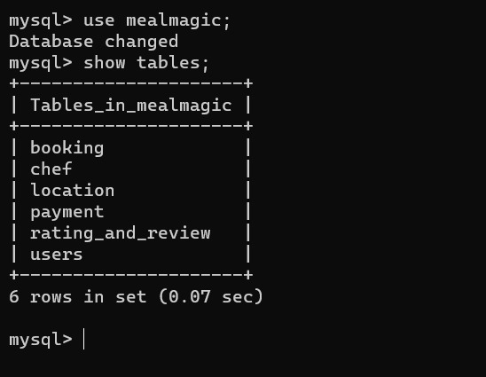

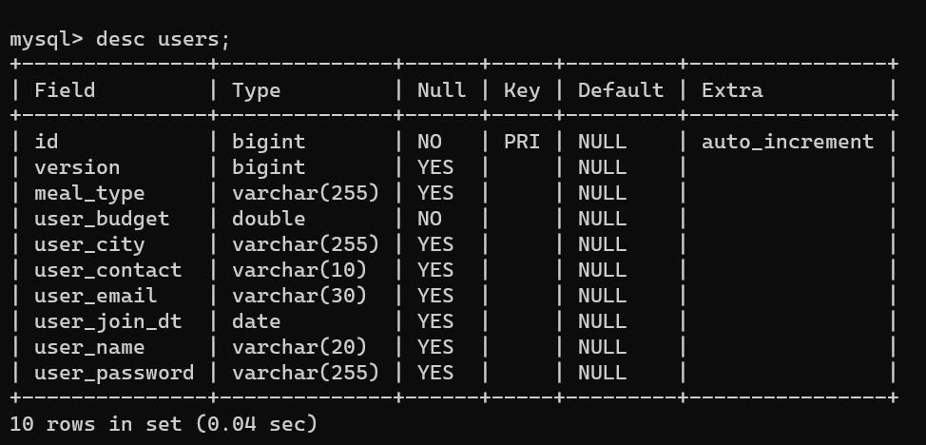**Table 1 User :**

**Table 2 Chef:**

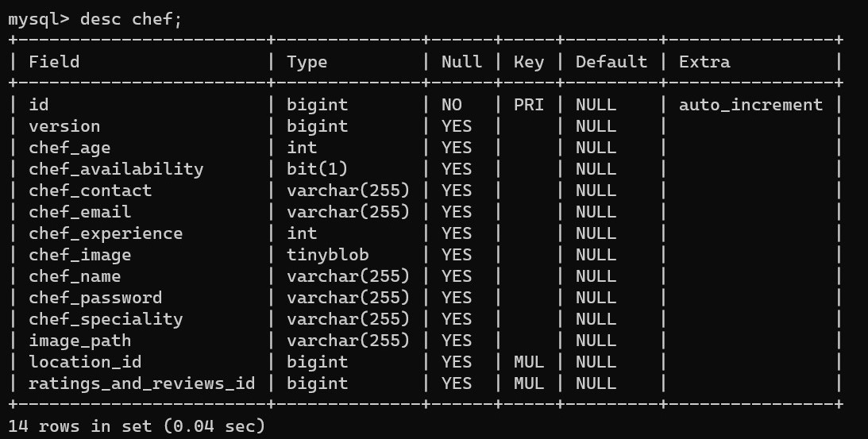

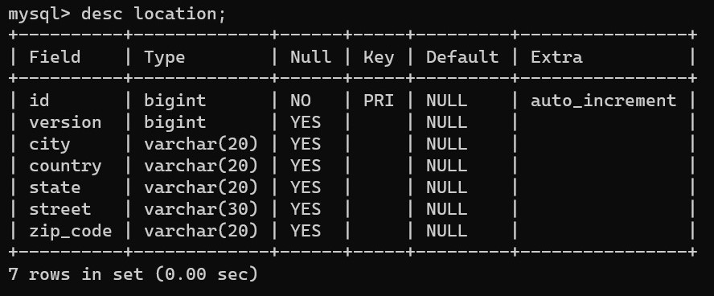**Table 3 Location:**

**Table 4 Booking:**

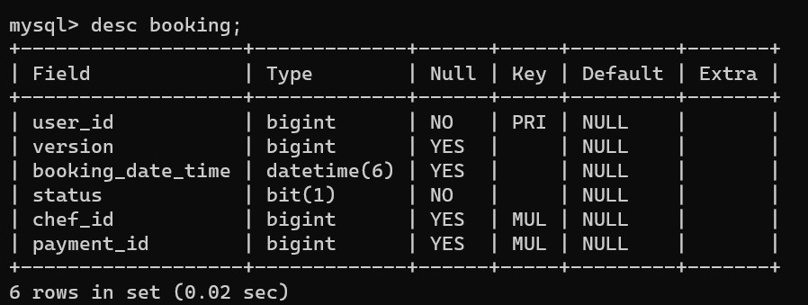

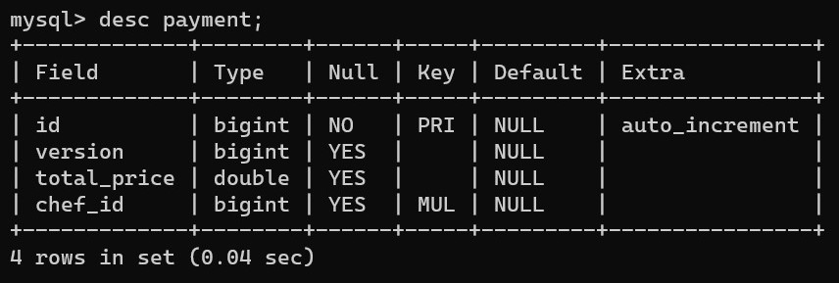**Table 5 Payment:**

**Table 6 Ratings_And_Reviews**:

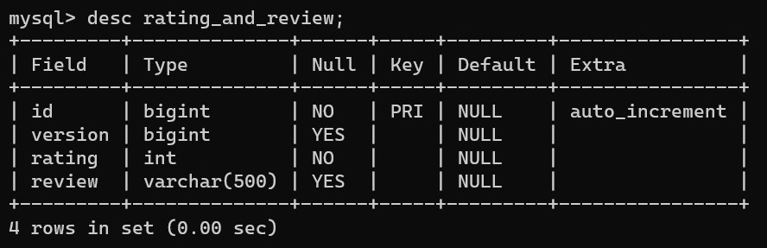

# 4.APPENDIX A

**Entity Relationship Diagram:**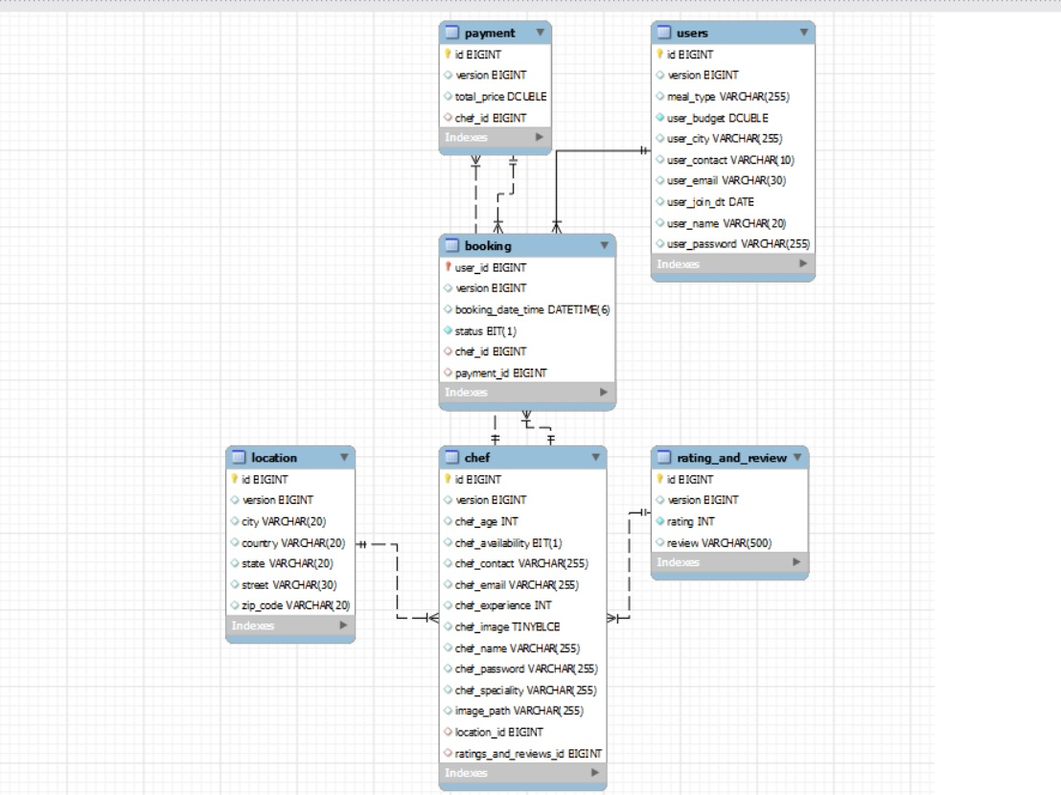

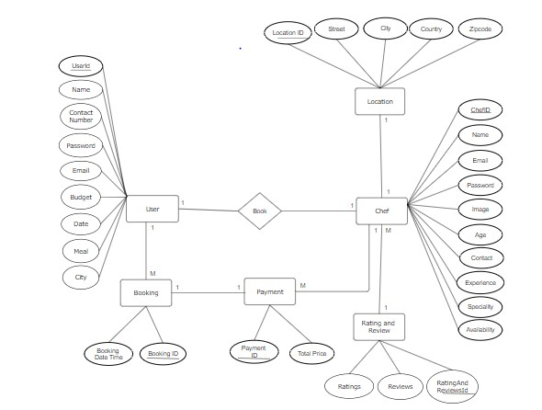

**Use Case Diagram:**

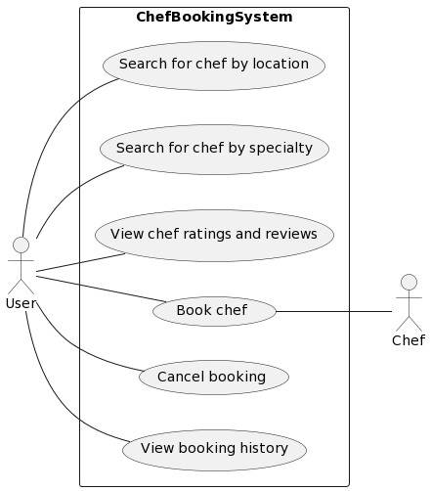

**Data Flow Diagram:**

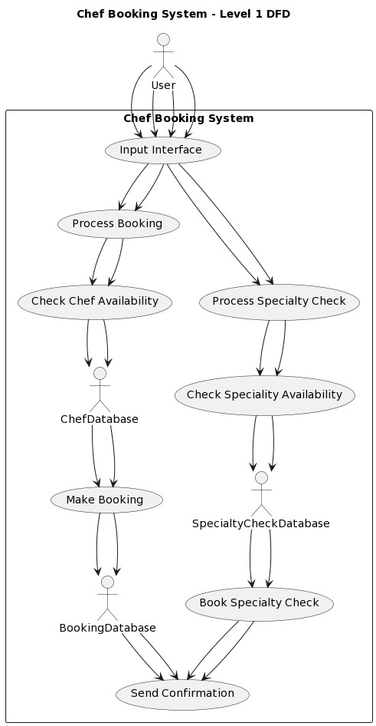

**User Activity Diagram:**

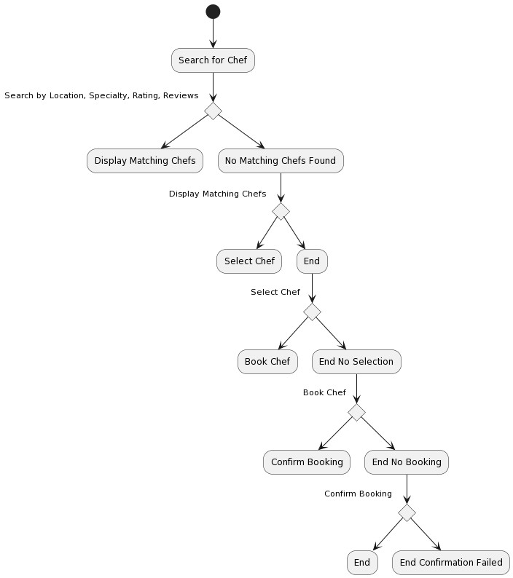

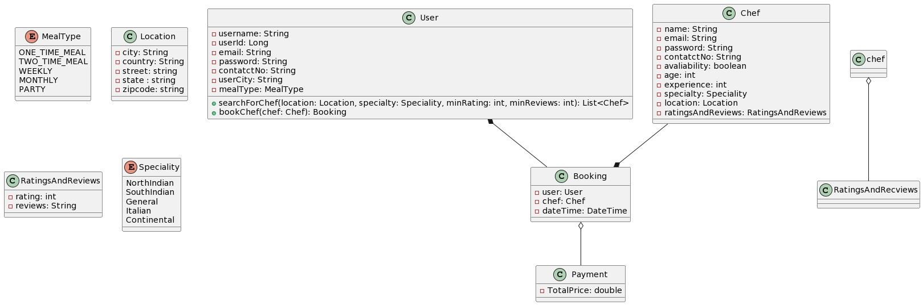**Class diagram :**

**Sequence diagram :**

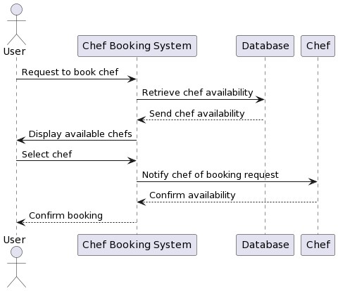

# 

# 5.APPENDIX B

**Homepage:**

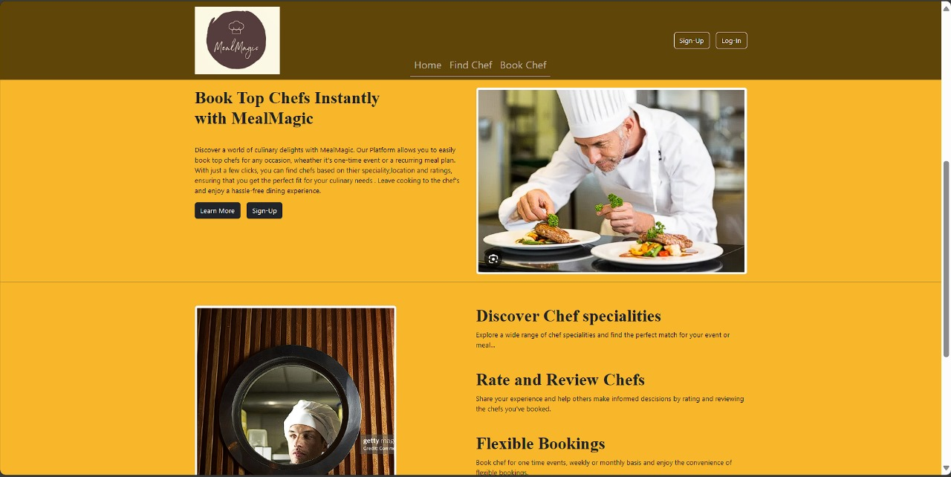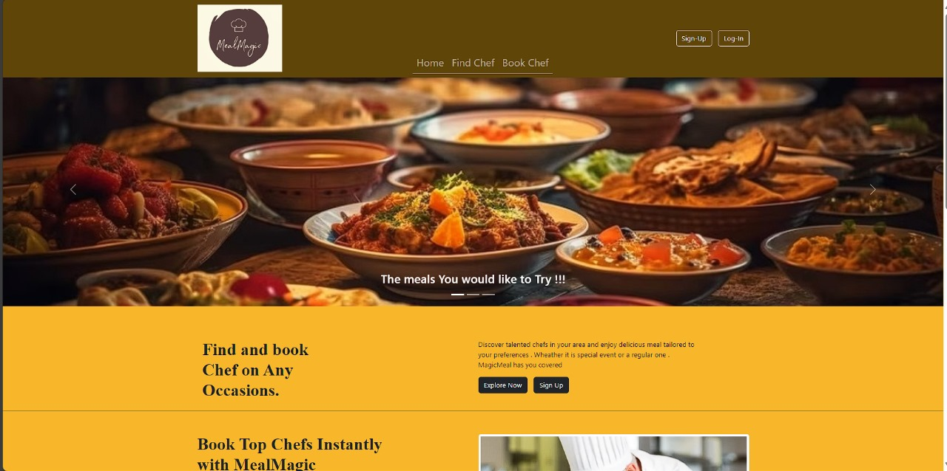

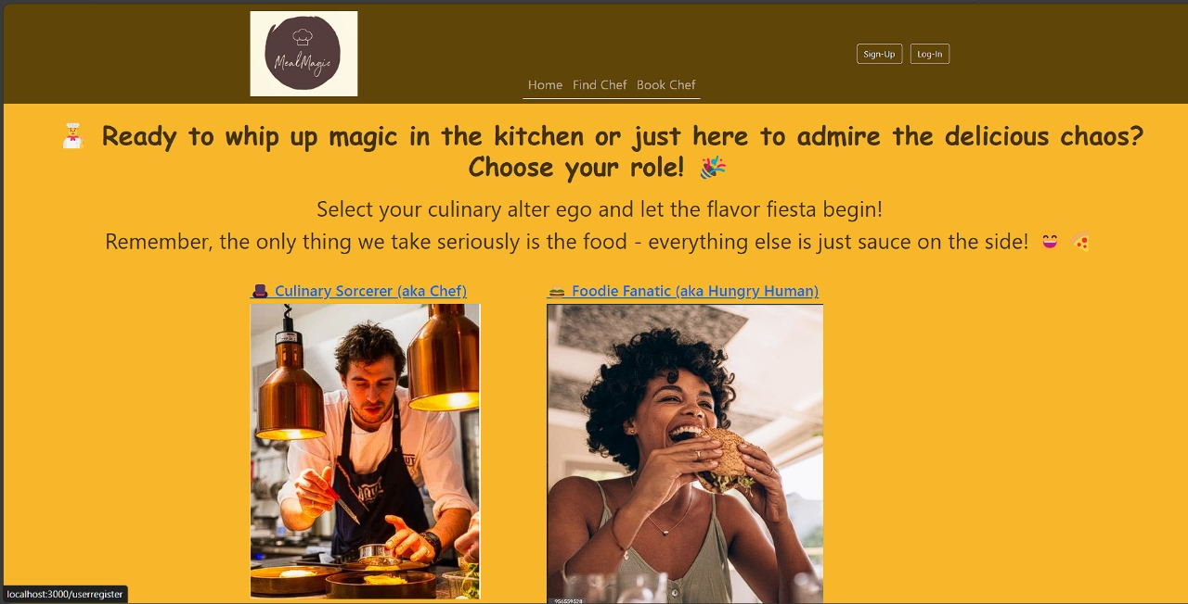**Role Based Sign-Up**:

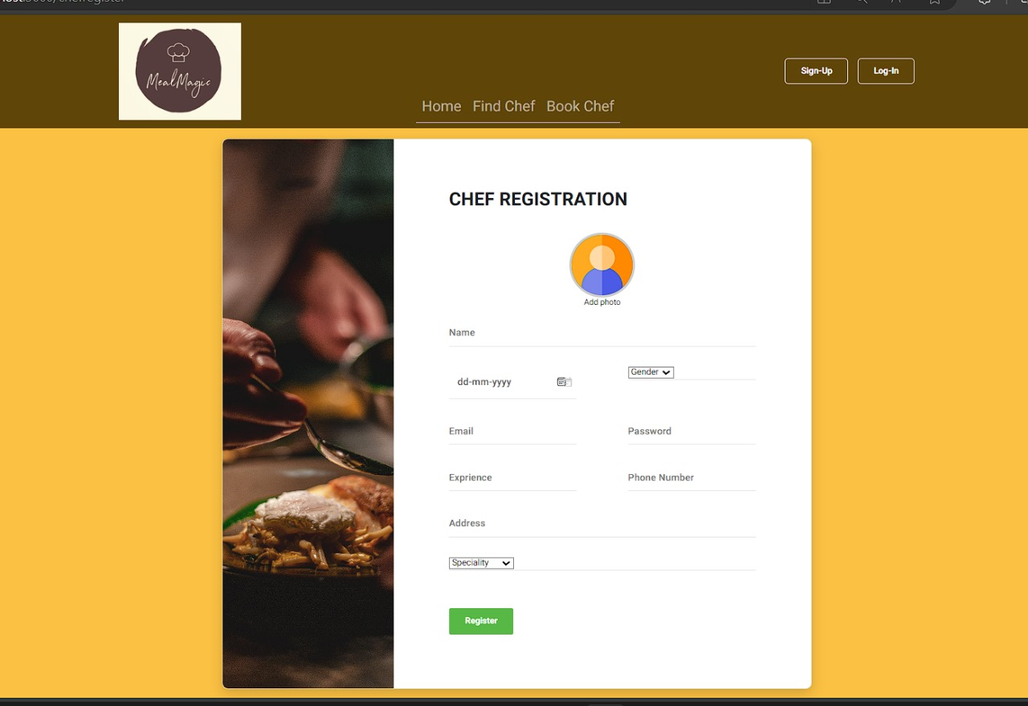**Chef Registration Form:**

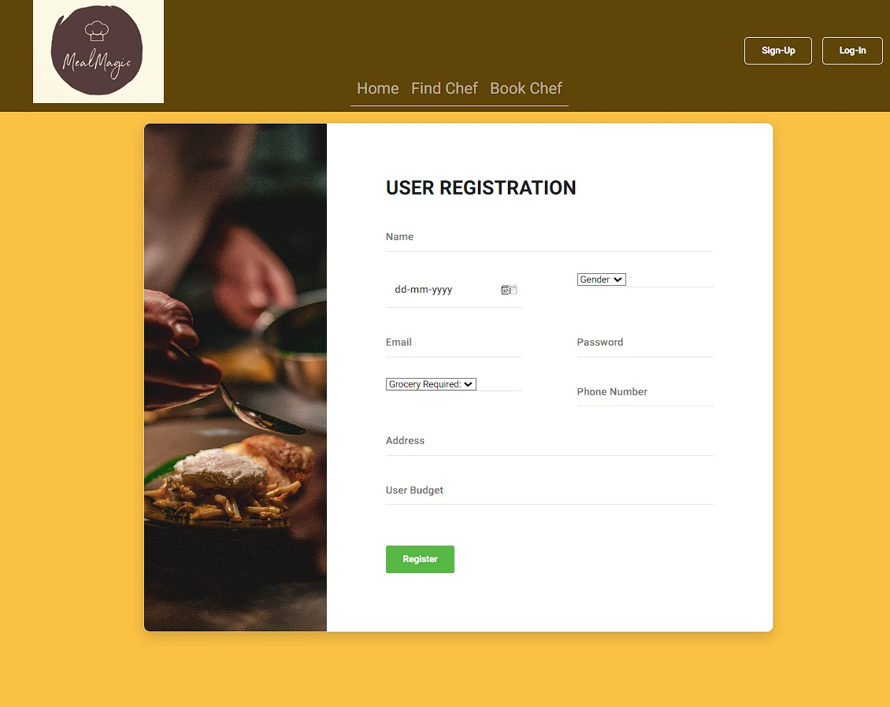**User Registration Form:**

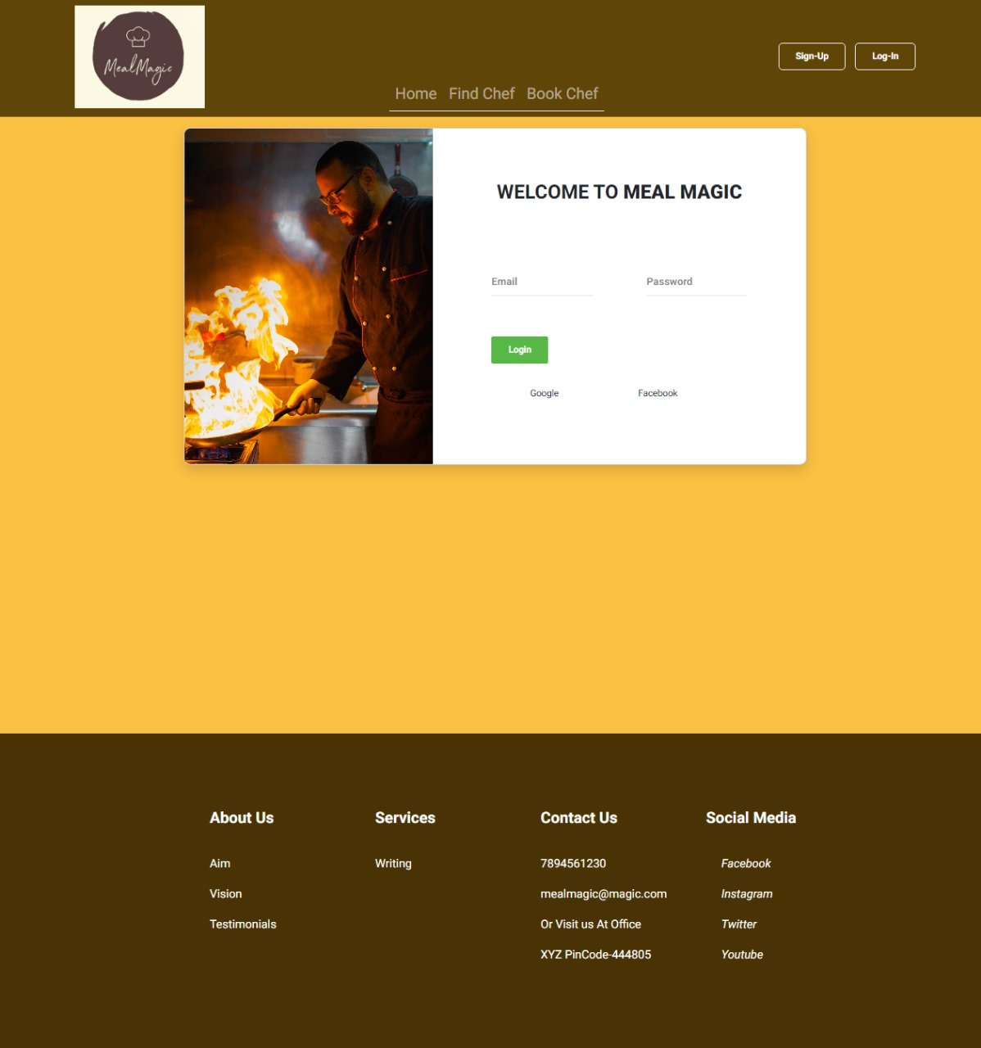**Login :**

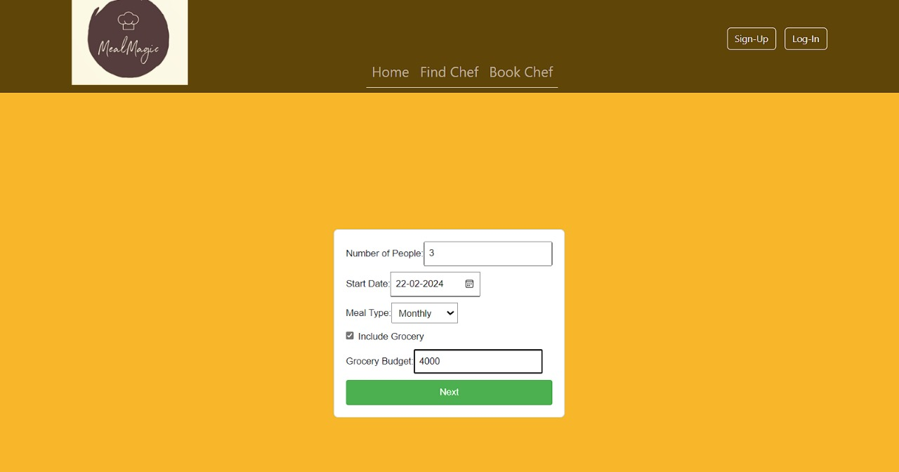**Booking Form:**

**Payment:**

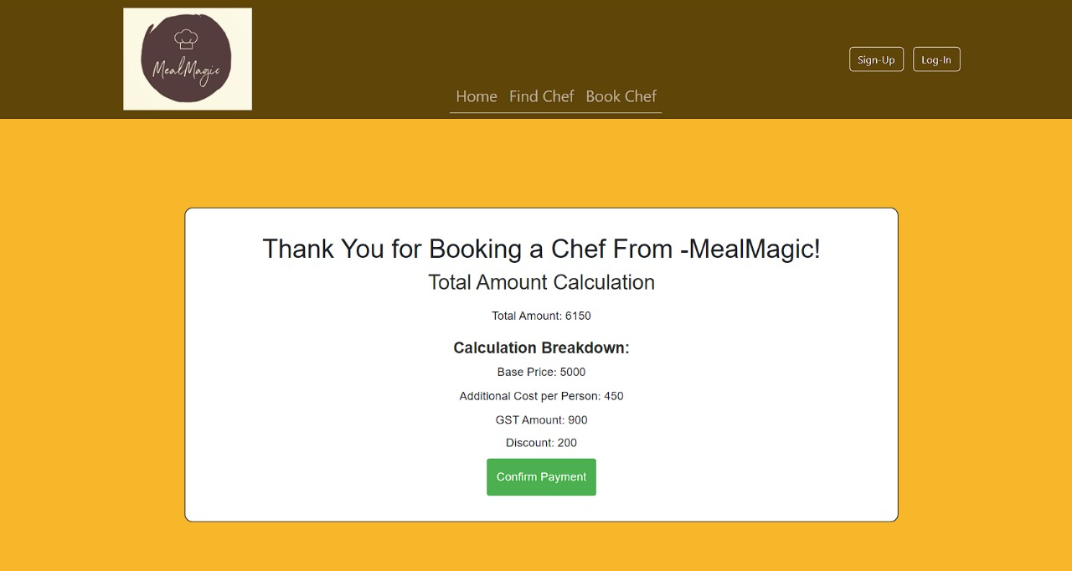

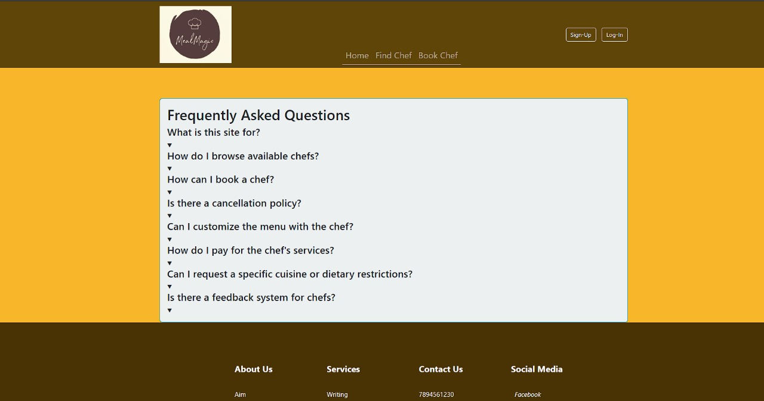**FAQ:**

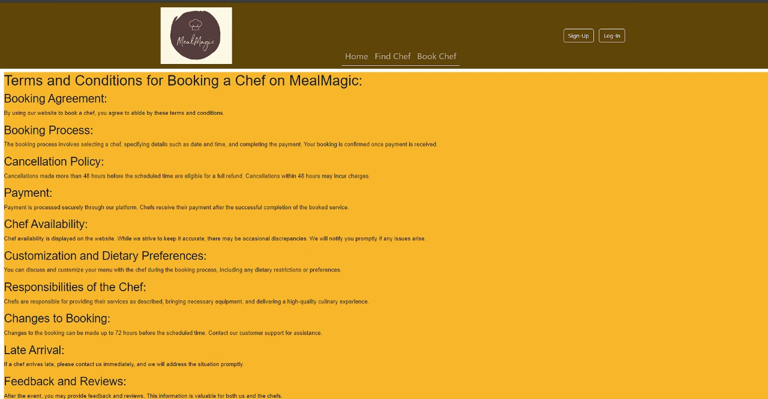**Terms And Condidtion**

# 5.REFERENCES

https://[www.tutorialspoint.com/java](http://www.tutorialspoint.com/java)

<https://stackoverflow.com>

tutorial [http://www.w3.org](http://www.w3.org/)

<http://www.javatpoint.com/java->