Module 11 – Version Control – Git
Hands-on Lab Report
- Name: Prachi Yadav
- Module: Git HOL
- Date: 26-07-2026

Step 1: Check Git Installation
Command
git --version
Output
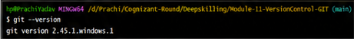

Observation
Git is successfully installed on the system.

Step 2: Configure Username
Command
git config --global user.name "Prachi Yadav"
Output
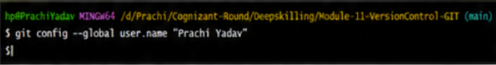

Observation
Git username has been configured successfully.

Step 3: Configure Email
Command
git config --global user.email "prachi29003@gmail.com"
Output
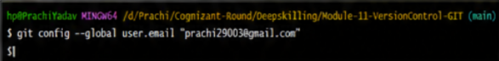

Observation
Git email has been configured successfully.

Step 4: Verify Configuration
Command
git config --list
Output
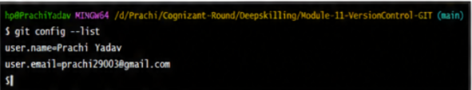

Observation
Username and email are displayed correctly.

Step 5: Initialize Repository
Command
git init
Output
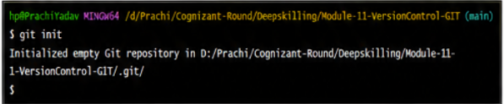

Observation
Empty Git repository has been initialized.

Step 6: Verify Repository
Command
ls -a
Output
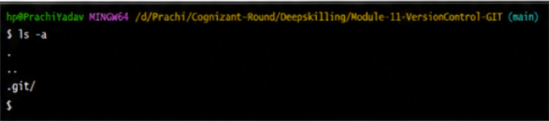
Observation
.git folder is created.

Step 7: Create File
Command
echo "Welcome to Git" > welcome.txt
Output
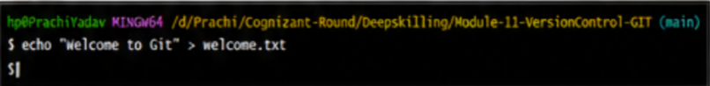

Step 8: Display File
Command
cat welcome.txt
Output
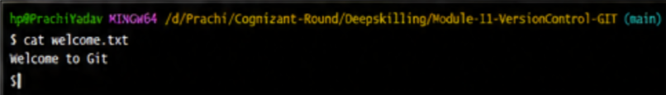

Step 9: Check Status
Command
git status
Output
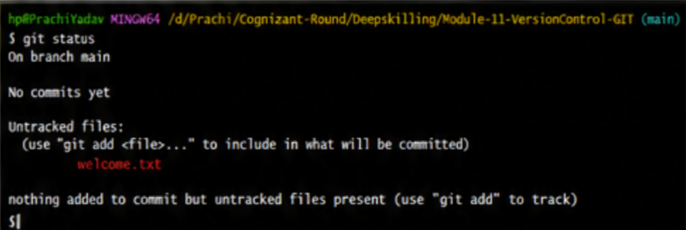

Step 10: Add File
Command
git add welcome.txt
Verify
git status
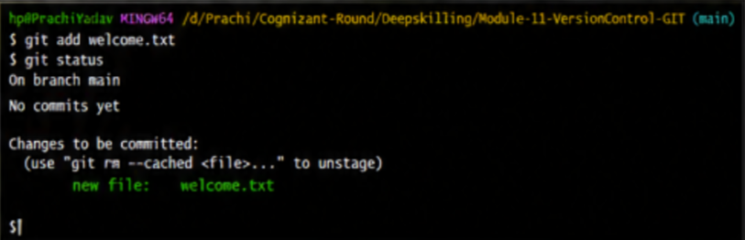

Step 11: Commit
Command
git commit -m "Added welcome file"
Output
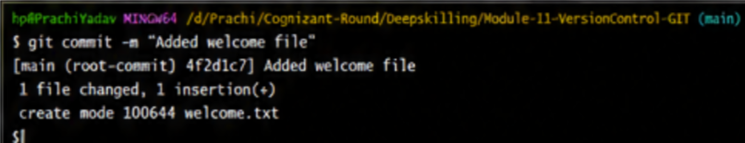

Step 12: Final Status
Command
git status
Output
