Module 11 – Version Control – Git
Hands-On Lab 2: Git Ignore
Name: Prachi Yadav
Module: Version Control – Git
Exercise: Git-HOL 2

Objective
- Explain Git Ignore.
- Learn how to ignore unwanted files and folders using .gitignore.

Description
The purpose of this exercise is to understand how Git ignores unwanted files and directories using the .gitignore file. Files with the .log extension and the log folder are excluded from version control.

Step 1: Create a Log File
Command
echo "Error Log" > error.log
Output
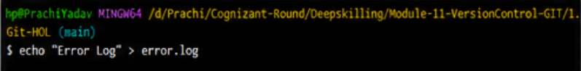
Observation
A log file named error.log was created successfully.

Step 2: Create a Log Folder
Command
mkdir log
Output
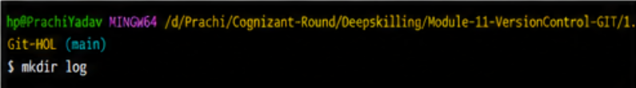
Observation
A directory named log was created successfully.

Step 3: Create a File Inside Log Folder
Command
echo "Test Log File" > log/test.txt
Output
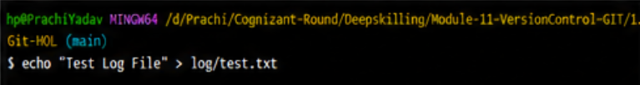
Observation
A file named test.txt was created inside the log folder.

Step 4: Create .gitignore File
Command
touch .gitignore
(If touch does not work)
notepad .gitignore
Output
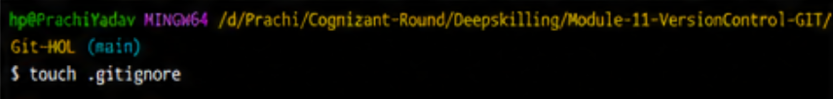
Observation
The .gitignore file was created successfully.

Step 5: Update .gitignore File
Content of .gitignore
*.log
log/
Output
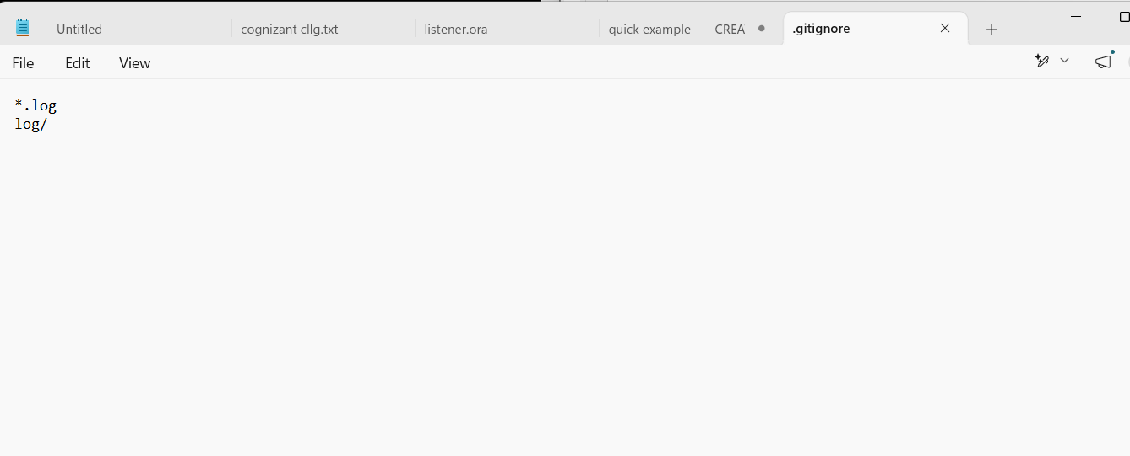
Observation
Git is configured to ignore all .log files and the log folder.

Step 6: Verify Git Status
Command
git status
Expected Output
Untracked files:
.gitignore
Note:
error.log and the log folder should not appear because they are ignored by Git.
Output
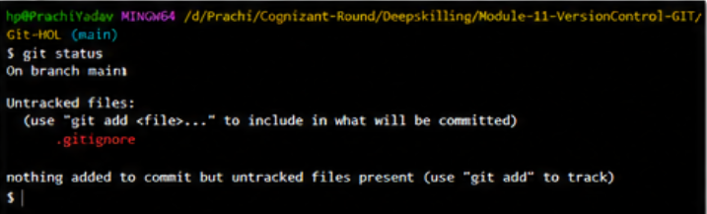
Observation
Git ignored the specified files and folders successfully.

Step 7: Add .gitignore File
Command
git add .gitignore
Output
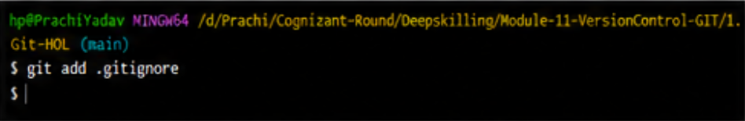
Observation
The .gitignore file was added to the staging area.

Step 8: Commit Changes
Command
git commit -m "Added .gitignore file"
Output
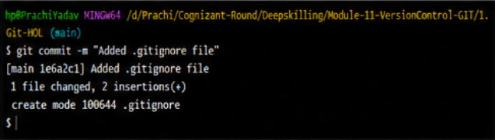
Observation
The .gitignore file was committed successfully.

Step 9: Verify Repository Status
Command
git status
Expected Output
nothing to commit, working tree clean
Output
