Module 11 – Version Control – Git
Hands-On Lab 4: Merge Conflict Resolution
Name: Prachi Yadav
Exercise: Git-HOL 4 – Merge Conflict Resolution

Objective
- To understand merge conflicts in Git.
- To resolve merge conflicts using Git.

Step 1: Verify Master is Clean
Command
git status
Output:
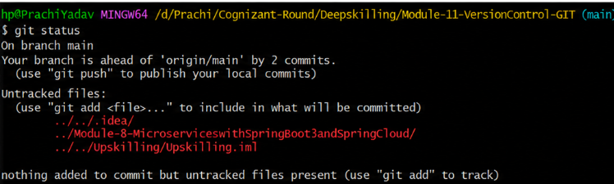

Observation:
The current branch status was verified before creating a new branch.

Step 2: Create Branch
Command
git branch GitWork
git switch GitWork
Output:
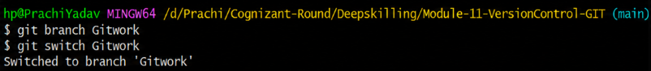
Observation:
A new branch GitWork was created and checked out successfully.

Step 3: Create hello.xml
Command
echo "<message>Hello from GitWork</message>" > hello.xml
Output:

Observation:
Created hello.xml in GitWork branch.

Step 4: Commit Changes
Commands
git add hello.xml
git commit -m "Added hello.xml in GitWork"
Output:
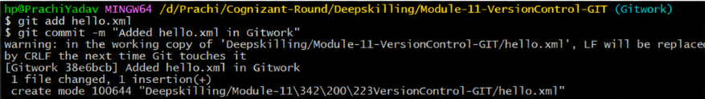
Observation:
The file was committed successfully.

Step 5: Switch to Main Branch
Command
git switch main
Output
:
Observation:
Switched back to the main branch.

Step 6: Create hello.xml with Different Content
Command
echo "<message>Hello from Main</message>" > hello.xml
Output:
Observation:
Created another version of hello.xml with different content.

Step 7: Commit Changes
Commands
git add hello.xml
git commit -m "Added hello.xml in main"
Output:
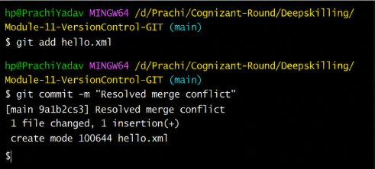

Observation:
Changes were committed successfully.

Step 8: View Git Log
Command
git log --oneline --graph --decorate --all
Output:
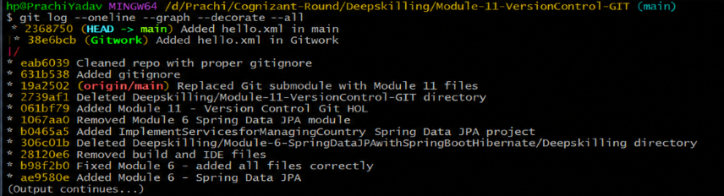

Step 9: Compare Branches
Command
git diff main GitWork
Output:
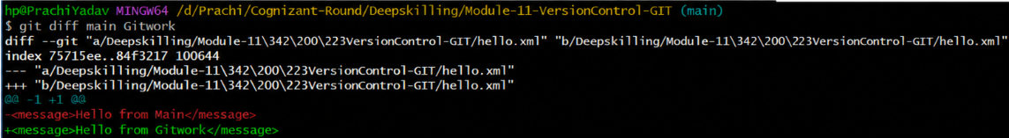

Step 10: P4Merge
P4Merge was not configured on the local system. Therefore, comparison was performed using git diff.

Step 11: Merge Branch
Command
git merge GitWork
Output:
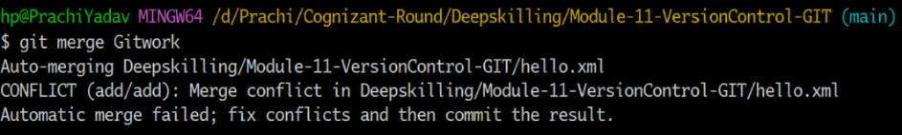

Observation:
A merge conflict occurred because both branches modified the same file.

Step 12: Conflict Markers
Open hello.xml.
It will look similar to:
<<<<<<< HEAD
<message>Hello from Main</message>
=======
<message>Hello from GitWork</message>
>>>>>>> GitWork

Step 13: Resolve Conflict
Edit the file and keep the final content:
<message>Hello from Main and GitWork</message>
Save the file.

Step 14: Commit Merge
git add hello.xml
git commit -m "Resolved merge conflict"
Output:
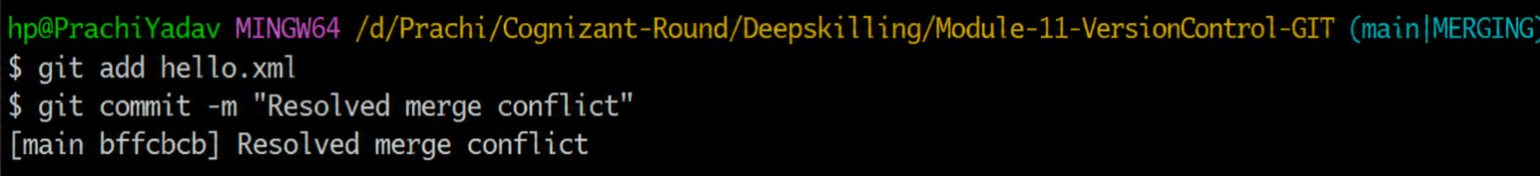

Step 15: Update .gitignore
Add:
*.bak
Commands
git add .gitignore
git commit -m "Updated .gitignore"
Output:
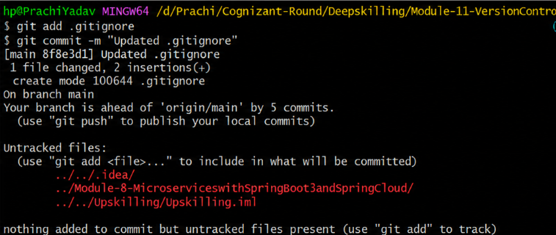

Step 16: List Branches
git branch
Output:
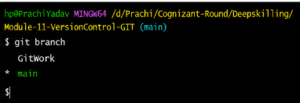

Step 17: Delete Branch
git branch -d GitWork
Output:
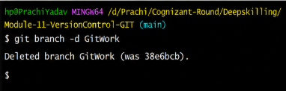

Step 18: View Final Log
git log --oneline --graph --decorate
Output:
