As-Is, To-Be & Process Flow

1. UPI Failure Scenarios Covered
Scenario | Example | Needed action
Debit success, credit failed | Remitter debited, beneficiary bank down | Auto-reversal by T+1
Timeout / Pending | Switch timeout, status unknown | Status check, then success/reverse
Deemed Approved | Beneficiary bank slow, NPCI deems approved | Wait for TCC, reconcile
Debit failed but NPCI success | CBS rollback, NPCI shows success | Raise exception / UDIR
Duplicate debit | Same RRN debited twice | Reverse duplicate

2. As-Is Process (Manual)
- NPCI raw file downloaded manually by Ops (~10:30).
- CBS and switch extracts requested from IT by email (~11:30).
- Analyst opens three Excel files and runs VLOOKUP on RRN.
- Mismatches pasted into a tracker sheet; categorised by judgement.
- Reversals raised by email to Finance; GL entries manual.
- Customer complaints arrive via call centre; agent asks Ops over email.
- Compensation computed manually in Excel at month-end.

Pain points: manual and error-prone, T+2/T+3 TAT, no audit trail, no real-time status, penalty risk, key-person dependency.
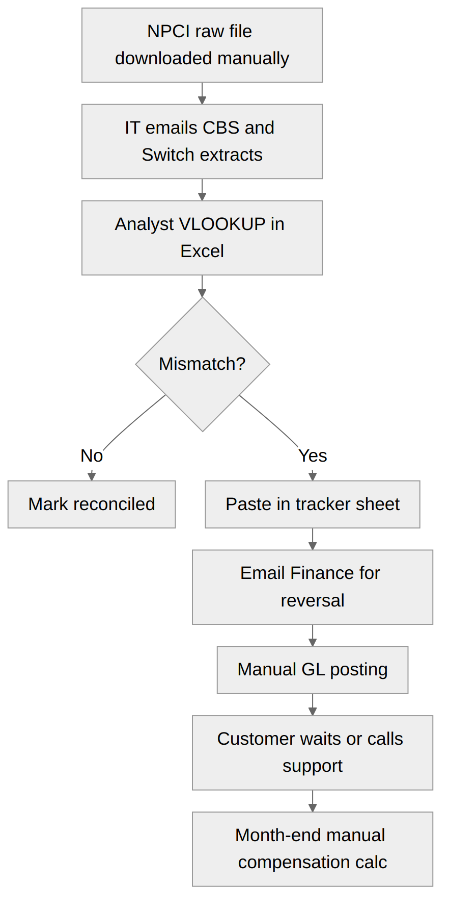

3. To-Be Process (Automated)
- Scheduler pulls NPCI file via SFTP; Switch and CBS data via API/DB feed.
- Validation (checksum, record count, duplicates).
- Three-way auto-match on RRN + amount + date + status.
- Mismatches auto-classified into exception categories.
- Failed-debit transactions enter the Reversal Tracker with a T+1 clock.
- Exceptions routed to a work queue; analyst acts (maker), supervisor approves (checker).
- Approved adjustment posted to CBS/GL via API; customer notified.
- Breach engine calculates Rs 100/day compensation automatically.
- Dashboards and MIS refreshed; audit log stored.

Benefits: T+1 recon, ~70% effort reduction, real-time status API, full audit trail, automated compensation.

4. To-Be Process Flow
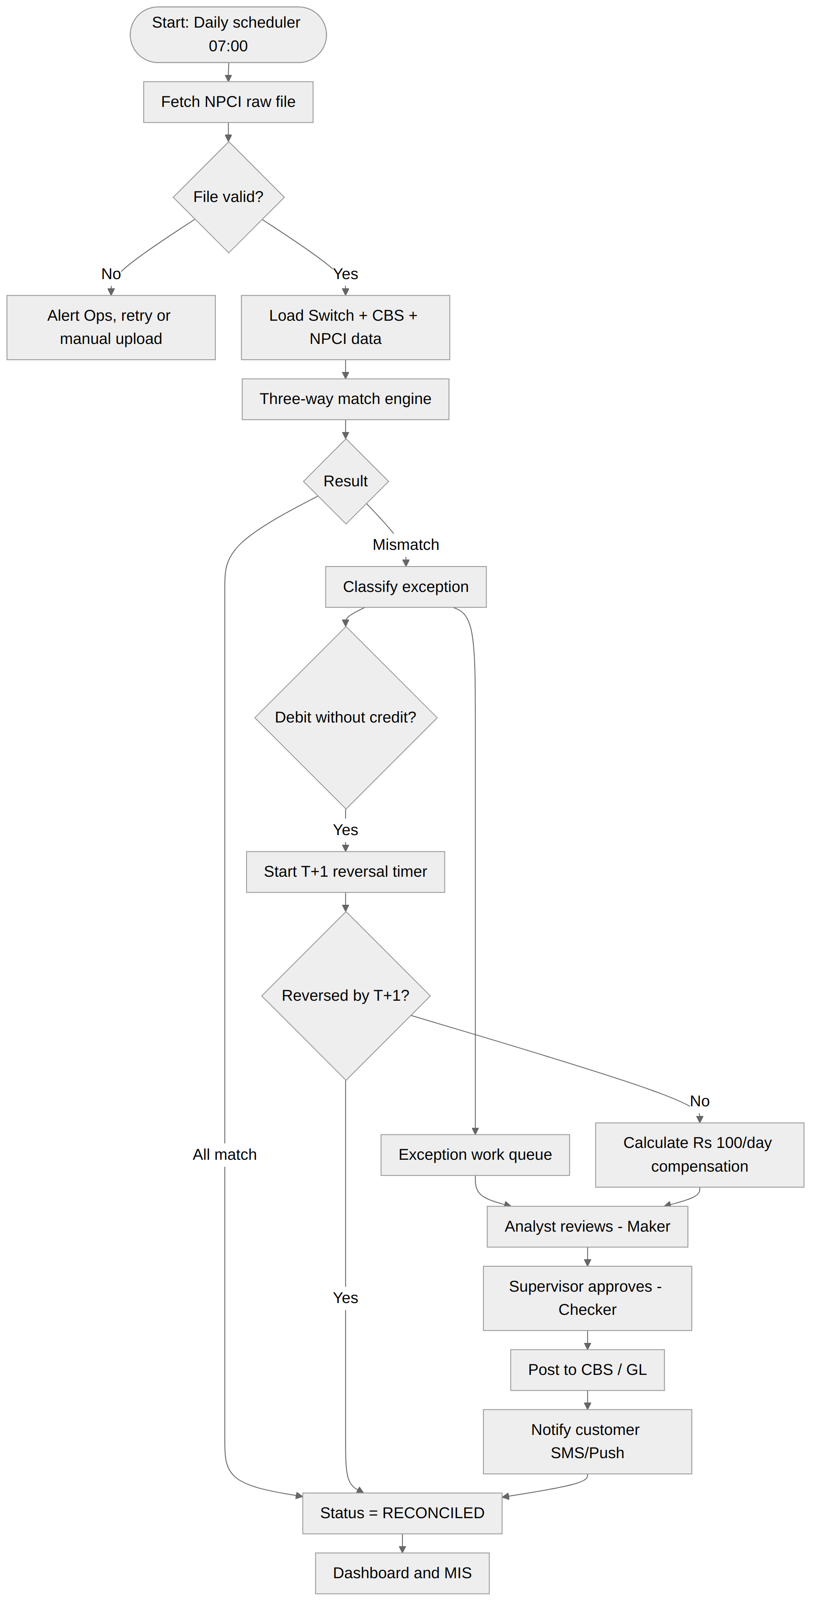

5. Transaction Sequence (Failed credit, auto-reversal)
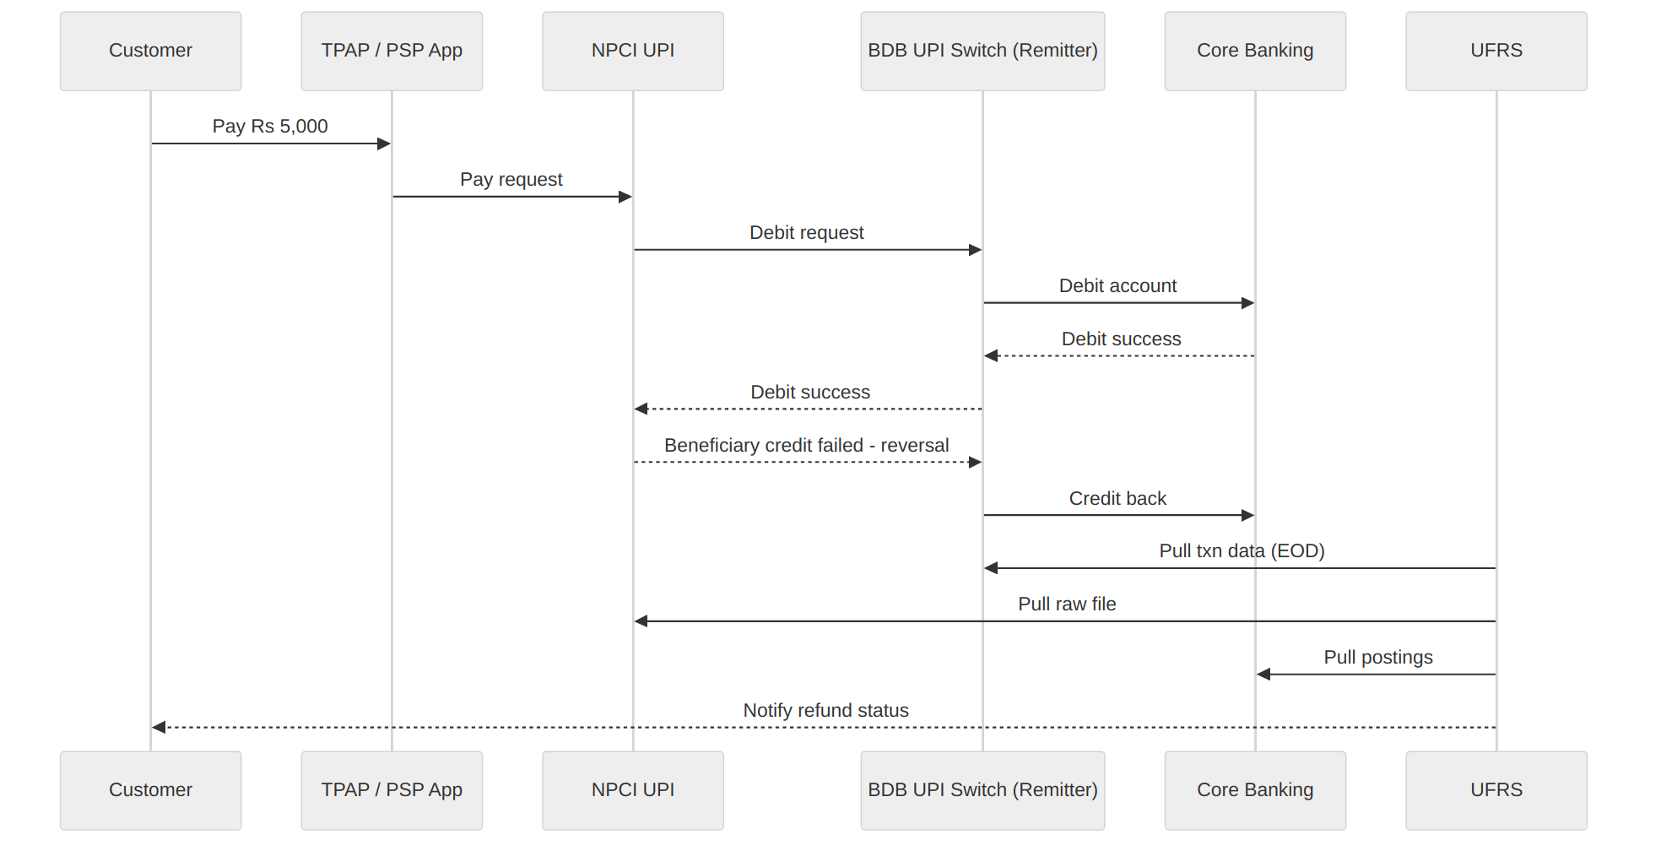

6. Gap Analysis
Area | As-Is | To-Be | Gap
Data ingestion | Manual | Automated SFTP/API | Build connectors
Matching | Excel VLOOKUP | Rule engine | Build engine
Exceptions | Email/Excel | Work queue | Build module
Reversal TAT | Not tracked | Real-time timer | Build tracker
Compensation | Monthly manual | Auto daily | Build calculator
Audit | None | Immutable log | Build

