API Flow & Sample JSON
Illustrative internal REST APIs for UFRS. (NPCI's real UPI interfaces are XML-based and not public in detail; this project models the bank-side integration layer.)

1. Integration Overview
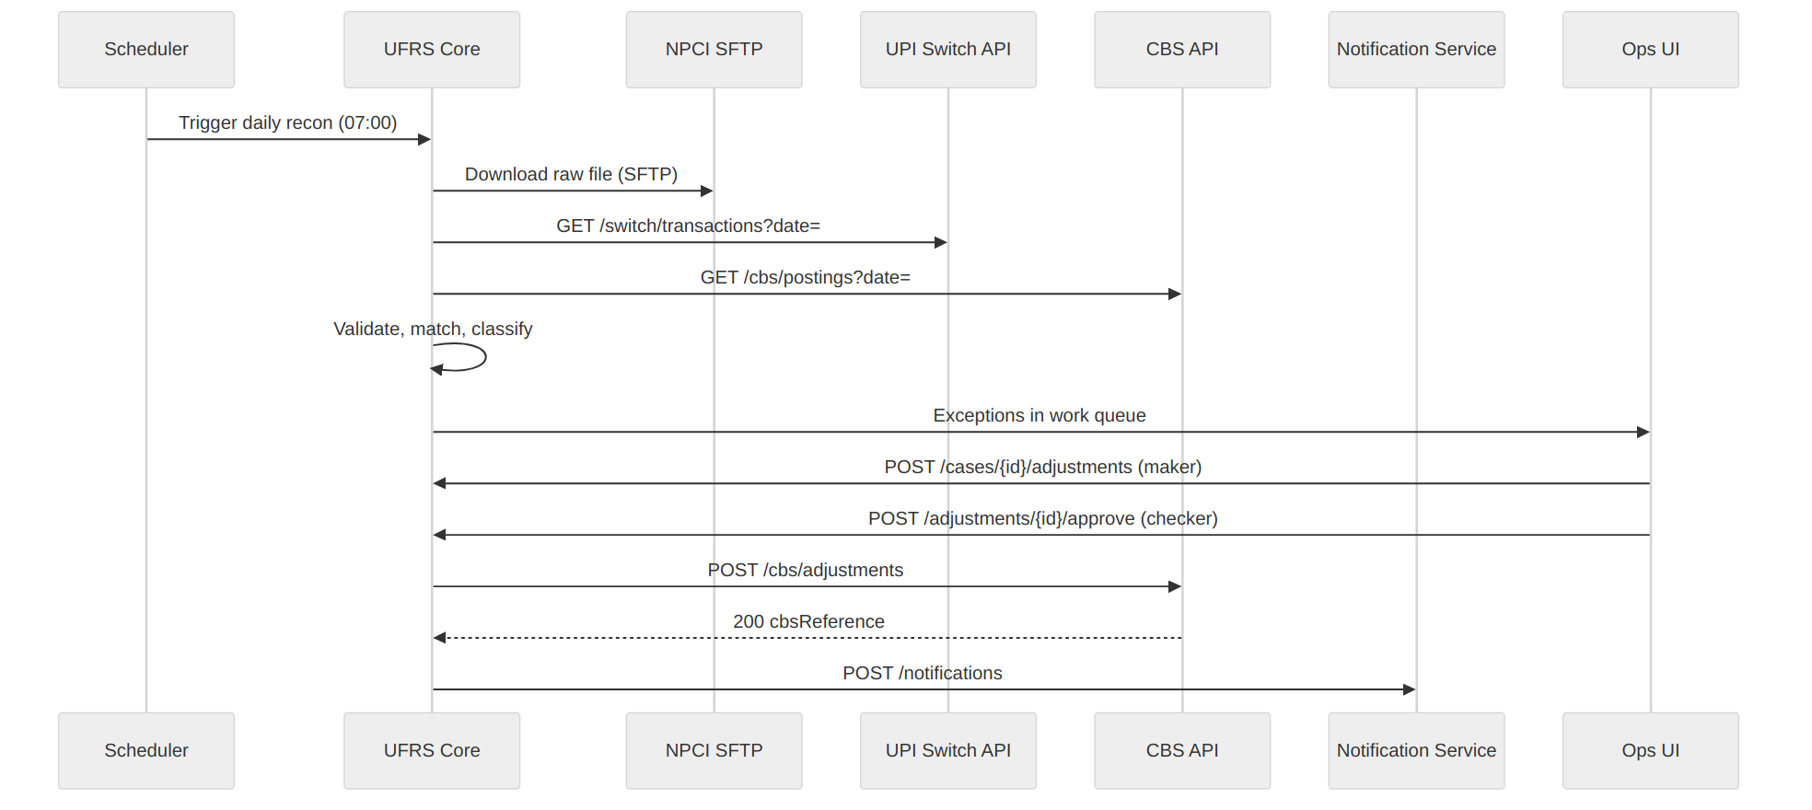

2. API Catalogue
# | API | Method | Purpose | Consumer
1 | /switch/transactions | GET | Fetch switch txns by date | UFRS
2 | /cbs/postings | GET | Fetch CBS postings by date | UFRS
3 | /recon/runs | POST | Trigger reconciliation run | Scheduler/Ops
4 | /transactions/{rrn}/status | GET | Transaction status for support/app | Support, App
5 | /cases/{caseId}/adjustments | POST | Maker raises adjustment | Ops UI
6 | /adjustments/{id}/approve | POST | Checker approves | Ops UI
7 | /cbs/adjustments | POST | Post reversal/adjustment to CBS | UFRS
8 | /compensations/calculate | POST | Compute compensation | UFRS/Finance

3. Standard Error Handling
HTTP | Code | Meaning
400 | UFRS-4001 | Validation error / missing field
401 | UFRS-4010 | Unauthorised
403 | UFRS-4030 | Maker cannot approve own entry
404 | UFRS-4040 | Transaction / case not found
409 | UFRS-4090 | Duplicate request (idempotency key reused)
500 | UFRS-5000 | Internal error
504 | UFRS-5040 | Downstream (CBS/Switch) timeout

Headers: Authorization: Bearer <token>, X-Idempotency-Key, X-Correlation-Id.

4. Sample: Transaction Status (API #4)
Request
GET /api/v1/transactions/427715689012/status
Authorization: Bearer eyJhbGciOi...
X-Correlation-Id: 7f2c1e9a-3c11-4a3b-9d4e-5b1e7a2b10aa
Response 200
{
"rrn": "427715689012",
"upiTxnId": "BDB8A1F3C2D94E7B9A10",
"txnDate": "2026-10-04T14:32:11+05:30",
"payerVpa": "prachi***@bdb",
"payeeVpa": "grocer***@okbank",
"amount": 5000.00,
"currency": "INR",
"switchStatus": "SUCCESS",
"npciStatus": "FAILED",
"cbsStatus": "DEBITED",
"reconStatus": "EXCEPTION",
"exception": {
"caseId": "EX-2026-100245",
"category": "EX01",
"description": "Debit without credit - reversal pending",
"reversalDueDate": "2026-10-05",
"tatBreached": false
}
}

5. Sample: Trigger Recon Run (API #3)
Request
{
"txnDate": "2026-10-04",
"sources": ["SWITCH", "CBS", "NPCI"],
"triggeredBy": "SCHEDULER"
}
Response 202
{
"runId": "RUN-20261004-001",
"status": "IN_PROGRESS",
"startedAt": "2026-10-05T07:00:03+05:30"
}

6. Sample: Maker Raises Adjustment (API #5)
Request
{
"adjustmentType": "REVERSAL_CREDIT",
"rrn": "427715689012",
"amount": 5000.00,
"currency": "INR",
"customerAccountNo": "XXXXXXXX1234",
"reasonCode": "DEBIT_NO_CREDIT",
"remarks": "NPCI status FAILED; no credit-back in CBS",
"makerId": "ops.analyst01"
}
Response 201
{
"adjustmentId": "ADJ-2026-000781",
"caseId": "EX-2026-100245",
"status": "PENDING_APPROVAL",
"createdAt": "2026-10-05T10:15:42+05:30"
}

7. Sample: Checker Approval - Error Case (API #6)
Request
{ "approverId": "ops.analyst01", "decision": "APPROVE", "comments": "OK" }
Response 403
{
"errorCode": "UFRS-4030",
"message": "Maker cannot approve own adjustment",
"correlationId": "7f2c1e9a-3c11-4a3b-9d4e-5b1e7a2b10aa"
}

8. Sample: CBS Posting (API #7)
Request
{
"idempotencyKey": "ADJ-2026-000781",
"debitGl": "UPI_SETTLEMENT_SUSPENSE",
"creditAccount": "XXXXXXXX1234",
"amount": 5000.00,
"narration": "UPI REV 427715689012",
"valueDate": "2026-10-05"
}
Response 200
{
"cbsReference": "CBS20261005000912",
"status": "POSTED",
"postedAt": "2026-10-05T10:22:07+05:30"
}

9. Sample: Compensation (API #8)
Request
{ "rrn": "427715689012", "txnDate": "2026-10-04", "reversalDate": "2026-10-08" }
Response 200
{
"rrn": "427715689012",
"tatDueDate": "2026-10-05",
"daysDelayed": 3,
"ratePerDay": 100,
"compensationAmount": 300,
"currency": "INR"
}

10. UPI Response Codes Used (reference)
Code | Meaning | UFRS handling
00 | Approved / success | Match
U16 | Risk threshold exceeded | Failed, no debit expected
U28 | PSP not available | Failed; check debit
U30 | Debit failed | Failed
ZM | Invalid MPIN | Failed, no action
BT / DEEMED | Pending / deemed approved | EX08 - wait for TCC

(Codes shown for illustration; verify against the current NPCI specification before production use.)

