Bootsrap
If you want to add your own css file for additional work you have to link that file after the cdn of bootstrap or file of bootstrap.

It has two types of layout
Container-it takes fixed length of browser.
Container-fluid-it takes full browser length.

In bootstrap only 12 columns are present in a row if u try to insert more than 12 it comes in another row.it has total 12! Combination of columns present for a row.
First add class row in div
After that choose combination
1-1-1-1-1-1-1-1-1-1-1-1
2-2-2-2-2-2
2-2-4-4
3-3-3-3-3-3
6-6
6-3-3

It has 5 breakpoints..
Extra small .col class
Small -.col-sm class
Medium- .col-md class
Large-.col-lg class
Extra-large-.col-xl class
This is the all structure for Extra Large,large screen,medium,small,extra small screen
Only one column also have large,medium,small an all.

Extra Large large screen medium small
col-xl-2 col-lg-3 col-md-4 col-sm-6"
col-xl-2 col-lg-3 col-md-4 col-sm-6"
col-xl-2 col-lg-3 col-md-4 col-sm-6"
col-xl-2 col-lg-3 col-md-4 col-sm-6"
col-xl-2 col-lg-3 col-md-4 col-sm-6"
col-xl-2 col-lg-3 col-md-4 col-sm-6"

how to forcefully break columns
<div class="w-100"></div>
Forcefully set the order of column by using order class with position no.
Offset is used for left margin of a column.

COlOR SCHEME IN BOOTSTRAP
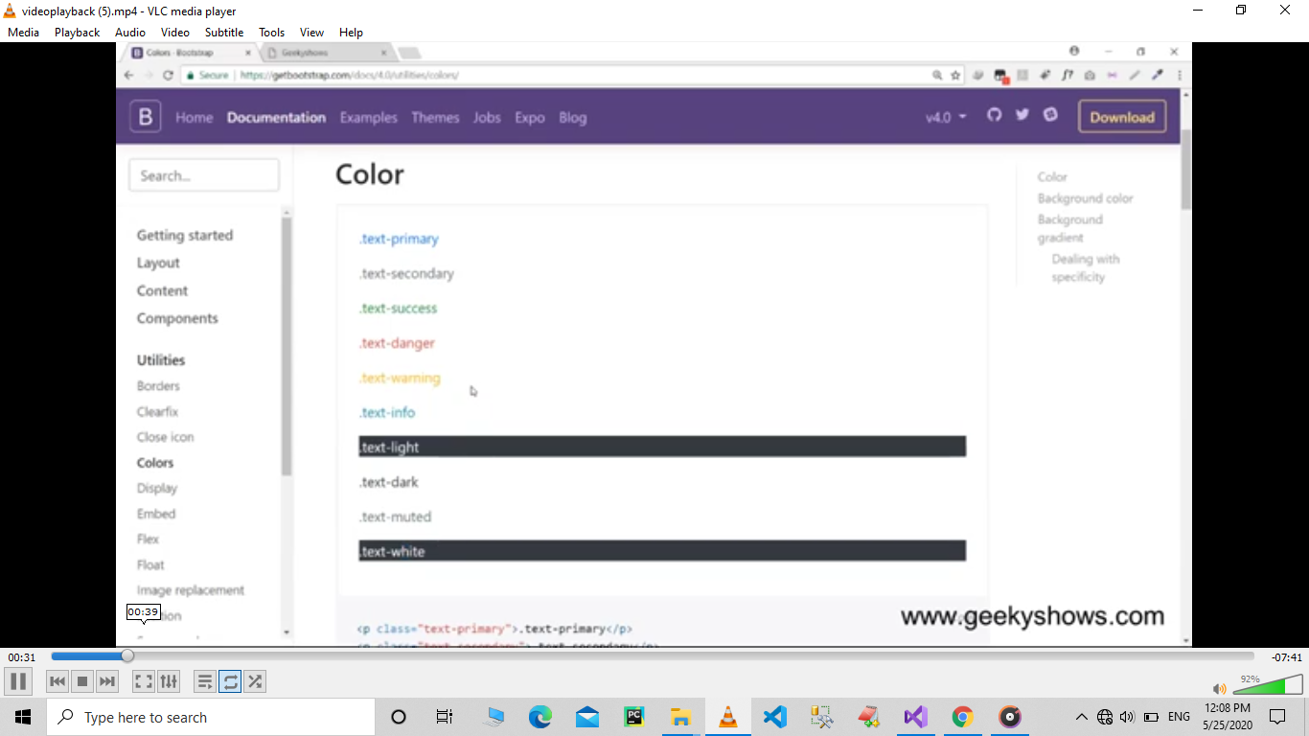
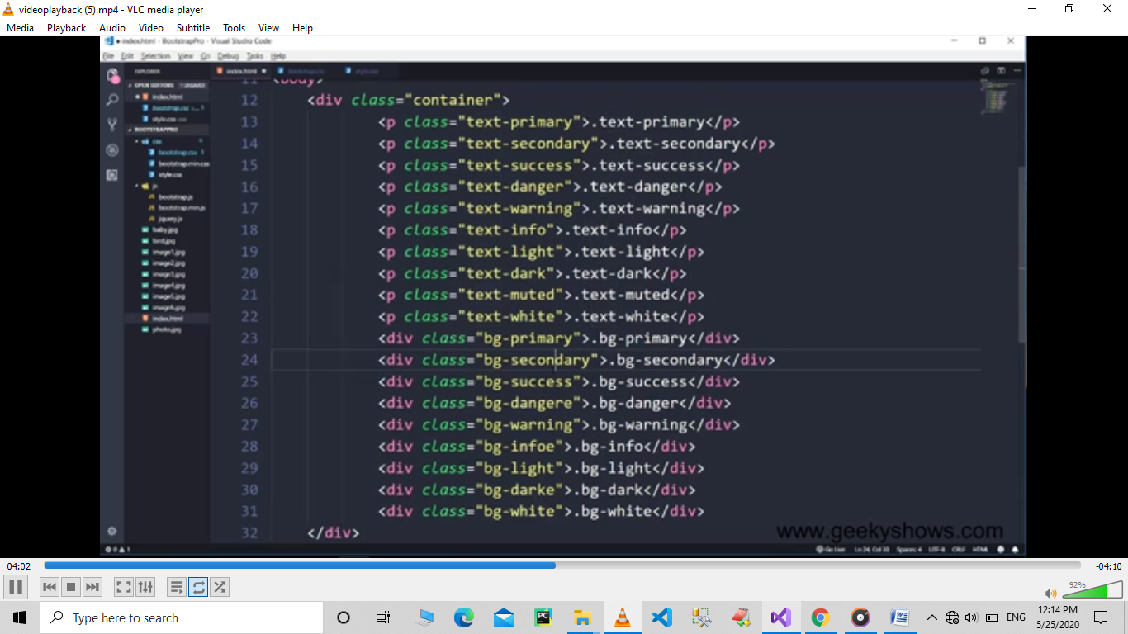

Breadcrumb is used to show the directory path of our website..

