**Client Identification /Need Identification/ Identification of relevant contemporary issue**

Today's society primarily relies on the Internet to meet our requirements and solve challenges like placing food orders. Finding repair services or other solutions in the area of Chandigarh University is one of these issues. We are attempting to address this issue because it is extremely important to those who are new to the area.

Therefore, we are putting out the concept of Repair & Co., which will concentrate on highlighting the businesses around our campus, outlining the cost of simple repairs, and offering advice on how to fix things yourself.

We will properly survey it, and as a result, it will address many concerns and benefit our users.

**Identification of Problem**

Data and surveys indicate that there is a critical need for a website that displays the precise location and cost of various repairs. When a newcomer to the area encounters a problem with their device and tries to look for a business nearby, they almost always wind up in the wrong location.

Our website will therefore concentrate on offering customers numerous services, such as the location and price range of fundamental repairs. Additionally, it will instruct them on a variety of topics, such as proper gadget use and problems that a user may resolve on their own.

**Identification of Tasks:**

Here is a list of some of the tasks that can be accomplished in order for this project to be completed successfully.

* Location: The ability to locate and choose repair service providers conveniently based on their geographic location makes the location element of a website for repair services crucial. Users may use this function to look up repair shops in their neighbourhood, guaranteeing that they can quickly and easily get trustworthy assistance for laptop repairs.

Users can often view city, ZIP code, or address information using a dropdown menu that is part of the location function.

* Price Range: A laptop repair website project must include a pricing range function since it promotes transparency and enables users to estimate repair costs prior to beginning the service. Users can use this tool to set a certain spending limit or filter repair services depending on their price range, enabling them to make well-informed judgements and select options that fit their budgetary needs.

A variety of repair prices are often shown when using the pricing range option. For an estimated price range for the service, users can view the model of their laptop, the type of repair required, or choose from established repair categories. The intricacy of the repair, new parts, labour charges, and any added services or warranties provided are all taken into account by this feature.

* Laptop Suggestion: The laptop suggestion feature is an important part of a website project for laptop repairs since it assists consumers in making decisions about whether to fix or replace their laptops. With the help of this tool, users can receive personalised suggestions for laptop models that best meet their requirements, taking into account their spending limit, desired specs, and usage needs.

Typically, the laptop suggestion feature uses a search filter. Aspects like price range, preferred screen size, processor power, storage capacity, graphics capabilities, and intended usage (such gaming, professional work, or multimedia) may be covered on the page. The website compiles a list of suggested laptop models that fit the users' criteria based on their comments.

**Problem Identification:**

**Providing contact information for better working**: Imagine that a person handed over his equipment but failed to provide the necessary information, such as his address or email, making it impossible for the repairman to get in touch with him.

**Finding exact location of shop**: From the perspective of the consumer, if he is new to an area and his gadget develops a problem, he won't be able to get it addressed in a timely manner since Google doesn't offer the required information or he'll end up paying more for the same thing.

**Search Filters**: Because it allows them the option to choose the right products they want in line with their budget, customers will cherish the ease and time savings that a thorough search tool with many parameters may offer.

**Profile Customization and Registration**: In essence, the user's profile is a database of data. Past purchases, preferences determined by order analytics, shipping addresses, saved stores, payment methods, and more may all be taken into account.

Diagram:

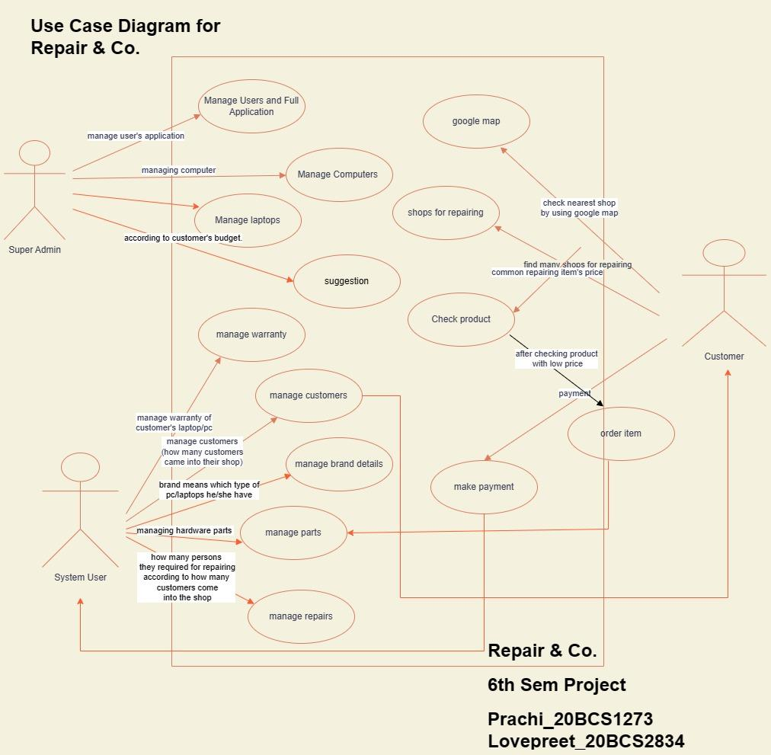

**Solution:**

Some of the features include

* **Google map places API:** Provide your application with full access to Google’s global database with over 100 million businesses and points of interest. Let's think about a restaurant you've visited recently - you probably remember the name, but do you know its exact address? People tend to think about places by name rather than keeping the street in their minds. Here, Google provides the missing data. Furthermore, if you do not remember the exact name of a location, the Google Places API features Autocomplete. Place-information can get returned based on only a few keystrokes that your customer types in, resulting in a very low error rate. Use the power of the Places API to give your users all contextual information that are needed.

* **Basic repair prices:** Provide a clear and concise description of each repair service, highlighting what it entails and the benefits it offers. This helps customers understand what they can expect from each repair. Specify the price range for each repair service or provide a starting price. This gives customers an idea of the potential cost and allows them to compare prices between different services. Provide visible and easily accessible contact information, such as phone numbers, email addresses, or a contact form. This allows customers to reach out for more detailed pricing information or to schedule appointments.

* **Laptop suggestion:** Present users with a list of personalized laptop recommendations based on their responses. Include key details such as the laptop model, brand, price, and a brief description of its features. You can also provide a rating or review score based on user feedback. Display the price range for each recommended laptop, along with links to online retailers or authorized sellers where users can make a purchase. Include information about the availability of the laptop to ensure users can easily find and buy their preferred model. Ensure that the laptop suggestion feature is responsive and works seamlessly across different devices and screen sizes. Optimize the user interface to provide a user-friendly experience on desktops, laptops, tablets, and mobile devices.