An Analysis of Grade Data in In-Person vs Online Course Delivery

Prachi Sardana

2023-09-23

## Introduction

This report indicates the final scores of students taught by different instructors in-person during the Spring term and online during the Fall term. All assignments, lectures, materials, and assessments were identical between both terms.

## Analysis

The course CS1000 was taken during the Spring term by 696 students and by 696 in the Fall. The Spring course was delivered using a traditional in-situ and in-person modality, while the in the Fall the course was delivered using a synchronous online modality.

The breakdown of students by instructor was as follows[1]:

Aiken Dupal Levkoviz Paloma Seier Yang   
 152 93 182 86 98 85

The mean grade during the Spring was 89.1 ( $σ$ = 13.25) with a median of 93.9, while the mean grade during the fall was 94.5 ( $σ$ = 8.69) with a median of 97). The mean grade for the Fall term was 5.3 points higher.

The grades ranged from 11 to 103.1 in the Spring and from 19.5 to 102.7 in the Fall[2].

## Shapiro wilk test

To evaluate whether the difference in means is statistically significant requires determining whether the distribution of both sets of grades is reasonably normal so that the appropriate hypothesis test can be applied.

A Shapiro-Wilk test for both Spring and Fall grades showed that they are not normally distributed (*WSpring* = 0.775, *WFall* = 0.631, *p* < 0.05 for both data sets).

## Including Plots

A histogram shows that the set of grades is skewed on the right side, as shown below:

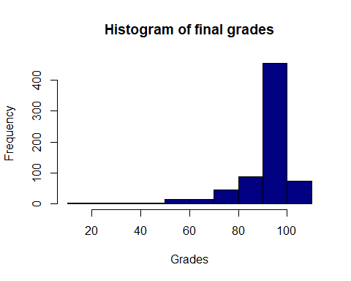

A non-parametric Wilcoxon test showed that the difference in scores is statistically significant (*p < 0.05*, *W = 4.334^{4}*).

1. The grouping was performed using the R function table().
2. Grades range from 0 to 100, but can be above 100 as bonus points were earned by some students.