NAME: PRACHI TANNA PS NO. 99005011

Contents

SET 1 2

1. Given a list of elements all elements are equal except one. Write a code to find the odd man out(Stray number) 2

2. In the given list of elements, find the element which is close to its mean. 3

3. Find the average speed of vehicle, given the distance travelled for fixed time intervals, e.g. [0,0.1,0.25,0.45,0.55,0.7,0.9,1.0] 3

4. Find the number of people in a bus, given the data of people onboarding and alighting at each station. 4

5. Find the missing number given the original and modified one. 4

6. Find the difference between two lowest numbers in the list. 4

7. In a given list, count number of elements smaller than mean 5

SET 2 6

1. Correct the malformed time string, for e.g. “5:70:65” to “6:11:05” 6

2. Correct the malformed date string, for e.g. “45/8/2018” to “14/9/2018” 6

3. Convert IP address to integer and vice versa 7

4. Check whether the given string is isogram or not. 8

5. Given a string, find the Mexican wave. 8

6. Given a number, find the largest number by deleting a single digit (Order will remain same) 9

7. Given a number, find the largest number by shuffling it. 10

8. Compute word frequency in given message 10

9. Convert RGB to Hex and vice versa 11

10. Generate accumulated strings, e.g. abcd == > A-Bb-Ccc-Dddd 11

# 

# SET 1

### Given a list of elements all elements are equal except one. Write a code to find the odd man out(Stray number)

mylist = [4, 2, 2, 2, 2]

a = mylist[0]

k = mylist[1]

if a != k:

p = mylist.count(a)

q = mylist.count(k)

if p > q:

print("The odd element is", k)

else:

print("The odd element is", a)

else:

for i in range(1, len(mylist)):

if a == mylist[i]:

e = mylist[i]

else:

f = mylist[i]

m = i + 1

b = mylist[m]

c = mylist.count(f)

d = mylist.count(b)

if c > d:

print("The odd element is", mylist[m])

else:

print("The odd element is", mylist[i])

#### Output:

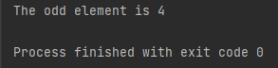

### In the given list of elements, find the element which is close to its mean.

list_1 = [1, 2, 3, 4, 5, 6, 7]  
t = 0  
new_list = []  
for i in list_1:  
 t += i  
mean = t / len(list_1)  
# print(mean)  
for i in range(0, len(list_1)):  
 new_list.append(mean - list_1[i])  
 if new_list[i] < 0:  
 new_list[i] = new_list[i] * (-1)  
min = new_list[0]  
for i in range(0, len(new_list)):  
 if min > new_list[i]:  
 min = new_list[i]  
for i in range(0, len(new_list)):  
 if min == new_list[i]:  
 print(list_1[i])  
 break

#### Output:

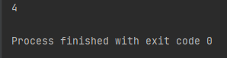

### Find the average speed of vehicle, given the distance travelled for fixed time intervals, e.g. [0,0.1,0.25,0.45,0.55,0.7,0.9,1.0]

distance = [0, 0.1, 0.25, 0.45, 0.55, 0.7, 0.9, 1.0]

time = 1

total = 0

for i in distance:

total += i

avg_speed = total/len(distance)

print("The average speed is \n", avg_speed)

#### Output:

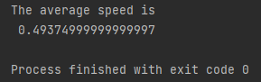

### Find the number of people in a bus, given the data of people onboarding and alighting at each station.

pas_onboard = [30, 23, 35, 14, 45, 26, 19]

pas_alight = [33, 25, 23, 44, 21, 16, 11]

pas = 0

for x in range(len(pas_onboard)):

pas += pas_onboard[x] - pas_alight[x]

print(pas)

#### Output:

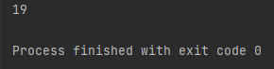

### Find the missing number given the original and modified one.

list_p = [12, 23, 14, 36, 27, 18, 20]  
mod_list = [12, 23, 14, 27, 18, 20]  
for i in range(0, len(list_p)):  
 if list_p[i] in mod_list:  
 continue  
 else:  
 print("Missing element is", list_p[i])

#### Output:

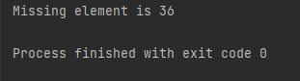

### Find the difference between two lowest numbers in the list.

my_list = [4, 8, 9, 3, 6, 1]

new_list = []

while my_list:

mini = my_list[0]

for x in my_list:

if x < mini:

mini = x

new_list.append(mini)

my_list.remove(mini)

print("The difference between two lowest numbers is", abs(new_list[1] - new_list[0]))

#### Output:

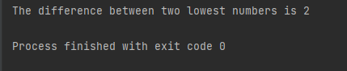

### In a given list, count number of elements smaller than mean

my_list = [12, 13, 16, 17, 19, 20]

new_list = []

a = 0

for i in my_list:

a = a + i

mean = a/len(my_list)

for x in range(0, len(my_list)):

b = my_list[x]

if b < mean:

new_list.append(b)

print("The count of number of elements smaller than the mean is", len(new_list))

#### Output:

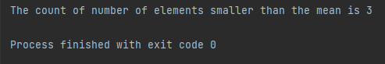

# SET 2

### Correct the malformed time string, for e.g. “5:70:65” to “6:11:05”

input_time = "5:70:65"

list_time = input_time.split(':')

hh = int(list_time[0])

mm = int(list_time[1])

ss = int(list_time[2])

correct_time = ""

if ss >= 60:

extra_min = ss // 60

mm = mm + extra_min

ss = ss % 60

if mm >= 60:

extra_hour = mm // 60

hh = hh + extra_hour

mm = mm % 60

if hh >= 24:

hh = hh % 24

correct_time = str(hh) + ":" + str(mm) + ":" + str(ss)

print(correct_time)

#### Output:

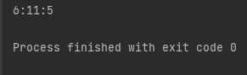

### Correct the malformed date string, for e.g. “45/8/2018” to “14/9/2018”

months = {1: 31, 2: 28, 3: 31, 4: 30, 5: 31, 6: 30, 7: 31, 8: 31, 9: 30, 10: 31, 11: 30, 12: 31}

input_date = input("Enter the date (dd/mm/yyyy): \n")

list_date = input_date.split('/')

dd = int(list_date[0])

mm = int(list_date[1])

yyyy = int(list_date[2])

newDate = ""

if (yyyy % 4) == 0:

if (yyyy % 100) == 0:

if (yyyy % 400) == 0:

months[2] = 29

else:

months[2] = 28

else:

months[2] = 29

else:

months[2] = 28

c1 = dd // months[int(mm)]

rem1 = dd % months[int(mm)]

mm += c1

dd = rem1

c2 = mm // 12

rem2 = mm % 12

yyyy += c2

mm = rem2

print('The correct date is', dd, '/', mm, '/', yyyy)

#### Output:

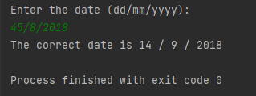

### Convert IP address to integer and vice versa

ip = input("Enter the ip address (a.b.c.d format): \n")  
p = 0  
int_value = 0  
for i in ip.split('.')[::-1]:  
 int_value += int(i) * 256**p  
 p += 1  
print(int_value)  
  
ip_address = ""  
for i in range(3, -1, -1):  
 num = int_value // (256**i)  
 ip_address = ip_address + str(num)  
 int_value = int_value % (256**i)  
 if i > 0:  
 ip_address = ip_address + '.'  
print(ip_address)

#### Output:

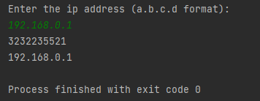

### Check whether the given string is isogram or not.

word_in = input("Enter string \n")

word = word_in.lower()

# print(word)

a = 0

char_list = []

for char in word:

if char.isalpha():

if char in char_list:

a += 1

char_list.append(char)

if a >= 1:

print("Input string is not an isogram")

else:

print("Input string is an isogram")

#### Output:

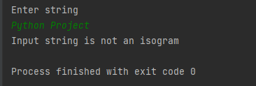

### Given a string, find the Mexican wave.

word = 'alphabet'  
new = []  
for i, val in enumerate(word[:]):  
 up = word[i].upper()  
 c = word[:i] + up + word[i+1:]  
 new.append(c)  
print(new)

#### Output:

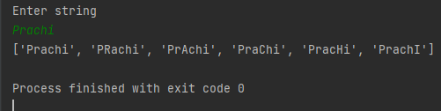

### Given a number, find the largest number by deleting a single digit (Order will remain same)

num = input("Enter number \n")

res = [int(x) for x in str(num)]

li = [int(x) for x in str(num)]

# print(li)

new_list = []

while li:

mini = li[0]

for x in li:

if x < mini:

mini = x

new_list.append(mini)

li.remove(mini)

# print(new_list)

a = new_list[0]

# print(a)

# print(res)

for i in range(0, len(res)):

if res[i] == a:

b = i

break

res.remove(res[b])

# print(res)

strings = [str(integer) for integer in res]

a_string = "".join(strings)

an_integer = int(a_string)

print("The largest number deleting single digit is", an_integer)

#### Output:

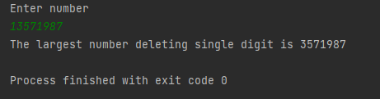

### Given a number, find the largest number by shuffling it.

number = 19216804  
new = []  
s = str(number)  
new[:0] = s  
new_list = []  
while new:  
 mini = new[0]  
 for x in new:  
 if x > mini:  
 mini = x  
 new_list.append(mini)  
 new.remove(mini)  
  
s1 = ""  
  
for x in new_list:  
 s1 += x  
  
print(int(s1))

#### Output:

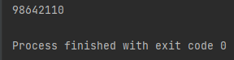

### Compute word frequency in given message

str = "she laughs she dances she plays she eats"  
str = str.split()  
str2 = []  
  
for i in str:  
 if i not in str2:  
 str2.append(i)  
  
for i in range(0, len(str2)):  
 print('Frequency of', str2[i], 'is :', str.count(str2[i]))

#### Output:

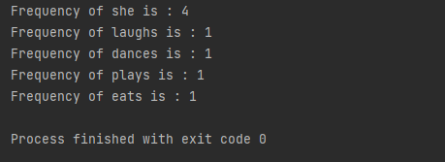

### Convert RGB to Hex and vice versa

#Hex to RGB

value = "FF65BA"

print("Hex input:", value)

value = value.lstrip('#')

print('RGB =', tuple(int(value[i:i+2], 16) for i in (0, 2, 4)))

#RGB to Hex

rgb = (255, 230, 50)

print("RGB input:", rgb)

print('Hex = %02x%02x%02x' % rgb)

#### Output:

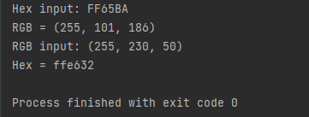

### Generate accumulated strings, e.g. abcd == > A-Bb-Ccc-Dddd

word = input("Enter string \n")

accum_str = ''

r = range(len(word))

for n in r:

ch = word[n]

accum_str += '-' + ch.upper() + ch.lower() * n

print(accum_str[1:])

#### Output:

