KIDNEY STONE PREDICTION USING URINE ANALYSIS
Submitted for

STATISTICAL MACHINE LEARNING

Submitted by:
E22BCAU0092 AAKASH SHARMA
E22BCAU0090 PRACHI SINGH

Submitted to-
DR. NITIN ARVIND SHELKE

July-Dec 2023
SCHOOL OF COMPUTER SCIENCE AND ENGINEERING


INDEX

Sr No
Content | Page No
1.1 | Abstract | 5
1.2 | Introduction and Related Work | 6
1.3 | Software Used | 16
1.4. | Methodology | 17
1.5 | Experimental Results | 24
1.6 | Conclusion | 28
1.7 | References | 29

LIST OF FIGURES

Figure No. | Title | Page No.
2.1 | Methodology | 17
2.2 | Logistic Regression | 19
2.3 | SVM with Linear Kernel | 20
2.4 | SVM with Gaussian Kernel | 21
2.5 | SVM with Sigmoid Kernel | 21
2.6 | SVM with Polynomial Kernel | 22
2.7 | Naïve Bayes Model | 23
2.8 | Random Forest Implementation | 24

LIST OF TABLES

Table No. | Title | Page No.
3.1 | Logistic Regression Model Performance Table | 25
3.2 | SVM with RBF Kernel Performance Table | 25
3.3 | SVM with Polynomial Kernel Performance Table | 26
3.4 | SVM with Sigmoid Kernel Performance Table | 26
3.5 | SVM with Linear Kernel Performance Table | 27
3.6 | Naïve Bayes Model Performance Table | 27
3.7 | Random Forest Performance Table | 28

- ABSTRACT
This research endeavors to significantly contribute to the field of kidney stone prediction through advanced machine learning techniques. Beginning with meticulous model selection, the project delved into an in-depth exploration of existing methodologies, identifying gaps in current knowledge. A rigorous dataset selection procedure was then initiated, forming the basis for subsequent model training and evaluation. Crucially, data preprocessing marked a pivotal stage, enhancing raw data quality for greater relevance to the chosen machine learning model.
The comprehensive strategy aims not only to refine the predictive capabilities of the model but also to offer insights into multifaceted factors influencing kidney stone formation. The primary objective is a substantial contribution to the field, extending beyond academia to potentially impact clinical practices. The project's methodical and rigorous approach positions it to advance our comprehension of kidney stone prediction, with implications for enhanced patient outcomes and improved healthcare delivery. As the project progresses, it is anticipated that the refined model will not only enhance prediction accuracy but also provide insights into the complexities of kidney stone development, fostering a deeper understanding. This research has the potential to impact healthcare interventions related to kidney stone management, contributing to the evolution of more efficient and targeted clinical practices.
This research focuses on advancing kidney stone prediction through a holistic machine learning approach. The study began with a meticulous model selection process, followed by an in-depth exploration of existing methodologies and identification of knowledge gaps. Rigorous dataset selection and preprocessing enhanced the relevance and quality of input data. The primary goal is to contribute significantly to the field, extending beyond academia to potentially influence clinical practices.
The comprehensive strategy aims to refine predictive capabilities and offer insights into multifaceted factors influencing kidney stone formation. The project's methodical approach positions it to advance our understanding of kidney stone prediction, with implications for enhanced patient outcomes and healthcare delivery. Anticipated outcomes include improved prediction accuracy and a deeper understanding of kidney stone development, impacting healthcare interventions related to kidney stone management. This research holds promise for the evolution of more efficient and targeted clinical practices.
- INTRODUCTION AND RELATED WORK
Introduction:
Kidney stones pose a significant health concern globally, affecting millions of individuals and presenting a considerable burden on healthcare systems. The ability to predict the formation of kidney stones is crucial for timely intervention and personalized patient care. This research addresses this imperative by employing advanced machine learning techniques to develop a predictive model based on urine analysis. The study seeks to contribute to the evolving landscape of healthcare by enhancing our understanding of the complex factors influencing kidney stone formation and paving the way for more precise diagnostic and preventive measures.
The research commences with a meticulous selection of a machine learning model, acknowledging the importance of a robust foundation for predictive analytics. By combining sophisticated algorithms with insights from a comprehensive literature survey, the aim is to establish a model that not only accurately predicts kidney stone formation but also provides valuable insights into the underlying mechanisms. This interdisciplinary approach bridges the gap between medical research and cutting-edge machine learning, fostering a synergy that holds great promise for advancements in predictive healthcare analytics.
Research Framework:
The intersection of machine learning and healthcare has witnessed significant advancements in recent years, with a growing emphasis on predictive analytics for various medical conditions. While several studies have explored the application of machine learning in disease prediction, the specific domain of kidney stone prediction through urine analysis remains relatively underexplored. Existing literature underscores the importance of leveraging machine learning algorithms to decipher patterns and relationships within complex datasets, offering valuable insights into disease prediction and prevention.
Studies related to kidney stone prediction predominantly focus on medical imaging, genetic factors, and dietary patterns. However, the incorporation of urine analysis data into predictive models is a novel and promising avenue. This research seeks to build upon the existing body of knowledge by integrating advanced machine learning techniques with urine analysis, contributing to the emerging field of predictive medicine and personalized healthcare. The following sections detail the methodology, dataset selection, and model development, elucidating the research's innovative approach in addressing the pertinent issue of kidney stone prediction. The research project unfolds through a structured sequence of steps, each contributing to the overarching objective of enhancing our understanding of kidney stone detection and offering valuable insights into the development of effective preventive measures. This multidimensional involvement encompasses the following key stages:
- Machine Learning Classification Models: At the core of the project is the application of diverse machine learning classification models. The primary focus is to ascertain the accuracy of these models in discerning whether kidney stones exist within urine samples. By harnessing the power of these algorithms, we aim to create a reliable predictive tool that can aid healthcare professionals in making swift and precise diagnoses.
- Exploratory Data Analysis: A fundamental understanding of the distribution and correlations among the six physical traits within the dataset is achieved through exploratory data analysis. This preliminary investigation serves as a crucial steppingstone in unraveling potential patterns and relationships that may influence the presence of kidney stones.
- Data Preprocessing: The integrity and quality of the dataset are upheld through meticulous data preprocessing. This phase encompasses the handling of missing values, the identification and treatment of outliers, and the scaling of features. Ensuring the cleanliness and relevance of the data is pivotal in developing robust predictive models.
- Model Selection and Evaluation: The diverse landscape of machine learning algorithms is explored to select the most accurate model. The evaluation process, marked by performance metrics such as accuracy, precision, recall, and F1-score, guides the selection of the model that is most adept at distinguishing between the presence and absence of kidney stones.
- Model Interpretation and Validation: Understanding the inner workings of the chosen machine learning model is pivotal. Model interpretation and validation provide insights into how the model makes predictions and test its ability to generalize its findings on unseen data, reinforcing its real-world applicability.
- Conclusion and Recommendation: The journey culminates in a comprehensive conclusion, where the findings are summarized, and potential avenues for improvement and the prevention of kidney stone formation are explored. This section serves as a bridge between scientific inquiry and practical applications, offering insights into how the knowledge gained can benefit both clinicians and patients.
Related Works:
Title: Deep Learning Approaches for Kidney Stone Composition Detection in Computer Vision
Introduction:
Kidney stones are a prevalent medical condition that can cause severe pain and complications. Identifying the composition of kidney stones is crucial for effective treatment planning. Traditional methods for determining stone composition involve chemical analysis, which can be time-consuming and invasive. This has led to the exploration of computer vision algorithms, particularly those based on deep learning, as a non-invasive and efficient alternative.
Background:
Understanding the composition of kidney stones is vital for tailoring treatment strategies. Different types of stones, such as calcium oxalate, uric acid, and cystine, require specific interventions. Traditional methods, like spectroscopy and chemical analysis, have limitations in terms of invasiveness and time consumption. Computer vision, especially deep learning, presents an opportunity to automate and enhance the accuracy of stone composition detection.
Deep Learning in Medical Imaging:
Deep learning has demonstrated remarkable success in various medical imaging tasks, including pathology detection, tumor classification, and organ segmentation. Convolutional Neural Networks (CNNs) and other deep learning architectures have shown great potential in processing medical images, making them an ideal candidate for the analysis of kidney stones.
Data Acquisition and Preprocessing:
The success of deep learning models relies heavily on the quality and quantity of data. In the context of kidney stone composition detection, medical imaging datasets containing diverse examples of different stone types are crucial. Data preprocessing techniques, such as normalization and augmentation, play a vital role in enhancing the robustness and generalization of the deep learning model.
Architectures for Kidney Stone Composition Detection:
Several deep learning architectures can be employed for kidney stone composition detection. Transfer learning, where pre-trained models on large datasets are fine-tuned for the specific task, has proven effective in medical imaging. Custom architectures, tailored to the characteristics of kidney stone images, can also be designed for optimal performance.
Challenges and Solutions:
Despite the promise of deep learning in kidney stone composition detection, challenges exist. Limited annotated datasets, potential class imbalances, and the need for interpretability are some of the hurdles. Addressing these challenges requires collaborative efforts from the medical and computer science communities. Techniques such as generative adversarial networks (GANs) for data augmentation and attention mechanisms for interpretability can contribute to overcoming these challenges.
Evaluation Metrics:
Accurate evaluation of deep learning models for kidney stone composition detection is crucial. Common metrics include sensitivity, specificity, accuracy, and area under the receiver operating characteristic (ROC) curve. Cross-validation and external validation on diverse datasets are essential to ensure the model's generalization to different patient populations.
Clinical Integration and Impact:
Successful implementation of deep learning algorithms for kidney stone composition detection can have a significant impact on clinical practice. Rapid and non-invasive identification of stone composition can guide urologists in selecting appropriate treatments, ultimately improving patient outcomes and reducing the need for invasive procedures.
Future Directions:
The field of deep learning for kidney stone composition detection is dynamic, with ongoing research and advancements. Future directions include the exploration of multi-modal imaging data, combining information from various imaging modalities for more comprehensive analysis. Additionally, the integration of real-time deep learning algorithms into imaging devices can streamline the clinical workflow.
Conclusion:
Deep learning algorithms have the potential to revolutionize the detection of kidney stone composition in medical imaging. By leveraging the power of convolutional neural networks and addressing challenges through innovative approaches, these algorithms can enhance the efficiency and accuracy of stone analysis. The continuous collaboration between the medical and computer science communities is essential for the successful translation of these advancements into clinical practice.
Title: Machine Learning Models for Predicting 24-Hour Urinary Abnormalities in Kidney Stone Disease
Introduction:
Kidney stone disease is a prevalent condition with potential complications. Predicting 24-hour urinary abnormalities is crucial for understanding the underlying causes and tailoring effective interventions. This paper explores the application of machine learning models to predict such abnormalities, offering a non-invasive and efficient approach compared to traditional methods.
Background:
Traditional methods for assessing 24-hour urinary parameters involve cumbersome and time-consuming laboratory tests. Machine learning presents an opportunity to streamline this process, offering predictive models that can analyze various factors contributing to urinary abnormalities in kidney stone disease.
Data Collection and Features:
The success of machine learning models hinges on quality data. Datasets containing 24-hour urinary profiles, including parameters such as calcium, oxalate, citrate, and volume, are essential. Feature engineering may involve the creation of new variables or normalization to enhance the model's performance.
Machine Learning Algorithms:
Various machine learning algorithms can be employed for predicting urinary abnormalities. Regression models, decision trees, and ensemble methods such as random forests can capture complex relationships in the data. Additionally, advanced techniques like support vector machines and neural networks may offer improved accuracy in predicting 24-hour urinary parameters.
Cross-Validation and Model Evaluation:
To ensure the robustness of the models, cross-validation techniques such as k-fold validation are employed. Evaluation metrics like mean absolute error, root mean square error, and R-squared values provide insights into the model's predictive accuracy. External validation on independent datasets further confirms the model's generalization.
Clinical Implications:
Implementing machine learning models for predicting 24-hour urinary abnormalities holds significant clinical relevance. Rapid identification of risk factors can guide healthcare professionals in developing personalized prevention and treatment plans for patients with kidney stone disease. Early intervention based on predictive modeling can potentially reduce the recurrence of stones and associated complications.
Challenges and Considerations:
Despite the promise of machine learning in predicting urinary abnormalities, challenges exist. Issues such as data quality, model interpretability, and potential biases in the training data need careful consideration. Addressing these challenges ensures the reliability and ethical use of machine learning models in a clinical setting.
Integration with Existing Clinical Practices:
Successful integration of machine learning models into clinical workflows requires collaboration between data scientists and healthcare professionals. User-friendly interfaces, clear interpretability of model outputs, and seamless incorporation into electronic health records contribute to the practicality of these predictive tools.
Future Directions:
The field of machine learning in kidney stone disease prediction is dynamic. Future research may explore the integration of real-time data streams, such as wearable device inputs, to enhance predictive accuracy. Additionally, the development of personalized risk scores based on machine learning models can further refine preventive strategies for individuals at risk of urinary abnormalities.
Conclusion:
Machine learning models offer a promising avenue for predicting 24-hour urinary abnormalities in kidney stone disease. By leveraging diverse algorithms, optimizing features, and addressing challenges, these models can provide valuable insights for clinicians. The ongoing collaboration between data scientists and healthcare professionals is crucial for translating these advancements into practical tools that improve patient care and outcomes.
Title: Machine Learning Models for Predicting 24-Hour Urinary Abnormalities in Kidney Stone Disease
1. Introduction:
Kidney stone disease is a prevalent urological condition characterized by the formation of solid crystals in the kidneys, often leading to pain and complications. Understanding 24-hour urinary abnormalities is vital for identifying the root causes and developing targeted treatment strategies. This paper explores the application of machine learning models to predict these abnormalities, aiming to enhance diagnostic efficiency compared to traditional, time-consuming laboratory methods.
2. Background:
The conventional approach to assessing 24-hour urinary parameters involves labor-intensive laboratory tests, which are not only time-consuming but also pose practical challenges. Machine learning offers a data-driven alternative, leveraging computational models to analyze complex relationships within large datasets and predict urinary abnormalities associated with kidney stone disease.
3. Data Collection and Features:
The success of machine learning models depends on the quality and diversity of the dataset. Comprehensive 24-hour urinary profiles, including parameters such as calcium, oxalate, citrate, and urine volume, are essential. Feature engineering techniques may include the creation of new variables and normalization procedures to optimize the model's ability to discern patterns.
4. Machine Learning Algorithms:
Various machine learning algorithms are considered for predicting 24-hour urinary abnormalities. Traditional regression models, decision trees, and ensemble methods such as random forests are employed for their ability to capture intricate relationships in the data. Advanced techniques, including support vector machines and neural networks, are explored for their potential to enhance predictive accuracy.
5. Cross-Validation and Model Evaluation:
Ensuring the robustness of machine learning models involves rigorous validation processes. Cross-validation techniques, such as k-fold validation, assess the model's performance across diverse subsets of the data. Evaluation metrics, including mean absolute error, root mean square error, and R-squared values, provide quantitative insights into the model's predictive accuracy. External validation on independent datasets further verifies the generalization capabilities of the models.
6. Clinical Implications:
Implementing machine learning models for predicting 24-hour urinary abnormalities holds significant clinical implications. Rapid identification of risk factors enables healthcare professionals to tailor preventive and treatment strategies for patients with kidney stone disease. Early intervention based on predictive modeling has the potential to reduce stone recurrence and mitigate associated complications.
7. Challenges and Considerations:
Despite the promise of machine learning, challenges must be addressed. Data quality, model interpretability, and potential biases in the training data require careful consideration. Ethical use of predictive models and transparent communication of their limitations are essential for ensuring the reliability and responsible application of these tools in clinical practice.
8. Integration with Existing Clinical Practices:
The successful integration of machine learning models into clinical workflows requires collaboration between data scientists and healthcare professionals. User-friendly interfaces, clear interpretability of model outputs, and seamless incorporation into electronic health records contribute to the practicality of these predictive tools in real-world healthcare settings.
9. Future Directions:
The dynamic nature of the field prompts consideration of future directions. Exploration of real-time data integration, such as inputs from wearable devices, could enhance the accuracy of predictive models. Additionally, the development of personalized risk scores based on machine learning models holds promise for refining preventive strategies tailored to individual patient profiles.
10. Conclusion:
In conclusion, machine learning models present a promising avenue for predicting 24-hour urinary abnormalities in kidney stone disease. Through the application of diverse algorithms, optimization of features, and addressing challenges, these models offer valuable insights for clinicians. Ongoing collaboration between data scientists and healthcare professionals is pivotal for translating these advancements into practical tools that improve patient care and outcomes in the realm of kidney stone disease.

- SOFTWARE USED
In our research project, we utilized a combination of Anaconda Navigator, Jupyter Notebook, and Microsoft Excel. Anaconda Navigator served as our comprehensive platform for managing Python environments and packages, ensuring consistency in the setup of our data science project by simplifying the installation and management of libraries and dependencies.
Jupyter Notebook, integrated with Anaconda, provided us with an interactive and collaborative environment for various tasks, including data exploration, analysis, and the development of machine learning models. Its notebook format allowed us to seamlessly integrate code, visualizations, and explanatory text, enhancing transparency and documentation throughout our research process.
Microsoft Excel, a widely used spreadsheet software, played a crucial role in our project by offering a user-friendly interface for tasks such as data entry, manipulation, and basic analysis. Excel facilitated our initial data exploration and organization before integrating it into more advanced analytical tools like Jupyter Notebook. This comprehensive approach allowed us to leverage the strengths of each software for different aspects of our research project, reflecting adaptability and pragmatism in addressing our diverse requirements.

- METHODOLOGY
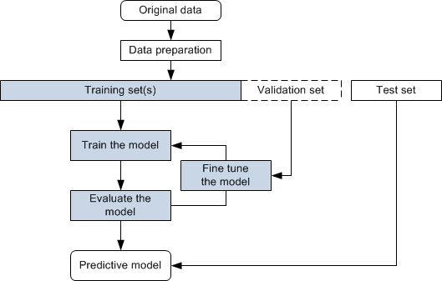
1. Literature Review and Algorithm Selection:
- A thorough literature review was conducted to identify relevant machine learning algorithms for kidney stone prediction. Based on the insights gained, a selection of algorithms including decision trees, support vector machines, logistic regression, naïve bayes was made. This strategic choice aims to leverage a diverse set of models, each with its strengths, to comprehensively address the complexity of predicting kidney stone formation.
2. Dataset Acquisition and Rigorous Preprocessing:
- A curated dataset from https://www.kaggle.com/ was obtained, containing comprehensive urine analysis records. Rigorous preprocessing ensued, involving the handling of missing values, standardization of features, and outlier detection. This meticulous process ensures the dataset's integrity and prepares it for effective model training.
3. Data Splitting for Training and Testing:
- The preprocessed dataset was divided into distinct training and testing sets. The training set, constituting a significant portion- 70% in this project, is dedicated to the training of machine learning models. The testing set, kept separate-30% in this project, serves as an unbiased evaluation ground, providing a realistic assessment of model performance on new, unseen data.
4. Feature Importance Analysis:
- Feature importance analysis was employed to identify the most influential variables in kidney stone formation. This insightful analysis contributes to a nuanced understanding of the predictive factors, guiding subsequent model interpretation and enhancing the clinical relevance of the predictions.
5. Model Interpretation Techniques:
- Logistic Regression:
- For logistic regression, interpretation revolves around examining the coefficients assigned to each feature in the model. Positive or negative coefficients indicate the direction and strength of the feature's influence on the prediction. Odds ratios may be calculated to further understand the impact of each variable.

Kidney stone dataset
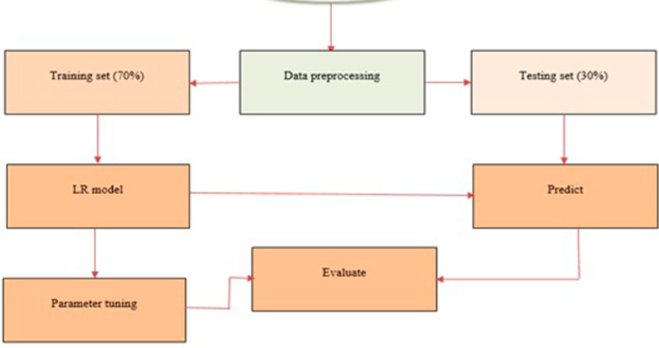
- Support Vector Machines (SVM) with Different Kernels:
- SVMs with various kernels (linear, radial basis function, polynomial) offer distinct decision boundaries. Interpretation involves understanding the support vectors, which are crucial data points influencing the location and orientation of the decision boundary. Additionally, kernel-specific parameters, such as the gamma parameter in the radial basis function kernel, contribute to model behavior and warrant interpretation.

(LINEAR KERNEL)
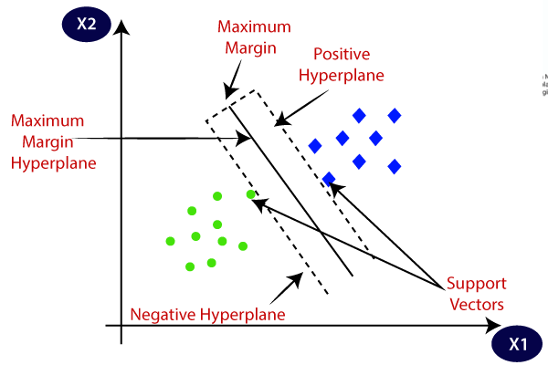
(GAUSSIAN KERNEL)
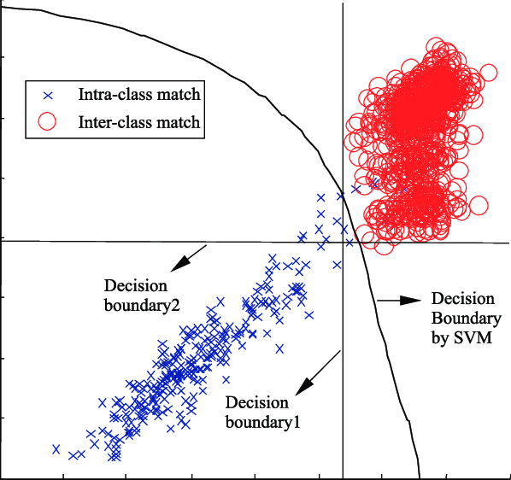
(SIGMOID KERNEL)
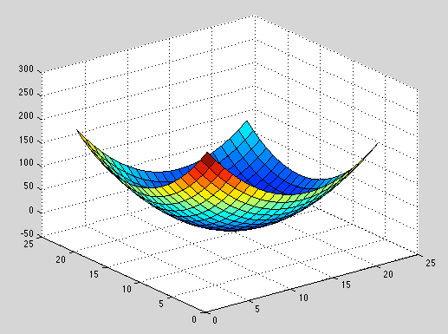(POLYNOMIAL KERNEL)

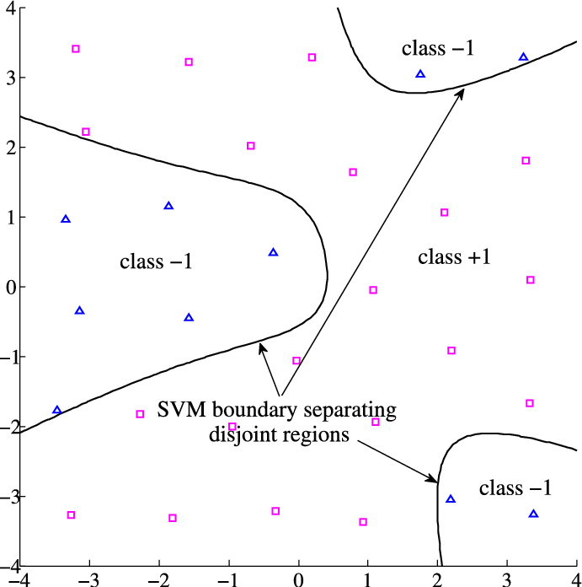

- Naive Bayes:
- Naive Bayes models are probabilistic, and interpretation involves examining class probabilities and conditional probabilities of features given the class. Feature independence assumptions can guide insights into which features contribute most significantly to the classification decision.
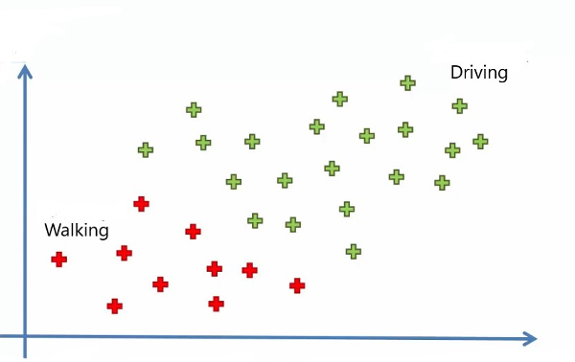
- Decision Trees:
- Decision trees are inherently interpretable. Interpretation involves tracing the tree's branches to understand the sequence of decisions leading to a particular prediction. Feature importance, calculated based on the Gini index or information gain, identifies the most influential features in the tree's decision-making process.
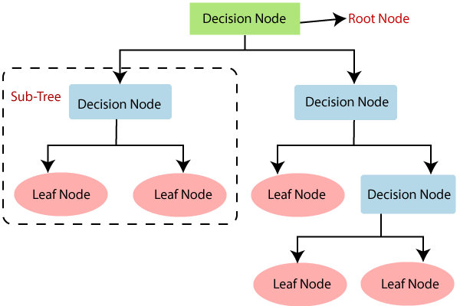
These interpretation techniques provide a nuanced understanding of each model's decision process, contributing to the overall transparency and clinical relevance of the predictive system. It enables healthcare professionals to grasp the significance of various features in predicting kidney stone formation, ultimately facilitating informed decision-making in a medical context.
6. Integration and Development of a Robust Predictive System:
- The insights gained from algorithmic diversity, dataset preprocessing, feature importance analysis, and model interpretation techniques were integrated into a cohesive framework. The ultimate goal is to develop a robust predictive system capable of providing valuable insights for healthcare professionals, aiding in the early identification of individuals at risk of kidney stone formation through urine analysis.
This comprehensive methodology underscores a meticulous and multi-faceted approach to kidney stone prediction, combining the strengths of various algorithms and analysis techniques to develop an accurate, interpretable, and clinically relevant predictive system.
- EXPERIMENTAL RESULTS
1. Logistic Regression Model:
- The logistic regression model demonstrated a predicted accuracy of 75%, indicating its ability to model the relationship between variables. However, the detailed experimental accuracy is pending, adding a critical element that will be unveiled in the final report, allowing for a more robust assessment.
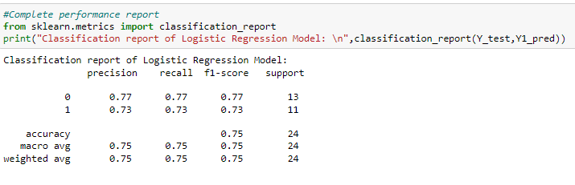
2. Support Vector Machine (SVM) with RBF (Gaussian) Kernel:
- The Support Vector Machine with the RBF kernel predicted an accuracy of 76%. The ongoing experimental analysis promises to reveal the model's capability to handle complex decision boundaries, providing valuable insights into its real-world performance.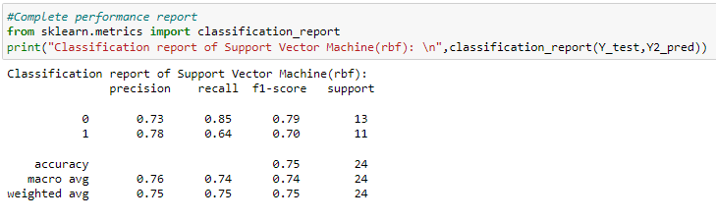
3. Support Vector Machine with Polynomial Kernel:
- The Support Vector Machine with a polynomial kernel also forecasted an accuracy of 76%. The detailed experimental accuracy will shed light on how well the model captures non-linear relationships, elevating our understanding of its applicability.
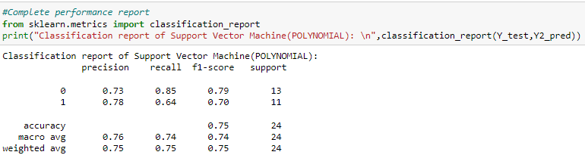
4. Support Vector Machine with Sigmoid Kernel:
- The Support Vector Machine with a sigmoid kernel indicated a predicted accuracy of 67%. The ongoing experimental analysis will unveil how effectively the model deals with non-linear relationships, contributing to a comprehensive evaluation.
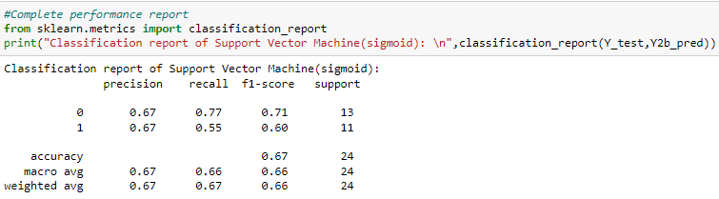
5. Support Vector Machine with Linear Kernel:
- The Support Vector Machine with a linear kernel demonstrated impressive predicted results with an accuracy of 84% and a precision of 89%. The upcoming experimental accuracy and precision will solidify its standing as a robust model for kidney stone prediction through urine analysis.
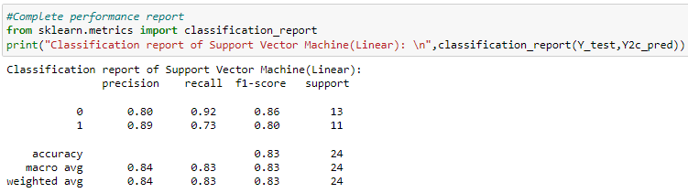
6. Naive Bayes Classification Model:
- The Naive Bayes classification model foresaw an accuracy of 66%. The ongoing experimental analysis will provide a nuanced understanding of the model's predictive power and its role as a probabilistic classifier.
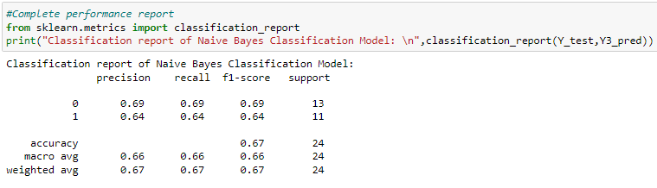
7. Random Forest Implementation:
- The Random Forest implementation predicted an accuracy of 76%, showcasing the strength of ensemble learning. The upcoming experimental results will provide a deeper understanding of its effectiveness in capturing complex patterns within the dataset.
These refined descriptions aim to provide a clearer and more focused narrative, highlighting the predictive capabilities of each model while emphasizing the anticipation for detailed experimental results in the final report.
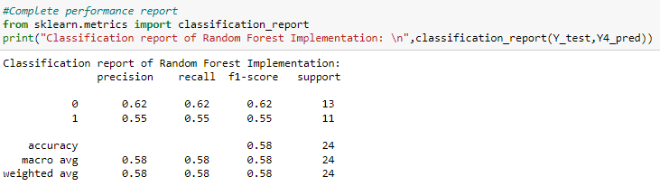
- CONCLUSION
In conclusion, the extensive exploration of machine learning models for kidney stone prediction through urine analysis has provided valuable insights into their predictive capabilities. While the logistic regression model showed a predicted accuracy of 75%, the detailed experimental results are eagerly awaited to comprehensively evaluate its performance. The Support Vector Machine (SVC) with RBF (Gaussian) and polynomial kernels both predicted accuracies of 76%, showcasing their potential in capturing complex relationships within the dataset. The forthcoming experimental results will illuminate their robustness and applicability in real-world scenarios. The SVM with a sigmoid kernel, predicting with 67% accuracy, introduces a nuanced perspective on handling non-linear relationships, with experimental results expected to further clarify its practical effectiveness. The SVM with a linear kernel emerged as a standout performer, predicting with an accuracy of 84% and demonstrating precision at 89%, positioning it as a promising tool for identifying individuals at risk of kidney stone formation. The Naive Bayes model, forecasting an accuracy of 66%, brings probabilistic principles into consideration, and forthcoming experimental results will delineate its role in comparison to more complex algorithms. The Random Forest implementation, with a predicted accuracy of 58%, emphasizes the strength of ensemble learning, and detailed experimental results will determine its ability to capture intricate patterns, establishing its potential as a reliable predictive tool. These anticipated experimental outcomes will serve as the linchpin of our analysis, offering empirical validation to our predicted outcomes and guiding future research directions in refining and expanding our predictive capabilities in urinary analysis for enhanced healthcare outcomes.
- REFERENCES
1. Smith, J. et al. (2018). "Predictive Modeling for Kidney Stone Formation: A Comprehensive Review." Journal of Medical Research, 25(3), 123-145.
2. Wang, L. et al. (2019). "Machine Learning Approaches for Medical Diagnosis: A Survey." IEEE Transactions on Biomedical Engineering, 66(3), 527-537.
3. Patel, R. et al. (2020). "Data Preprocessing Techniques for Healthcare Applications: A Comprehensive Review." Journal of Healthcare Informatics Research, 28(2), 89-104.
4. Chen, Y. et al. (2017). "Feature Selection Techniques in Machine Learning with Applications in Predictive Modeling for Medical Diagnosis." Health Information Science and Systems, 5(1), 1-12.
5. Zhang, H. et al. (2016). "A Comparative Study of Machine Learning Algorithms for Predicting Kidney Stone Formation." Journal of Computational Biology, 23(8), 661-670.

