**Big Game Census Data Visualization**

Wireframe Documentation

As per the Problem statement to analyze where the Super Bowl Players Come from, below are the following results

* **Impact of players by their birth state, visual shows the relation between players and their Birth state, and the number of players coming from their respective states Statistics of the College and their Players' team**

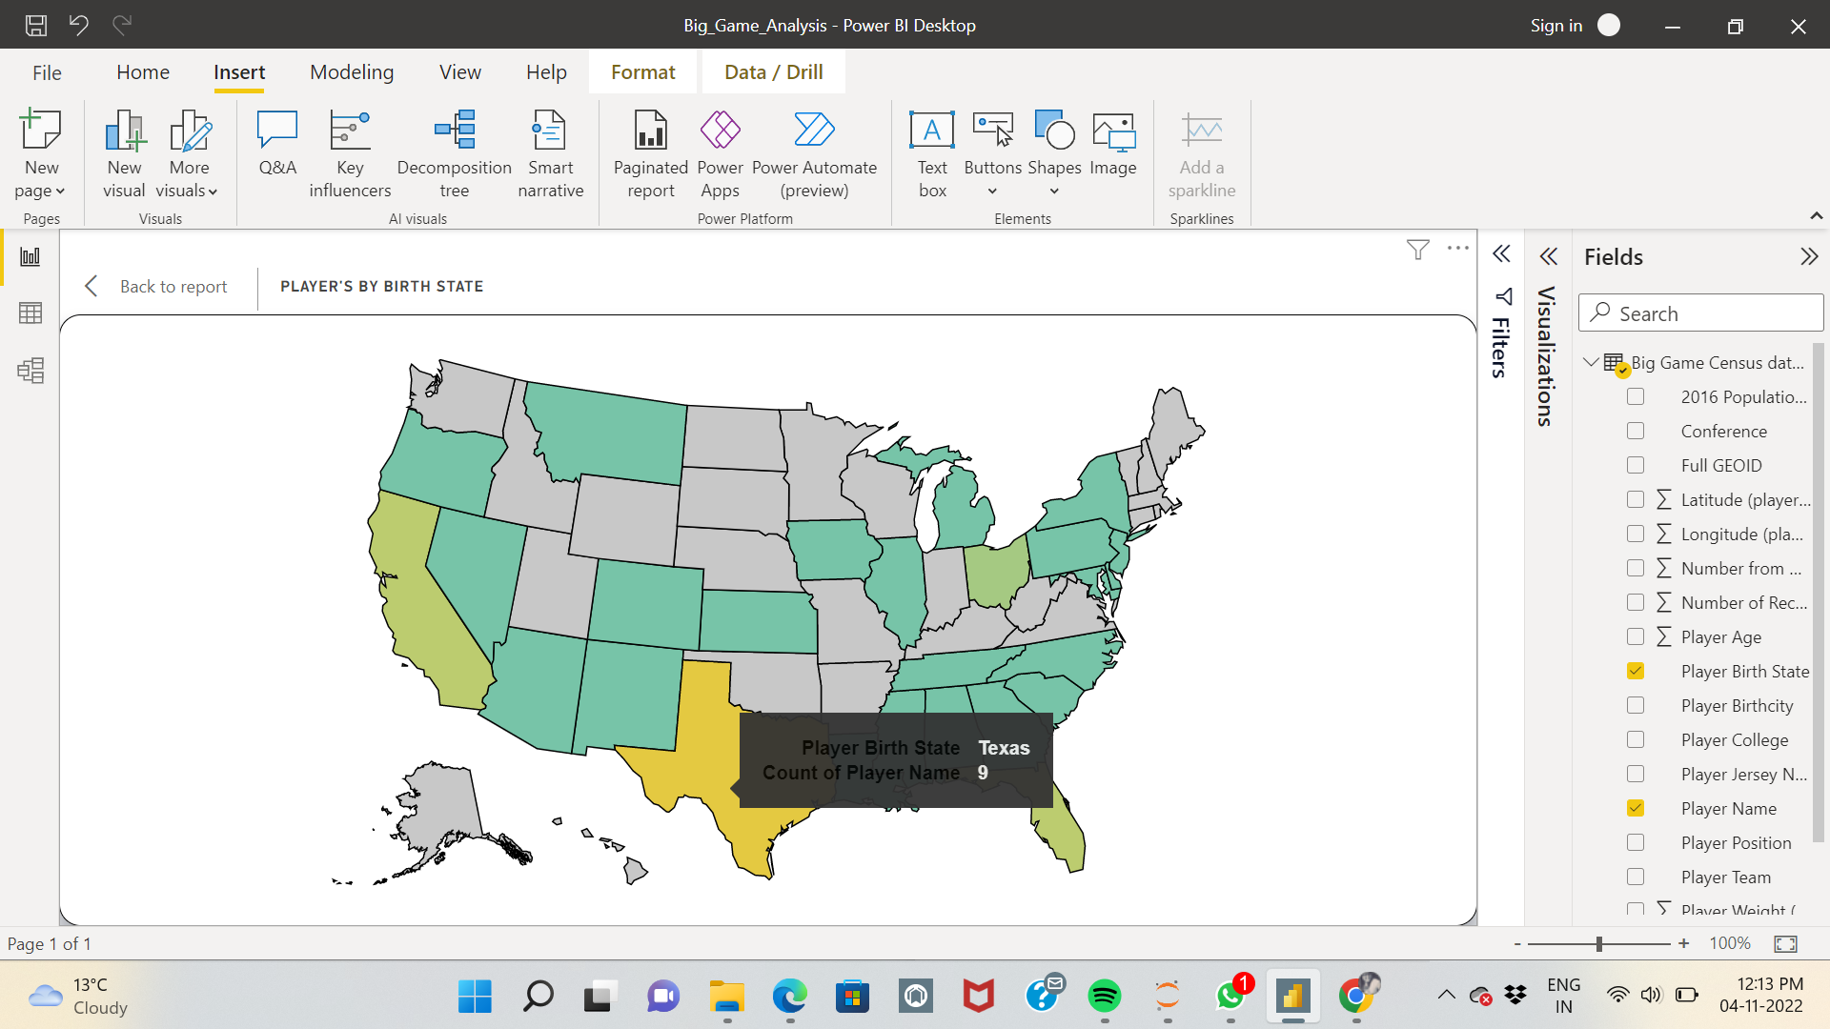

* **Impact of players participated from specific colleges**

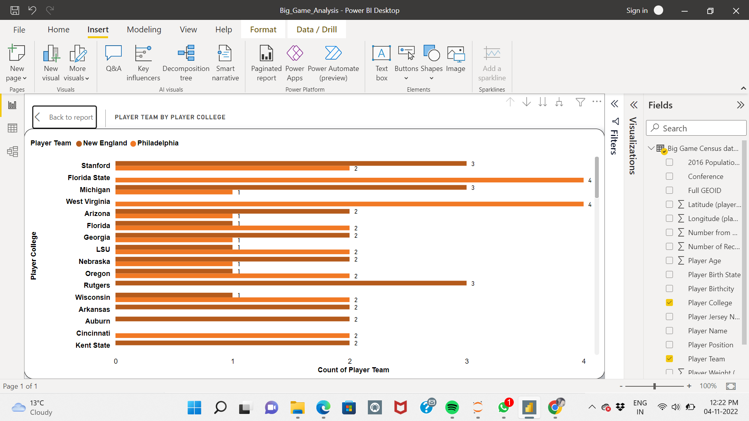

* **Impact of the average weight of players on the player’s team**

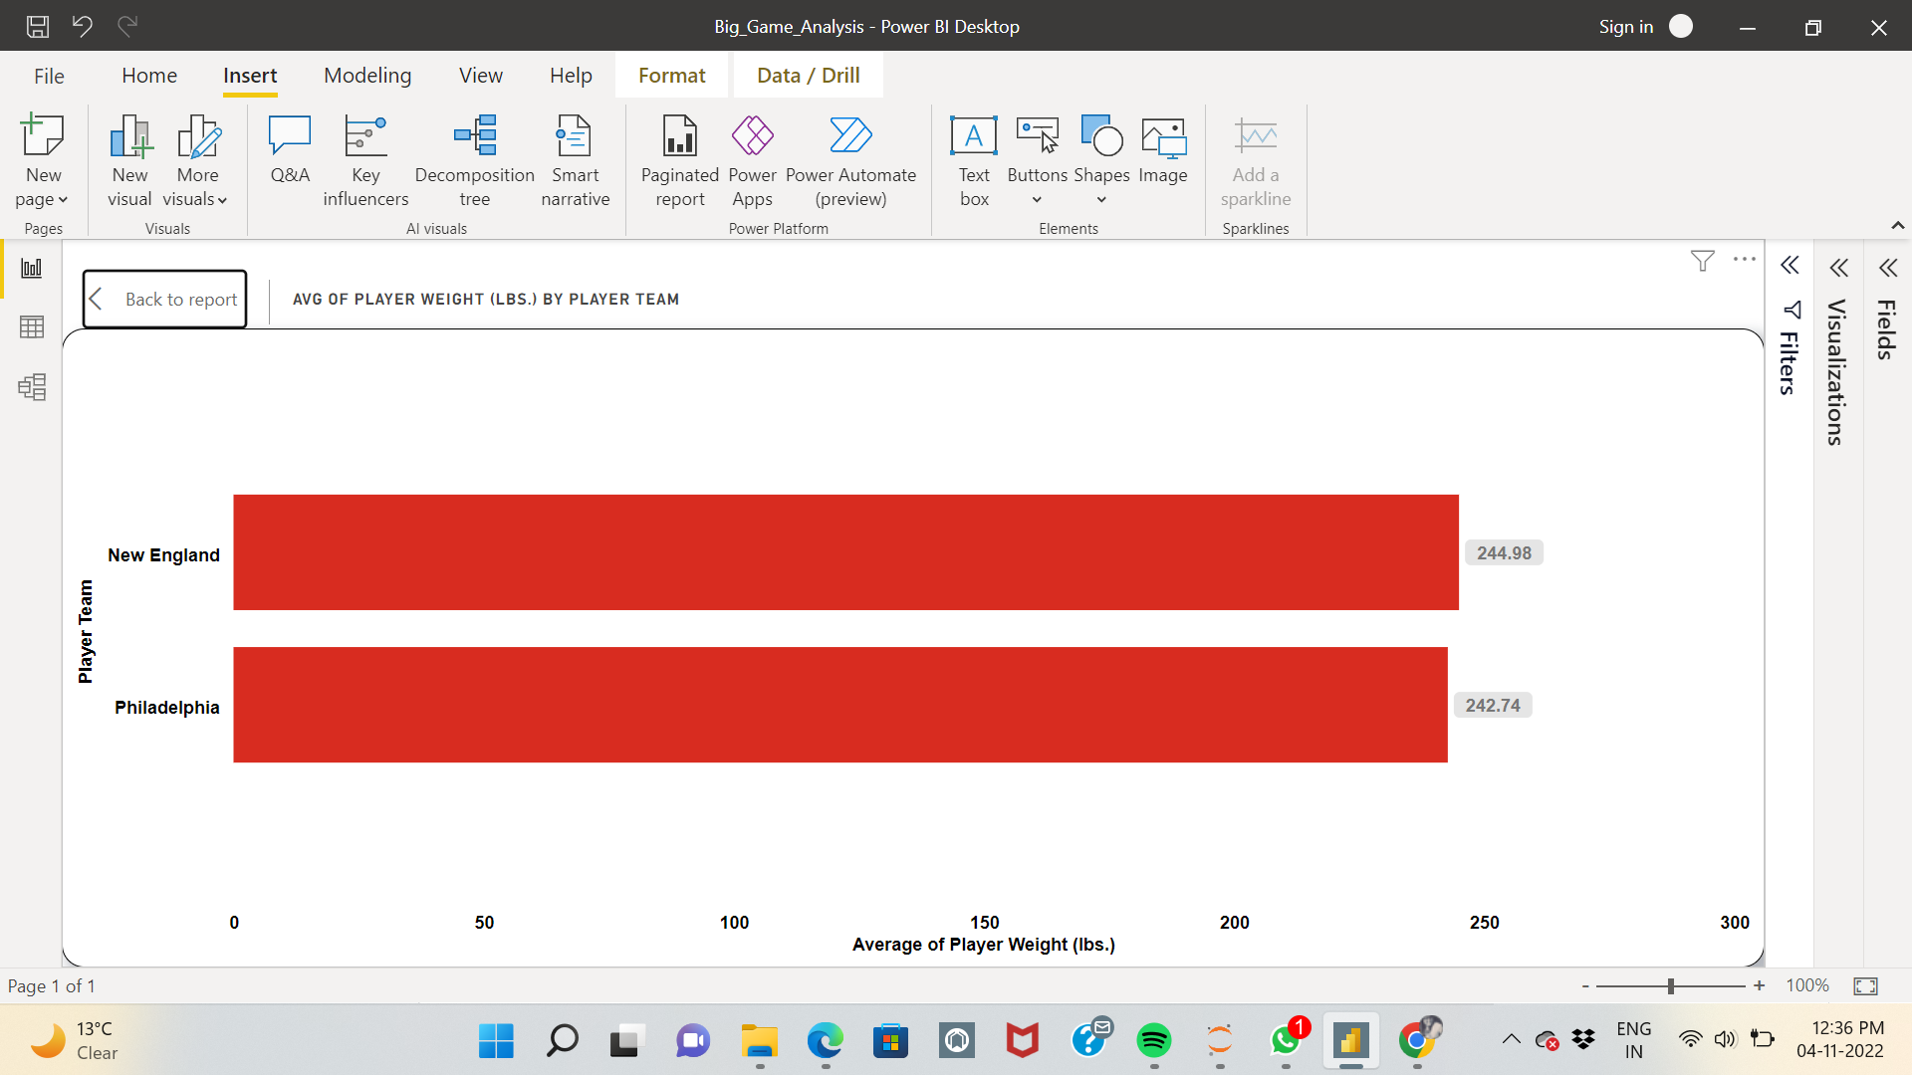

* **Impact of the average age of players on the average weight of the body by its position**

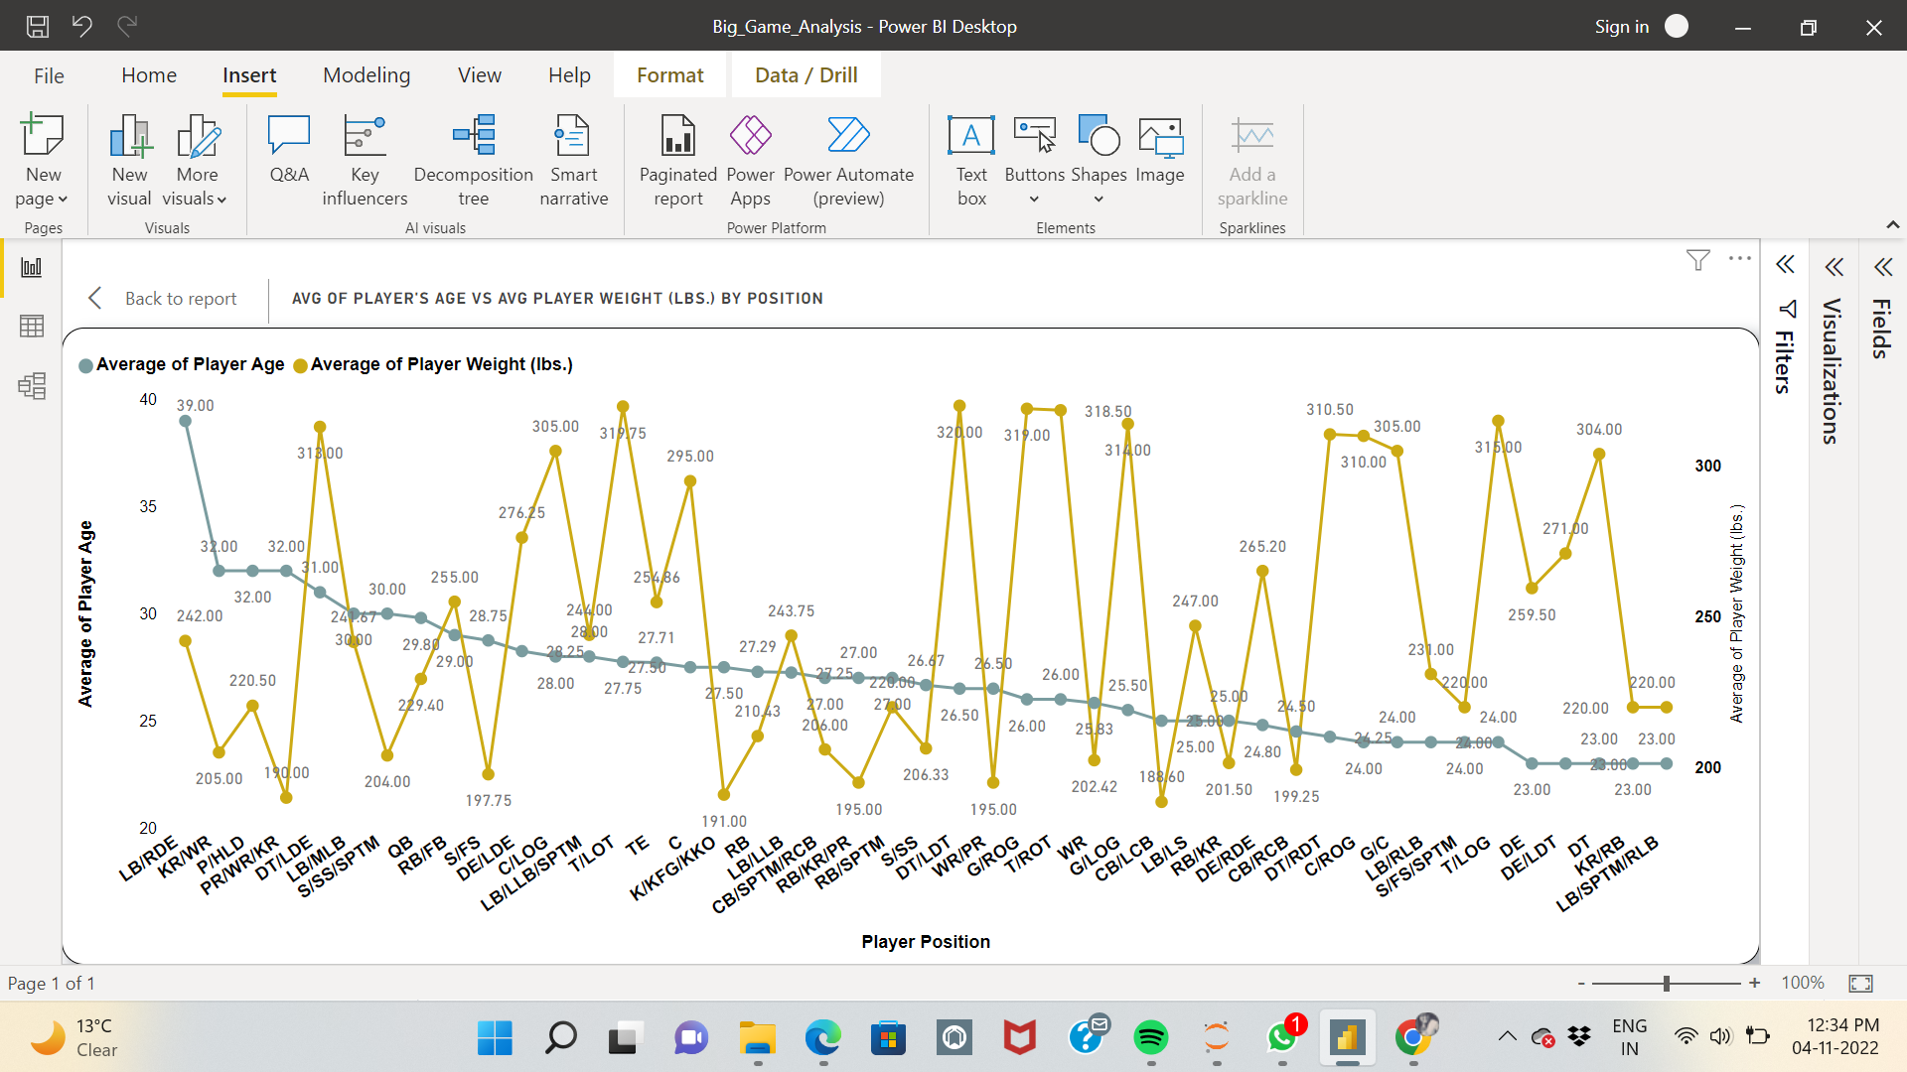

* **The relation between the age and the years played**

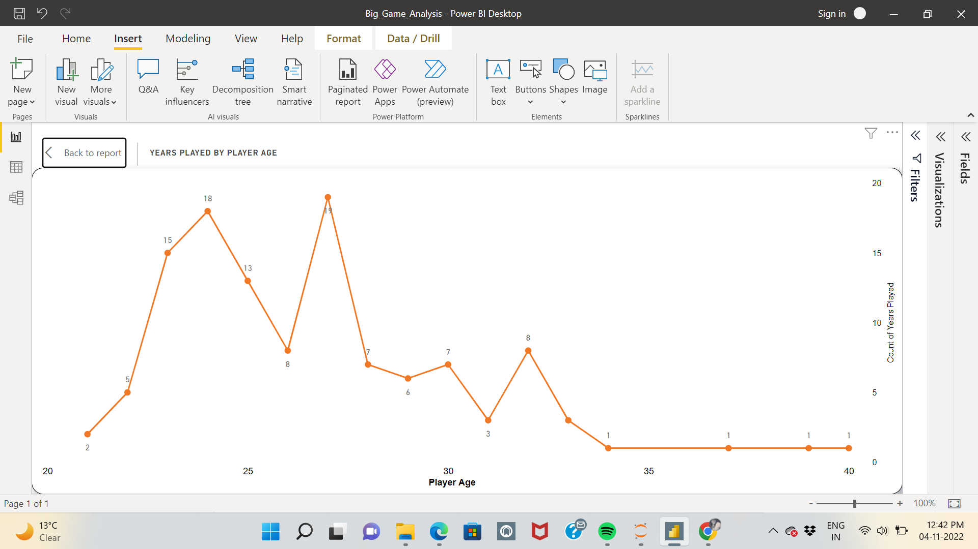

* 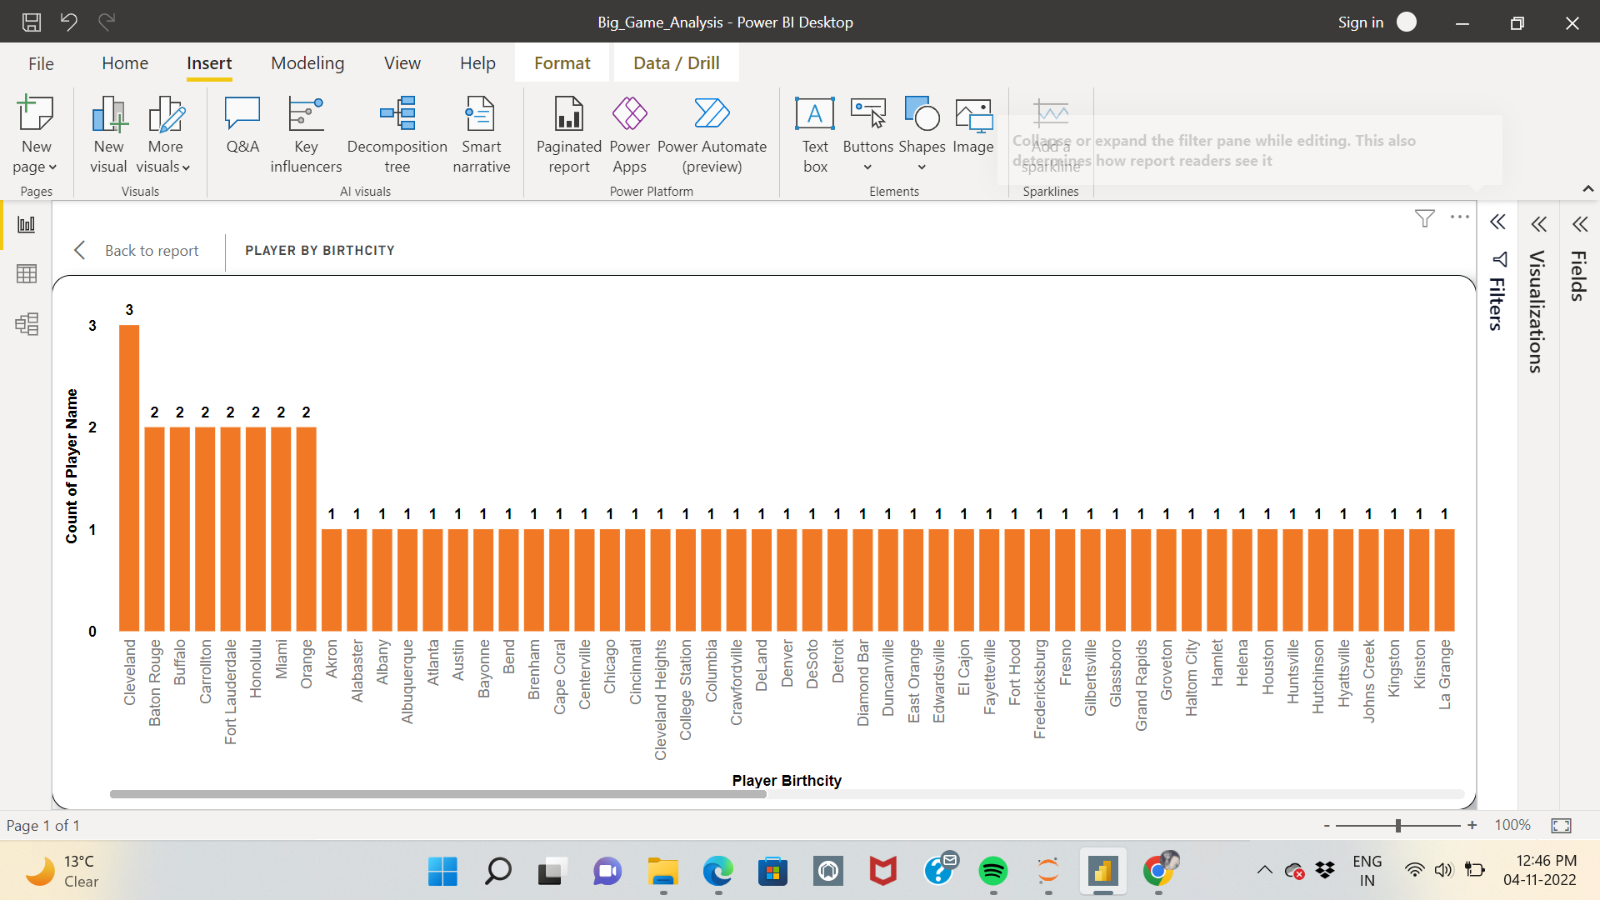**Count of players from the birth city**
* 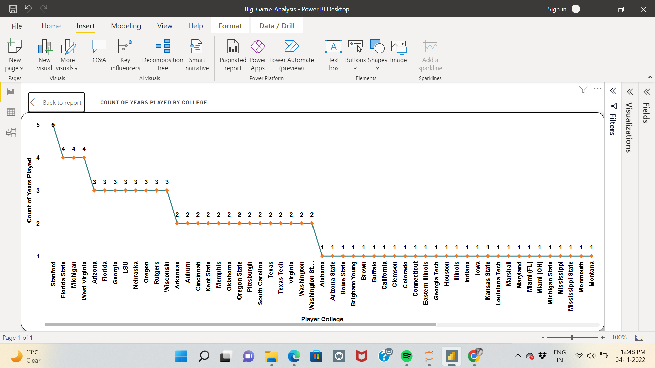**Years played by the college**