# **Flutter Assignment**

**Assignment : Image Assignment**

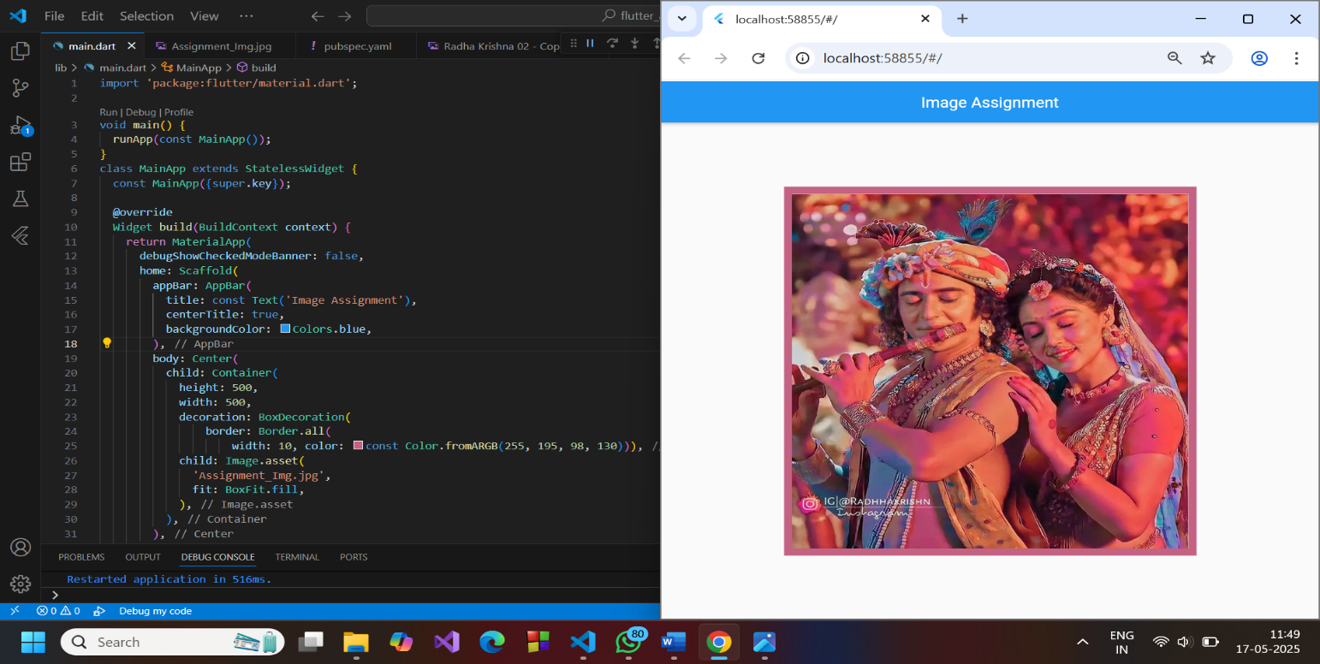

**Assignment : Cake Assignment**

