**Basic Linux Commands**

**ls command:** ls command is used to list all the files and directories in the current working directory.

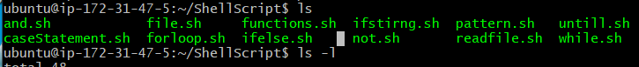

**ls –l:** this coands lst all the files and directories with detailed information such as owner, group, permissions, and time.

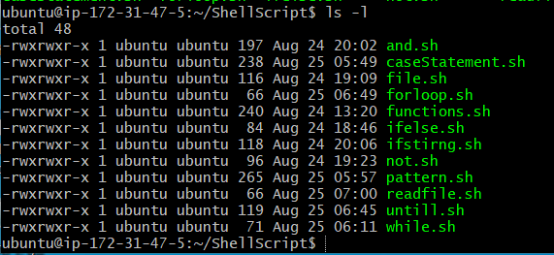

**ls –a:** lists all the hidden files and directories as well.



ls –i: list the files and directories with index number in order

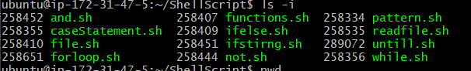

**ls –d */:** list only the directories



**pwd :** it shows the present working directory

**mkdir directoryname: creates** a directory in current working directory

**mkdir .directory:** creates a hidden folder in the current directory

**mkdir dir1 dir2 dir3:** to create multiple directories

**mkdir folder/new/file:** to create directory in a specific location

**mkdir –p folder/new/file:** to create nested directories