**ADVANCE SQL & JDBC ASSIGNMENT**

**Q-1 Find all employees whose Employee name ends with 'N'. List the**

**employee number, the Employee name, and the last character of the Employee name.**

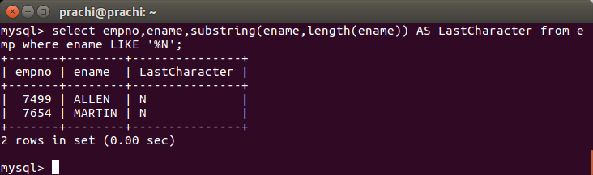

**Q-2 Write a procedure to increment the sallary of employee who works in sales department**

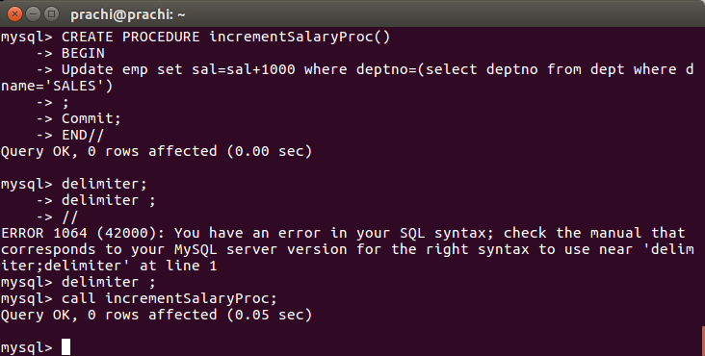

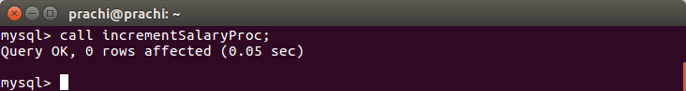

**Q-3 Write a function to find the total salary of employees, who works in Accounts department**

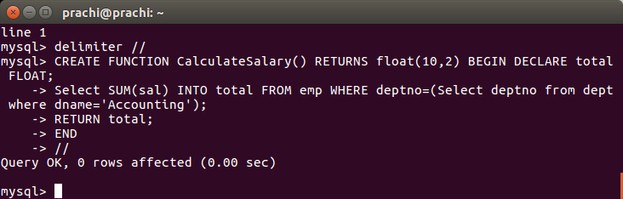

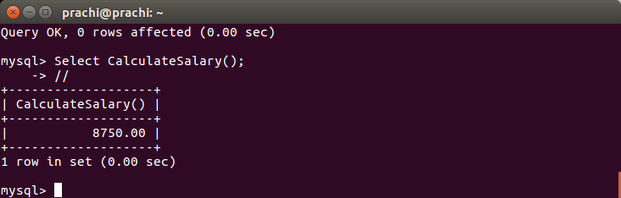

**Q-4 Create a new table for keeping transaction records,record will be updated in this table when there is deduction in the salary,when salary is deducted a trigger is executed which insert employee name ,updatedby , changedsalary, updateddate in new table.**

