Q1 Create Database

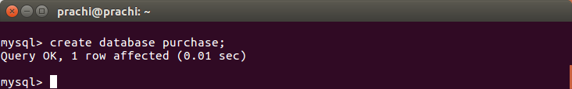

Q2 Design Schema

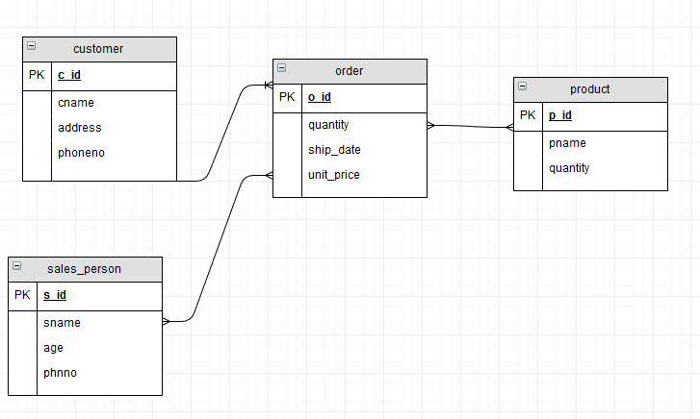

Q3 Create tables





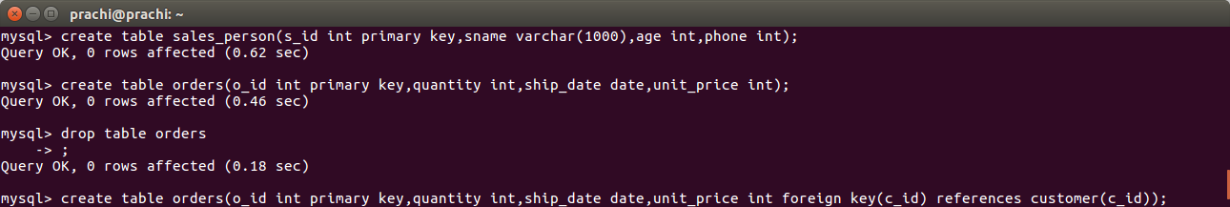

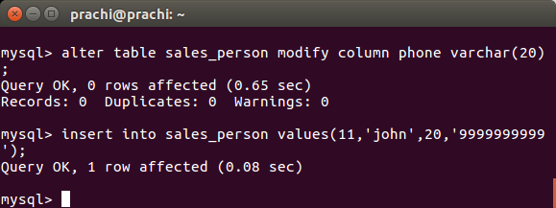

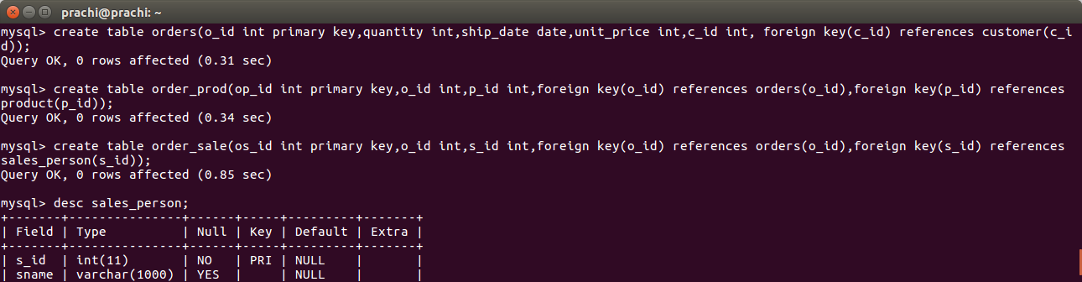

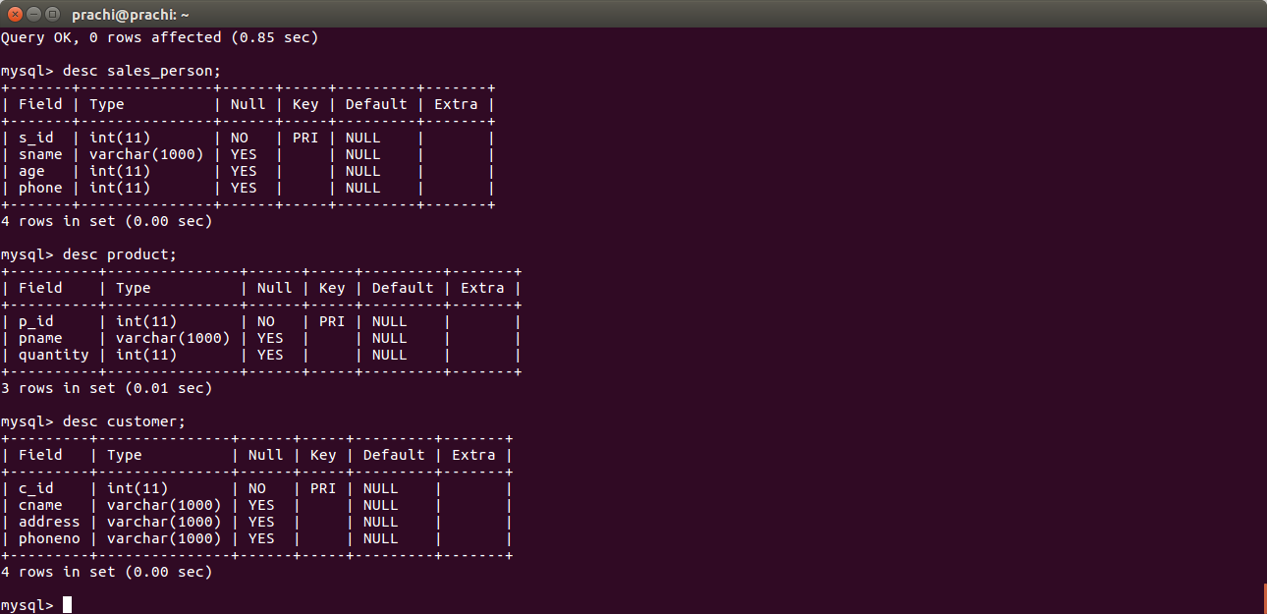

Q4 Insert sample data.

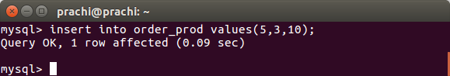

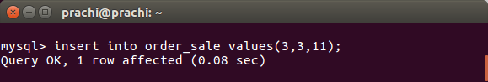

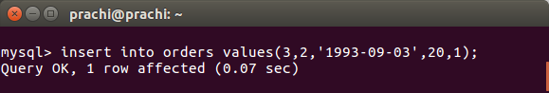

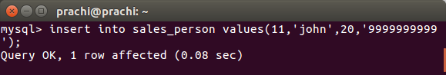

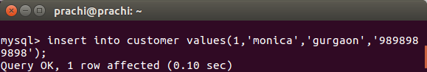

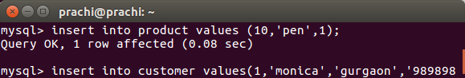

Q5 Find the sales person have multiple orders.

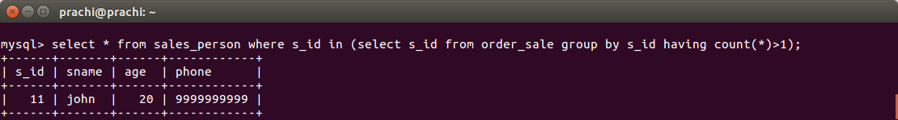

Q6 Find the all sales person details along with order details

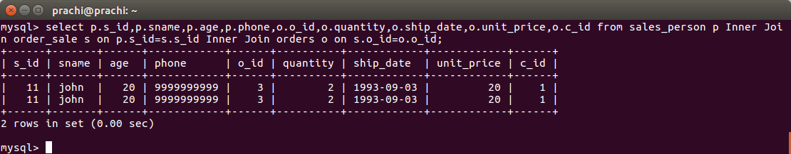

Q7 Create index

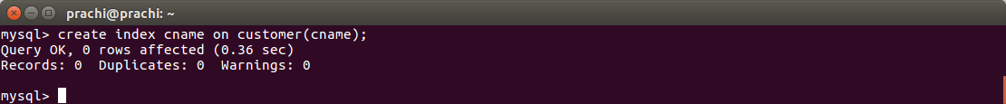

Q8. How to show index on a table.

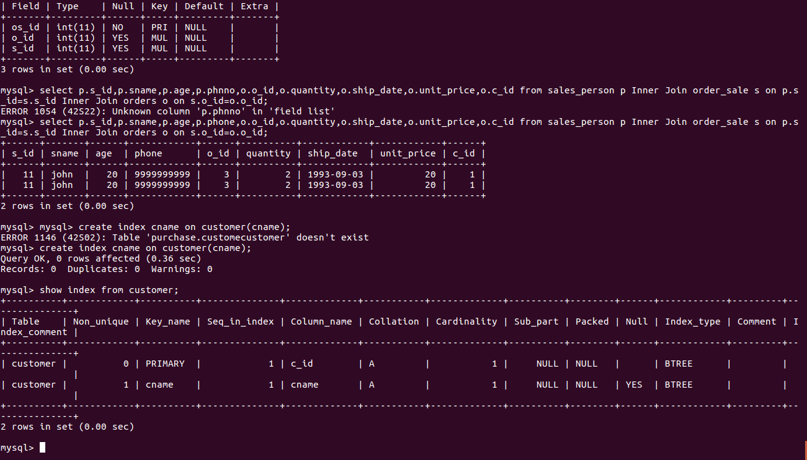

Q9. Find the largest order amount for each salesperson and the associated order number, along with the customer to whom that order belongs to.  
