**Q1 Create a directory "exercise" inside your home directory and create nested(dir1/dir2/dir3) directory structure inside "excerise" with single command.**

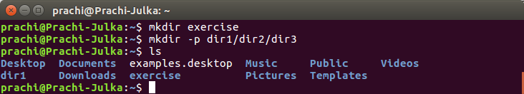



**Q2 Create two empty files inside dir2 directory: emptyFile1,emptyFile2 in single command**

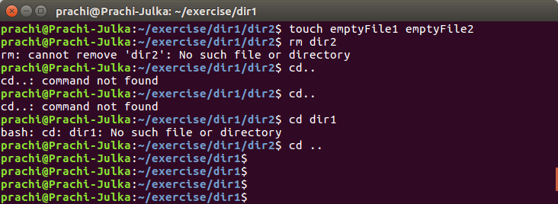



**Q3 Create one file file1.txt containing text "hello world" and save it.**

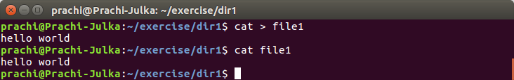

**Q4 Find a "passwd" file using find command inside /etc. copy this files as passwd_copy and then rename this file as passwd_backup.**

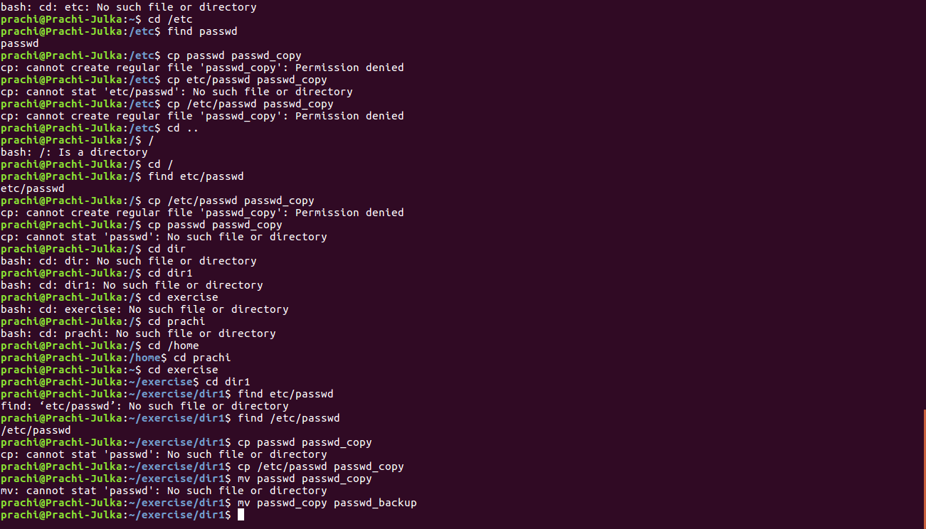

**Q5 Try reading passwd_backup file in multiple tools: less,more,cat,strings etc and find the difference in their usage.**

Less

a) You can navigate the page up/down using the less command and not possible in more command.

b) You can search a string in less command. (use /keywordto search)

c) “more” was fairly limited, and additional development on “more” had stopped

d) it uses same functions as vi editor

the usage : **less filename**

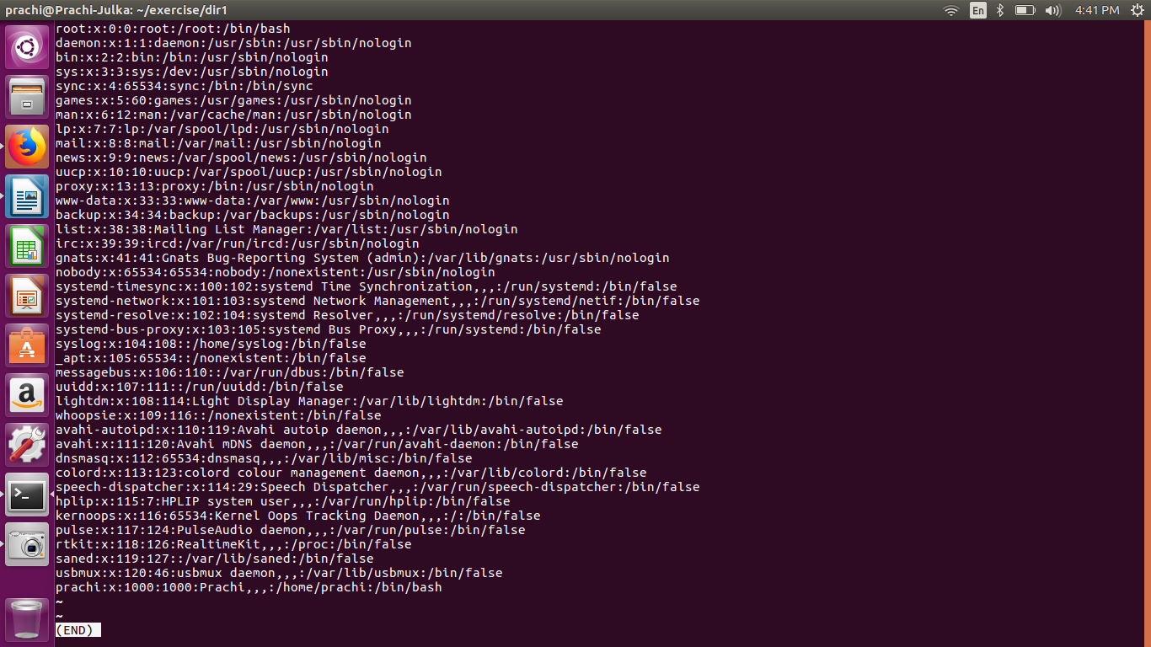

More

to view a text file one page at a time, press spacebar to go to the next page

**more *filename :*** show the document one page at a time

**more -num filename** : show the document page few lines as specified bu (-num)

example : **more -10 filename** will show 10 lines for every page

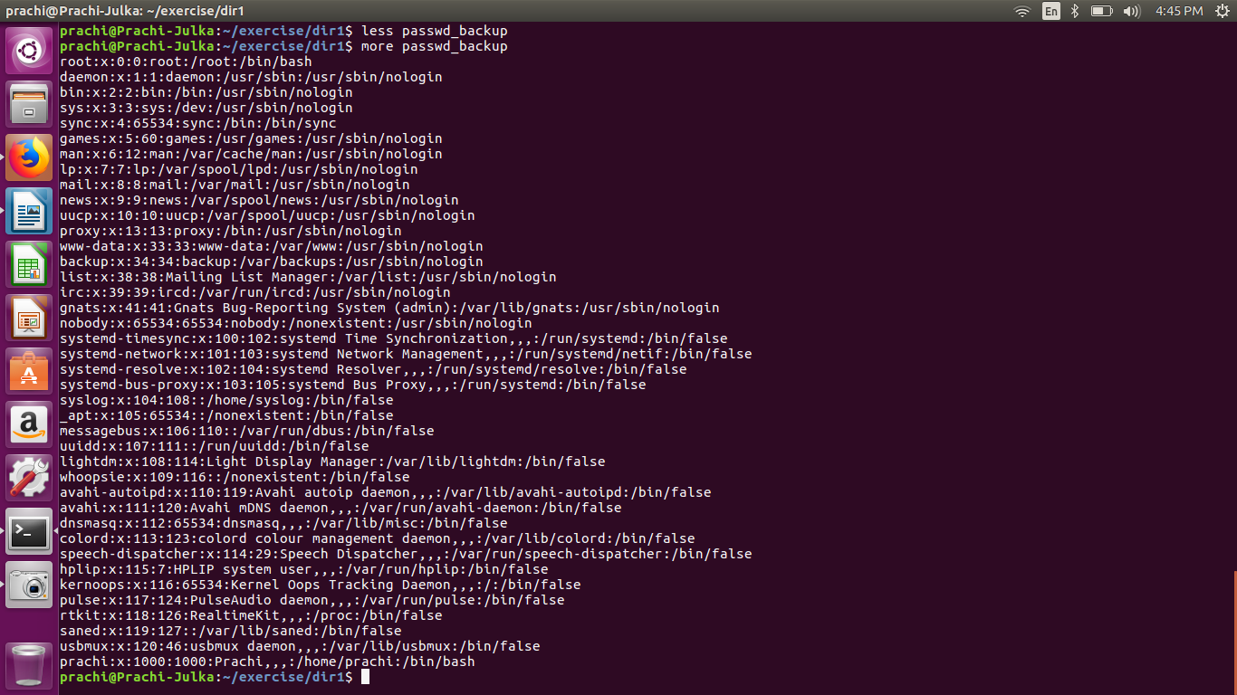

Strings

Using strings command, you will be able to view all the printable strings from the binary file.

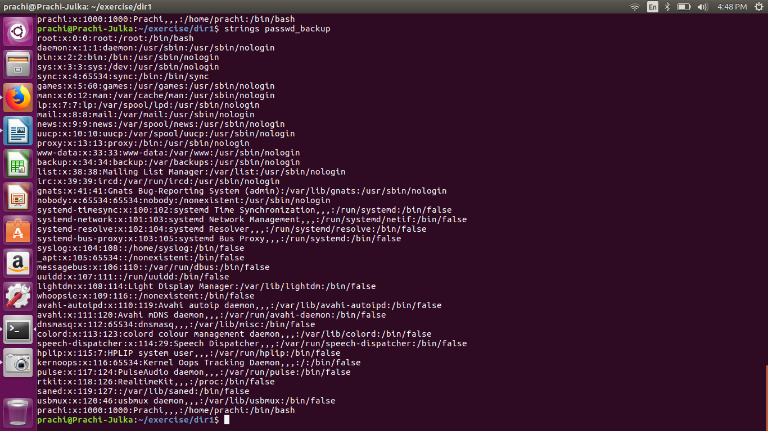

Cat backup

can be used to join multiple files together and print the result on screen (it will not show page by page)

usage:

**cat 01.txt**

to displat the contents of file 01.txt

**cat 01.txt 02.txt**

to display the contents of both files

**cat file1.txt file2.txt** > file3.txt – Reads file1.txt and file2.txt and combines those files to make

**cat note5 >> notes** – attach note5 to notes

**cat >> file1** – add additional data in file1

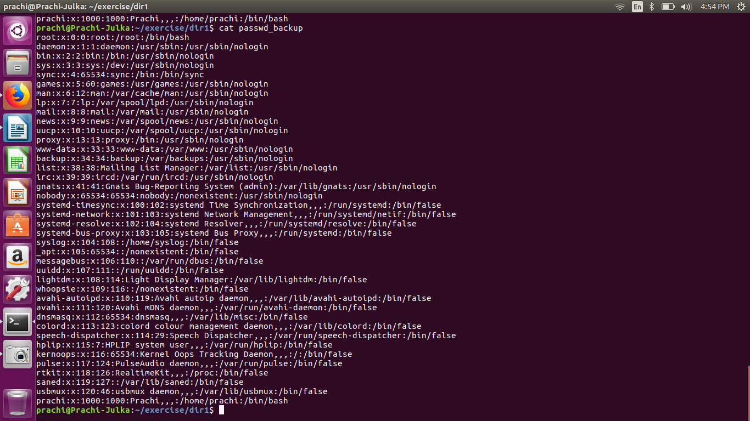

**Q6 Find out the number of line in password_backup containing "/bin/false".**

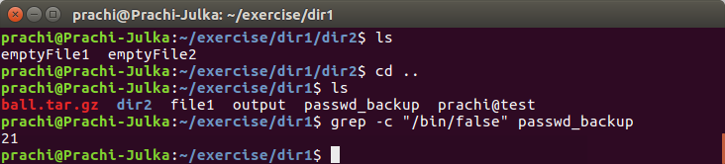

**Q-7 Get the first 5 lines of a file “password_backup” and Redirect the output of the above commands into file "output".**

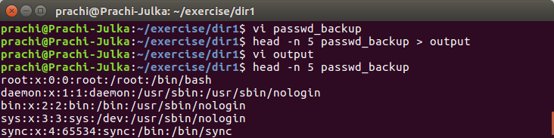

**Q8 Create a "test" user,create its password and find out its uid and gid.** 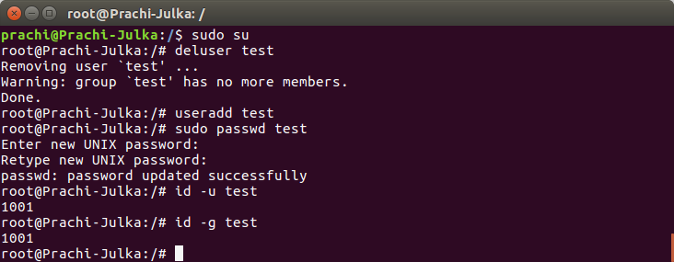

**Q 9 Change the timestamp of emptyFile1,emptyFile2 which are exist in dir2**



**Q10 Login as test user and edit the "output" file created above. Since the permission wont allow you to save the changes. Configure such that test user can edit it.**

**10.1 Add group owner of the "output" file as the secondary group of testuser and check/change the "output" file permission if it is editable by group. Once done revert the changes**

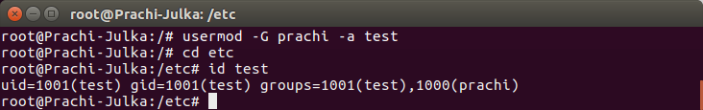

**10.2 Make the file editable to the world so that test user can access it. Revert the changes after verification**

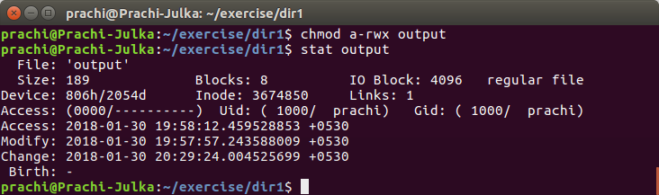**10.3 Change the ownership to edit the file.**

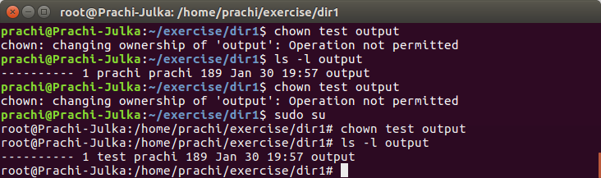

**Q11 Create alias with your name so that it creates a file as "/tmp/aliastesting".**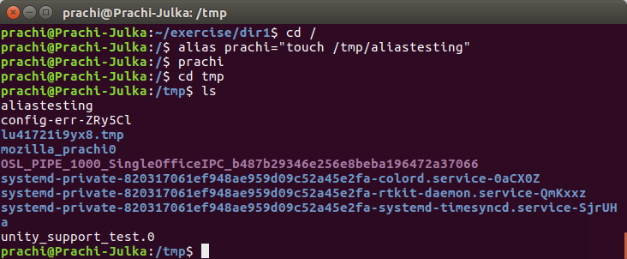

**Q12 Edit ~/.bashrc file such that when you change to "test" user it should clear the screen and print "Welcome".**

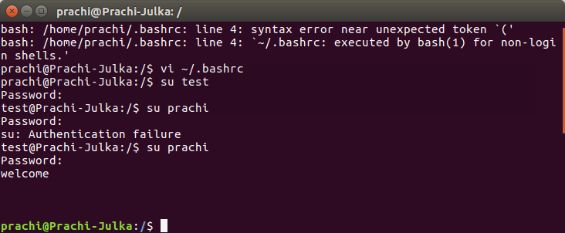

**Q13 Install “zip” package.**

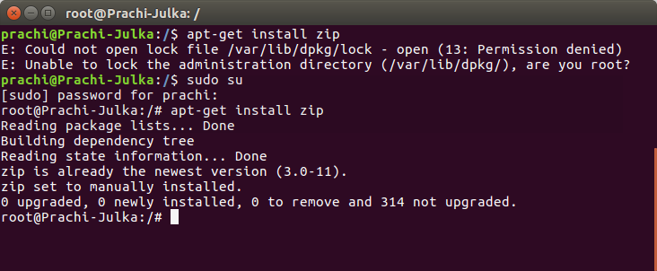

**Q14 Compress "output" and "password_backup" files into a tar ball. List the files present inside the tar created.**

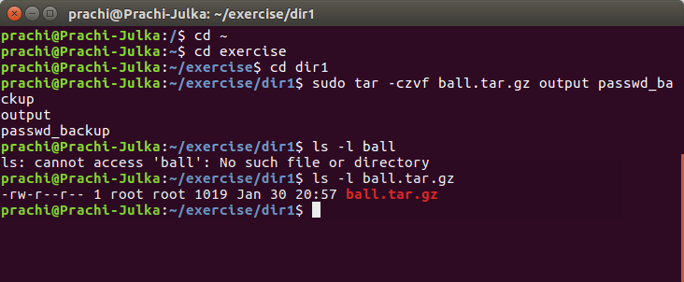

**Q15 scp this file to test user**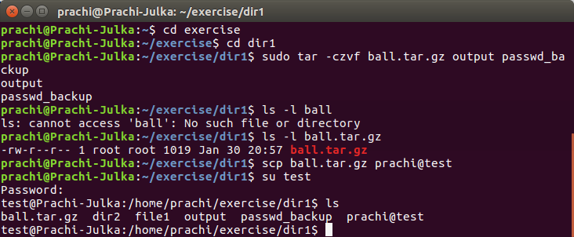

**Q16 Unzip this tar bar by logging into the remote server**



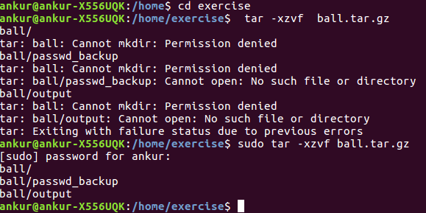

**Q17 Download any image from web and move to desktop**

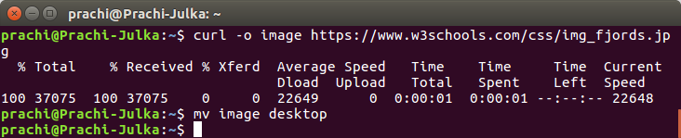

**Q18 How to get help of commands usages.**

Command:- man ls

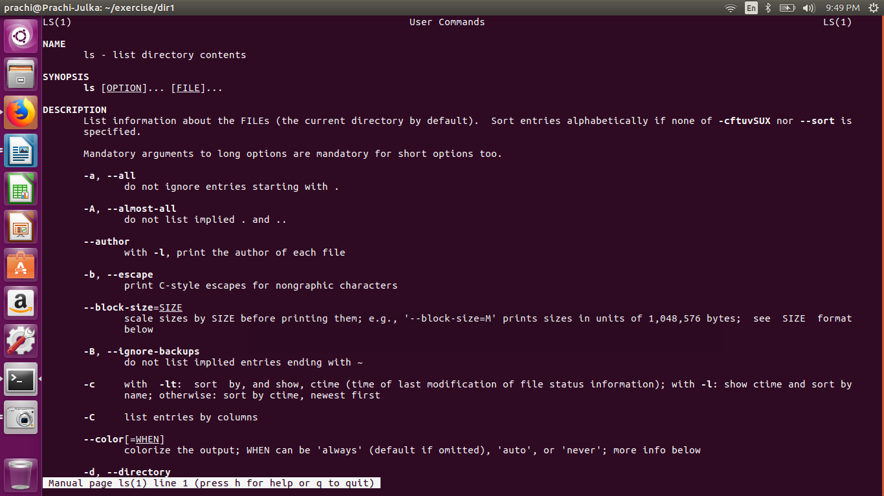

**Q19 Create a symlink of /etc/services into /tmp/ports-info** 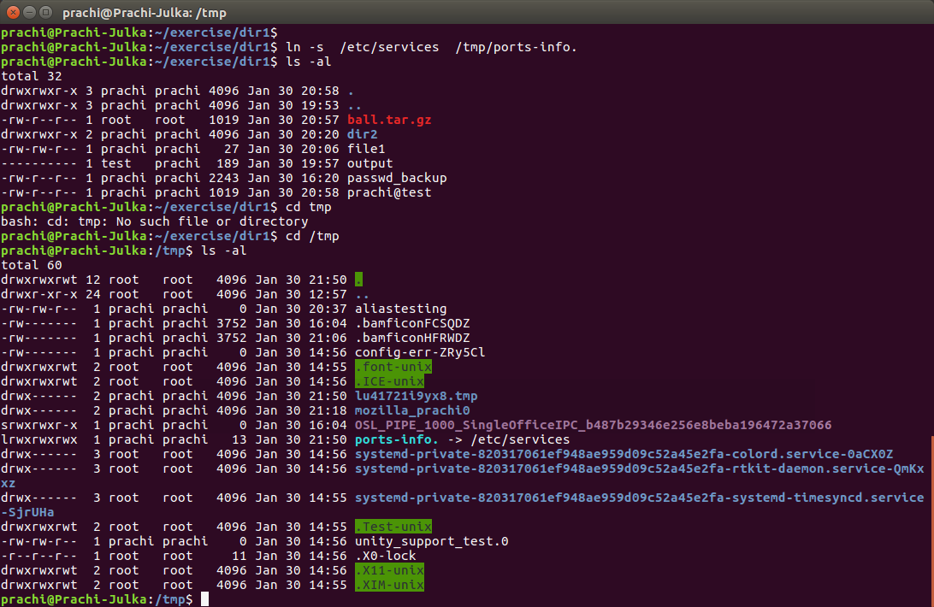

**Q20. You are appointed as a Software/DevOps Engineer in ABC media services. On your first day you need to troubleshoot a problem. There is a command “xyz” somewhere installed in that linux system. But as a new joinee you do not have any idea about where is that Installed. How can you check that?**

