**JAVA CORE ASSIGNMENT**

*Q1.* **Write a program to replace a substring inside a string with other string.**

***public class Q1 {***

***public static void main(String[] args) {***

***ReplaceString replaceString=new ReplaceString();***

***replaceString.replace();***

***}***

***}***

***class ReplaceString{***

***void replace(){***

***Scanner sc=new Scanner(System.in);***

***System.out.println("Enter a String");***

***String str=sc.nextLine();***

***System.out.println("Enter a String to replace");***

***String str1=sc.nextLine();***

***System.out.println("Enter a String to add");***

***String str2=sc.nextLine();***

***str=str.replace(str1, str2);***

***System.out.println(str);***

***}***

***}***

***Output:***

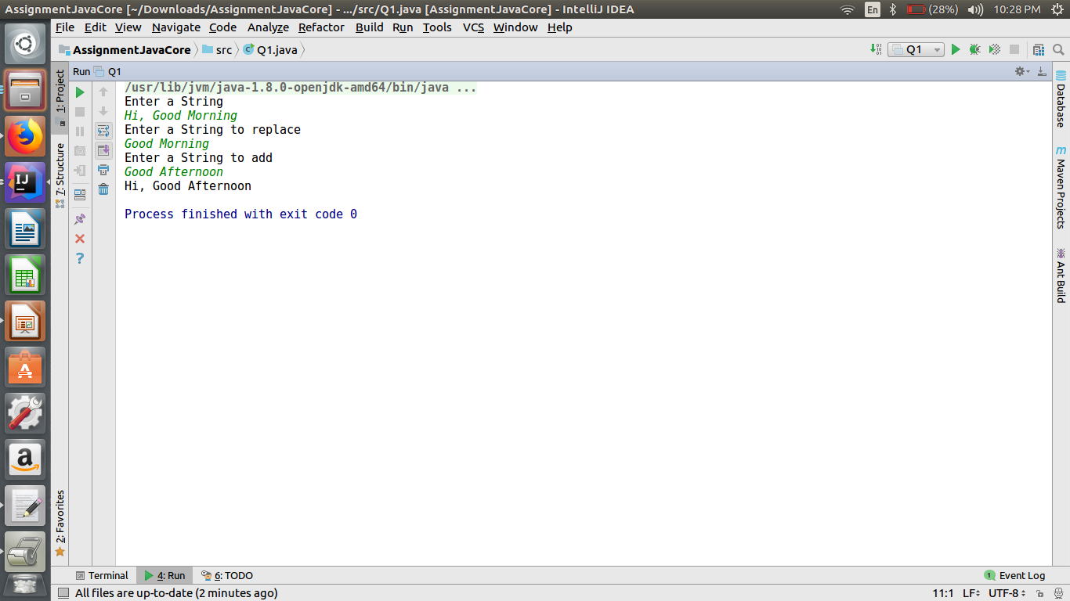

**Q-2 Write a program to find the number of occurrences of the duplicate words in a string and print them ?**

**import java.util.Scanner;**

**public class Q2 {**

**public static void main(String[] args){**

**FindDuplicateWord findDuplicateWord=new FindDuplicateWord();**

**findDuplicateWord.getDuplicateWords();**

**}**

**}**

**class FindDuplicateWord{**

**Scanner sc = new Scanner(System.*in*);**

**void getDuplicateWords() {**

**String str;**

**System.*out*.println("Enter a String");**

**str = sc.nextLine();**

**int count;**

**String key = null;**

**String[] str1 = str.split(" ");**

**boolean[] flag = new boolean[str1.length];**

**for (int i = 0; i < flag.length; i++) {**

**flag[i] = true;**

**}**

**for (int i = 0; i < str1.length; i++) {**

**count = 1;**

**if (flag[i] == true) {**

**if (str1[i].matches("^\\s*$")) {**

**continue;**

**} else {**

**key = str1[i];**

**flag[i] = false;**

**for (int j = i + 1; j < str1.length; j++) {**

**if (str1[i].equals(str1[j]) && flag[j] == true) {**

***//key=str1[i];***

**flag[j] = false;**

**count++;**

**} else {**

**continue;**

**}**

**System.*out*.println("Word " + key + " Occurence " + count);**

**}**

**}**

**}**

**}**

**}**

**}**

**OUTPUT:-**

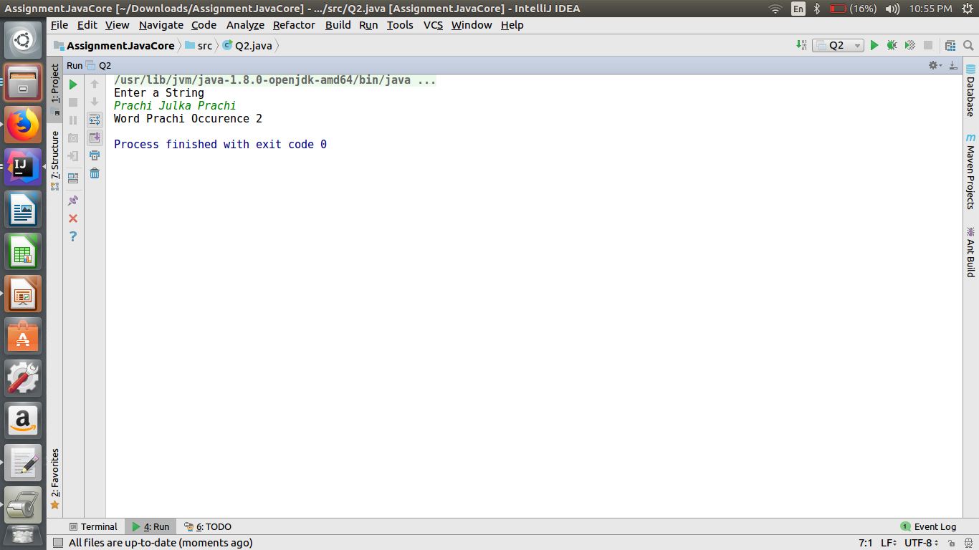

**Q-3 Write a program to find the number of occurrences of a character in a string without using loop.**

**import java.util.Scanner;**

**public class Q3 {**

**public static void main(String[] args) {**

**Q3 obj=new Q3();**

**Scanner sc = new Scanner(System.*in*);**

**char c;**

**System.*out*.println("Enter a String");**

**String str = sc.nextLine();**

**System.*out*.println("Enter a character to count");**

**c = sc.next().charAt(0);**

**int total = obj.charcterCount(str, c, 0, 0);**

**System.*out*.println("Number of times the character occurs:" +total);**

**}**

**int charcterCount(String str, char c, int start, int count) {**

**if (start == str.length()) {**

**return count;**

**}**

**else {**

**if (c == str.charAt(start)) {**

**count++;**

**}**

**start++;**

**return (charcterCount(str, c, start, count));**

**}**

**}**

**}**

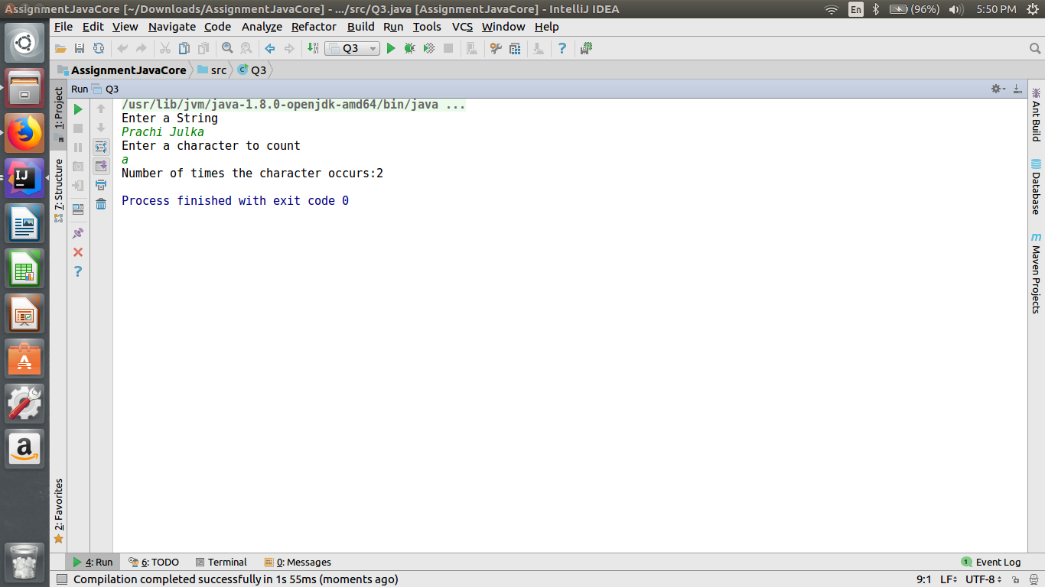

**Q-4 Calculate the number & Percentage Of Lowercase Letters,Uppercase Letters, Digits And Other Special Characters In A String.**

public class Q4 {

String str;

void checkString(){

System.*out*.println("Enter String");

Scanner sc=new Scanner(System.*in*);

str=sc.next();

int lower=0,upper=0,digit=0,special=0;

float size=str.length();

for(int i=0;i<size;i++){

if(Character.*isLowerCase*(str.charAt(i))){

lower++;

}

else if(Character.*isUpperCase*(str.charAt(i))){

upper++;

}

else if(Character.*isDigit*(str.charAt(i))){

digit++;

}

else{

special++;

}

}

System.*out*.println("Total UpperCase Character: "+upper);

System.*out*.println("Total LowerCase Character: "+lower);

System.*out*.println("Total Digit Character: "+digit);

System.*out*.println("Total Special Character: "+special);

System.*out*.println("Percentage of Uppercase Character "+(upper/size)*100 );

System.*out*.println("Percentage of Lowercase Character "+(lower/size)*100 );

System.*out*.println("Percentage of Digits"+(digit/size)*100 );

System.*out*.println("Percentage of Special Character "+(special/size)*100 );

}

public static void main(String[] args) {

Q4 obj=new Q4();

obj.checkString();

}

}

**OUTPUT:-**

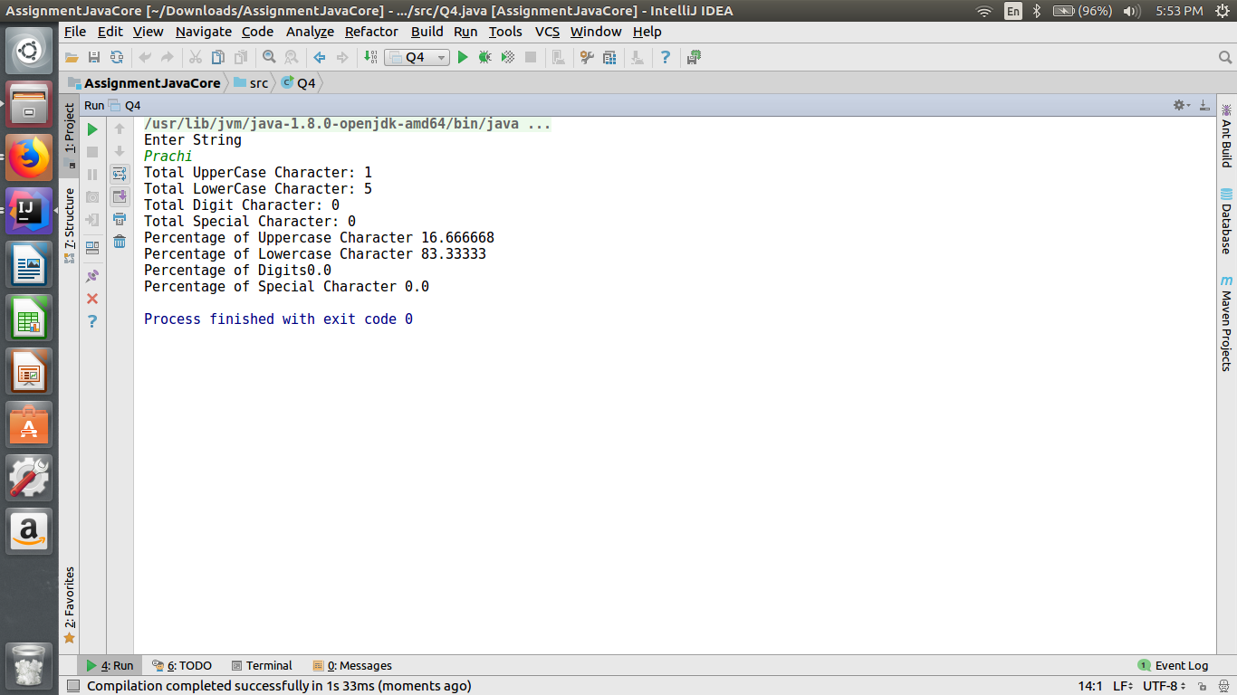

**Q-5 Find common elements between two arrays.**

**import java.util.Scanner;**

**public class Q5 {**

**public static void main(String[] args) {**

**Scanner sc=new Scanner(System.*in*);**

**System.*out*.println("Enter size of array1");**

**int size=sc.nextInt();**

**System.*out*.println("Enter size of array2");**

**int size1=sc.nextInt();**

**System.*out*.println("Enter elements in array1");**

**int[] array1=new int[size];**

**int[] array2=new int[size1];**

**for(int i=0;i<size;i++){**

**array1[i]=sc.nextInt();**

**}**

**System.*out*.println("Enter elements in array2");**

**for(int i=0;i<size;i++){**

**array2[i]=sc.nextInt();**

**}**

**System.*out*.println("Common Element:");**

**for(int i=0;i<array1.length;i++){**

**for(int j=0;j<array2.length;j++){**

**if(array1[i]==array2[j]){**

**System.*out*.println(array1[i]);**

**break;**

**}**

**}**

**}**

**}**

**}**

**OUTPUT:-**

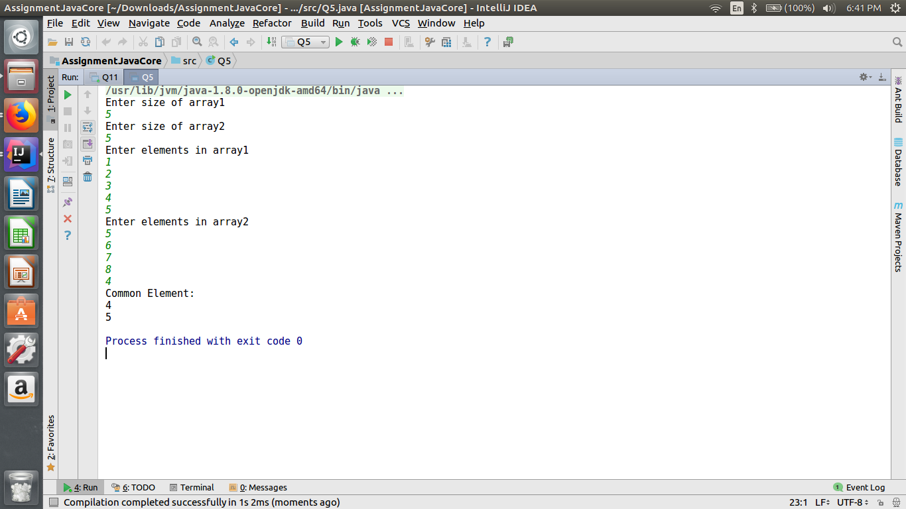

**Q-6 There is an array with every element repeated twice except one. Find that element?**

import java.util.Scanner;

public class Q6 {

void nonRepeatedElement(){

Scanner sc=new Scanner(System.*in*);

System.*out*.println("Enter size of an array");

int size=sc.nextInt();

System.*out*.println("Enter elements in an array");

int arr[]=new int[size];

boolean flag[]=new boolean[size];

for(int i=0;i<size;i++){

arr[i]=sc.nextInt();

flag[i]=true;

}

for(int i=0;i<size;i++){

for(int j=i+1;j<size;j++){

if((flag[i]==true || flag[j]==true) && arr[i]==arr[j]){

flag[i]=false;

flag[j]=false;

}

}

}

System.*out*.println("Non Repeated Element is");

for(int i=0;i<size;i++){

if(flag[i]==true){

System.*out*.println(arr[i]);

}

}

}

public static void main(String[] args) {

Q6 obj=new Q6();

obj.nonRepeatedElement();

}

}

**OUTPUT:-**

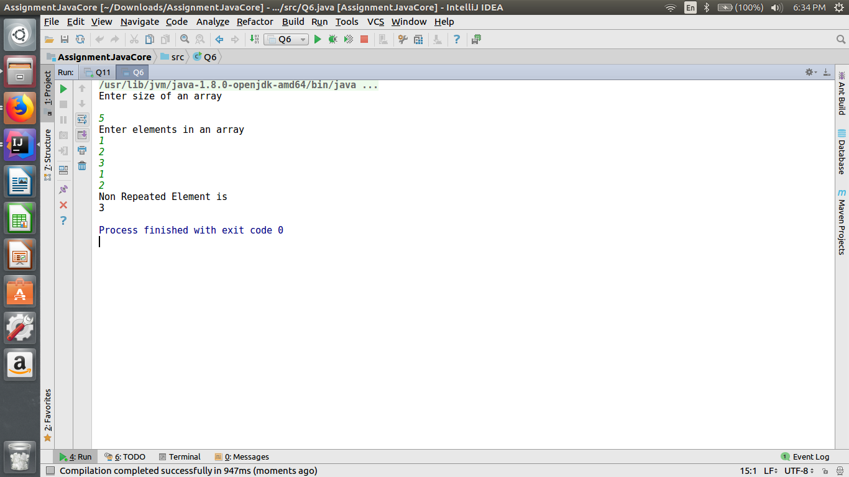

**Q-7 Write a program to print your Firstname,LastName & age using static block,static method & static variable respectively.**

**public class Q7 {**

**public static void main(String args[])**

**{**

**System.*out*.println("FirstName= "+StaticBlock.*firstName*);**

**System.*out*.println("Last Name= "+StaticBlock.*lastName*);**

**System.*out*.println("Age= "+StaticBlock.*age*);**

**}**

**}**

**class StaticBlock{**

**static String *firstName*;**

**static String *lastName*;**

**static int *age*;**

**static{**

***firstName* = "Prachi";**

***lastName*="Julka";**

***age*=23;**

**}**

**}**

**OUTPUT:-**

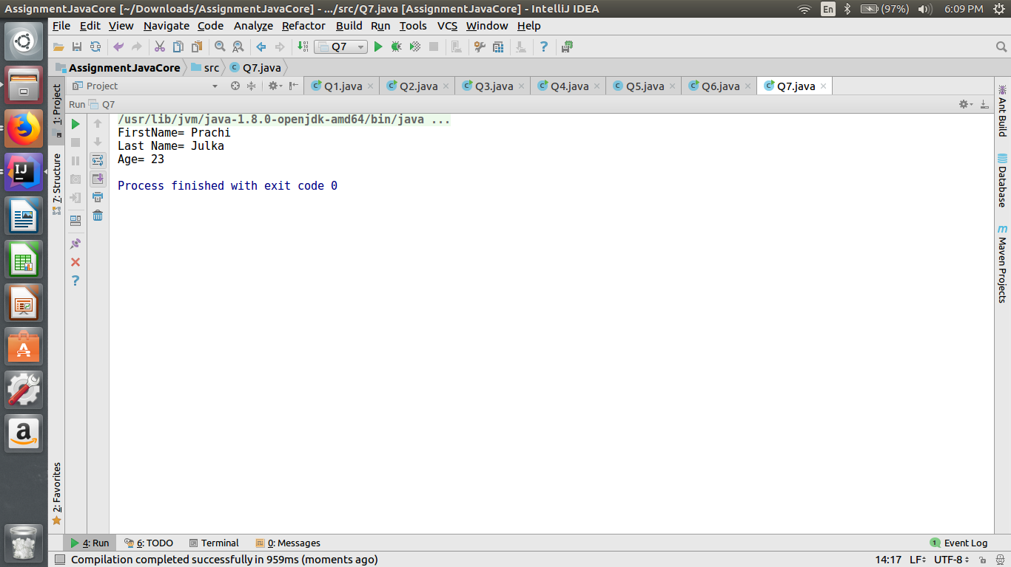

**Q-8 Write a program to reverse a string and remove character from index 4 to index 9 from the reversed string using String Buffer.**

**import java.util.Scanner;**

**public class Q8 {**

**void reverse(){**

**System.*out*.println("Enter a string");**

**Scanner sc=new Scanner(System.*in*);**

**String str=sc.next();**

**StringBuffer sb=new StringBuffer();**

**for(int i=str.length()-1;i>=0;i--){**

**sb.append(str.charAt(i));**

**}**

**System.*out*.println(sb);**

**sb.replace(4, 9, "");**

**System.*out*.println(sb);**

**}**

**public static void main(String[] args) {**

**Q8 obj=new Q8();**

**obj.reverse();**

**}**

**}**

**OUTPUT:-**

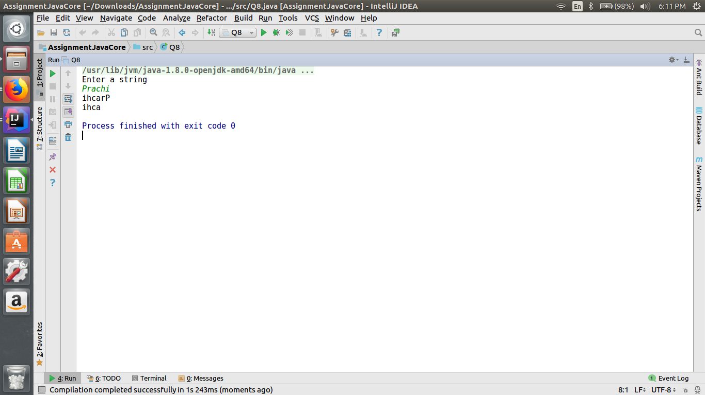

**Q-9 Write a program to read text file & print the content of file using String Builder.**

**import java.io.BufferedReader;**

**import java.io.FileReader;**

**import java.io.IOException;**

**public class Q9 {**

**public static void main(String[] args) {**

**try {**

**FileReader fr = null;**

**BufferedReader br = null;**

**String line;**

**StringBuilder sb = new StringBuilder();**

**br = new BufferedReader(new FileReader("/home/prachi/Downloads/demo.txt"));**

**while ((line=br.readLine()) != null) {**

**System.*out*.println(sb.append(line));**

**}**

**} catch(IOException e) {**

**e.printStackTrace();**

**}**

**}**

**}**

**OUTPUT:-**

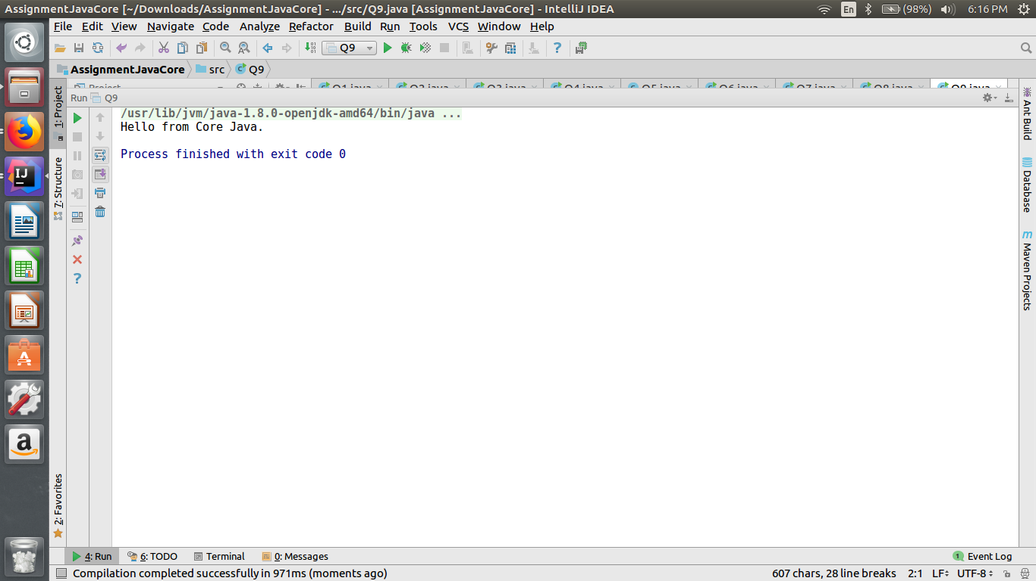

**Q-10 Write a program to display values of enums using a constructor & getPrice() method(Example display house & their prices ).**

**enum house {**

***TWOBHK*(3000),**

***THREEBHK*(2000),**

***FOURBHK*(4000);**

**private final int rupees;**

**house(int rupees) {**

**this.rupees = rupees;**

**}**

**public int getPrice() {**

**return this.rupees;**

**}**

**}**

**public class Q10 {**

**public static void main(String[] args) {**

**house hs= house.*TWOBHK*;**

**house hs1= house.*THREEBHK*;**

**house hs2= house.*FOURBHK*;**

**System.*out*.println(hs+" "+hs.getPrice());**

**System.*out*.println(hs1+" "+hs1.getPrice());**

**System.*out*.println(hs2+" "+hs2.getPrice());**

**}**

**}**

**OUTPUT:-**

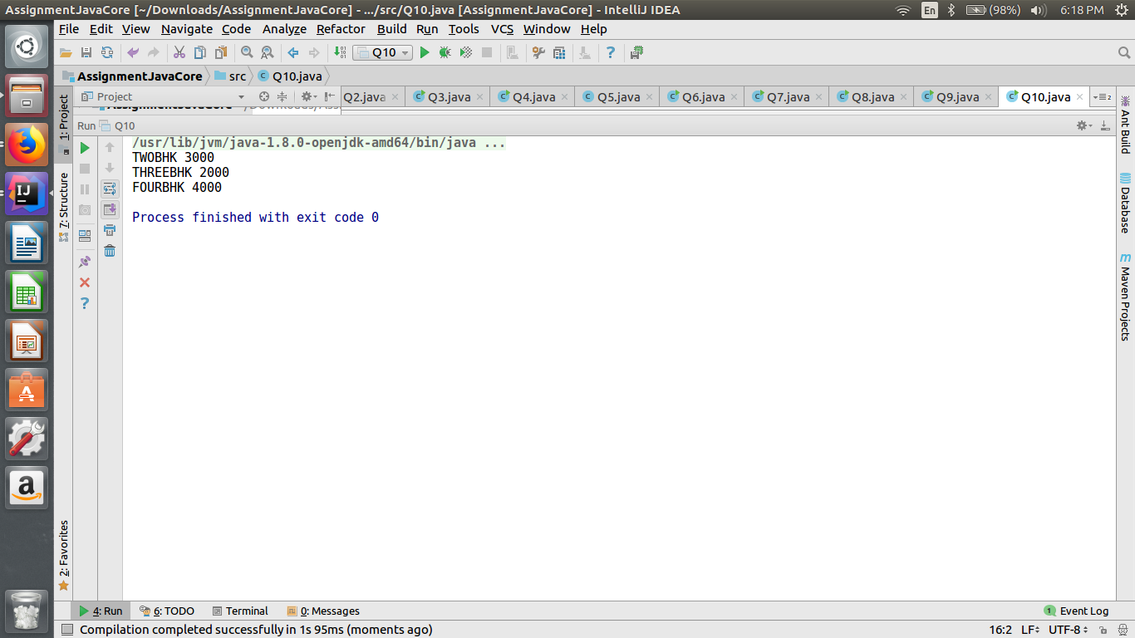

**Q-11 Write a single program for following operation using overloading A) Adding 2 integer number B) Adding 2 double C) Multipling 2 float d) Multipling 2 int E) concate 2 string F) Concate 3 String.**

**import java.util.Scanner;**

**public class Q11 {**

**int add(int num1, int num2) {**

**return (num1 + num2);**

**}**

**double add(double dnum1, double dnum2) {**

**return (dnum1 + dnum2);**

**}**

**float mul(float fnum1, float fnum2) {**

**return (fnum1 * fnum2);**

**}**

**int mul(int num1, int num2) {**

**return (num1 * num2);**

**}**

**String concat(String str1, String str2) {**

**return (str1 + str2);**

**}**

**String concat(String str1, String str2, String str3) {**

**return (str1 + str2 + str3);**

**}**

**public static void main(String[] args) {**

**Q11 obj = new Q11();**

**Scanner sc = new Scanner(System.*in*);**

**int c;**

**int num1, num2;**

**double dnum1, dnum2;**

**float fnum1, fnum2;**

**String str1, str2, str3;**

**do {**

**System.*out*.println("Enter 1 to add integer");**

**System.*out*.println("Enter 2 to add double");**

**System.*out*.println("Enter 3 to multiply float");**

**System.*out*.println("Enter 4 to multiply integer");**

**System.*out*.println("Enter 5 to concatinate 2 String");**

**System.*out*.println("Enter 6 to concatinate 3 String");**

**System.*out*.println("Enter 7 to exit");**

**System.*out*.println("Enter Your Choice");**

**c = sc.nextInt();**

**switch (c) {**

**case 1:**

**System.*out*.println("Enter first number");**

**num1 = sc.nextInt();**

**System.*out*.println("Enter second number");**

**num2 = sc.nextInt();**

**System.*out*.println("result " + obj.add(num1, num2));**

**break;**

**case 2:**

**System.*out*.println("Enter first number");**

**dnum1 = sc.nextDouble();**

**System.*out*.println("Enter second number");**

**dnum2 = sc.nextDouble();**

**System.*out*.println("result " + obj.add(dnum1, dnum2));**

**break;**

**case 3:**

**System.*out*.println("Enter first number");**

**fnum1 = sc.nextFloat();**

**System.*out*.println("Enter second number");**

**fnum2 = sc.nextFloat();**

**System.*out*.println("result " + obj.mul(fnum1, fnum2));**

**break;**

**case 4:**

**System.*out*.println("Enter first number");**

**num1 = sc.nextInt();**

**System.*out*.println("Enter second number");**

**num2 = sc.nextInt();**

**System.*out*.println("result " + obj.mul(num1, num2));**

**break;**

**case 5:**

**System.*out*.println("Enter first String");**

**str1 = sc.next();**

**System.*out*.println("Enter second String");**

**str2 = sc.next();**

**System.*out*.println("result " + obj.concat(str1, str2));**

**break;**

**case 6:**

**System.*out*.println("Enter first String");**

**str1 = sc.next();**

**System.*out*.println("Enter second String");**

**str2 = sc.next();**

**System.*out*.println("Enter third String");**

**str3 = sc.next();**

**System.*out*.println("result " + obj.concat(str1, str2, str3));**

**break;**

**case 7:**

**System.*out*.println("exit!!");**

**break;**

**default:**

**System.*out*.println("Enter correct choice");**

**}**

**} while (c != 7);**

**}**

**}**

**OUTPUT:-**

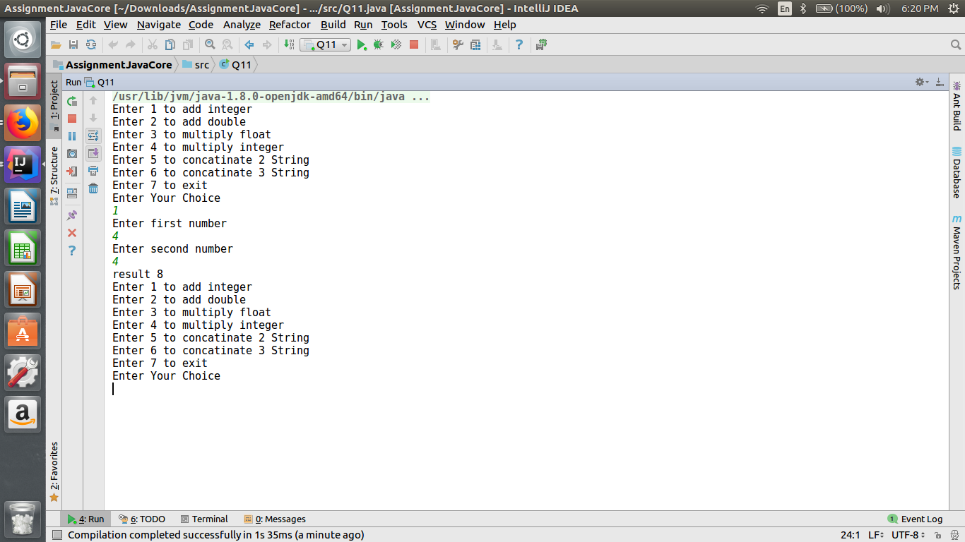

**Q-12 Create 3 sub class of bank SBI,BOI,ICICI all 4 should have method called getDetails which provide there specific details like rateofinterest etc,print details of every banks.**

class Bank {

void getDetails(){

System.*out*.println("Headquaters: Mumbai,India");

}

}

class SBI extends Bank{

void getDetails(){

super.getDetails();

System.*out*.println("Rate of Interest "+ 2.5);

System.*out*.println("Number Of Employees "+ 207739 );

}

}

class BOI extends Bank{

void getDetails(){

super.getDetails();

System.*out*.println("Rate of Interest "+1.5);

System.*out*.println("Number Of Employees "+ 45613);

}

}

class ICICI extends Bank{

void getDetails(){

super.getDetails();

System.*out*.println("Rate of Interest "+2.0);

System.*out*.println("Amount " + 74096);

}

}

public class Q12 {

public static void main(String[] args) {

SBI sbi = new SBI();

System.*out*.println("SBI Bank");

sbi.getDetails();

BOI boi = new BOI();

System.*out*.println("-----------------------------------------------------------------");

System.*out*.println("BOI Bank");

boi.getDetails();

ICICI icici = new ICICI();

System.*out*.println("-----------------------------------------------------------------");

System.*out*.println("ICICI Bank");

icici.getDetails();

}

}

**OUTPUT:-**

