**Q1. Git Setup https://confluence.atlassian.com/bitbucket/set-up-git-744723531.html**

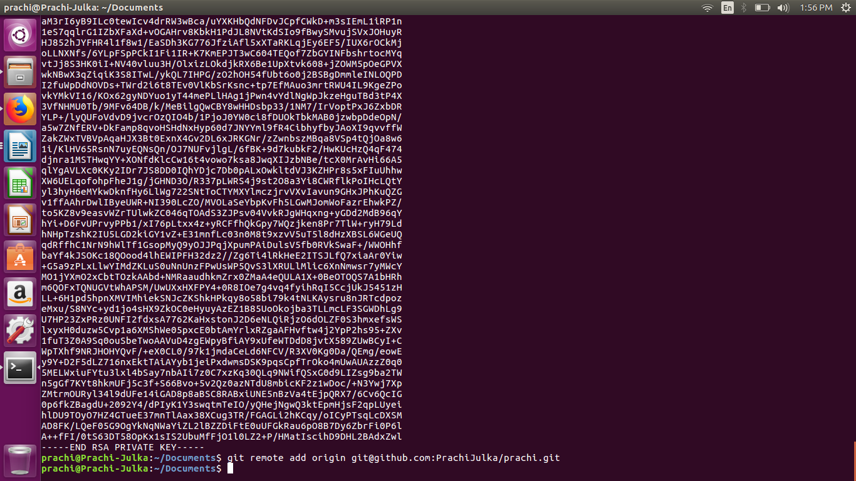

**Q2. Initialize a Git Repository**



**Q3. Add files to the repository**

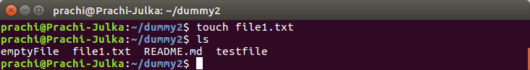

**Q4. Unstage 1 file**

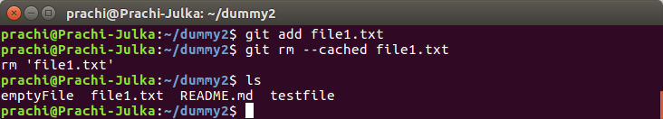

**Q5. Commit the file**

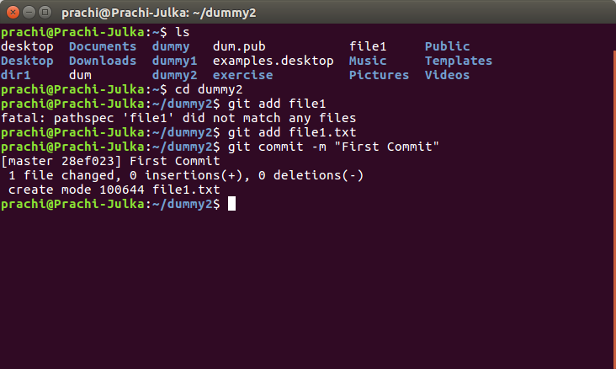

**Q6. Add a remote**

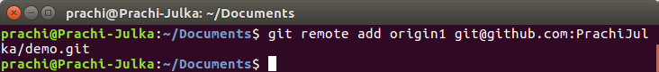

**Q7. Undo changes to a particular file**

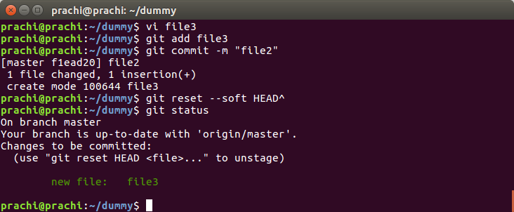

**Q8. Push changes to Github**

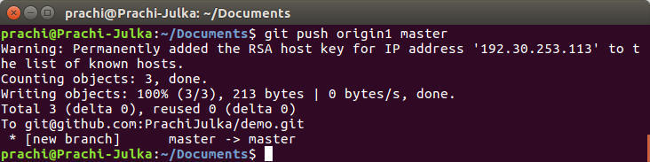

**Q9. Clone the repository**

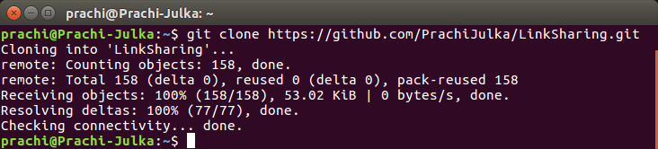

**Q10. Add changes to one of the copies and pull the changes in the other.**

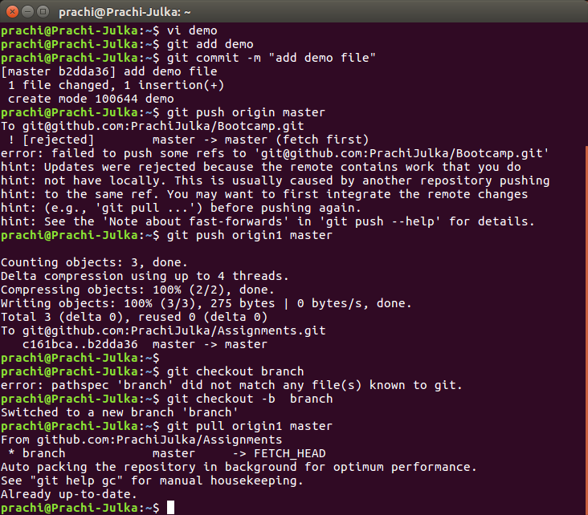

**Q11. Check differences between a file and its staged version**

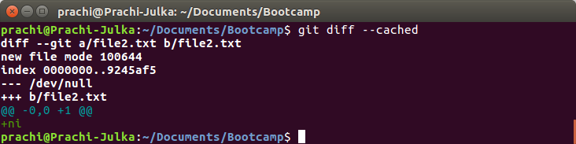

**Q12. Ignore a few files to be checked in**

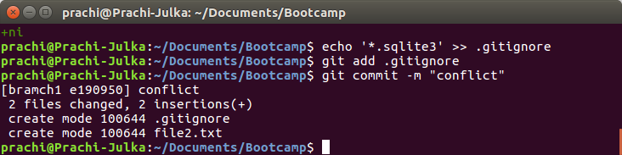

**Q13. Create a new branch.**

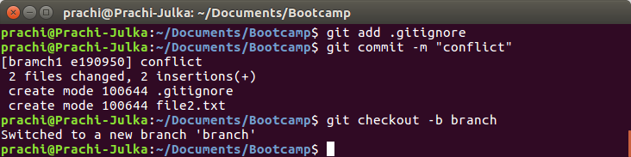

**Q14. Diverge them with commits.**

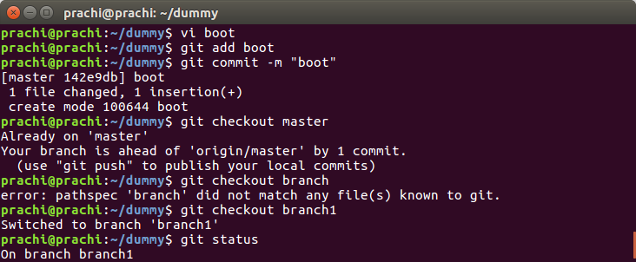

**Q15. Edit the same file at the same line on both branches and commit**

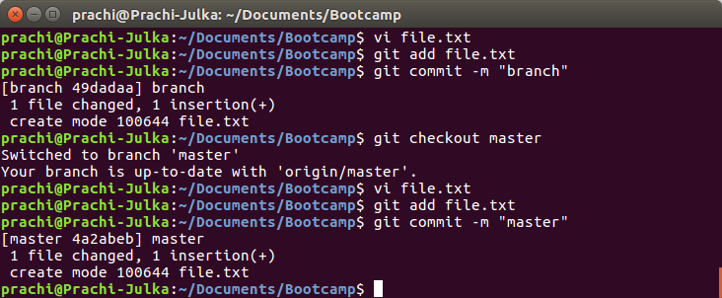

**Q16. Try merging and resolve merge conflicts.**

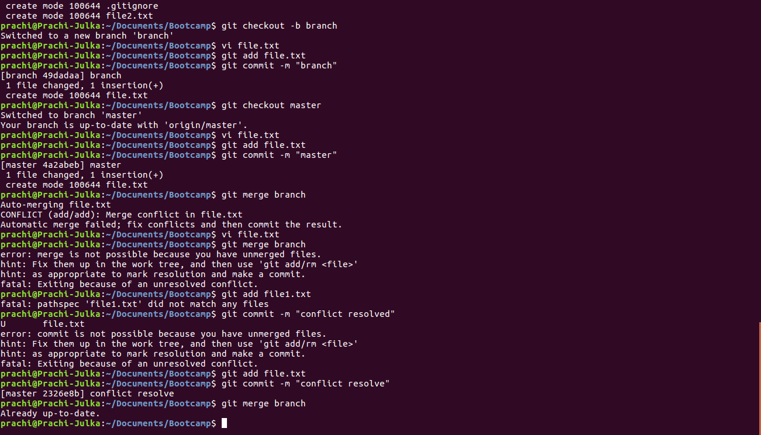

**Q17. Stash the changes and pop them.**

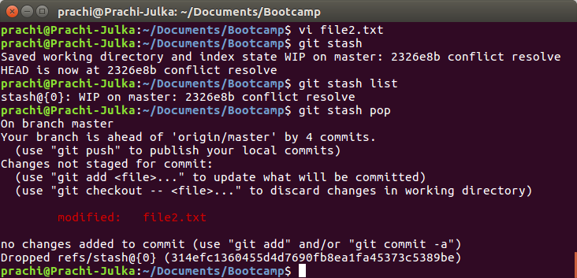

**Q18. Add the following code to your .bashrc file : color_prompt="yes"**

**parse_git_branch() {**

**git branch 2> /dev/null | sed -e '/^[^*]/d' -e 's/* \(.*\)/(\1)/'**

**}**

**if [ "$color_prompt" = yes ]; then**

**PS1='\u@\h\[\033[00m\]:\[\033[01;34m\]\W\[\033[01;31m\] $(parse_git_branch)\[\033[00m\]\$ '**

**else**

**PS1='\u@\h:\W $(parse_git_branch)\$ '**

**fi**

**unset color_prompt force_color_promp**

