**[Introduction to Version Control](http://learning.tothenew.com/ttn/session/show/?sessionId=492" \o "Summer Internship - JVM)**

**Q-1 Git Setup https://confluence.atlassian.com/bitbucket/set-up-git-744723531.html**

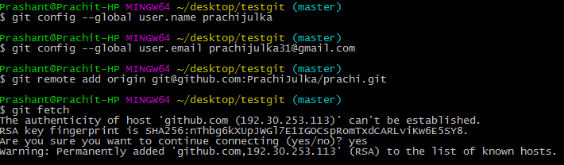

**Q-2 Initialize a Git Repository**



**Q-3 Add files to the repository**

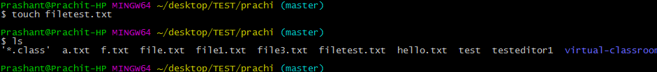

**Q-4 Unstage 1 file**

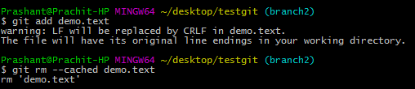

**Q-5 Commit the file**

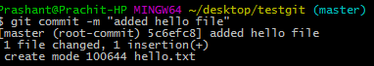

**Q-6 Add a remote**



**Q-7 Undo changes to a particular file**

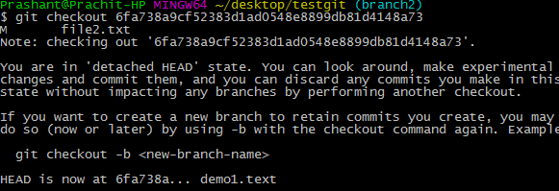

**Q-8 Push changes to Github**

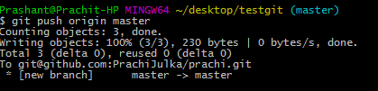

**Q-9 Clone the repository**

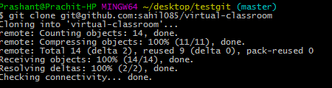

**Q-10 Add changes to one of the copies and pull the changes in the other.**

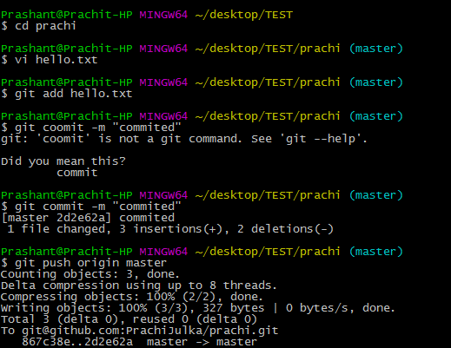

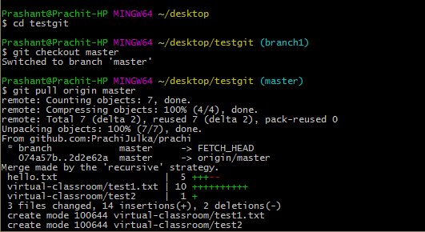

**Q-11 Check differences between a file and its staged version**

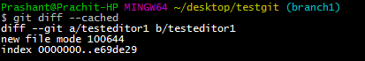

**Q-12 Ignore a few files to be checked in**

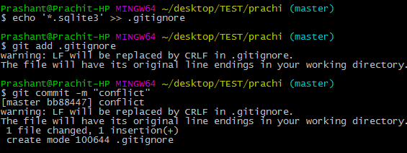

**Q-13 Create a new branch.**



**Q-14 Diverge them with commits**

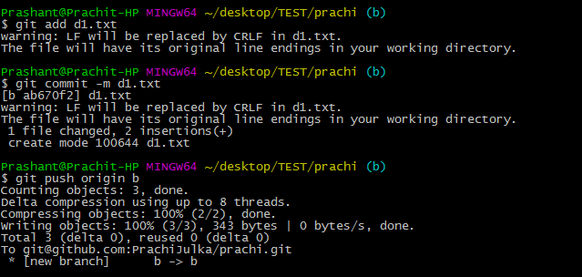

**Q-15 Edit the same file at the same line on both branches and commit**

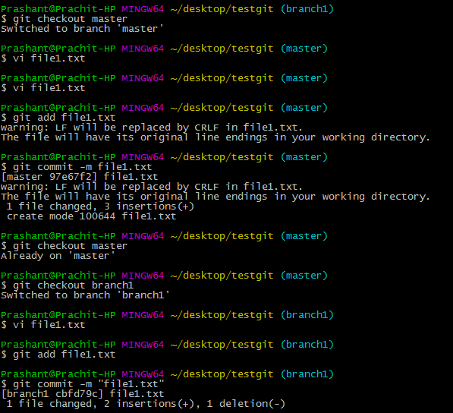

**Q-16 Try merging and resolve merge conflicts**

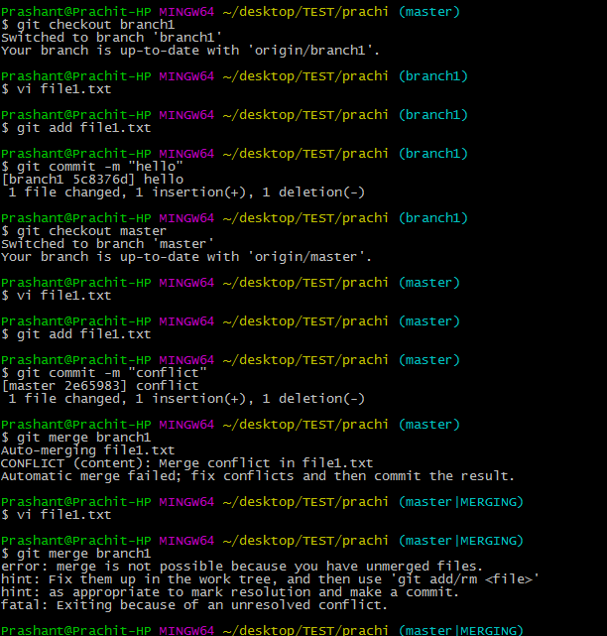

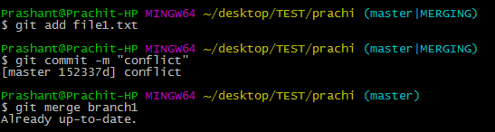

**Q-17 Stash the changes and pop them**

